Supplement - Highly specific and ultrasensitive plasma test detects Abeta(1-42) and Abeta(1-40) in Alzheimer’s disease

Supplementary Materials and Methods

Prototype assays reagent preparation and assay set-up
For the prototype assays, paramagnetic carboxylated beads (Quanterix) were conjugated with ADx102 (21F12) monoclonal antibody (mAb) for Abeta₄₂ and ADx103 (2G3) for Abeta₄₀. Biotinylated mAb ADx101 (3D6), specific for detection of Abeta₁, was provided by ADx NeuroSciences with a Ab/biotin ratio of 8. Both the assay for Abeta₁₋₄₂ and Abeta₁₋₄₀ were performed on the fully automated Quanterix Simoa HD-1 with a 2-step protocol. Samples had dilution factor (df) 4 for Abeta₁₋₄₂ and df10 for Abeta₁₋₄₀, needing respectively 60 μL and 24 μL sample with dead volume per well. The sample dilution buffer was similar to the calibrator diluent and consisted of 1xPBS with 1% milk, 0,1% Tween20 and 333 µg/mL TRU-block (Meridian Life Sciences). The first incubation step of the sample with the beads was 80 cadences for Abeta₁₋₄₂ and 47 cadences (1 cadence = 45 s) for Abeta₁₋₄₀. After washing, the second incubation step with 100 µL 50 pM streptavidin-β-galactosidase (Quanterix) was 7 cadences for both assays. Prior to reading Resorufin-β-D-galactopyranoside (Quanterix) was added.

Amyblood assays reagent preparation and assay set-up
Reagents of the upscaled batch were prepared as follows. For capture bead conjugation, 2.56*10^9 beads in 2 mL conjugation volume were activated using 0.1 mg/mL 1-Ethyl-3-(3-Dimethylaminopropyl)carbodiimide (EDAC) for 20 minutes at 4 °C and conjugated for 2 hours at RT with 0.2 mg/mL ADx102 (21F12) or ADx103 (2G3). Beads were blocked after couping using Quanterix Blocking buffer for 45 minutes at RT. Detector antibody ADx101 (3D6) was biotinylated using sNHS-Lc-Bio (Thermo Fisher) in a 8x molar excess at 1 mg/mL antibody concentration in 50 mM boric acid/sodium tetraborate buffer pH 8.5 and the biotinylation reaction was quenched by addition of 20 mM Tris. Capture beads and detector antibody were subsequently diluted in sample diluent (1xPBS w. 0.1% Casein, 0.1% Tween-20 and 50 µg/mL HBR-1 heterophylic blocker (Scantibodies, USA)) as RTU solutions. Bead RTU solution contained 2*10^7 beads per analyte from which 50% were helper beads (Quanterix). Detector RTU solution contained 0.1 µg/mL biotinylated ADx101 (3D6) in sample diluent. Calibrator RTU solutions were prepared using a 7-point 1:2 serial dilution series of 64 pg/mL Abeta₁₋₄₂ or Abeta₁₋₄₀ peptide (custom made by Polypeptide, BE) in sample diluent.

The Amyblood assays are 2-step assays combining 25 µL RTU beads, 20 µL RTU Detector and 100 µL RTU calibrator or pre-diluted EDTA plasma in sample diluent (dilution factor (df) 4 for Abeta₁₋₄₂; df10 for Abeta₁₋₄₀) in a first incubation step of 160 cadences (2 hours) on the Simoa HD-1 analyzer. After washing, a second incubation step of 7 cadences (5.25 minutes) followed wherein the 100 µL 50 pM enzyme conjugate streptavidin-β-galactosidase (Quanterix) labels the immunocomplex, followed by addition of the substrate resorufin β-D-galactopyranoside (RGP) for the fluorescent read-out. Research staff was blinded for clinical diagnoses.

Specificity and selectivity analyses
Specificity is the ability of an assay to distinguish between the analyte that the assay is intended to measure, and structurally similar analytes. We tested specificity of the Amyblood Abeta₁₋₄₂ assay by measuring the assay signal in response to increasing concentrations of 6 pg/mL, 25 pg/mL and 60 pg/mL of the fragments Abeta₁₋₄₀, Abeta₁₋₄₃, Abeta₂₋₄₂ and Abeta₃₋₄₂ (custom made by Polypeptide, BE) in sample buffer. We tested specificity of the Amyblood Abeta₁₋₄₀ assay by measuring the assay signal in response to increasing concentrations of 6 pg/mL, 25 pg/mL and 60 pg/mL of the fragments Abeta₁₋₄₂, Abeta₁₋₃₈, Abeta₁₋₃₉ and Abeta₁₁₋₄₀ (custom made by Polypeptide, BE) in sample buffer. The AEBs from Abeta1-42 and Abeta1-40 in buffer measured with the Amyblood assays were extrapolated from the calibration curve to calculate the corresponding concentrations. The AEBs from Abeta₁₋₄₂ and Abeta₁₋₄₀ in buffer measured with the Quanterix triplex were calculated derived from the linear measurements in 4, 25, and 130 pg/mL for Abeta₁₋₄₂ and 1, 15, and 40 pg/mL for Abeta₁₋₄₀. These AEBs were then extrapolated from the calibration curve to calculated the corresponding concentrations.

Selectivity is the ability of an assay to accurately detect an analyte concentration, in the presence of another, independent analyte that is expected to be present in a test sample. We tested selectivity by measuring the signal of one analyte in sample diluent (either Abeta₁₋₄₂ or Abeta₁₋₄₀), in the presence of a known concentration of the other analyte. The added concentrations were selected to include the physiological concentrations present in plasma, as well as concentrations lower and higher than the physiological concentrations. For Abeta₁₋₄₂ selectivity, we spiked either 6 pg/mL, 25 pg/mL or 60 pg/mL Abeta₁₋₄₂ in sample diluent, combined with 0 pg/mL (reference condition), 3 pg/mL, 15 pg/mL and 60 pg/mL Abeta₁₋₄₀. For Abeta₁₋₄₀ selectivity, we spiked either 3 pg/mL, 15 pg/mL or 60 pg/mL Abeta₁₋₄₀ in sample diluent, combined with 0 pg/mL (reference condition), 6 pg/mL, 25 pg/mL or 60 pg/mL Abeta₁₋₄₂.

Quanterix and ELISA assay validation
The Quanterix commercial assays were validated at Amsterdam UMC. Linearity was based on three native EDTA plasma samples, six dilutions were assessed that ranged from df4 to df12500. Intra-assay %CV, LLOQs, specificity and sensitivity were assessed with the same method as the Amyblood assays. Inter-assay %CV was based on 3 neat plasma QC samples: QC Low and QC Medium were measured in 4 different runs on different days. QC high was measured in 3 different runs on different days. We tested specificity of the Quanterix Abeta_{x-42} assay by measuring the assay signal in response to increasing concentrations of 1 pg/mL, 15 pg/mL and 40 pg/mL of the fragments Abeta₁₋₄₀, Abeta₁₋₄₃, Abeta₂₋₄₂, and Abeta₃₋₄₂ in sample buffer. We tested specificity of the Quanterix Abeta_{x-40} assay by measuring the assay signal in response to increasing concentrations of 4 pg/mL, 25 pg/mL and 130 pg/mL of the fragments Abeta₁₋₄₂, Abeta₁₋₃₈, Abeta₁₋₃₉, and Abeta₁₁₋₄₀ in sample buffer. For Quanterix Abeta_{x-42} selectivity, we spiked either 1 pg/mL, 15 pg/mL or 40 pg/mL Abeta₁₋₄₂ in sample diluent, combined with 0 pg/mL (reference condition), 4 pg/mL, 25 pg/mL and 130 pg/mL Abeta₁₋₄₀. For Abeta_{x-40} selectivity, we spiked either 4 pg/mL, 25 pg/mL or 130 pg/mL Abeta₁₋₄₀ in sample diluent, combined with 0 pg/mL (reference condition), 1 pg/mL, 15 pg/mL or 40 pg/mL Abeta₁₋₄₂.
The ELISA LLOQ’s were based on the limit of blank data provided by Euroimmun and calculated as the average concentration of 24 blank measurements + 10 standard deviations. The linearity of the ELISA assays was based on data provided by Euroimmun on two EDTA plasma pools spiked with recombinant Abeta₁₋₄₂ or Abeta₁₋₄₀ at different concentrations and one native EDTA plasma sample. Ten dilutions were assessed, from df 1 to df 10. We expect the ELISA assay to perform similar to the Amyblood, since both assays use the same antibodies, and we therefore did not include that assay in the specificity and selectivity studies.

Supplementary results

Prototype and Amyblood assay development and transfer
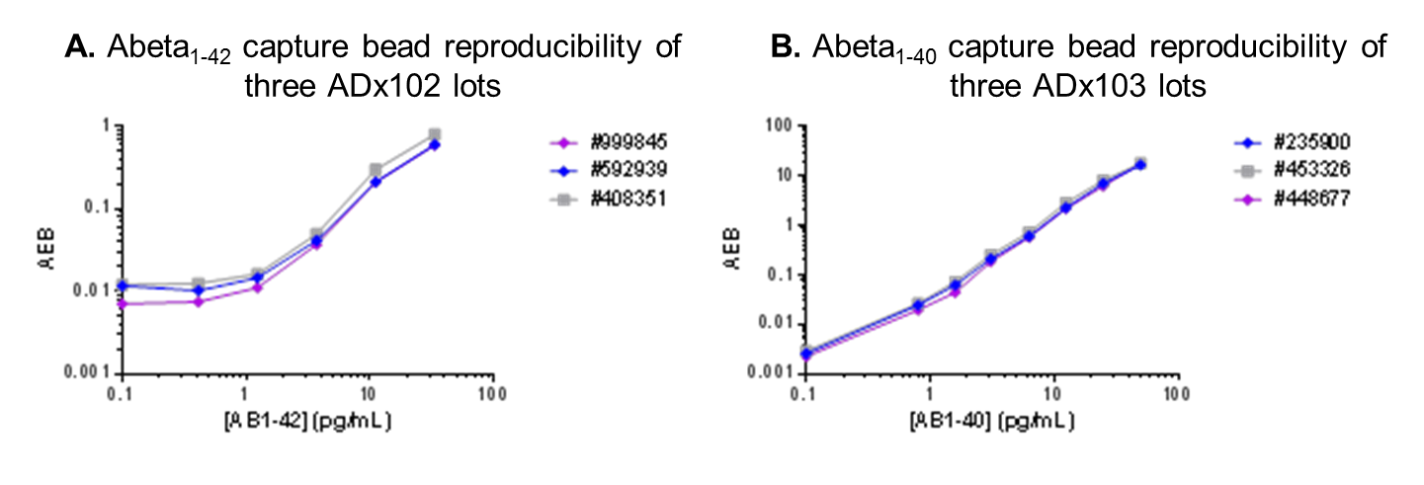
eFigure 1. Lot to lot variation tested on calibrator curves of three different capture antibody lots. A. The mean variation in AEB values between the three different antibody lots tested for Abeta₁₋₄₂ was 19%. B. The mean variation in AEB values between the three different antibody lots tested for Abeta₁₋₄₀ was 14%.

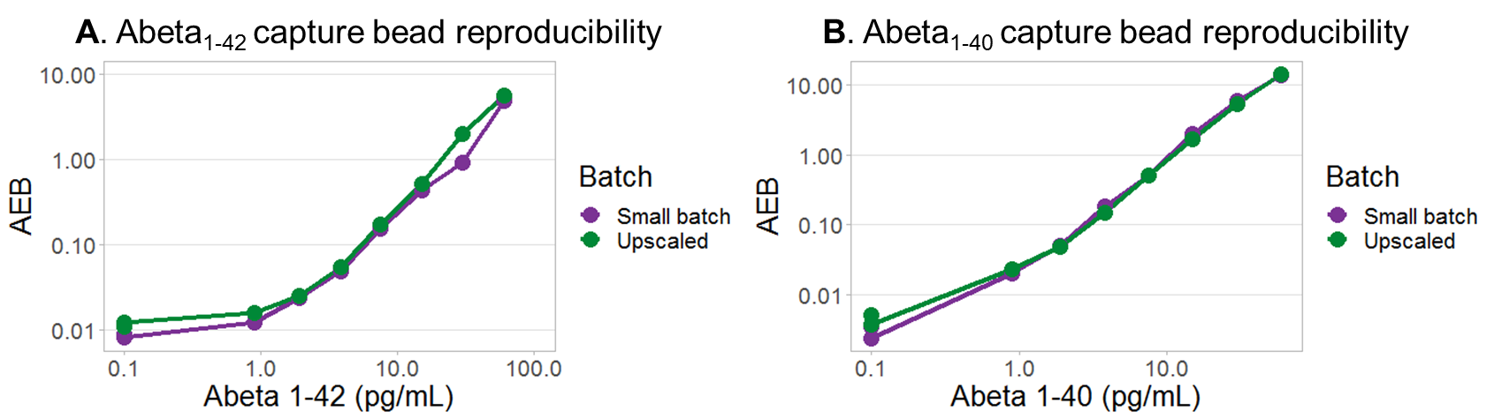
eFigure 2. Calibrator curve comparison between small and upscaled bead batch
A. Mean variation in AEB values between the small batch and upscaled batch is 15.9% for Abeta₁₋₄₂. B. Mean variation in AEB values between the small batch and upscaled batch is 7.0% for Abeta_{1-40.} Upscaling to bead conjugation volumes from 100µL to 2 mL did not affect calibrator AEB curves.

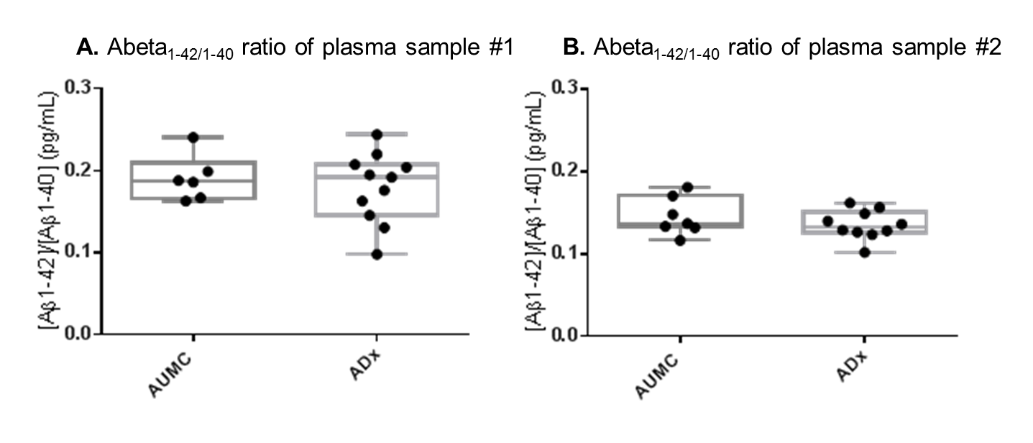
eFigure 3. Two neat plasma samples measured with the Amyblood assays at AUMC and ADx.
A. The mean Abeta_{1-42/1-40} ratio of plasma sample 1 was 0.17 ADx and 0.19 at AUMC. B. The mean Abeta_{1-42/40} ratio of plasma sample 2 was 0.13 ADx and 0.14 at Amsterdam UMC. Mean intra-assay %CV of the Abeta_{1-42/40} ratio of two neat samples was 3.5% and 2.0% at ADx and 3.9% and 2.2% at Amsterdam UMC. Mean inter-assay %CV of the Abeta_{1-42/40} ratio was 23% and 13% at ADx and 14% for both samples at Amsterdam UMC. Overall mean inter-assay and inter-center variation of the Abeta ratio was 17.2%, combining all results. Abeta: amyloid beta; AUMC: Amsterdam University Medical Centers; ADx; ADx Neurosciences

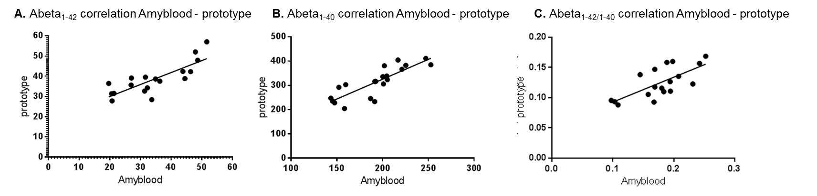
eFigure 4. Correlations between amyloid concentrations measured with the prototype and Amyblood
A. Correlation between the prototype and Amyblood measurements of Abeta₁₋₄₂ (R=0.77 (95%CI:0.46-0.91), p<0.001). B. Correlation between the prototype and Amyblood measurements of Abeta₁₋₄₀ (R=0.89 (95% CI: 0.74-0.96), p<0.001). C. Correlation between the prototype and Amyblood measurements of the Abeta_{1-42/1-40} ratio (R=0.69 (95% CI: 0.32-0.88), p=0.0014). Abeta: amyloid beta.
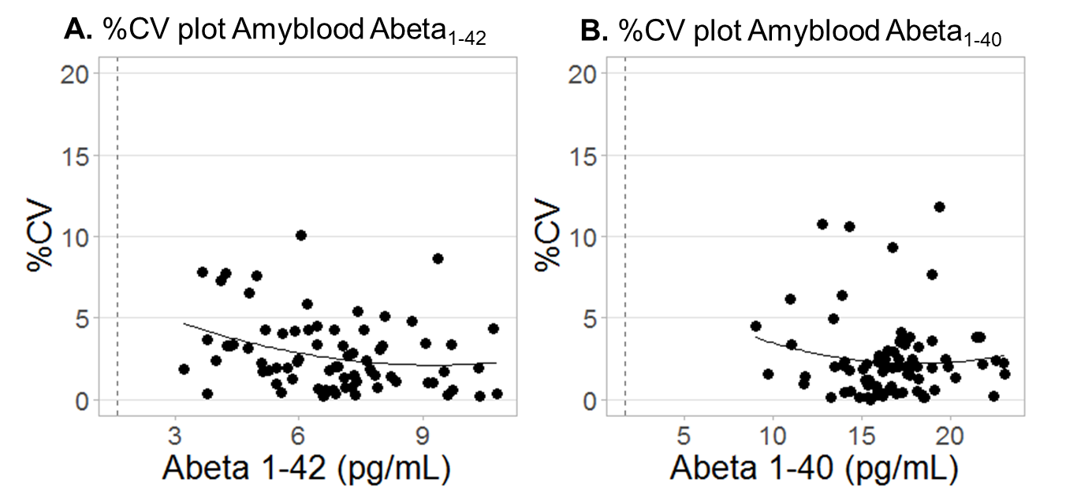
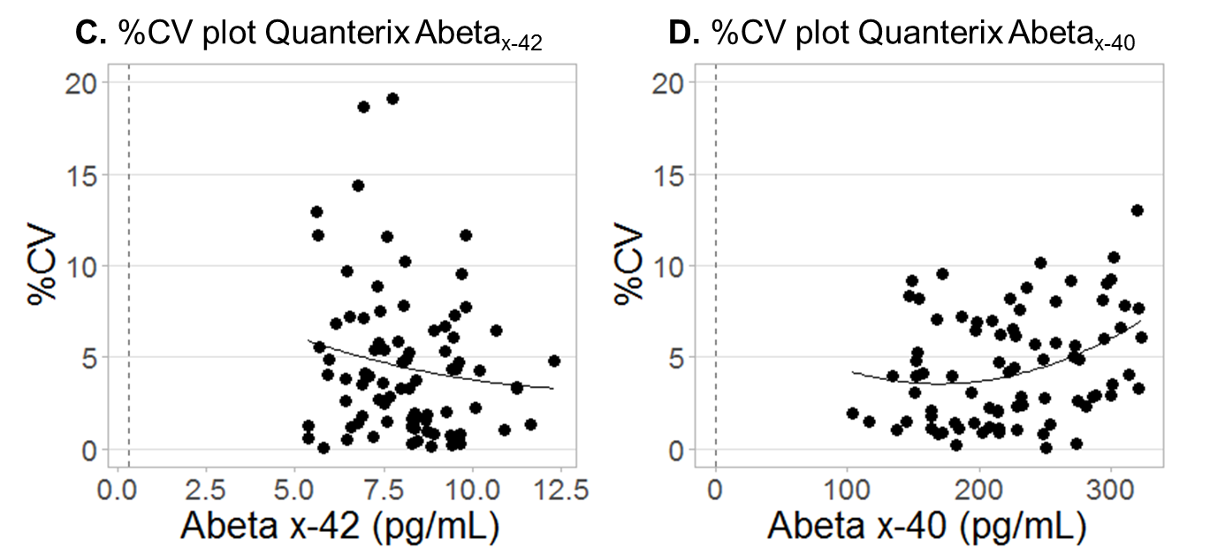
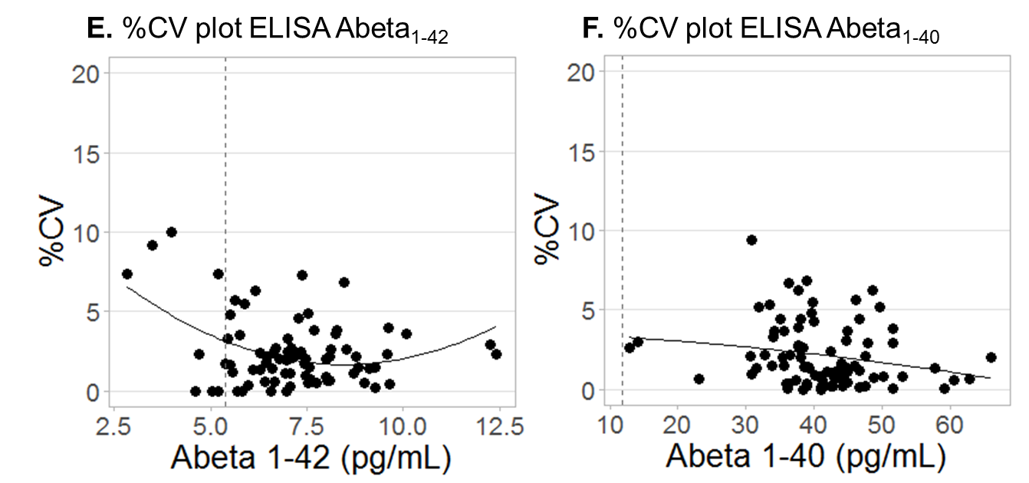
eFigure 5. Percentage coefficient of variation in patient samples measured with three immunoassays. A. Abeta₁₋₄₂ measured with the Amyblood assay. For visualization a sample with %CV of 26.1 and Abeta₋₄₂ of 5.2 pg/mL (below LLOQ) was excluded. This concentration was below LLOQ. B. Abeta₁₋₄₀ measured with the Amyblood assay. C. Abeta_{x-42} measured with the Quanterix assay. D. Abeta₁₋₄₀ measured with the Quanterix assay. E. Abeta₁₋₄₂ measured with the ELISA assay. Eight samples were measured below LLOQ. F. Abeta₁₋₄₀ measured with the ELISA assay. Dashed line represents the LLOQ per assay

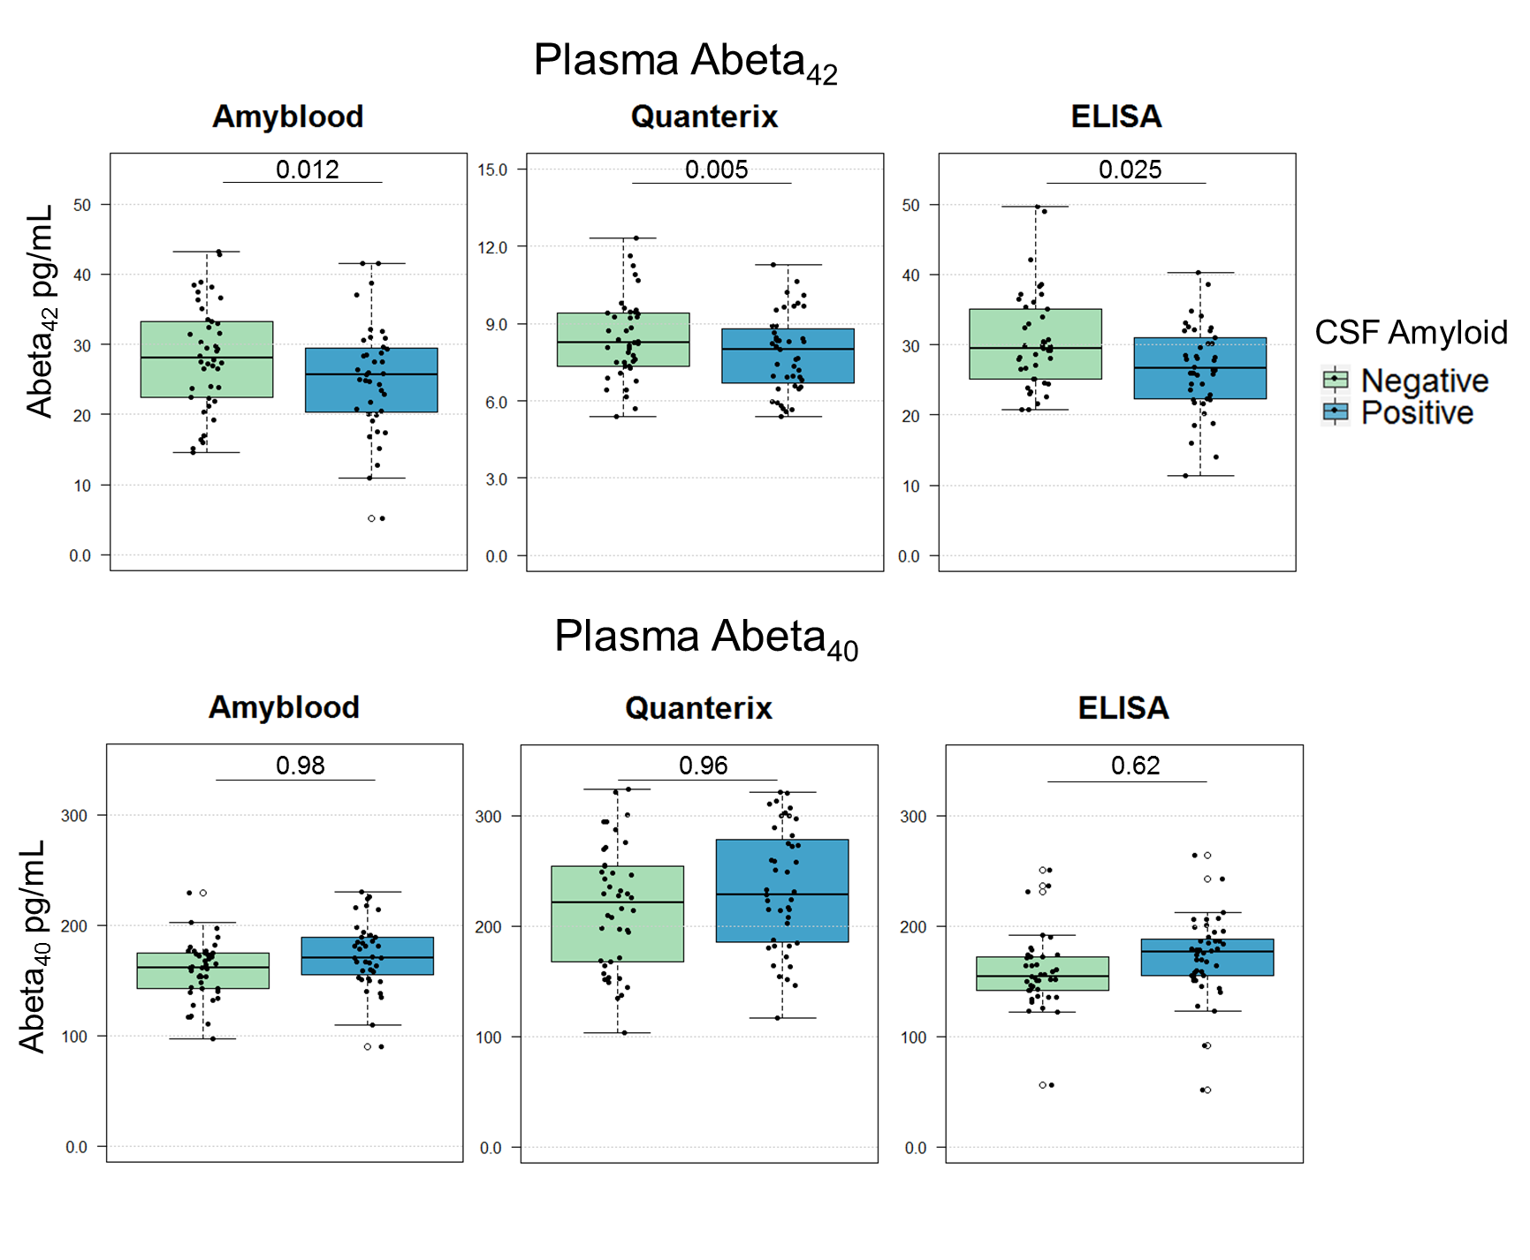
eFigure 6. Plasma Abeta₄₂ and Abeta₄₀ measured with three different immunoassays
Plasma Abeta₄₂ and Abeta₄₀ measured in CSF Abeta₄₂ negative and CSF Abeta₄₂ positive groups, using the Amyblood and Quanterix Simoa assays and the Euroimmun ELISA. P-values are corrected for age, sex, sample batch, and sample storage time.

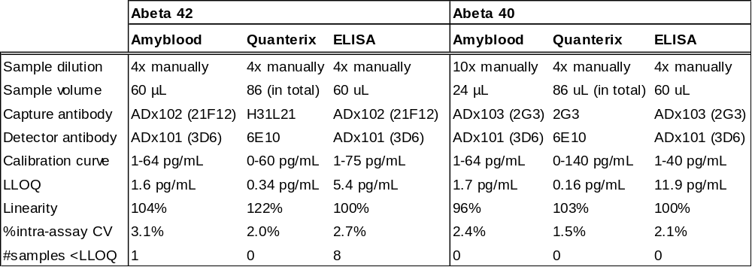

eTable 1: Technical specifications of the different assay versions
The Amyblood and Quanterix assays were performed using the Quanterix Simoa. The sample volume is for duplo measurement including dead volume. Abeta; amyloid beta, LLOQ; Lower limit of quantification.

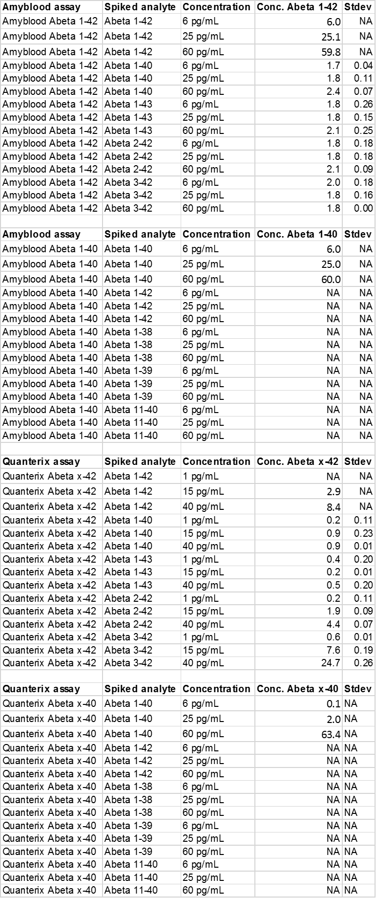

eTable 2. Specificity results Amyblood and Quanterix assays
The concentrations of Abeta₁₋₄₂ (pg/mL) measured with the Amyblood assay and the concentrations Abeta_{x-42} (pg/mL) measured with the Quanterix assay. The signal obtained with the Amyblood Abeta₁₋₄₀ assay and Quanterix Abeta_{x-40} assay was too low to detect and therefore not included in this table. Abeta: Amyloid beta

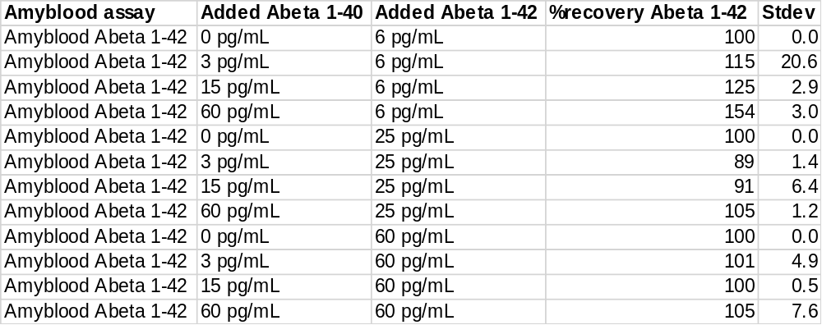

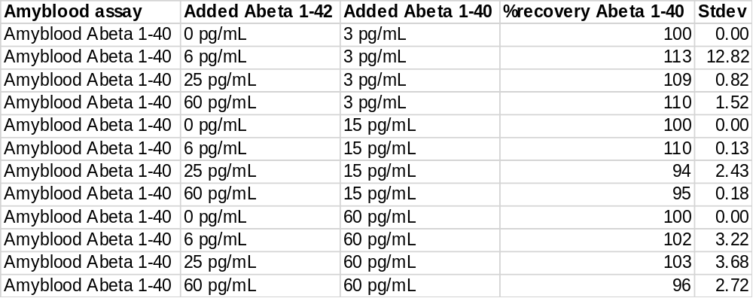

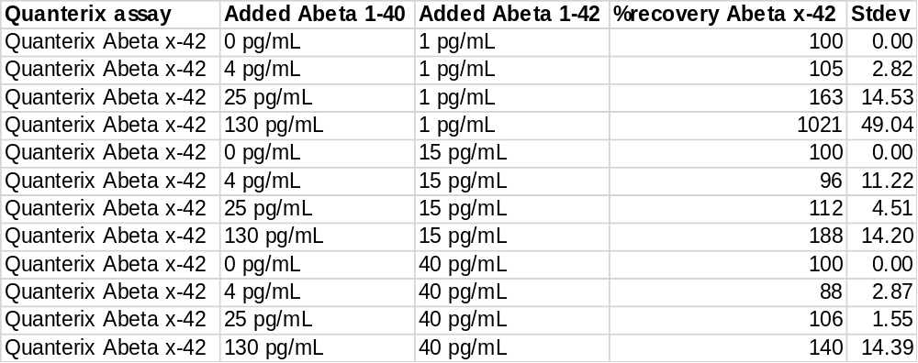

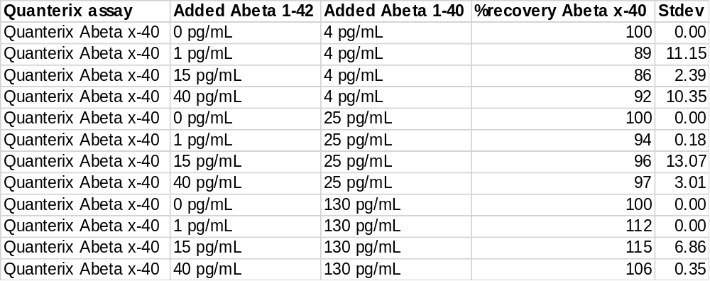

eTable 3. Selectivity results Amyblood and Quanterix assays
The percentage recovery (%recovery) of Abeta₁₋₄₂ and Abeta₁₋₄₀ measured with the Amyblood assays, and the %recovery of Abeta_{x-42} and Abeta_{x-40} measured with the Quanterix assays. Abeta: Amyloid beta.

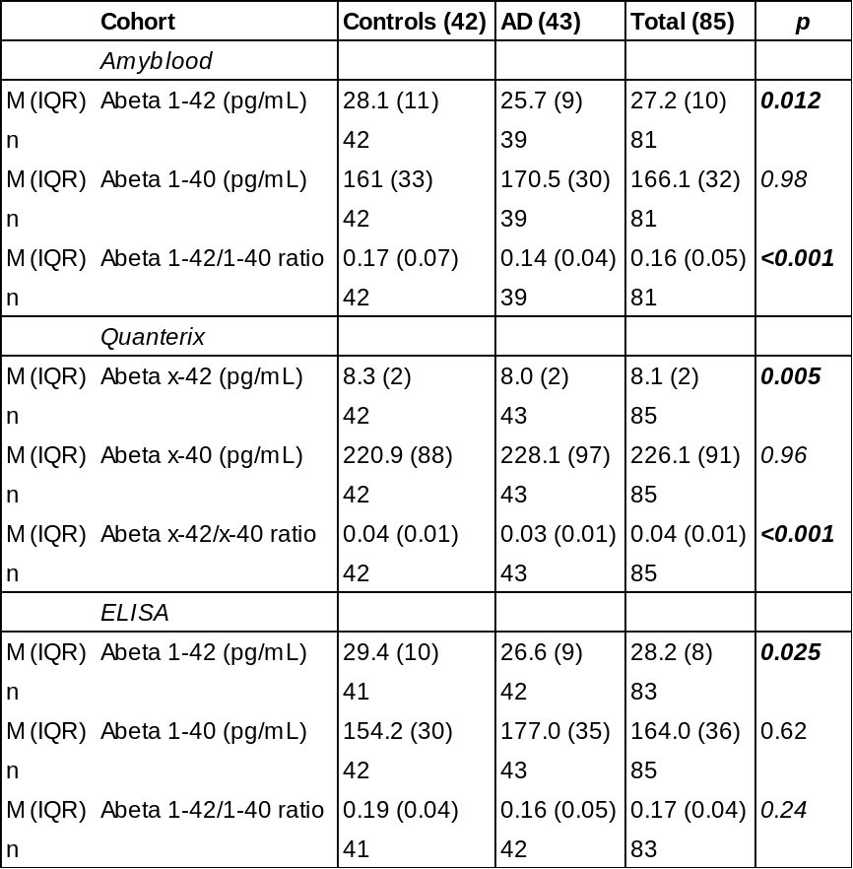

eTable 4: Cohort characteristics and biomarker values in the clinical validation
Abeta, Amyloid beta; ELISA, Enzyme-Linked Immuno Sorbent Assay; M (IQR) shows the median value and interquartile range. P values show the difference between the CSF Aβ negative and the CSF Aβ positive group. Plasma biomarker p-values are adjusted for sample storage time, sample run, age, and sex. Significant p-values are shown in bold (p<0.05).

