Supplementary Figures
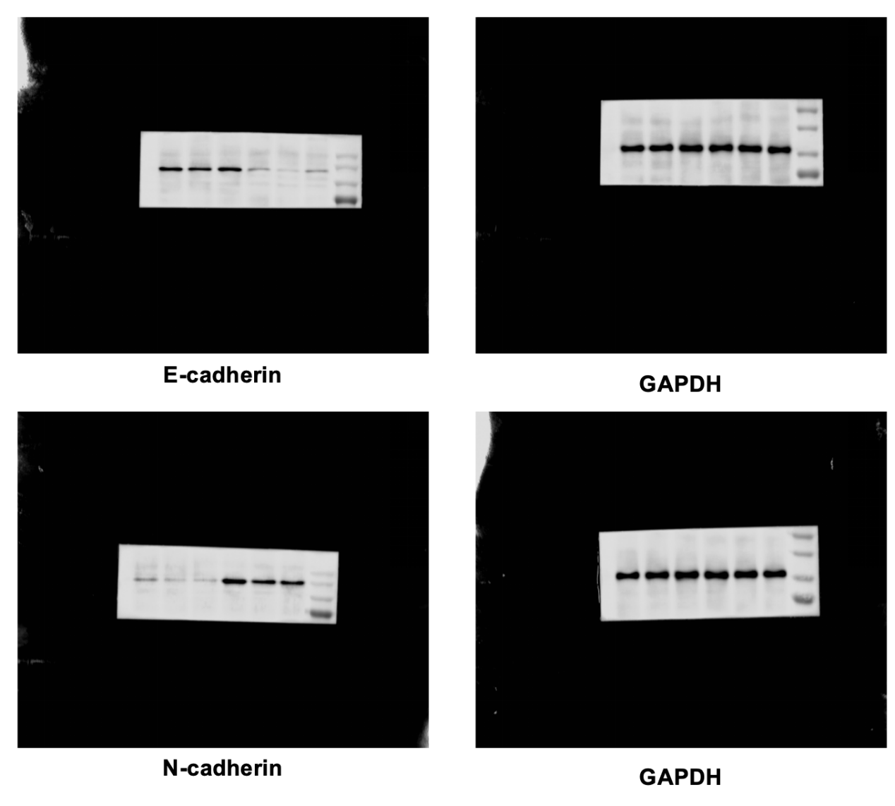
Fig. S1 Western blotting image of E-cadherin and N-cadherin.

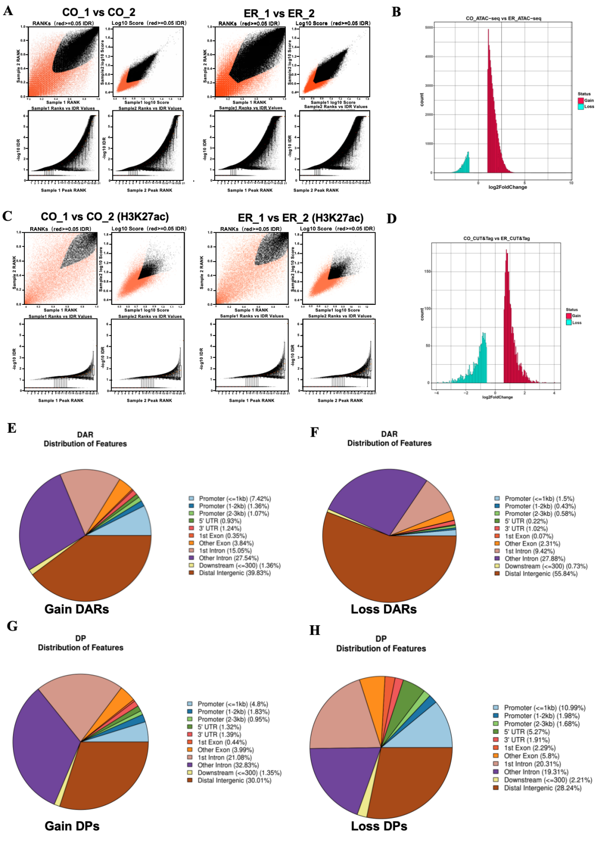
Fig. S2 ATAC-seq and CUT&Tag quality control and data analysis in the endometrium tissue. (A) and (C) Irreproducible discovery rate (IDR) analysis of reproducibility within groups. Histogram of (B) differentially accessible regions (DARs) and (D) differentially peaks (DP). Genome-wide distribution of (E) gain and (F) loss DARs. Genome-wide distribution of (G) gain and (H) loss DPs.

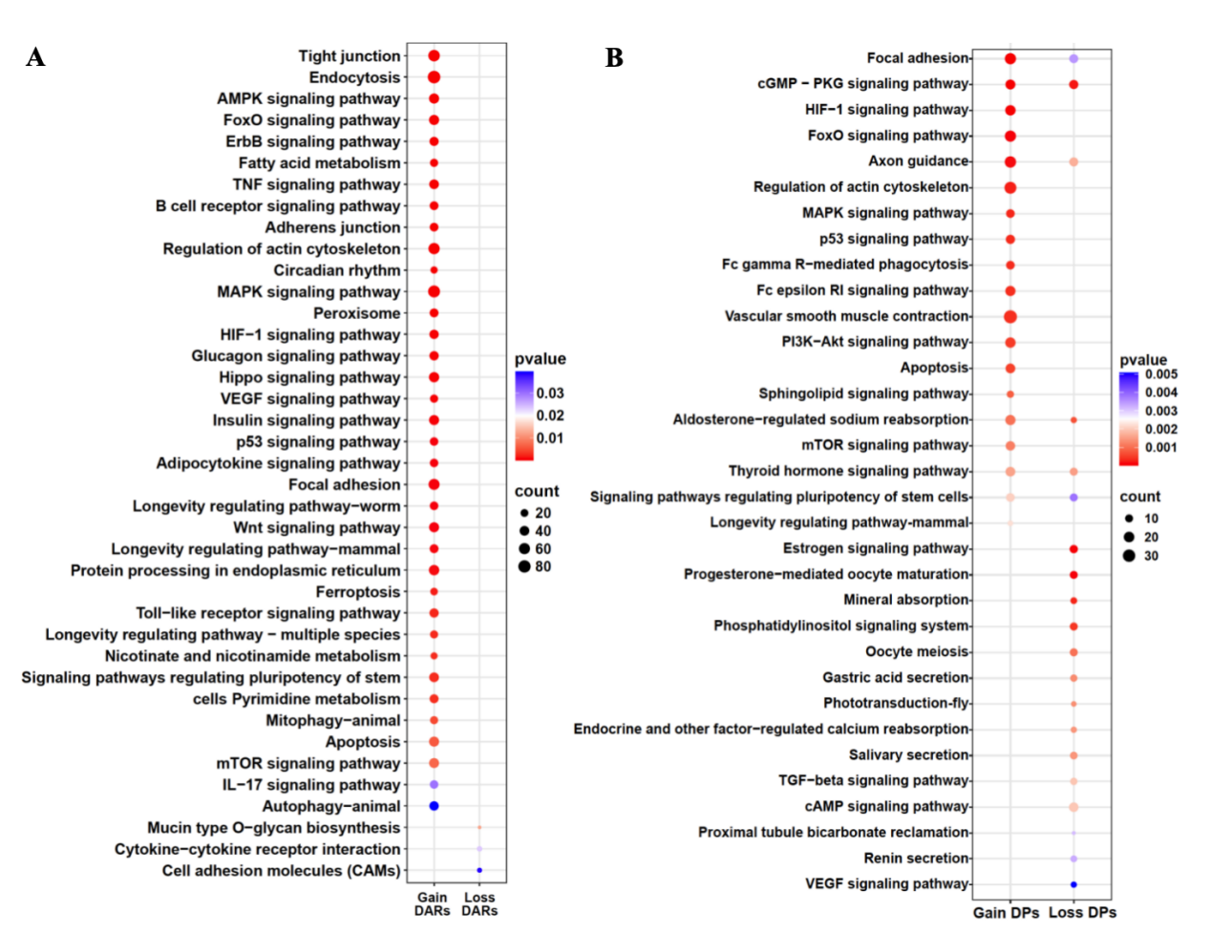
Fig. S3 KEGG pathway analysis of DARs and DPs. (A) KEGG pathway analysis of gain and loss promoter DAR associated genes. (B) KEGG pathway analysis of gain and loss DP associated genes.

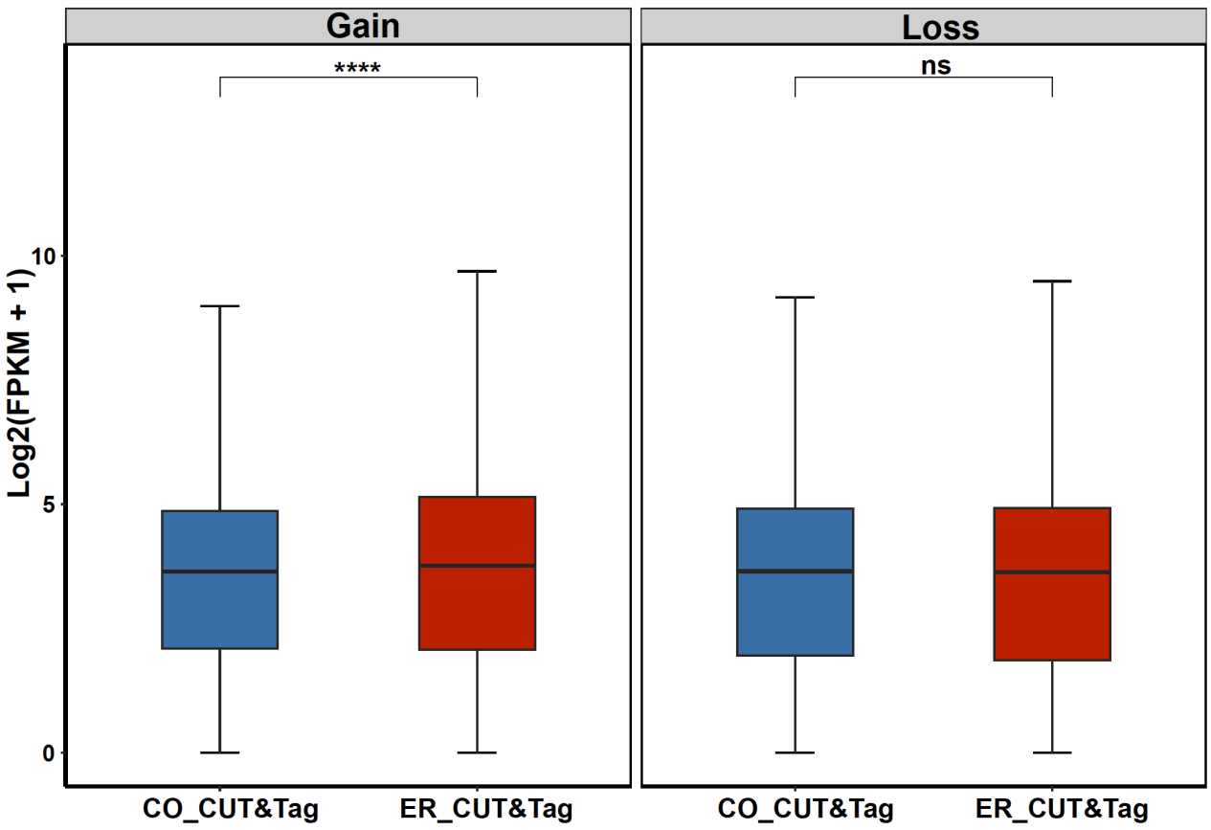
Fig. S4 Box plot of the expression levels of DP-related genes.

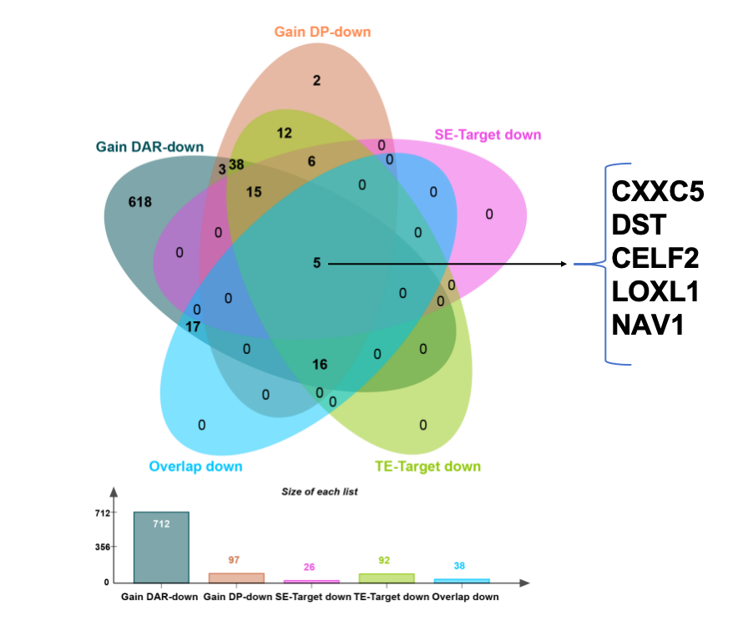
Fig. S5 Venn diagram showing overlap genes (5) with increase of RNA expression and differential ATAC accessibity and genes target by Enhs, in the CO group.

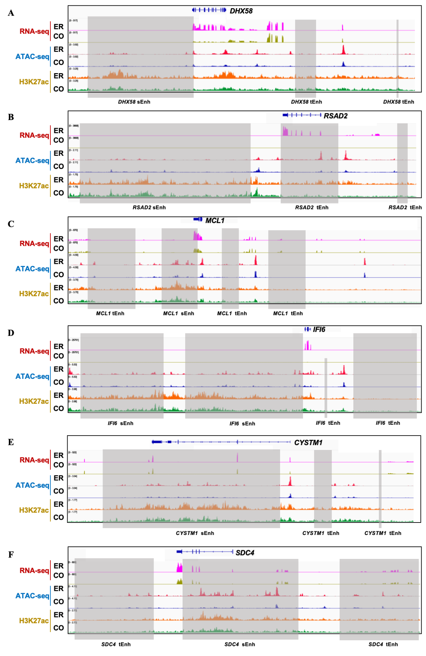
Fig. S6 ATAC-seq, H3K27ac, and RNA-seq profile at the DHX58, RSAD2, MCL1, IFI6, CYSTM1, and SDC4 locus. Grey boxes indicate super-enhancers (sEnh) and typitic enhancer (tEnh) identified.

