Supplementary info

Dispersal tracking in the future ocean combining statistical downscaling and dynamic modeling approaches

Trond Kristiansen^{1,2}, Jordan Miller², and Momme Butenschön³

^{*1}Farallon Institute, Petaluma, California, USA
²Actea Inc, San Francisco, California, USA
³CMCC Foundation - Euro-Mediterranean Center on Climate
Change, Italy

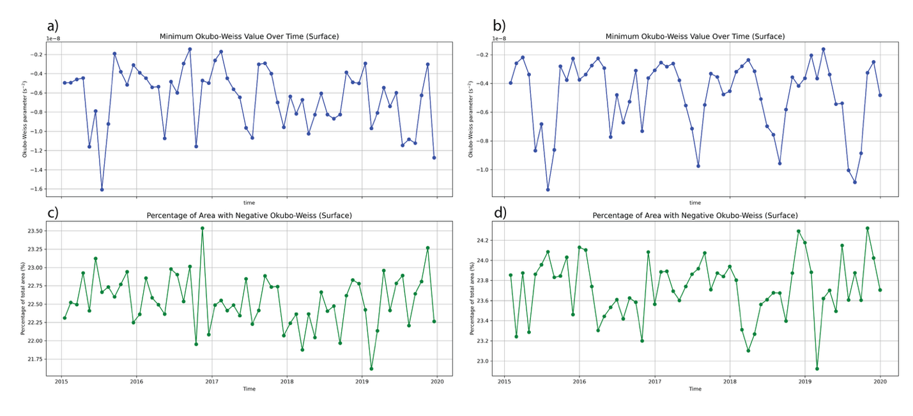
Supplementary Figure 1: Okubo-Weiss (OW) parameter calculated for the period 2015-2020 and area averaged. The upper panel shows the temporal variability of minimum OW parameter for a) GLORYS and b) SD-GLORYS. The percentage area with negative OW surface value are shown for c) GLORYS and d) SD-GLORYS.

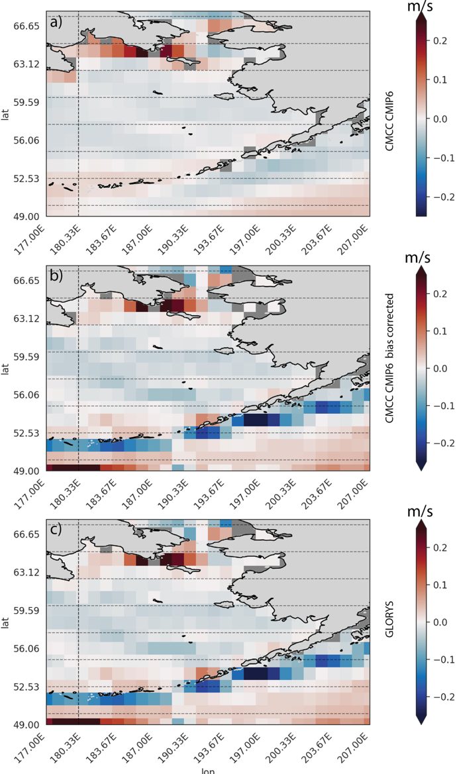

Supplementary figure 1: Mean (2015-2020) eastward ocean velocity (uo [m/s]) at 5 m depth shown for a) coarse resolution CMCC-CM2-SR5 CMIP6 model outputs, b) bias corrected downscaled outputs, c) GLORYS ocean reanalysis.

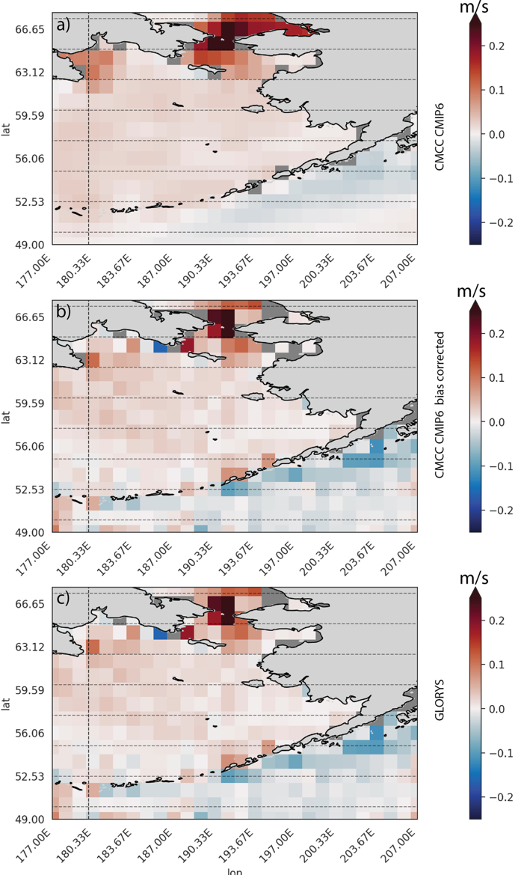

Supplementary figure 2: Mean (2015-2020) northward ocean velocity (vo [m/s]) at 5 m depth shown for a) coarse resolution CMCC-CM2-SR5 CMIP6 model outputs, b) bias corrected downscaled outputs, c) GLORYS ocean reanalysis.

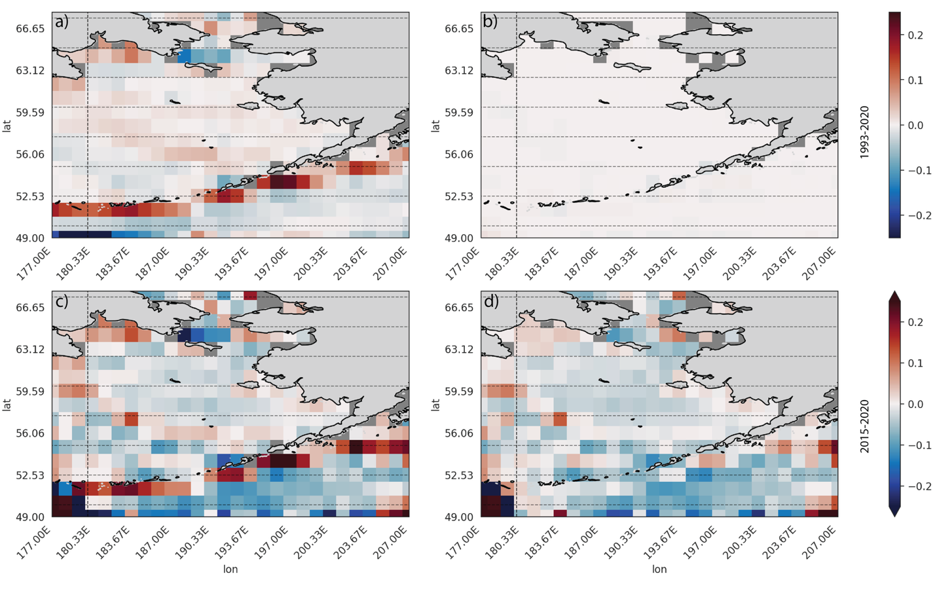
Supplementary figure 3: Bias of eastward velocity (uo) between a) CMCC-CM2-SR5 and GLORYS ocean reanalysis and b) bias corrected CMCC-CM2-SR5 for the training period 2010-2015 and bias between c) CMCC-CM2-SR5 and GLORYS ocean reanalysis and d) bias corrected CMCC-CM2-SR5 for the validation period 2015-2020.

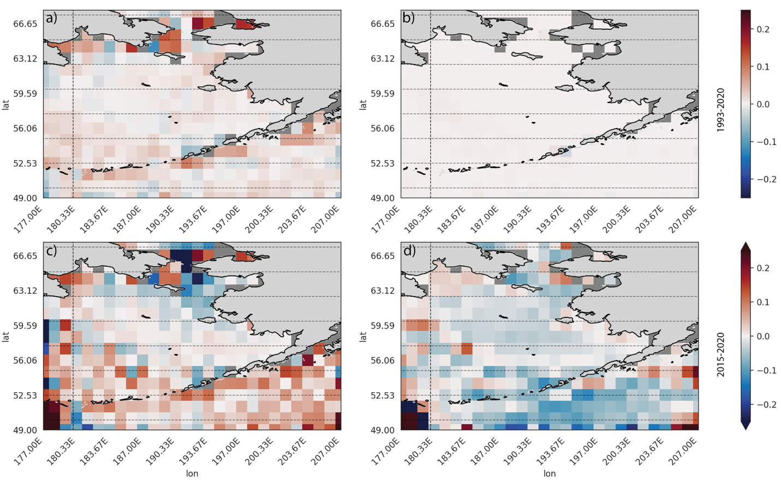
Supplementary figure 4: Bias of eastward velocity (vo) between a) CMCC-CM2-SR5 and GLORYS ocean reanalysis and b) bias corrected CMCC-CM2-SR5 for the training period 2010-2015 and bias between c) CMCC-CM2-SR5 and GLORYS ocean reanalysis and d) bias corrected CMCC-CM2-SR5 for the validation period 2015-2020.

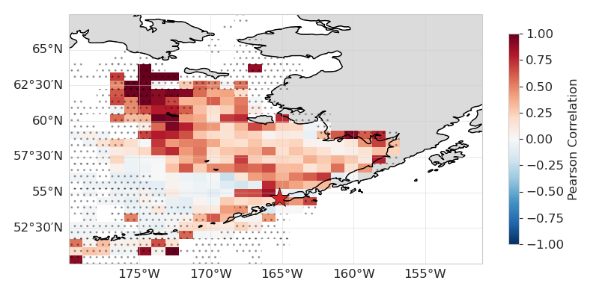
Supplementary figure 5: Spatial correlation of particle distributions between GLORYS-ERA5 and SD-GLORYS-SD-ERA5 simulations over the years 2015-2020. Correlations were calculated by binning the distributions at the end of each month for each year 2015-2020 using a 30 x 30 grid. Concentrations within each cell were then correlated using Pearson correlation.
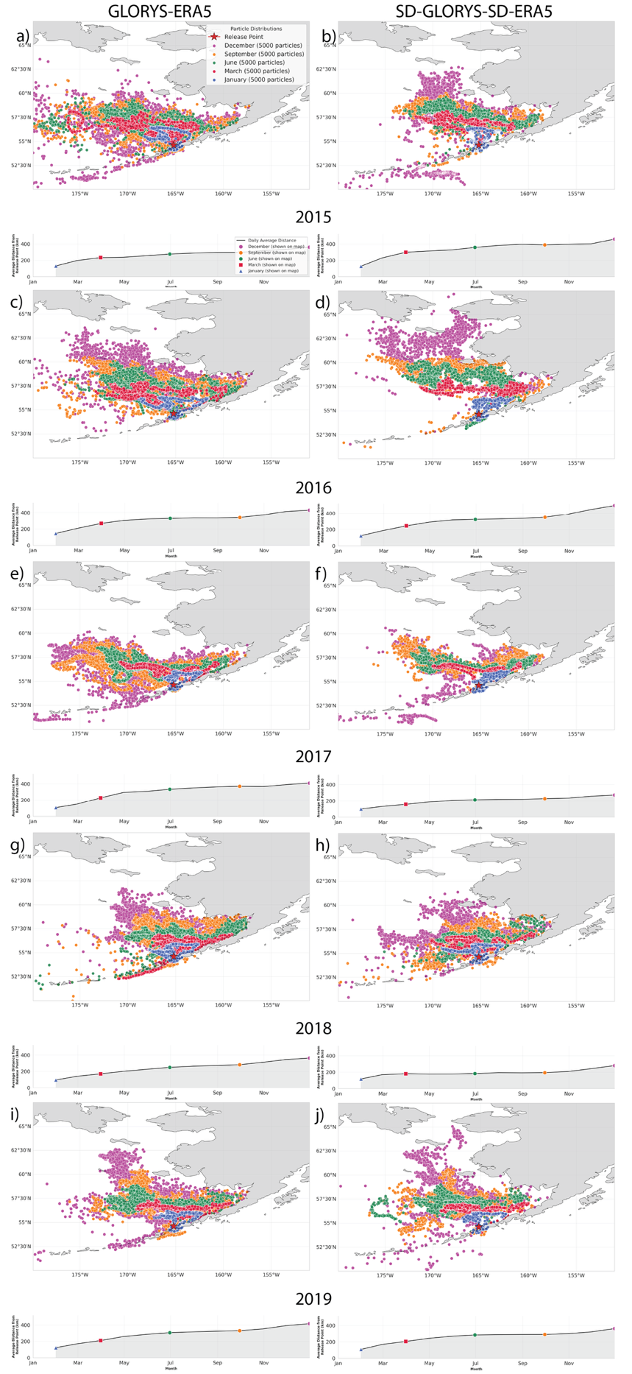
Supplementary figure 6: Spatial particle distributions at five different times during simulations. One the last day of January (blue), March (red), June (green), September (orange), and December (magenta) the distribution of particles is shown with a distinct color. The left column shows the GLORYS-ERA5 results while the right column shows the SD-GLORYS-SD-ERA5 simulation results for each year 2015-2020. Release site is shown as a red star where all particles were released on January 1st of each year and tracked for exactly 1 year.

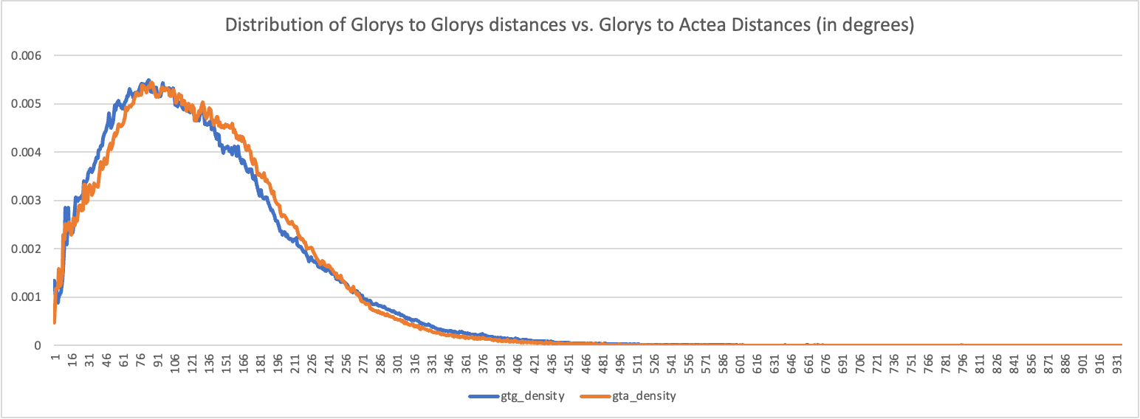
Supplementary Figure 7: Separation distance between each individual GLORYS-ERA5 to GLORYS-ERA5 particles compared with SD-GLORYS-SD-ERA5 to SD-GLORYS-Sd-ERA5.

