Supplementary Data

The mechanistic study of novel immuno-adjuvant NCL-P2 improve the effectiveness of anti- PD-1 in colorectal cancer treatment through suppressing the expression of USP2

Wu Shan 1,2 ， Zhang Miao1,2 ， Wang Huaqing 1,2*

*Correspondence to： Huaqing WANG; Email： huaqingw@163.com

1.Department of Oncology, Tianjin Union Medical Center, The First Affiliated Hospital of Nankai University, Tianjin 300121, China; 2.Tianjin Cancer Institute of Integrative Traditional Chinese and Western Medicine, Tianjin Union Medical Center, The First Affiliated Hospital of Nankai University, Tianjin 300121, China

Supplementary data for Figure 4.1
Detection of PD-L1 by western blotting. The original blot of 2 seperate experiments were shown here

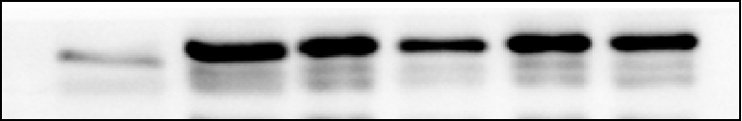
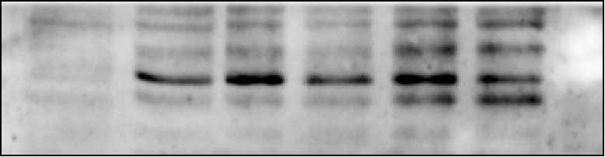
NCL-P2(ug/ml)
con1 con 2
10 50 100 200
PD-L1
GAPDH

Experiment 1

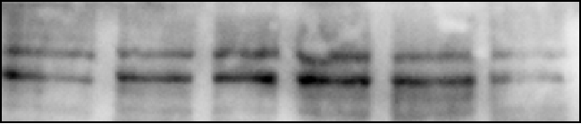
con1 con 2
10 50 100 200
NCL-P2(ug/ml)
GAPDH
PD-L1

Experiment 2

