Supplementary Figures:
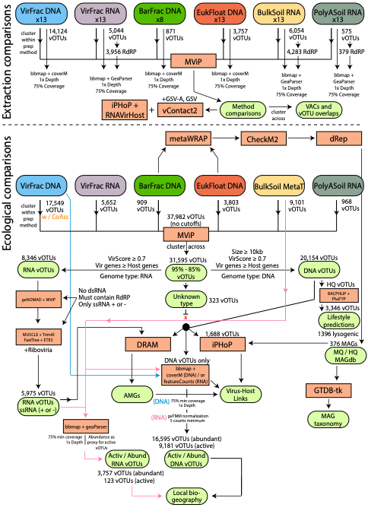
Supplementary Figure 1: Conceptual diagram of computational workflow used for manuscript. Top of figure shows the process that was done for the comparisons of the different methods. Bottom of the figure shows what was done for the ecological interpretation analyses of the consolidated vOTU database of all methods. For both, we applied a 10kb size cutoff for DNA vOTUs, and no size cutoff RNA vOTUs. Only RNA vOTUs that had ssRNA + or - sense genomes were considered. Both genome types had to have a VirScore ≥ 0.7 and at least as many viral genes as host genes. vOTUs that did not agree with data type (i.e., DNA genome in RNA) were removed as well. Viral contigs are clustered at 95% ANI across 85% of shortest contig.
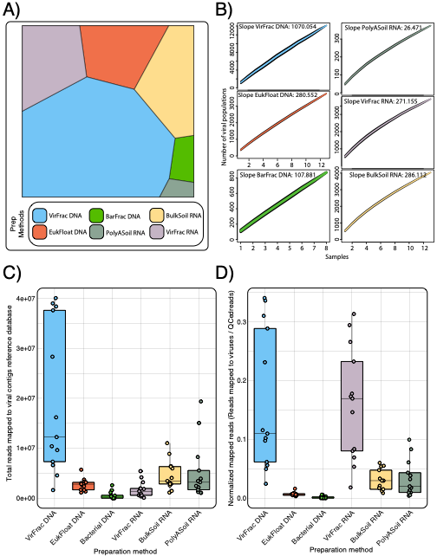Supplementary Figure 2: Bio-fractionation methods vary in their ability to acquire viral sequences A) Voronoi plot of the number of vOTUs detected per method. B) Viral accumulation plots highlight how many viral contigs (y-axis) are found per each sample (x-axis) across methods (colors). Confidence intervals are denoted as the width of each line. C) The total number of reads and (D) library-size normalized reads from each method that map to the corresponding viral reference database created from each method. Colors denote each method.

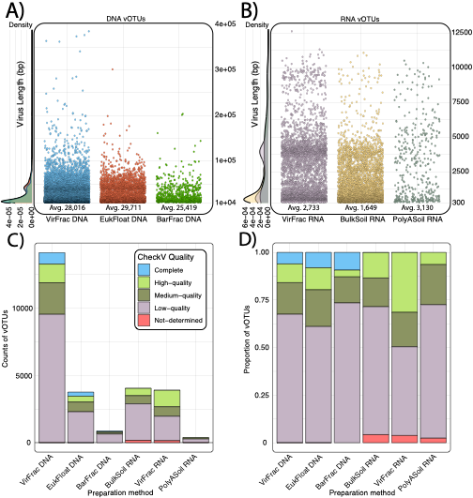Supplementary Figure 3: Varying levels of quality per DNA and RNA bio-fractionation methods. Plots show the length of each vOTU detected for either A) DNA or B) RNA methods. Colors denote each method. C) Total counts of vOTUs corresponding to each preparation method. Colors denote the different CheckV quality levels. D) Proportion of vOTUs of each CheckV Quality per method.

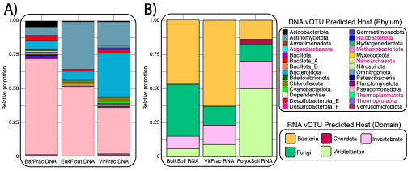Supplementary Figure 4. DNA and RNA virus-host predictions show enrichment of certain hosts between methods, alternative visualization. A) Phylum-level composition of detectable host pool for different DNA methods. B) Domain-level composition of detectable host pool for different RNA methods. Pink lettering reflects archaeal phyla.

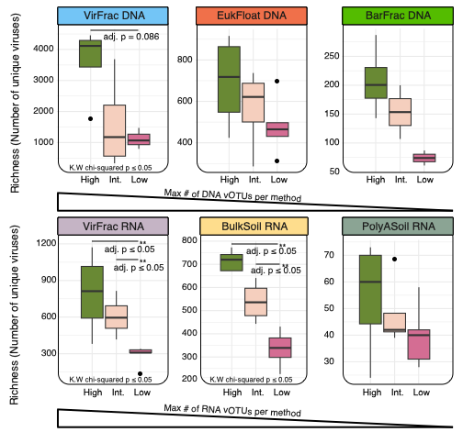Supplementary Figure 5. Viral richness across bio-fractionation methods. Boxplots show the overall richness (total counts) of viral contigs in each dataset. The bar colors denote sample moisture categories, as relatively higher moisture (15.5-16.7%, green, n = 4), intermediate moisture (13.3-14.8%, light pink, n = 4), or low moisture (11.1-12.7%, magenta, n = 5). Significant differences by Kruskal-Wallis and a post-hoc pairwise Wilcoxon with p-value adjustment using a Benjamini-Hochberg is denoted by asterisks.

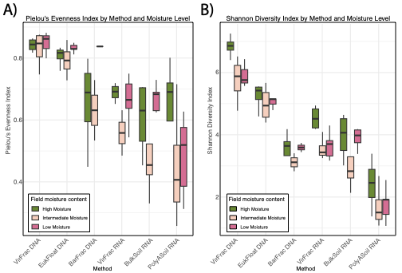Supplementary Figure 6. Viral expression and abundance across bio-fraction methods (parent database). Boxplots show A) Pielou’s evenness across all methods colored by moisture category and B) Shannon’s diversity across methods colored by moisture category. Significant differences by Kruskal-Wallis and a post-hoc pairwise Wilcoxon with p-value adjustment using a Benjamini-Hochberg is denoted by asterisks.
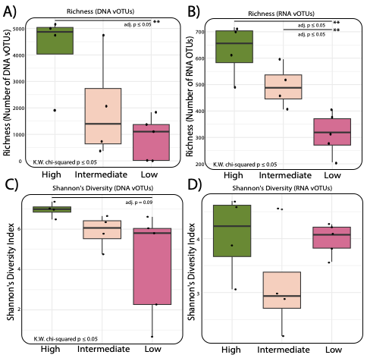Supplementary Figure 7. Diversity (as richness) of DNA and RNA viruses (consolidated database). Richness across moisture categories for A) DNA vOTUs and B) RNA vOTUs. Significant differences by Kruskal-Wallis and a post-hoc pairwise Wilcoxon with p-value adjustment using a Benjamini-Hochberg is denoted by asterisks. C-D) Shannon’s diversity of consolidated DNA or RNA vOTUs across moisture categories.

