Western Blot Images
The following are full uncropped Western blot images for Figure 7 (A).
FATP5 (70 kDa)
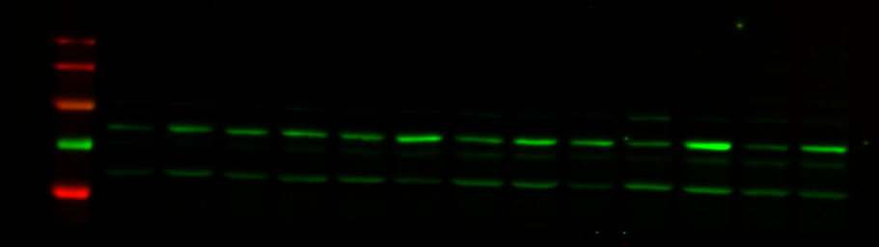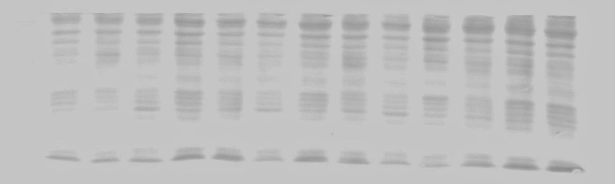
FATP2 (70 kDa)
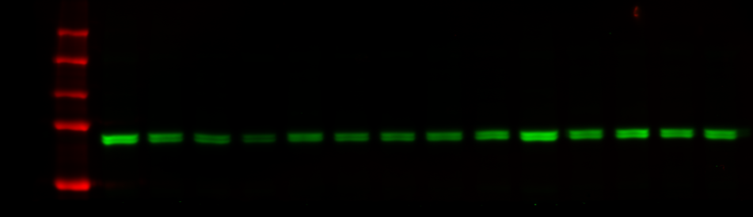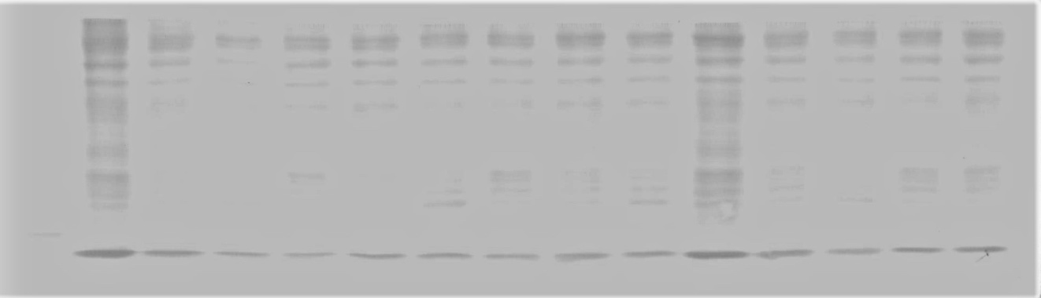

CD36 (88 kDa)
