Supplementary Table of Contents
- Supplementary Materials Overview
- eMethods
  - Search Strategy (eTable 1-5 and eFigure 1)
  - Data Integration and Matching Procedures (eFigure 2)
  - Target Population Selection and Data Processing (eFigure 3)
  - Greedy and Least Squares-Based Matching Algorithm
  - Variable Mapping Across Databases (eTable 6)
- eResults
  - Basic Analyses (eTable 7-8 and eFigure 4)
  - Sensitivity Analyses (eTable 9-14 and eFigure 5-10)
- eTables
  - eTable 1. PubMed Search Strategy and Results
  - eTable 2. Web of Science Search Strategy and Results
  - eTable 3. Embase Search Strategy and Results
  - eTable 4. Cochrane Library Search Strategy and Results
  - eTable 5. Characteristics of Key Randomized Controlled Trials: FOURIER and ODYSSEY OUTCOMES
  - eTable 6. Summary of Differences of Covariates between Combined cohort and RCT
  - eTable 7. Imputed Subgroup Covariate Distributions After Meta-Interpolation Matching
  - eTable 8. Regression Coefficients and P Values
  - eTable 9. Imputed Subgroup Covariate Distributions After Meta-Interpolation Matching - LDL-C correlations from CHARLS
  - eTable 10. Regression coefficients and P values - LDL-C correlations from CHARLS
  - eTable 11. Imputed Subgroup Covariate Distributions After Meta-Interpolation Matching - ±5% covariate balance threshold
  - eTable 12. Regression coefficients and P values - ±5% covariate balance threshold
  - eTable 13. Imputed Subgroup Covariate Distributions After Meta-Interpolation Matching - ±15% covariate balance threshold
  - eTable 14. Regression coefficients and P values - ±15% covariate balance threshold
  - eTable 15. Variable Selection and Mapping Across Included Real-World Databases
- eFigures
  - eFigure 1. PRISMA Flow Diagram of Literature Screening
  - eFigure 2. Data Processing Flowchart for Real-World Datasets
  - eFigure 3. Data Processing Flowchart for Target Population Selection
  - eFigure 4. Heatmap of the correlation coefficients among the covariates
  - eFigure 5. Heatmap of the correlation coefficients among the covariates - LDL-C correlations from CHARLS
  - eFigure 6. Forest plot of regression results - LDL-C correlations from CHARLS
  - eFigure 7. Heatmap of the correlation coefficients among the covariates-±5% covariate balance threshold
  - eFigure 8. Forest plot of regression results - ±5% covariate balance threshold
  - eFigure 9. Heatmap of the correlation coefficients among the covariates -±15% covariate balance threshold
  - eFigure 10. Forest plot of regression results - ±15% covariate balance threshold

Supplementary Materials Overview
This supplementary file provides additional methodological details, sensitivity analyses, and extended results to support the findings presented in the main manuscript entitled “Real-World and Subgroup Data Synthesis to Guide PCSK9 Inhibitor Use in Cardiovascular Disease.”
Specifically, the supplement includes:
- A detailed description of the search strategies and selection criteria for identifying relevant randomized controlled trials.
- An explanation of the data integration and matching procedures applied to multiple large-scale, population-based cohorts.
- Subgroup-level imputation methods using best linear unbiased prediction (BLUP) and covariate harmonization techniques.
- Results from sensitivity analyses evaluating different covariate balance thresholds and LDL-C correlation structures.
- Expanded tables presenting subgroup-specific covariate distributions and regression model outputs.
- Figures illustrating literature screening flow diagrams, data processing workflows, heatmaps of covariate correlations, and subgroup-specific forest plots.
All supplementary materials are intended to enhance transparency and reproducibility of the meta-interpolation framework introduced in this study.

Search Strategy and Results of identify relevant clinical trials
eTable1. PubMed Search Strategy and Results
Concept | Search strategy | Results
#1 | "evolocumab"[Title/Abstract] OR "amg 145"[Title/Abstract] OR "alirocumab"[Title/Abstract] OR "regn 727"[Title/Abstract] OR "sar 236553"[Title/Abstract]
#2 | "Controlled Clinical Trial" [Publication Type] OR "randomized Controlled Trial" [Publication Type]
#3 | #1 AND #2 | 243
eTable2. Web of Science Search Strategy and Results
Concept | Search strategy | Results
#1 | TS=( evolocumab OR "amg 145" OR alirocumab OR "regn 727" OR "sar 236553" )
#2 | ((TS=(randomi?ed controlled trial*)) OR TS=(RCT)) OR TS=(clinical trial*)
#3 | (((TS=(animal*)) OR TS=(murine)) OR TS=(rat)) OR TS=(mouse)
#4 | (#1 AND #2) NOT #3 | 543
eTable3. Embase Search Strategy and Results
Concept | Search strategy | Results
#1 | 'evolocumab' OR 'evolocumab'/exp OR 'amg 145'/exp OR 'amg 145' OR 'alirocumab' OR 'alirocumab'/exp OR 'regn 727'/exp OR 'regn 727' OR 'sar 236553'/exp OR 'sar 236553'
#2 | 'randomized controlled trial'/exp
#3 | 'controlled trial, randomized':ti,ab,kw OR 'randomised controlled study':ti,ab,kw OR 'randomised controlled trial':ti,ab,kw OR 'randomized controlled study':ti,ab,kw OR 'trial, randomized controlled':ti,ab,kw OR 'randomized controlled trial':ti,ab,kw
#4 | #2 OR #3
#5 | #1 AND #4 | 489
eTable4. Cochrane Library Search Strategy and Results
Concept | Search strategy | Results
#1 | (evolocumab):ti,ab,kw OR (amg145):ti,ab,kw OR (alirocumab):ti,ab,kw OR (regn727):ti,ab,kw OR (sar236553):ti,ab,kw in Trials
#2 | ("randomized-controlled trial"):ti,ab,kw OR ("randomized-controlled trials"):ti,ab,kw OR (controlled clinical trial):ti,ab,kw in Trials
#3 | #1 AND #2 in Trials | 547

eFigure 1. PRISMA Flow Diagram of Literature Screening
Identification of studies via databases and registers

Records removed before screening:
Duplicate records removed
(n =319 )
Records marked as ineligible by automation tools (n = 0)
Records removed for other reasons (n =0 )
Records identified from*:
Databases (n =4 )
Registers (n =1822 )

Identification

Records excluded
(n =319 )
Records screened
(n =1505 )

Reports screened for title and abstract
(n = 186)
(n = )
Reports not retrieved
(n =1319 )
Screening

Reports excluded:
Unable to dowmload (n =7 )
Patient unsuitable(n =3)
Intervention unsuitable(n = 3)
Comparator unsuitable(n =2 )
Outcome unsuitable(n = 14)
Non-RCT (n =57)
Meeting abstracts and others(n =98) 87)
Reports assessed for eligibility
(n =2 )

Studies included in review
(n = 2)
Included

eTable 5. Characteristics of Key Randomized Controlled Trials: FOURIER and ODYSSEY OUTCOMES
 | FOURIER | ODYSSEY OUTCOMES
Intervention | Evolocumab | Alirocumab
Sample Size | 27,564 patients | 18,924 patients
Study Population | Patients with clinically evident atherosclerotic cardiovascular disease and LDL-C ≥70 mg/dL or non–HDL-C ≥100 mg/dL | Patients 1–12 months post–acute coronary syndrome with LDL-C ≥70 mg/dL or non–HDL-C ≥100 mg/dL
Study Design | Multicenter, randomized, double-blind, placebo-controlled | Multicenter, randomized, double-blind, placebo-controlled
Follow-up Duration | Median 2.8 years | Median 2.2 years
Primary Endpoint | Composite of CHD death, nonfatal MI, fatal/nonfatal ischemic stroke, or hospitalization for unstable angina | Composite of CV death, MI, stroke, hospitalization for unstable angina, or coronary revascularization
Primary Endpoint Rate | 9.5% in Alirocumab group; 11.1% in placebo (HR=0.85) | 9.8% in Evolocumab group; 11.3% in placebo (HR=0.85)
LDL-C Reduction | Reduced from 92 to 40–66 mg/dL | Reduced from 92 to 30 mg/dL (59% reduction)
Abbreviations: LDL-C: Low-Density Lipoprotein Cholesterol: HDL-C: High-Density Lipoprotein Cholesterol; CHD: Coronary Heart Disease; MI: Myocardial Infarction; CV: Cardiovascular; HR: Hazard Ratio.

eFigure 2. Data Processing Flowchart for Real-World Datasets
Records from multiple international datasets were merged to create a unified analytic sample, including SHARE (n = 327,266), HRS (n = 208,674), ELSA (n = 90,069), CHARLS (n = 96,628), LASI (n = 73,408), and MHAS (n = 76,505), for a total of 872,550 participants. After extracting relevant variables, individuals with a history of cardiovascular disease and elevated cholesterol levels were identified. Following screening and dataset harmonization, 27,413 eligible records remained. Covariates were subsequently binarized to match trial subgroup structures, including age, sex, race, stroke, myocardial infarction (MI), and diabetes status. A matching procedure was then implemented, resulting in a final cohort of 11,682 participants aligned with the FOURIER trial and 7,189 participants aligned with the ODYSSEY LONG TERM trial.
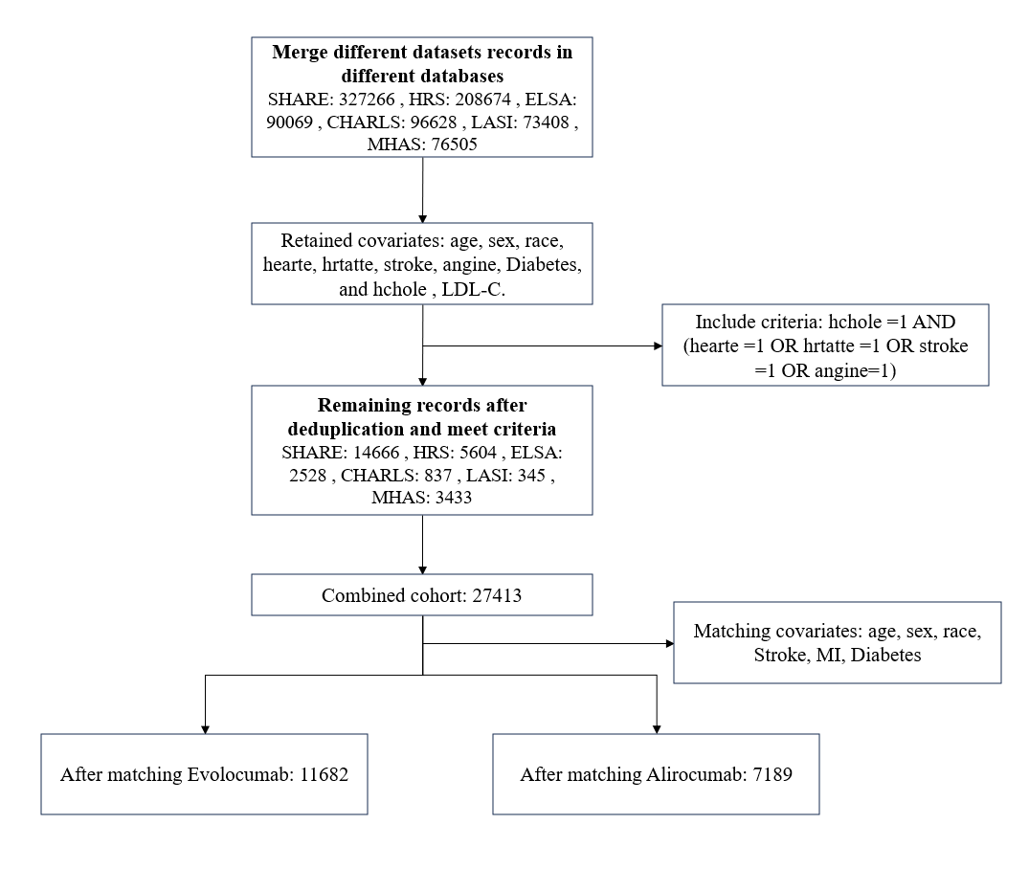
Abbreviations: SHARE: Ageing and Retirement in Europe; HRS: Health and Retirement Study; ELSA: English Longitudinal Study of Ageing; CHARLS: China Health and Retirement Longitudinal Study; LASI: Longitudinal Aging Study in India; MHAS: Mexican Health and Aging Study; MI: Myocardial Infarction.

eFigure 3. Data Processing Flowchart for Target Population Selection
The integrated dataset was deduplicated to retain 8,897 unique records. Among these, 631 patients with cardiovascular disease who met the initial inclusion criteria were identified. To address missing data, multiple imputation was conducted, resulting in the imputation of 347 missing data points to achieve data completeness. Further filtering based on an LDL-C threshold of ≥70 mg/dL excluded 136 records that did not meet eligibility criteria. Ultimately, 495 records fulfilled all prespecified inclusion criteria and were included in the final analysis cohort. Covariates were then converted into binary variables, and correlation coefficients among these variables were calculated for subsequent modeling.
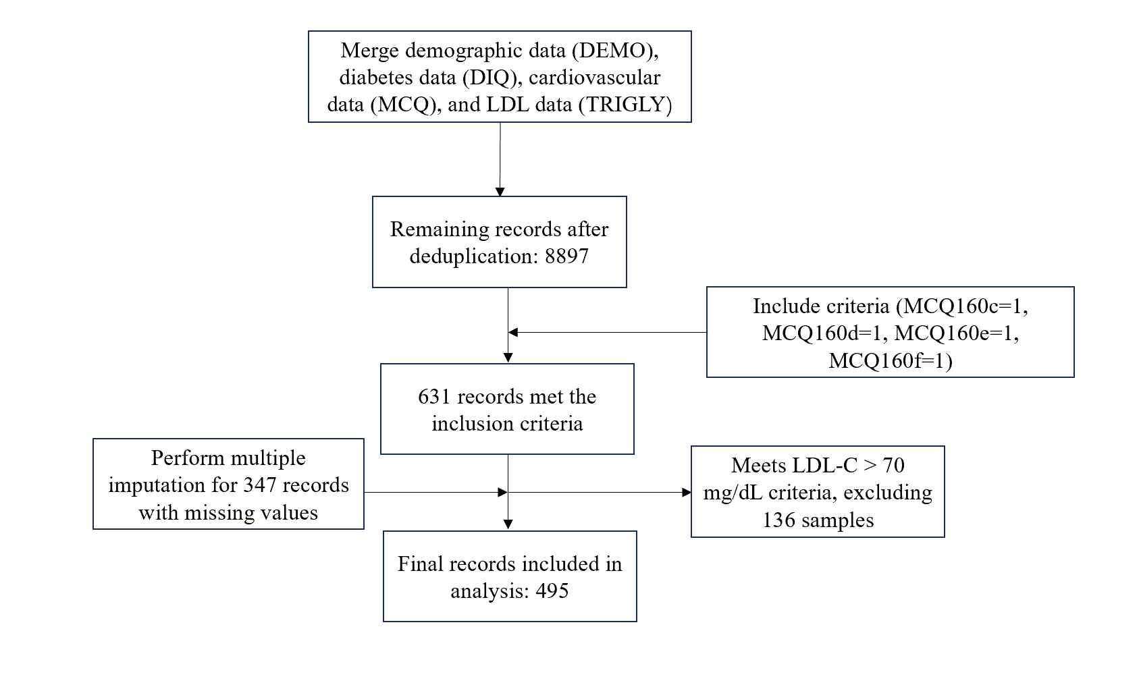
Abbreviations: DEMO: Demographics; DIQ: Diabetes Questionnaire; MCQ: Medical Conditions Questionnaire; TRIGLY: Triglycerides and LDL data; MCQ160c: History of coronary heart disease: MCQ160d: History of angina; MCQ160e: History of myocardial infarction; MCQ160f: History of stroke; LDL-C: Low-Density Lipoprotein Cholesterol.

eTable 6. Summary of Differences of Covariates between Combined cohort and RCT
Variable | Variable as measured in study | Combined cohort（N=27413） | FOURIER  （N=27,564） |  |  | ODYSSEY LONG TERM  （N=18924）
Variable | Variable as measured in study | Combined cohort（N=27413） | Target means | Matched means（N=11682） |  | Target means | Matched means（N=7189）
Age | Age≥65: n (%) | 68.84% | 44.00% |  | 46.27% | 26.90% | 26.92%
Gender | Male: n (%) | 48.63% | 78.30% |  | 77.20% | 74.80% | 74.79%
Race | White: n (%) | 76.83% | 85.00% |  | 82.79% | 79.40% | 79.37%
CVD | Stroke: n (%) | 28.23% | 12.00% |  | 13.20% | 5.00% | 5.49%
 | MI: n (%) | 61.62% | 69.00% |  | 71.43% | 83.00% | 83.17%
Metabolic | Diabetes: n (%) | 32.86% | 25.00% |  | 25.22% | 28.80% | 28.81%
Abbreviations: CVD，Cardiovascular Disease; MI， Myocardial Infarction; LDL-C， Low-Density Lipoprotein Cholesterol.

Greedy and Least Squares-Based Matching Algorithm
To achieve optimal covariate balance in the matched sample, we first define a target mean vector $μ_{target}= \left(μ_{1}, μ_{2}, …,μ_{k} \right)$, which represents the desired average values for each of the $k$ covariates. For any selected subset of samples, the actual mean vector is computed as $μ_{actual}=\left(\frac{1}{n}\sum_{i=1}^{n}{x_{i1}}, \frac{1}{n}\sum_{i=1}^{n}{x_{i2}}, …, \frac{1}{n}\sum_{i=1}^{n}{x_{ik}}\right)$, where $n$ is the number of selected samples and $x_{ij}$​ denotes the value of the $j$-th covariate for the $i$-th sample. The discrepancy between the actual and target means is quantified using a squared error function:
$$\text{Distance}=\sum_{j=1}^{k}{{\left(μ_{\text{actual},j}-μ_{\text{target},j}\right)}^{2}}$$
which serves as the optimization criterion for subset selection. A tolerance margin ±10% is applied to each target mean to define acceptable bounds:
${\text{Lower}}_{j}=μ_{j}×\left(1-\text{tolerance}\right)$, ${\text{Upper}}_{j}=μ_{j}×\left(1+\text{tolerance}\right)$
and the subset is considered acceptable if $μ_{actual},j∈\left[Lower_{j},Upper_{j}\right]$ for all $j$. If the initial full sample does not satisfy the tolerance constraints, a greedy optimization algorithm is applied. In each iteration, one sample iii is temporarily removed to form a new subset $S'=S∖\{i\}$, and the new distance is recalculated as:
$${Distance}_{S^{'}}=\sum_{j=1}^{k}{{\left(μ_{S^{'},j}-μ_{target,j}\right)}^{2}}$$
If the removal reduces the distance or results in all covariates falling within the specified tolerance bounds, the new subset is accepted. This iterative process continues until no further improvement is achieved, at which point the current subset is returned as the matched sample.

eFigure 4. Heatmap of the correlation coefficients among the covariates
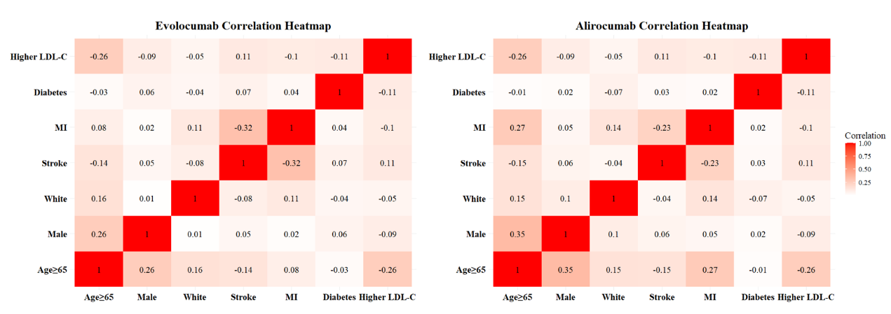
Abbreviations: LDL-C: Low-Density Lipoprotein Cholesterol; MI: Myocardial Infarction.

eTable 7. Imputed Subgroup Covariate Distributions After Meta-Interpolation Matching
 |  | Age≥65 | Male | White | Stroke | MI | Diabetes | HigherLDL-C
Evolocumab | OVERALL | 44.46% | 78.28% | 85.10% | 12.21% | 69.34% | 40.02% | 24.78%
 | Subgroup
 | Age
 | ≥65 | 100.00% | 92.85% | 93.82% | 4.34% | 73.92% | 38.46% | 10.59%
 | <65 | 0.00% | 66.62% | 78.12% | 18.51% | 65.67% | 41.27% | 36.14%
 | Sex
 | Male | 50.16% | 100.00% | 85.25% | 13.22% | 69.74% | 41.35% | 22.78%
 | Female | 23.92% | 0.00% | 84.56% | 8.55% | 67.91% | 35.22% | 31.99%
 | Race
 | White | 46.80% | 78.38% | 100.00% | 10.97% | 71.05% | 39.35% | 23.97%
 | non-White | 31.11% | 77.69% | 0.00% | 19.32% | 59.56% | 43.85% | 29.38%
 | CVDs
 | Stroke | 32.02% | 82.38% | 77.77% | 100.00% | 41.10% | 46.06% | 34.69%
 | non-Stroke | 46.19% | 77.71% | 86.12% | 0.00% | 73.27% | 39.18% | 23.40%
 | MI | 46.99% | 78.84% | 88.62% | 2.35% | 100.00% | 41.16% | 21.66%
 | non-MI | 38.74% | 77.02% | 77.13% | 34.51% | 0.00% | 37.43% | 31.83%
 | Metabolism
 | Diabetes | 42.78% | 81.96% | 82.40% | 16.34% | 71.58% | 100.00% | 18.23%
 | non-Diabetes | 45.58% | 75.82% | 86.90% | 9.46% | 67.85% | 0.00% | 29.15%
 | Baseline LDL-C
 | ≥110 mg/dL | 25.24% | 71.35% | 81.03% | 20.70% | 61.69% | 31.80% | 100.00%
 | <110 mg/dL | 50.79% | 80.56% | 86.44% | 9.41% | 71.86% | 42.73% | 0.00%
Alirocumab | OVERALL | 26.87% | 74.84% | 79.40% | 4.99% | 83.02% | 28.77% | 29.75%
 | Subgroup
 | Age
 | ≥65 | 100.00% | 100.60% | 90.41% | -5.71% | 102.99% | 27.74% | 11.07%
 | <65 | 0.00% | 65.37% | 75.36% | 8.92% | 75.68% | 29.15% | 36.61%
 | Sex
 | Male | 35.73% | 100.00% | 81.81% | 6.50% | 84.18% | 29.30% | 27.43%
 | Female | 0.50% | 0.00% | 72.22% | 0.51% | 79.56% | 27.18% | 36.64%
 | Race
 | White | 29.97% | 76.82% | 100.00% | 4.07% | 85.90% | 27.29% | 28.64%
 | non-White | 14.92% | 67.22% | 0.00% | 8.53% | 71.90% | 34.48% | 34.04%
 | CVDs
 | Stroke | 12.97% | 80.53% | 75.17% | 100.00% | 60.93% | 31.74% | 40.48%
 | non-Stroke | 27.60% | 74.54% | 79.62% | 0.00% | 84.18% | 28.61% | 29.19%
 | MI | 31.51% | 75.63% | 81.78% | 1.04% | 100.00% | 29.18% | 28.02%
 | non-MI | 4.20% | 71.00% | 67.78% | 24.29% | 0.00% | 26.75% | 38.20%
 | Metabolism
 | Diabetes | 25.86% | 76.35% | 74.28% | 7.22% | 84.75% | 100.00% | 21.97%
 | non-Diabetes | 27.28% | 74.23% | 81.47% | 4.09% | 82.32% | 0.00% | 32.89%
 | Baseline LDL-C
 | ≥100 mg/dL | 8.92% | 68.37% | 75.60% | 12.92% | 75.87% | 21.10% | 100.00%
 | <100 mg/dL | 34.47% | 77.58% | 81.01% | 1.63% | 86.05% | 32.02% | 0.00%
Abbreviations: MI, myocardial infarction; LDL-C, low-density lipoprotein cholesterol; CVD, cardiovascular disease.
eTable 8. Regression coefficients and P values
Variable | Intervention | Coefficient | P | 95%CL
Age | Evolocumab | -0.0705 | 0.5622 | (-0.3009, 0.1575)
 | Alirocumab | -0.1988*** | 0.0000 | (-0.2351, -0.1627)
Gender | Evolocumab | 0.0890 | 0.3862 | (-0.0932, 0.2871)
 | Alirocumab | -0.0472* | 0.0127 | (-0.0749, -0.0193)
Race | Evolocumab | 0.2276* | 0.0488 | (0.0504, 0.4284)
 | Alirocumab | -0.1713*** | 0.0000 | (-0.1923, -0.1501)
Stroke | Evolocumab | -0.2634* | 0.0436 | (-0.4869, -0.0644)
 | Alirocumab | 0.2001*** | 0.0000 | (0.1799, 0.2201)
MI | Evolocumab | -0.1617 | 0.1481 | (-0.3458, 0.0332)
 | Alirocumab | 0.3430*** | 0.0000 | (0.3132, 0.3733)
Metabolic | Evolocumab | -0.0057 | 0.9540 | (-0.1976, 0.1789)
 | Alirocumab | -0.0825*** | 0.0003 | (-0.1072, -0.0581)
LDL-C | Evolocumab | 0.0790 | 0.4181 | (-0.1100, 0.2540)
 | Alirocumab | -0.2389*** | 0.0000 | (-0.2680, -0.2101)
* P < 0.05, ** P < 0.01, *** P < 0.001
Abbreviations: MI: Myocardial Infarction; LDL-C: Low-Density Lipoprotein Cholesterol.

eFigure 5. Heatmap of the correlation coefficients among the covariates - LDL-C correlations from CHARLS
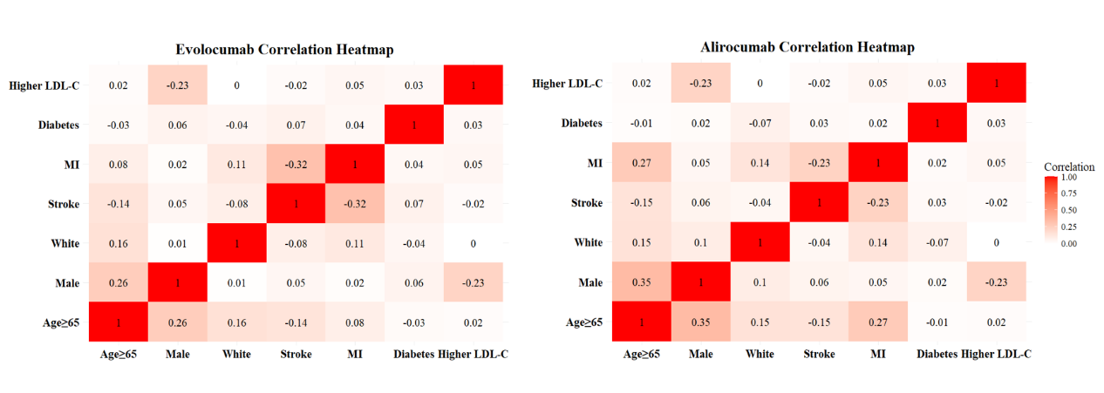
Abbreviations: LDL-C: Low-Density Lipoprotein Cholesterol; MI: Myocardial Infarction; SE: Sensitivity analysis.

eTable 9. Imputed Subgroup Covariate Distributions After Meta-Interpolation Matching - LDL-C correlations from CHARLS
 |  | Age≥65 | Male | White | Stroke | MI | Diabetes | HigherLDL-C
Evolocumab | OVERALL | 44.46% | 78.28% | 85.10% | 12.21% | 69.34% | 40.02% | 24.78%
 | Subgroup
 | Age
 | ≥65 | 100.00% | 92.85% | 93.82% | 4.34% | 73.92% | 38.46% | 25.89%
 | <65 | 0.00% | 66.62% | 78.12% | 18.51% | 65.67% | 41.27% | 23.89%
 | Sex
 | Male | 50.16% | 100.00% | 85.25% | 13.22% | 69.74% | 41.35% | 19.88%
 | Female | 23.92% | 0.00% | 84.56% | 8.55% | 67.91% | 35.22% | 42.44%
 | Race
 | White | 46.80% | 78.38% | 100.00% | 10.97% | 71.05% | 39.35% | 24.78%
 | non-White | 31.11% | 77.69% | 0.00% | 19.32% | 59.56% | 43.85% | 24.78%
 | CVDs
 | Stroke | 32.02% | 82.38% | 77.77% | 100.00% | 41.10% | 46.06% | 22.62%
 | non-Stroke | 46.19% | 77.71% | 86.12% | 0.00% | 73.27% | 39.18% | 25.08%
 | MI | 46.99% | 78.84% | 88.62% | 2.35% | 100.00% | 41.16% | 26.20%
 | non-MI | 38.74% | 77.02% | 77.13% | 34.51% | 0.00% | 37.43% | 21.56%
 | Metabolism
 | Diabetes | 42.78% | 81.96% | 82.40% | 16.34% | 71.58% | 100.00% | 26.84%
 | non-Diabetes | 45.58% | 75.82% | 86.90% | 9.46% | 67.85% | 0.00% | 23.40%
 | Baseline LDL-C
 | ≥110 mg/dL | 45.96% | 61.31% | 85.10% | 10.36% | 72.83% | 42.61% | 100.00%
 | <110 mg/dL | 43.96% | 83.87% | 85.10% | 12.82% | 68.19% | 39.17% | 0.00%
Alirocumab | OVERALL | 26.87% | 74.84% | 79.40% | 4.99% | 83.02% | 28.77% | 29.75%
 | Subgroup
 | Age
 | ≥65 | 100.00% | 100.60% | 90.41% | -5.71% | 102.99% | 27.74% | 31.21%
 | <65 | 0.00% | 65.37% | 75.36% | 8.92% | 75.68% | 29.15% | 29.21%
 | Sex
 | Male | 35.73% | 100.00% | 81.81% | 6.50% | 84.18% | 29.30% | 24.07%
 | Female | 0.50% | 0.00% | 72.22% | 0.51% | 79.56% | 27.18% | 46.64%
 | Race
 | White | 29.97% | 76.82% | 100.00% | 4.07% | 85.90% | 27.29% | 29.75%
 | non-White | 14.92% | 67.22% | 0.00% | 8.53% | 71.90% | 34.48% | 29.75%
 | CVDs
 | Stroke | 12.97% | 80.53% | 75.17% | 100.00% | 60.93% | 31.74% | 27.41%
 | non-Stroke | 27.60% | 74.54% | 79.62% | 0.00% | 84.18% | 28.61% | 29.87%
 | MI | 31.51% | 75.63% | 81.78% | 1.04% | 100.00% | 29.18% | 30.54%
 | non-MI | 4.20% | 71.00% | 67.78% | 24.29% | 0.00% | 26.75% | 25.90%
 | Metabolism
 | Diabetes | 25.86% | 76.35% | 74.28% | 7.22% | 84.75% | 100.00% | 32.20%
 | non-Diabetes | 27.28% | 74.23% | 81.47% | 4.09% | 82.32% | 0.00% | 28.76%
 | Baseline LDL-C
 | ≥100 mg/dL | 28.27% | 58.99% | 79.40% | 3.26% | 86.28% | 31.19% | 100.00%
 | <100 mg/dL | 26.28% | 81.55% | 79.40% | 5.72% | 81.64% | 27.75% | 0.00%
Abbreviations: MI, myocardial infarction; LDL-C, low-density lipoprotein cholesterol; CVD, cardiovascular disease.

eFigure 6. Forest plot of regression results - LDL-C correlations from CHARLS
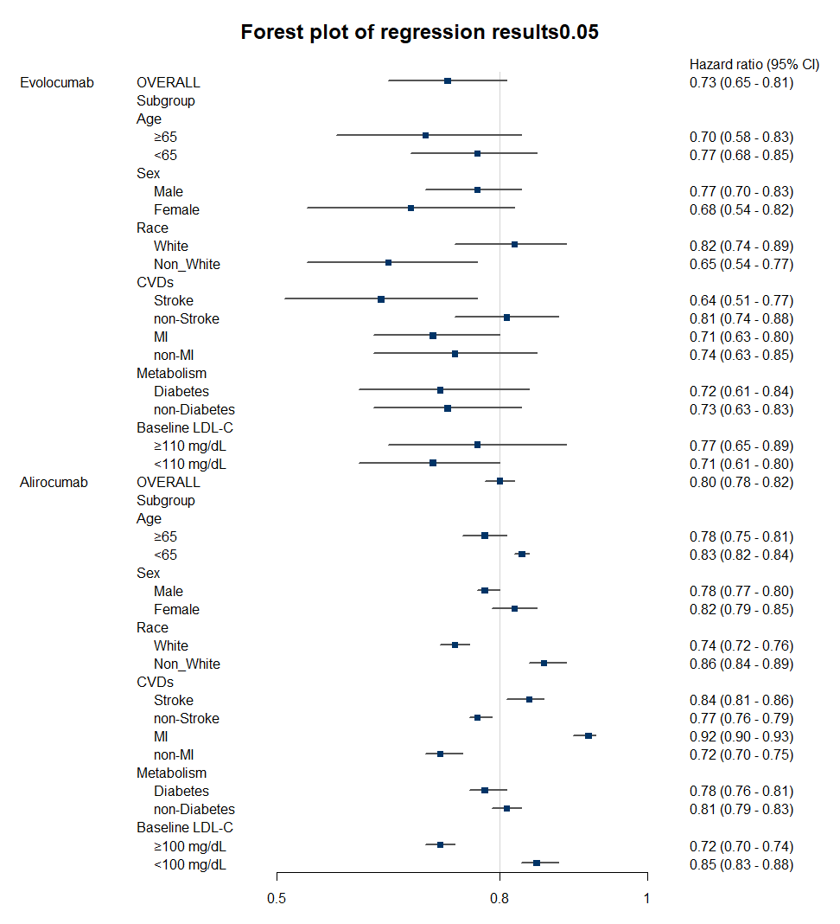
Abbreviations: CVDs: Cardiovascular Diseases; MI: Myocardial Infarction; LDL-C: Low-Density Lipoprotein Cholesterol.

eTable 10. Regression coefficients and P values - LDL-C correlations from CHARLS
Variable | Intervention | Coefficient | P | 95%CL
Age | Evolocumab | -0.0973 | 0.4049 | (-0.3160, 0.1182)
 | Alirocumab | -0.1201*** | 0.0003 | (-0.1549, -0.0856)
Gender | Evolocumab | 0.1105 | 0.3237 | (-0.0868, 0.3242)
 | Alirocumab | -0.1008*** | 0.0003 | (-0.1311, -0.0703)
Race | Evolocumab | 0.2281* | 0.0485 | (0.0507, 0.4291)
 | Alirocumab | -0.1645*** | 0.0000 | (-0.1855, -0.1433)
Stroke | Evolocumab | -0.2587* | 0.0461 | (-0.4817, -0.0600)
 | Alirocumab | 0.1841*** | 0.0000 | (0.1640, 0.2040)
MI | Evolocumab | -0.1703 | 0.1314 | (-0.3550, 0.0249)
 | Alirocumab | 0.3524*** | 0.0000 | (0.3225, 0.3827)
Metabolic | Evolocumab | -0.0196 | 0.8400 | (-0.2081, 0.1611)
 | Alirocumab | -0.0463** | 0.0069 | (-0.0704, -0.0224)
LDL-C | Evolocumab | 0.0929 | 0.3257 | (-0.0883, 0.2601)
 | Alirocumab | -0.2084*** | 0.0000 | (-0.2367, -0.1804)
* P < 0.05, ** P < 0.01, *** P < 0.001
Abbreviations: MI: Myocardial Infarction; LDL-C: Low-Density Lipoprotein Cholesterol.

eFigure 7. Heatmap of the correlation coefficients among the covariates-±5% covariate balance threshold
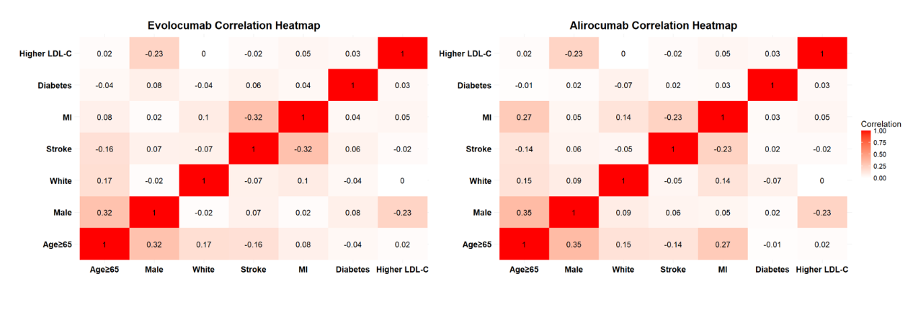
Abbreviations: LDL-C: Low-Density Lipoprotein Cholesterol; MI: Myocardial Infarction; SE: Sensitivity analysis.

eTable 11. Imputed Subgroup Covariate Distributions After Meta-Interpolation Matching - ±5% covariate balance threshold
 |  | Age≥65 | Male | White | Stroke | MI | Diabetes | HigherLDL-C
Evolocumab | OVERALL | 44.46% | 78.28% | 85.10% | 12.21% | 69.34% | 40.02% | 24.78%
 | Subgroup
 | Age
 | ≥65 | 100.00% | 95.83% | 94.50% | 3.33% | 73.69% | 37.93% | 25.89%
 | <65 | 0.00% | 64.23% | 77.57% | 19.32% | 65.86% | 41.69% | 23.89%
 | Sex
 | Male | 51.32% | 100.00% | 84.73% | 13.76% | 69.75% | 41.78% | 19.88%
 | Female | 19.73% | 0.00% | 86.42% | 6.63% | 67.86% | 33.68% | 42.44%
 | Race
 | White | 46.98% | 78.03% | 100.00% | 11.09% | 70.81% | 39.46% | 24.78%
 | non-White | 30.05% | 79.72% | 0.00% | 18.58% | 60.92% | 43.22% | 24.78%
 | CVDs
 | Stroke | 30.42% | 84.54% | 78.53% | 100.00% | 41.06% | 45.58% | 22.62%
 | non-Stroke | 46.41% | 77.41% | 86.01% | 0.00% | 73.27% | 39.25% | 25.08%
 | MI | 46.86% | 78.86% | 88.13% | 2.33% | 100.00% | 41.19% | 26.20%
 | non-MI | 39.03% | 76.97% | 78.24% | 34.55% | 0.00% | 37.38% | 21.56%
 | Metabolism
 | Diabetes | 42.20% | 83.14% | 82.85% | 16.01% | 71.62% | 100.00% | 26.84%
 | non-Diabetes | 45.97% | 75.04% | 86.60% | 9.67% | 67.82% | 0.00% | 23.40%
 | Baseline LDL-C
 | ≥110 mg/dL | 45.96% | 61.31% | 85.10% | 10.36% | 72.83% | 42.61% | 100.00%
 | <110 mg/dL | 43.96% | 83.87% | 85.10% | 12.82% | 68.19% | 39.17% | 0.00%
Alirocumab | OVERALL | 26.87% | 74.84% | 79.40% | 4.99% | 83.02% | 28.77% | 29.75%
 | Subgroup
 | Age
 | ≥65 | 100.00% | 100.60% | 90.37% | -5.45% | 103.03% | 27.88% | 31.21%
 | <65 | 0.00% | 65.38% | 75.37% | 8.83% | 75.67% | 29.10% | 29.21%
 | Sex
 | Male | 35.73% | 100.00% | 81.77% | 6.42% | 84.24% | 29.28% | 24.07%
 | Female | 0.51% | 0.00% | 72.36% | 0.75% | 79.40% | 27.25% | 46.64%
 | Race
 | White | 29.96% | 76.78% | 100.00% | 4.02% | 85.93% | 27.34% | 29.75%
 | non-White | 14.96% | 67.37% | 0.00% | 8.72% | 71.81% | 34.30% | 29.75%
 | CVDs
 | Stroke | 13.31% | 80.23% | 74.94% | 100.00% | 60.96% | 31.09% | 27.41%
 | non-Stroke | 27.58% | 74.56% | 79.63% | 0.00% | 84.18% | 28.65% | 29.87%
 | MI | 31.52% | 75.66% | 81.80% | 1.05% | 100.00% | 29.22% | 30.54%
 | non-MI | 4.15% | 70.82% | 67.68% | 24.27% | 0.00% | 26.55% | 25.90%
 | Metabolism
 | Diabetes | 26.00% | 76.29% | 74.44% | 6.73% | 84.92% | 100.00% | 32.20%
 | non-Diabetes | 27.22% | 74.25% | 81.40% | 4.29% | 82.25% | 0.00% | 28.76%
 | Baseline LDL-C
 | ≥100 mg/dL | 28.27% | 58.99% | 79.40% | 3.26% | 86.28% | 31.19% | 100.00%
 | <100 mg/dL | 26.28% | 81.55% | 79.40% | 5.72% | 81.64% | 27.75% | 0.00%
Abbreviations: MI, myocardial infarction; LDL-C, low-density lipoprotein cholesterol; CVD, cardiovascular disease.

eFigure 8. Forest plot of regression results - ±5% covariate balance threshold
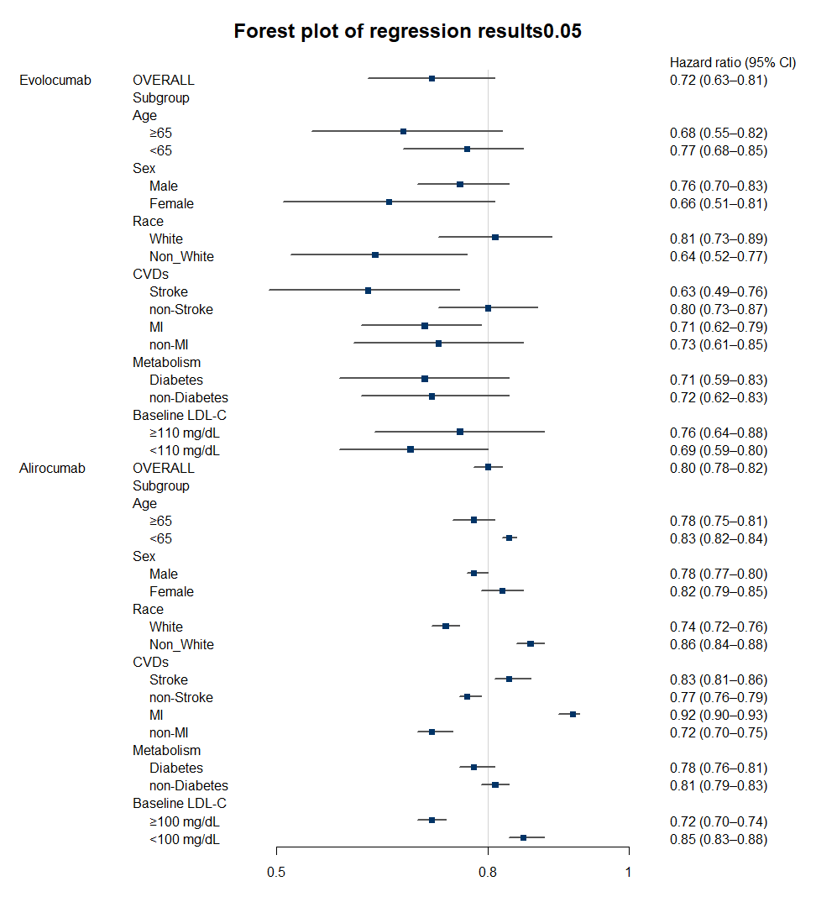
Abbreviations: CVDs: Cardiovascular Diseases; MI: Myocardial Infarction; LDL-C: Low-Density Lipoprotein Cholesterol.

eTable 12. Regression coefficients and P values - ±5% covariate balance threshold
Variable | Intervention | Coefficient | P | 95%CL
Age | Evolocumab | -0.1245 | 0.3320 | (-0.3625, 0.1101)
 | Alirocumab | -0.1212*** | 0.0002 | (-0.1559, -0.0867)
Gender | Evolocumab | 0.1399 | 0.2582 | (-0.0765, 0.3724)
 | Alirocumab | -0.1010*** | 0.0003 | (-0.1313, -0.0706)
Race | Evolocumab | 0.2355* | 0.0452 | (0.0557, 0.4386)
 | Alirocumab | -0.1645*** | 0.0000 | (-0.1855, -0.1433)
Stroke | Evolocumab | -0.2705* | 0.0429 | (-0.4986, -0.0665)
 | Alirocumab | 0.1834*** | 0.0000 | (0.1633, 0.2032)
MI | Evolocumab | -0.1703 | 0.1313 | (-0.3549, 0.0249)
 | Alirocumab | 0.3531*** | 0.0000 | (0.3232, 0.3834)
Metabolic | Evolocumab | -0.0283 | 0.7722 | (-0.2178, 0.1536)
 | Alirocumab | -0.0453** | 0.0076 | (-0.0695, -0.0214)
LDL-C | Evolocumab | 0.1001 | 0.2973 | (-0.0830, 0.2693)
 | Alirocumab | -0.2085*** | 0.0000 | (-0.2368, -0.1805)
* P < 0.05, ** P < 0.01, *** P < 0.001
Abbreviations: MI: Myocardial Infarction; LDL-C: Low-Density Lipoprotein Cholesterol.

eFigure 9. Heatmap of the correlation coefficients among the covariates -±15% covariate balance threshold
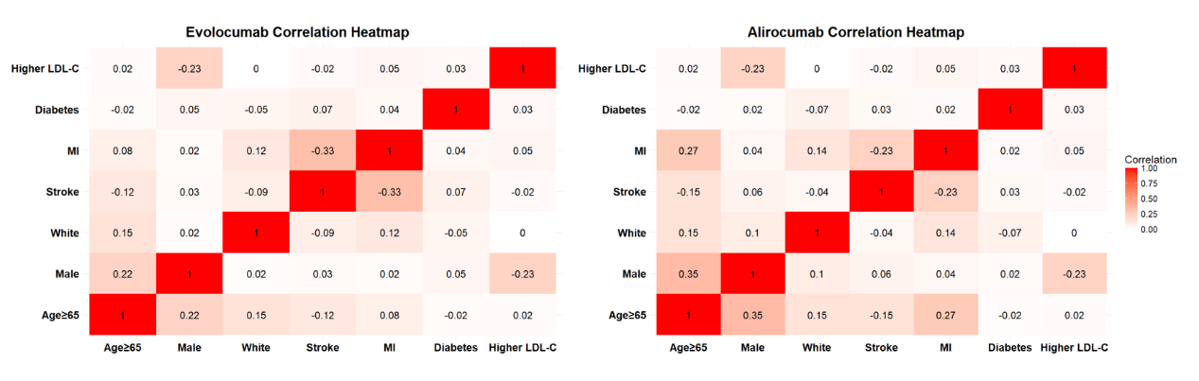
Abbreviations: LDL-C: Low-Density Lipoprotein Cholesterol; MI: Myocardial Infarction; SE: Sensitivity analysis.

eTable 13. Imputed Subgroup Covariate Distributions After Meta-Interpolation Matching - ±15% covariate balance threshold
 |  | Age≥65 | Male | White | Stroke | MI | Diabetes | HigherLDL-C
Evolocumab | OVERALL | 44.46% | 78.28% | 85.10% | 12.21% | 69.34% | 40.02% | 24.78%
 | Subgroup
 | Age
 | ≥65 | 100.00% | 90.67% | 93.43% | 5.46% | 73.72% | 38.75% | 25.89%
 | <65 | 0.00% | 68.37% | 78.43% | 17.61% | 65.83% | 41.04% | 23.89%
 | Sex
 | Male | 49.30% | 100.00% | 85.47% | 12.86% | 69.82% | 41.13% | 19.88%
 | Female | 27.00% | 0.00% | 83.78% | 9.88% | 67.61% | 36.03% | 42.44%
 | Race
 | White | 46.69% | 78.53% | 100.00% | 10.92% | 71.11% | 39.31% | 24.78%
 | non-White | 31.70% | 76.85% | 0.00% | 19.57% | 59.25% | 44.10% | 24.78%
 | CVDs
 | Stroke | 33.80% | 80.90% | 77.51% | 100.00% | 40.64% | 46.15% | 22.62%
 | non-Stroke | 45.94% | 77.92% | 86.16% | 0.00% | 73.33% | 39.17% | 25.08%
 | MI | 46.88% | 78.96% | 88.73% | 2.19% | 100.00% | 41.19% | 26.20%
 | non-MI | 38.99% | 76.75% | 76.88% | 34.88% | 0.00% | 37.37% | 21.56%
 | Metabolism
 | Diabetes | 43.09% | 81.34% | 82.22% | 16.40% | 71.63% | 100.00% | 26.84%
 | non-Diabetes | 45.37% | 76.24% | 87.02% | 9.42% | 67.81% | 0.00% | 23.40%
 | Baseline LDL-C
 | ≥110 mg/dL | 45.96% | 61.31% | 85.10% | 10.36% | 72.83% | 42.61% | 100.00%
 | <110 mg/dL | 43.96% | 83.87% | 85.10% | 12.82% | 68.19% | 39.17% | 0.00%
Alirocumab | OVERALL | 26.87% | 74.84% | 79.40% | 4.99% | 83.02% | 28.77% | 29.75%
 | Subgroup
 | Age
 | ≥65 | 100.00% | 100.64% | 90.36% | -5.98% | 103.00% | 27.64% | 31.21%
 | <65 | 0.00% | 65.36% | 75.37% | 9.02% | 75.68% | 29.18% | 29.21%
 | Sex
 | Male | 35.75% | 100.00% | 81.81% | 6.54% | 84.12% | 29.30% | 24.07%
 | Female | 0.47% | 0.00% | 72.24% | 0.39% | 79.74% | 27.19% | 46.64%
 | Race
 | White | 29.96% | 76.81% | 100.00% | 4.10% | 85.88% | 27.30% | 29.75%
 | non-White | 14.97% | 67.24% | 0.00% | 8.40% | 72.00% | 34.43% | 29.75%
 | CVDs
 | Stroke | 12.62% | 80.68% | 75.32% | 100.00% | 60.86% | 31.91% | 27.41%
 | non-Stroke | 27.62% | 74.53% | 79.61% | 0.00% | 84.18% | 28.61% | 29.87%
 | MI | 31.51% | 75.59% | 81.76% | 1.03% | 100.00% | 29.18% | 30.54%
 | non-MI | 4.19% | 71.20% | 67.88% | 24.35% | 0.00% | 26.75% | 25.90%
 | Metabolism
 | Diabetes | 25.77% | 76.34% | 74.32% | 7.34% | 84.75% | 100.00% | 32.20%
 | non-Diabetes | 27.31% | 74.23% | 81.45% | 4.04% | 82.32% | 0.00% | 28.76%
 | Baseline LDL-C
 | ≥100 mg/dL | 28.27% | 58.99% | 79.40% | 3.26% | 86.28% | 31.19% | 100.00%
 | <100 mg/dL | 26.28% | 81.55% | 79.40% | 5.72% | 81.64% | 27.75% | 0.00%
Abbreviations: MI, myocardial infarction; LDL-C, low-density lipoprotein cholesterol; CVD, cardiovascular disease.

eFigure 10. Forest plot of regression results - ±15% covariate balance threshold
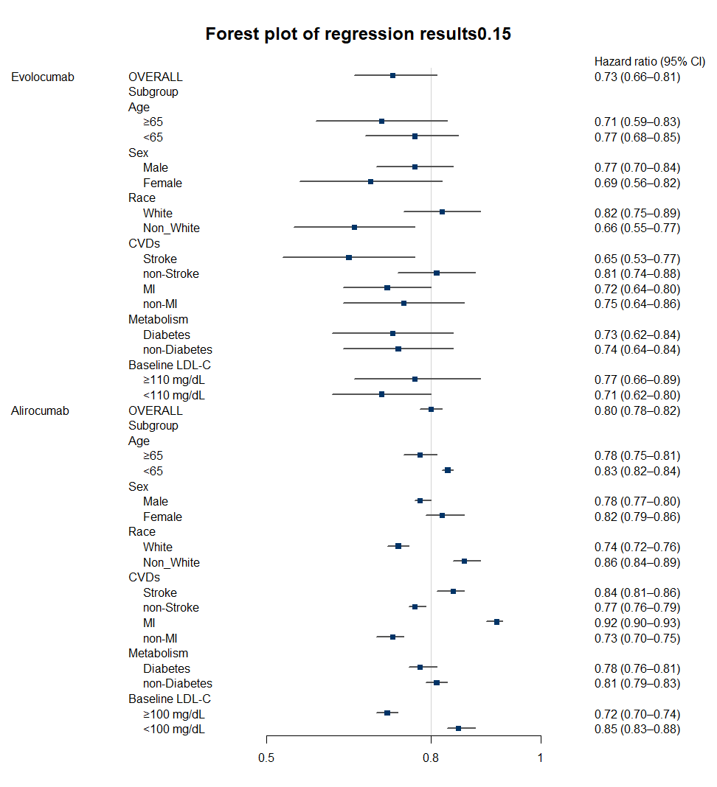
Abbreviations: CVDs: Cardiovascular Diseases; MI: Myocardial Infarction; LDL-C: Low-Density Lipoprotein Cholesterol.

eTable 14. Regression coefficients and P values - ±15% covariate balance threshold
Variable | Intervention | Coefficient | P | 95%CL
Age | Evolocumab | -0.0820 | 0.4585 | (-0.2906, 0.1231)
 | Alirocumab | -0.1196*** | 0.0003 | (-0.1545, -0.0850)
Gender | Evolocumab | 0.0961 | 0.3658 | (-0.0918, 0.3007)
 | Alirocumab | -0.1004*** | 0.0004 | (-0.1308, -0.0698)
Race | Evolocumab | 0.2249* | 0.0503 | (0.0483, 0.4252)
 | Alirocumab | -0.1645*** | 0.0000 | (-0.1855, -0.1433)
Stroke | Evolocumab | -0.2540* | 0.0478 | (-0.4754, -0.0570)
 | Alirocumab | 0.1844*** | 0.0000 | (0.1642, 0.2043)
MI | Evolocumab | -0.1722 | 0.1298 | (-0.3581, 0.0242)
 | Alirocumab | 0.3520*** | 0.0000 | (0.3222, 0.3824)
Metabolic | Evolocumab | -0.0160 | 0.8684 | (-0.2043, 0.1643)
 | Alirocumab | -0.0467** | 0.0066 | (-0.0708, -0.0228)
LDL-C | Evolocumab | 0.0895 | 0.3407 | (-0.0910, 0.2558)
 | Alirocumab | -0.2083*** | 0.0000 | (-0.2366, -0.1803)
* P < 0.05, ** P < 0.01, *** P < 0.001
Abbreviations: MI: Myocardial Infarction; LDL-C: Low-Density Lipoprotein Cholesterol.

eTable 15. Variable Selection and Mapping Across Included Real-World Databases
This table describes the source variables extracted from six international, population-based longitudinal studies to construct the analytical covariates used in the meta-interpolation framework. Variable names correspond to the original dataset variable identifiers. Age, gender, race, cardiovascular conditions, diabetes, dyslipidemia, and LDL-C measures were harmonized across datasets to align with subgroup summaries from randomized controlled trials. “NA” indicates that the corresponding variable was not available in the source dataset. Race/ethnicity was harmonized using the following assumptions: participants from the SHARE study were classified as White, while participants from CHARLS, LASI, and MHAS were classified as non-White, reflecting their respective source populations. HRS and ELSA included self-reported race variables and were categorized accordingly.
 | Age | Gender | Race | CVDs |  | Diabetes | Dyslipidemia | LDL-C
 |  |  |  | Stroke | MI | Diabetes | Dyslipidemia | LDL-C
SHARE | agey | ragender | NA | hearte | stroke | diabe | hchole | NA
HRS | ragey_e | ragender | raracem | hrtatte | stroke | diabe | hchole | NA
ELSA | agey | ragender | raracem | hrtatte | stroke | diabe | hchole | NA
CHARLS | Rabyear, iwy | ragender | NA | hearte | stroke | diabe | dyslipe | bl_ldl
LASI | agey | ragender | NA | r1hrtatte | r1stroke | r1diabe | r1hchole | NA
MHAS | agey | ragender | NA | hrtatte | stroke | diabe | NA | NA
Abbreviations: SHARE, Ageing and Retirement in Europe; HRS, Health and Retirement Study; ELSA, English Longitudinal Study of Ageing; CHARLS, China Health and Retirement Longitudinal Study; LASI, Longitudinal Aging Study in India; MHAS, Mexican Health and Aging Study; LDL-C, Low-Density Lipoprotein Cholesterol; MI, myocardial infarction.

