Supplementary Table 1 Identified species in different context of the Tyresta mound, NISP. Not all unidentified fragments were counted
Art | Filling | Secondary burial 1 | Secondary burial 2 | Badger layer | Badger layer, tunnels | Central cairn | Cremation layer | Urns (2) | Cremation layer, bottom | Central cairn, ring stones | Excavation square, bottom of cremation layer | Stray find | Total
Human |  |  |  | 46 |  | 35 | 121 | 8 | 1 | 25 | 16 |  | 252
Human? |  |  |  | 1 |  | 1 |  |  |  |  | 2 |  | 4
Horse |  |  |  | 2 | 3 | 7 | 49 |  | 2 | 7 | 4 |  | 74
Large mammal |  |  |  | 4 | 7 | 22 | 98 |  | 11 | 50 | 7 | 1 | 200
Sheep/goat |  |  |  |  |  | 3 | 4 |  |  |  |  |  | 7
Dog |  | 3 |  | 10 |  | 28 | 179 |  | 4 | 13 | 10 |  | 247
Dog? |  |  |  |  |  |  | 1 |  |  |  |  |  | 1
Middle sized mam. |  |  | 3 | 32 | 6 | 19 | 155 |  | 12 | 51 | 47 | 1 | 326
Cat |  |  |  | 2 | 1 | 2 | 28 |  |  | 1 | 1 |  | 35
Small mam. |  | 2 | 3 | 20 | 1 | 2 | 76 |  | 9 | 5 | 34 | 4 | 156
Mammal | 1 | 16 | 20 | 100 | 38 | 544 | 1358 | 6 | 33 | 141 | 251 | 47 | 2555
Goose |  |  |  |  |  |  | 1 |  |  |  |  |  | 1
Galliformes |  |  |  |  |  | 1 |  |  |  |  |  |  | 1
Bird |  |  |  |  |  |  | 14 |  |  |  |  |  | 14
Bird? |  |  |  |  |  |  |  |  |  |  | 3 | 2 | 5
Fish |  |  |  |  |  |  | 1 |  |  |  |  |  | 1
Indeterminate* |  | 2 | 1 | 14 |  | 70 | 86 |  | 37 | 41 | 139 |  | 390
Total | 1 | 23 | 27 | 231 | 56 | 734 | 2171 | 14 | 109 | 334 | 514 | 55 | 4269

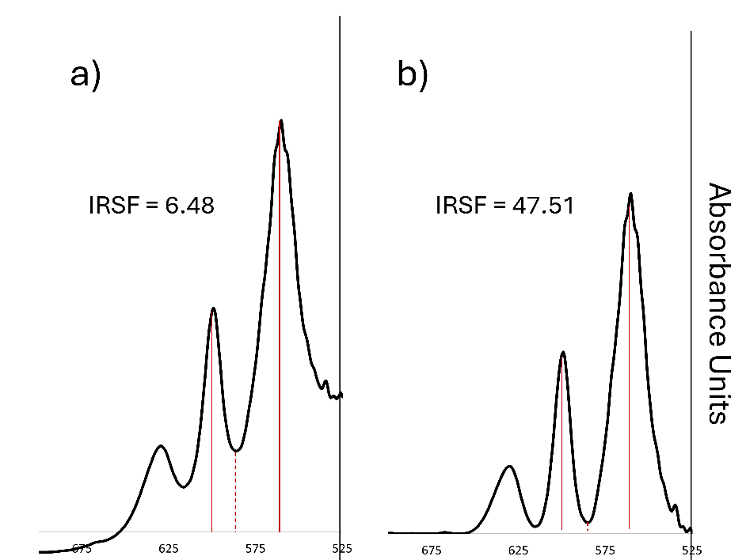
Supplementary fig 1 Effect of baseline correction in the IRSF index. a) raw spectrum of sample Tyr012 in the 700-525 cm⁻¹ absorbance range; b) rubber-band baseline corrected spectrum of sample Tyr012 in the same absorbance range
Supplementary Table 2 CIELab parameters for the cortical bone sampled for Hg analysis
Sample | L* | a* | b* | C* | h
ªTyr002 | 82.02 | 0.98 | 7.12 | 7.19 | 82.2
Tyr018 | 83.56 | 0.47 | 3.01 | 3.05 | 81.21
Tyr025 | 76.48 | 0.96 | 6.67 | 6.74 | 81.8
Tyr026 | 81.16 | 0.98 | 6.33 | 6.41 | 81.18
Tyr032 | 81.96 | 0.96 | 6.29 | 6.36 | 81.35
Tyr033 | 81.24 | 0.99 | 6.84 | 6.91 | 81.75
Tyr035 | 82.09 | 0.88 | 6.21 | 6.27 | 81.93
Tyr042 | 73.74 | 0.62 | 4.63 | 4.67 | 82.42
Tyr044 | 81.16 | 1.05 | 6.76 | 6.84 | 81.15
Tyr054 | 71.54 | 0.78 | 4.51 | 4.57 | 80.19
Tyr055 | 77.05 | 0.62 | 4.93 | 4.96 | 82.87
Tyr059 | 82.28 | 0.28 | 4.7 | 4.71 | 86.59
Tyr066 | 83.67 | 0.84 | 6.26 | 6.32 | 82.34
Tyr068 | 67.63 | 0.87 | 3.99 | 4.08 | 77.74
Tyr087 | 81.62 | 1.33 | 8.91 | 9.01 | 81.5
^{b}Tyr091 | 62.81 | 5.28 | 19.26 | 19.97 | 74.67
Tyr092 | 64.39 | 5.66 | 18.93 | 19.76 | 73.34
Tyr102 | 61.9 | 5.27 | 18.21 | 18.96 | 73.87
Tyr105 | 59.49 | 5.09 | 16.43 | 17.2 | 72.78
Tyr107 | 63.14 | 4.92 | 17.1 | 17.8 | 73.96
Tyr109 | 25.08 | 2.26 | 5.25 | 5.71 | 66.73
ªUpper table: calcined samples; ^{b}lower table: not-calcined samples

Supplementary text 1 In the figure (Supplementary figure 2) we see both classification methods produce similar spectroscopic features for each grade, but the classification made by the discrimination analysis shows less variation among samples. The main features of each grade are:
- Grade 0 (n=13): the spectra present the spectra characteristic of bone with an intense phosphate peak at ~1015 cm⁻¹, the characteristic ν₄ phosphate doublet at 598 and 560 cm⁻¹carbonate peaks between 1490 and 1380 cm⁻¹, and amide A and B (3500-3020 cm⁻¹), I (1690-1590 cm⁻¹), and II (1585-1500 cm⁻¹). Shoulders at ~1088 and ~961 cm⁻¹ are shown.
- Grade 1 (n=0): no spectrum was classified as this grade of burning.
- Grade 2 (n=2): absorbance at amide A, B, I and II is less intense. Peak at 961 cm⁻¹ is more defined.
- Grade 3 (n=4): no apparent differences were shown regarding grade 2.
- Grade 4 (n=7): absorbance in the amide regions is less intense and disappears in some samples. A peak at ~631 cm⁻¹ appears. Peak at ~961 cm⁻¹ becomes sharper, and peak at ~1088 cm⁻¹ is no longer a shoulder, but a well-defined peak. In some samples peaks at ~3570, ~2012 and ~698 cm⁻¹ are observable. The valley between 598 and 560 cm⁻¹ becomes observably deeper. Peaks at 1490-1390 cm⁻¹ and 872 cm⁻¹ are less intense.
- Grade 5 (n=11): absorbance at amide regions is almost imperceptible for most samples. Peaks at 1088 and 961 cm⁻¹ become sharper. Peak at 872 cm⁻¹ loses intensity. Peak at 631cm⁻¹ is more intense. Peaks at 3570, 2012 and 698 cm⁻¹ are present in some samples. Peaks at 1490-1390 cm⁻¹ are less intense.
- Grade 6A (n=37) and 6B (n=33) : more samples present the cyanamide band at 2012 cm⁻¹, which is more intense. Peaks at ~1088 and ~961 cm⁻¹ are sharper. Peaks at 1490-1390 and ~872 cm⁻¹ are less intense. No amide absorption is observable. The ν₄ phosphate valley is deeper. Peaks at ~3570, and ~698 cm⁻¹ are present in some samples.

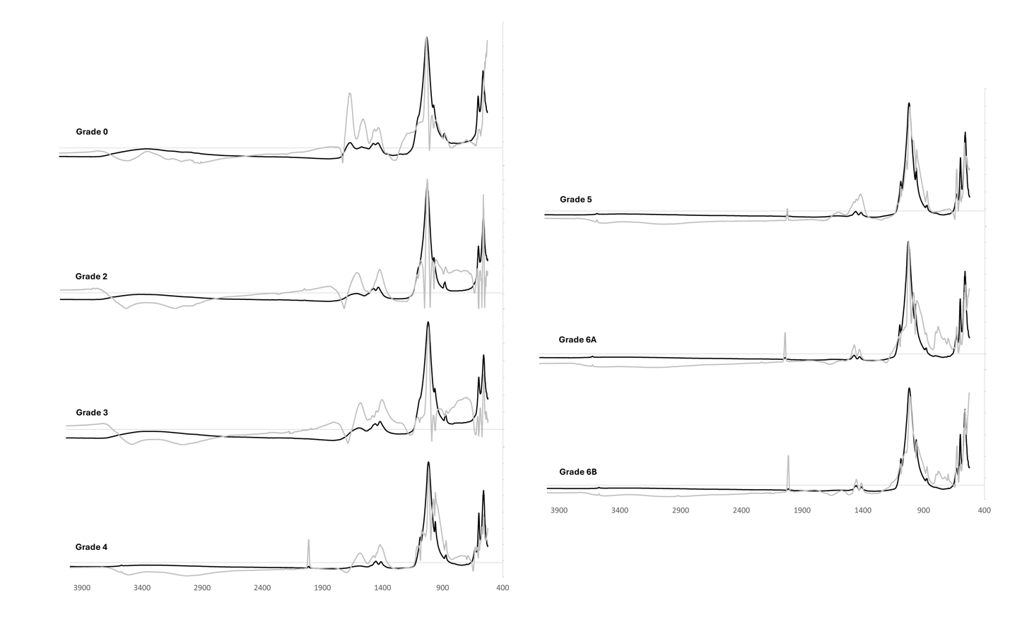
Supplementary fig 2 Average and standard deviation spectra for the samples classified by m-Stiner

Suplementary table 3 Pearson correlation coefficient for the IR absorbance bands and the CIELab parameters for the burnt group
WN (cm⁻¹) | L* | a* | b* | C* | h
557 | -0.439 |  | -0.394 | -0.385 | -0.673
571 | 0.350 |  | 0.332 | 0.326 | 0.511
598 | -0.471 | -0.418 |  |  | 0.376
602 |  | -0.433 |  |  | 0.672
616 |  | 0.417 | 0.627 | 0.624
650 | -0.487 | -0.326 |  |  | 0.340
693 | -0.610
698 | -0.459 | -0.503 | -0.453 | -0.456
717 |  |  | 0.505 | 0.502
739 | -0.3373 | 0.316 | 0.478 | 0.475
754 |  |  | 0.447 | 0.442 | 0.304
872 |  |  | 0.345 | 0.338 | 0.519
961 |  | -0.469 | -0.302 | -0.307 | 0.364
965 |  | -0.326 |  |  | 0.471
1014 |  |  |  |  | -0.530
1037 |  |  | 0.302 |  | 0.526
1075 | 0.353 |  | 0.472 | 0.465 | 0.583
1086 |  | -0.369 |  |  | 0.494
1123 |  | 0.600 | 0.827 | 0.825
1147 |  | 0.766 | 0.652 | 0.657 | -0.369
1196 |  | 0.511 |  | 0.300 | -0.484
1381 |  | 0.533 | 0.678 | 0.678
1413 | 0.394 | 0.375 | 0.638 | 0.636
1432 | 0.323 | 0.471 | 0.645 | 0.644
1453 | 0.470 | 0.326 | 0.595 | 0.592 | 0.311
1460 | 0.447 |  | 0.583 | 0.580 | 0.352
1498 |  | 0.481 | 0.674 | 0.672
1500 |  | 0.483 | 0.674 | 0.673
1529 |  | 0.605 | 0.563 | 0.567
1560 |  | 0.400 |  |  | -0.447
1621 | -0.309 | 0.341 |  |  | -0.402
2001 | -0.601 | -0.389 | -0.646 | -0.644 | -0.315
2010 | -0.434 | -0.563 | -0.583 | -0.585
2028 | -0.630 | -0.437 | -0.685 | -0.682
2855 |  |  | -0.325 | -0.319 | -0.406
2918 |  |  | -0.313 | -0.308 | -0.347
3248 |  |  | -0.33 | -0.326 | -0.397
3562 |  |  | -0.441 | -0.435 | -0.421

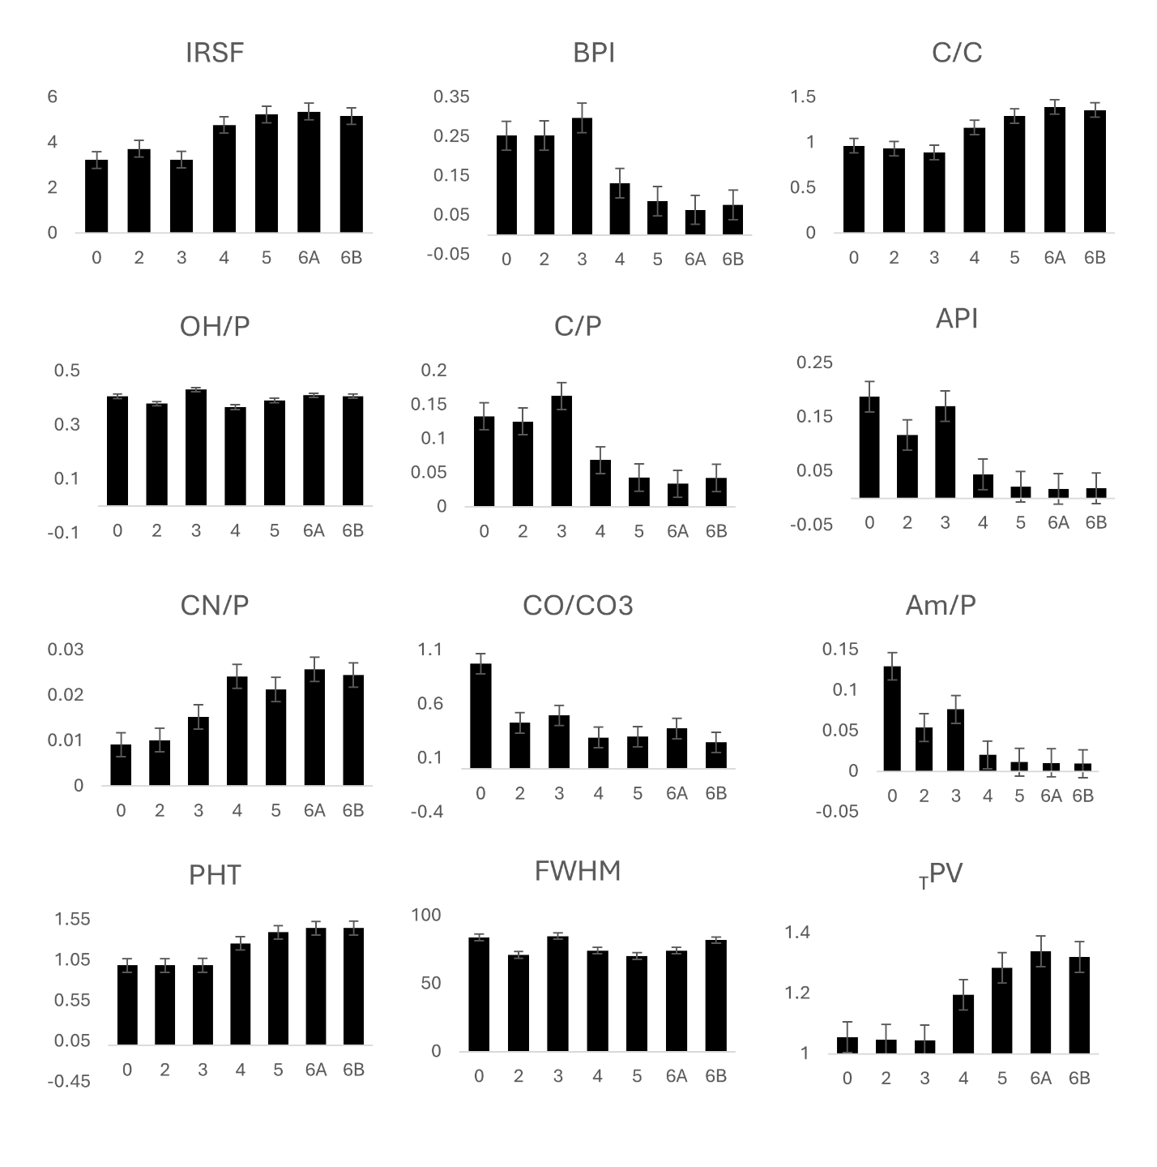
Supplementary fig 3 Values for the MIR-indices classified by m-Stiner degree of burning

Supplementary table 4 Loadings for the selected bands for the global PCA
Band assignation | WN (cm⁻¹) | PC1 | PC2 | PC3 | PC4 | PC5
ν₃ CO₃²⁻/Amide II | 1505 | ª0.934 | 0.265 | 0.099 | 0.127 | 0.095
ν₃ CO₃²⁻ | 1417 | 0.933 | 0.168 | 0.08 | 0.203 | -0.147
Amide I | 1617 | 0.926 | 0.121 | 0.116 | 0.001 | 0.292
Amide II | 1560 | 0.921 | 0.17 | 0.138 | 0.032 | 0.286
 | 667 | 0.901 | -0.164 | 0.028 | -0.264 | 0.193
ν₃ CO₃²⁻ | 1456 | 0.820 | 0.191 | 0.040 | ^{b}0.373 | -0.301
ν₂ CO₃²⁻ | 872 | 0.784 | -0.51 | -0.126 | 0.209 | -0.186
Cyanamide | 2012 | -0.597 | 0.322 | -0.569 | -0.194 | 0.189
OH (lib) | 630 | -0.672 | -0.331 | 0.504 | 0.235 | 0.195
ν₁PO₄³⁻ | 962 | -0.676 | -0.483 | -0.366 | 0.312 | 0.109
ν₄PO₄³⁻ | 560 | -0.703 | 0.489 | 0.227 | 0.204 | 0.138
ν₄PO₄³⁻ | 599 | -0.754 | 0.105 | 0.141 | 0.524 | 0.13
νOH | 3571 | -0.972 | 0.035 | 0.064 | 0.031 | -0.121
ν₃PO₄³⁻ | 1023 | -0.541 | 0.643 | 0.274 | -0.266 | -0.215
Phosphate | 1086 | -0.284 | -0.588 | 0.468 | -0.382 | -0.046

ªBold type= loadins>0.7 and <-0.7. ^{b}Red = loadings from 0.3 to 0.69 and -0.3 to -0.7.
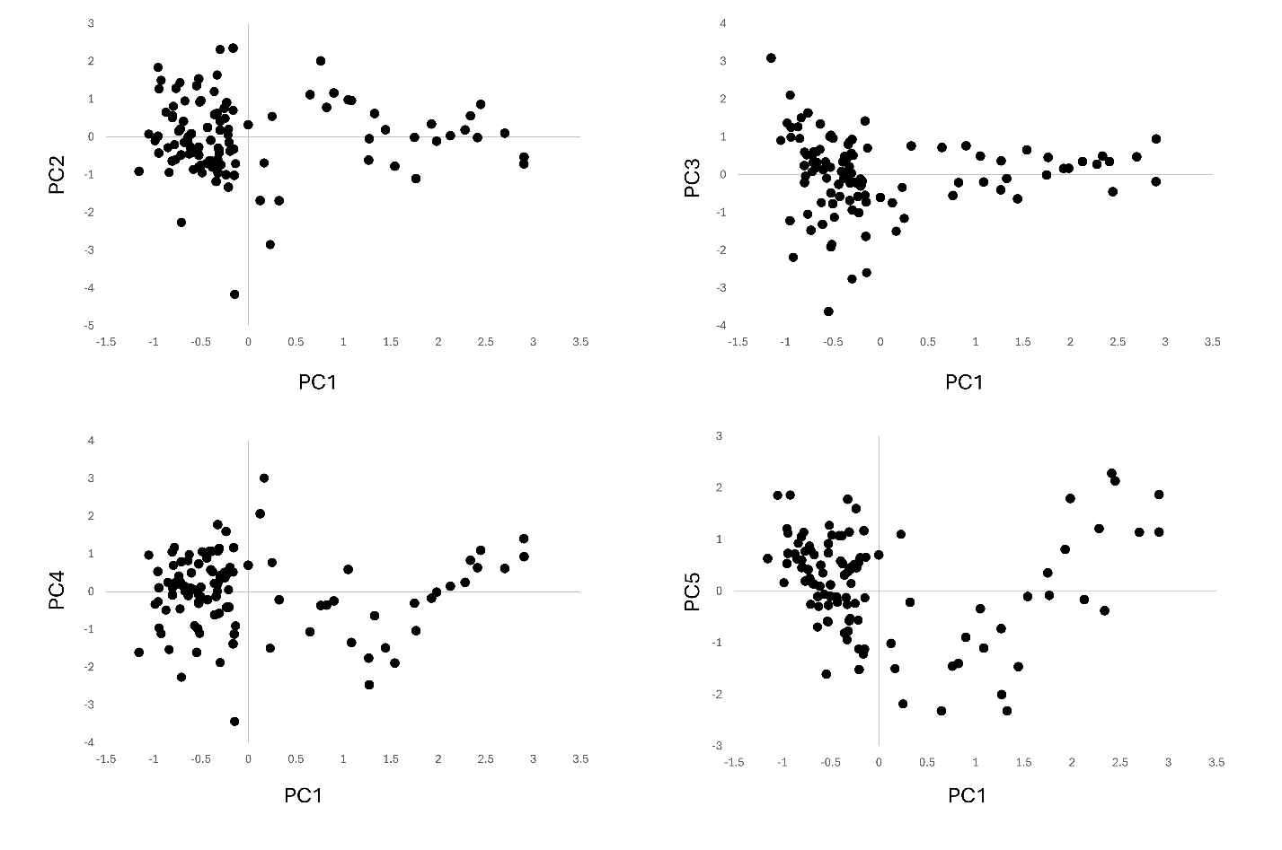
Supplementary fig 4 Scores for the 5 PCs extracted in the global PCA

Supplementary table 5 Loadings for the selected bands for the PCA of the non-calcined group
Band assignation | WN (cm⁻¹) | PC1 | PC2 | PC3 | PC4
Amide I | 1652 | ª0.888 | 0.257 | -0.121 | -0.084
Amide A/OH | 3270 | 0.884 | ^{b}0.326 | -0.172 | -0.149
ν₁PO₄³⁻ | 961 | 0.810 | 0.029 | 0.343 | 0.269
Amide II | 1558 | 0.692 | 0.662 | 0.007 | 0.097
ν₂ CO₃²⁻ | 872 | 0.681 | 0.603 | 0.323 | -0.123
ν₃PO₄³⁻ | 1015 | -0.809 | -0.468 | -0.168 | 0.106
ν₃ CO₃²⁻ | 1417 | 0.161 | 0.962 | 0.041 | 0.127
ν₃ CO₃²⁻ | 1456 | 0.237 | 0.942 | -0.003 | 0.153
ν₃ CO₃²⁻ | 1505 | 0.597 | 0.775 | -0.088 | 0.079
Phosphate | 1089 | -0.174 | -0.049 | 0.893 | -0.077
ν₄PO₄³⁻ | 560 | -0.521 | -0.149 | -0.769 | 0.183
ν₄PO₄³⁻ | 599 | -0.060 | 0.220 | -0.173 | 0.942
ªBold type= loadins>0.7 and <-0.7. ^{b}Red = loadings from 0.3 to 0.69 and -0.3 to -0.7.

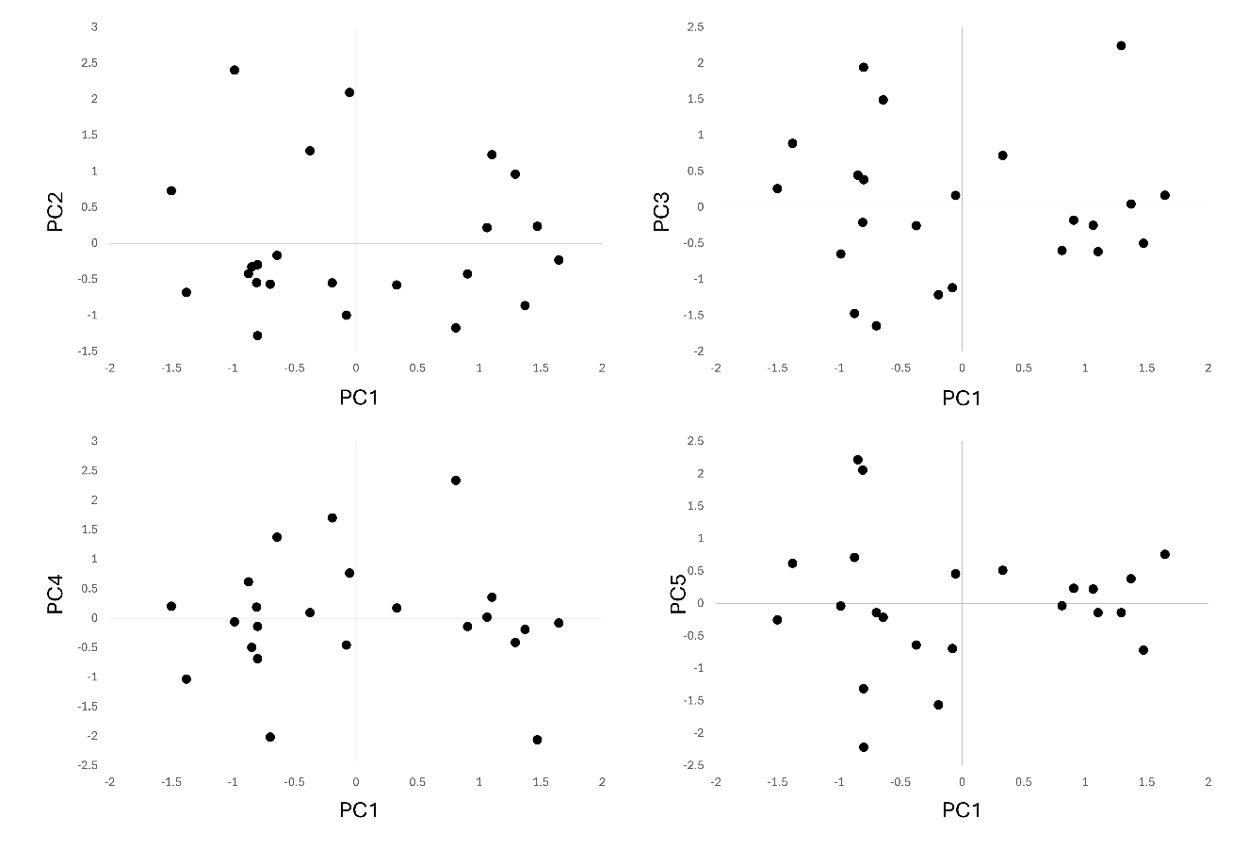
Supplementary fig 5 Scores for the 5 PCs extracted in the PCA of non-calcined group of samples

Supplementary table 6 Loadings for the selected bands for the PCA of the calcined group
Band assignation | WN (cm⁻¹) | PC1 | PC2 | PC3 | PC4 | PC5
ν₃PO₄³⁻ | 1023 | ª0.824 | -0.080 | 0.210 | -0.064 | -0.125
ν₄PO₄³⁻ | 560 | 0.619 | -0.016 | ^{b}0.593 | -0.093 | -0.047
ν₂ CO₃²⁻ | 873 | -0.77 | 0.435 | -0.304 | 0.228 | 0.165
ν₁PO₄³⁻ | 962 | -0.929 | -0.144 | -0.008 | -0.023 | -0.177
ν₃CO₃²⁻ | 1456 | -0.027 | 0.967 | 0.138 | -0.037 | -0.077
ν₃ CO₃²⁻ | 1411 | -0.001 | 0.959 | 0.083 | 0.032 | -0.165
ν₄PO₄³⁻ | 599 | 0.057 | 0.141 | 0.855 | 0.059 | -0.105
OH(Hap) | 3572 | 0.244 | -0.406 | 0.702 | 0.087 | 0.326
Cyanamide | 699 | -0.147 | -0.396 | -0.819 | -0.242 | 0.101
OH(Hap) | 630 | -0.022 | -0.363 | 0.359 | 0.806 | 0.108
Cyanamide | 2012 | 0.125 | -0.247 | -0.017 | -0.876 | -0.123
Phosphate | 1087 | 0.039 | -0.199 | -0.211 | 0.427 | 0.745
Amide II | 1560 | 0.613 | 0.175 | -0.218 | 0.089 | -0.623
ªBold type= loadins>0.7 and <-0.7. ^{b}Red = loadings from 0.3 to 0.69 and -0.3 to -0.7.

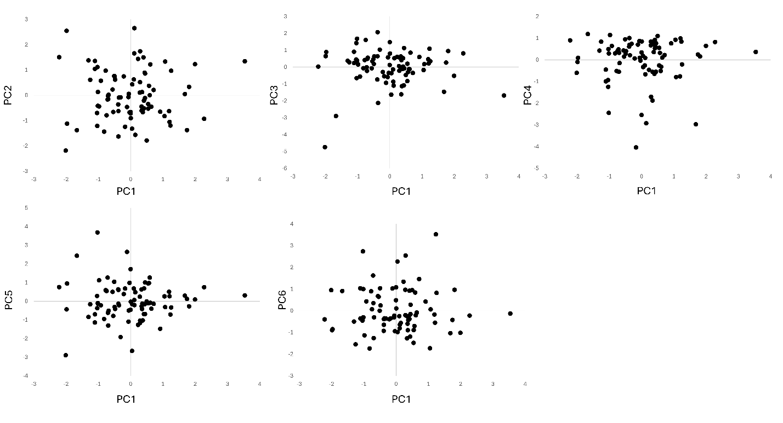

Supplementary fig 6 Scores for the 6 PCs extracted in the PCA of the calcined group of samples

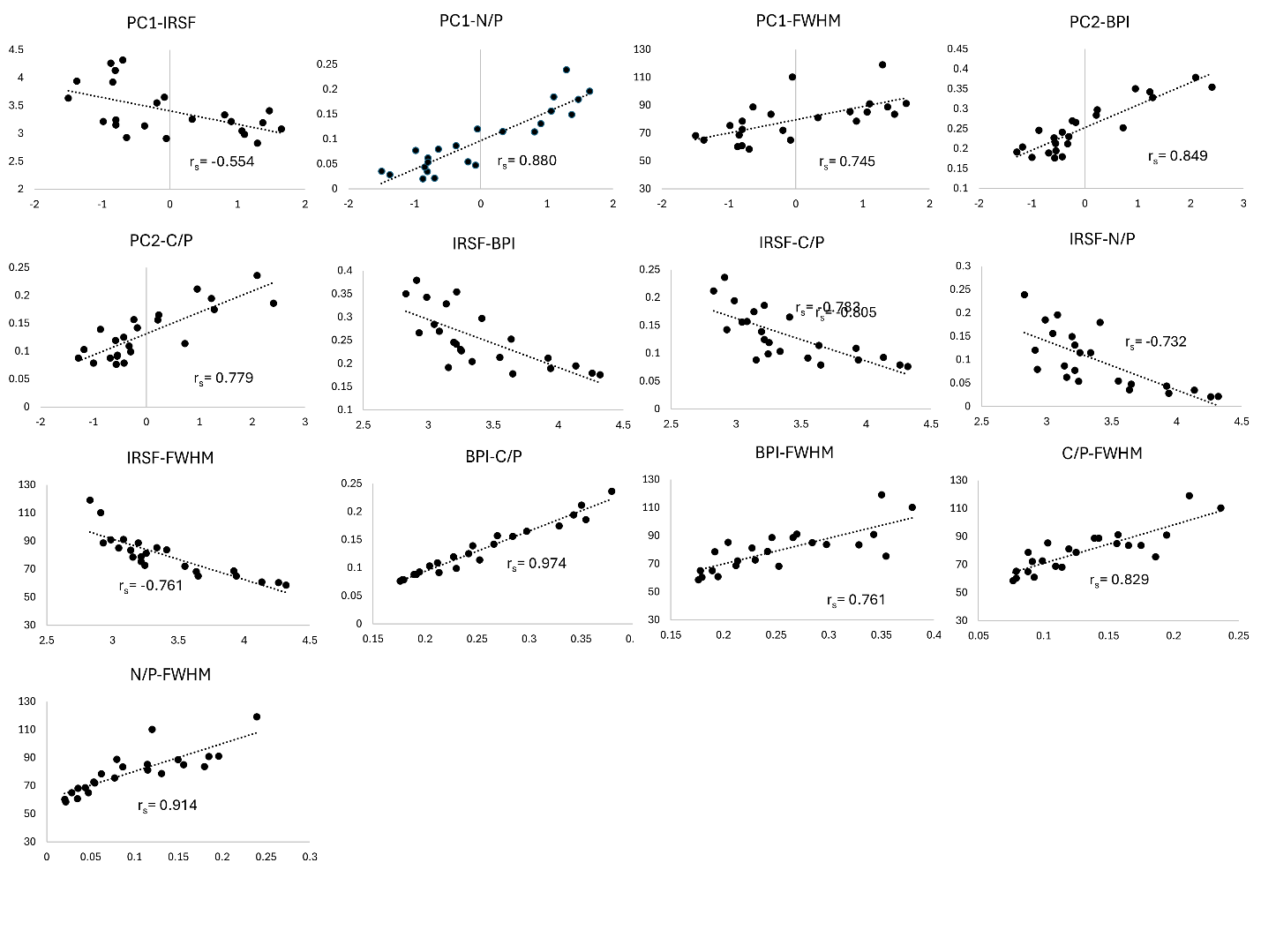Supplementary fig 7 Correlation between MIR-indices and PCs for non-calcined samples

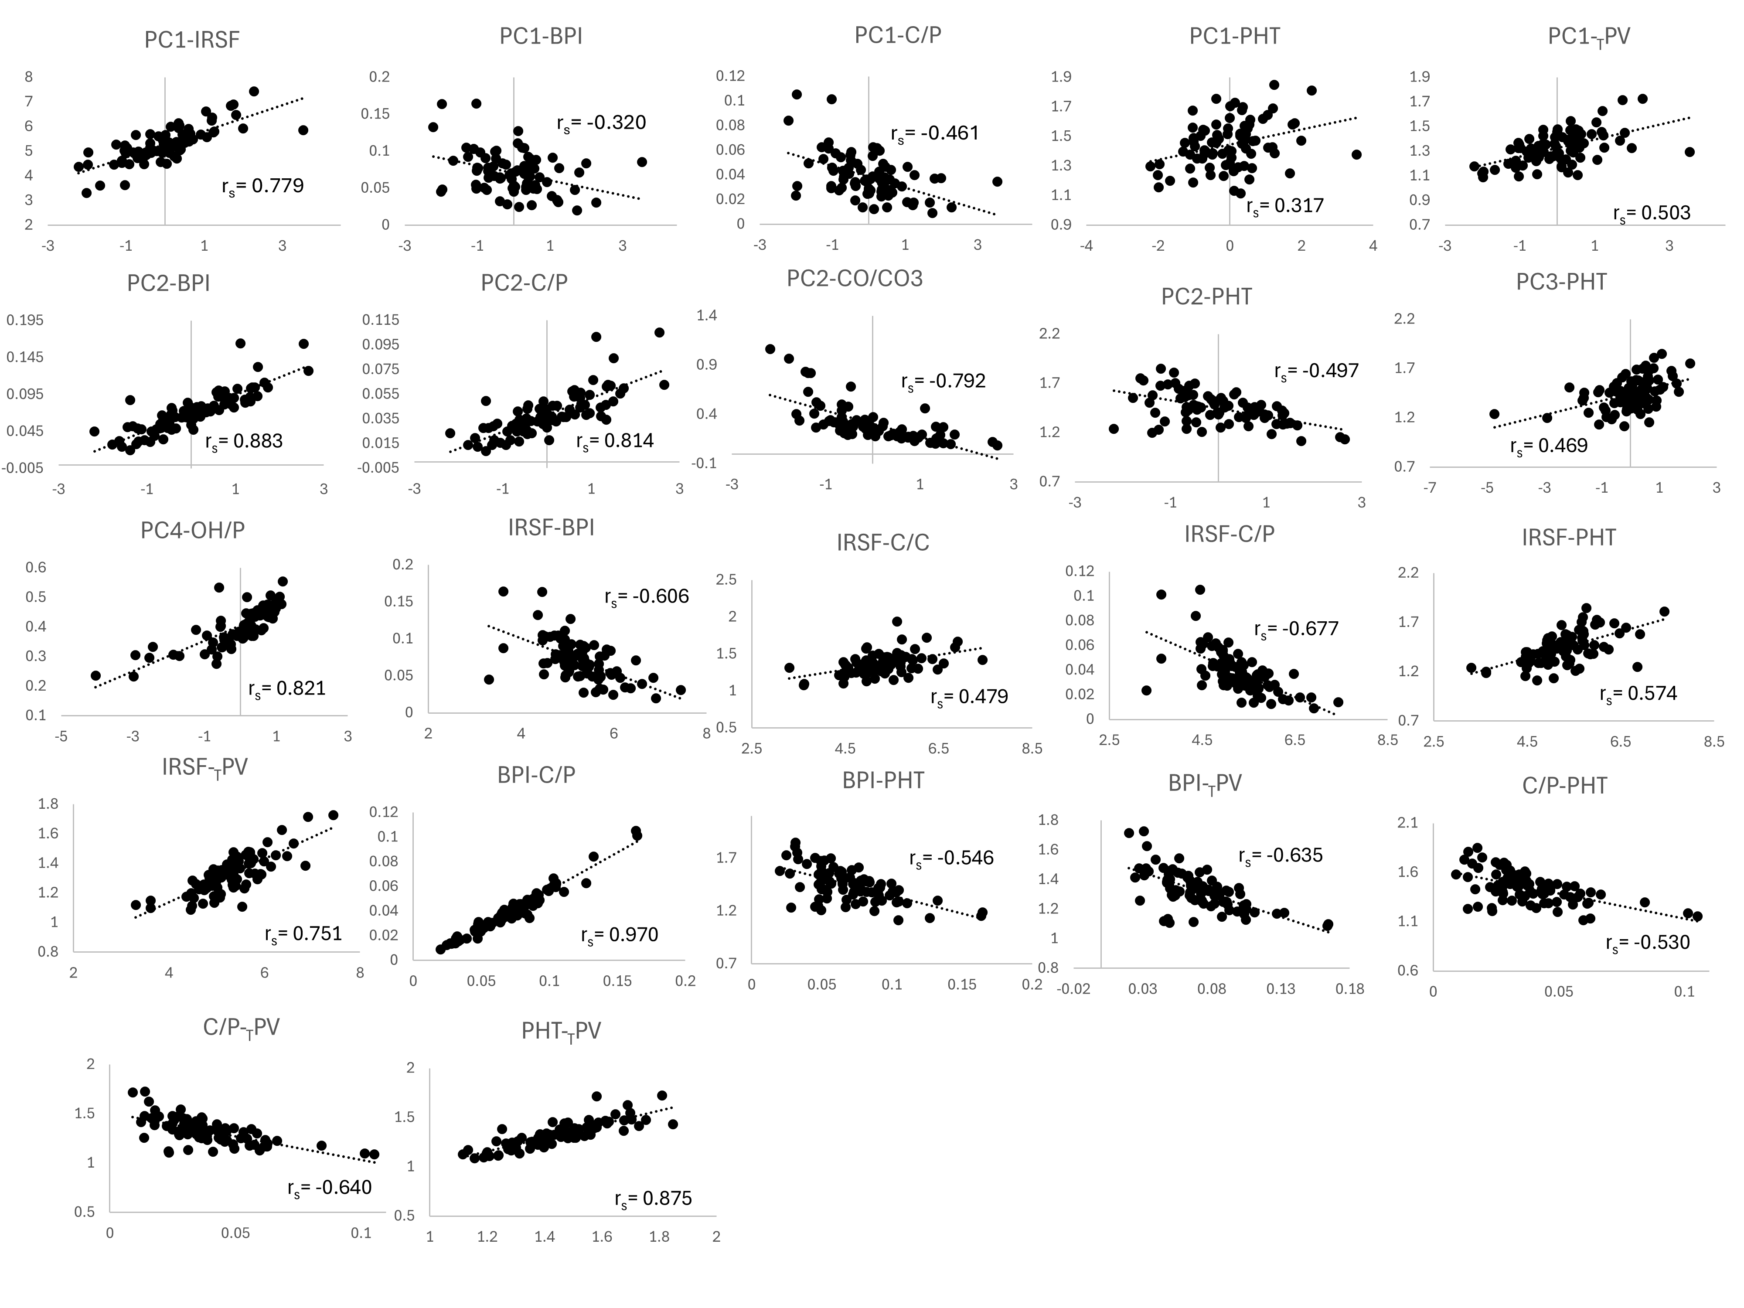
Supplementary figure 8. Correlation between MIR-indices and PCs for calcined samples.

