Supplementary Figures
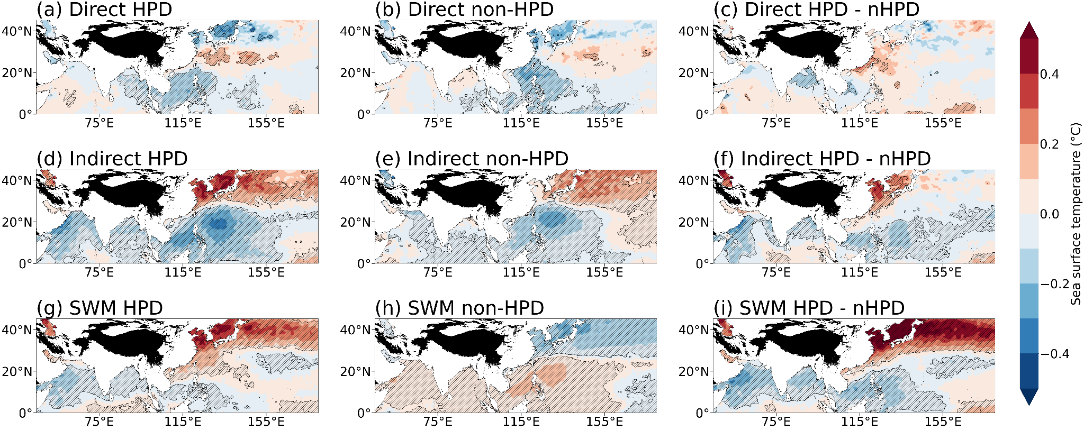
Figure S1. Sea surface temperature anomalies during each HPD type, as well as their respective non-HPDs. The difference between HPDs and non-HPDs is also shown. The hatched regions are anomalies that are statistically significant at the 95 % confidence level.

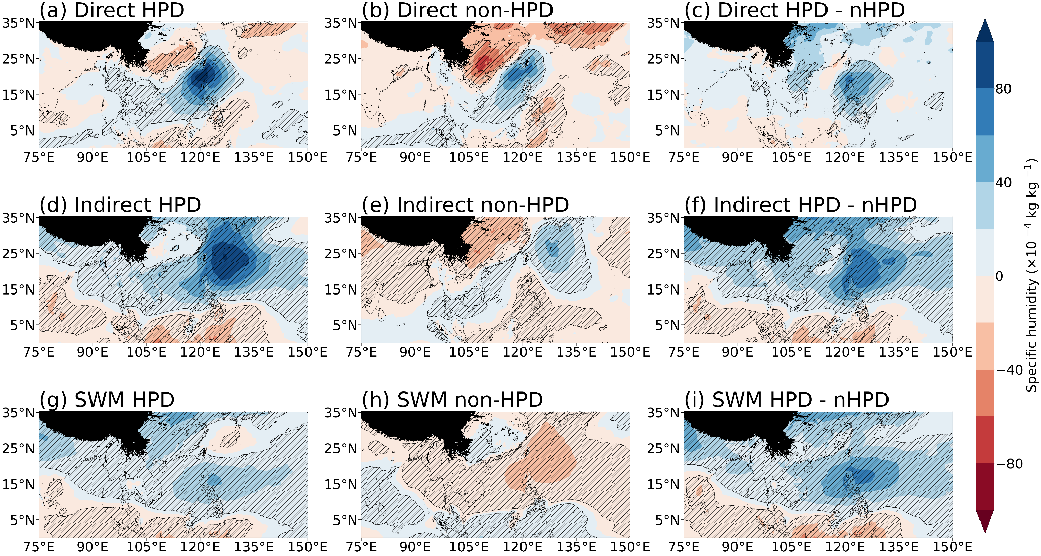
Figure S2. Vertically integrated specific humidity anomalies during each HPD type, as well as their respective non-HPDs. The difference between HPDs and non-HPDs is also shown. The hatched regions are anomalies that are statistically significant at the 95 % confidence level.

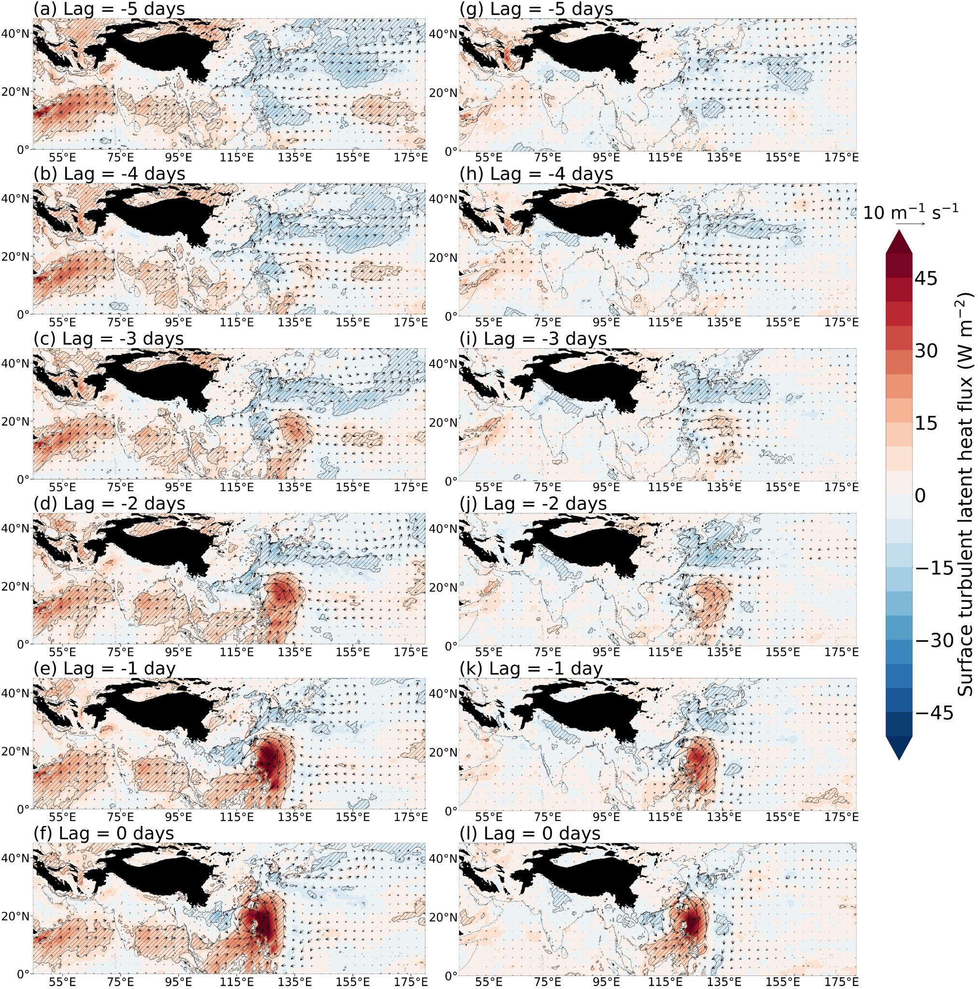
Figure S3. Surface latent heat flux anomalies (W m⁻²; shaded), and 10 meter horizontal wind anomalies (10 m s⁻¹; vectors) anomalies for the days preceding the first day of the HPE during direct TC HPEs (a-f) and direct TC non-HPEs (g-l). The hatched regions are anomalies that are statistically significant at the 95 % confidence level.

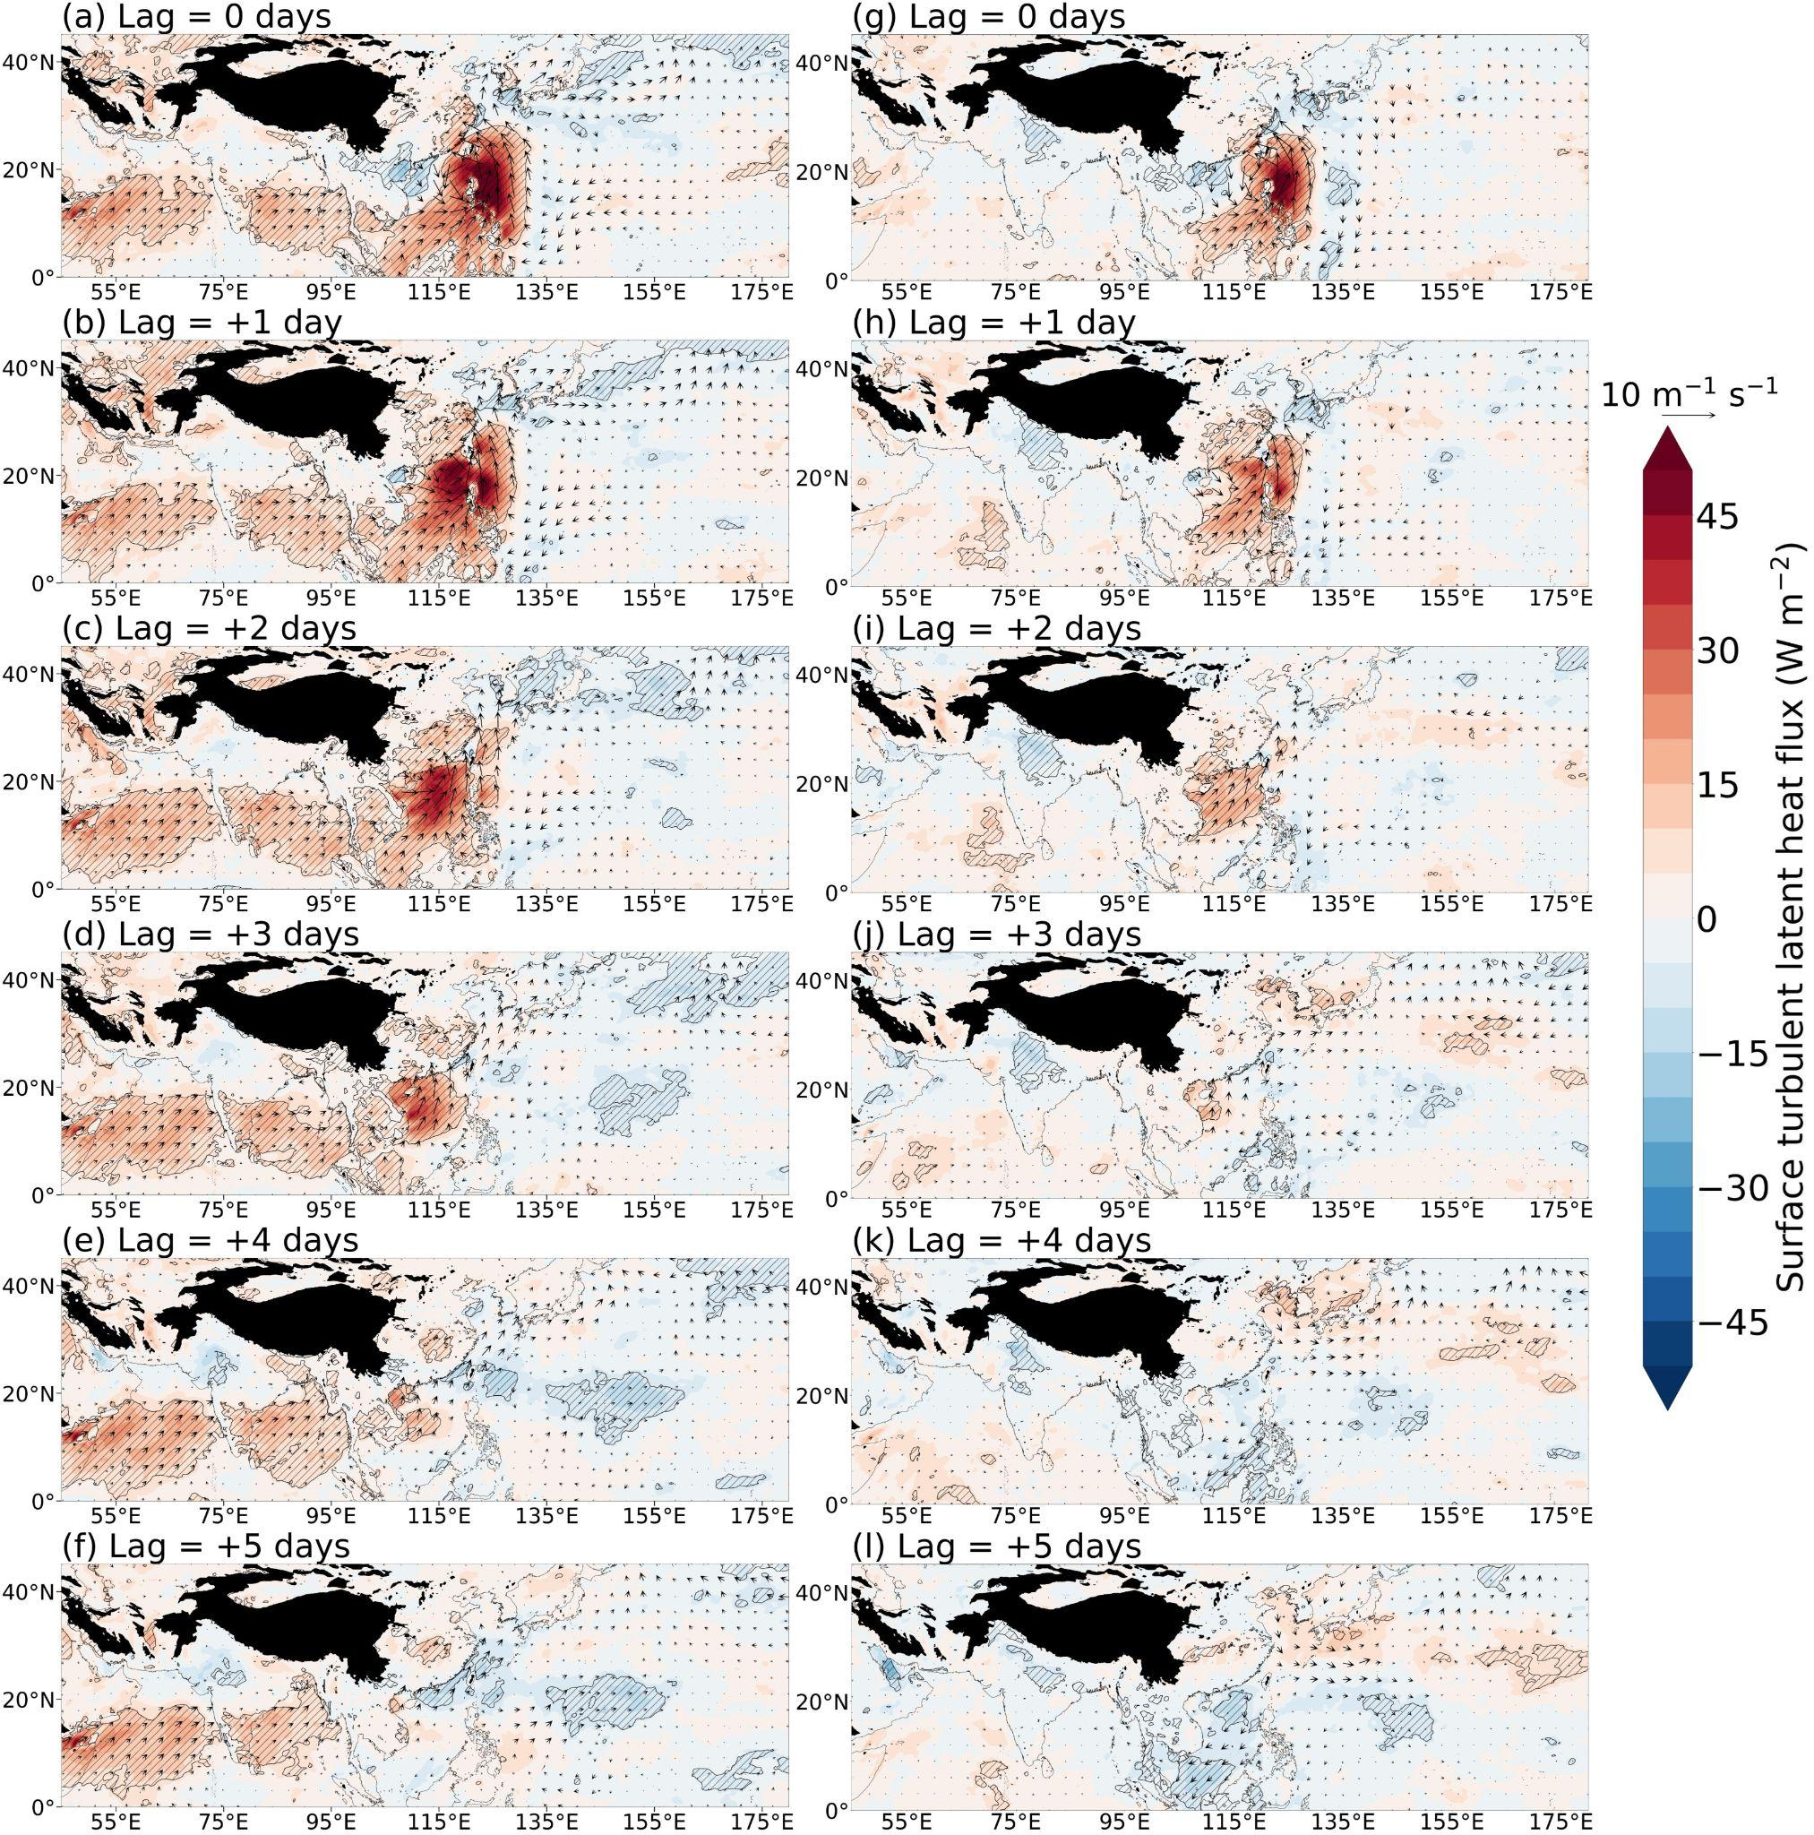
Figure S4. Surface latent heat flux anomalies (W m⁻²; shaded), and 10 meter horizontal wind anomalies (10 m s⁻¹; vectors) anomalies for the days succeeding the first day of the HPE during direct TC HPEs (a-f) and direct TC non-HPEs (g-l). The hatched regions are anomalies that are statistically significant at the 95 % confidence level.

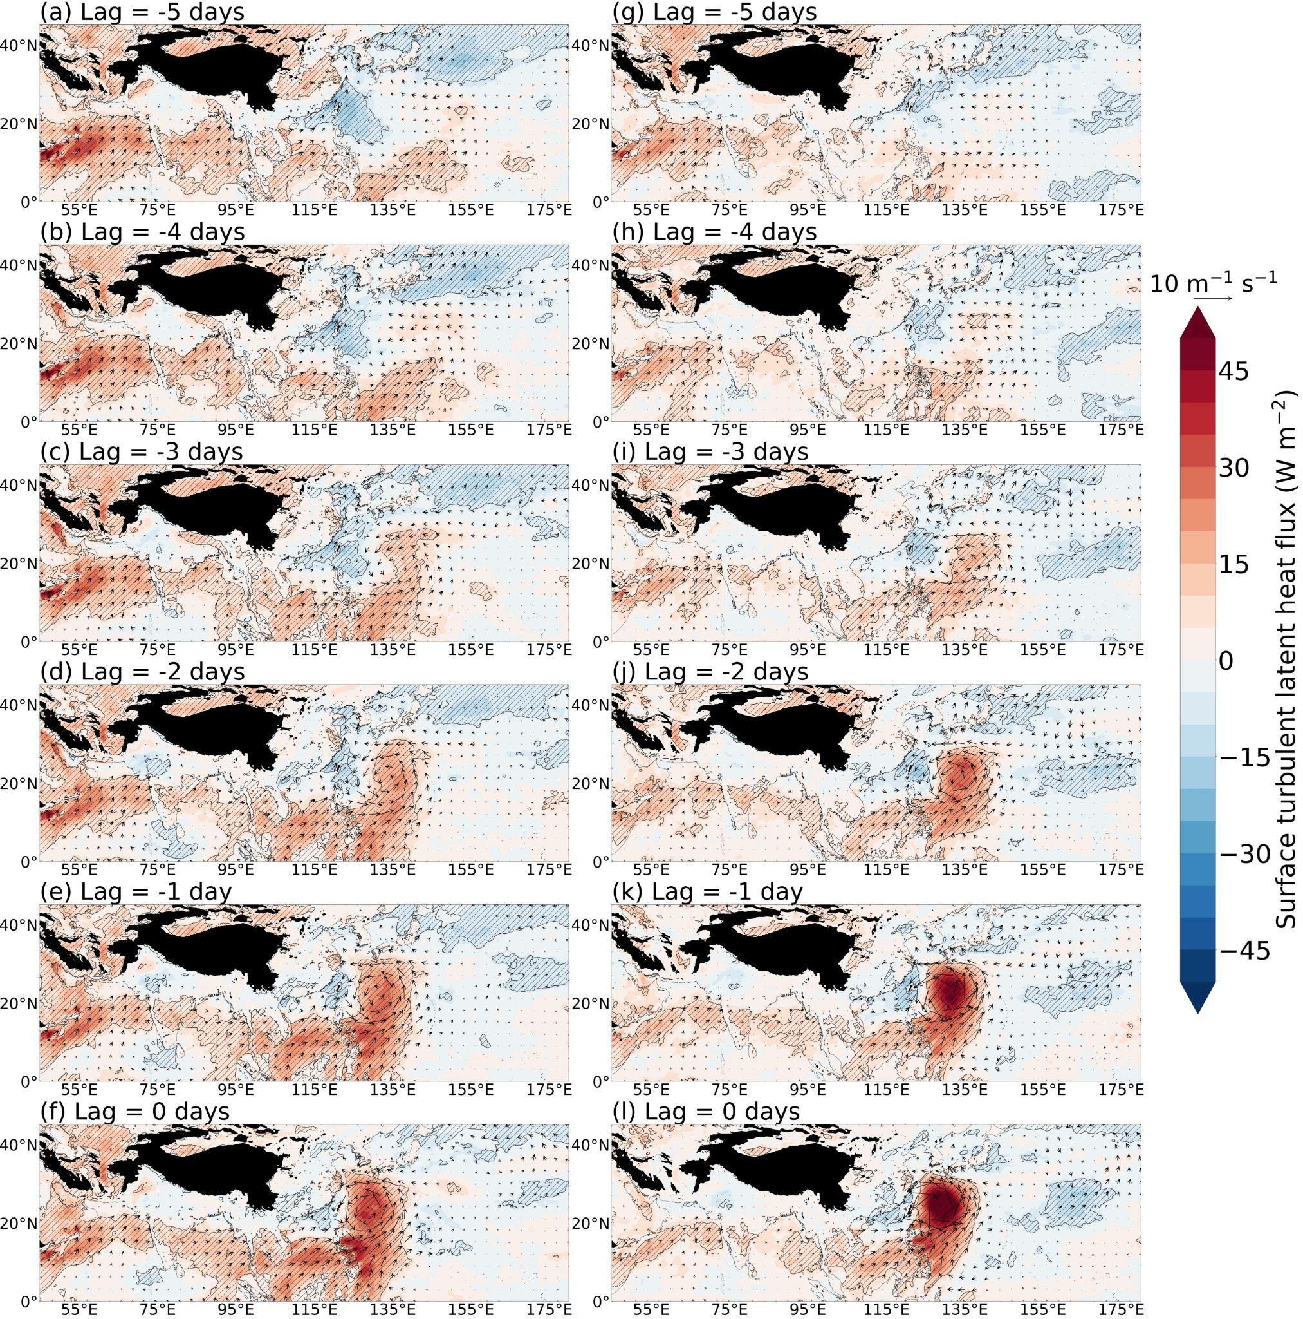
Figure S5. Surface latent heat flux anomalies (W m⁻²; shaded), and 10 meter horizontal wind anomalies (10 m s⁻¹; vectors) anomalies for the days preceding the first day of the HPE during indirect TC HPEs (a-f) and indirect TC non-HPEs (g-l). The hatched regions are anomalies that are statistically significant at the 95 % confidence level.

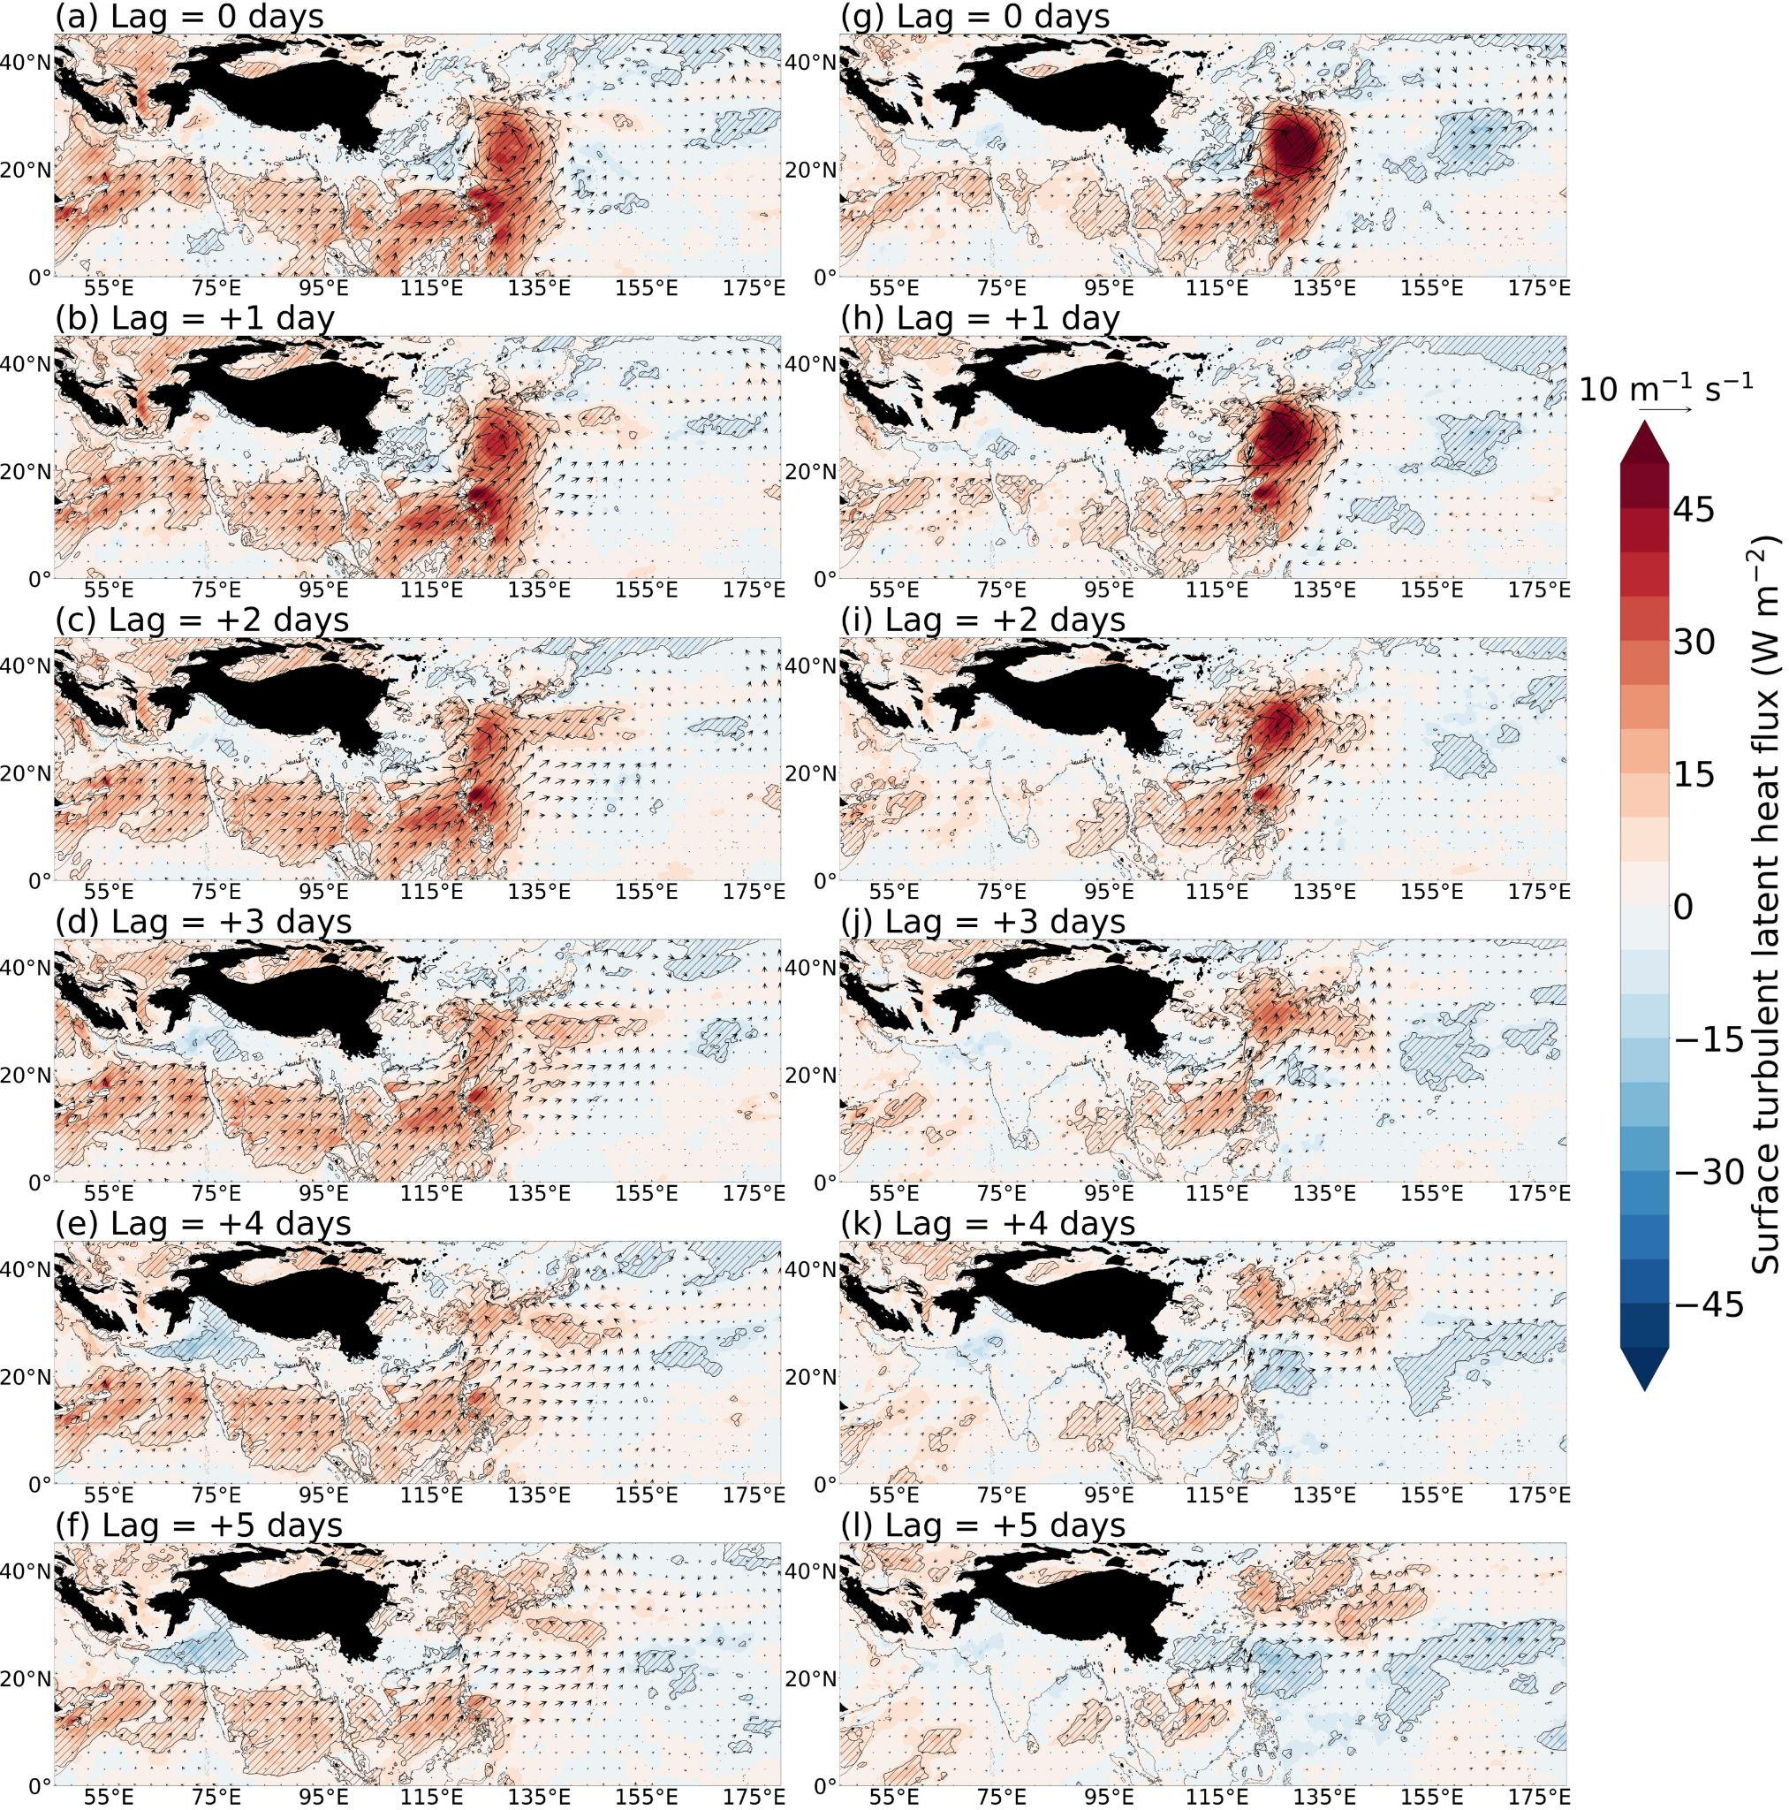
Figure S6. Surface latent heat flux anomalies (W m⁻²; shaded), and 10 meter horizontal wind anomalies (10 m s⁻¹; vectors) anomalies for the days succeeding the first day of the HPE during indirect TC HPEs (a-f) and indirect TC non-HPEs (g-l). The hatched regions are anomalies that are statistically significant at the 95 % confidence level.

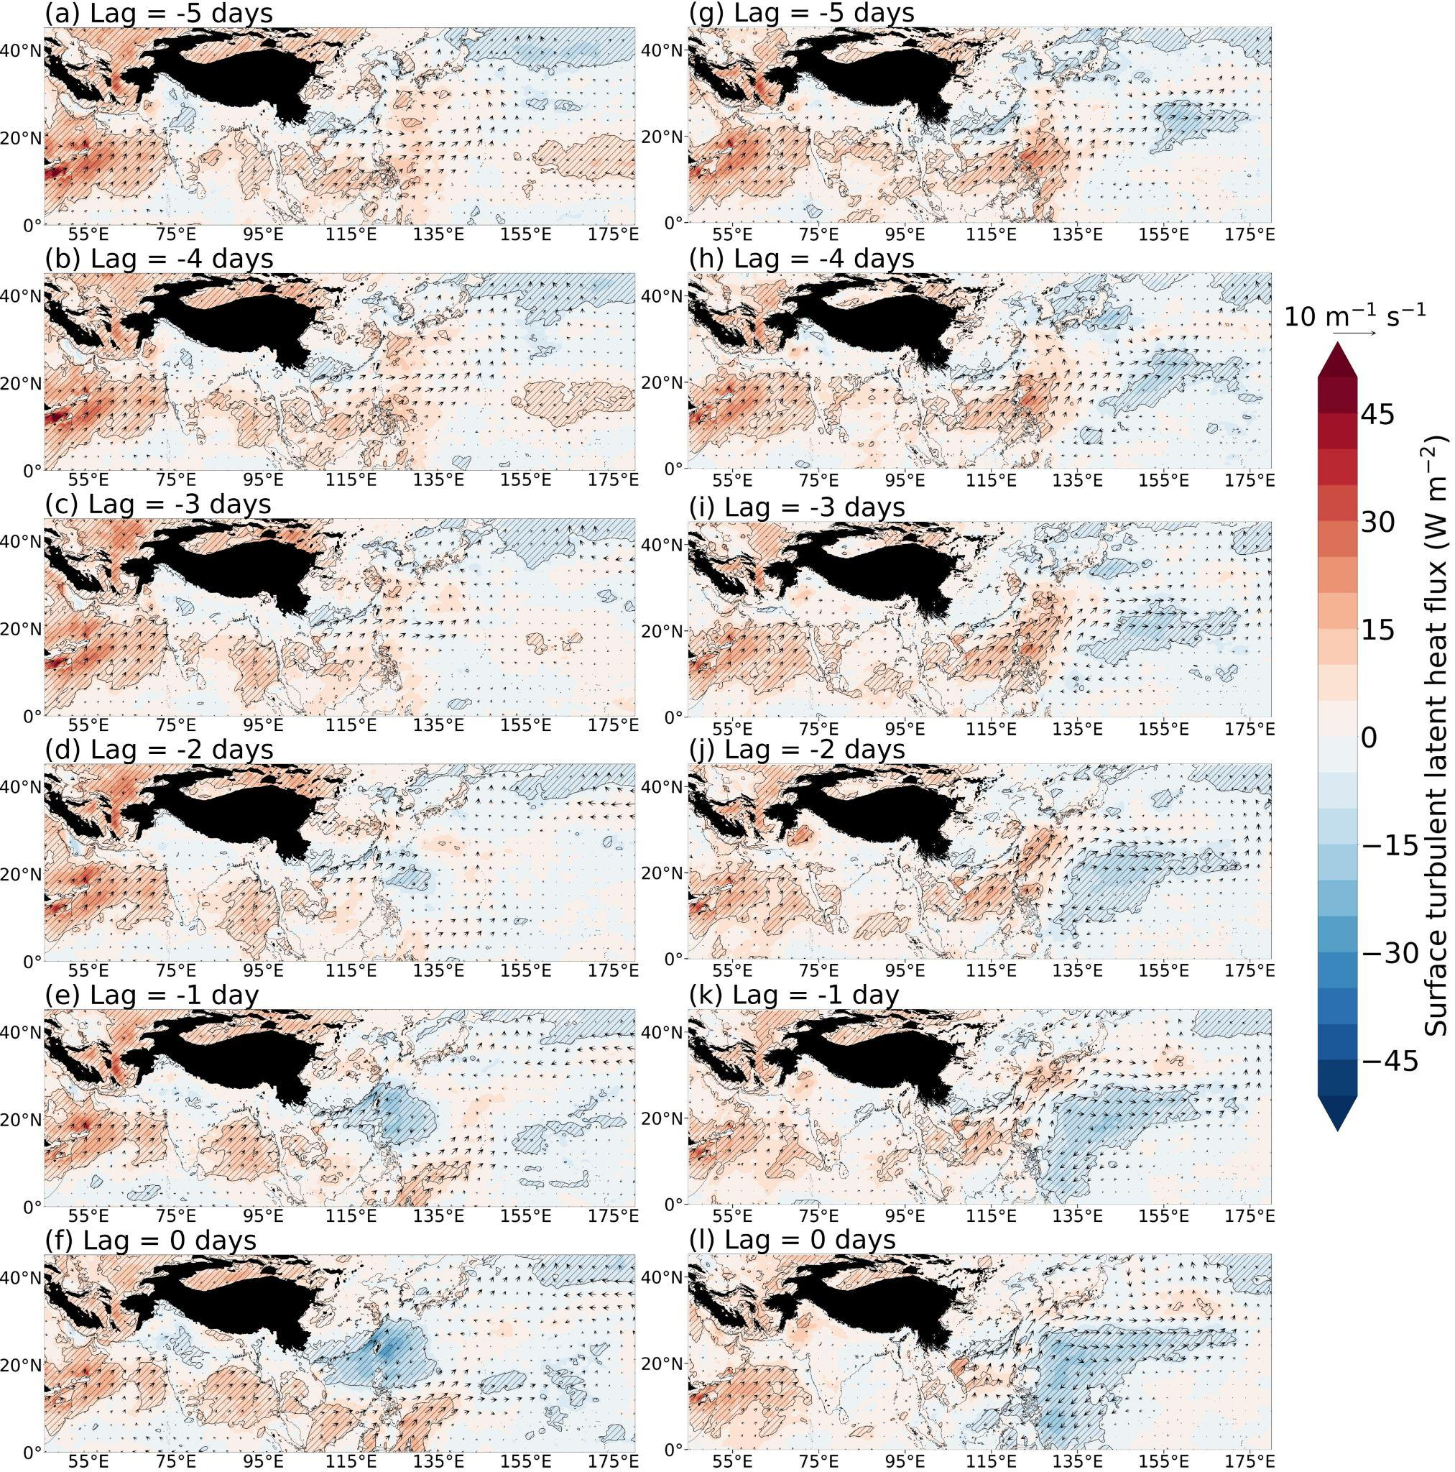
Figure S7. Surface latent heat flux anomalies (W m⁻²; shaded), and 10 meter horizontal wind anomalies (10 m s⁻¹; vectors) anomalies for the day preceding the first day of the HPE during SWM HPEs (a-f) and SWM non-HPEs (g-l). The hatched regions are anomalies that are statistically significant at the 95 % confidence level.

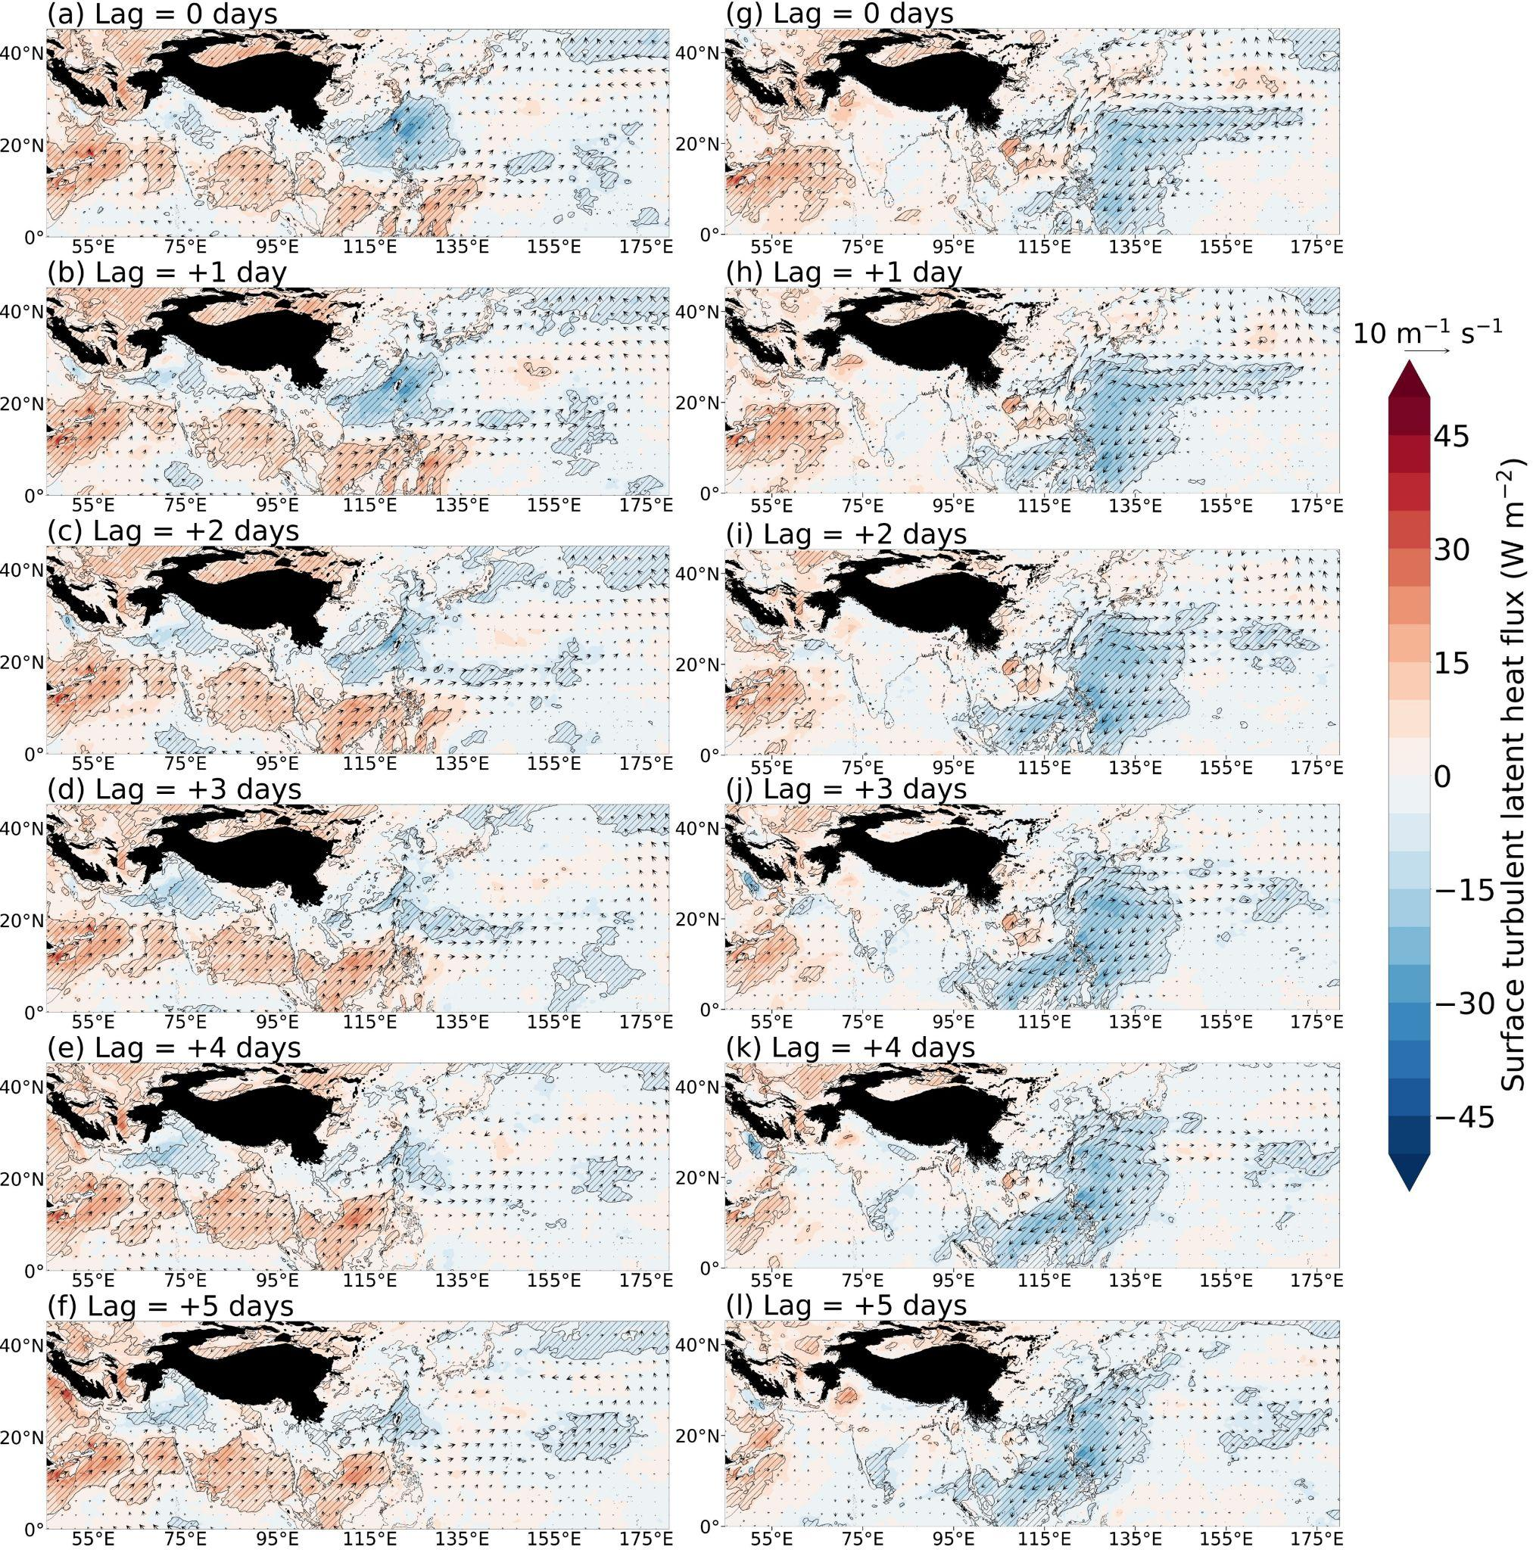
Figure S8. Surface latent heat flux anomalies (W m⁻²; shaded), and 10 meter horizontal wind anomalies (10 m s⁻¹; vectors) anomalies for the day succeeding the first day of the HPE during SWM HPEs (a-f) and SWM non-HPEs (g-l). The hatched regions are anomalies that are statistically significant at the 95 % confidence level.

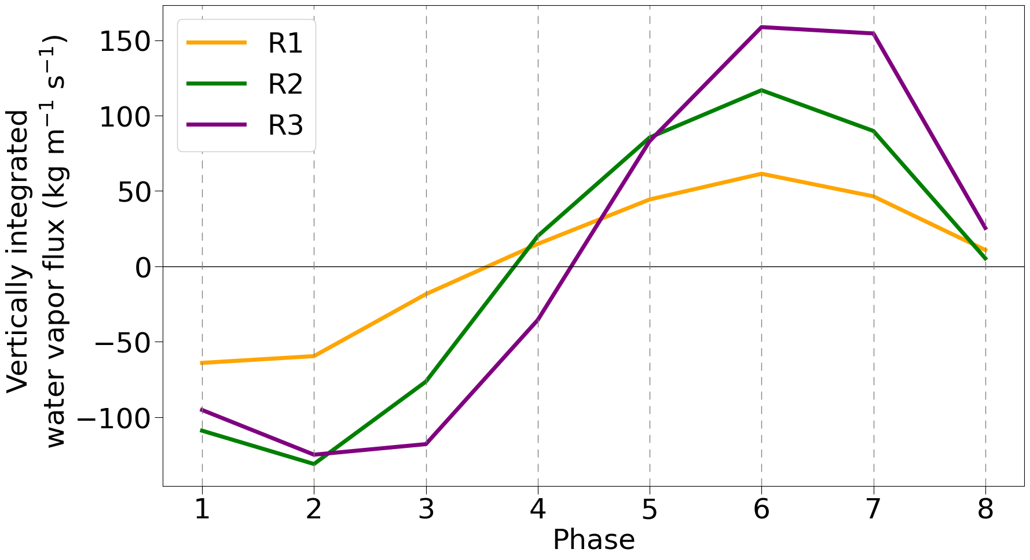
Figure S9. Moisture flux anomalies averaged over R1, R2, and R3 for each BSISO phase from 1981 to 2022.

