Supporting Information for:

Phase Transition Induced Ligand-to-Metal Charge Transfer in Li_{x}CoO₂
Abiram Krishnan¹, Sang-Jun Lee², Hirohito Ogasawara², and Faisal M Alamgir¹*
¹School of Materials Science and Engineering, Georgia Institute of Technology, Atlanta, Georgia 30332, United States
²Stanford Synchrotron Radiation Lightsource, SLAC National Accelerator Laboratory, Menlo Park, California 94025, United States

Corresponding Author
*faisal.alamgir@mse.gatech.edu

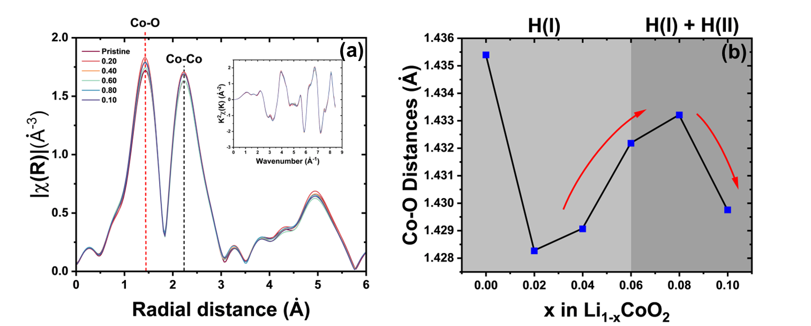
Figure S1: (a) : EXAFS R-space for ex-situ LCO samples (K-space included in the inset) used to determine (b) Co-O interatomic distances. The Co-O distances are found to increase during the formation of H(II) phase, indicating reduction of cobalt ions in LCO. The range of the Hanning window used for R-space calculation is between 2 to 8.5 Å⁻¹.
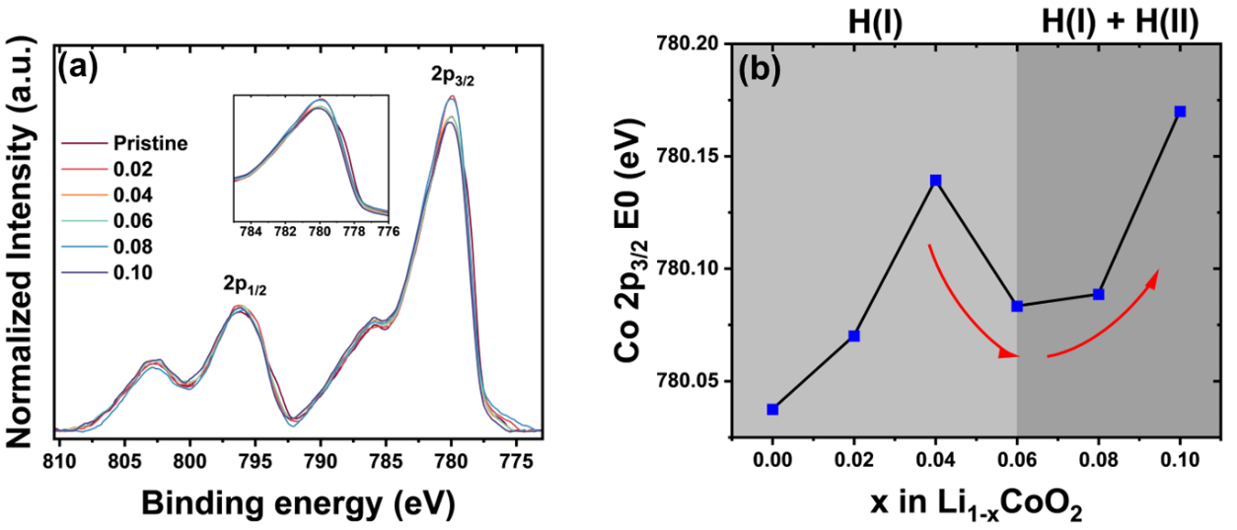
Figure S2: (a) Normalized Co 2p x-ray photoelectron spectra for LCO samples. The binding energy of Co 2p_{3/2} orbitals is found to decrease during the formation of H(II) phase, marking reduction of cobalt ions in LCO.
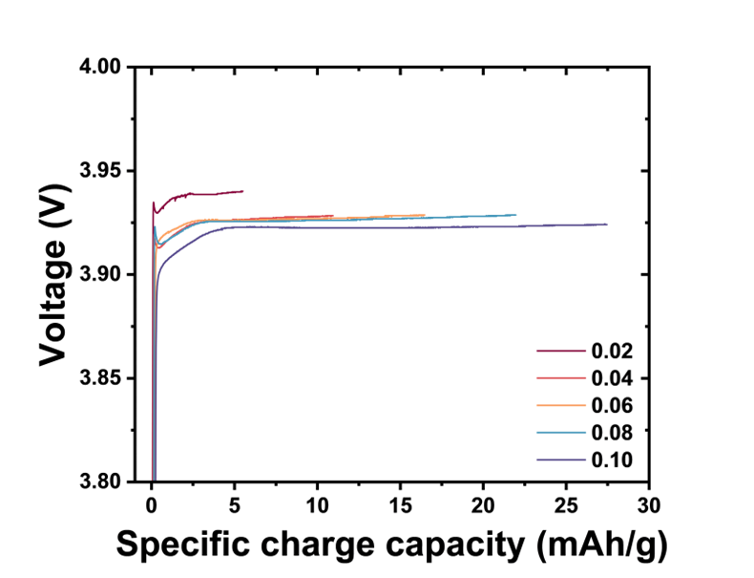
Figure S3: Voltage profiles for ex-situ samples of Li_{1-x}CoO₂ prepared using a constant current corresponding to a slow C-rate of C/50.
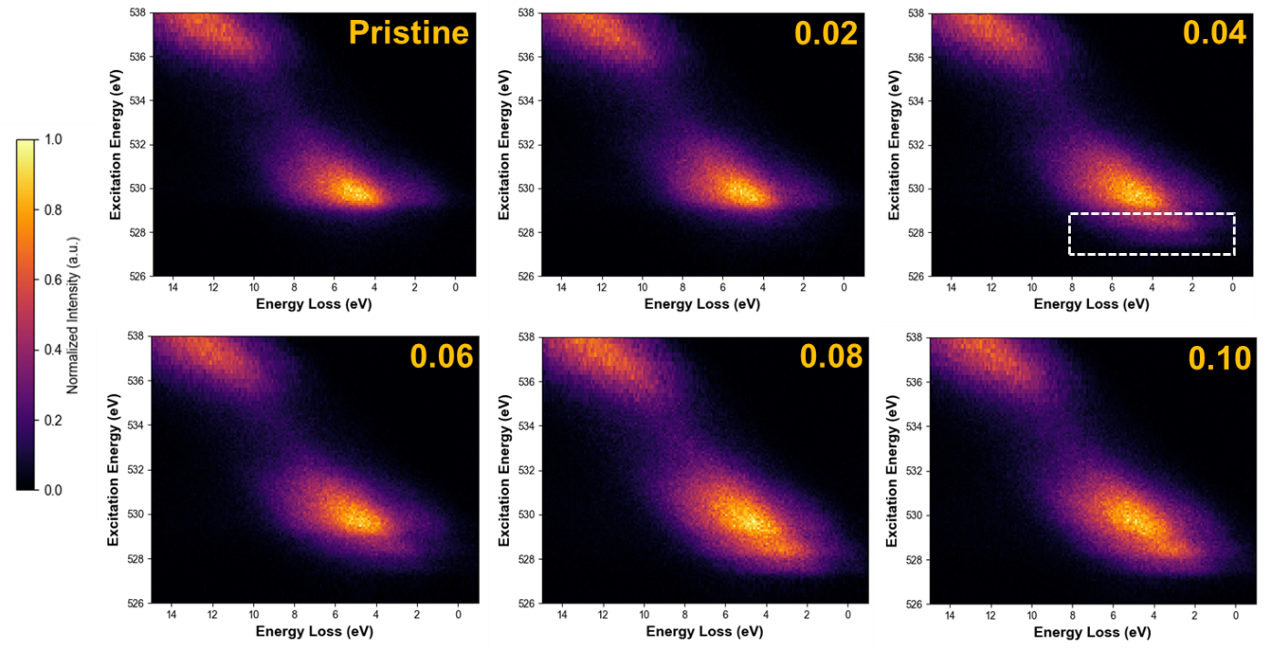
Figure S4: O K-edge RIXS maps of Li_{1-x}CoO₂ during the initial growth of H(II) phase. The shoulder marked at lower excitation energies indicates the formation of delocalize O 2p electron during phase change.
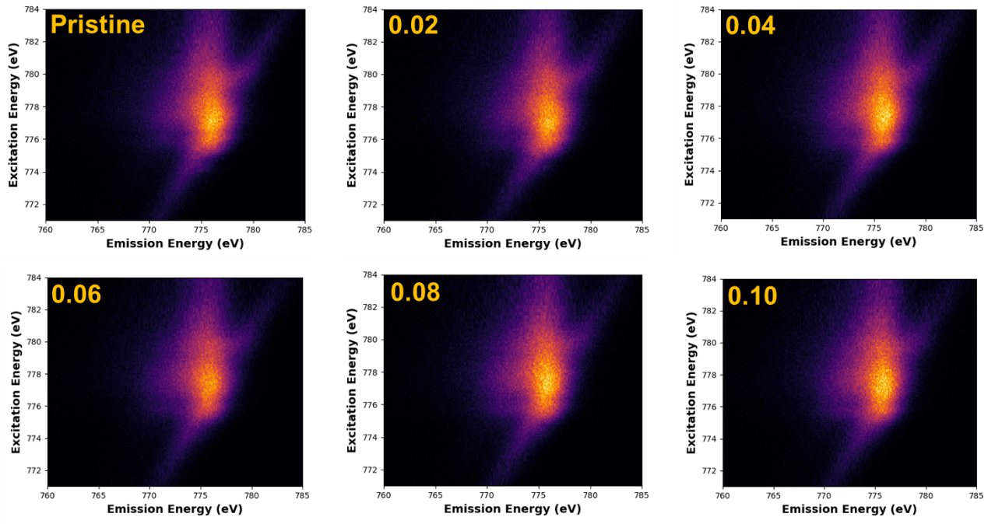
Figure S5: Co L₃ RIXS maps of Li_{1-x}CoO₂ during the start of the two-phase region. These maps are used to obtain the difference plots for further analysis.

