SUPPORTING INFORMATION

Intriguing the significance of hydrophobic groove by the inhibitory mechanism of mineralocorticoid receptor bound with spironolactone through mutations using long-range molecular dynamics simulations in conjunction with statistical analysis.

Seshan Gunalan¹, Kanagasabai Somarathinam¹, Ananthasri Sailapathi¹, Dharani Amirtha Metilda A¹, Sam Paul D.¹, Vijayakumar Rajendran², Anand Gowri Shankar³, Senthilkumar G P⁴, Jaimohan S.M.⁵, Gugan Kothandan¹*

¹ Biopolymer Modelling Laboratory, Centre of Advanced Study in Crystallography and Biophysics, Guindy Campus, University of Madras, Chennai 600025, India
² Molecular Biophysics Unit, Indian Institute of Science, Bangalore 560012, India
³ Learners Cortex, Kasturba Nagar, Adyar, Chennai, Tamil Nadu - 600 020, India
⁴ Department of Pharmaceutical Chemistry, Faculty of Pharmacy, Sree Balaji Medical College and Hospital Campus, Bharath Institute of Higher Education and Research (BIHER), Chromepet, Chennai -44, India
⁵ Advanced Materials Laboratory, CSIR-Central Leather Research Institute, Adyar, Chennai 600020, India

Author for correspondence
E-mail: drgugank@gmail.com

COMPLEX 1 | 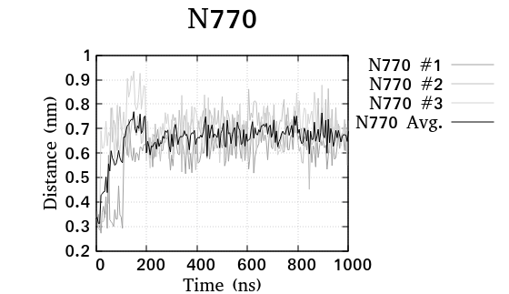 | 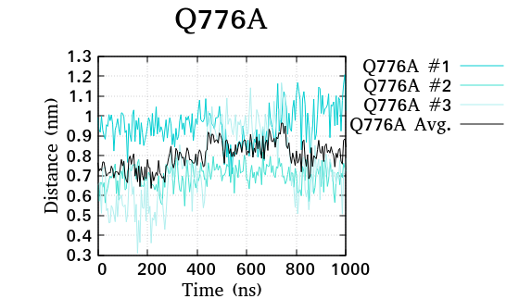
COMPLEX 1 | 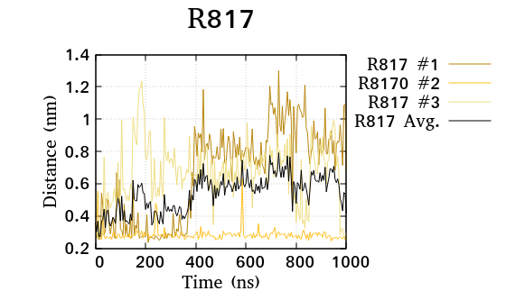 | 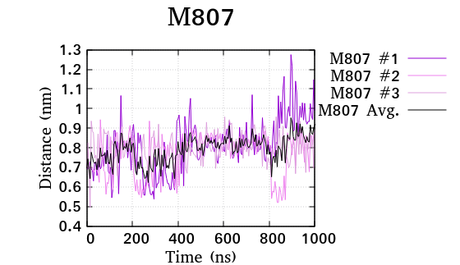
COMPLEX 1 | 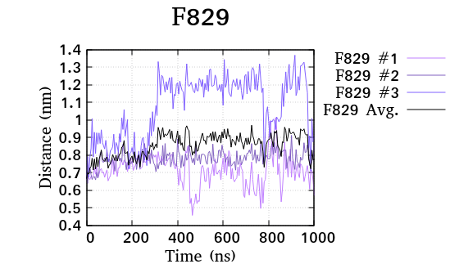 | 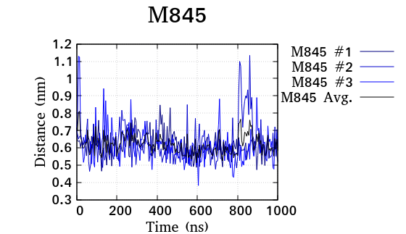
COMPLEX 1 | 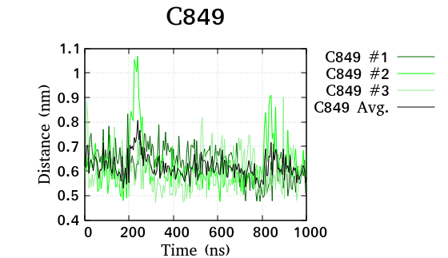 | 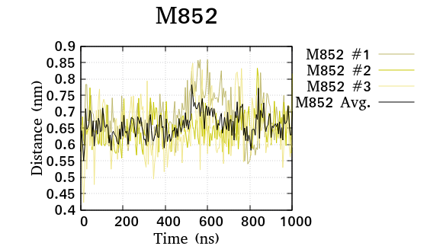
COMPLEX 1 | 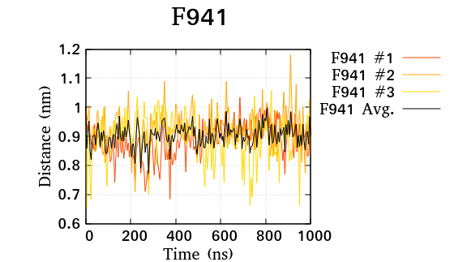 | 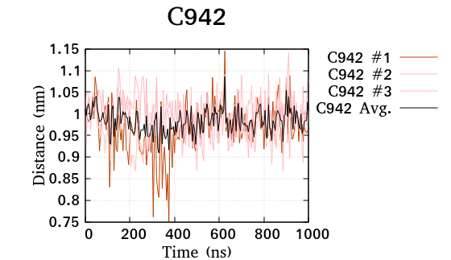

Figure S1. Inferring the interaction of the average distance plot of the triplicate between the key residues of MR-spironolactone complex-1 over the simulation of 1μs.
COMPLEX 2 | 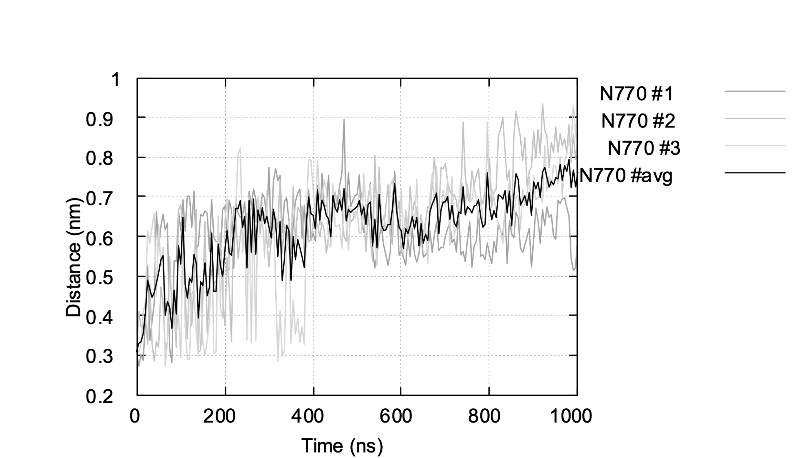 | 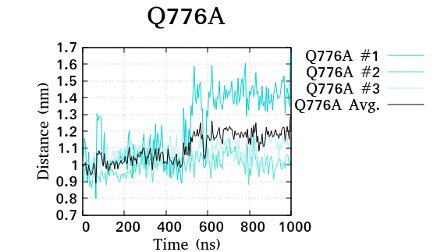
COMPLEX 2 | 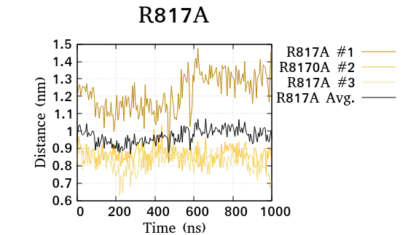 | 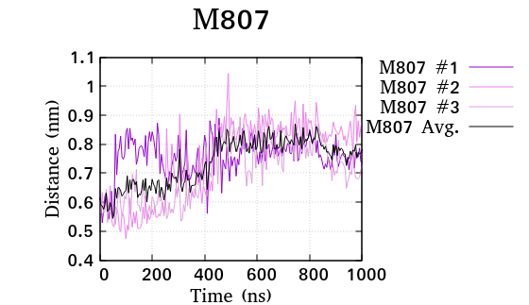
COMPLEX 2 | 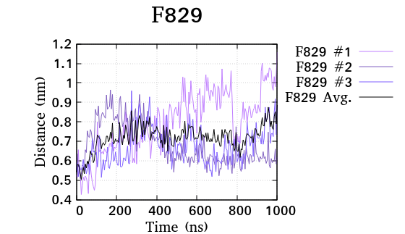 | 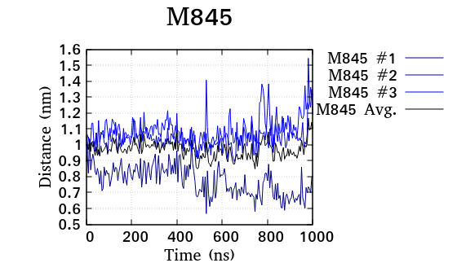
COMPLEX 2 | 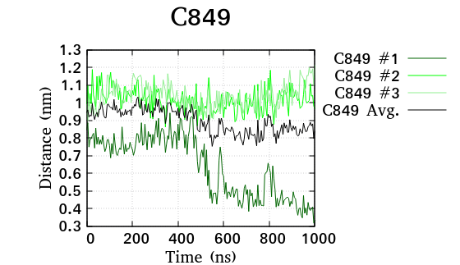
COMPLEX 2 |  | 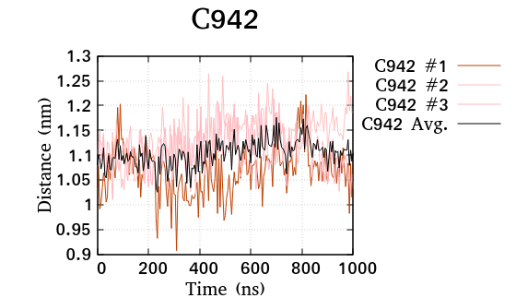

Figure S2. Inferring the interaction of the average distance plot of the triplicate between the key residues of MR-spironolactone complex-2 over the simulation of 1μs.
COMPLEX 3 | 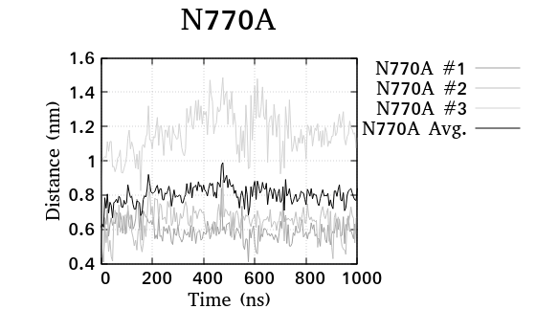 | 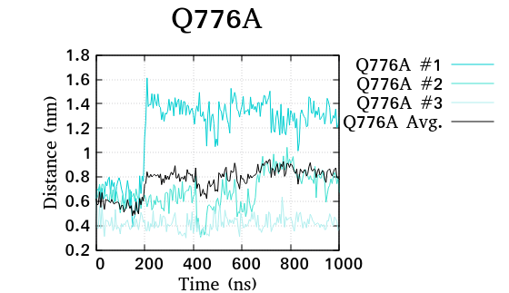
COMPLEX 3 | 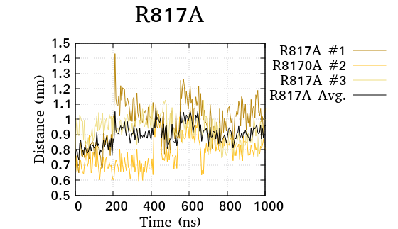 | 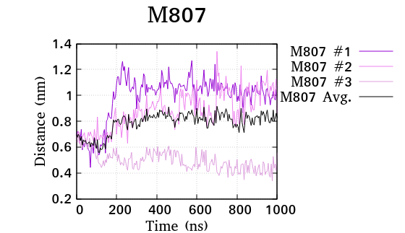
COMPLEX 3 | 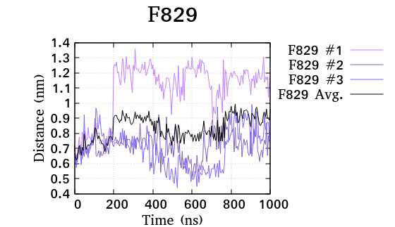 | 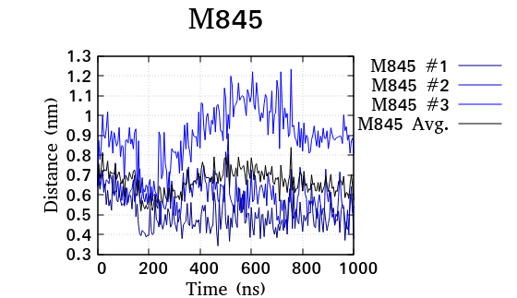
COMPLEX 3 | 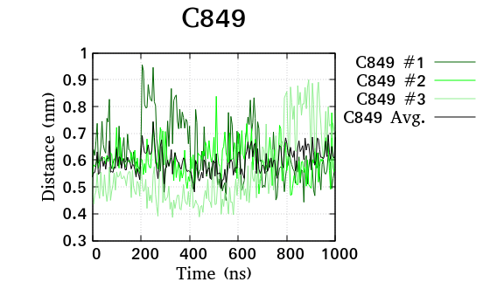 | 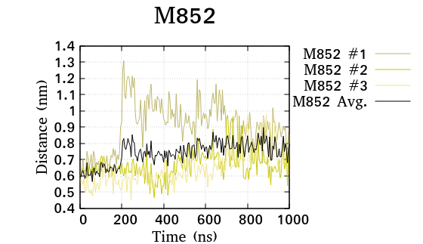
COMPLEX 3 | 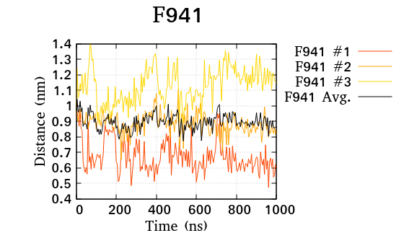 | 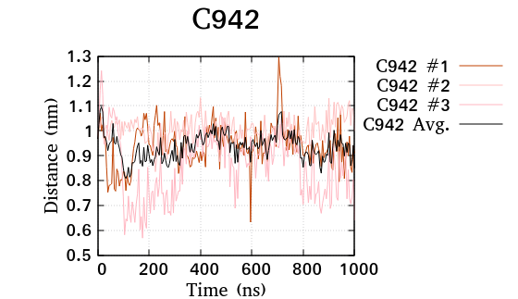

Figure S3. Inferring the interaction of the average distance plot of the triplicate between the key residues of MR-spironolactone complex-3 over the simulation of 1μs.
COMPLEX 4 | 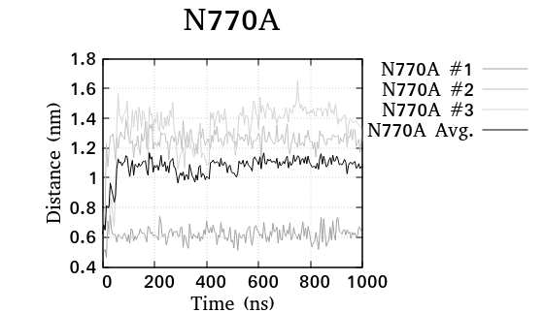 | 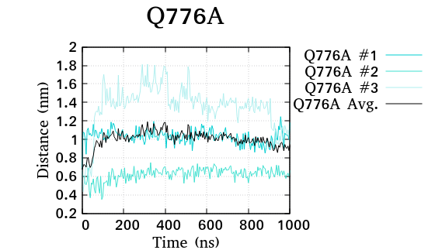
COMPLEX 4 | 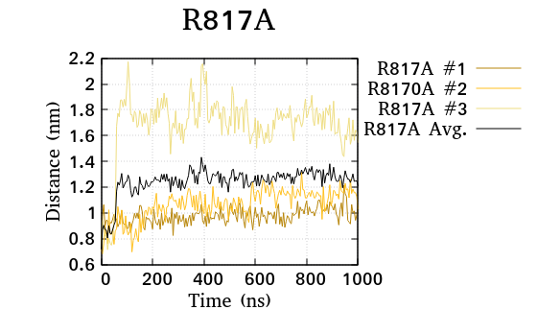 | 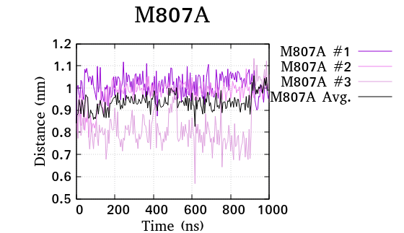
COMPLEX 4 | 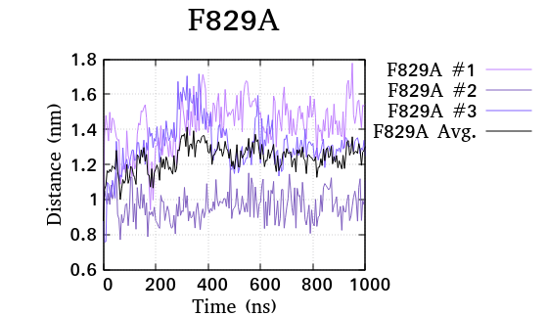 | 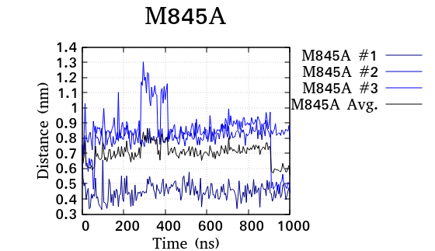
COMPLEX 4 | 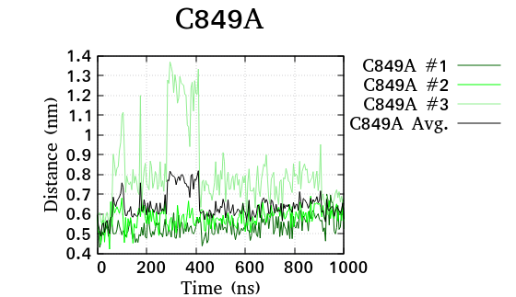 | 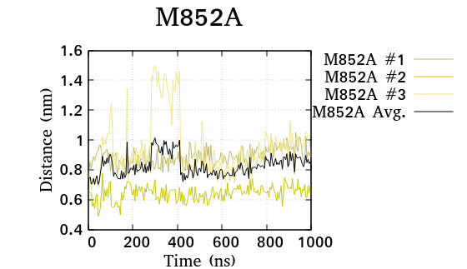
COMPLEX 4 | 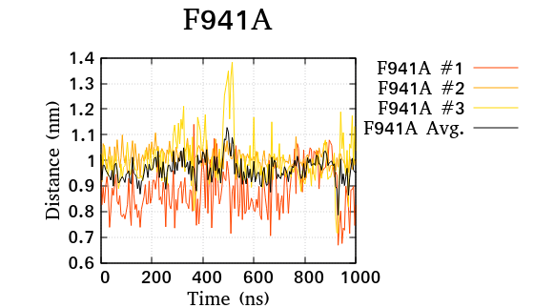 | 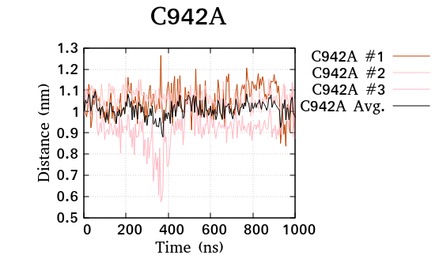

Figure S4. Inferring the interaction of the average distance plot of the triplicate between the key residues of MR-spironolactone complex-4 over the simulation of 1μs.
COMPLEX 5 | 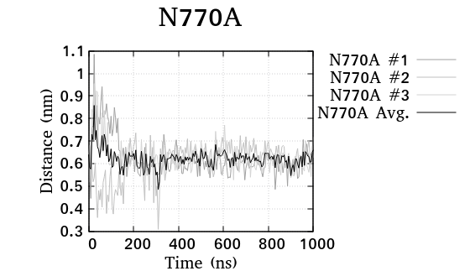 | 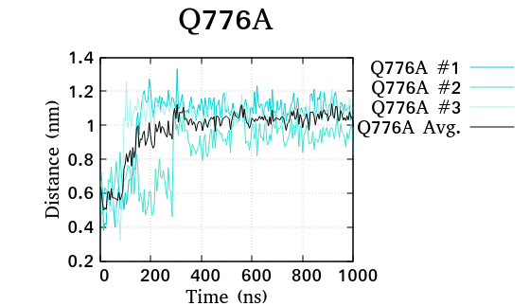
COMPLEX 5 | 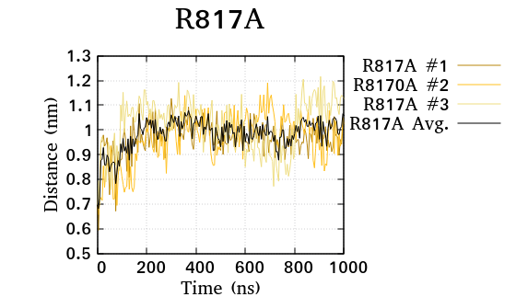 | 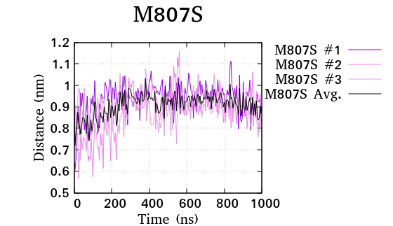
COMPLEX 5 | 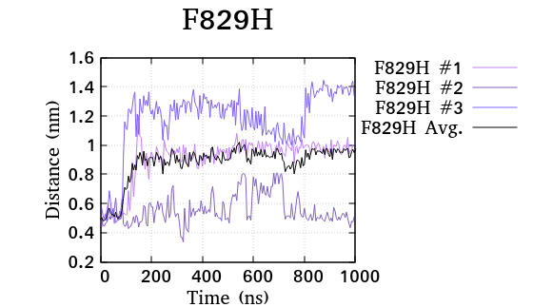 | 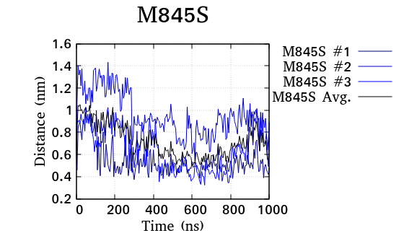
COMPLEX 5 | 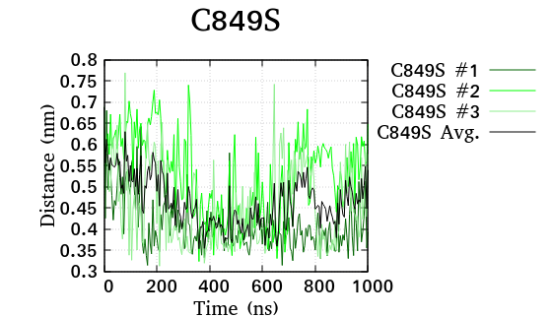 | 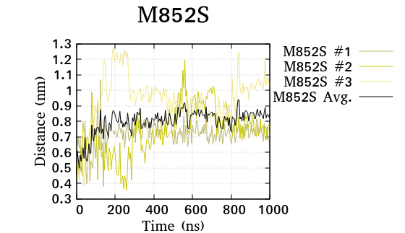
COMPLEX 5 | 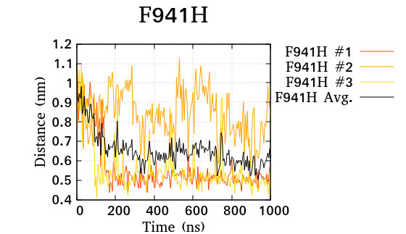 | 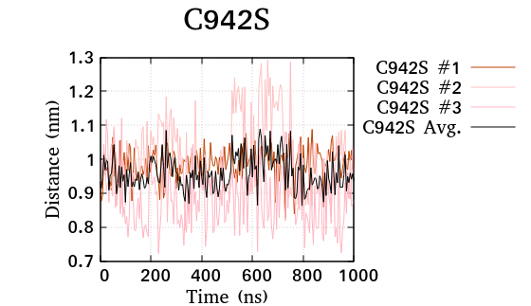

Figure S5. Inferring the interaction of the average distance plot of the triplicate between the key residues of MR-spironolactone complex-5 over the simulation of 1μs.
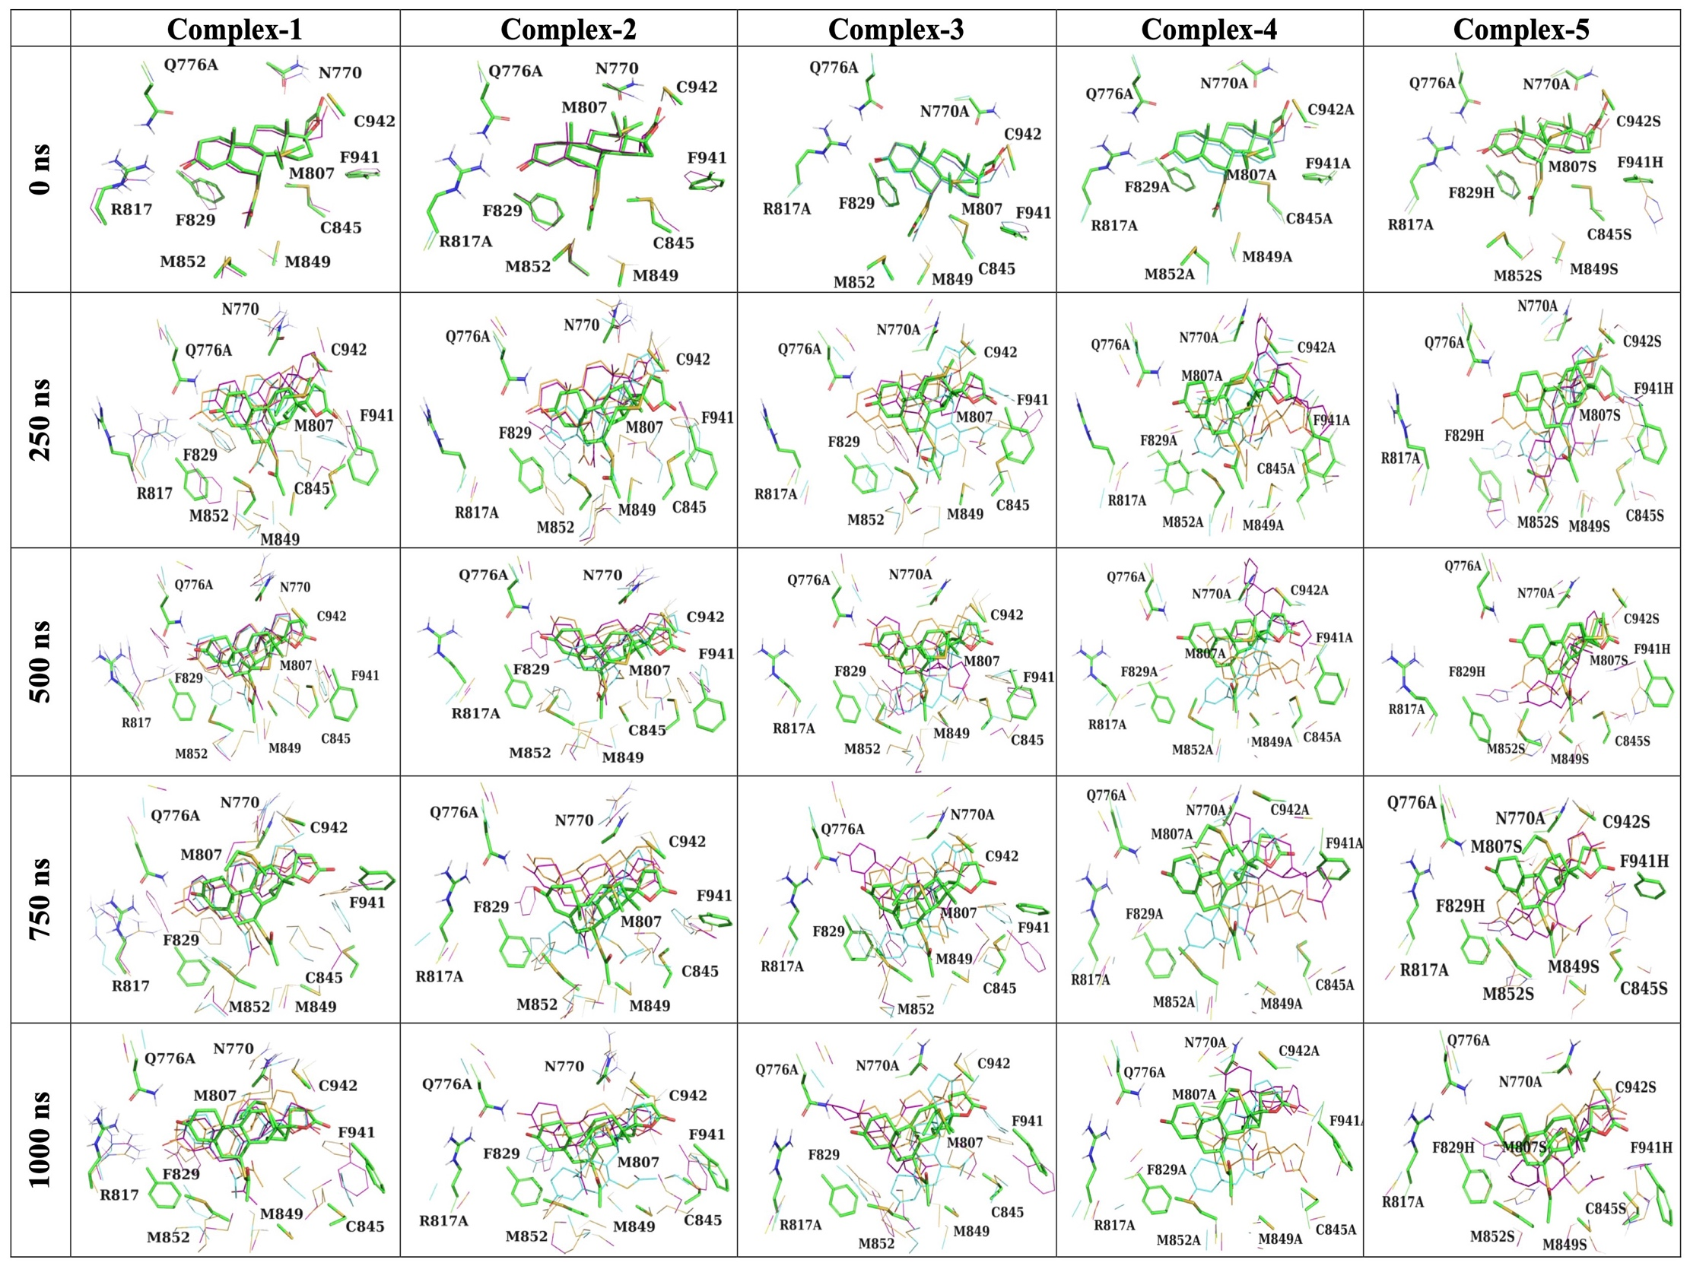
Figure S6. Binding interaction pattern of spironolactone (replicate #1, #2 and #3 in cyan, gold and magenta, respectively) superposed over the crystal structure of MR-spironolactone (in green) complex (PDBID: 3VHU as control) at the binding cavity of mutated Complex 1-5 highlighting the key binding residues at an interval of 250ns of simulation time.
Complex 5 (kcal/mol) | Avg. | -274.275 | -53.104 | 117.37 | -19.2787 | 0 | 0 | -229.282
Complex 5 (kcal/mol) | #3 | -275.217 | -58.779 | 114.392 | -19.158 | 0 | 0 | -238.762
Complex 5 (kcal/mol) | #2 | -278.589 | -52.741 | 114.915 | -19.26 | 0 | 0 | -235.674
Complex 5 (kcal/mol) | #1 | -269.019 | -47.792 | 122.819 | -19.418 | 0 | 0 | -213.41
Complex 4 (kcal/mol) | Avg. | -237.565 | -19.7827 | 72.2766 | -18.7377 | 0 | 0 | -203.809
Complex 4 (kcal/mol) | #3 | -226.936 | -13.871 | 59.423 | -18.203 | 0 | 0 | -199.588
Complex 4 (kcal/mol) | #2 | -236.213 | -26.467 | 80.086 | -18.339 | 0 | 0 | -200.933
Complex 4 (kcal/mol) | #1 | -249.547 | -19.01 | 77.321 | -19.671 | 0 | 0 | -210.907
Complex 3 (kcal/mol) | Avg. | -262.352 | -25.237 | 80.5563 | -19.6793 | 0 | 0 | -226.713
Complex 3 (kcal/mol) | #3 | -258.014 | -30.943 | 83.738 | -19.24 | 0 | 0 | -224.459
Complex 3 (kcal/mol) | #2 | -271.39 | -26.993 | 80.478 | -19.902 | 0 | 0 | -237.808
Complex 3 (kcal/mol) | #1 | -257.653 | -17.775 | 77.453 | -19.896 | 0 | 0 | -217.871
Complex 2 (kcal/mol) | Avg. | -271.974 | -24.74 | 81.91 | -19.3057 | 0 | 0 | -234.11
Complex 2 (kcal/mol) | #3 | -277.444 | -14.659 | 75.904 | -19.805 | 0 | 0 | -236.003
Complex 2 (kcal/mol) | #2 | -267.128 | -21.562 | 80.037 | -19.295 | 0 | 0 | -227.948
Complex 2 (kcal/mol) | #1 | -271.35 | -37.999 | 89.789 | -18.817 | 0 | 0 | -238.378
Complex 1 (kcal/mol) | Avg. | -272.909 | -41.2233 | 99.50267 | -19.5397 | 0 | 0 | -234.169
Complex 1 (kcal/mol) | #3 | -275.276 | -48.912 | 109.174 | -19.162 | 0 | 0 | -234.177
Complex 1 (kcal/mol) | #2 | -280.604 | -52.75 | 112.479 | -19.611 | 0 | 0 | -240.486
Complex 1 (kcal/mol) | #1 | -262.846 | -22.008 | 76.855 | -19.846 | 0 | 0 | -227.845
MR-Spironolactone interaction |  | van der Waal energy | Electrostatic energy | Polar solvation energy | SASA energy | SAV energy | WCA energy | Binding energy
Complex 5 (kcal/mol) | Avg. | -9.97233 | 11.796 | -16.9593 | -6.80833 | 0 | 0 | -21.9433
Complex 5 (kcal/mol) | #3 | -7.024 | 18.876 | -27.064 | -6.153 | 0 | 0 | -21.365
Complex 5 (kcal/mol) | #2 | -7.034 | 20.525 | -18.539 | -5.737 | 0 | 0 | -10.784
Complex 5 (kcal/mol) | #1 | -15.859 | -4.013 | -5.275 | -8.535 | 0 | 0 | -33.681
Complex 4 (kcal/mol) | Avg. | -34.085 | -1.575 | 9.907 | -5.98267 | 0 | 0 | -31.7363
Complex 4 (kcal/mol) | #3 | -18.663 | -0.583 | 3.211 | -3.626 | 0 | 0 | -19.662
Complex 4 (kcal/mol) | #2 | -34.27 | -7.686 | 16.773 | -6.894 | 0 | 0 | -32.077
Complex 4 (kcal/mol) | #1 | -49.322 | 3.544 | 9.737 | -7.428 | 0 | 0 | -43.47
Complex 3 (kcal/mol) | Avg. | -73.3747 | -6.028 | 24.344 | -10.306 | 0 | 0 | -65.365
Complex 3 (kcal/mol) | #3 | -60.76 | -15.414 | 30.776 | -8.699 | 0 | 0 | -54.098
Complex 3 (kcal/mol) | #2 | -77.657 | -0.356 | 18.217 | -10.865 | 0 | 0 | -70.662
Complex 3 (kcal/mol) | #1 | -81.707 | -2.314 | 24.039 | -11.354 | 0 | 0 | -71.335
Complex 2 (kcal/mol) | Avg. | -63.891 | 0.784 | 14.122 | -8.778 | 0 | 0 | -57.7627
Complex 2 (kcal/mol) | #3 | -51.41 | -0.251 | 8.951 | -7.233 | 0 | 0 | -49.943
Complex 2 (kcal/mol) | #2 | -53.268 | 2.207 | 11.661 | -7.767 | 0 | 0 | -47.167
Complex 2 (kcal/mol) | #1 | -86.995 | 0.396 | 21.754 | -11.334 | 0 | 0 | -76.178
Complex 1 (kcal/mol) | Avg. | -74.9317 | 1.838667 | 16.83467 | -10.535 | 0 | 0 | -66.7937
Complex 1 (kcal/mol) | #3 | -74.335 | 2.073 | 18.141 | -11.157 | 0 | 0 | -65.279
Complex 1 (kcal/mol) | #2 | -78.73 | 2.729 | 16.373 | -11.364 | 0 | 0 | -70.992
Complex 1 (kcal/mol) | #1 | -71.73 | 0.714 | 15.99 | -9.084 | 0 | 0 | -64.11
Hydrophobic grove of MR-Spironolactone interaction |  | van der Waal energy | Electrostatic energy | Polar solvation energy | SASA energy | SAV energy | WCA energy | Binding energy
Table S1. The various MM/PBSA terms calculated (averaging the triplicate) for the binding of mutated MR complexed 1-5 with Spironolactone using g_mmpbsa modules (Kumari R, et.al.).

Table S2. The evaluation of various MM/PBSA terms calculated (averaging the triplicate) for the hydrophobic grove of mutated MR complexed 1-5 with Spironolactone using g_mmpbsa modules (Kumari R, et.al.)

Table S3. One-Way Analysis of Variance of the key binding residues of the mutated complex 1-5 compared with control (compound 6: Crystal structure PDB ID-VHU) using using IBM SPSS Statistics (Version 25).

Dependent  Variable | (I)  Complex No. (control) | (J)  Complex No. | Shapiro-  Wilk Test for Normality | Multiple Comparisons  (ANOVA) - LSD | ANOVA | Sum of  Squares | df | Mean  Square | F | Sig.
Dependent  Variable | (I)  Complex No. (control) | (J)  Complex No. | Sig. | P Value
N770 | 6 | 1 | 0.693 | P>0.0001 | Between | 24.973 | 5 | 4.995 | 1752.86 | 0
N770 | 6 | 2 | 0.002 | P>0.0001 | Groups
N770 | 6 | 3 | 0.032 | P>0.0001 | Within | 2.889 | 1014 | 0.003
N770 | 6 | 4 | 0 | P>0.0001 | Groups | 2.889 | 1014 | 0.003
N770 | 6 | 5 | 0 | P>0.0001 | Total | 27.862 | 1019
N770 | 6 | 6 | 0.837 |  | Total | 27.862 | 1019
Q776 | 6 | 1 | 0.252 | P>0.0001 | Between | 22.349 | 5 | 4.47 | 952.47 | 0
Q776 | 6 | 2 | 0 | P>0.0001 | Groups
Q776 | 6 | 3 | 0 | P>0.0001 | Within | 4.759 | 1014 | 0.005
Q776 | 6 | 4 | 0.218 | P>0.0001 | Groups | 4.759 | 1014 | 0.005
Q776 | 6 | 5 | 0 | P>0.0001 | Total | 27.108 | 1019
Q776 | 6 | 6 | 0.197 |  | Total | 27.108 | 1019
R817 | 6 | 1 | 0.007 | P>0.0001 | Between | 43.466 | 5 | 8.693 | 2025.681 | 0
R817 | 6 | 2 | 0.406 | P>0.0001 | Groups
R817 | 6 | 3 | 0.041 | P=0.769 | Within | 4.352 | 1014 | 0.004
R817 | 6 | 4 | 0.592 | P>0.0001 | Groups | 4.352 | 1014 | 0.004
R817 | 6 | 5 | 0.009 | P>0.0001 | Total | 47.817 | 1019
R817 | 6 | 6 | 0.005 |  | Total | 47.817 | 1019
M807 | 6 | 1 | 0.001 | P>0.0001 | Between | 6.496 | 5 | 1.299 | 319.877 | 0
M807 | 6 | 2 | 0 | P>0.0001 | Groups
M807 | 6 | 3 | 0.003 | P>0.0001 | Within | 4.119 | 1014 | 0.004
M807 | 6 | 4 | 0.023 | P>0.0001 | Groups | 4.119 | 1014 | 0.004
M807 | 6 | 5 | 0.324 | P>0.0001 | Total | 10.615 | 1019
M807 | 6 | 6 | 0 |  | Total | 10.615 | 1019
F829 | 6 | 1 | 0 | P>0.0001 | Between | 42.116 | 5 | 8.423 | 2072.117 | 0
F829 | 6 | 2 | 0.018 | P>0.0001 | Groups
F829 | 6 | 3 | 0 | P>0.0001 | Within | 4.122 | 1014 | 0.004
F829 | 6 | 4 | 0.618 | P>0.0001 | Groups | 4.122 | 1014 | 0.004
F829 | 6 | 5 | 0.355 | P>0.0001 | Total | 46.238 | 1019
F829 | 6 | 6 | 0 |  | Total | 46.238 | 1019
M845 | 6 | 1 | 0.001 | P>0.0001 | Between | 20.012 | 5 | 4.002 | 692.944 | 0
M845 | 6 | 2 | 0.01 | P>0.001 | Groups
M845 | 6 | 3 | 0.584 | P>0.0001 | Within | 5.857 | 1014 | 0.006
M845 | 6 | 4 | 0 | P>0.0001 | Groups | 5.857 | 1014 | 0.006
M845 | 6 | 5 | 0 | P>0.0001 | Total | 25.868 | 1019
M845 | 6 | 6 | 0 |  | Total | 25.868 | 1019

…contd.

C849 | 6 | 1 | 0 | P>0.0001 | Between | 17.032 | 5 | 3.406 | 984.201 | 0
C849 | 6 | 2 | 0 | P>0.0001 | Groups
C849 | 6 | 3 | 0.298 | P>0.0001 | Within | 3.51 | 1014 | 0.003
C849 | 6 | 4 | 0 | P>0.0001 | Groups | 3.51 | 1014 | 0.003
C849 | 6 | 5 | 0.016 | P>0.0001 | Total | 20.542 | 1019
C849 | 6 | 6 | 0.001 |  | Total | 20.542 | 1019
M852 | 6 | 1 | 0.039 | P>0.0001 | Between | 16.858 | 5 | 3.372 | 1362.157 | 0
M852 | 6 | 2 | 0.566 | P>0.0001 | Groups
M852 | 6 | 3 | 0.511 | P>0.0001 | Within | 2.51 | 1014 | 0.002
M852 | 6 | 4 | 0 | P>0.0001 | Groups | 2.51 | 1014 | 0.002
M852 | 6 | 5 | 0.471 | P>0.0001 | Total | 19.368 | 1019
M852 | 6 | 6 | 0 |  | Total | 19.368 | 1019
F941 | 6 | 1 | 0.075 | P>0.0001 | Between | 28.012 | 5 | 5.602 | 2551.504 | 0
F941 | 6 | 2 | 0.597 | P>0.0001 | Groups
F941 | 6 | 3 | 0.266 | P>0.0001 | Within | 2.226 | 1014 | 0.002
F941 | 6 | 4 | 0.029 | P>0.0001 | Groups | 2.226 | 1014 | 0.002
F941 | 6 | 5 | 0.355 | P>0.0001 | Total | 30.239 | 1019
F941 | 6 | 6 | 0.382 |  | Total | 30.239 | 1019
C942 | 6 | 1 | 0.236 | P>0.0001 | Between | 17.748 | 5 | 3.55 | 1627.018 | 0
C942 | 6 | 2 | 0.023 | P>0.0001 | Groups
C942 | 6 | 3 | 0.025 | P>0.0001 | Within | 2.212 | 1014 | 0.002
C942 | 6 | 4 | 0.055 | P>0.0001 | Groups | 2.212 | 1014 | 0.002
C942 | 6 | 5 | 0.003 | P>0.0001 | Total | 19.96 | 1019
C942 | 6 | 6 | 0.001 |  | Total | 19.96 | 1019

****************************

Data Availability: https://doi.org/10.5281/zenodo.10374814

- Supplementary_statistics.xlsx

Sheet 1: Table SA1. Boolean values indicating the presence or lack of interaction between the spironolactone and crucial residues of MR (0:absence and 1:presence)

Sheet 2: Table SA2. The distance between the key residues of MR complex 1-6 with the spironolactone over the simulation time of 5ns interval of 1μs.

Sheet 3: Table SA3. The input data provided for the ANOVA analysis from the trajectories of simulation studies.

