Table 1. Variable description
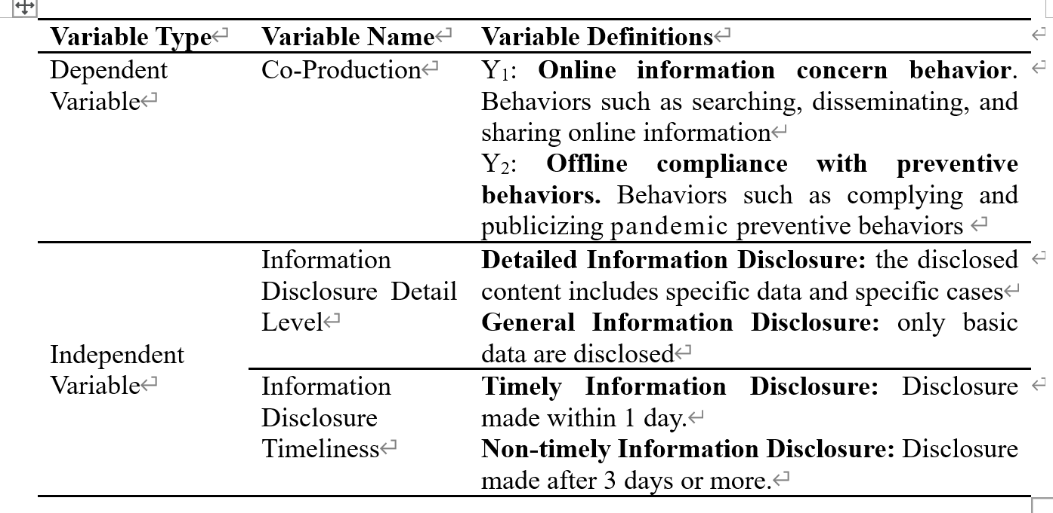

Table2. Descriptive statistics for variables
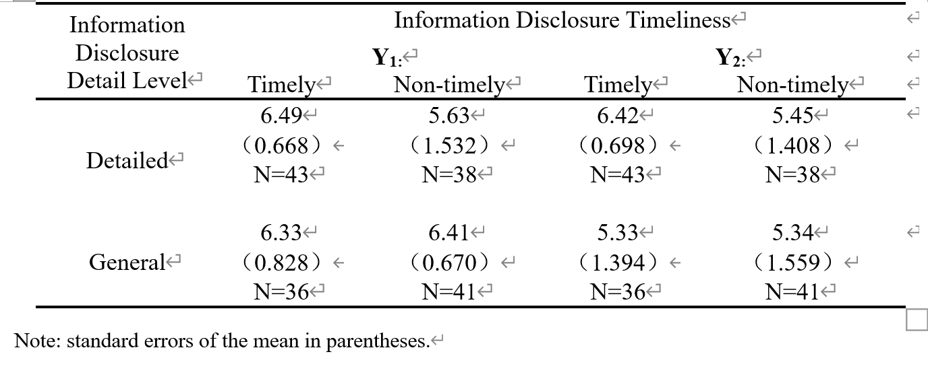

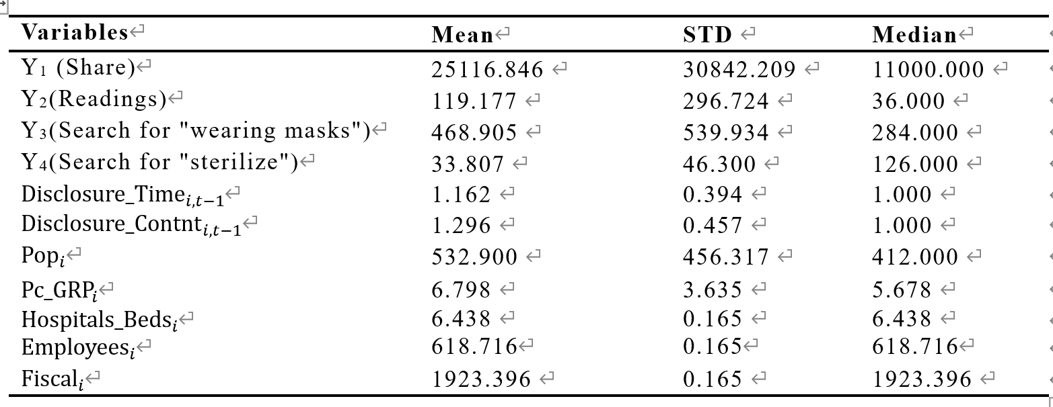
Table 3. Descriptive statistics of main variables

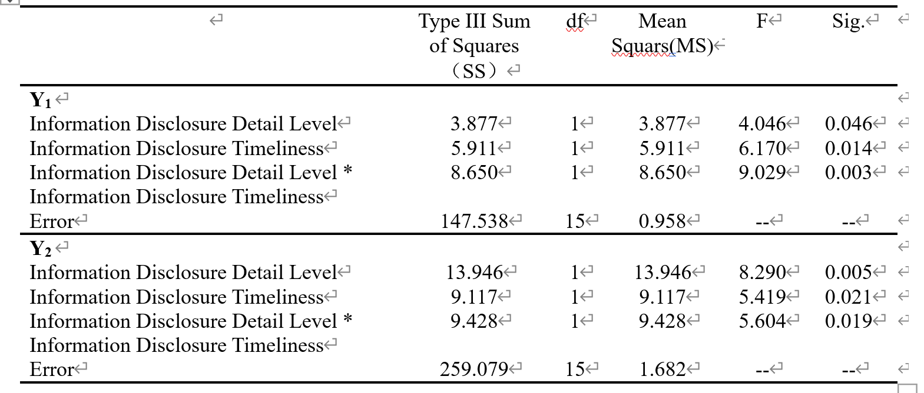
Table 4. Analysis of Variance

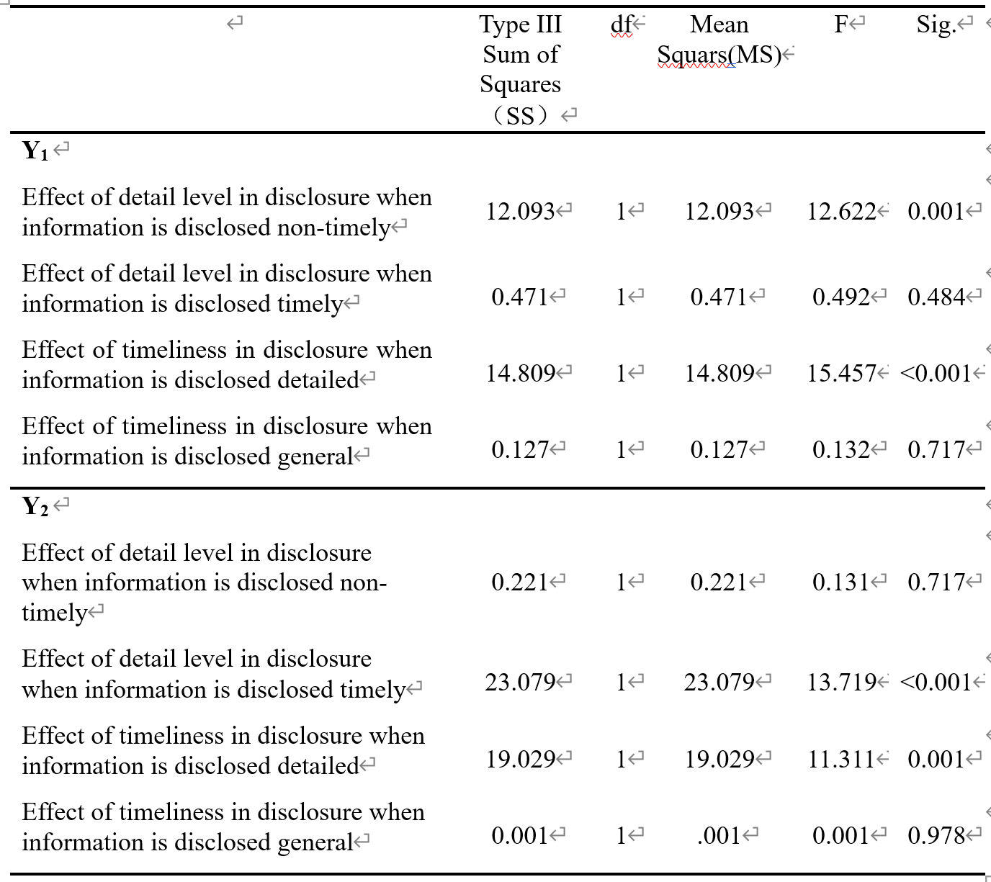
Table 5：Simple Main Effects Analysis

Table 6: Negative binomial regression results (regression coefficients, significance)
