A1. IMAGE modelling framework
We apply the Integrated Model to Assess the Global Environment (IMAGE) framework(Stehfest et al., 2014) to explore the unequal impacts of a global uniform carbon price on residential energy expenditures across income groups. The IMAGE framework is an integrated assessment model (IAM) applied to study the long-term dynamics of global change in the energy and land system. The framework comprises various system dynamic sub-models, including the energy model TIMER and the climate policy cost-benefit model MIMOSA.
The energy model TIMER describes the annual demand and supply of different energy carriers for a set of 26 world regions. Changes in energy demand within the available sectors (industry, transport, residential, services, non-energy and other) are related to structural changes, autonomous and price-induced changes in energy intensity and price-based fuel substitution. Several sub-modules of TIMER simulate the various demand sectors in more detail, such as REMG for household energy use (Daioglou et al., 2012) and NEDE for the non-energy (petrochemical) sector (Daioglou et al., 2013). TIMER projects future energy demand for each end-use sector based on relationships between energy services and activity, the latter related to economic growth (Mulders et al., 2006; Rogner, 1997; van Vuuren et al., 2011).

A1.1 Modelling residential energy demand
The residential energy demand sub-model in TIMER captures the different energy use characteristics of 260 represented households. Energy demand for each household is disaggregated across five end-use functions: cooking, space heating, space cooling, water heating, and appliances. Demand for each end-use is driven by household characteristics such as household size, total household expenditures (proxy for income), floor space, ownership levels and energy efficiencies of end-use equipment or technology (e.g., appliances, stoves, heaters, insulation types).
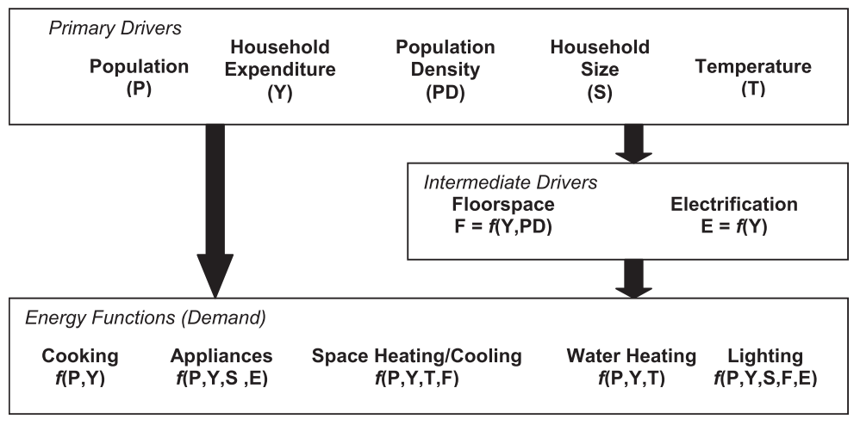
Figure A1: Relationship between key model drivers and household energy demand by end-use in the residential sector sub-model in TIMER. Figure reproduced from (Daioglou et al., 2012)
A multinomial logit function determines the market share of energy carriers or technologies used, accounting for differences in relative costs and preferences per option(van Vuuren et al., 2011). For each end-use function, energy carriers compete based on relative costs with each other to meet the useful energy demand. This assigns market shares to different options fulfilling a service based on their relative costs, where the cheapest option gets the largest market share, the second cheapest the second largest market share, and so on. Energy prices are based on supply curves of energy carriers(Mulders et al., 2006; Rogner, 1997). All households within a region face the same energy prices. To represent climate policy in the model, a ‘carbon price’ is introduced to induce a shift towards low-carbon technologies. In these mitigation scenarios, the household characteristics and activity levels driving total energy demand remain the same, but may be met with different choices of energy carriers through the logit function.
Additionally, households can further adopt energy-efficiency measures such as insulation to reduce demand in mitigation scenarios based on the relative costs of doing so compared to incurring additional heating costs. This dynamic is based on recent model development reported in detail in Daioglou et al., (2022). In short, the model accounts for regional building stocks (construction, lifetimes, decommissioning), calculation of investments in six insulation levels, inclusion of energy-efficient heat pumps as a space heating technology, and possibility for households to invest in rooftop solar PV (described in further detail in Section A1.2 below). Additionally, the model already accounts for endogenous efficiency changes in end-use energy conversion representing the availability of more efficient appliances over time. Thus, although the socioeconomic household characteristics and activity level that drive the demand remain unchanged, they may be met by a slightly smaller (larger) final energy demand as households make choices towards more (less) energy-efficient options available to them (see Fig. A11 below and Fig. 3 in the main article).
Correspondingly, key mitigation options in TIMER on the energy supply side include increasing the share of nuclear power and renewables in electricity generation, equipping fossil fuel technologies with Carbon Capture and Sequestration (CCS), improving energy efficiency, and reducing non-CO₂ greenhouse gas emissions (Edelenbosch et al., 2024; van Vuuren et al., 2017).
Previously, these model dynamics have been used to assess the contribution of the residential sector in meeting climate mitigation targets (Daioglou et al., 2012), the role of strategies such as behaviour change and technology adoption in this sector (Daioglou et al., 2022; van Sluisveld et al., 2016), and the interactions of the residential sector with the rest of the energy system(Dagnachew et al., 2018; Daioglou et al., 2013) in different mitigation scenarios. The model has also been used to explore pathways towards universal electricity access (Dagnachew et al., 2017; Lucas et al., 2017)and universal access to clean cooking(Hof et al., 2018) in Sub-Saharan Africa. The present work analyses the distribution of resulting energy expenditures across the modelled households, specifically the disproportionality of additional energy expenditure burdens across increasing income levels in mitigation scenarios.

A1.2 Implementation of incentivised rooftop PV
The IMAGE model is unique among IAMs in representing decentralised electricity generation through rooftop photovoltaic technology, exploring its role in long-term energy and climate scenarios. A detailed account of the methods, data, and overall energy system implications can be seen in (Gernaat et al., 2020). In this section, we give a brief overview, particularly focusing on the implementation of incentivised rooftop PV scenarios in the present study.
The implementation in IMAGE follows two main steps. First, regional supply cost curves of rooftop PV are derived based on global technical and economic potential. Second, household investment in rooftop PV is determined through a logit choice function based on comparing electricity prices from utility-scale electricity grid (hereforth, grid electricity) and self-generated rooftop electricity. This is similar to modelling the choice between increased heating costs and adopting more energy-efficient insulation. The technical annual potential of electricity generated through rooftop PV is calculated by combining estimates on solar irradiation with available rooftop area and present technical capacity of solar PV in energy conversion as follows:
 | $E_{rt}$ = G. η. PR .SRA | (1)

where G is the solar irradiation based on the NASA SSE6 Global Horizontal Radiation dataset available in 0.5◦ × 0.5◦ (kWh $m^{-2}$) resolution (Zhang et al., 2008), ƞ is the panel efficiency, PR is the performance ratio expressing the difference between performance under standard test conditions and the actual output of the system due to losses from sub-optimal angles and cable or inverter losses, and SRA is the suitable roof area. Due to the lack of global rooftop data, suitable roof area (SRA) is estimated indirectly by modelling residential floorspace based on household expenditure and population data (see Fig. A1). This is calibrated using census data-derived floor-to-roof ratios, and adjusted with a suitability factor accounting for roof types, shading, orientation and architectural obtrusions to approximate realistic rooftop availability for PV deployment.
The levelized cost of electricity (LCOE) for rooftop PV is calculated as the total lifetime cost of installation (including capital, maintenance, and financing) divided by expected lifetime electricity generation capacity. Through the logit choice modelling, households compare the LCOE of rooftop PV with the local grid electricity prices. Rooftop PV is adopted when it becomes the least-cost option for meeting the household electricity demand. This investment decision accounts for consumer discount rates which reflect their investment preference (willingness to pay upfront costs).
Literature on applicable consumer discount rates (CDRs) suggests that income is consistently the primary driver, while their values show highly context-driven variation(Reddy, 1996). Consumer discount rates are accordingly modelled inversely proportional to income with a converging behaviour over time. They are also used elsewhere in the model such as in estimating appliance diffusion or improved insulation adoption (Daioglou et al., 2022). A higher discount rate characteristic of lower income levels leads to a higher annuity factor, increasing the perceived annualised investment costs and thus total lifetime costs. Conversely, lower discount rates reduce these annualised costs, making rooftop PV a more affordable choice. In contrast to household investment decisions, utility-scale electricity producers in IMAGE are modelled with a constant, lower discount rate (assumed 10%), reflecting their better access to financing, lower investment risk preferences, and longer planning horizons. The assumed value is not regionally differentiated, but is consistent with literature as a reasonable mean value for long-term investment costs in LCOE calculations (Hassett & Metcalf, 1993; Howarth & Sanstad, 1995; Kozlovas et al., 2023; Sigrin, 2013).
Scenarios representing incentivised adoption of rooftop PV are implemented by reducing its perceived costs for targeted disadvantaged groups, achieved by reducing the consumer discount rate. We assign the targeted households the lower CDR used for utility-scale electricity producers (10%). This is a conservative choice, as studies on distributed rooftop PV suggest even lower rates (4–8%) may be appropriate (Tarigan, 2023). The reduced discount rate reflects policies aimed at incentivising the uptake of rooftop PV among the disadvantaged income groups by lowering the financial barriers. Additionally, a net-metering policy is simultaneously applied in scenarios incentivising roof PV uptake. Net-metering is a form of energy policy where excess electricity generated by rooftop PV can be sold to the grid at retail prices. This implies that households only pay grid electricity prices for the part of the electricity demand in excess of rooftop PV production. In the model, net-metering is represented in two ways: a) full utilisation of installed generation capacity (i.e., production not regulated by own residential demand, but driven by technical annual capacity), and b) annual electricity demand is first met by rooftop generated electricity priced at calculated operational costs, and only the remained of electricity demand, if any, is priced at incident grid or utility prices.
The results show that residential rooftop PV can supply up to 21% of global electricity demand by 2100 without additional incentives, contingent on scenario assumptions. Adoption is highest in regions with high solar irradiation, such as southern Africa and Asia. Adoption increases over time as income levels rise and technology costs fall. In the PVIncentivise scenario, generated rooftop PV electricity in targeted poor households sees a corresponding increase, helping them bridge the gap to richer households in terms of the shares of total electricity demand generated (Figs. A6-A8, Fig. 2 in main article text).

A1.3 Global regions in IMAGE

Region | Countries
Canada | Canada
USA | St. Pierre and Miquelon, United States
Mexico | Mexico
Central America | Anguilla, Aruba, Bahamas, The, Barbados, Belize, Bermuda, Cayman Islands, Costa Rica, Dominica, Dominican Republic, El Salvador, Grenada, Guadeloupe, Guatemala, Haiti, Honduras, Jamaica, Martinique, Montserrat, Netherlands Antilles, Nicaragua, Panama, Puerto Rico, St. Kitts and Nevis, St. Lucia, St. Vincent and the Grenadines, Trinidad and Tobago, Turks and Caicos Isl., Virgin Isl. (Br.), Virgin Islands (U.S.)
Brazil | Brazil
Rest of South America | Argentina, Bolivia, Chile, Colombia, Ecuador, Falklands Isl., French Guyana, Guyana, Paraguay, Peru, Suriname, Uruguay, Venezuela, RB
Northern Africa | Algeria, Egypt, Arab Rep., Libya, Morocco, Tunisia, Western Sahara
Western Africa | Benin, Burkina Faso, Cameroon, Cape Verde, Central African Republic, Chad, Congo, Dem. Rep., Congo, Rep., Cote d’Ivoire, Equatorial Guinea, Gabon, Gambia, The, Ghana, Guinea, Guinea-Bissau, Liberia, Mali, Mauritania, Niger, Nigeria, Sao Tome and Principe, Senegal, Sierra Leone, St. Helena, Togo
Eastern Africa | Burundi, Comoros, Djibouti, Eritrea, Ethiopia, Kenya, Madagascar, Mauritius, Reunion, Rwanda, Seychelles, Somalia, Sudan, Uganda
South Africa | South Africa
Western Europe | Andorra, Austria, Belgium, Denmark, Faeroe Islands, Finland, France, Germany, Gibraltar, Greece, Iceland, Ireland, Italy, Liechtenstein, Luxembourg, Malta, Monaco, Netherlands, Norway, Portugal, San Marino, Spain, Sweden, Switzerland, United Kingdom, Vatican City State
Central Europe | Albania, Bosnia and Herzegovina, Bulgaria, Croatia, Cyprus, Czech Republic, Estonia, Hungary, Latvia, Lithuania, Macedonia, FYR, Poland, Romania, Serbia and Montenegro, Slovak Republic, Slovenia
Turkey | Turkey
Ukraine region | Belarus, Moldova, Ukraine
Central Asia | Kazakhstan, Kyrgyz Republic, Tajikistan, Turkmenistan, Uzbekistan
Russia region | Armenia, Azerbaijan, Georgia, Russian Federation
Middle East | Bahrain, Iran, Islamic Rep., Iraq, Israel, Jordan, Kuwait, Lebanon, Oman, Qatar, Saudi Arabia, Syrian Arab Republic, United Arab Emirates, Yemen, Rep.
India | India
Korea region | Korea, Dem. Rep., Korea, Rep.
China region | China, Hong Kong, China, Macao, China, Mongolia, Taiwan
Southeastern Asia | Brunei, Cambodia, Lao PDR, Malaysia, Myanmar, Philippines, Singapore, Thailand, Vietnam
Indonesia region | East Timor, Indonesia, Papua New Guinea
Japan | Japan
Oceania | American Samoa, Australia, Cook Isl., Fiji, French Polynesia, Kiribati, Marshall Islands, Micronesia, Fed. Sts., Nauru, New Caledonia, New Zealand, Niue, Northern Mariana Islands, Palau, Pitcairn, Samoa, Solomon Islands, Tokelau, Tonga, Tuvalu, Vanuatu, Wallis ans Futuna Island
Rest of South Asia | Afghanistan, Bangladesh, Bhutan, Maldives, Nepal, Pakistan, Sri Lanka
Rest of Southern Africa | Angola, Botswana, Lesotho, Malawi, Mozambique, Namibia, Swaziland, Tanzania, Zambia, Zimbabwe

A2. Extra Figures

A2.1. Scenario setup

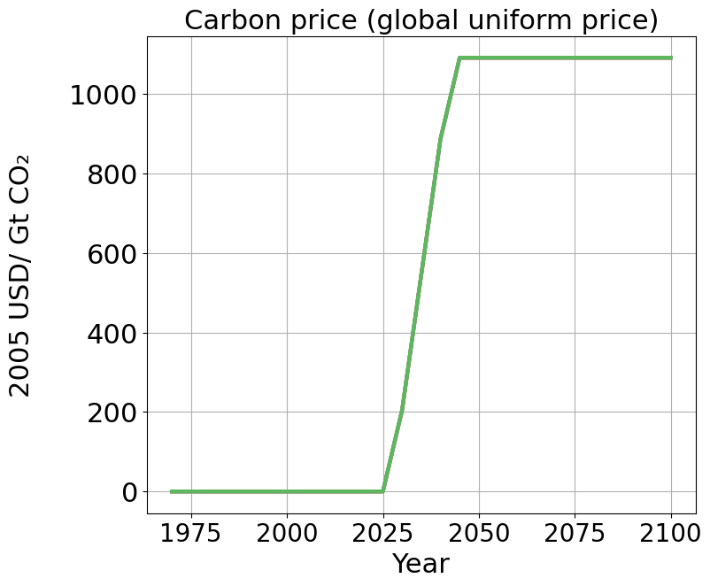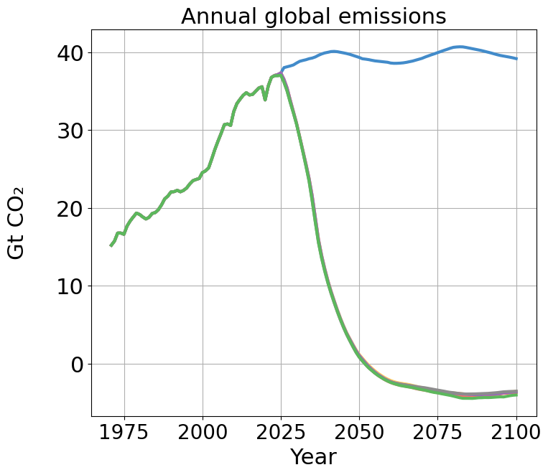
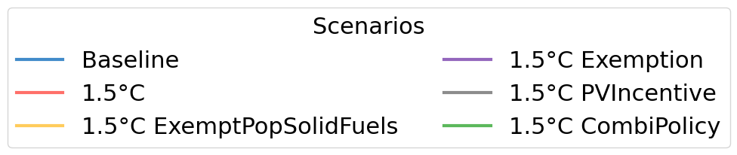
Figure A2: Global uniform carbon price trajectory in mitigation scenarios and corresponding emission pathways

A2.2 Energy carrier shares of residential energy demand

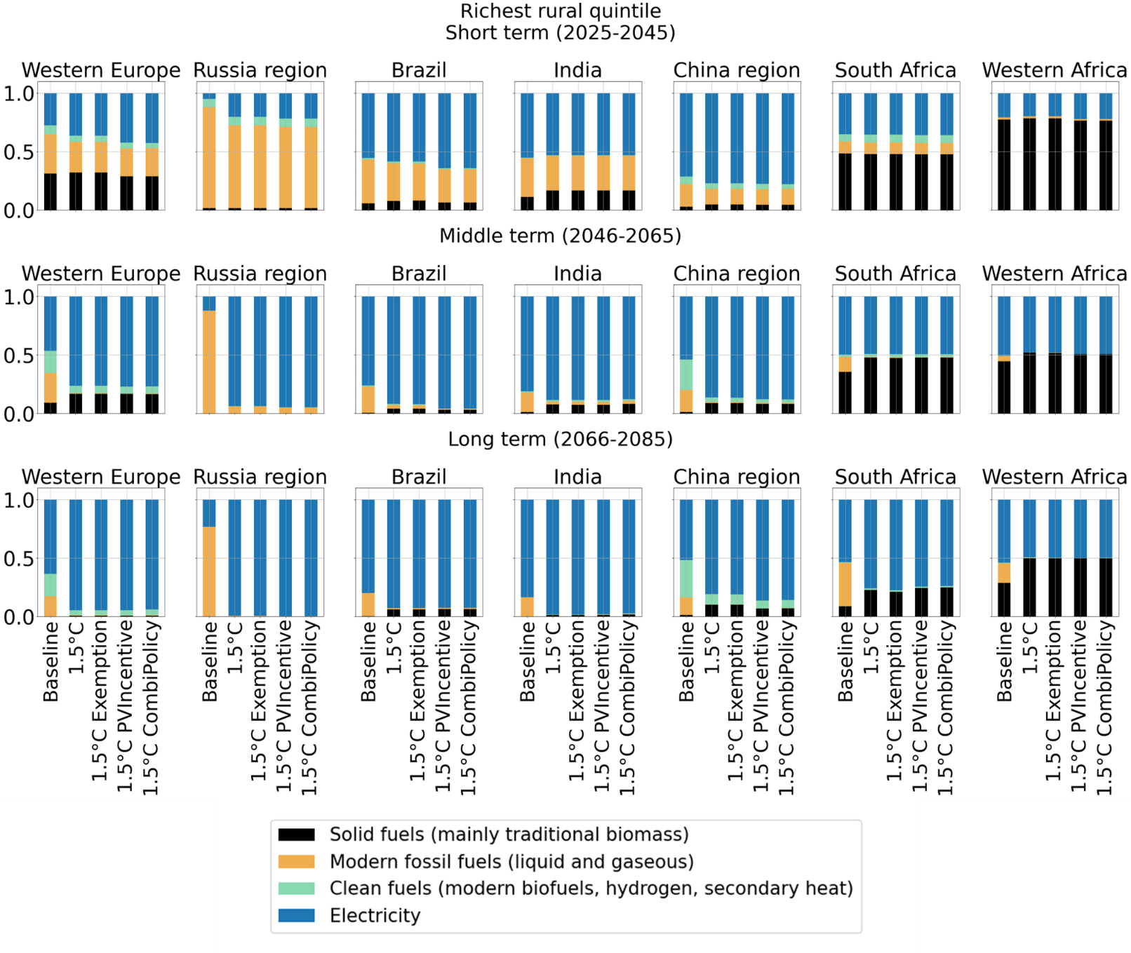
Figure A3: Energy carrier shares of residential energy demand across scenarios for the richest rural quintiles

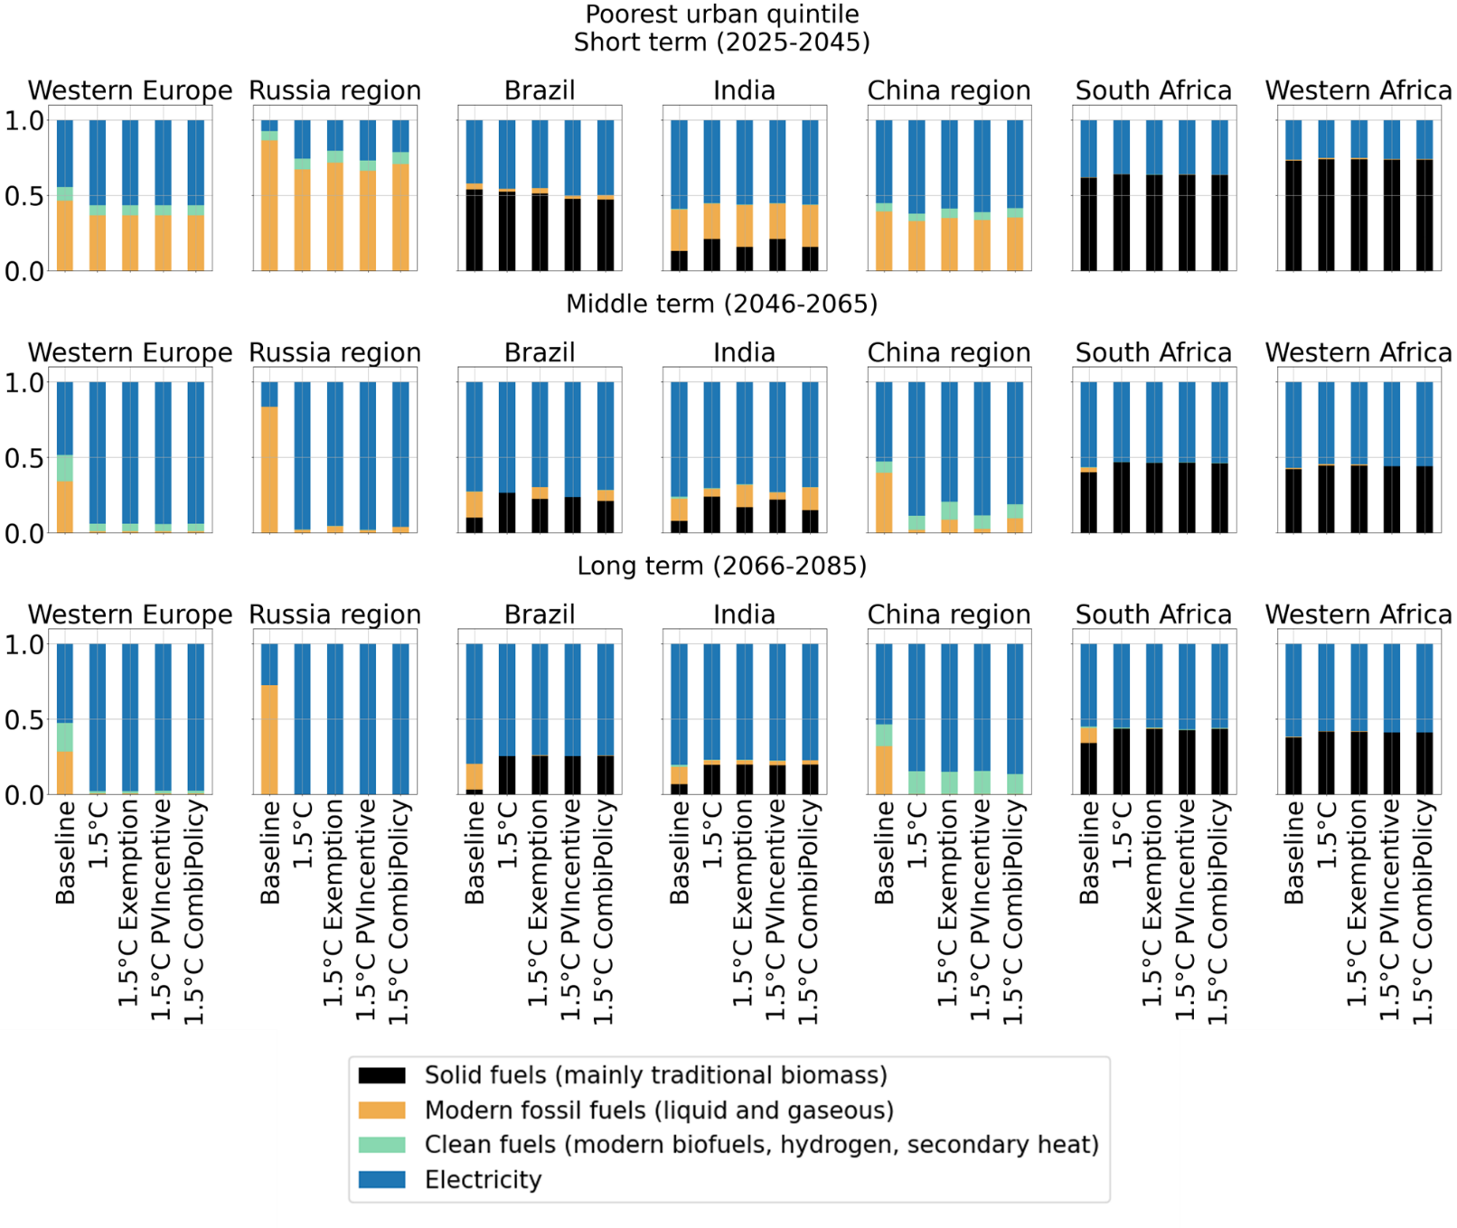
Figure A4: Energy carrier shares of residential energy demand across scenarios for the poorest urban quintiles

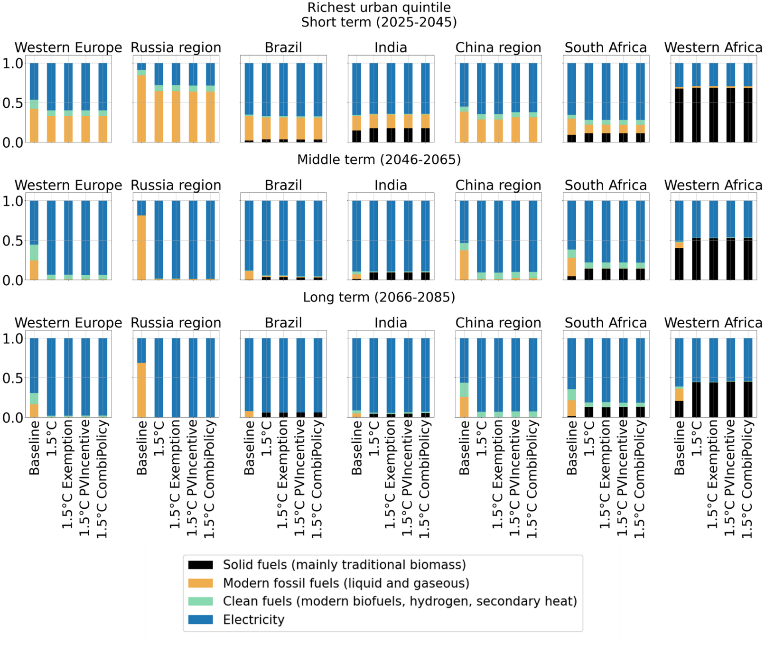
Figure A5: Energy carrier shares of residential energy demand across scenarios for the richest urban quintiles

A2.3 ResElecGen as share of total demanded energy for residential services

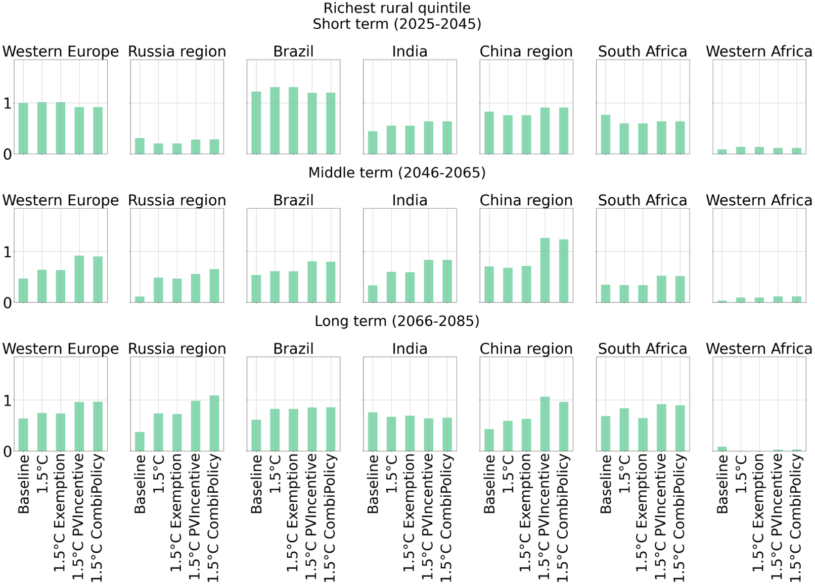
Figure A6: Generated rooftop electricity as share of total household electricity demand, richest rural quintiles

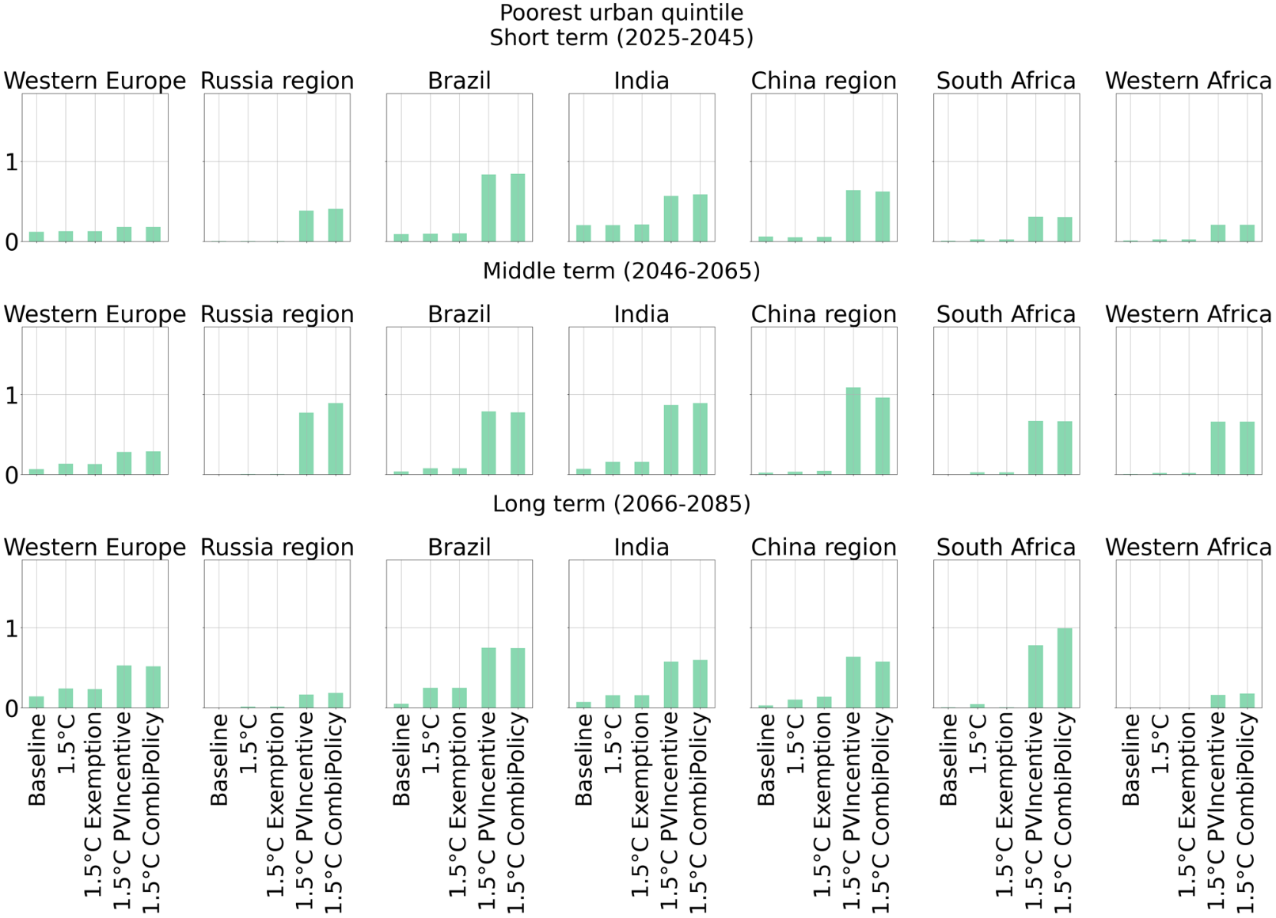
Figure A7: Generated rooftop electricity as share of total household electricity demand, poorest urban quintiles

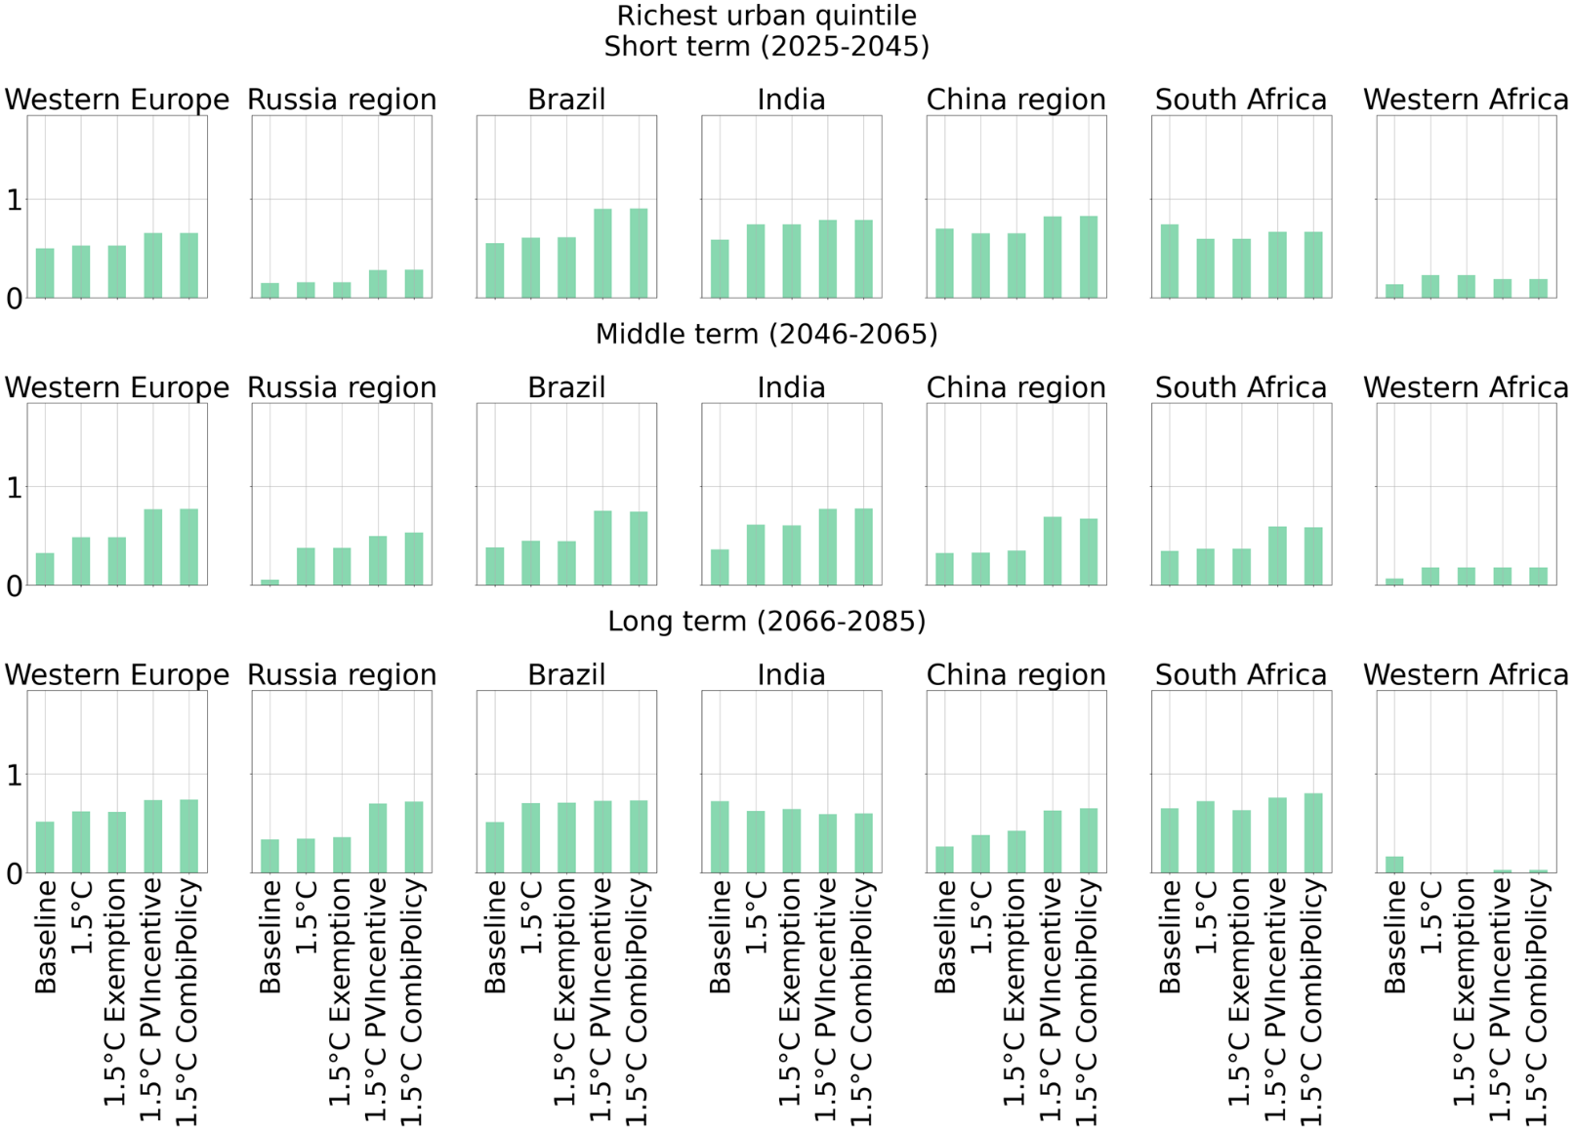
Figure A8: Generated rooftop electricity as share of total household electricity demand, richest urban quintiles

A2.4 Energy burden changes in mitigation scenarios

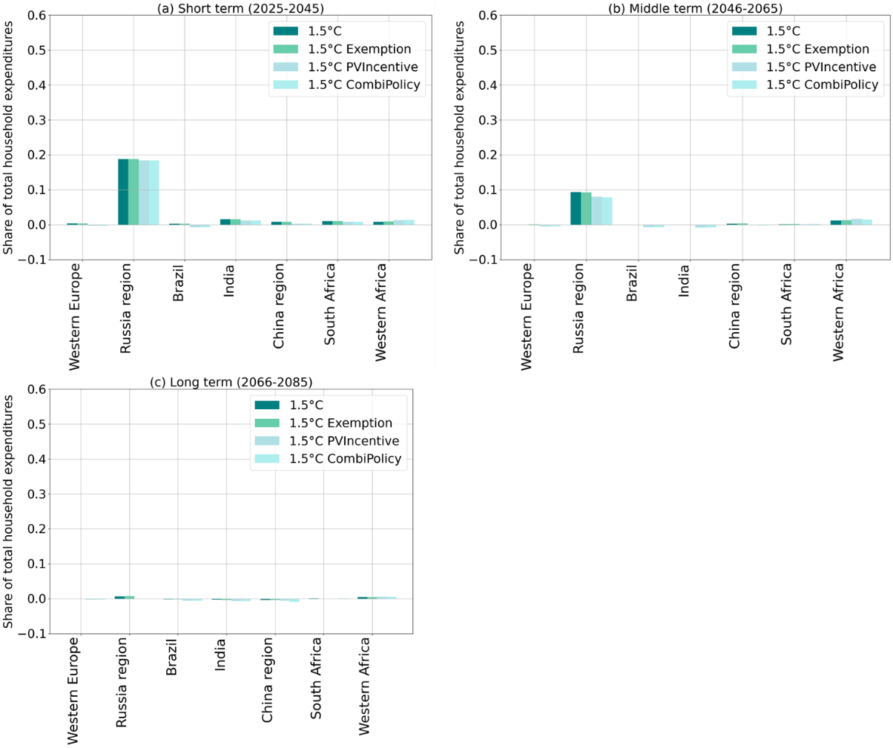
Figure A9: Energy burden (energy expenditure per capita as fraction of total household expenditures per capita) change in the 1.5ºC mitigation scenario relative to baseline for richest rural quintiles in selected model regions, (a) Short term, (b) Middle term, (c) Long term.

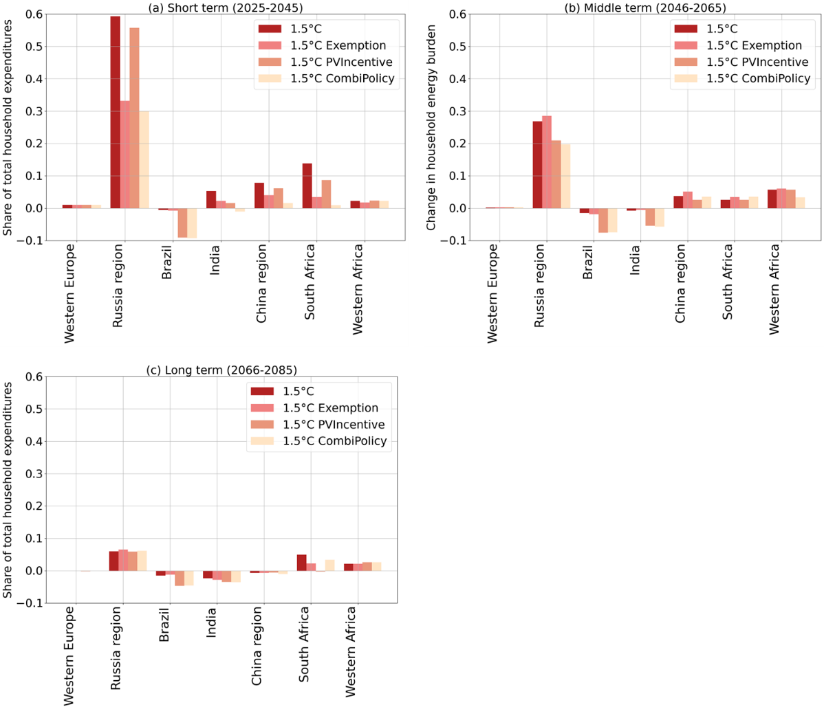
Figure A10: Energy burden change(energy expenditure per capita as fraction of total household expenditures per capita) in the 1.5ºC mitigation scenarios relative to baseline for poorest urban quintiles in selected model regions, (a) Short term, (b) Middle term, (c) Long term.

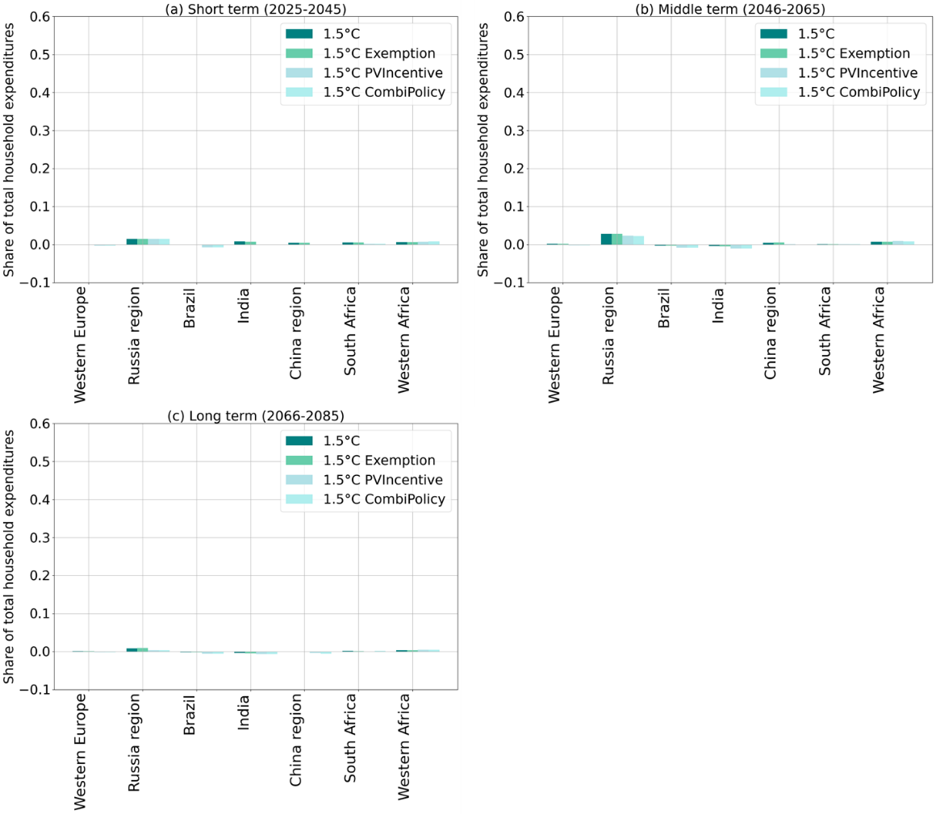
Figure A11: Energy burden change(energy expenditure per capita as fraction of total household expenditures per capita) in the 1.5ºC mitigation scenarios relative to baseline for richest urban quintiles in selected model regions, (a) Short term, (b) Middle term, (c) Long term.

A2.5 Electricity production per technology (shares of total)

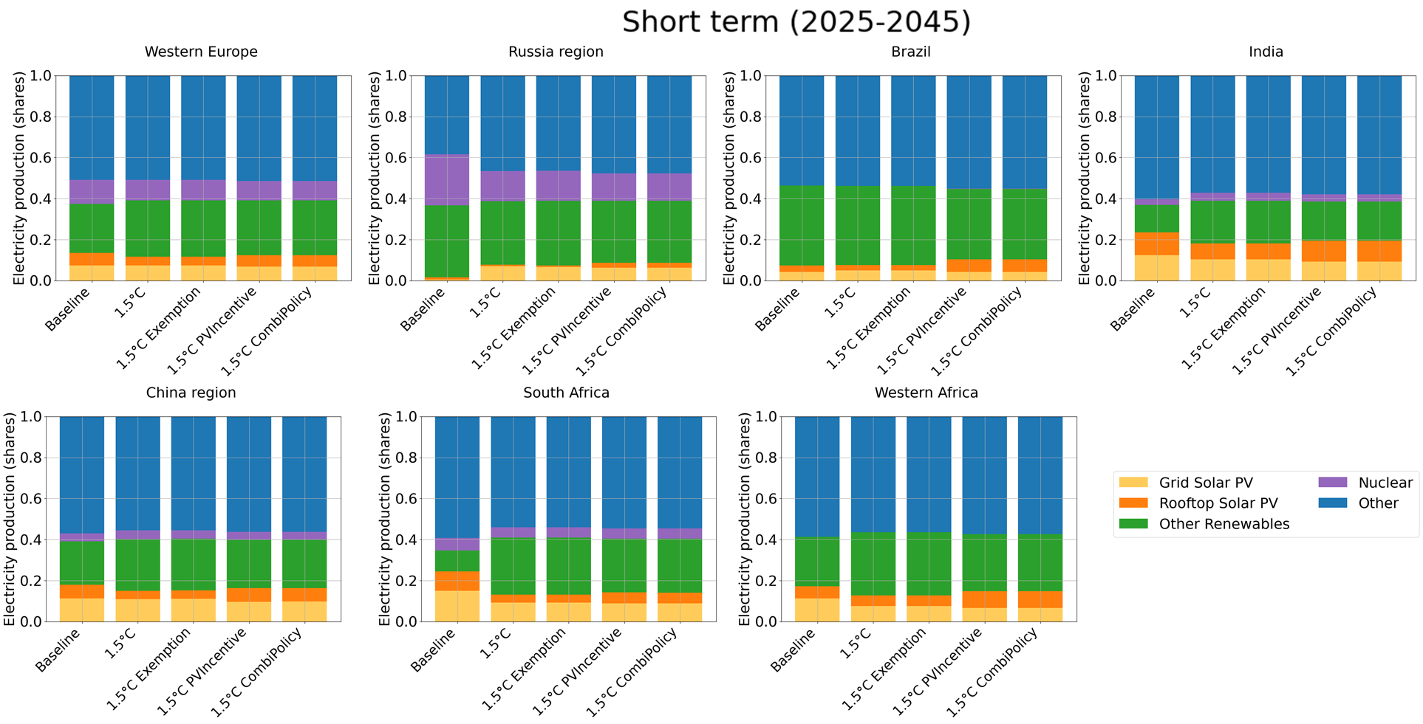
Figure A12: Technology shares of generated electricity in the short term (2025-2044)
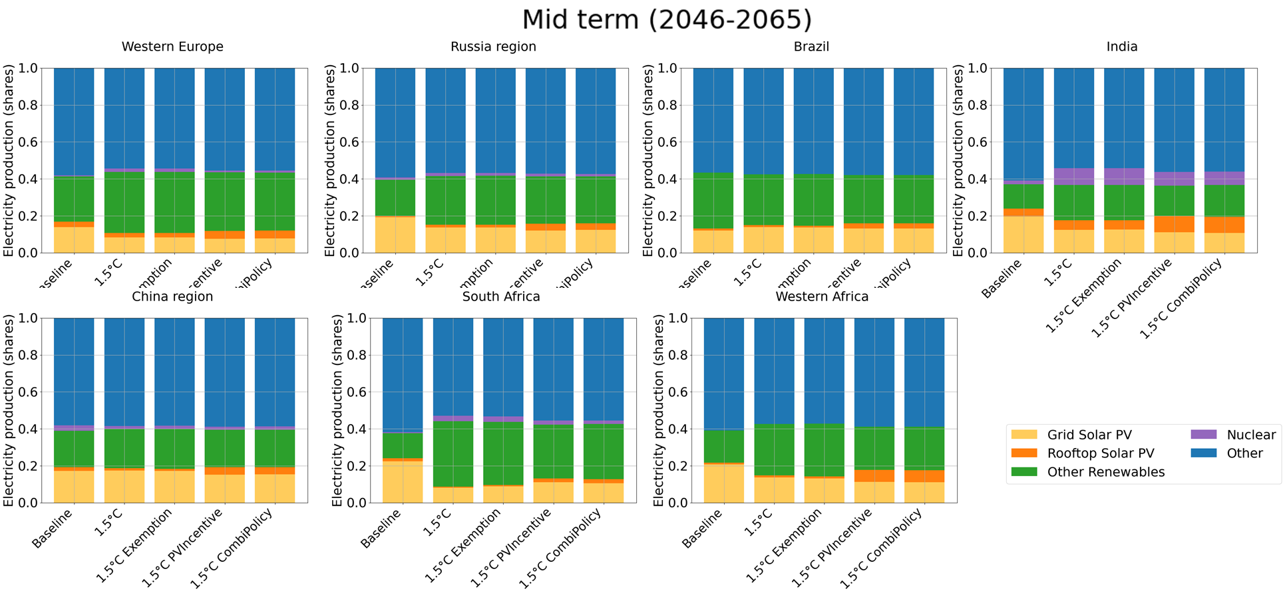
Figure A13: Technology shares of generated electricity in the middle term (2045-2065)

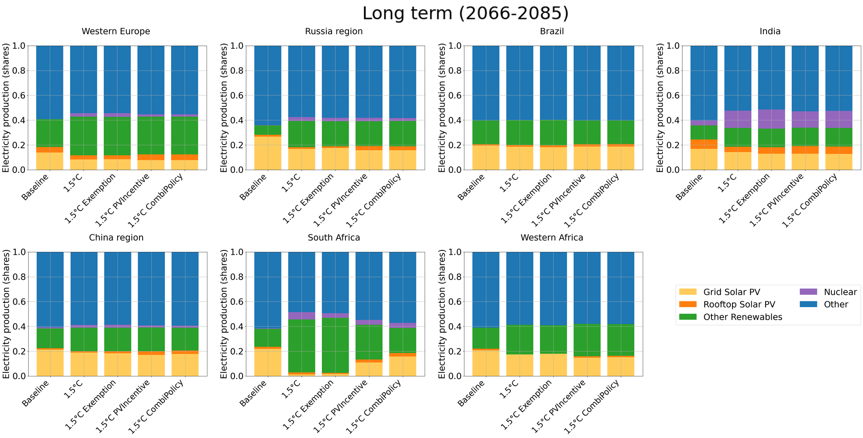
Figure A14: Technology shares of generated electricity in the long term (2066-2085)

A2.5 Electricity production per technology (GW)

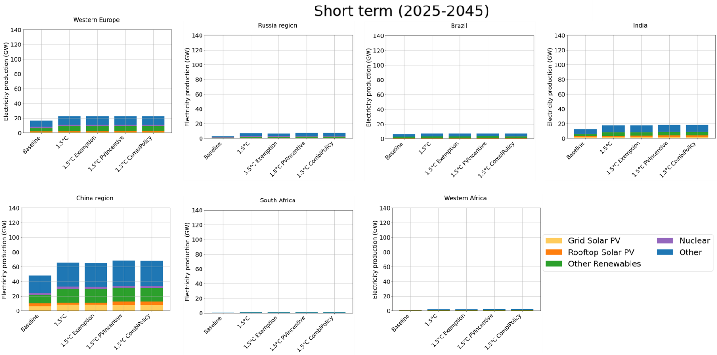
Figure A15: Electricity generation by technology in the short term (2025-2044)

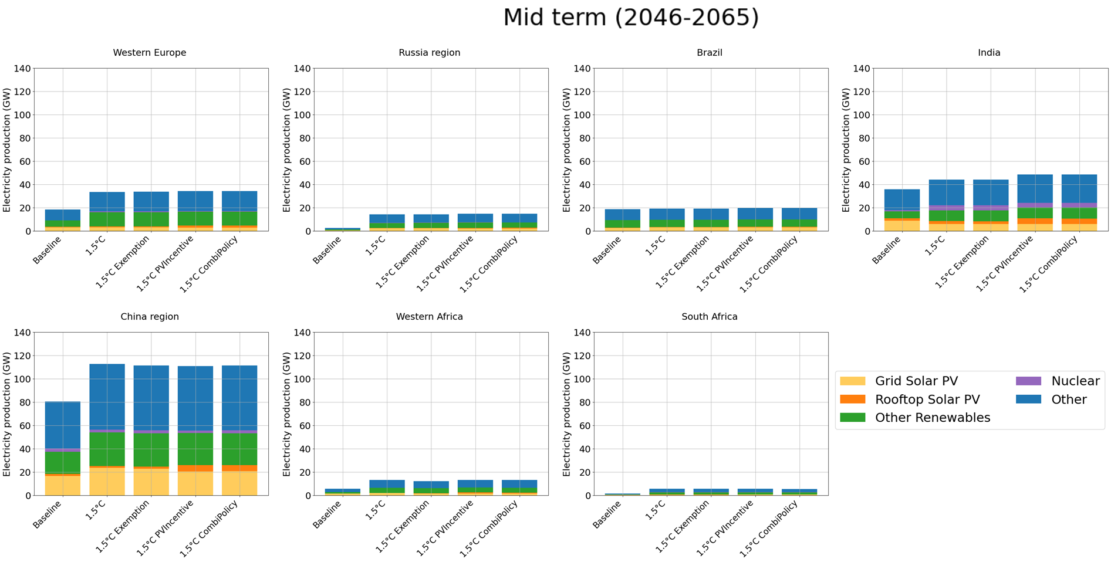
Figure A16: Electricity generation by technology in the middle term (2045-2065)

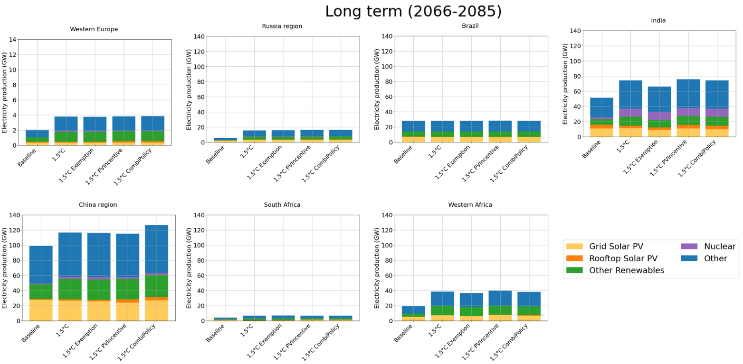
Figure A17: Electricity generation by technology in the long term (2066-2085)

A2.6 Gini changes with redistribution policies targeting income groups based on alternative conditions
Income groups receiving redistributive policy benefits (carbon price exemptions, PV incentives, or both) are identified based on shares of population dependent on solid fuels. The globally and temporally uniform minimum threshold is set at 5% through trial and error, to maximise coverage of income groups that are disproportionately affected in the 1.5°C mitigation scenario sans redistributive policy. Income groups with energy expenditure shares lower than 10% of total household expenditures are further excepted; this criterion excludes highest income quintiles in regions like Brazil and South Africa with high solid fuel demand due to cultural reasons.

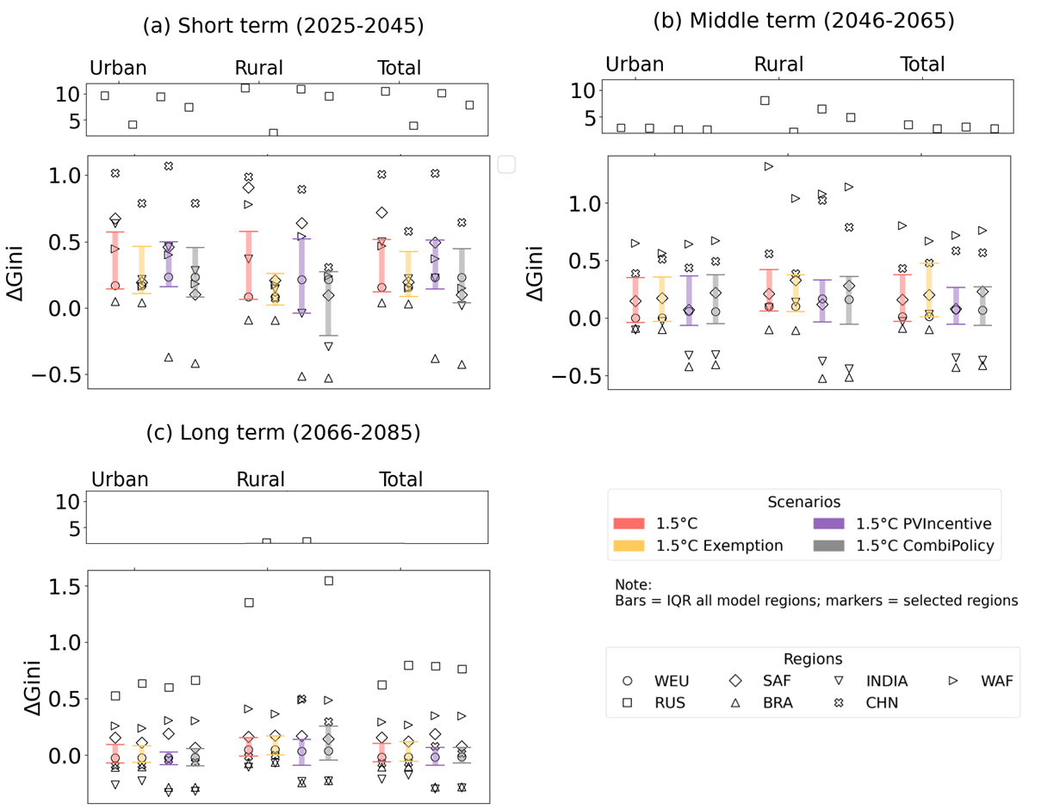
Figure A18: Gini changes with redistribution policies targeting income groups based on dependency on solid fuels

References
Dagnachew, A. G., Lucas, P. L., Hof, A. F., Gernaat, D. E. H. J., de Boer, H. S., & van Vuuren, D. P. (2017). The role of decentralized systems in providing universal electricity access in Sub-Saharan Africa – A model-based approach. Energy, 139, 184–195. https://doi.org/10.1016/j.energy.2017.07.144
Dagnachew, A. G., Lucas, P. L., Hof, A. F., & van Vuuren, D. P. (2018). Trade-offs and synergies between universal electricity access and climate change mitigation in Sub-Saharan Africa. Energy Policy, 114(November 2017), 355–366. https://doi.org/10.1016/j.enpol.2017.12.023
Daioglou, V., Faaij, A. P. C., Saygin, D., Patel, M. K., Wicke, B., & van Vuuren, D. P. (2013). Energy demand and emissions of the non-energy sector. Energy and Environmental Science, 7(2), 482–498. https://doi.org/10.1039/c3ee42667j
Daioglou, V., Mikropoulos, E., Gernaat, D., & van Vuuren, D. P. (2022). Efficiency improvement and technology choice for energy and emission reductions of the residential sector. Energy, 243, 122994. https://doi.org/10.1016/j.energy.2021.122994
Daioglou, V., van Ruijven, B. J., & van Vuuren, D. P. (2012). Model projections for household energy use in developing countries. Energy, 37(1), 601–615. https://doi.org/10.1016/j.energy.2011.10.044
Edelenbosch, O. Y., Hof, A. F., van den Berg, M., de Boer, H. S., Chen, H. H., Daioglou, V., Dekker, M. M., Doelman, J. C., den Elzen, M. G. J., Harmsen, M., Mikropoulos, S., van Sluisveld, M. A. E., Stehfest, E., Tagomori, I. S., van Zeist, W. J., & van Vuuren, D. P. (2024). Reducing sectoral hard-to-abate emissions to limit reliance on carbon dioxide removal. Nature Climate Change, 14(7), 715–722. https://doi.org/10.1038/s41558-024-02025-y
Gernaat, D. E. H. J., de Boer, H. S., Dammeier, L. C., & van Vuuren, D. P. (2020). The role of residential rooftop photovoltaic in long-term energy and climate scenarios. Applied Energy, 279(September), 115705. https://doi.org/10.1016/j.apenergy.2020.115705
Hassett, K. A., & Metcalf, G. E. (1993). Energy conservation investment. Energy Policy, 21(6), 710–716. https://doi.org/10.1016/0301-4215(93)90294-p
Hof, A. F., Dagnachew, A. G., Lucas, P. L., & Vuuren, D. P. van. (2018). Towards universal access to clean cooking solutions in Sub-Saharan Africa: An integrated assessment of the cost, health and environmental implications of policies and targets. https://www.pbl.nl/sites/default/files/cms/publicaties/pbl-2019-clean-cooking-solutions-sub-saharan-africa_3421.pdf
Howarth, R. B., & Sanstad, A. H. (1995). DISCOUNT RATES AND ENERGY EFFICIENCY. Contemporary Economic Policy, 13, 101–109. https://doi.org/https://doi.org/10.1111/j.1465-7287.1995.tb00726.x
Kozlovas, P., Gudzius, S., Ciurlionis, J., Jonaitis, A., Konstantinaviciute, I., & Bobinaite, V. (2023). Assessment of Technical and Economic Potential of Urban Rooftop Solar Photovoltaic Systems in Lithuania. Energies, 16(14). https://doi.org/10.3390/en16145410
Lucas, P., Dagnachew, A., & Hof, A. (2017). Towards universal electricity access in Sub-Saharan Africa (Issue August). http://www.pbl.nl/sites/default/files/cms/publicaties/pbl-2017-towards-universal-electricity-access-in-sub-saharan-africa-1952.pdf
Mulders, F. M. M., Hettelar, J. M. M., & Van Bergen, F. (2006). Assessment of the global fossil fuel reserves and resources for TIMER.
Reddy, B. S. (1996). Consumer discount rates and energy carrier choices in urban households. International Journal of Energy Research, 20, 187–195. https://doi.org/https://doi.org/10.1002/(SICI)1099-114X(199603)20:3%3C187::AID-ER112%3E3.0.CO;2-4
Rogner, H.-H. (1997). An assessment of world hydrocarbon resources. Annual Review of Energy and the Environment, 22(1), 217–262.
Sigrin, B. O. (2013). Financial Modeling of Consumer Discount Rate in Residential Solar Photovoltaic Purchasing Decisions. 66. https://repositories.lib.utexas.edu/handle/2152/21759
Stehfest, E., van Vuuren, D., Kram, T., Bouwman, L., Alkemade, R., Bakkenes, M., Biemans, H., Bouwman, A., Den Elzen, M., Janse, J., Lucas, P., Van Minnen, J., Müller, M., & Prins, A. (2014). Integrated assessment of global environmental change with IMAGE 3.0. Model description and policy applications. PBL Netherlands Environmental Assessment Agency, The Hague. The Netherlands.
Tarigan, E. (2023). Financial Analysis of Solar Rooftop PV System: Case Study in Indonesia. International Journal of Energy Economics and Policy, 13(3), 15–19. https://doi.org/10.32479/ijeep.14214
van Sluisveld, M. A. E., Martínez, S. H., Daioglou, V., & van Vuuren, D. P. (2016). Exploring the implications of lifestyle change in 2°C mitigation scenarios using the IMAGE integrated assessment model. Technological Forecasting and Social Change, 102, 309–319. https://doi.org/10.1016/j.techfore.2015.08.013
van Vuuren, D. P., Riahi, K., Moss, R., Edmonds, J., Thomson, A., Nakicenovic, N., Kram, T., Berkhout, F., Swart, R., Janetos, A., Rose, S. K., & Arnell, N. (2011). A proposal for a new scenario framework to support research and assessment in different climate research communities. Global Environmental Change, 22(1), 21–35. https://doi.org/10.1016/j.gloenvcha.2011.08.002
van Vuuren, D. P., Stehfest, E., Gernaat, D. E. H. J., Doelman, J. C., van den Berg, M., Harmsen, M., de Boer, H. S., Bouwman, L. F., Daioglou, V., Edelenbosch, O. Y., Girod, B., Kram, T., Lassaletta, L., Lucas, P. L., van Meijl, H., Müller, C., van Ruijven, B. J., van der Sluis, S., & Tabeau, A. (2017). Energy, land-use and greenhouse gas emissions trajectories under a green growth paradigm. Global Environmental Change, 42, 237–250. https://doi.org/10.1016/j.gloenvcha.2016.05.008
Zhang, T., Chandler, W. S., Hoell, M., J., Westberg, D., Whitlock, C. H., & Stackhouse, P. W. J. (2008). A global perspective on renewable energy resources: NASA’s prediction of worldwide energy resources (power) project. Proceedings of ISES World Congress 2007 (Vol. I–Vol. V) Solar Energy and Human Settlement, 2636–2640.

