Supplementary Information for
Optimized spatial planning offers a dual solution for managing urban heat and air pollution in humid subtropical climates
Liuhua Zhu et al.
*Corresponding author. Email: mgao2@seas.harvard.edu

This file includes:
Notes 1 to 3
Figures 1 to 14
Tables 1 to 5

Note 1. Description for NSGA-II
The flowchart of NSGA-II is shown in Supplementary Fig. 14. NSGA-II is essentially a genetic algorithm, which imitates the evolution by natural selection to obtain the best solution based on objective functions. A diverse population of solutions was initialized based on the given constraints. Subsequently, the evaluation based on objective functions were conducted, followed by the ranking for all the solutions. Offsprings were then generated using an evolution strategy. This process was iterated until the maximum number of iterations (set for 2000) was reached to obtain optimal solutions. NSGA-II comprises four key modules outlined below:
- Initialization
Diverse solutions were randomly generated, representing potential urban plans by selecting 110 urban areas based on the constraints. Urban fractions, green space fractions, and other land use types for each urban grid were also randomly assigned. A population of 400 solutions were created, with each solution representing a competitive individual.
- Evaluation
The values of four objective functions were calculated for each solution to facilitate subsequent ranking.
- Elitism
A rapid non-dominated sorting method was employed to rank the population based on objective function values. Solution A dominates Solution B if two conditions are met: 1) All objective function values of A are equal to or better than those of B. 2) At least one objective function value of A surpasses that of B. Solutions were graded accordingly, with the first class forming the Pareto front. To maintain population diversity, solutions from other fronts also have the chance to be retained. Crowding distance was introduced on each front to preserve diversity, calculated as the sum of Euclidean distances of each objective function with its neighbors.
- Evolution
Evolution encompassed selection, crossover, and mutation. New "children" populations were generated by inheriting favorable "genes" from "parents" (population before evolution). Selection involved the binary tournament method, where two individuals were randomly selected from the population, and the one with higher ranking and larger crowding distance advances to the next generation. This process was repeated until the desired number of individuals was selected. Crossover operators were then applied to the selected parent solutions, creating a new generation comprising the first 70% of parent A and the second 30% of parent B. Mutation involved random changes in urban area locations, urban fractions, and urban greening fractions in newly developed urban areas.

Note 2. Validation for WRF-GC Performance
We used observed meteorological variables and air quality data to evaluate reliability of the control simulation. The observed near surface temperature and relative humidity at 2m (T₂ and RH₂) were sourced from China National Meteorological Information Center (NMIC, http://data.cma.cn/). Hourly particulate matters with diameter smaller than 2.5 micrometer (PM_{2.5}) and ozone concentrations were taken from the China National Environment Monitoring Center (CNEMC) network. Comparisons from September 1st 0800 local time (LT) to September 6th 0800 LT of T₂ and RH₂ in 41 stations, and of surface PM_{2.5} and ozone in 63 stations were performed. The validation performed by leveraging the mean bias (MB), root mean square error (RMSE), correlation coefficient (R), index of agreement (IOA), mean fractional bias (MFB) and mean fraction error (MFA). All statistics are defined as follows:
$MB = \frac{1}{n}\sum_{i=1}^{n}{(S_{i}-O_{i}}$)
$$RMSE = \sqrt{\frac{\sum_{i=1}^{n}{{(S_{i}-O_{i})}^{2}}}{n}}$$
$$R=\frac{\sum_{i=1}^{n}{(S_{i}-\overline{S_{i}})(O_{i}-\overline{O_{i}})}}{\sqrt{\sum_{i=1}^{n}{{(S_{i}-\overline{S_{i}})}^{2}}}\sqrt{\sum_{i=1}^{n}{{(O_{i}-\overline{O_{i}})}^{2}}}}$$
$$IOA=1-\frac{n∙{RMSE}^{2}}{\sum_{i=1}^{n}{{(\left|S_{i}\right|+\left|O_{i}\right|)}^{2}}}$$
$$MFB= \frac{2}{n}\sum_{i=1}^{n}{\frac{S_{i}-O_{i}}{S_{i}+O_{i}}}$$
$$MFE= \frac{2}{n}\sum_{i=1}^{n}{\frac{\left|{S_{i}-O}_{i}\right|}{S_{i}+O_{i}}}$$
Where i is the sample of simulation-observation pairs during the simulation period. $S_{i}$and $O_{i}$ present simulated and observed variables, respectively. The higher R, the closer IOA to 1, the smaller RMSE and the closer MB to 0 indicate the better performance of simulation.

The summary of results is presented in Supplementary Fig. 9, Table 2 and Table 3. R and IOA for all indicators exceed 0.7 and 0.9 respectively, indicating the consistency between simulations and observations. The model exhibits a cool bias on 2m-temperature and a wet bias on RH₂, respectively, yet the biases are satisfactory compared to other’s studies also refer to simulation of heatwave events (Supplementary Table 2). PM_{2.5} concentrations are underestimated with a normalized mean bias of -11.45%. Although the negative biases exist, they are comparable to those reported by Feng et al.¹ and superior than those in Fan et al.². Additionally, the mean fraction bias and mean fraction error are within acceptable criteria (Supplementary Table 3). Ozone concentrations are also underestimated during pollution episodes, consistent with findings from Wu et al.³ and Zhang et al.⁴. The uncertainties from the emission inventory and the reaction mechanisms are two major problems that can be responsible for the inaccuracy of air quality simulation⁵. Overall, the time series analysis (Supplementary Fig. 9cd and Fig. 9gh) reveals that our simulation successfully captured daily variation of these variables.

Note 3. Description for adjusting anthropogenic emissions
In response to updated land use data, adjustments to anthropogenic emissions were made by establishing relationship between the current land use data and monthly emission inventory. We first interpolated the land use data to ensure consistency in spatial resolution with the emission inventory. A ridge regression model was then employed for each emission source to predict new grid emission, utilizing land use fractions in each grid as independent variables. The R of resulting regression was assessed, with R values exceeding 0.7 affirming the applicable of the regression model. Alternatively, for cases where R was below 0.7, a different method was adopted.

Firstly, the top three land use types ($L_{1}$, $L_{2}$, $L_{3}$) correlated with emissions were identified based on the Pearson correlation coefficient ($R_{1}$, $R_{2}$, $R_{3}$). Then, for grid i with the updated land use fraction, we computed the similarity between grid i and all other grids. The similarity metric was defined as follows:
$${Similarity}_{i,j}= \sum_{k=1}^{3}{α_{k}{({LF}_{i,k}-{LF}_{j,k})}^{2} }$$
$$α_{k}= {R_{k}}/{(R_{1}+R_{2}+R_{3})}$$
Where, i,j means the different grid. K pertains to the used land use types, LF is the land use fraction, $α_{k}$ is the weight derived from $R_{k}$. The emission from the grid with the largest similarity was adopted as the new emission for grid i.

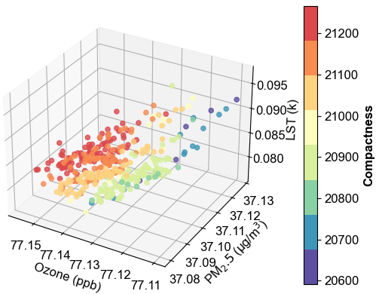
Fig. 1 The distribution for defined 4 objective function values derived from optimized urban plans.

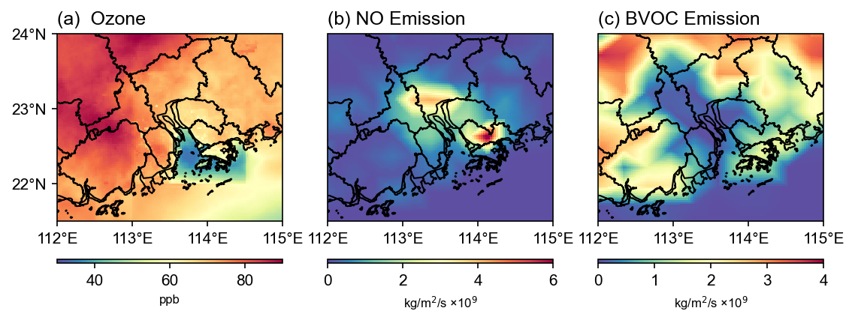
Fig. 2 The spatial distribution of (a) simulated ozone; (b) NO emission from MEIC; and (c) BVOC emission from MEGAN simulation.

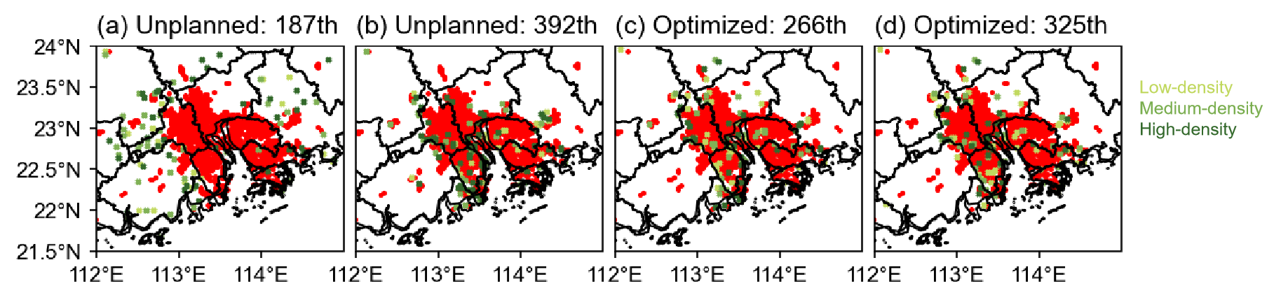
Fig. 3 Changed urban grids distribution of four selected urban plans.

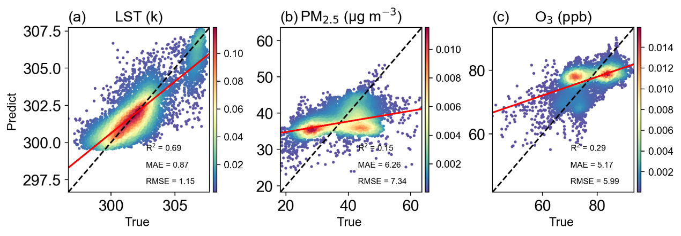
Fig. 4 Density scatter plot of predictions and true values based on the least square method: (a) LST; (b) PM_{2.5}; and (c) ozone.

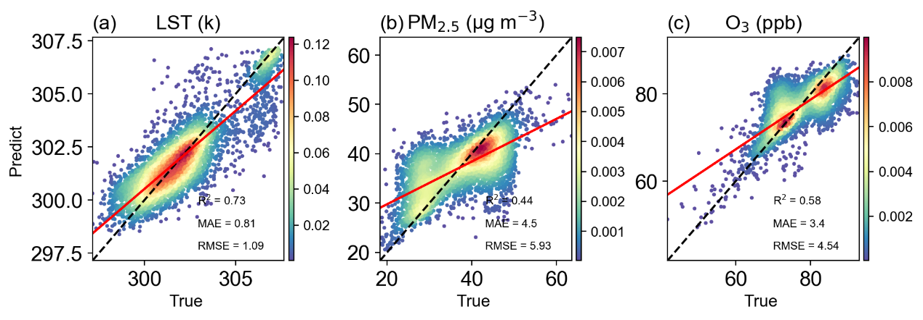
Fig. 5 Density scatter plot of predictions and true values based on the Random Forest Regression: (a) LST; (b) PM_{2.5}; and (c) ozone.

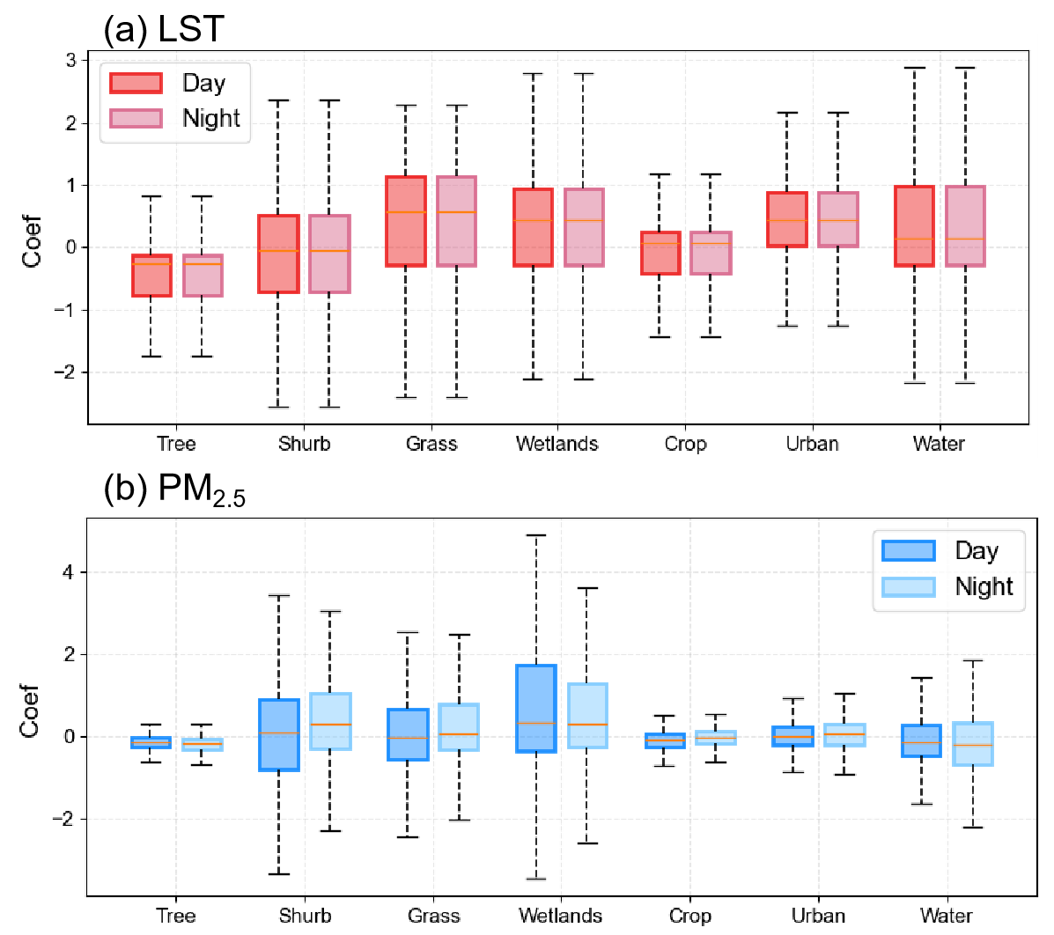
Fig. 6 The boxplot for GWR coefficients of different land use types at daytime and nighttime. (a) is for LST and (b) is for PM_{2.5}.

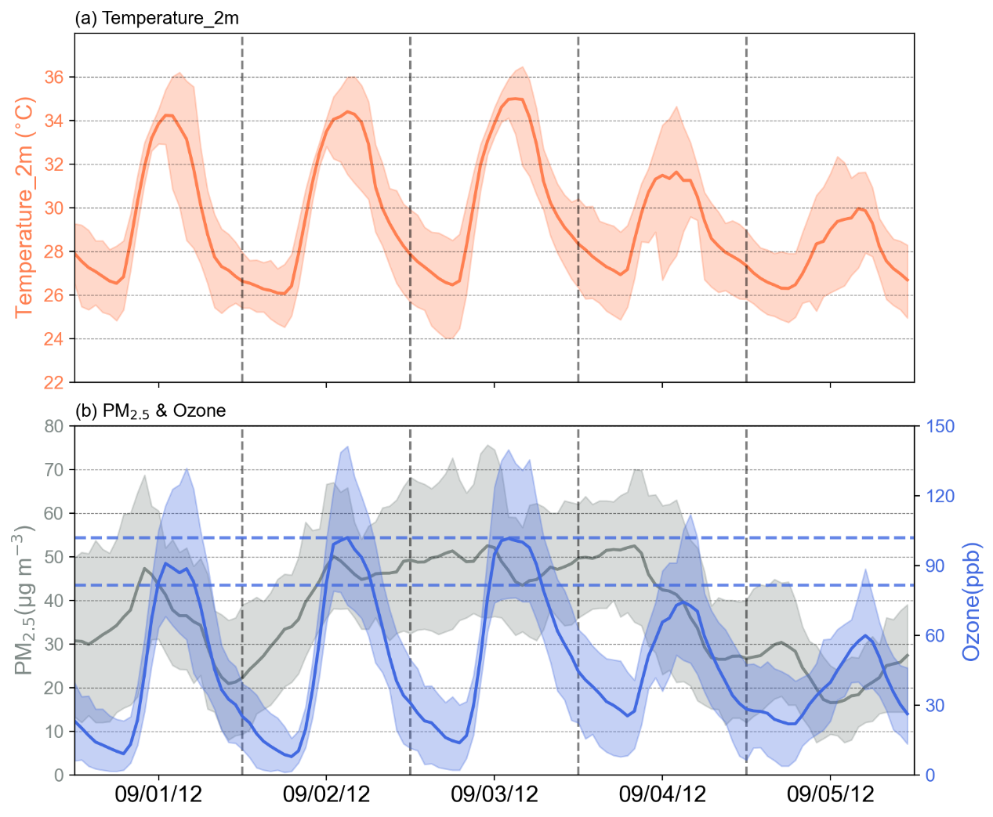
Fig. 7 Meteorology and air quality conditions in selected case. (a) Time series of temperature at 2m. (b) Time series of PM2.5 concentration (grey line) and ozone concentration (blue line). The dashed blue lines are the first level and second level ozone pollution limits according to China Ambient air quality standards. The observed near-surface temperature and relative humidity at 2m (T₂ and RH₂) were sourced from China National Meteorological Information Center (NMIC, http://data.cma.cn/). Hourly PM_{2.5} and ozone concentrations were taken from the China National Environment Monitoring Center (CNEMC) network.

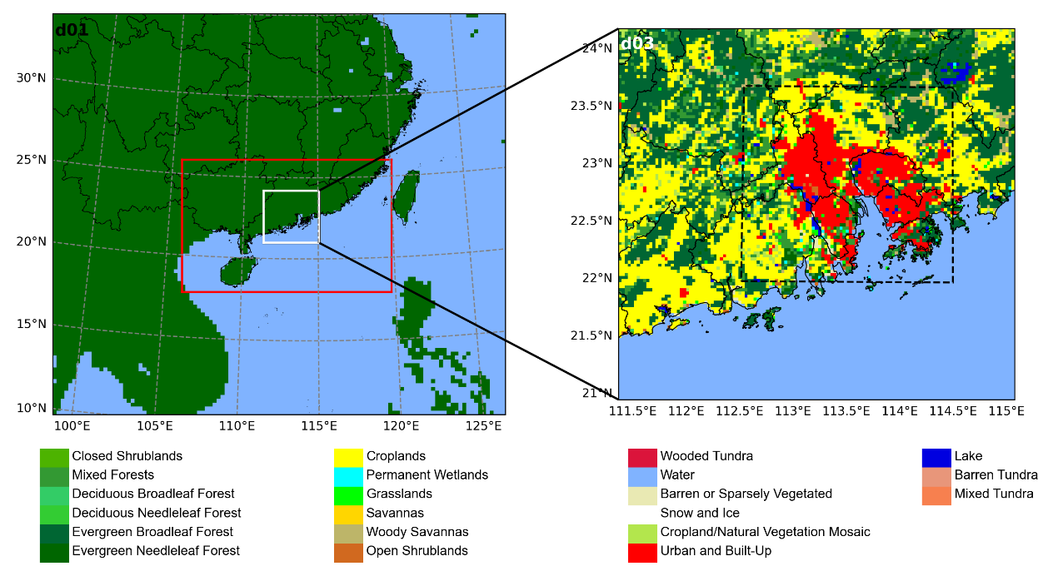
Fig. 8 Domain configuration of WRF-GC model.

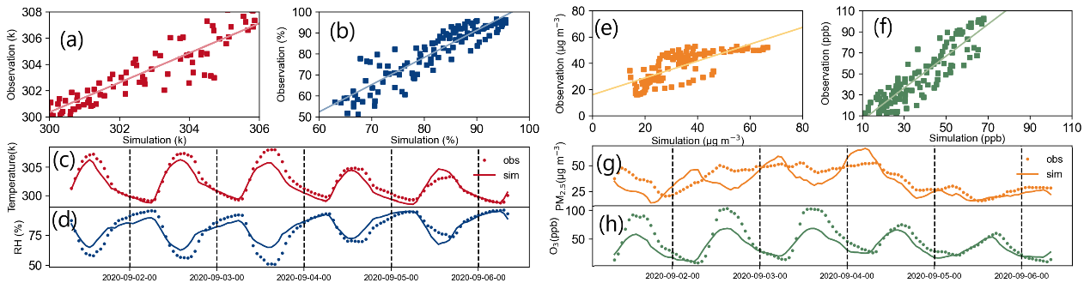
Fig. 9 Model evaluation with site observations. Scatter plots of simulated near-surface temperature (a), relative humidity at 2m (b), PM_{2.5} (e), ozone(f). Time series of near-surface temperature (c), relative humidity at 2m (d), PM_{2.5} (g), ozone(h).

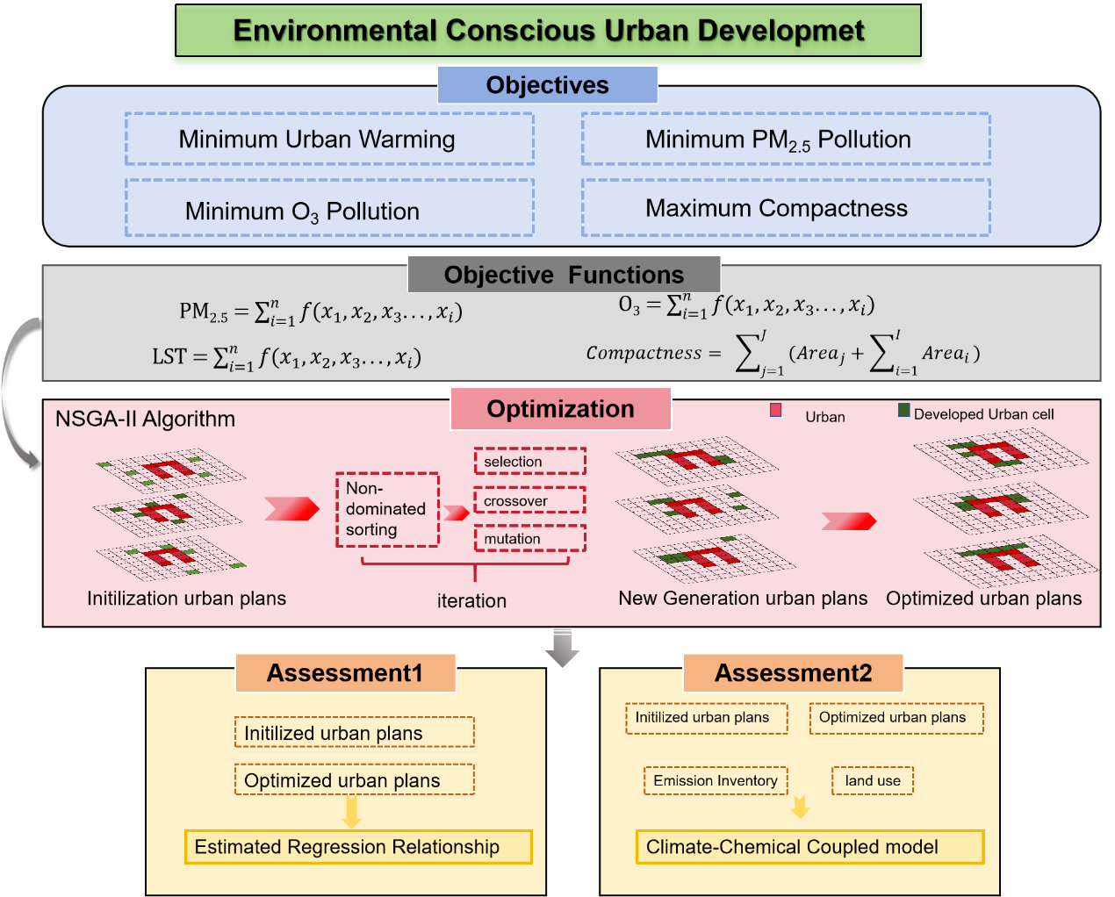
Fig. 10 The framework structure of multi-objectives optimization environmental conscious urban development.

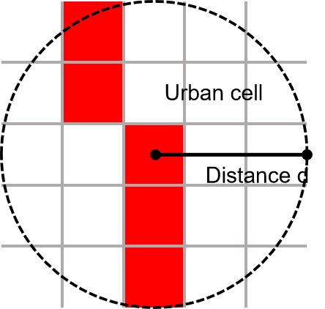
Fig. 11 The concept of the compactness for each newly developed urban area. The total number of red grid cells is the compactness for j_{th} urban area.

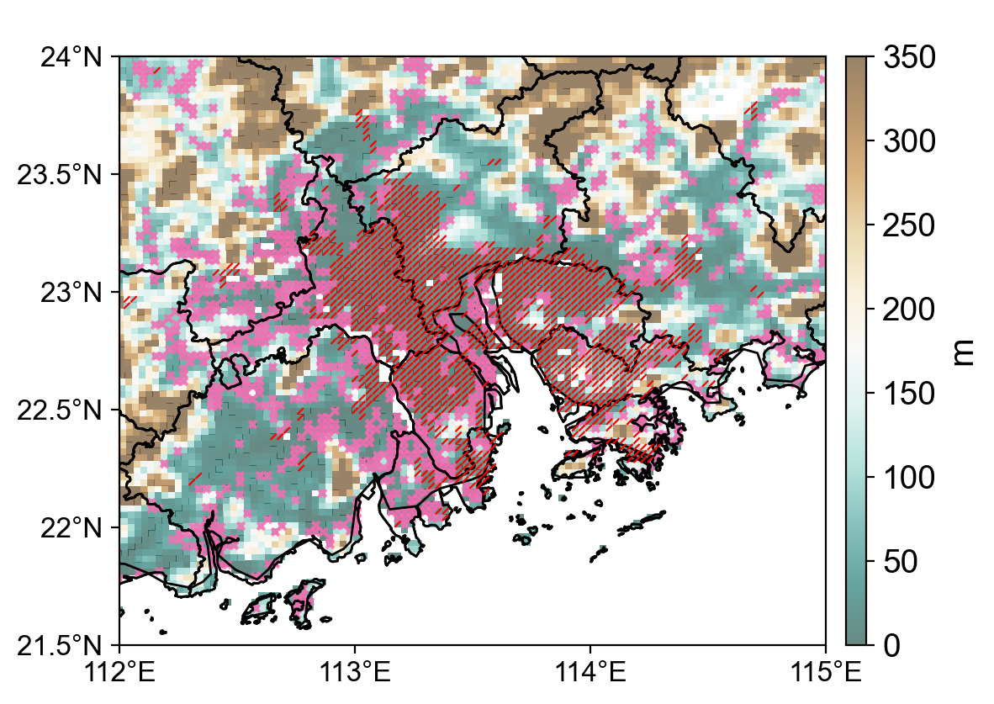
Fig. 12 The spatial distribution of urban land use grid cells (denoted as red slash) and potential urban grid cells (denoted as pink cross mark). Shaded colors represent the elevation over GBA area.

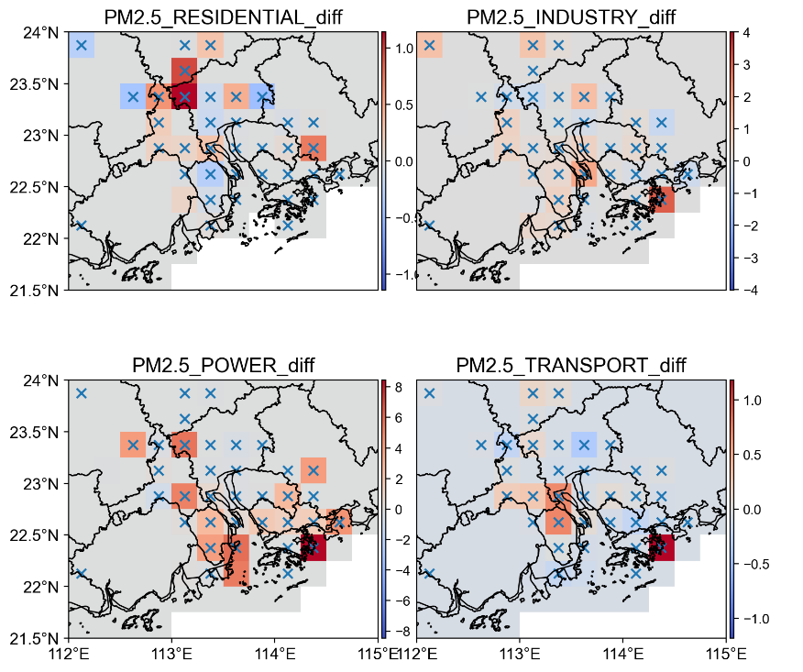
Fig. 13 The differences of PM_{2.5} concentrations between updated and the original emission inventory. Blue mark ‘x’ represents the newly developed urban areas.

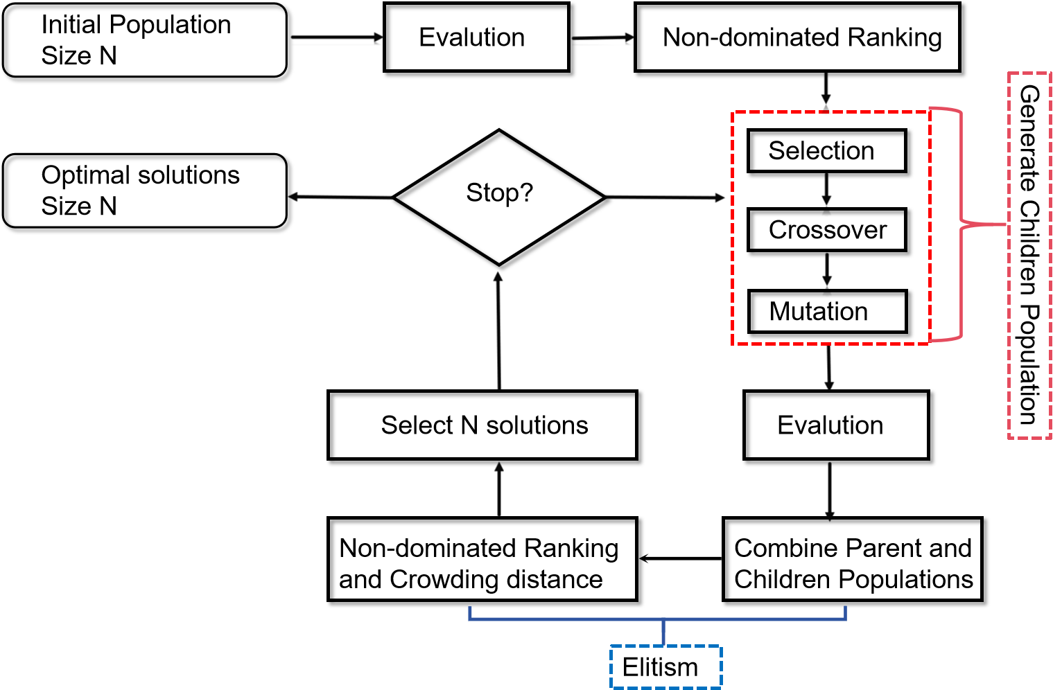
Fig. 14 Flowchart of NSGA-II.

Table 1 Physical options and domain settings used in the WRF-GC simulation
Settings | D01 | D02 | D03
Horizontal Resolution(km) | 27 | 9 | 3
Vertical layers | 39 | 39 | 39
Cumulus parameterization | New Tiedtke⁶⁻⁸ | Off | Off
Microphysics | Morrison (two-moment)⁹
Longwave/Shortwave Radiation | RRTMG¹⁰
Planetary Boundary Layer | YSU¹¹
Land Surface Model | Unified Noah land-surface model¹²
Surface Urban Physics | Single-layer urban canopy model¹³
Aerosol-Radiation interaction | On
Aerosol-cloud interaction | On

Table 2 Meteorology variables statistical metrics from 1st September to 5th September in PRD.
Indicator | Study | Area | MB | RMSE | R | IOA
T2 (℃) | This study | PRD | -0.58 | 2.02 | 0.95 | 1.0
 | Chen et al.¹⁴ | Guangzhou | 0.6
 | Wang et al.¹⁵ | Eastern China | <-0.6
RH (%) | This study | PRD | 1.22 | 11.94 | 0.91 | 0.99

Table 3 Air quality variables statistical metrics from 1st September to 5th September in the Great Bay Area (GBA).
Indicator | MB | RMSE | R | IOA | MFB | MFE
PM_{2.5} (μg/m³) | -4.25 | 19.4 | 0.75 | 0.93 | -0.15(≤±0.6) | 0.43(≤0.75)
O₃ (ppb) | -9.37 | 25.04 | 0.91 | 0.93 | -0.13 | 0.56
*The marked red means the criteria suggested by EPA¹⁶

Table 4 Land type in WRF-GC and its remapped classes for GWR estimations.
Index | Original Land type | Index | New Land Type
1 | Evergreen Needleleaf Forest | 1 | Tree
2 | Evergreen Broadleaf Forest | 1 | Tree
3 | Deciduous Needleleaf Forest | 1 | Tree
4 | Deciduous Broadleaf Forest | 1 | Tree
5 | Mixed Forests | 1 | Tree
8 | Woody Savannas | 1 | Tree
9 | Savannas | 1 | Tree
6 | Closed Shrublands | 2 | Shrub
7 | Open Shrublands | 2 | Shrub
10 | Grasslands | 3 | grass
11 | Permanent Wetlands | 4 | wetland
12 | Croplands | 5 | crop
14 | Cropland/Natural Vegetation | 5 | crop
13 | Urban and built-up | 6 | urban
16 | Barren or Sparsely Vegetated | 7 | barren
17 | Water | 8 | water
21 | Lake | 8 | water
15 | Snow and Ice | 9 | Others (not used)
18 | Wooded Tundra | 9 | Others (not used)
19 | Mixed Tundra | 9 | Others (not used)
20 | Barren Tundra | 9 | Others (not used)

Table 5 Urban plans selected for WRF-GC simulations.
Source | Index | LST (k) | Ozone (μg/m³) | PM_{2.5} (μg/m³) | Compactness
Initial | 187 | 302.11 | 77.151 | 37.217 | 19353
Initial | 392 | 302.091 | 77.177 | 37.138 | 21247
Initial | Average | 302.114 | 77.158 | 37.199 | 19654
Optimized | 266 | 302.087 | 77.145 | 37.118 | 21265
Optimized | 325 | 302.083 | 77.134 | 37.097 | 21119
Optimized | Average | 302.083 | 77.136 | 37.099 | 21045
*Bold character represents that objectives are inferior to the average of corresponding source.

References
1. Feng X, et al. WRF-GC (v2.0): online two-way coupling of WRF (v3.9.1.1) and GEOS-Chem (v12.7.2) for modeling regional atmospheric chemistry–meteorology interactions. Geoscientific Model Development 14, 3741-3768 (2021)
2. Fan Q, et al. Effect of different meteorological fields on the regional air quality modelling over Pearl River Delta, China. International journal of environment and pollution 53, 3-23 (2013)
3. Wu W, et al. Temperature-Dependent Evaporative Anthropogenic VOC Emissions Significantly Exacerbate Regional Ozone Pollution. Environ Sci Technol 58, 5430-5441 (2024)
4. Zhang J, Zhai S, Tai AP. Responses of biogenic volatile organic compound emissions and surface ozone air pollution in the Greater Bay Area to heatwaves. In: EGU General Assembly Conference Abstracts) (2024).
5. Zheng B, et al. Trends in China's anthropogenic emissions since 2010 as the consequence of clean air actions. Atmospheric Chemistry and Physics 18, 14095-14111 (2018)
6. Tiedtke M. A comprehensive mass flux scheme for cumulus parameterization in large-scale models. Monthly weather review 117, 1779-1800 (1989)
7. Zhang C, Wang Y. Projected future changes of tropical cyclone activity over the western North and South Pacific in a 20-km-mesh regional climate model. Journal of Climate 30, 5923-5941 (2017)
8. Zhang C, Wang Y, Hamilton K. Improved representation of boundary layer clouds over the southeast Pacific in ARW-WRF using a modified Tiedtke cumulus parameterization scheme. Monthly Weather Review 139, 3489-3513 (2011)
9. Morrison H, Thompson G, Tatarskii V. Impact of cloud microphysics on the development of trailing stratiform precipitation in a simulated squall line: Comparison of one-and two-moment schemes. Monthly weather review 137, 991-1007 (2009)
10. Iacono MJ, Delamere JS, Mlawer EJ, Shephard MW, Clough SA, Collins WD. Radiative forcing by long‐lived greenhouse gases: Calculations with the AER radiative transfer models. Journal of Geophysical Research: Atmospheres 113, (2008)
11. Hong S-Y, Noh Y, Dudhia J. A new vertical diffusion package with an explicit treatment of entrainment processes. Monthly weather review 134, 2318-2341 (2006)
12. Chen F, Dudhia J. Coupling an advanced land surface–hydrology model with the Penn State–NCAR MM5 modeling system. Part I: Model implementation and sensitivity. Monthly weather review 129, 569-585 (2001)
13. Kusaka H, Kondo H, Kikegawa Y, Kimura F. A simple single-layer urban canopy model for atmospheric models: Comparison with multi-layer and slab models. Boundary-layer meteorology 101, 329-358 (2001)
14. Chen G, Zhao L, Mochida A. Urban heat island simulations in Guangzhou, China, using the coupled WRF/UCM model with a land use map extracted from remote sensing data. Sustainability 8, 628 (2016)
15. Wang J, Yan Z, Quan X-W, Feng J. Urban warming in the 2013 summer heat wave in eastern China. Climate Dynamics 48, 3015-3033 (2017)
16. Epa U. Guidance on the use of models and other analyses for demonstrating attainment of air quality goals for ozone, PM2. 5, and regional haze. US Environmental Protection Agency, Office of Air Quality Planning and Standards, (2007)

