Supplementary Figures
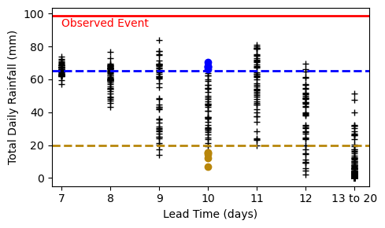
Fig.S1: Daily rainfall within the CESM2 event ensemble. The maximum daily rainfall total at any grid point (approximately 140 x 60 km) within the region 48 to 52 °N, 4 to 9 °E for the reference event date, with the 5 wet and 5 dry simulations from the 10-day lead time that we assessed further marked as circles.
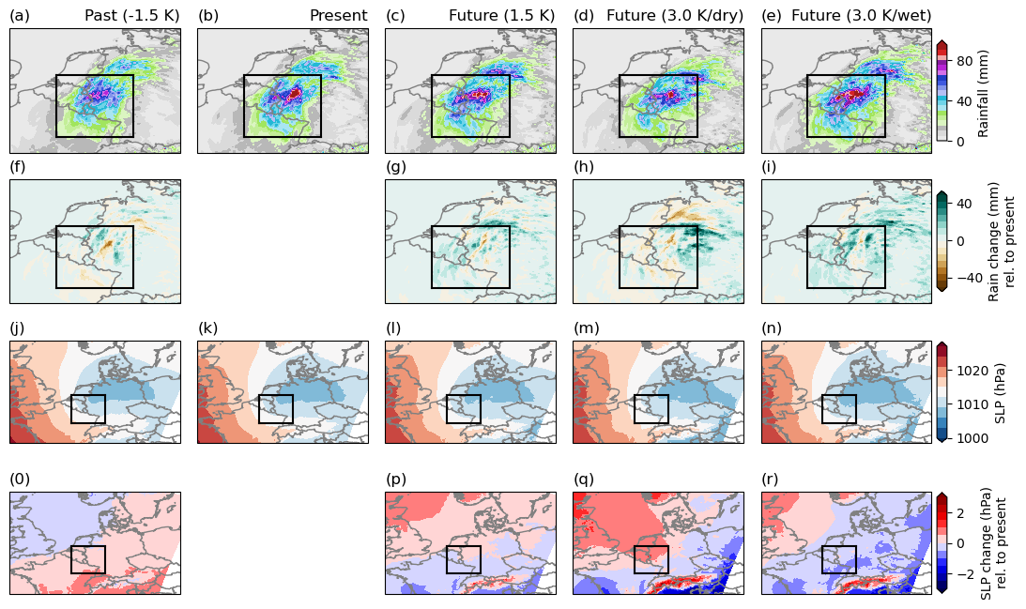
Fig.S2: Pseudo global warming ensemble of 14th July 2021, initialised at 0000 on 14th July. (a-e) Composite of ensemble mean of daily rainfall totals for the event day in past, present, and three future scenarios, initialised from 0000 on 14th July. (f-i) Differences between present day simulations and other scenarios for rainfall. (j-r) As in (a-i) showing SLP. On all, the box indicates the defined event region.

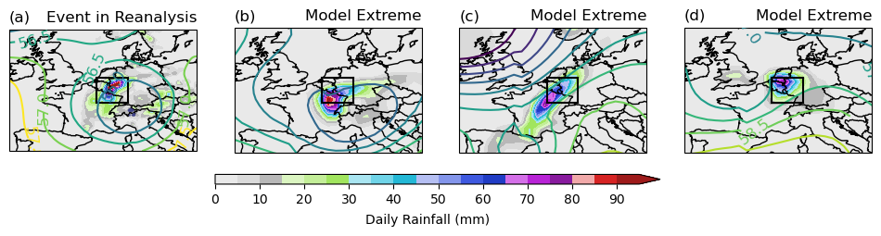Fig.S3: Unprecedented rainfall events within the CESM2 ensemble. (a) July 14th 2021 ERA5 daily rainfall (shading) and Z500 (contours). (b-d) Three summertime days showing unprecedented daily rainfall totals over the event region, rainfall (shaded) and Z500 (contours).

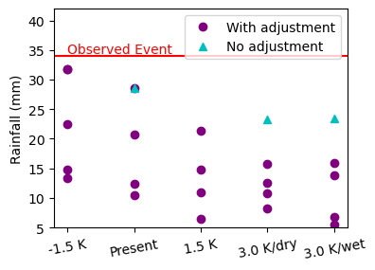
Fig.S4 Total daily rainfall in the pseudo global warming simulations. Showing the total daily rainfall over 48 to 52 °N, 4 to 9 °E for 4 different climates, with (purple circle) and without (teal triangle) a circulation adjustment applied to the initialisation and boundary states.

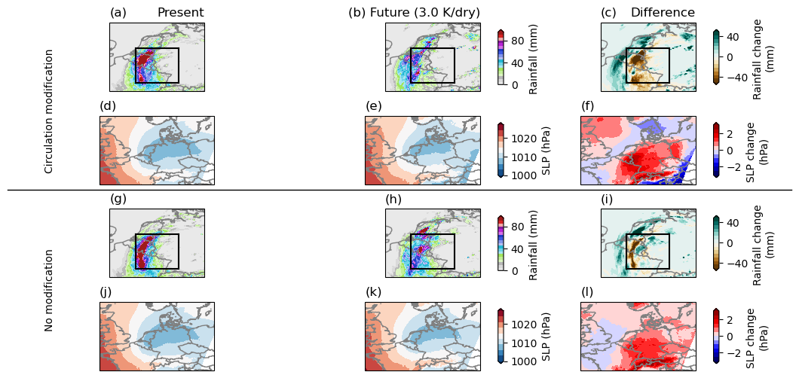
Fig.S5 Impact of modifying the initial circulation in PGW experiments. (a) Single simulation of July 14th 2021 in the present climate (b) As in (a) for a future (3 K/dry) climate. (c) Difference between present and future. (d-f) As in (a-c) for SLP field. (g-l) As in (a-f) for single simulations without a modification in the circulation pattern in the boundary conditions).

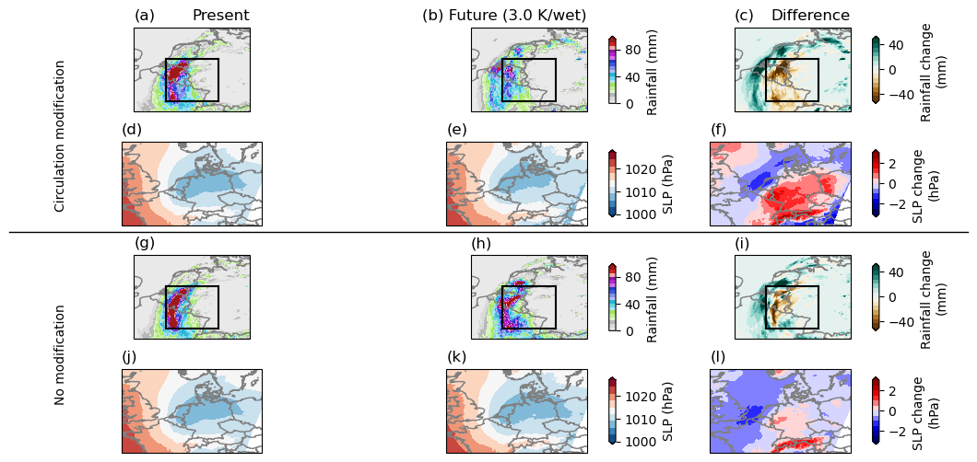
Fig.S6 Impact of modifying the initial circulation in PGW experiments. As in Fig.S5, for a single simulation of 3K/wet future climate.

