Supplementary material

Table 1S. Identified constituents of the essential oil of E. camaldulensis leaves (from the field) determined by GC-MS. Only peaks over 1% of the total area were identified.

Peak number | TR (min) | Area % | % similarity | LRI | Compound
1 | 4.93 | 12.14 | 97 | 948 | α-Pinene
2 | 5.248 | 0.86
3 | 5.981 | 14.25 | 92 | 958 | ꞵ-Myrcene
4 | 6.327 | 0.26
5 | 7.272 | 5.02 | 94 | 1042 | Cymene
6 | 7.377 | 1.36 |  |  | NI
7 | 7.463 | 6.24 | 93 | 1059 | Eucalyptol
8 | 8.219 | 9.86 |  |  | NI
9 | 9.82 | 2.06 | 81 | 1087 | α-Fhenchyl methyl ether
10 | 10.554 | 2.74 | 95 | 1131 | L-Pinocarveol
11 | 10.8 | 0.52
12 | 11.204 | 0.78
13 | 11.343 | 2.18 | 93 | 1138 | Isoborneol
14 | 11.671 | 3.99 | 96 | 1137 | Terpinen-4-ol
15 | 12.125 | 4.05 | 96 | 1143 | Terpineol
16 | 12.286 | 1.02 | 94 | 1191 | Myrtenol
17 | 18.591 | 4.11 | 95 | 1386 | (+)-Aromadendrene
18 | 19.118 | 0.72
19 | 21.599 | 3.62 | 95 | 1530 | Epiglobulol
20 | 21.758 | 0.98
21 | 22.28 | 13.92 | 94 | 1530 | Globulol
22 | 22.399 | 3.55 | 92 | 1530 | Viridiflorol
23 | 22.611 | 1.92 | 84 | 1593 | ꞵ-Eudesmol
24 | 22.901 | 0.87
25 | 23.071 | 1.55 | 83 | 1598 | α-Eudesmol
26 | 23.174 | 0.43
27 | 23.856 | 0.74
28 | 23.965 | 0.26
Total |  | 100
TR: Retention Time; LRI: Linear Retention Index; NI: not identified

Table 2S. Identified constituents of the essential oil of E. camaldulensis leaves from the greenhouse determined by GC-MS. Only peaks over 1% of the total area were identified.

Peak number | TR (min) | Area % | % similarity | LRI | Compound
1 | 4.899 | 2.01 | 97 | 948 | α-Pinene
2 | 5.933 | 0.20
3 | 7.325 | 0.12
4 | 7.447 | 10.64 | 96 | 1059 | Eucalyptol
5 | 9.538 | 0.16
6 | 9.812 | 1.92 | 80 | 1087 | α-Fhenchyl methyl ether
7 | 10.157 | 0.10
8 | 10.549 | 2.76 | 94 | 1131 | L-pinocarveol
9 | 10.795 | 0.17
10 | 11.111 | 0.14
11 | 11.195 | 0.73
12 | 11.339 | 1.71 | 90 | 1138 | Isoborneol
13 | 11.406 | 0.17
14 | 11.662 | 2.45 | 89 | 1137 | Terpinen-4-ol
15 | 12.172 | 11.23 | 96 | 1143 | α-Terpineol
16 | 12.289 | 0.93
17 | 12.768 | 0.20
18 | 12.878 | 0.10
19 | 13.000 | 0.33
20 | 13.210 | 0.74
21 | 13.364 | 0.09
22 | 13.695 | 0.10
23 | 14.129 | 0.67
24 | 14.597 | 0.24
25 | 16.132 | 0.09
26 | 16.325 | 2.89 | 95 | 1333 | Α-terpineol acetate
27 | 16.847 | 0.11
28 | 16.933 | 0.06
29 | 17.288 | 0.25
30 | 17.802 | 0.37
31 | 18.061 | 0.93
32 | 18.273 | 0.16
33 | 18.375 | 0.45
34 | 18.607 | 5.74 | 93 | 1386 | (+)-Aromadendrene
35 | 18.665 | 0.02
36 | 18.925 | 0.15
37 | 19.124 | 2.98 | 96 | 1386 | Alloaromadendrene
38 | 19.385 | 0.16
39 | 19.497 | 0.33
40 | 19.754 | 0.17
41 | 19.801 | 0.14
42 | 19.971 | 1.32 | 93 | 1419 | Viridiflorene
43 | 20.089 | 0.13
44 | 20.428 | 0.67
45 | 20.565 | 0.41
46 | 20.644 | 0.31
47 | 20.807 | 0.24
48 | 20.988 | 0.04
49 | 21.156 | 0.10
50 | 21.24 | 0.04
51 | 21.393 | 0.32
52 | 21.606 | 4.42 | 94 | 1530 | Epiglobulol
53 | 21.764 | 2.61 | 87 | 1530 | Ledol
54 | 22.321 | 16.7 | 92 | 1530 | Globulol
55 | 22.461 | 7.8 | 84 | 1530 | Viridiflorol
56 | 22.633 | 3.65 | 87 | 1593 | ꞵ-Eudesmol
57 | 22.902 | 1.52 |  |  | NI
58 | 23.084 | 4.27 | 82 | 1598 | α-Eudesmol
59 | 23.167 | 0.30
60 | 23.474 | 0.30
61 | 23.732 | 0.16
62 | 23.835 | 1.06 | 82 | 1647 | Eudesm-7(11)-em-4-ol
63 | 23.960 | 0.25
64 | 25.711 | 0.30
65 | 25.918 | 0.17
Total |  | 100
TR: Retention Time; LRI: Linear Retention Index; NI: not identified

Table 3S. Identified constituents of the essential oil of E. dunni leaves from the field determined by GC-MS. Only peaks over 1% of the total area were identified.

Peak number | TR (min) | Area % | % similarity | LRI | Compound
1 | 4.93 | 12.34 | 97 | 948 | α-Pinene
2 | 5.955 | 0.35
3 | 6.344 | 0.60
4 | 6.688 | 0.79
5 | 7.458 | 48.34 | 95 | 1059 | Eucalyptol
6 | 9.144 | 0.20
7 | 9.556 | 0.74
8 | 10.117 | 0.00
9 | 10.579 | 0.54
10 | 11.232 | 0.19
11 | 11.44 | 0.18
12 | 11.683 | 0.62
13 | 12.204 | 13.17 | 97 | 1143 | Terpineol
14 | 17.837 | 0.81
15 | 18.406 | 0.25
16 | 18.619 | 4.12 | 95 | 1386 | (+)-Aromadendrene
17 | 19.14 | 0.66
18 | 20.00 | 0.34
19 | 21.614 | 1.95 | 95 | 1530 | Epiglobulol
20 | 21.777 | 0.53
21 | 22.271 | 8.94 | 90 | 1530 | Globulol
22 | 22.404 | 1.83 | 88 | 1530 | Viridiflorol
23 | 22.626 | 1.00 | 81 | 1593 | ꞵ-Eudesmol
24 | 22.919 | 0.32
25 | 23.092 | 0.69
26 | 23.506 | 0.22
27 | 23.877 | 0.28
Total |  | 100
TR: Retention Time; LRI: Linear Retention Index.

Table 4S. Identified constituents of the essential oil of E. dunni leaves from the greenhouse determined by GC-MS. Only peaks over 1% of the total area were identified.

Peak number | TR (min) | Area % | % similarity | LRI | Compound
1 | 4.891 | 0.37
2 | 7.409 | 5.62 | 96 | 1059 | Eucalyptol
3 | 9.835 | 0.20
4 | 10.560 | 0.49
5 | 11.217 | 0.14
6 | 11.351 | 0.18
7 | 11.430 | 0.12
8 | 11.673 | 0.33
9 | 12.163 | 10.7 | 96 | 1143 | Terpineol
10 | 16.327 | 1.77 | 95 | 1333 | Terpinyl acetate
11 | 16.853 | 0.13
12 | 16.939 | 0.12
13 | 17.373 | 0.05
14 | 17.466 | 0.05
15 | 17.808 | 0.88
16 | 18.064 | 0.75
17 | 18.279 | 0.19
18 | 18.380 | 0.44
19 | 18.631 | 8.22 | 93 | 1386 | (+)-Aromadendrene
20 | 18.932 | 0.21
21 | 19.13 | 2.82 | 88 | 1386 | Alloaromadendrene
22 | 19.394 | 0.22
23 | 19.503 | 0.39
24 | 19.761 | 0.21
25 | 19.808 | 0.25
26 | 19.98 | 1.99 | 94 | 1419 | Viridiflorene
27 | 20.097 | 0.32
28 | 20.441 | 1.69 | 94 | 1435 | γ-Muurolene
29 | 20.578 | 0.95
30 | 20.658 | 1.34 | 90 | 1469 | delta-Cadinene
31 | 20.816 | 0.72
32 | 20.993 | 0.21
33 | 21.156 | 0.17
34 | 21.403 | 0.25
35 | 21.630 | 7.52 | 95 | 1530 | Epiglobulol
36 | 21.772 | 2.65 | 88 | 1530 | Ledol
37 | 21.859 | 0.28
38 | 22.291 | 21.81 | 93 | 1530 | Globulol
39 | 22.492 | 9.33 | 87 | 1530 | Viridiflorol
40 | 22.653 | 4.49 | 90 | 1593 | ꞵ-Eudesmol
41 | 22.917 | 1.64 |  |  | NI
42 | 23.100 | 5.03 | 82 | 1598 | α-Eudesmol
43 | 23.180 | 0.54
44 | 23.481 | 2.22 | 84 | 1626 | γ-Eudesmol
45 | 23.733 | 0.33
46 | 23.840 | 1.49 | 86 | 1647 | Eudesm-7(11)-em-4-ol
47 | 26.627 | 0.18
Total |  | 100
TR: Retention Time; LRI: Linear Retention Index; NI: not identified

Table 5S. Identified constituents of the essential oil of E. exserta leaves from the field determined by GC-MS. Only peaks over 1% of the total area were identified.

Peak number | TR (min) | Area % | % similarity | LRI | Compound
1 | 4.975 | 24.29 | 97 | 948 | α-Pinene
2 | 5.265 | 2.35 | 91 | 956 | Cyclopentene,4-ethenyl-1,5,5-trimethyl
3 | 5.960 | 5.57 | 89 | 958 | ꞵ-Myrcene
4 | 7.495 | 40.8 | 95 | 1059 | Eucalyptol
5 | 8.196 | 0.41
6 | 9.030 | 0.40
7 | 9.844 | 3.17 |  |  | NI
8 | 10.610 | 6.78 | 96 | 1085 | (-)-cis-Sabinol
9 | 10.824 | 0.49
10 | 11.240 | 3.99 | 93 | 1114 | Pinocarvone
11 | 11.385 | 3.97 | 92 | 1138 | Isoborneol
12 | 11.681 | 0.99
13 | 12.158 | 4.67 | 96 | 1143 | Terpineol
14 | 12.301 | 0.59
15 | 18.089 | 0.25
16 | 22.062 | 0.47
17 | 22.217 | 0.81
Total |  | 100
TR: Retention Time; LRI: Linear Retention Index; NI: not identified

Table 6S. Identified constituents of the essential oil of E. exserta leaves from the greenhouse determined by GC-MS. Only peaks over 1% of the total area were identified.

Peak number | TR (min) | Area % | % similarity | LRI | Compound
1 | 4.897 | 1.92 | 97 | 948 | α-Pinene
2 | 5.244 | 0.13
3 | 5.933 | 0.37
4 | 7.274 | 0.19
5 | 7.457 | 10.52 | 96 | 1059 | Eucalyptol
6 | 8.622 | 0.09
7 | 9.141 | 0.12
8 | 9.845 | 4.79 |  |  | NI
9 | 10.076 | 0.09
10 | 10.154 | 0.46
11 | 10.622 | 8.69 | 87 | 1085 | (-)-cis-Sabinol
12 | 10.814 | 0.83
13 | 11.068 | 0.09
14 | 11.214 | 2.40 | 90 | 1114 | Pinocarvone
15 | 11.373 | 4.12 | 93 | 1138 | Isoborneol
16 | 11.582 | 0.09
17 | 11.68 | 1.97 | 93 | 1137 | Terpinen-4-ol
18 | 12.206 | 12.04 | 96 | 1143 | Terpineol
19 | 12.361 | 4.83 | 96 | 1191 | Myrtenol
20 | 12.79 | 0.46
21 | 12.881 | 0.11
22 | 13.011 | 0.75
23 | 13.222 | 0.71
24 | 13.378 | 0.18
25 | 13.638 | 0.07
26 | 13.709 | 0.22
27 | 13.926 | 0.17
28 | 14.609 | 0.42
29 | 15.131 | 0.29
30 | 16.141 | 0.5
31 | 16.335 | 2.2 | 96 | 1333 | Terpinyl acetate
32 | 16.856 | 0.09
33 | 16.943 | 0.14
34 | 17.287 | 0.18
35 | 17.813 | 0.43
36 | 18.081 | 2.25 |  |  | NI
37 | 18.285 | 0.14
38 | 18.385 | 0.27
39 | 18.621 | 5.68 | 94 | 1386 | (+)-Aromadendrene
40 | 18.676 | 0.04
41 | 18.938 | 0.37
42 | 19.129 | 1.96 | 97 | 1386 | Alloaromadendrene
43 | 19.197 | 0.06
44 | 19.396 | 0.14
45 | 19.506 | 0.24
46 | 19.763 | 0.23
47 | 19.809 | 0.05
48 | 19.977 | 1.06 | 94 | 1419 | Viridiflorene
49 | 20.100 | 0.22
50 | 20.435 | 0.68
51 | 20.571 | 0.14
52 | 20.651 | 0.52
53 | 20.833 | 0.10
54 | 20.992 | 0.06
55 | 21.169 | 0.91
56 | 21.386 | 0.52
57 | 21.589 | 1.07 | 93 | 1530 | Epiglobulol
58 | 21.761 | 0.87
59 | 22.088 | 3.06 | 93 | 1536 | (-)-Spathulenol
60 | 22.25 | 4.95 | 95 | 1530 | Globulol
61 | 22.412 | 5.41 | 91 | 1530 | Viridiflorol
62 | 22.608 | 1.42 | 88 | 1593 | ꞵ-Eudesmol
63 | 22.749 | 0.16
64 | 22.918 | 1.75 |  |  | NI
65 | 23.074 | 1.66 | 82 | 1598 | α-Eudesmol
66 | 23.229 | 0.11
67 | 23.274 | 0.18
68 | 23.732 | 2.18 |  |  | NI
69 | 23.787 | 0.06
70 | 23.914 | 0.13
71 | 24.262 | 0.35
72 | 29.324 | 0.34
Total |  | 100
TR: Retention Time; LRI: Linear Retention Index; NI: not identified

Table 7S. Identified constituents of E. globulus leaf essential oil (from the field) determined by GC-MS. Only peaks over 1% of the total area were identified.

Peak number | TR (min) | Area % | % similarity | LRI | Compound
1 | 4.98 | 16.23 | 97 | 948 | α-Pinene
2 | 5.999 | 0.63
3 | 6.384 | 0.63
4 | 7.542 | 67.57 | 95 | 1059 | Eucalyptol
5 | 8.246 | 0.33
6 | 11.742 | 0.35
7 | 12.18 | 1.72 | 94 | 1143 | α-Terpineol
8 | 16.417 | 5.32 | 87 | 1143 | Terpineol
9 | 17.893 | 0.61
10 | 18.66 | 1.57 | 94 | 1386 | (+)-Aromadendrene
11 | 19.195 | 0.45
12 | 20.053 | 0.61
13 | 21.665 | 0.32
14 | 22.282 | 2.64 | 88 | 1461 | γ -Gurjuneno
15 | 22.443 | 0.66
16 | 23.14 | 0.36
Total |  | 100
TR: Retention Time; LRI: Linear Retention Index.

Table 8S. Identified constituents of the essential oil of E. globulus leaves from the greenhouse determined by GC-MS. Only peaks over 1% of the total area were identified.

Peak number | TR (min) | Area % | % similarity | LRI | Compound
1 | 4.876 | 0.52
2 | 7.393 | 6.64 | 96 | 1059 | Eucalyptol
3 | 9.851 | 0.13
4 | 10.593 | 0.27
5 | 11.369 | 0.19
6 | 11.723 | 0.19
7 | 12.145 | 1.74 | 95 | 1143 | Terpineol
8 | 16.321 | 6.45 | 95 | 1333 | Terpinyl acetate
9 | 16.845 | 0.16
10 | 16.931 | 0.08
11 | 17.311 | 0.53
12 | 17.797 | 0.80
13 | 18.052 | 0.63
14 | 18.267 | 0.16
15 | 18.367 | 0.32
16 | 18.588 | 8.81 | 94 | 1386 | (+)-Aromadendrene
17 | 18.656 | 0.05
18 | 18.92 | 0.13
19 | 19.108 | 2.88 | 97 | 1386 | Alloaromadendrene
20 | 19.383 | 0.23
21 | 19.492 | 0.34
22 | 19.753 | 0.11
23 | 19.797 | 0.35
24 | 19.966 | 2.62 | 94 | 1419 | Viridiflorene
25 | 20.088 | 0.2
26 | 20.424 | 0.85
27 | 20.562 | 0.94
28 | 20.64 | 0.77
29 | 20.803 | 0.47
30 | 20.986 | 0.08
31 | 21.158 | 0.19
32 | 21.391 | 0.23
33 | 21.586 | 5.99 | 95 | 1530 | Epiglobulol
34 | 21.747 | 2.54 | 88 | 1530 | Ledol
35 | 21.831 | 0.26
36 | 22.089 | 0.54
37 | 22.274 | 24.84 | 92 | 1530 | Globulol
38 | 22.418 | 12.25 | 88 | 1530 | Viridiflorol
39 | 22.604 | 4.51 | 85 | 1593 | ꞵ-Eudesmol
40 | 22.888 | 1.63 |  |  | NI
41 | 23.067 | 6.7 | 89 | 1598 | α-Eudesmol
42 | 23.156 | 0.22
43 | 23.468 | 0.92
44 | 23.734 | 0.3
45 | 23.839 | 1.24 | 82 | 1647 | Eudesm-7(11)-em-4-ol
Total |  | 100
TR: Retention Time; LRI: Linear Retention Index; NI: not identified

Table 9S. Identified constituents of E. grandis leaf essential oil (from the field) determined by GC-MS. Only peaks over 1% of the total area were identified.

Peak number | TR (min) | Area % | % similarity | LRI | Compound
1 | 4.987 | 25.33 | 98 | 948 | α-Pinene
2 | 5.293 | 1.98 | 90 | 956 | Cyclopentene,4-ethenyl-1,5,5-trimethyl
3 | 5.980 | 0.32
4 | 6.958 | 0.62
5 | 7.326 | 12.97 | 96 | 1042 | o-Cymene
6 | 7.401 | 1.51 | 94 | 1018 | D-Limonene
7 | 7.490 | 6.72 | 94 | 1059 | Eucalyptol
8 | 8.216 | 1.11 |  |  | NI
9 | 9.860 | 1.97 | 80 | 1087 | α-Fhenchyl methyl ether
10 | 10.19 | 1.50 | 81 | 1090 | 4- Methylenecyclohexylmethanol
11 | 10.603 | 3.95 | 94 | 1131 | trans-Pinocarveol
12 | 10.844 | 0.47
13 | 11.239 | 0.90
14 | 11.405 | 4.60 | 97 | 1138 | Isoborneol
15 | 11.705 | 1.24 | 96 | 1137 | Terpinen-4-ol
16 | 12.167 | 5.74 | 96 | 1143 | Terpineol
17 | 14.648 | 0.52
18 | 16.197 | 0.26
19 | 16.589 | 0.35
20 | 16.830 | 0.55
21 | 18.112 | 0.17
22 | 18.392 | 0.00
23 | 18.433 | 0.40
24 | 18.695 | 0.80
25 | 18.942 | 0.00
26 | 19.265 | 5.74 | 69 | 1415 | Tetrahydroactinidiolide
27 | 20.016 | 0.09
28 | 20.161 | 0.10
29 | 20.791 | 4.14 |  |  | NI
30 | 21.240 | 4.02 |  |  | NI
31 | 21.807 | 0.38
32 | 22.100 | 2.95 | 90 | 1536 | (-)-Spathulenol
33 | 22.242 | 0.78
34 | 22.413 | 1.91 | 89 | 1530 | Viridiflorol
35 | 22.658 | 0.60
36 | 22.985 | 3.51 |  |  | NI
37 | 23.150 | 0.36
38 | 23.214 | 0.63
39 | 23.501 | 0.45
40 | 23.770 | 0.17
41 | 23.861 | 0.19
42 | 24.350 | 0.00
Total |  | 100
TR: Retention Time; LRI: Linear Retention Index; NI: not identified

Table 10S. Identified constituents of the essential oil of E. grandis leaves from the greenhouse determined by GC-MS. Only peaks over 1% of the total area were identified.

Peak number | TR (min) | Area % | % similarity | LRI | Compound
1 | 4.886 | 1.94 | 97 | 948 | α-Pinene
2 | 5.232 | 0.06
3 | 5.921 | 0.12
4 | 7.246 | 0.14
5 | 7.408 | 7.30 | 96 | 1059 | Eucalyptol
6 | 8.590 | 0.74
7 | 9.118 | 0.31
8 | 9.308 | 0.08
9 | 9.805 | 2.49 | 79 | 1087 | α-Fhenchyl methyl ether
10 | 10.139 | 2.70 | 83 | 1090 | 4- Methylenecyclohexylmethanol
11 | 10.536 | 1.82 | 96 | 1131 | L-Pinocarveol
12 | 10.646 | 0.12
13 | 10.791 | 0.14
14 | 11.042 | 0.11
15 | 11.119 | 0.21
16 | 11.189 | 0.21
17 | 11.376 | 9.08 | 93 | 1138 | Isoborneol
18 | 11.673 | 0.34
19 | 12.133 | 11.39 | 96 | 1143 | Terpineol
20 | 12.754 | 0.11
21 | 12.981 | 0.44
22 | 14.364 | 0.12
23 | 14.595 | 0.12
24 | 15.514 | 0.07
25 | 15.781 | 0.41
26 | 16.145 | 0.18
27 | 16.315 | 2.35 | 95 | 1333 | Terpinyl acetate
28 | 16.539 | 0.25
29 | 16.786 | 1.99 | 71 | 1330 | Terpinyl formato
30 | 16.926 | 0.18
31 | 17.795 | 0.61
32 | 18.023 | 1.95 |  |  | NI
33 | 18.270 | 0.10
34 | 18.374 | 0.31
35 | 18.612 | 10.82 | 93 | 1386 | (+)-Aromadendrene
36 | 19.111 | 1.34 | 95 | 1386 | Alloaromadendrene
37 | 19.230 | 6.46 | 67 | 1415 | Tetrahydroactinidiolide
38 | 19.747 | 0.23
39 | 19.797 | 0.11
40 | 19.961 | 0.77
41 | 20.107 | 0.80
42 | 20.225 | 0.38
43 | 20.420 | 1.04 | 94 | 1435 | γ-Muurolene
44 | 20.675 | 1.84 |  |  | NI
45 | 20.791 | 0.23
46 | 21.196 | 5.88 |  |  | NI
47 | 21.583 | 1.15 | 96 | 1530 | Epiglobulol
48 | 21.752 | 0.68
49 | 22.035 | 1.15 | 95 | 1536 | (-)-Spathulenol
50 | 22.194 | 2.68 | 94 | 1530 | Globulol
51 | 22.361 | 2.81 | 89 | 1530 | Viridiflorol
52 | 22.540 | 0.38
53 | 22.710 | 1.63 |  |  | NI
54 | 22.945 | 7.61 |  |  | NI
55 | 23.091 | 0.53
56 | 23.149 | 0.49
57 | 23.228 | 0.14
58 | 23.273 | 0.09
59 | 23.451 | 0.24
60 | 23.715 | 1.53 |  |  | NI
61 | 27.125 | 0.09
62 | 27.717 | 0.19
63 | 29.309 | 0.22
Total |  | 100
TR: Retention Time; LRI: Linear Retention Index; NI: not identified

Table 11S. Identified constituents of the essential oil of C. henryi leaves from the field determined by GC-MS. Only peaks over 1% of the total area were identified.

Peak number | TR (min) | Area % | % similarity | LRI | Compound
1 | 4.761 | 1.23 | 95 | 902 | α-Tujeno
2 | 4.919 | 49.60 | 97 | 948 | α-Pinene
3 | 5.956 | 10.92 | 97 | 958 | ꞵ-Myrcene
4 | 7.268 | 0.66
5 | 7.352 | 1.40 | 94 | 1018 | D-Limonene
6 | 7.441 | 1.70 | 91 | 1059 | Eucalyptol
7 | 8.202 | 11.87 | 91 | 1327 | Acetato de 4-terpinenil
8 | 20.032 | 0.38
9 | 20.471 | 0.34
10 | 20.684 | 0.54
11 | 21.423 | 0.22
12 | 21.630 | 0.29
13 | 21.800 | 0.23
14 | 22.075 | 2.21 | 87 | 1536 | (-)-Spathulenol
15 | 22.227 | 3.20 | 88 | 1574 | ꞵ-Humulene
16 | 22.395 | 0.85
17 | 22.644 | 0.88
18 | 22.893 | 0.38
19 | 23.129 | 0.61
20 | 23.198 | 1.09 |  |  | NI
21 | 23.316 | 0.13
22 | 23.506 | 8.27 | 89 | 1580 | t-Cadinol
23 | 23.652 | 0.37
24 | 23.769 | 0.62
25 | 23.856 | 2.01 | 83 | 1647 | Eudesm-7(11)-em-4-ol
Total |  | 100
TR: Retention Time; LRI: Linear Retention Index; NI: not identified

Table 12S. Identified constituents of the essential oil of C. henryi leaves from the greenhouse determined by GC-MS. Only peaks over 1% of the total area were identified.

Peak number | TR (min) | Area % | % similarity | LRI | Compound
1 | 4.891 | 0.15
2 | 5.932 | 0.05
3 | 7.404 | 2.55 | 93 | 1059 | Eucalyptol
4 | 9.853 | 0.11
5 | 10.594 | 0.15
6 | 11.372 | 0.10
7 | 11.72 | 0.13
8 | 12.129 | 1.93 | 95 | 1143 | Terpineol
9 | 16.147 | 0.06
10 | 16.246 | 0.07
11 | 16.329 | 1.22 | 95 | 1333 | Terpinyl acetate
12 | 16.855 | 0.06
13 | 16.942 | 0.23
14 | 17.376 | 0.05
15 | 17.463 | 0.07
16 | 17.809 | 0.48
17 | 18.067 | 0.87
18 | 18.283 | 0.10
19 | 18.378 | 0.13
20 | 18.447 | 0.02
21 | 18.605 | 4.27 | 94 | 1386 | (+)-Aromadendrene
22 | 18.669 | 0.02
23 | 18.756 | 0.09
24 | 18.849 | 0.22
25 | 18.933 | 0.46
26 | 19.121 | 1.15 | 95 | 1386 | Alloaromadendrene
27 | 19.426 | 0.58
28 | 19.509 | 0.56
29 | 19.757 | 0.14
30 | 19.805 | 0.03
31 | 19.893 | 0.28
32 | 19.976 | 0.65
33 | 20.110 | 0.82
34 | 20.479 | 4.49 | 94 | 1435 | γ-Muurolene
35 | 20.594 | 0.12
36 | 20.729 | 6.91 | 89 | 1440 | ꞵ-Cadinene
37 | 20.887 | 0.25
38 | 21.010 | 1.05 | 95 | 1440 | α-Muurolene
39 | 21.153 | 0.32
40 | 21.417 | 6.12 | 96 | 1522 | Elemol
41 | 21.599 | 0.59
42 | 21.763 | 0.53
43 | 22.086 | 3.18 | 94 | 1536 | (-)-Spathulenol
44 | 22.221 | 1.89 | 95 | 1530 | Globulol
45 | 22.381 | 1.02 | 92 | 1530 | Viridiflorol
46 | 22.521 | 2.27 |  |  | NI
47 | 22.625 | 1.20 | 82 | 1580 | Cubenol
48 | 22.768 | 3.23 |  |  | NI
49 | 22.884 | 2.04 | 79 | 1580 | t-Muurolol
50 | 23.069 | 0.29
51 | 23.187 | 0.85
52 | 23.329 | 5.61 | 89 | 1598 | Agarospirol
53 | 23.611 | 12.96 | 83 | 1614 | Guaiol
54 | 23.895 | 22.26 | 73 | 1614 | Bulnesol
55 | 24.140 | 0.62
56 | 24.201 | 0.18
57 | 24.565 | 0.49
58 | 24.928 | 0.63
59 | 25.300 | 0.75
60 | 25.373 | 0.07
61 | 25.819 | 0.07
62 | 26.126 | 0.06
63 | 27.372 | 0.02
64 | 27.459 | 0.39
65 | 27.675 | 0.13
66 | 28.556 | 0.30
67 | 29.432 | 0.05
68 | 29.569 | 0.03
69 | 30.667 | 0.09
70 | 36.293 | 0.03
71 | 37.184 | 0.14
72 | 37.54 | 0.08
73 | 37.619 | 0.06
74 | 37.876 | 0.07
75 | 38.645 | 0.56
76 | 39.146 | 0.20
Total |  | 100
TR: Retention Time; LRI: Linear Retention Index; NI: not identified

Table 13S. Identified constituents of the essential oil of E. pellita leaves from the field determined by GC-MS. Only peaks over 1% of the total area were identified.

Peak number | TR (min) | Area % | % similarity | LRI | Compound
1 | 4.900 | 47.23 | 97 | 948 | α-Pinene
2 | 5.304 | 5.73 | 97 | 943 | Canphene
3 | 5.992 | 6.04 | 97 | 943 | ꞵ-Pinene
4 | 6.364 | 0.40
5 | 7.467 | 8.64 | 94 | 1059 | Eucalyptol
6 | 7.651 | 2.20 |  |  | NI
7 | 7.937 | 0.28
8 | 8.221 | 0.39
9 | 9.057 | 0.70
10 | 9.578 | 0.19
11 | 9.866 | 2.47 | 80 | 1087 | α-Fhenchyl methyl ether
12 | 10.198 | 0.21
13 | 10.606 | 3.86 | 94 | 1131 | trans-Pinocarveol
14 | 10.850 | 0.28
15 | 11.244 | 1.07 | 78 | 1136 | Myrtenal
16 | 11.403 | 3.8 | 93 | 1138 | Isoborneol
17 | 11.565 | 0.22
18 | 11.722 | 0.45
19 | 12.173 | 5.28 | 95 | 1143 | Terpineol
20 | 12.335 | 0.18
21 | 13.042 | 0.20
22 | 18.140 | 3.22 | 96 | 1494 | Caryophyllene
23 | 18.986 | 0.45
24 | 20.056 | 0.45
25 | 21.438 | 0.21
26 | 21.812 | 0.22
27 | 22.101 | 0.87
28 | 22.188 | 1.16 | 79 | 1599 | Trans-Longipinocarveol
29 | 22.244 | 0.35
30 | 22.417 | 0.79
31 | 22.658 | 0.45
32 | 22.787 | 0.16
33 | 23.115 | 0.20
34 | 23.221 | 1.65 |  |  | NI
Total |  | 100
TR: Retention Time; LRI: Linear Retention Index; NI: not identified

Table 14S. Identified constituents of E. pellita leaf essential oil (from the greenhouse) determined by GC-MS. Only peaks over 1% of the total area were identified.

Peak number | TR (min) | Area % | % similarity |  | LRI | Compound
1 | 4.884 | 1.85 | 97 |  | 948 | α-Pinene
2 | 5.232 | 0.06
3 | 5.923 | 0.20
4 | 7.249 | 0.07
5 | 7.329 | 0.18
6 | 7.401 | 3.49 | 93 |  | 1059 | Eucalyptol
7 | 9.811 | 2.61 | 80 |  | 1087 | α-Fhenchyl methyl ether
8 | 10.161 | 0.22
9 | 10.547 | 3.10 | 94 |  | 1131 | L-Pinocarveol
10 | 10.793 | 0.23
11 | 11.046 | 0.05
12 | 11.110 | 0.29
13 | 11.195 | 0.65
14 | 11.348 | 4.27 | 92 |  | 1138 | Isoborneol
15 | 11.508 | 0.04
16 | 11.670 | 1.24 | 92 |  | 1137 | Terpinen-4-ol
17 | 12.150 | 8.22 | 94 |  | 1143 | Terpineol
18 | 12.281 | 0.85
19 | 12.768 | 0.18
20 | 12.993 | 0.12
21 | 13.223 | 0.42
22 | 14.600 | 0.48
23 | 16.343 | 5.22 | 96 |  | 1333 | Terpinyl acetate
24 | 16.857 | 0.36
25 | 16.944 | 0.49
26 | 17.815 | 1.33 |  |  |  | NI
27 | 18.090 | 4.82 | 90 |  | 1386 | 1,1,7-Trimethyl-4-methylenedecahydro  -1H-cyclopropa(e)azulene
28 | 18.288 | 0.44
29 | 18.390 | 0.91
30 | 18.661 | 12.32 | 93 |  | 1386 | (+)-Aromadendrene
31 | 18.941 | 1.01 |  |  |  | NI
32 | 19.150 | 5.04 | 95 |  | 1386 | Alloaromadendrene
33 | 19.396 | 0.30
34 | 19.508 | 0.65
35 | 19.762 | 0.45
36 | 19.813 | 0.18
37 | 19.981 | 1.97 | 93 |  | 1419 | Viridiflorene
38 | 20.100 | 0.74
39 | 20.447 | 2.68 | 93 |  | 1435 | γ-Muurolene
40 | 20.575 | 0.26
41 | 20.670 | 2.99 | 77 |  | 1469 | delta-Cadinene
42 | 20.993 | 0.23
43 | 21.155 | 0.26
44 | 21.379 | 1.03 | 83 |  | 1507 | Óxido de Caryophyllene
45 | 21.586 | 1.16 | 94 |  | 1530 | Epiglobulol
46 | 21.756 | 0.94
47 | 22.063 | 1.24 | 90 |  | 1536 | (-)-Spathulenol
48 | 22.132 | 0.48
49 | 22.230 | 5.46 | 94 |  | 1530 | Globulol
50 | 22.388 | 4.28 | 91 |  | 1530 | Viridiflorol
51 | 22.608 | 2.02 | 83 |  | 1580 | Cubenol
52 | 22.741 | 0.66
53 | 22.899 | 0.28
54 | 23.066 | 1.19 | 80 |  | 1598 | α-Eudesmol
55 | 23.188 | 4.91 | 77 |  | 1757 | Humulano-1,6-dien-3-ol
56 | 23.325 | 0.15
57 | 23.413 | 0.34
58 | 23.468 | 0.18
59 | 23.500 | 0.10
60 | 23.606 | 0.44
61 | 23.717 | 0.31
62 | 23.818 | 0.70
63 | 23.909 | 0.34
64 | 24.251 | 0.67
65 | 25.903 | 0.25
66 | 26.571 | 0.18
67 | 27.138 | 0.21
68 | 29.324 | 1.01 |  |  |  | NI
Total |  | 100
TR: Retention Time; LRI: Linear Retention Index; NI: not identified

Table 15S. Identified constituents of the essential oil of E. resinifera leaves from the field determined by GC-MS. Only peaks over 1% of the total area were identified.

Peak number | TR (min) | Area % | % similarity | LRI | Compound
1 | 4.932 | 18.96 | 97 | 948 | α-Pinene
2 | 5.247 | 0.52
3 | 5.937 | 0.36
4 | 7.458 | 52.15 | 96 | 1059 | Eucalyptol
5 | 9.822 | 0.91
6 | 10.162 | 0.55
7 | 10.558 | 5.49 | 95 | 1131 | L-Pinocarveol
8 | 11.202 | 2.55 | 77 | 1136 | Myrtenal
9 | 11.345 | 1.37 | 92 | 1138 | Isoborneol
10 | 11.691 | 0.43
11 | 12.119 | 6.50 | 97 | 1143 | Terpineol
12 | 18.079 | 2.82 | 95 | 1494 | Caryophyllene
13 | 18.941 | 0.37
14 | 20.012 | 0.39
15 | 21.399 | 0.26
16 | 21.592 | 0.16
17 | 21.762 | 0.30
18 | 22.056 | 2.31 | 93 | 1536 | (-)-Spathulenol
19 | 22.132 | 1.09 |  |  | NI
20 | 22.198 | 0.48
21 | 22.365 | 0.64
22 | 22.613 | 0.48
23 | 23.083 | 0.34
24 | 23.474 | 0.57
Total |  | 100
TR: Retention Time; LRI: Linear Retention Index; NI: not identified

Table 16S. Identified constituents of the essential oil of E. resinifera leaves from the greenhouse determined by GC-MS. Only peaks over 1% of the total area were identified.

Peak number | TR (min) | Area % | % similarity | LRI | Compound
1 | 4.908 | 6.85 | 98 | 948 | α-Pinene
2 | 5.246 | 0.93
3 | 5.937 | 0.12
4 | 7.413 | 30.27 | 96 | 1059 | Eucalyptol
5 | 8.619 | 0.15
6 | 9.128 | 0.65
7 | 9.815 | 3.10 | 80 | 1087 | α-Fhenchyl methyl ether
8 | 10.151 | 0.53
9 | 10.597 | 10.69 | 95 | 1131 | L-Pinocarveol
10 | 10.775 | 0.00
11 | 11.033 | 0.00
12 | 11.208 | 3.73 | 77 | 1136 | Myrtenal
13 | 11.358 | 5.10 | 93 | 1138 | Isoborneol
14 | 11.425 | 0.00
15 | 11.492 | 0.00
16 | 11.674 | 0.40
17 | 12.129 | 5.63 | 95 | 1143 | Terpineol
18 | 12.294 | 0.22
19 | 12.733 | 0.00
20 | 12.99 | 0.21
21 | 13.25 | 0.01
22 | 13.366 | 0.24
23 | 14.567 | 0.00
24 | 14.983 | 0.00
25 | 16.323 | 2.07 | 95 | 1333 | Terpinyl acetate
26 | 16.817 | 0.00
27 | 16.908 | 0.00
28 | 17.803 | 0.34
29 | 18.072 | 2.68 | 89 | 1386 | 1,1,7-Trimethyl-4-methylenedecahydro  -1H-cyclopropa(e)azulene
30 | 18.242 | 0.00
31 | 18.373 | 0.2
32 | 18.425 | 0.00
33 | 18.592 | 5.72 | 94 | 1386 | (+)-Aromadendrene
34 | 18.650 | 0.00
35 | 18.927 | 0.48
36 | 19.113 | 1.80 | 96 | 1386 | Alloaromadendrene
37 | 19.358 | 0.00
38 | 19.458 | 0.00
39 | 19.717 | 0.00
40 | 19.792 | 0.00
41 | 19.968 | 0.69
42 | 20.067 | 0.00
43 | 20.429 | 0.53
44 | 20.567 | 0.09
45 | 20.646 | 0.40
46 | 20.832 | 0.24
47 | 21.375 | 0.99
48 | 21.576 | 0.64
49 | 21.748 | 0.42
50 | 21.841 | 0.22
51 | 22.061 | 4.36 | 94 | 1536 | (-)-Spathulenol
52 | 22.200 | 2.75 | 95 | 1530 | Globulol
53 | 22.358 | 2.07 | 93 | 1530 | Viridiflorol
54 | 22.593 | 0.97
55 | 22.726 | 0.22
56 | 23.055 | 0.61
57 | 23.320 | 0.07
58 | 23.419 | 1.16 | 82 | 1586 | ꞵ-Cedren-9-α-ol
59 | 23.716 | 0.93
60 | 23.914 | 0.52
61 | 24.233 | 0.00
Total |  | 100
TR: Retention Time; LRI: Linear Retention Index.

Tabela 17S. Identified constituents of the essential oil of E. saligna from the field determined by GC-MS. Only peaks over 1% of the total area were identified.

Peak number | TR (min) | Area % | % similarity | LRI | Compound
1 | 4.89 | 2.74 | 96 | 948 | α-Pinene
2 | 7.226 | 86.24 | 95 | 1042 | o-Cymene
3 | 7.405 | 5.28 | 89 | 1059 | Eucalyptol
4 | 8.185 | 1.6 | 91 | 1327 | 4-terpinenyl acetate
05 | 18.084 | 1.87 | 95 | 1494 | Caryophyllene
6 | 22.175 | 2.27 | 92 | 1536 | (-)-Spathulenol
Total |  | 100
TR: Retention Time; LRI: Linear Retention Index.

Table 18S. Identified constituents of the essential oil of E. saligna leaves from the greenhouse determined by GC-MS. Only peaks over 1% of the total area were identified.

Peak number | TR (min) | Area % | % similarity | LRI | Compound
1 | 4.891 | 1.05 | 94 | 948 | α-Pinene
2 | 7.428 | 2.98 | 90 | 1059 | Eucalyptol
3 | 9.900 | 0.64
4 | 10.691 | 0.77
5 | 11.413 | 2.87 | 92 | 1138 | Isoborneol
6 | 16.423 | 1.56 | 93 | 1333 | Terpinyl acetate
7 | 16.877 | 0.17
8 | 17.818 | 0.57
9 | 18.075 | 0.97
10 | 18.285 | 0.15
11 | 18.385 | 0.25
12 | 18.451 | 0.13
13 | 18.572 | 10.53 | 93 | 1386 | (+)-Aromadendrene
14 | 18.686 | 0.18
15 | 18.971 | 0.28
16 | 19.12 | 2.88 | 94 | 1386 | Alloaromadendrene
17 | 19.224 | 4.15 | 72 | 1415 | Tetrahydroactinidiolide
18 | 19.400 | 0.06
19 | 19.819 | 0.20
20 | 19.984 | 2.01 | 94 | 1419 | Viridiflorene
21 | 20.168 | 0.19
22 | 20.266 | 0.46
23 | 20.450 | 0.31
24 | 20.747 | 0.28
25 | 21.186 | 6.89 |  |  | NI
26 | 21.416 | 0.57
27 | 21.608 | 1.60 | 93 | 1530 | Epiglobulol
28 | 21.777 | 2.96 | 89 | 1530 | Ledol
29 | 21.885 | 0.08
30 | 22.057 | 8.99 | 95 | 1536 | (-)-Spathulenol
31 | 22.210 | 13.12 | 94 | 1530 | Globulol
32 | 22.372 | 14.87 | 93 | 1530 | Viridiflorol
33 | 22.628 | 3.10 | 83 | 1580 | Cubenol
34 | 22.740 | 0.44
35 | 22.921 | 7.84 |  |  | NI
36 | 23.114 | 2.77 | 80 | 1598 | α-Eudesmol
37 | 23.208 | 0.27
38 | 23.524 | 1.80 |  |  | NI
39 | 23.803 | 0.39
40 | 23.900 | 0.67
41 | 24.317 | 0.00
42 | 25.617 | 0.00
43 | 26.142 | 0.00
Total |  | 100
TR: Retention Time; LRI: Linear Retention Index; NI: not identified

Table 19S. Identified constituents of the essential oil of E. urophylla leaves from the field determined by GC-MS. Only peaks over 1% of the total area were identified.

Peak number | TR (min) | Area % | % similarity | LRI | Compound
1 | 4.909 | 11.06 | 97 | 948 | α-Pinene
2 | 6.325 | 0.53
3 | 6.673 | 5.21 | 96 | 969 | α-Phellandrene
4 | 7.408 | 8.14 | 95 | 1042 | o-Cymene
5 | 7.571 | 41.41 | 95 | 1059 | Eucalyptol
6 | 7.632 | 0.72
7 | 8.185 | 2.41 | 96 | 1327 | 4-terpinenyl acetate
8 | 11.681 | 1.58 | 95 | 1137 | Terpinen-4-ol
9 | 12.125 | 2.10 | 96 | 1143 | Terpineol
10 | 16.405 | 16.47 | 93 | 1333 | Terpinyl acetate
11 | 18.086 | 1.00 | 96 | 1494 | Caryophyllene
12 | 20.026 | 1.53 | 86 | 1499 | Biciclogermacreno
13 | 22.056 | 1.30 | 93 | 1536 | (-)-Spathulenol
14 | 22.214 | 2.50 | 88 | 1530 | Globulol
15 | 22.384 | 2.02 | 88 | 1530 | Viridiflorol
16 | 22.623 | 0.90
17 | 23.183 | 1.12 | 81 | 1580 | (-)-delta-Cadinol
Total |  | 100
TR: Retention Time; LRI: Linear Retention Index.

Table 20S. Identified constituents of the essential oil of E. urophylla leaves from the greenhouse determined by GC-MS. Only peaks over 1% of the total area were identified.

Peak number | TR (min) | Area % | % similarity | LRI | Compound
1 | 4.886 | 1.08 | 96 | 948 | α-Pinene
2 | 5.926 | 0.07
3 | 7.431 | 8.66 | 96 | 1059 | Eucalyptol
4 | 9.824 | 0.45
5 | 10.187 | 0.06
6 | 10.558 | 0.58
7 | 11.118 | 0.13
8 | 11.218 | 0.13
9 | 11.341 | 0.85
10 | 11.438 | 0.07
11 | 11.678 | 0.49
12 | 12.116 | 3.99 | 97 | 1143 | Terpineol
13 | 12.297 | 0.13
14 | 12.767 | 0.09
15 | 13.259 | 0.17
16 | 14.608 | 0.26
17 | 15.456 | 0.13
18 | 16.141 | 0.63
19 | 16.425 | 13.27 | 97 | 1333 | Terpinyl acetate
20 | 16.767 | 0.12
21 | 16.878 | 0.25
22 | 16.965 | 0.33
23 | 17.263 | 2.51 | 96 | 1352 | Geranyl acetate
24 | 17.480 | 0.08
25 | 17.827 | 1.49 |  |  | NI
26 | 17.952 | 0.07
27 | 18.081 | 1.43 | 90 | 1386 | 1,1,7-Trimethyl-4-methylenedecahydro  -1H-cyclopropa(e)azulene
28 | 18.292 | 0.34
29 | 18.394 | 0.56
30 | 18.461 | 0.04
31 | 18.676 | 12.53 | 94 | 1386 | (+)-Aromadendrene
32 | 18.947 | 0.37
33 | 19.159 | 3.7 | 96 | 1386 | Alloaromadendrene
34 | 19.402 | 0.42
35 | 19.514 | 0.63
36 | 19.772 | 0.32
37 | 19.824 | 0.46
38 | 19.998 | 2.71 | 93 | 1419 | Viridiflorene
39 | 20.107 | 0.64
40 | 20.204 | 0.12
41 | 20.460 | 2.86 | 94 | 1435 | γ-Muurolene
42 | 20.590 | 0.68
43 | 20.683 | 2.96 | 89 | 1469 | delta-Cadinene
44 | 20.829 | 0.24
45 | 20.999 | 0.34
46 | 21.156 | 0.35
47 | 21.393 | 0.41
48 | 21.599 | 2.65 | 94 | 1530 | Epiglobulol
49 | 21.764 | 1.33 | 90 | 1530 | Ledol
50 | 21.876 | 0.30
51 | 22.072 | 1.67 | 95 | 1536 | (-)-Spathulenol
52 | 22.259 | 7.71 | 95 | 1530 | Globulol
53 | 22.415 | 4.85 | 89 | 1530 | Viridiflorol
54 | 22.504 | 0.05
55 | 22.623 | 2.38 | 83 | 1580 | Cubenol
56 | 22.746 | 0.24
57 | 22.904 | 1.12 |  |  | NI
58 | 23.074 | 1.85 |  |  | NI
59 | 23.186 | 2.70 | 79 | 1580 | (-)-delta-Cadinol
60 | 23.275 | 0.03
61 | 23.473 | 2.16 | 90 | 1580 | t-Cadinol
62 | 23.615 | 0.36
63 | 23.724 | 0.76
64 | 23.820 | 0.62
65 | 23.921 | 0.08
66 | 24.104 | 0.06
67 | 24.255 | 0.41
68 | 27.704 | 0.26
69 | 29.321 | 0.04
70 | 32.875 | 0.17
Total |  | 100
TR: Retention Time; LRI: Linear Retention Index; NI: not identified

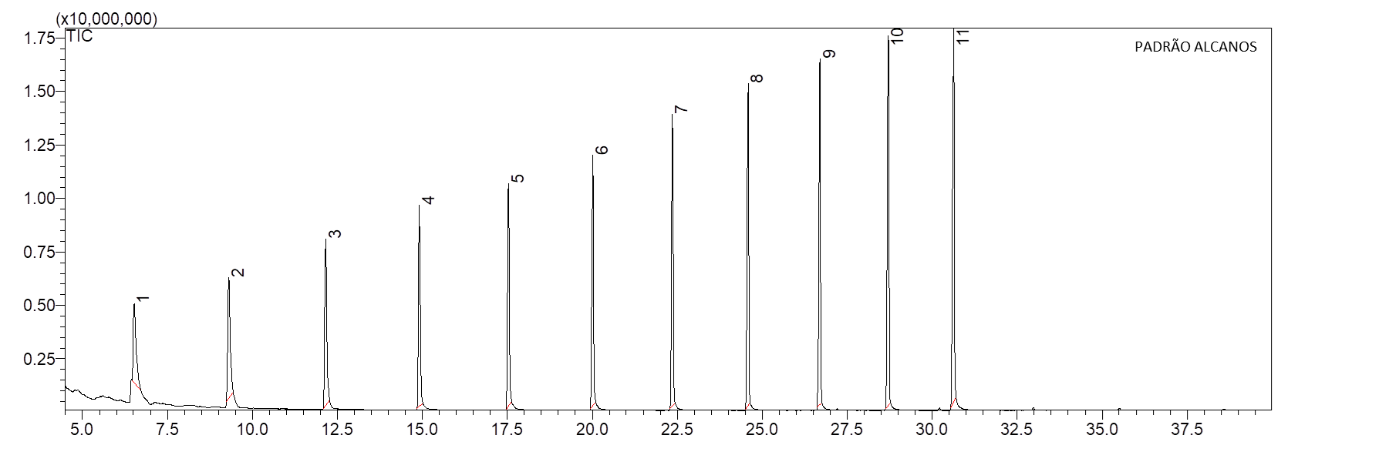
Figure 1S. Chromatogram obtained from GC-MS analysis of standard sample of n-alkanes (C8–C20).

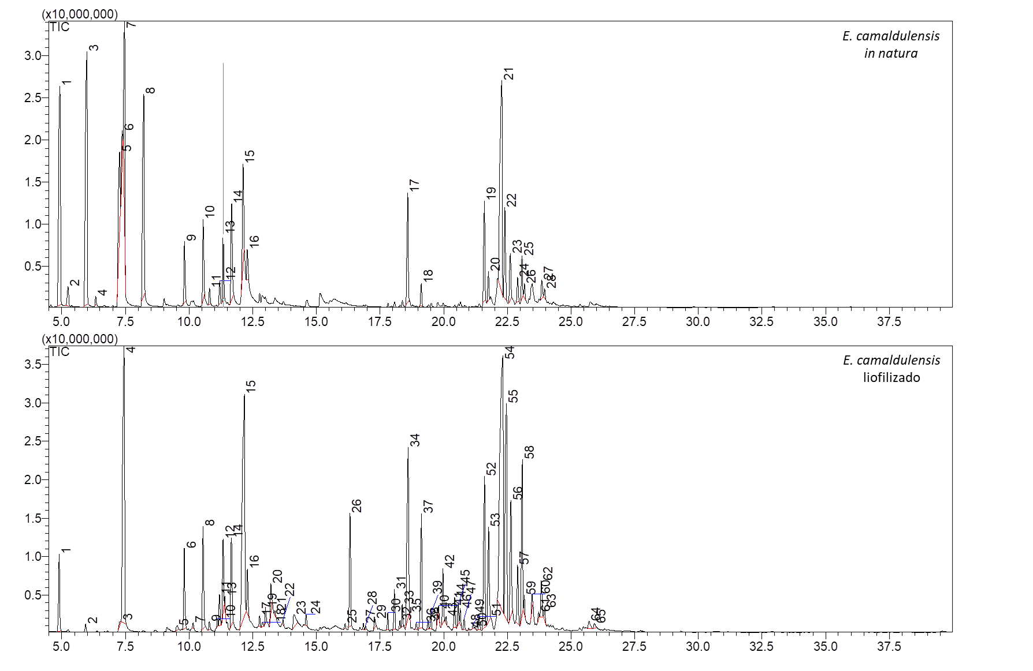
Figure 2S. Chromatogram obtained from the GC-MS analysis of the essential oil of E. camaldulensis extracted from the fresh leaves of adult plants grown in the field and the essential oil of E. camaldulensis extracted from the lyophilized leaves of young plants grown in the greenhouse.

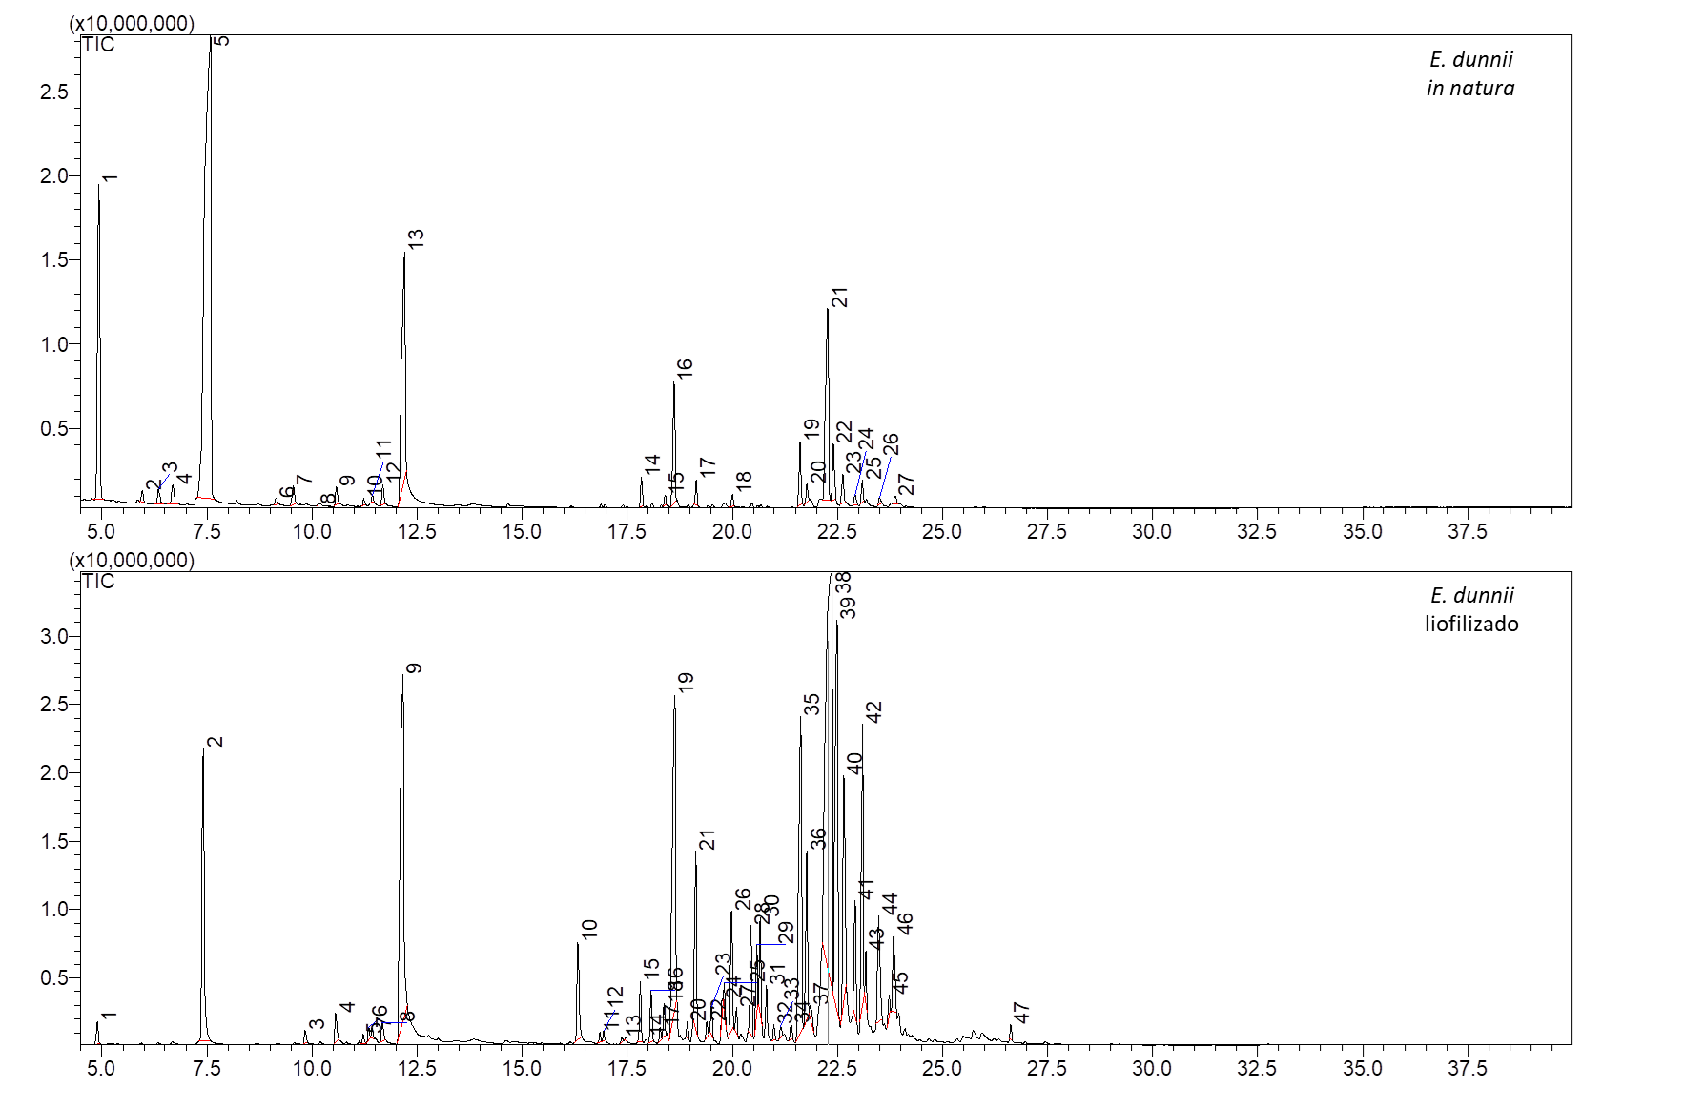
Figure 3S. Chromatogram obtained from the GC-MS analysis of E. dunnii essential oil extracted from fresh leaves of adult plants grown in field and E. dunnii essential oil extracted from freeze-dried leaves of young plants grown in greenhouse.

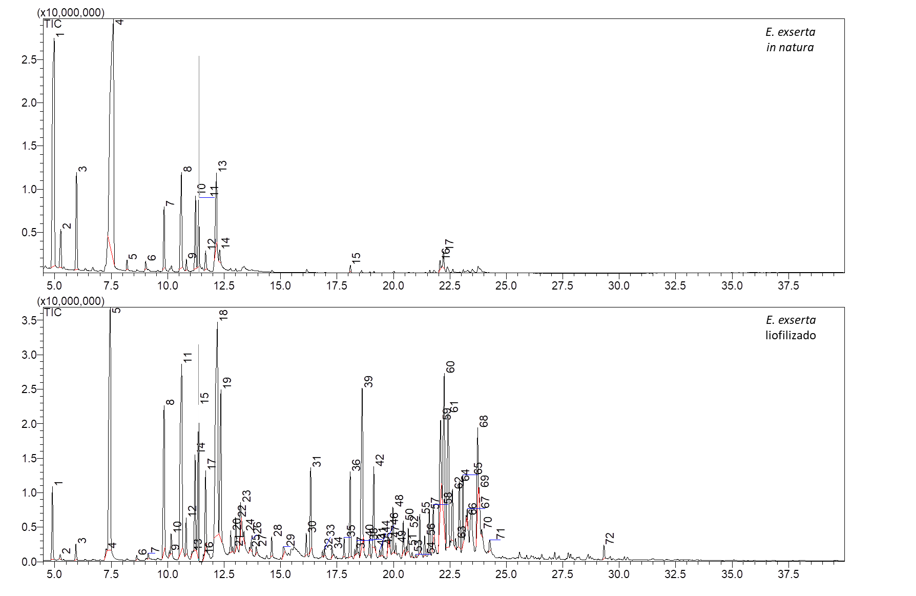
Figure 4S. Chromatogram obtained from GC-MS analysis of E. exserta essential oil extracted from fresh leaves of adult plants grown in field and E. exserta essential oil extracted from freeze-dried leaves of young plants grown in greenhouse.

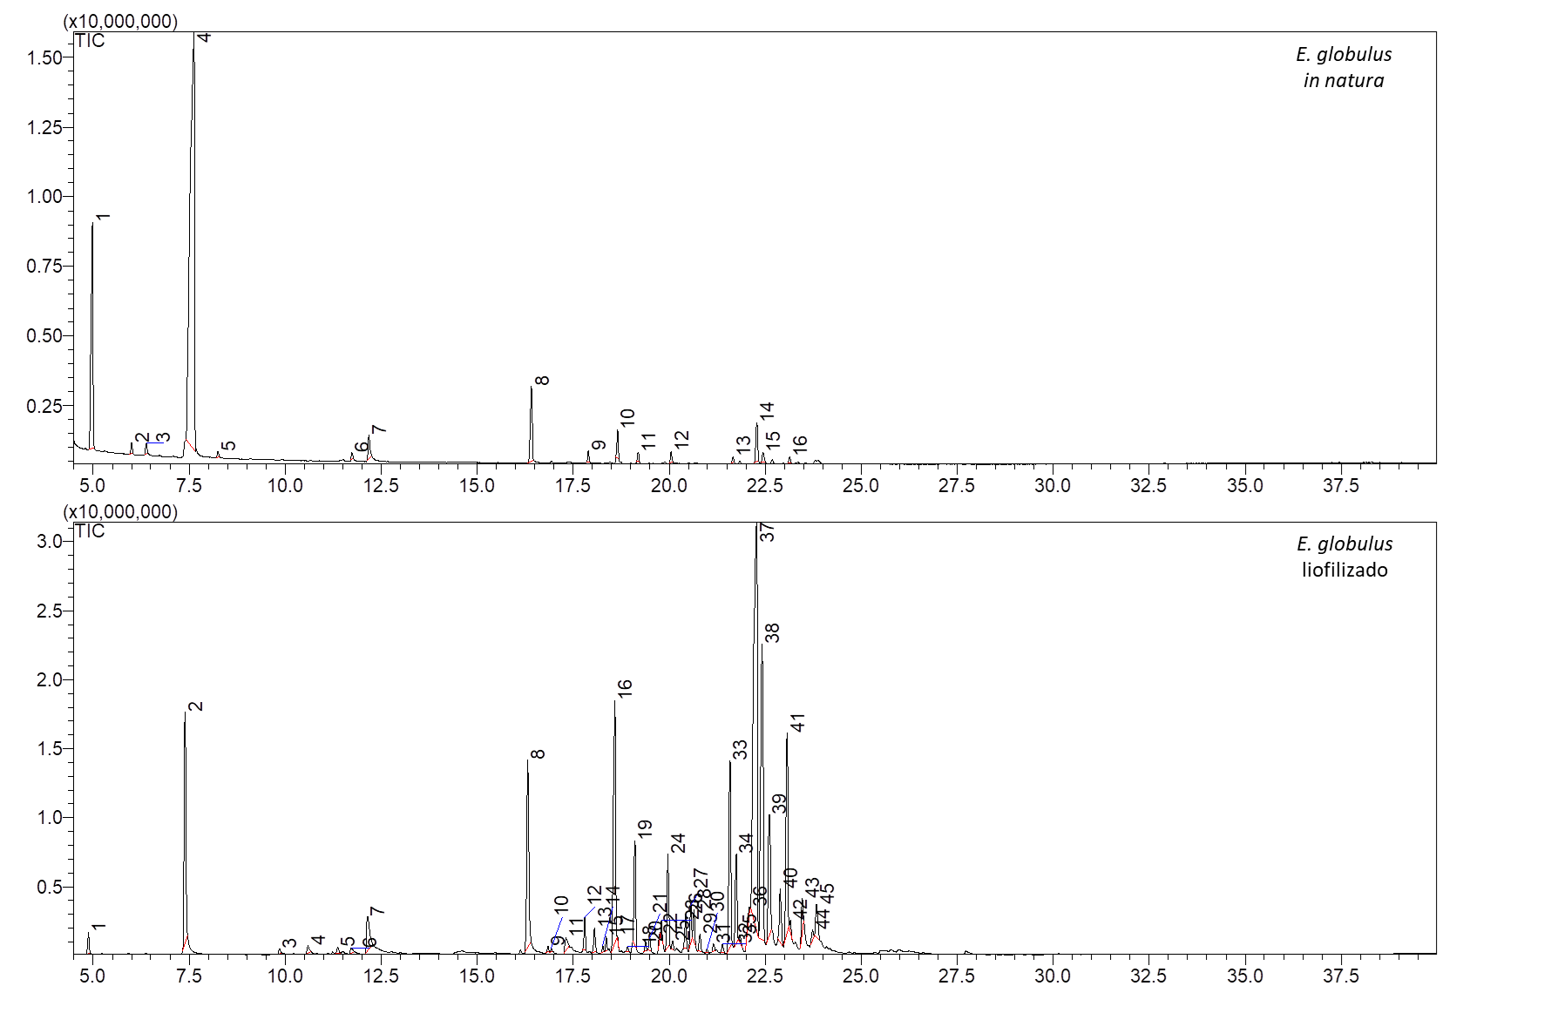
Figure 5S. Chromatogram obtained from the GC-MS analysis of E. globulus essential oil extracted from fresh leaves of adult plants grown in field and E. globulus essential oil extracted from freeze-dried leaves of young plants grown in greenhouse.

Figure 6S. Chromatogram obtained from the GC-MS analysis of E. grandis essential oil extracted from fresh leaves of adult plants grown in field and E. grandis essential oil extracted from freeze-dried leaves of young plants grown in greenhouse.

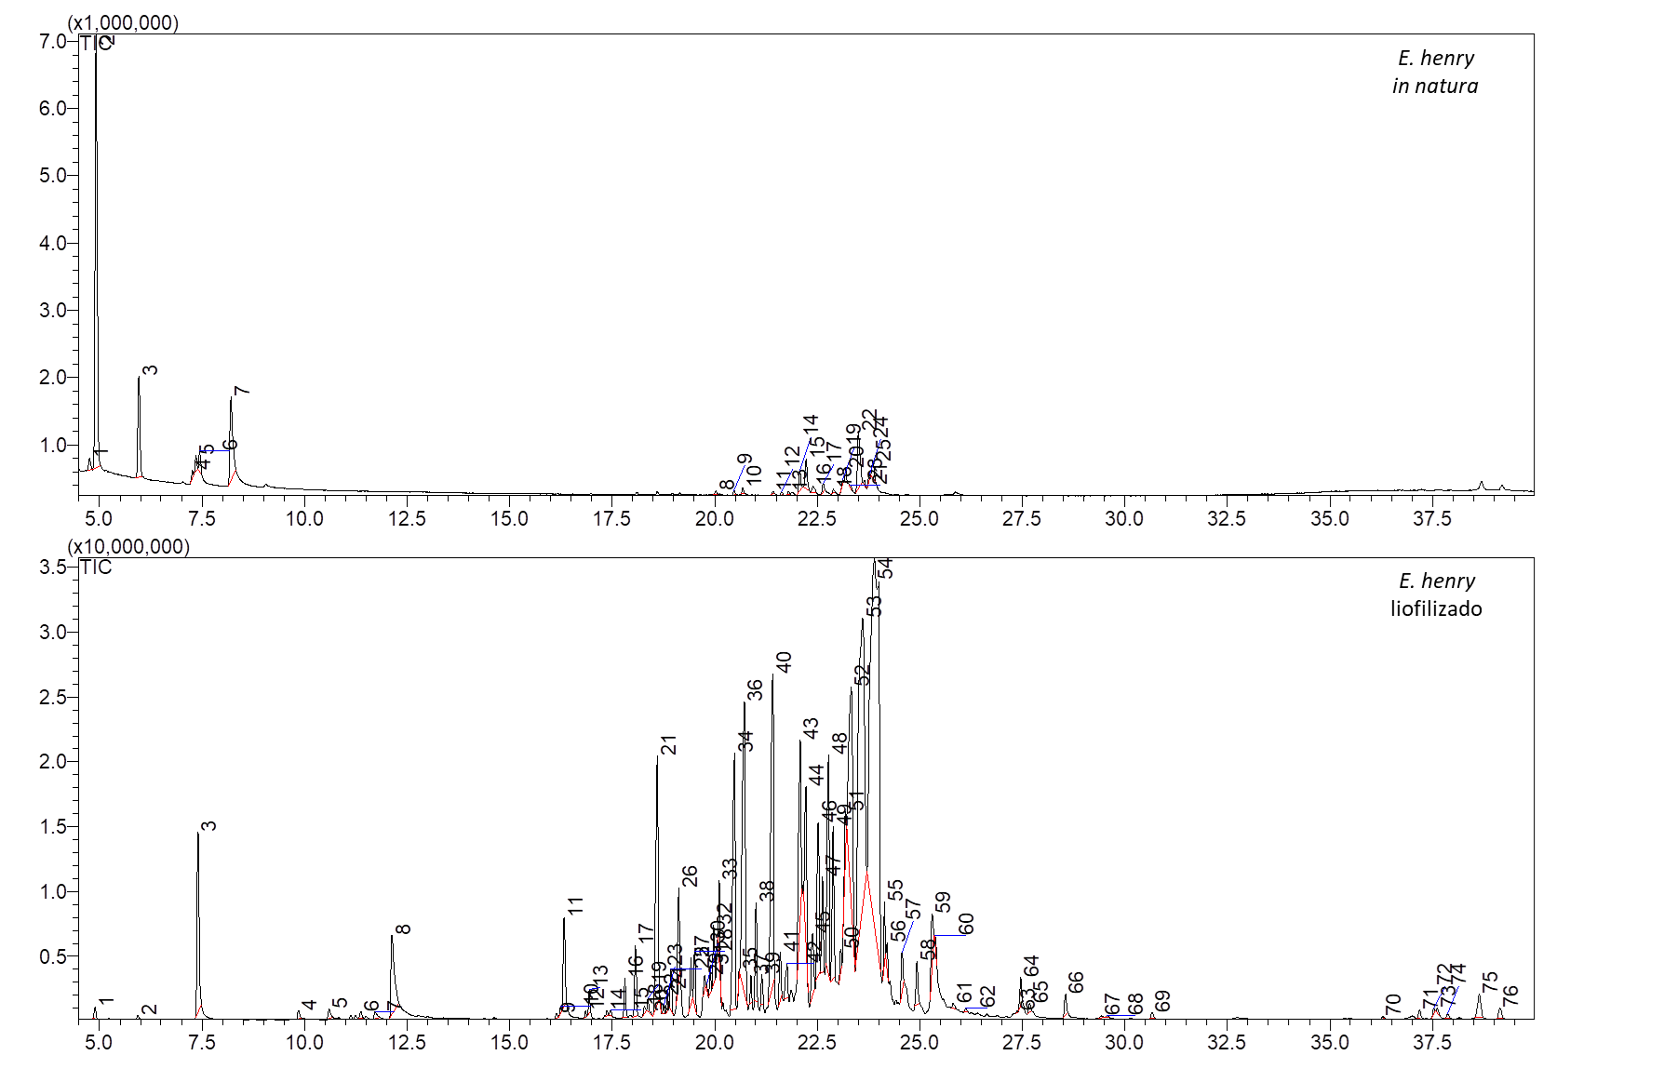
Figure 7S. Chromatogram obtained from the analysis by GC-MS of C. henryi essential oil extracted from fresh leaves of adult plants grown in field and C. henryi essential oil extracted from freeze-dried leaves of young plants grown in greenhouse.

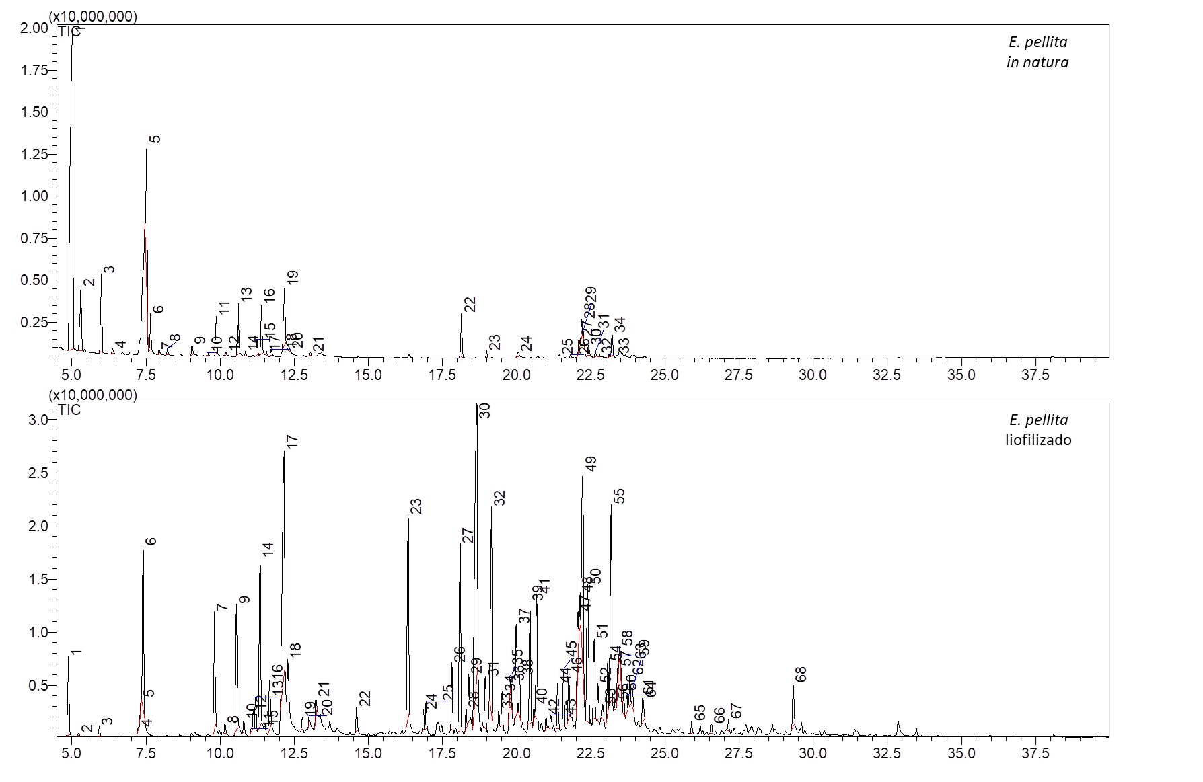
Figure 8S. Chromatogram obtained from the GC-MS analysis of E. pellita essential oil extracted from fresh leaves of adult plants grown in field and E. pellita essential oil extracted from freeze-dried leaves of young plants grown in greenhouse.

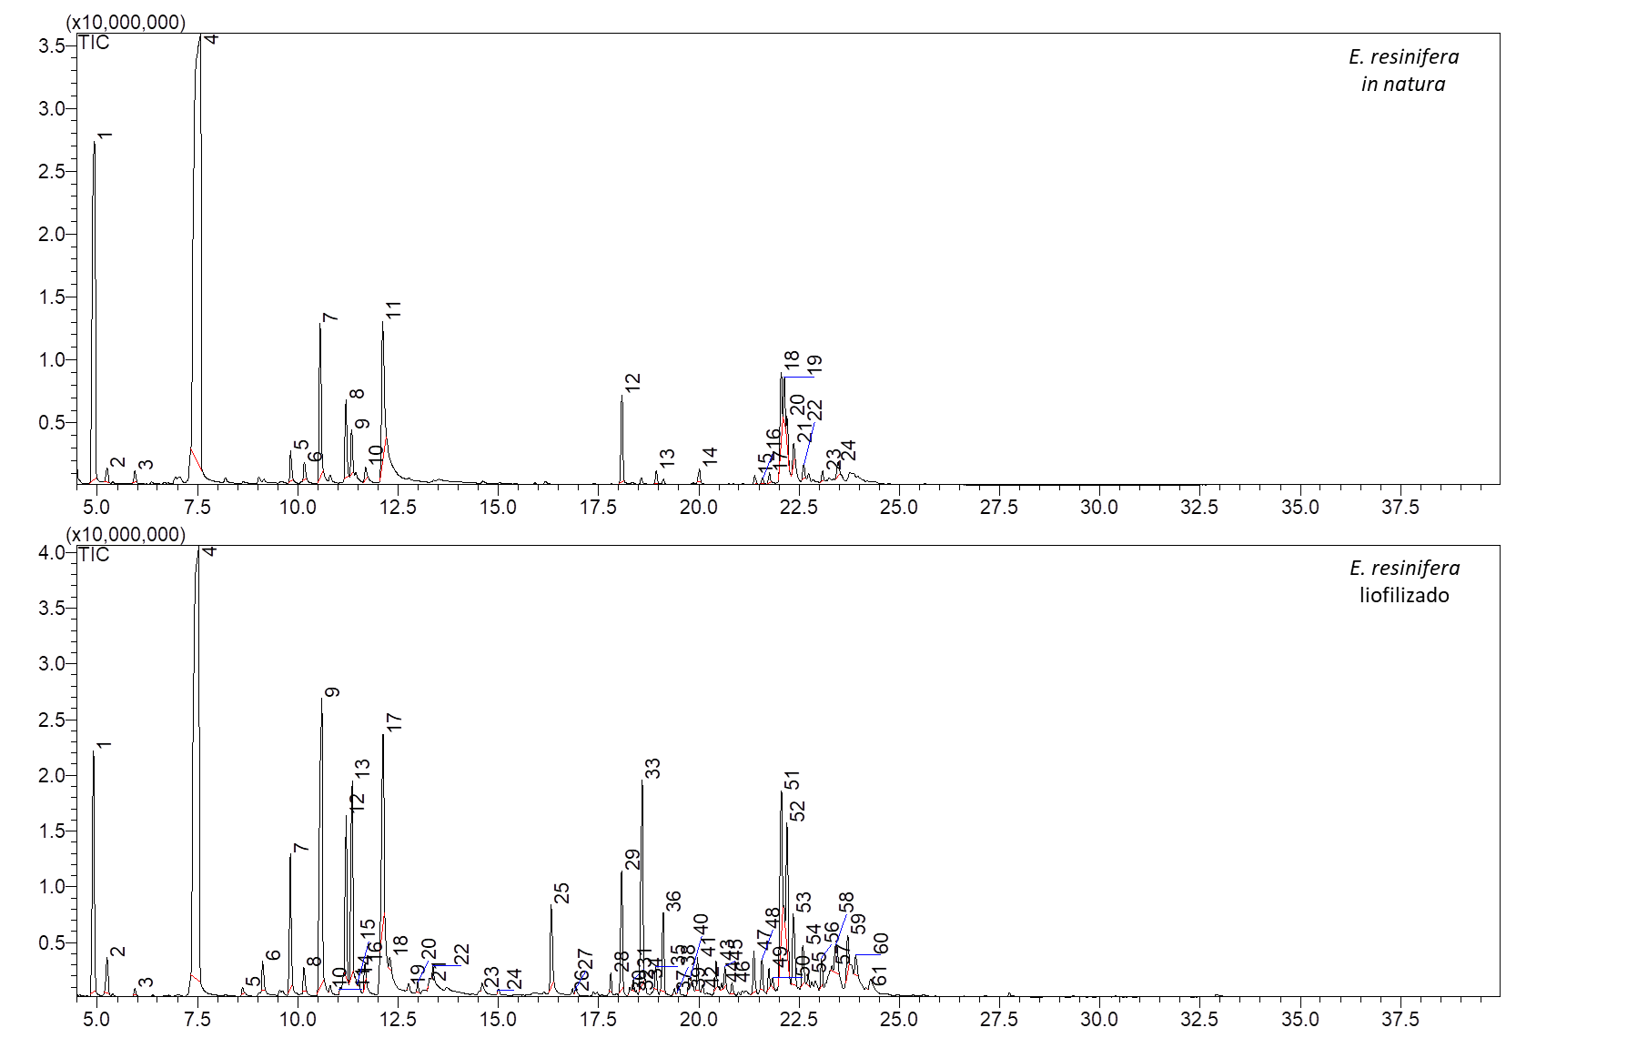
Figure 9S. Chromatogram obtained from the GC-MS analysis of E. resinifera essential oil extracted from fresh leaves of adult plants grown in field and E. resinifera essential oil extracted from freeze-dried leaves of young plants grown in greenhouse.

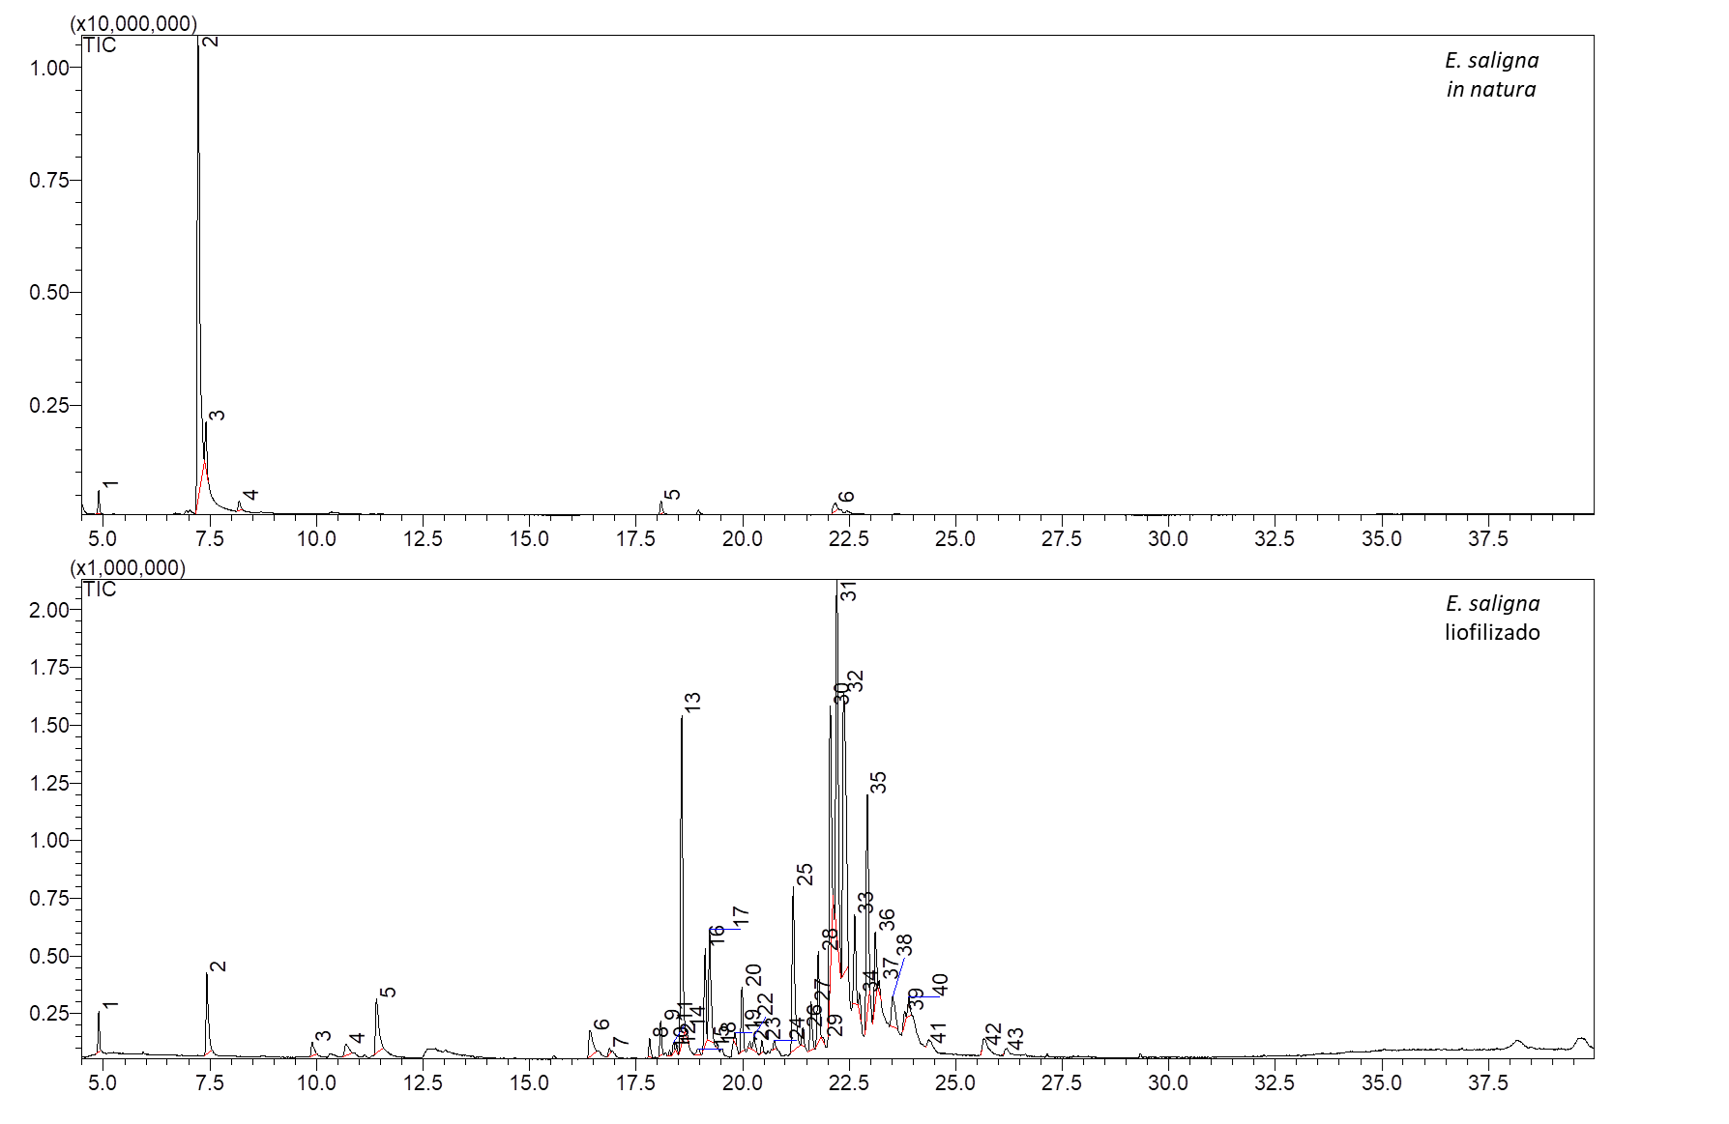
Figure 10S. Chromatogram obtained from GC-MS analysis of E. saligna essential oil extracted from fresh leaves of adult plants grown in field and E. saligna essential oil extracted from freeze-dried leaves of young plants grown in greenhouse.

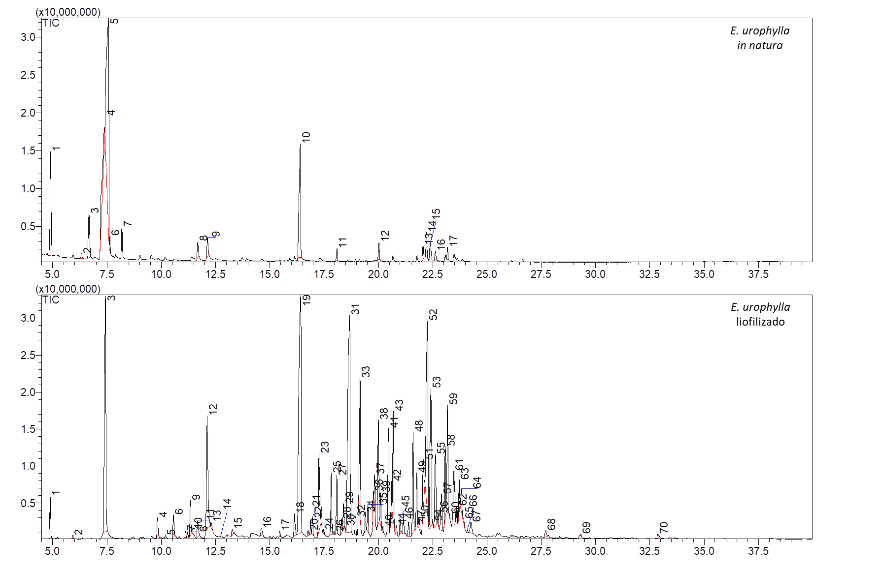
Figure 11S. Chromatogram obtained from the GC-MS analysis of E. urophylla essential oil extracted from fresh leaves of adult plants grown in field and E. urophylla essential oil extracted from freeze-dried leaves of young plants grown in greenhouse.

