Supplementary material
for
Evaluation of High-Protein Red Lentils in the Development of Gluten-Free Functional Bread
Büşra DOKUZ MURAT¹, Gülefşan PAŞA², Merve SAMANCI³, Pelin ÇETİNKAYA⁴, Miray DOĞAN⁵, Asuman AHMETBEYOĞLU⁶
¹Lecturer, Faculty of Health Sciences, Department of Nutrition and Dietetics, Avrasya University, Trabzon-TÜRKİYE, ORCID ID: 0000-0002-3871-5269
²Undergraduate Student, Faculty of Health Sciences, Department of Nutrition and Dietetics, Avrasya University, Trabzon-TÜRKİYE, ORCID ID: 0009-0003-6956-3362
³Lecturer, Faculty of Health Sciences, Department of Nutrition and Dietetics, Avrasya University, Trabzon-TÜRKİYE, ORCID ID: 0009-0002-5401-3299
⁴Undergraduate Student, Faculty of Health Sciences, Department of Nutrition and Dietetics, Avrasya University, Trabzon-TÜRKİYE, ORCID ID: 0009-0004-5789-3281
⁵Undergraduate Student, Faculty of Health Sciences, Department of Nutrition and Dietetics, Avrasya University, Trabzon-TÜRKİYE, ORCID ID: 0009-0006-2703-6697
⁶Undergraduate Student, Faculty of Health Sciences, Department of Nutrition and Dietetics, Avrasya University, Trabzon-TÜRKİYE, ORCID ID: 0009-0009-8067-4833

✉Corresponding author
Lecturer Büşra Dokuz Murat
Department of Nutrition and Dietetics,
Faculty of Health Sciences
Avrasya University, Trabzon
Email: busra.murat@avrasya.edu.tr
http://orcid.org/0000-0002-3871-5269
The following three-dimensional interaction graph is related to the graph of flavour, the graph of contour, the graph of main effect and the graph of interaction.
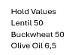
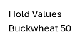
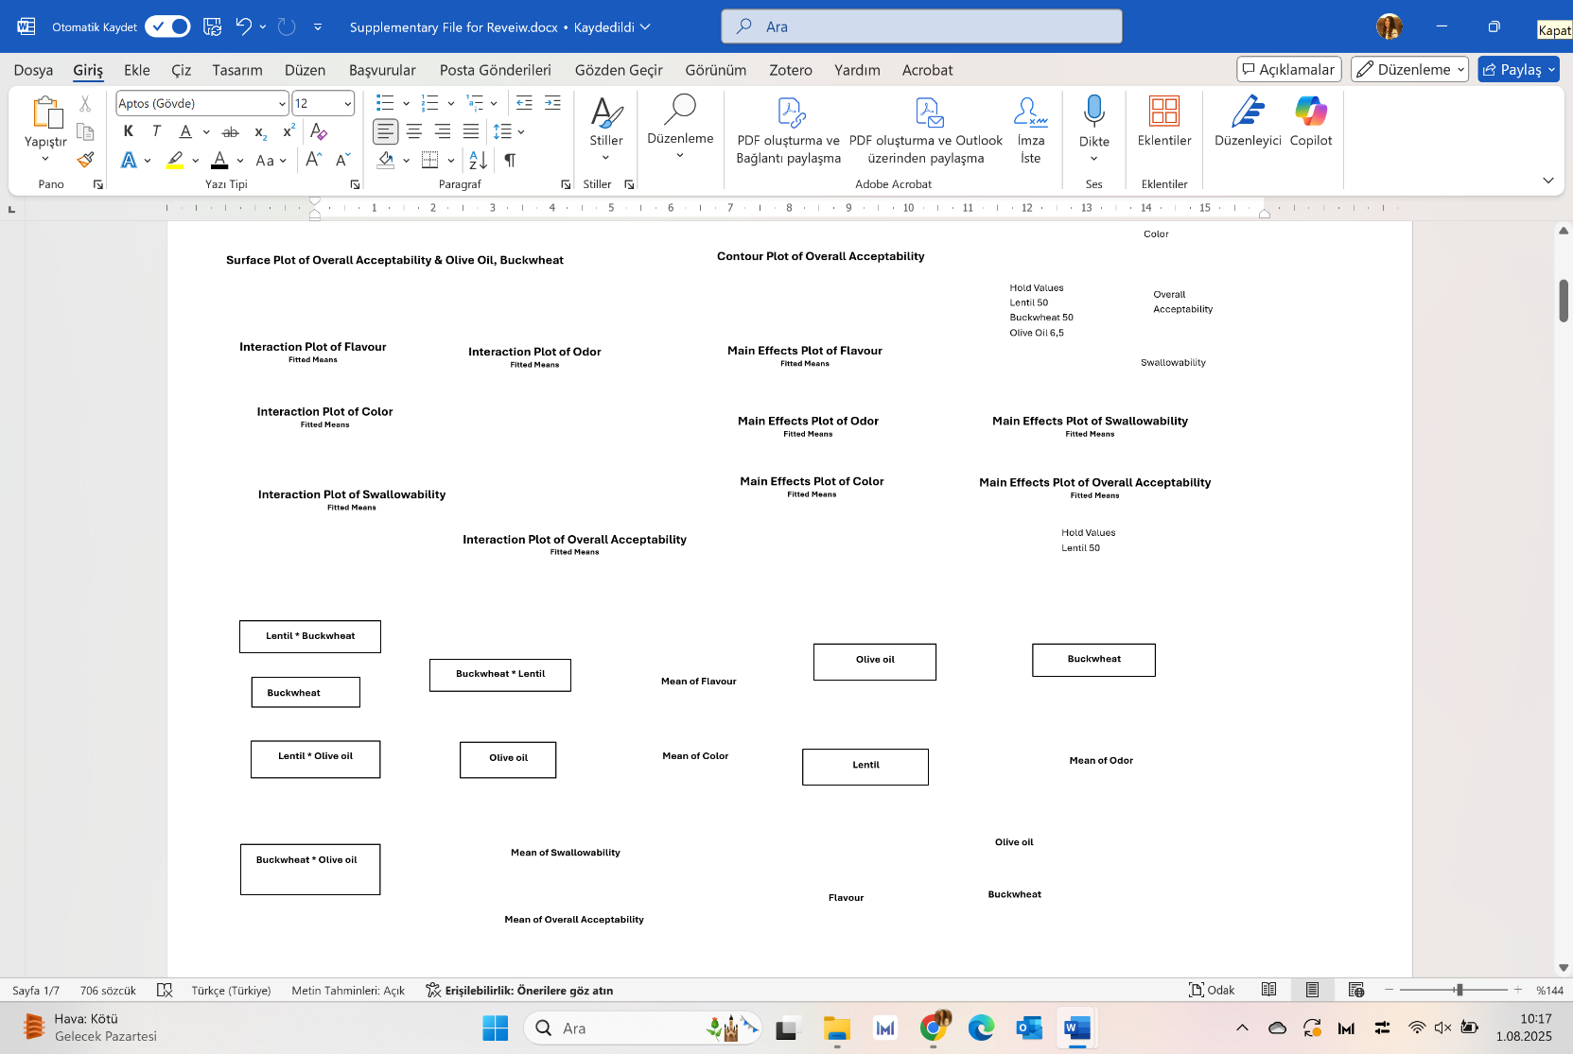
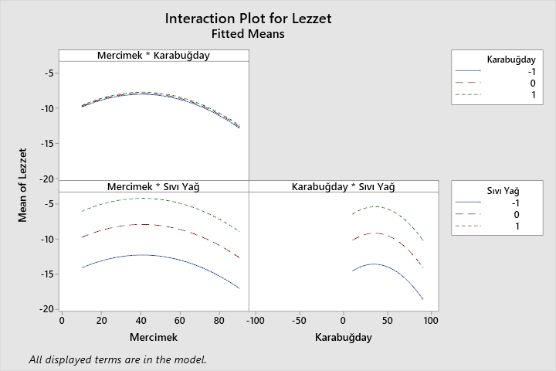
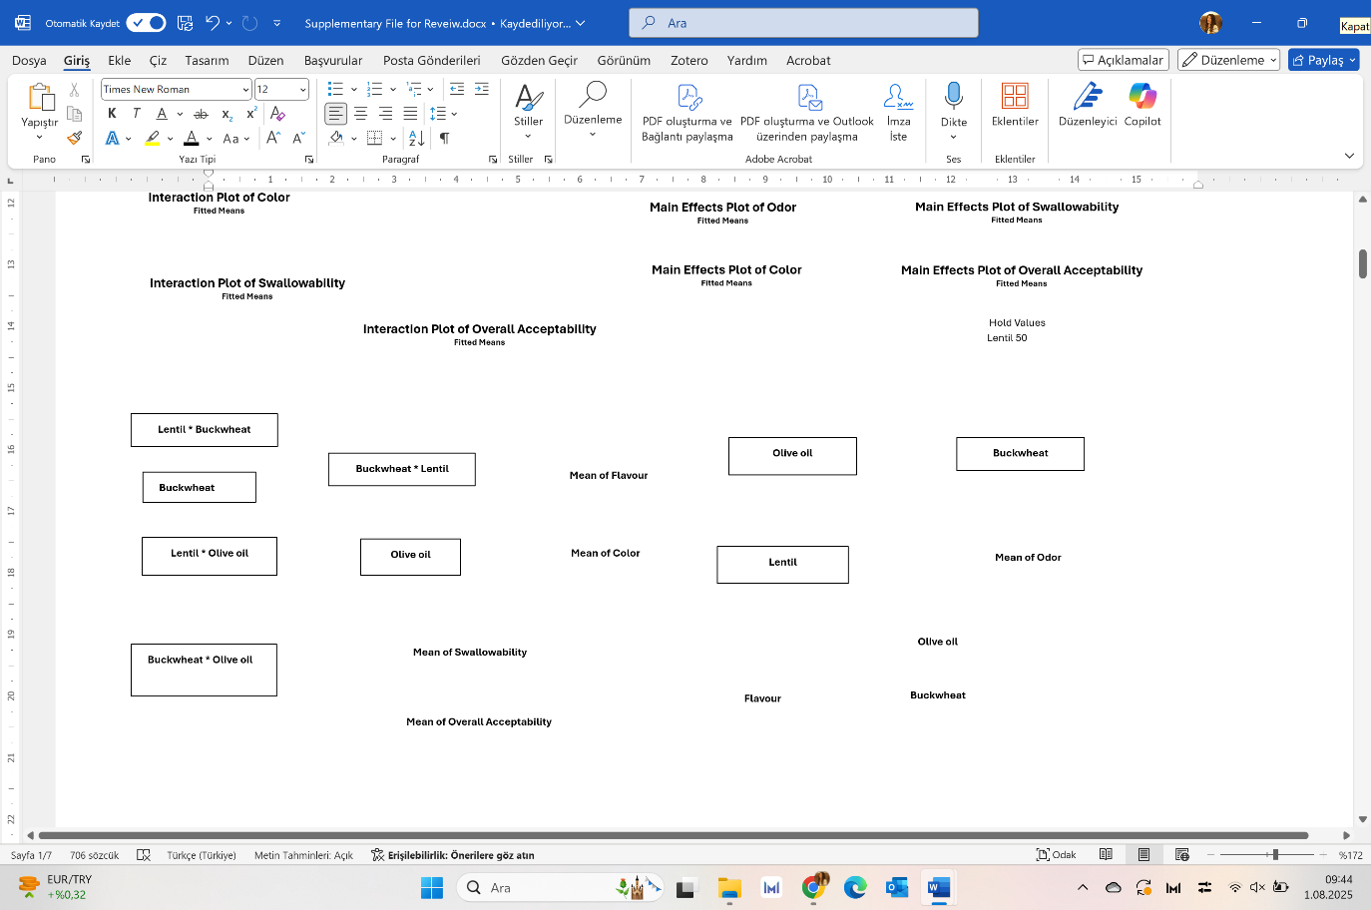
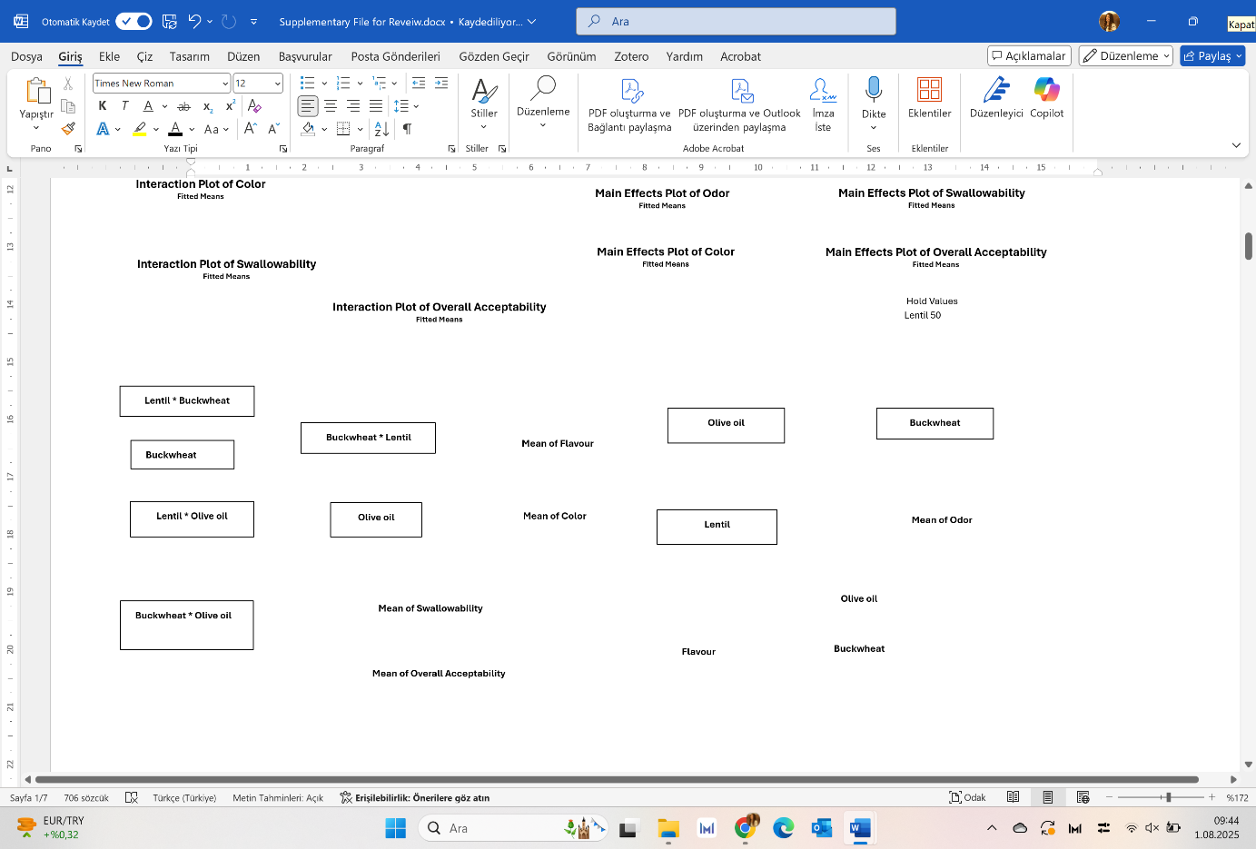
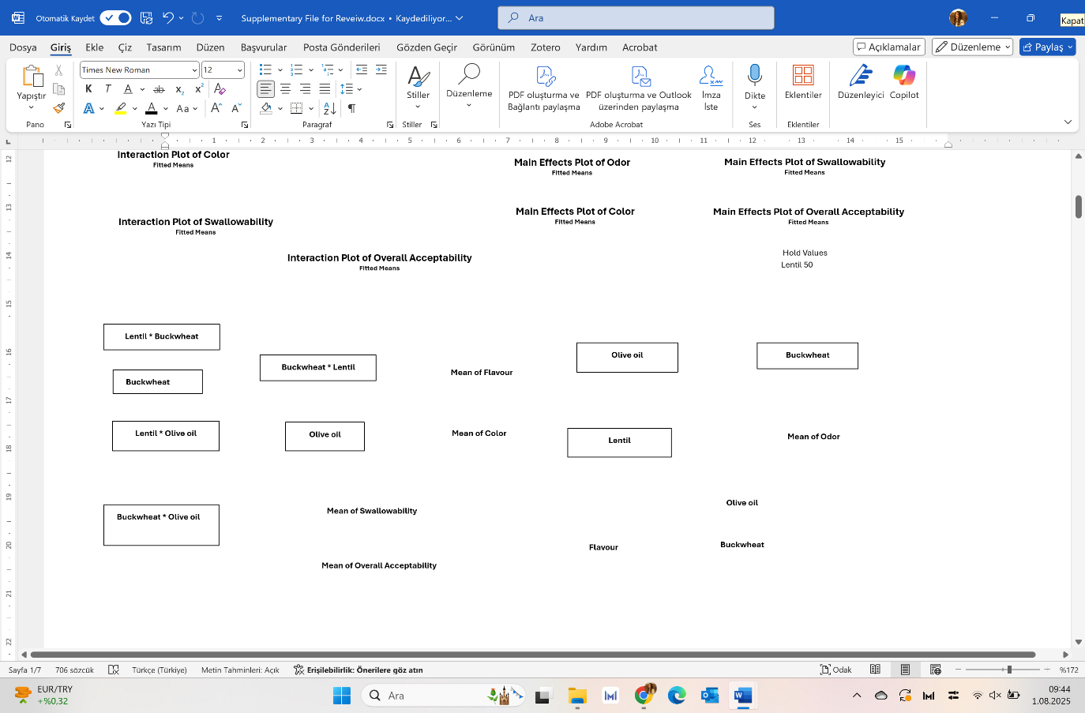
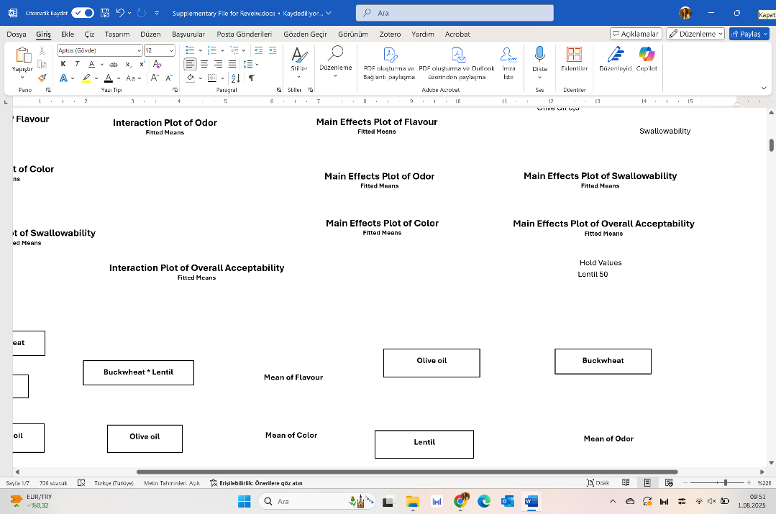
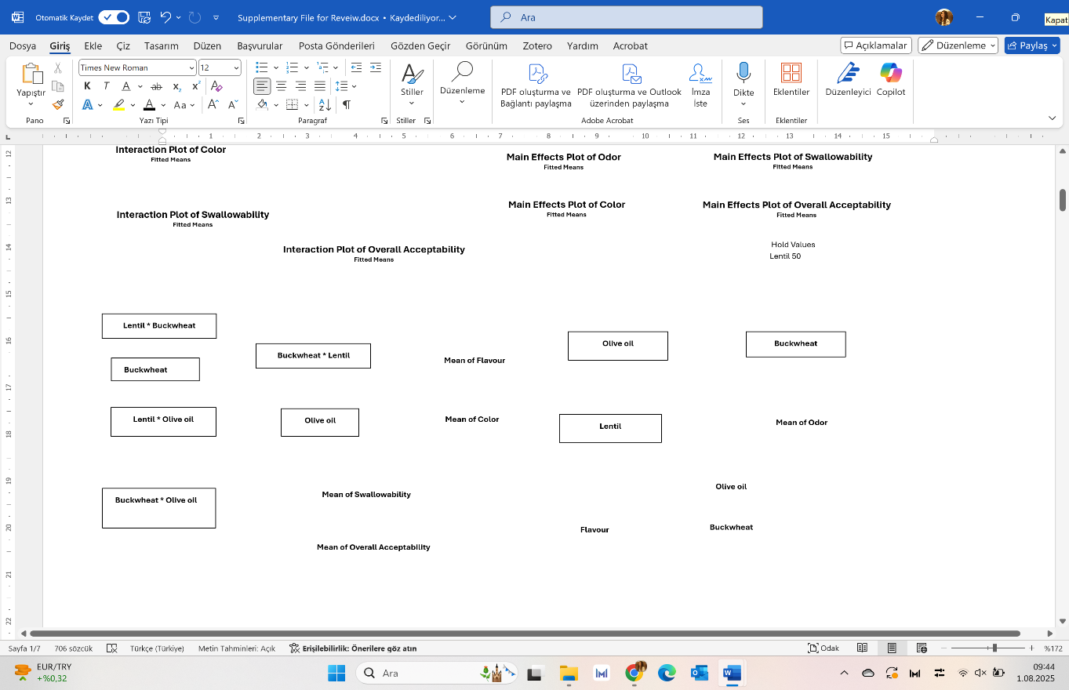
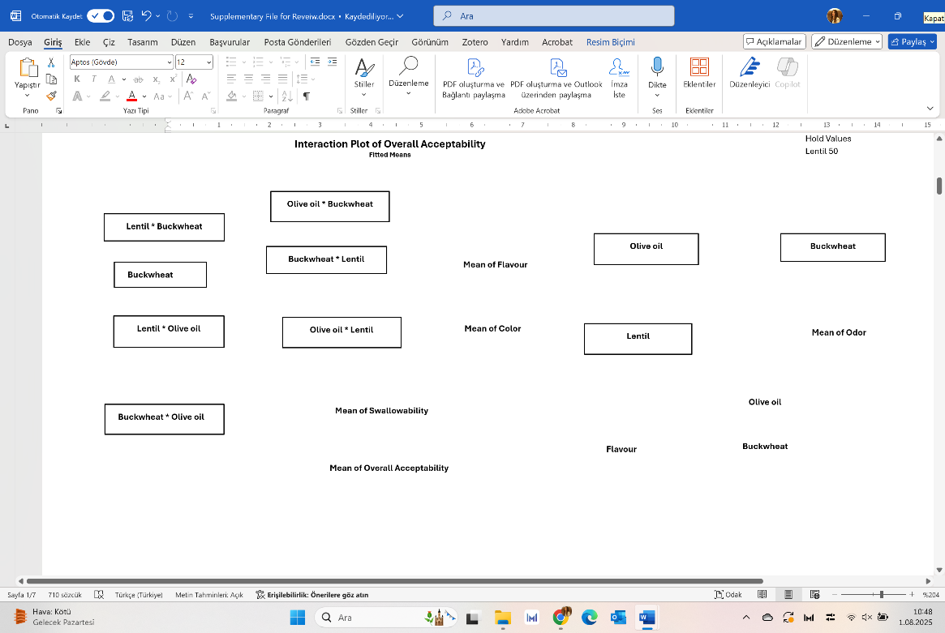
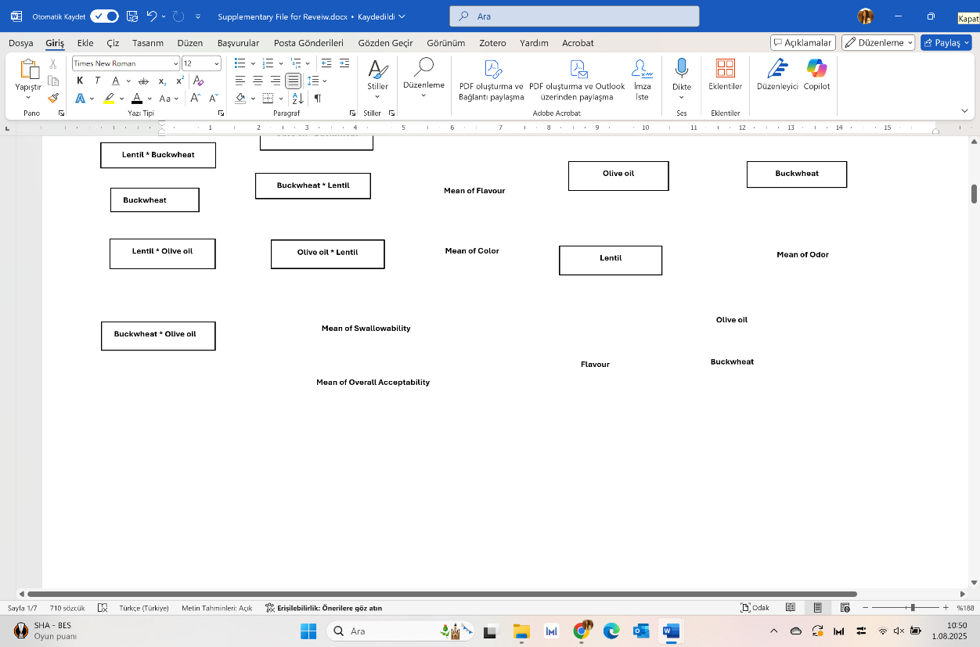
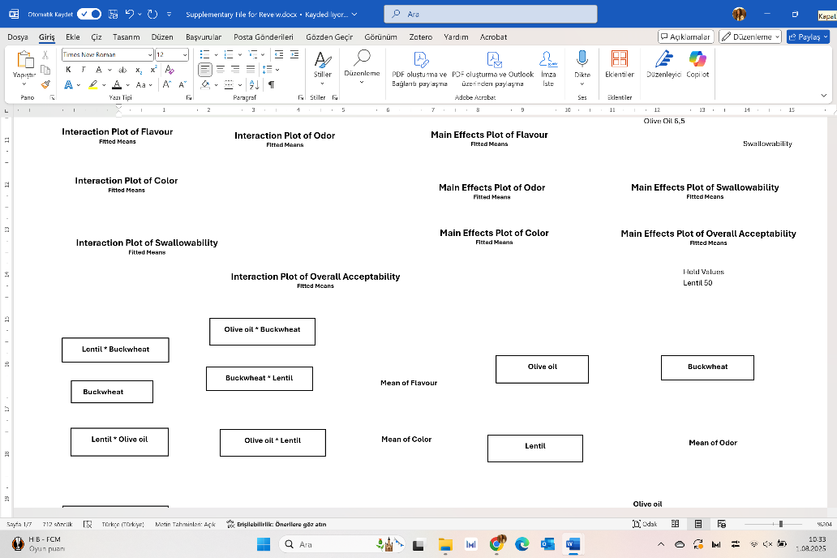
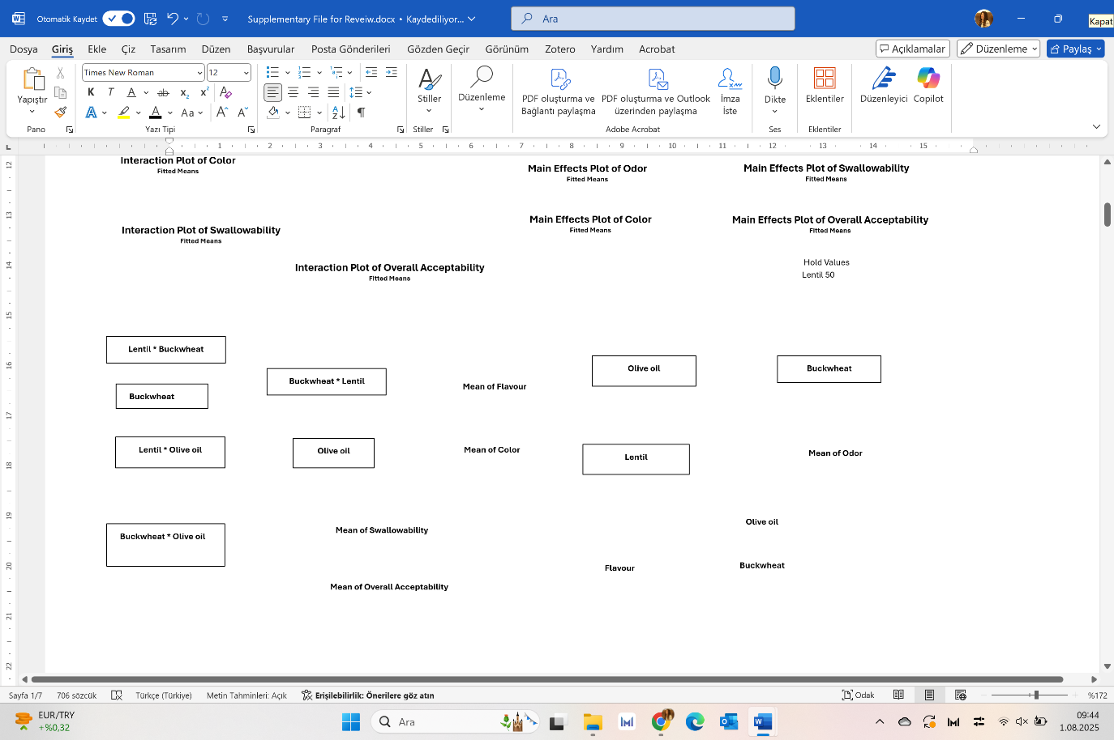
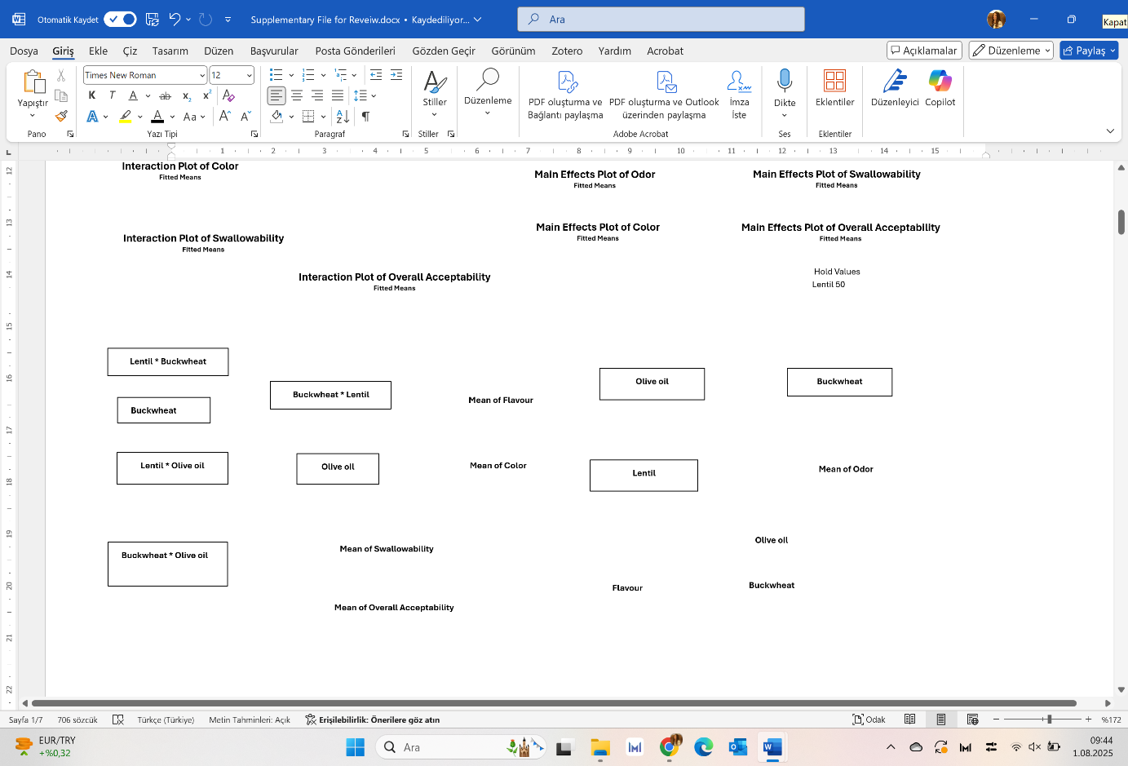
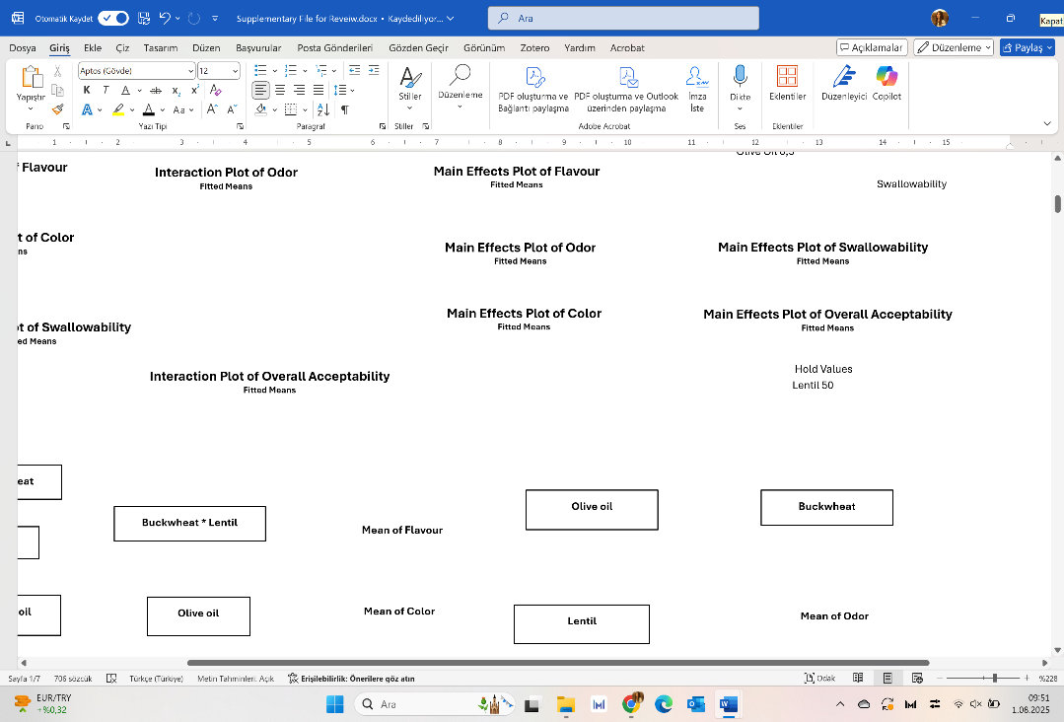
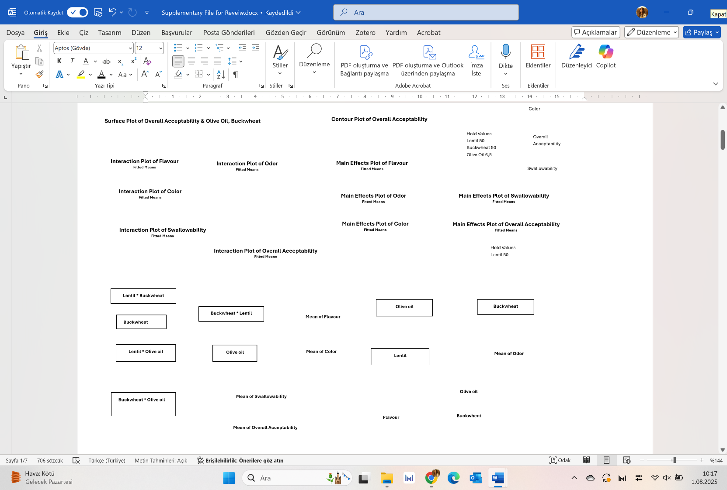
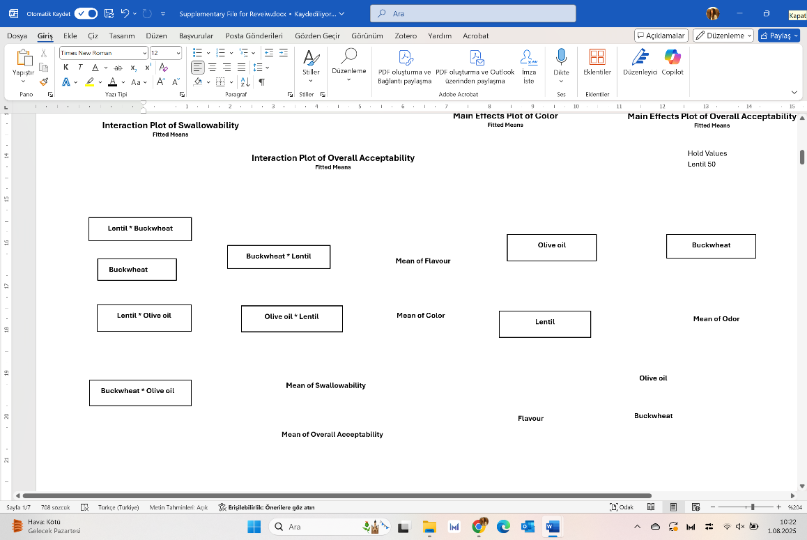
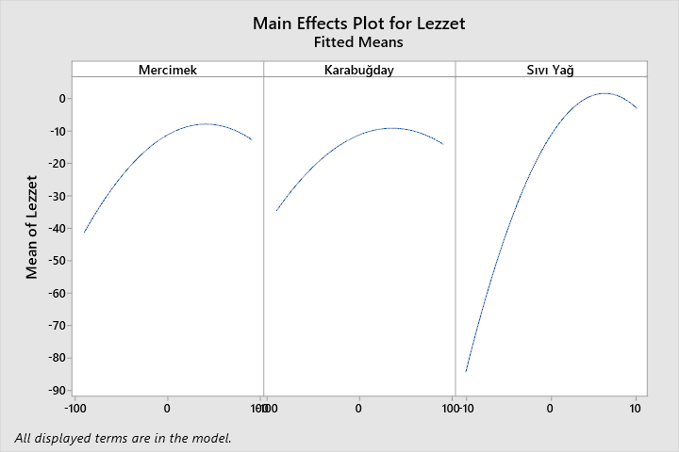
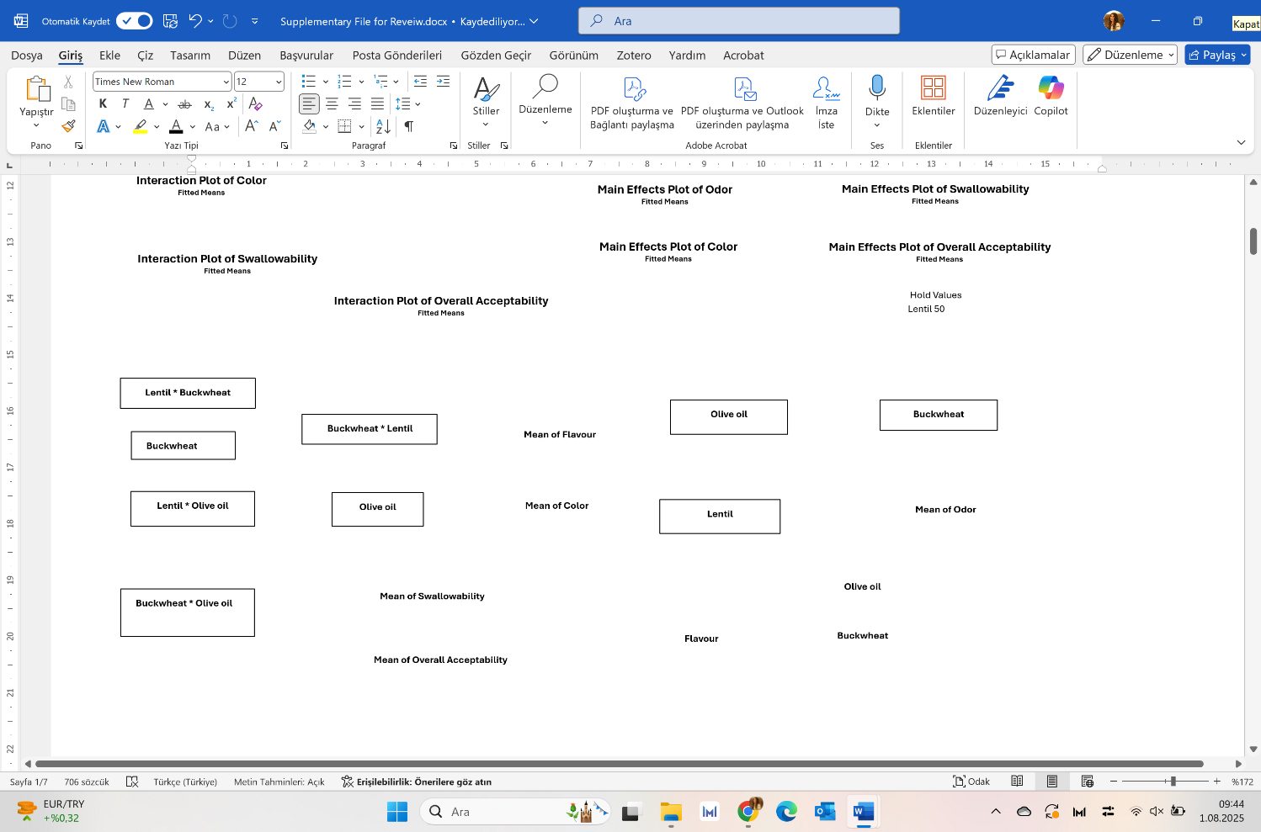
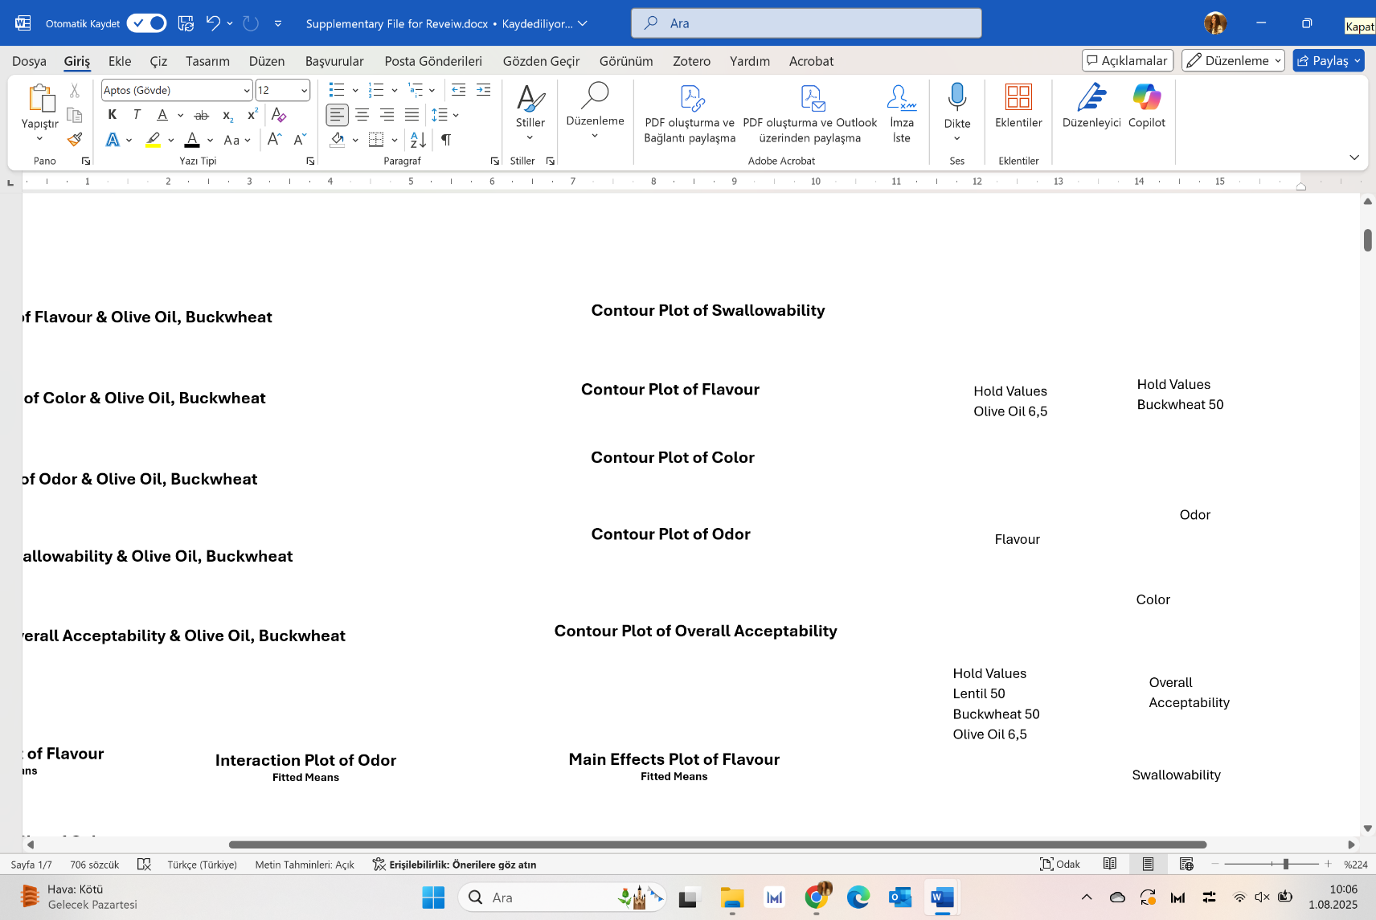
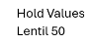
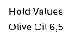
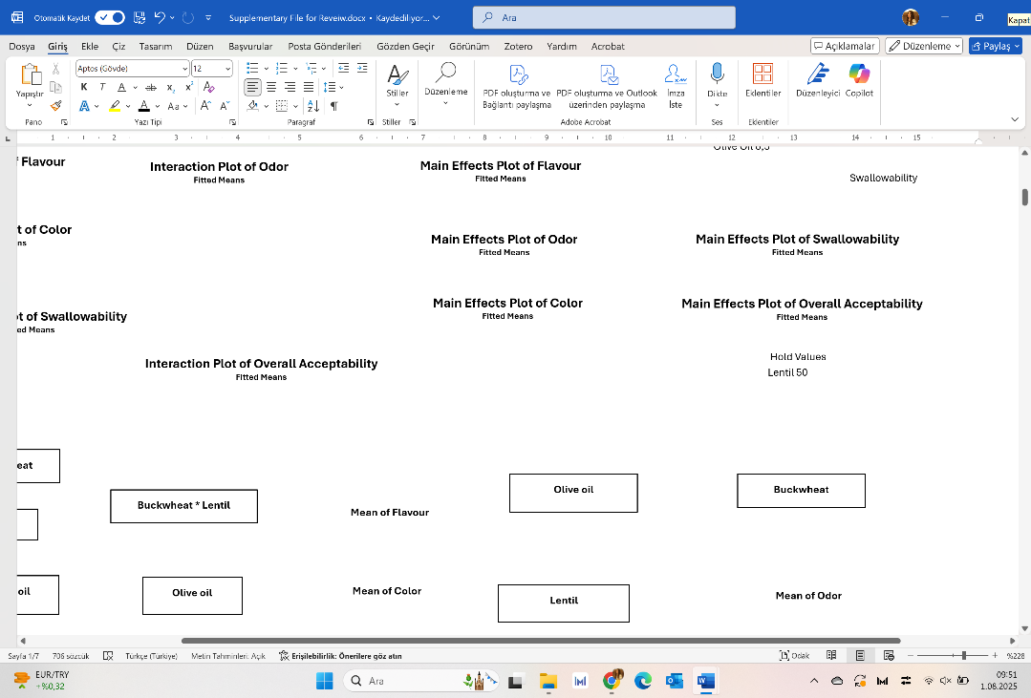
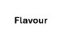
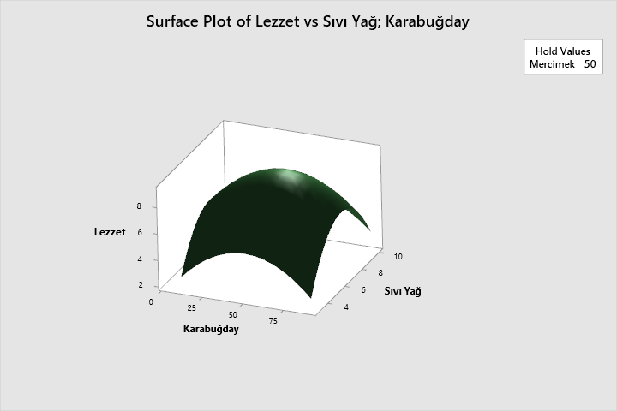
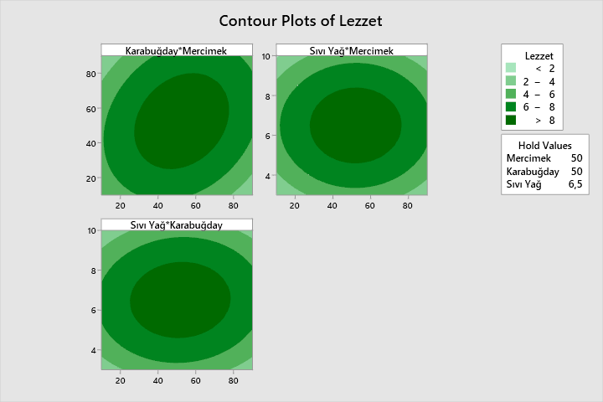
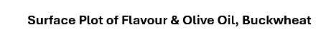
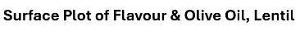
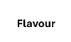
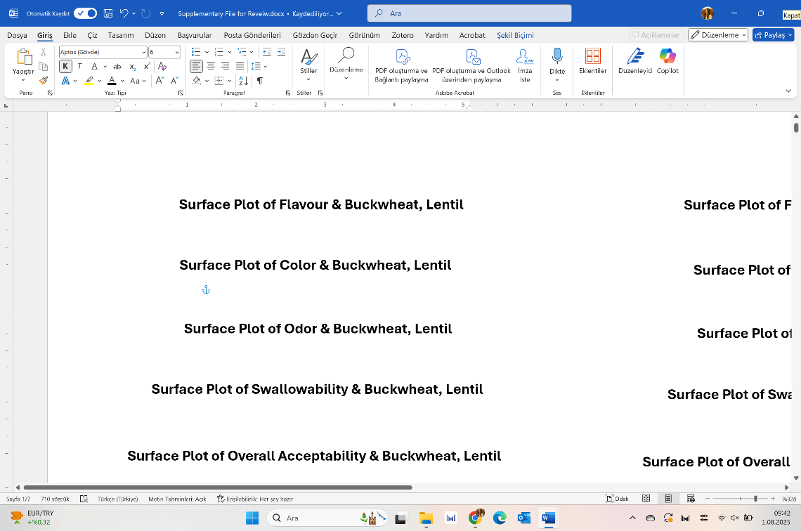
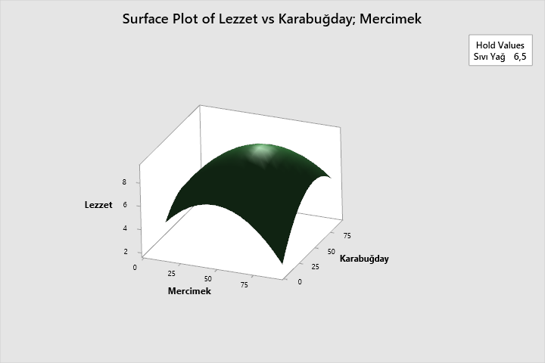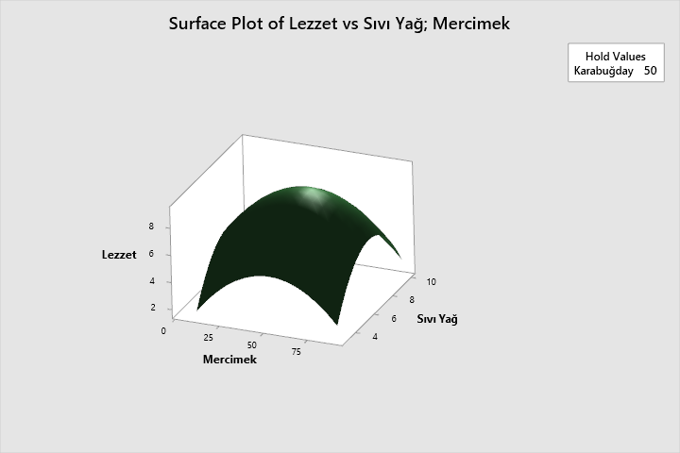

The following three-dimensional interaction graph is related to the graph of chewiness, the graph of contour, the graph of main effect and the graph of interaction
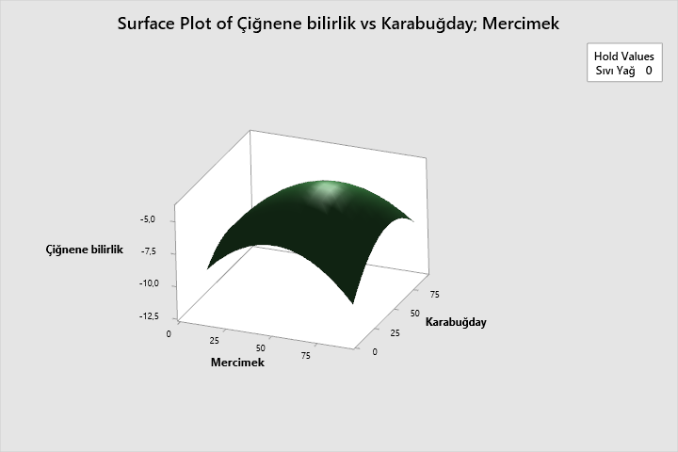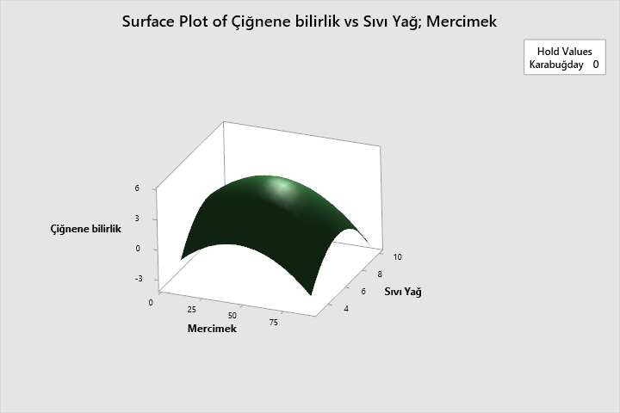
Surface Plot of Chewiness & Buckwheat, Lentil
Chewiness
Hold Values
Buckwheat 0
Surface Plot of Chewiness & Olive Oil, Lentil
Hold Values
Olive Oil 0
Olive oil
Lentil
Lentil
Chewiness
Buckwheat
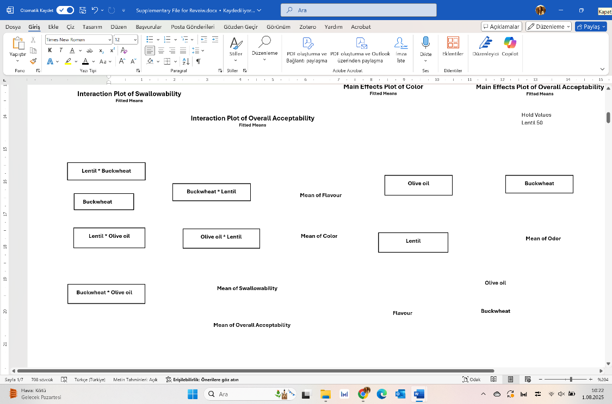
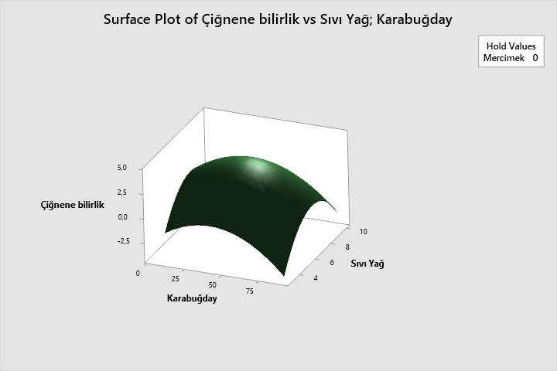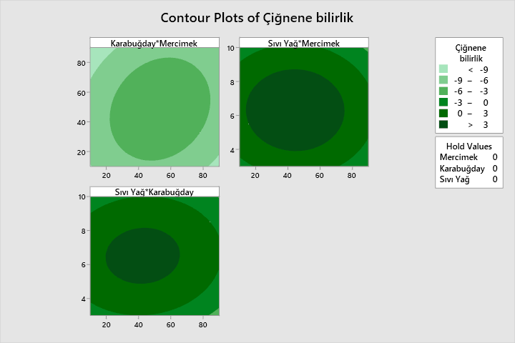
Chewiness
Hold Values
Lentil 0 Buckwheat 0 Olive Oil 0
Buckwheat
Main Effects Plot of Chewiness
Fitted Means
Interaction Plot of Chewiness
Fitted Means
Contour Plot of Chewiness
Hold Values
Lentil 0
Surface Plot of Chewiness & Olive Oil, Buckwheat
Chewiness
Olive oil
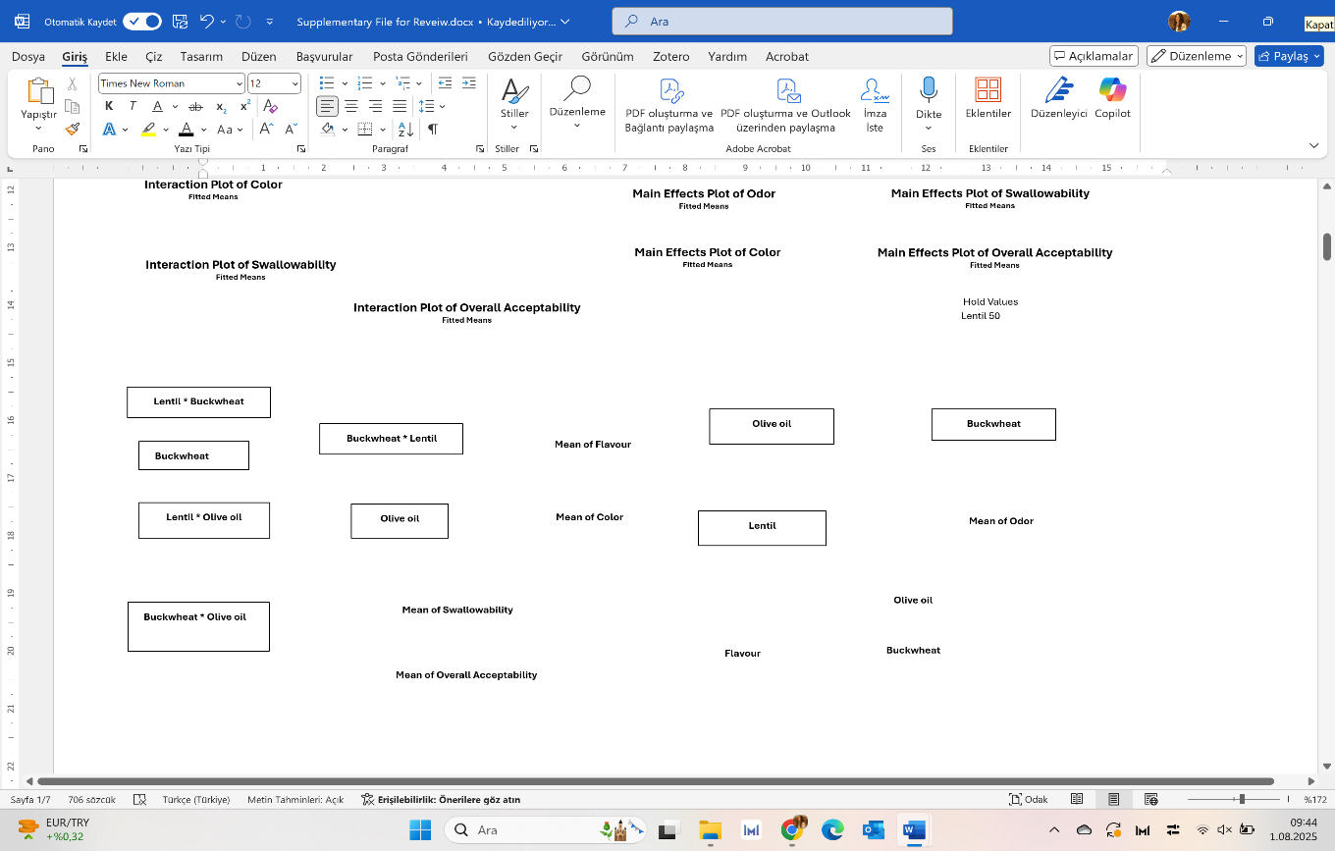
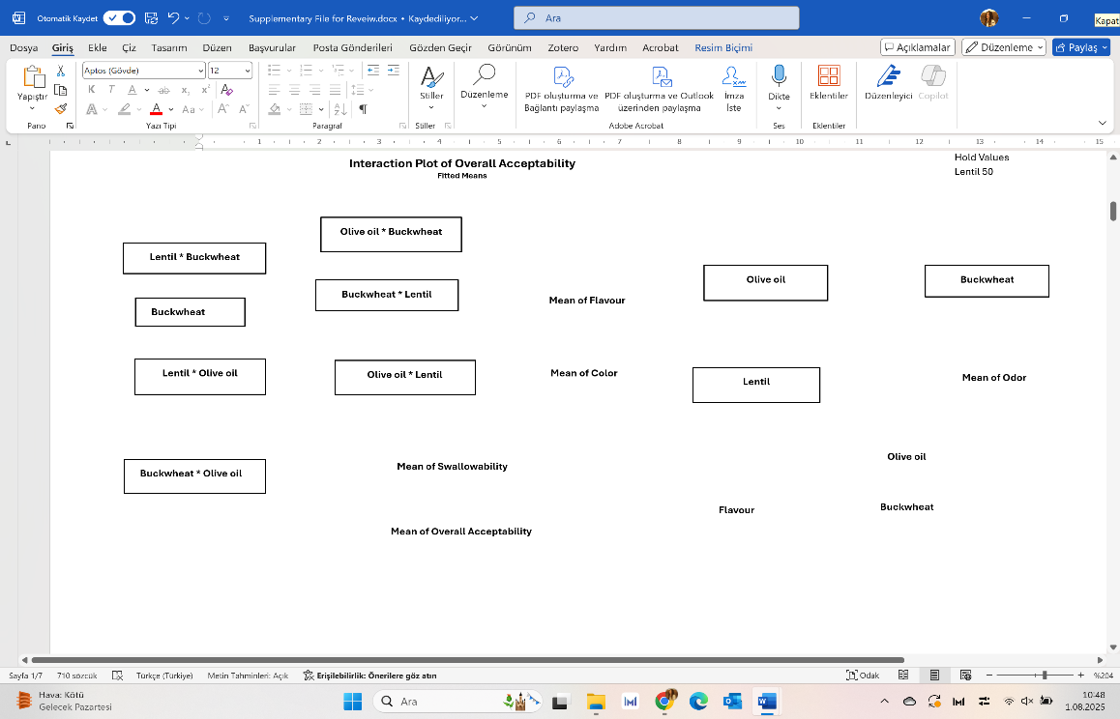
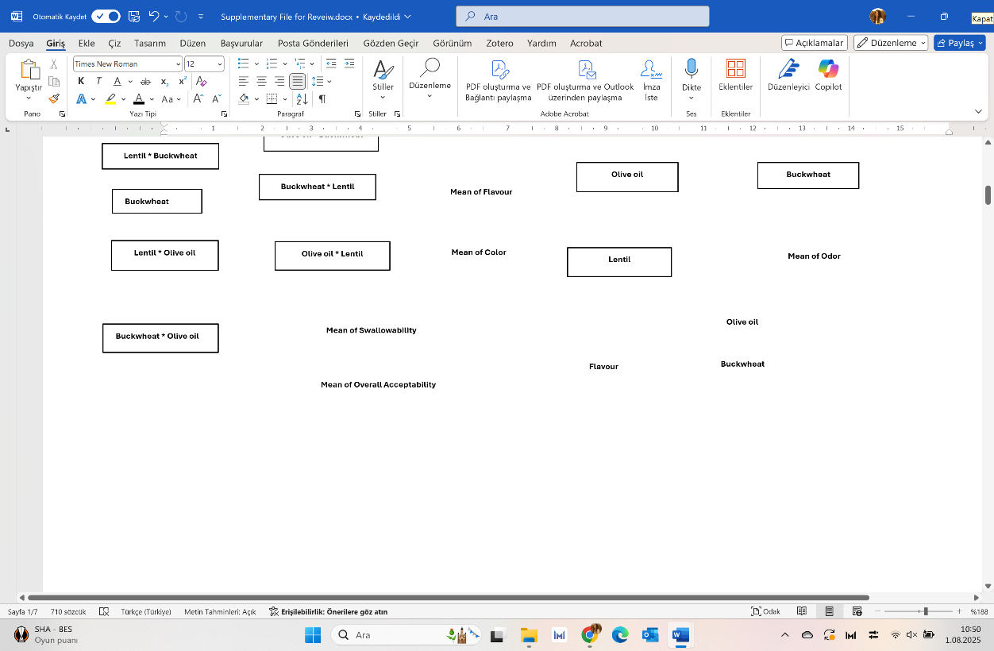
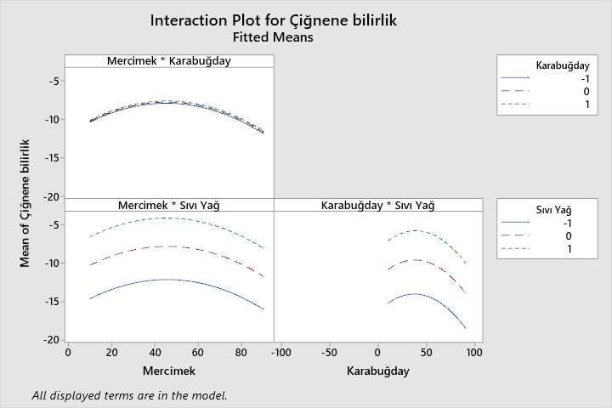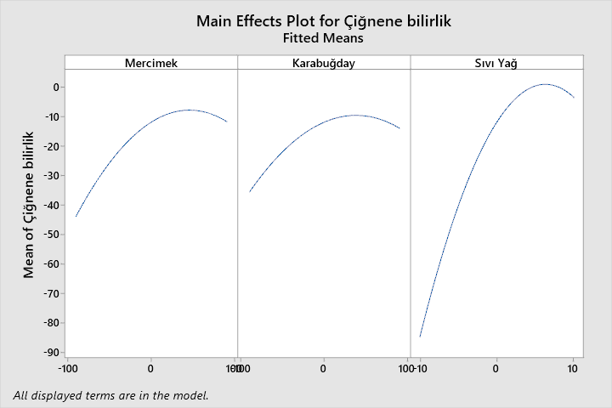
Buckwheat
Mean of Chewiness

Olive oil
Mean of Chewiness

The following three-dimensional interaction graph is related to the graph of color, the graph of contour, the graph of main effect and the graph of interaction
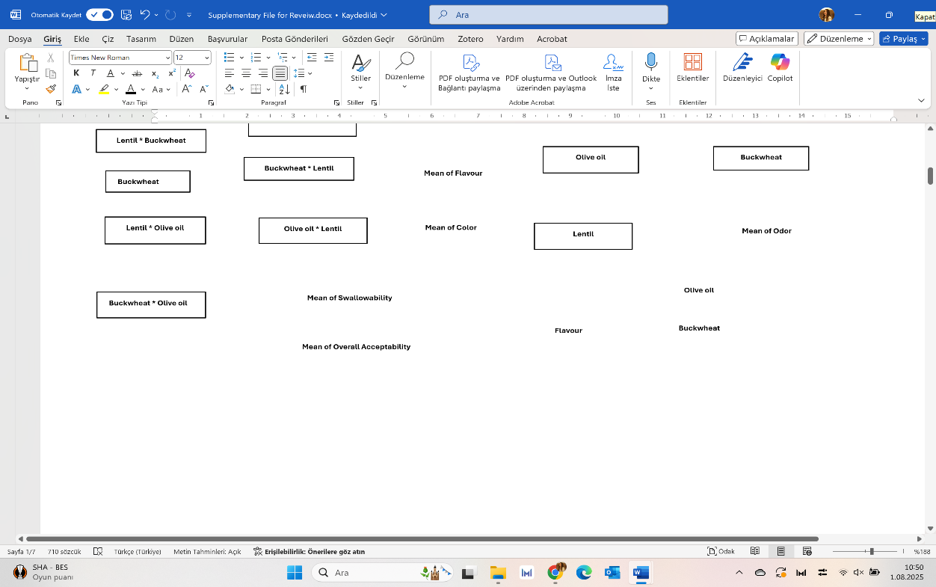
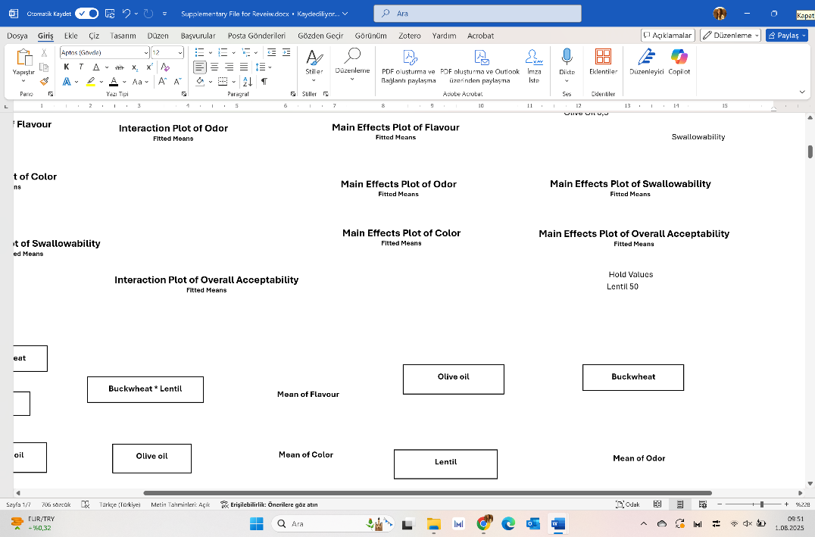
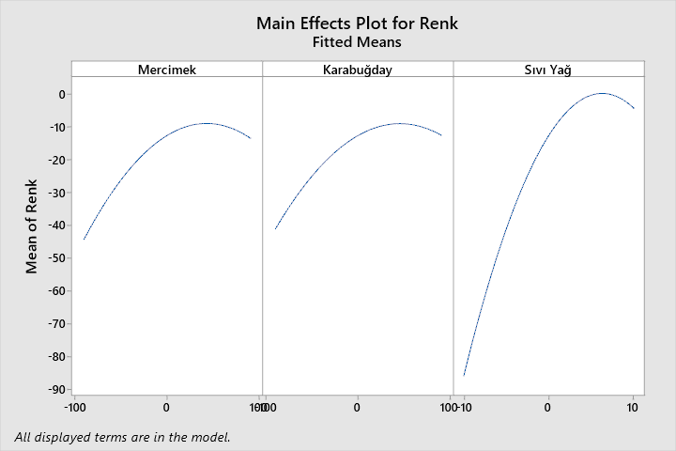
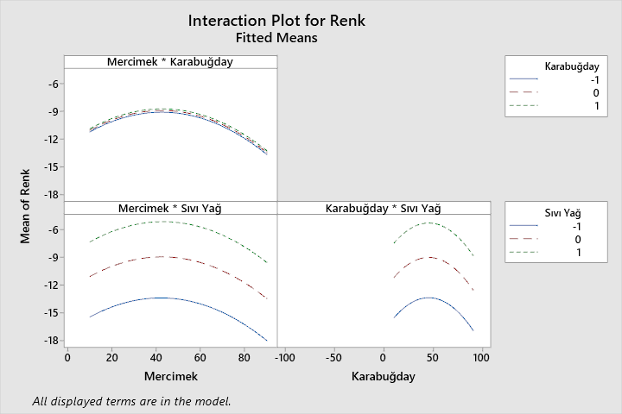
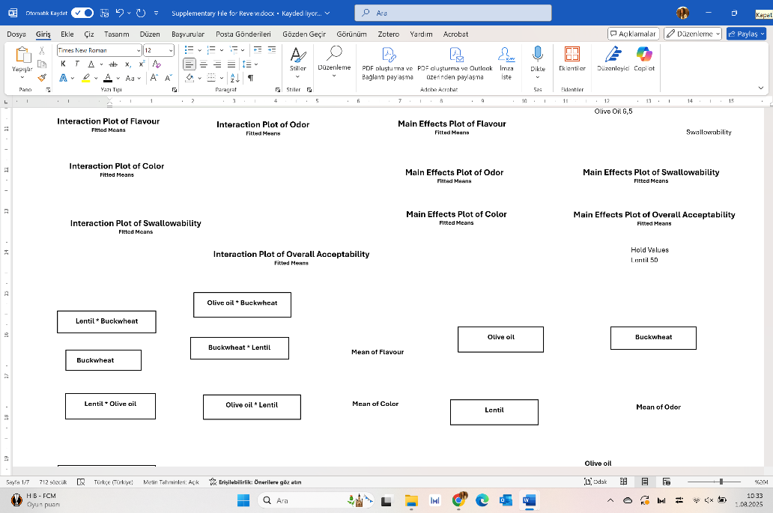
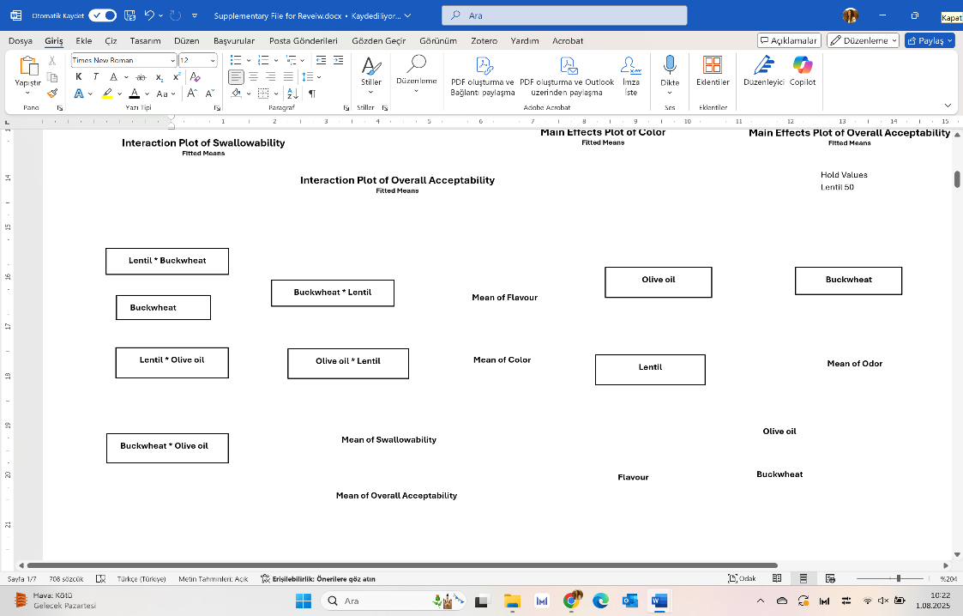
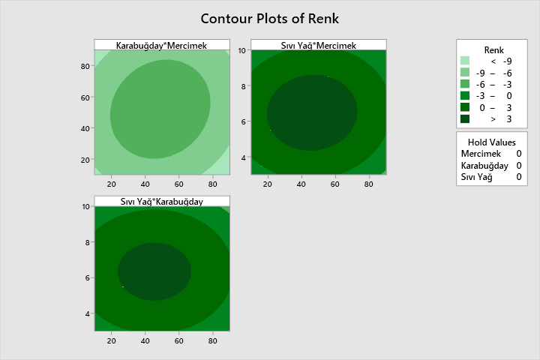
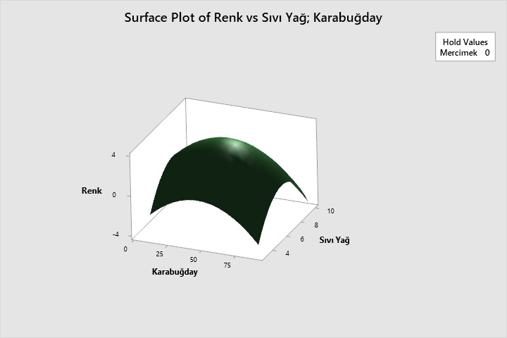
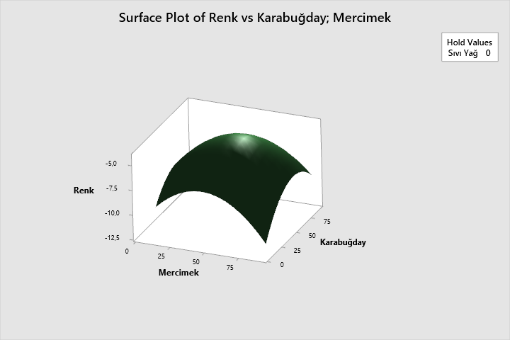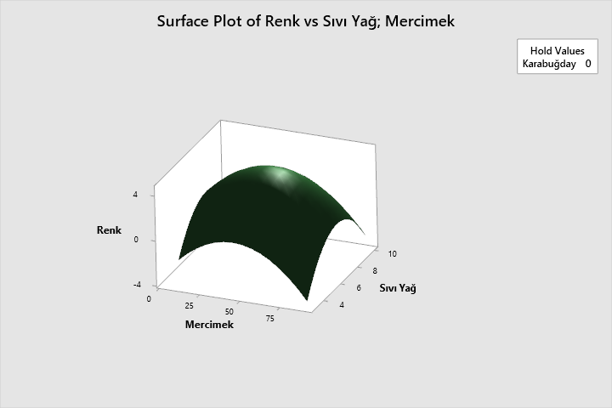
Olive oil
Mean of Color

Mean of Color

Interaction Plot of Color
Fitted Means

Main Effects Plot of Color
Fitted Means
Hold Values
Lentil 0 Buckwheat 0 Olive Oil 0
Contour Plot of Color
Surface Plot of Color & Olive Oil, Buckwheat
Surface Plot of Color & Buckwheat, Lentil
Surface Plot of Color & Olive Oil, Lentil
Color
Olive oil
Lentil
Buckwheat
Color
Hold Values
Buckwheat 0
Hold Values
Olive Oil 0
Lentil
Buckwheat
Hold Values
Lentil 0
Color
Buckwheat
Olive oil
Color

The following three-dimensional interaction graph is related to the graph of odor, the graph of contour, the graph of main effect and the graph of interaction
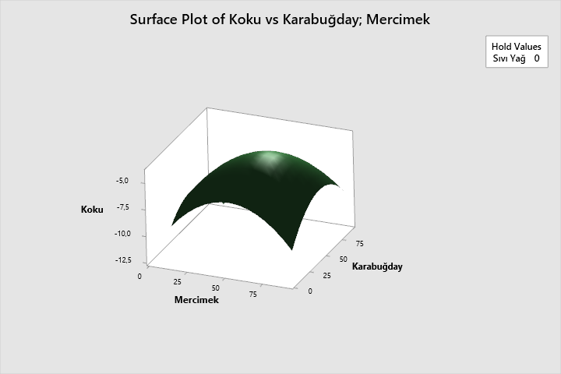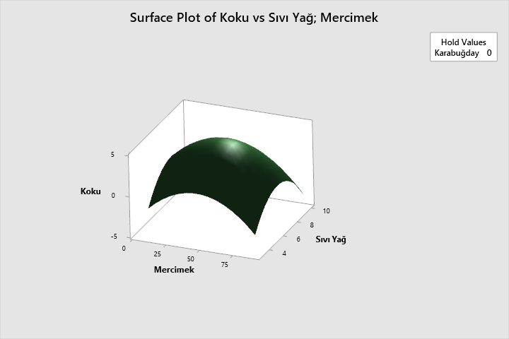
Lentil
Buckwheat
Odor
Surface Plot of Odor & Buckwheat, Lentil
Surface Plot of Odor & Olive Oil, Lentil
Odor
Odor
Lentil
Olive oil
Hold Values
Buckwheat 0
Buckwheat
Lentil
Hold Values
Olive Oil 0
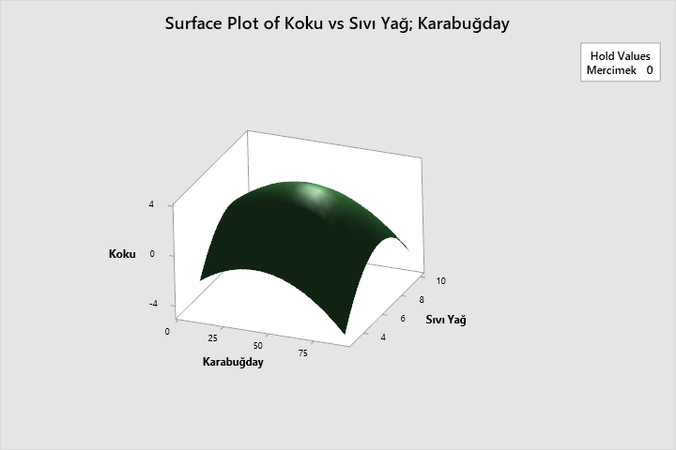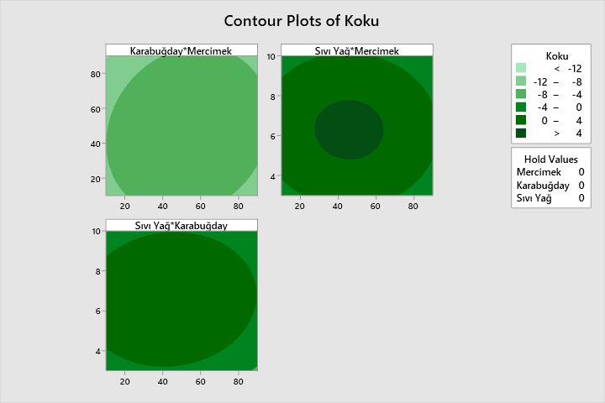
Buckwheat
Odor
Olive oil
Odor
Contour Plot of Odor
Odor
Buckwheat
Hold Values
Lentil 0 Buckwheat 0 Olive Oil 0
Hold Values
Lentil 0
Olive oil
Main Effects Plot of Odor
Fitted Means
Interaction Plot of Odor
Fitted Means
Surface Plot of Odor & Olive Oil, Buckwheat
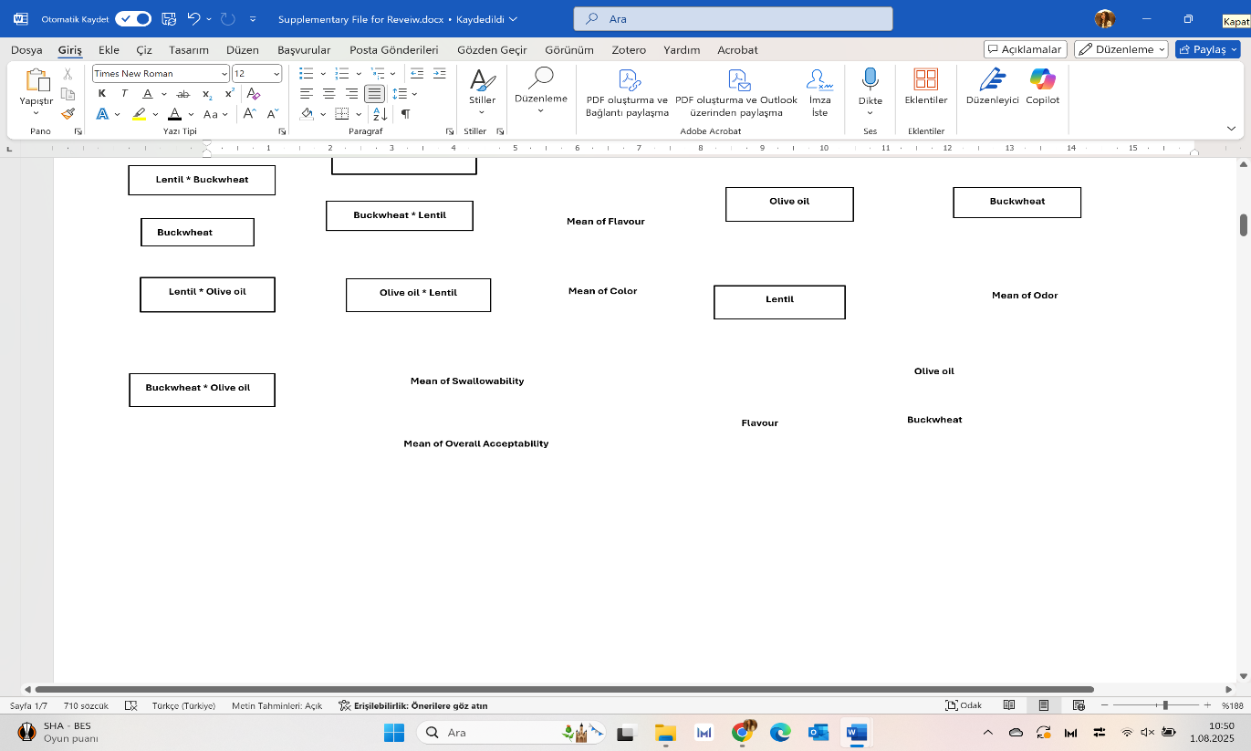
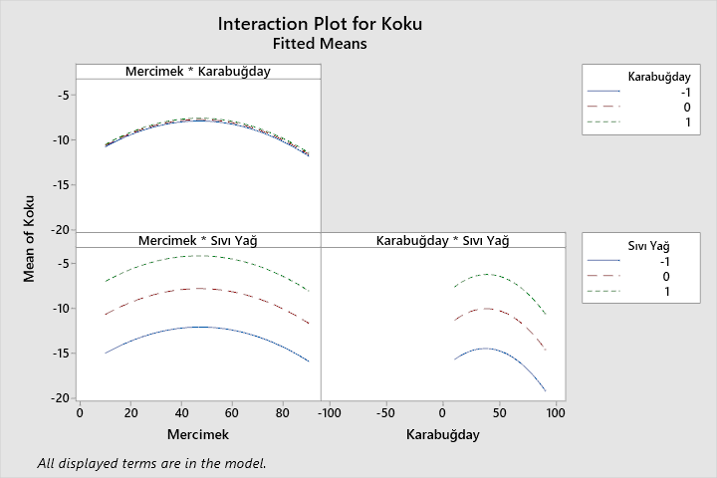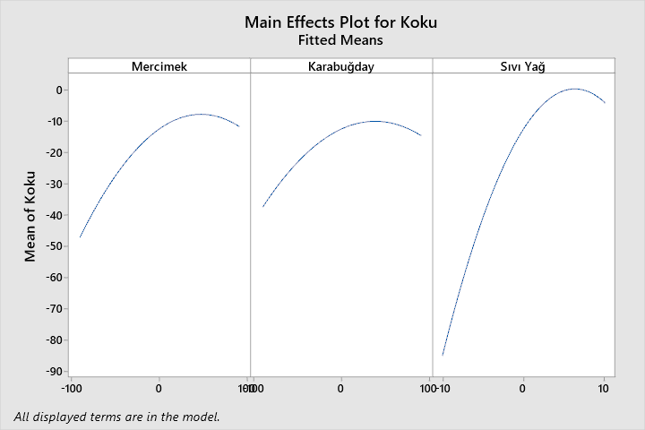
Olive oil
Buckwheat
Mean of Odor

Mean of Odor

The following three-dimensional interaction graph is related to the graph of swallowability, the graph of contour, the graph of main effect and the graph of interaction
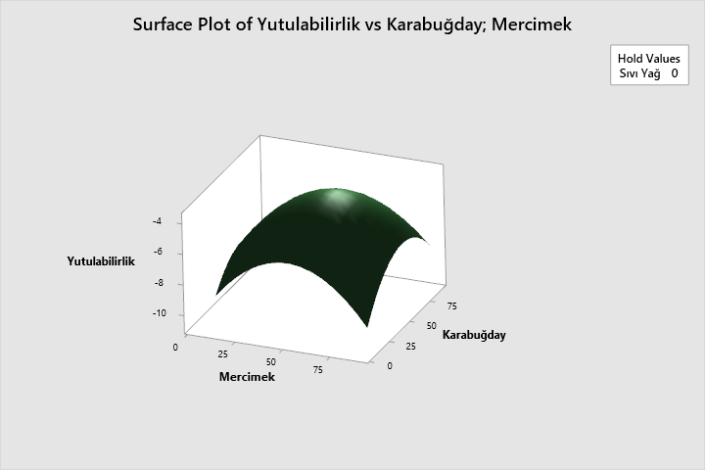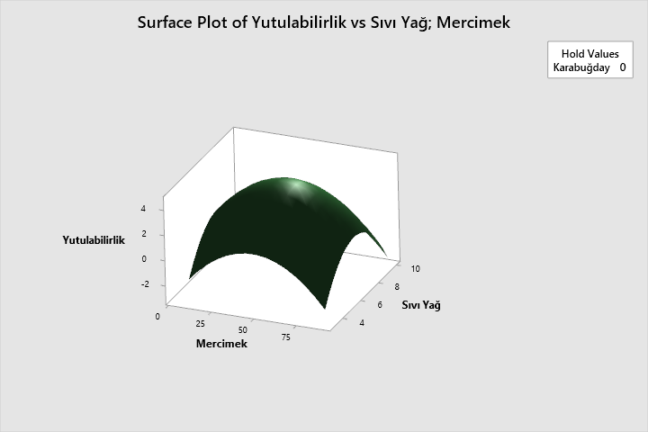
Olive oil
Hold Values
Olive Oil 0
Swallowability
Lentil
Hold Values
Buckwheat 0
Swallowability
Buckwheat
Lentil
Olive oil
Buckwheat
Surface Plot of Swallowability & Olive Oil, Lentil
Surface Plot of Swallowability & Buckwheat, Lentil
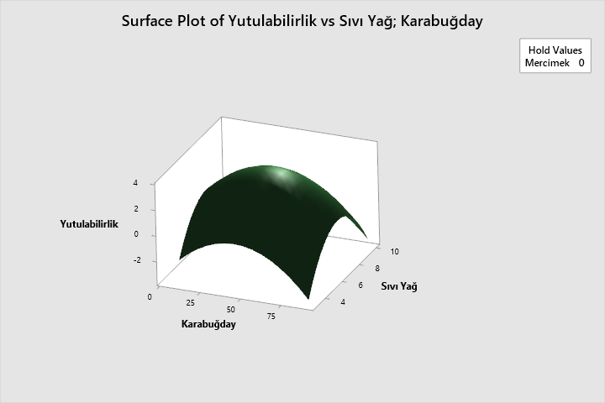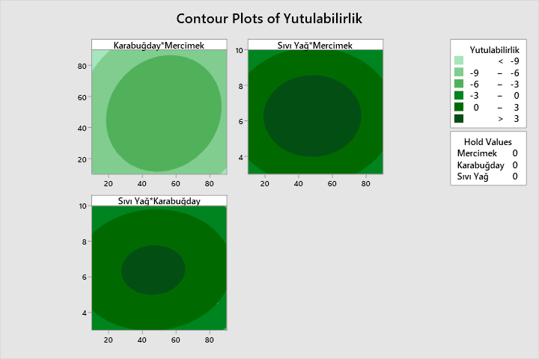
Interaction Plot of Swallowability
Fitted Means
Hold Values
Lentil 0
Swallowability
Swallowability
Hold Values
Lentil 0 Buckwheat 0 Olive Oil 0
Contour Plot of Swallowability
Surface Plot of Swallowability & Olive Oil, Buckwheat
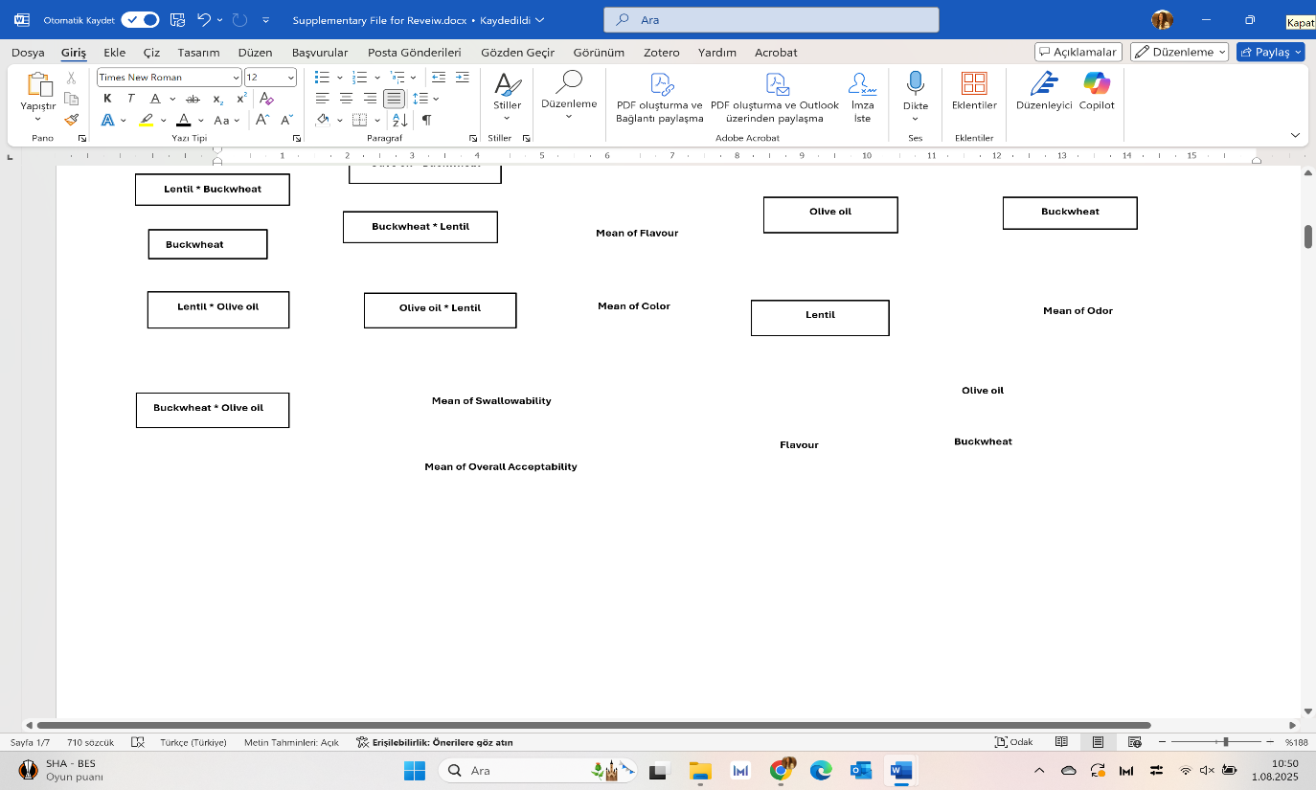
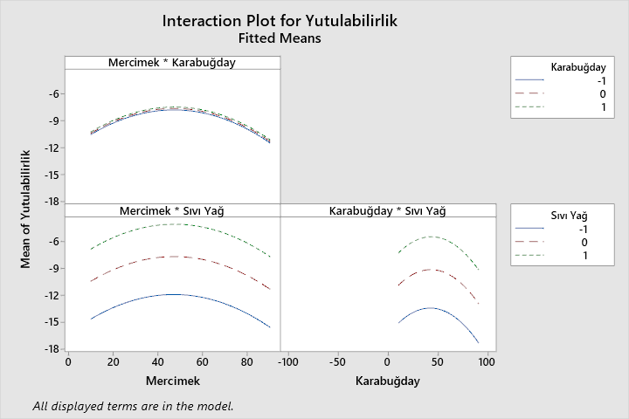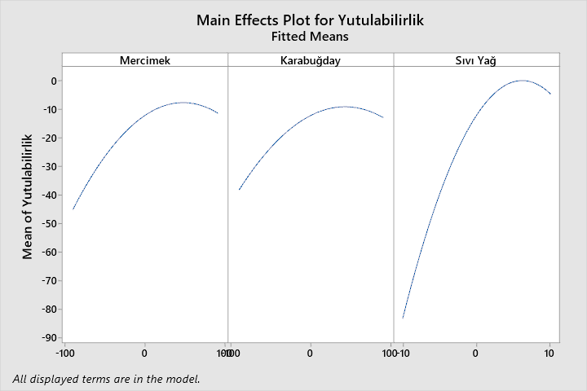
Main Effects Plot of Swallowability
Fitted Means
Mean of Swallowability
Mean of Swallowability
Olive oil
Buckwheat

The following three-dimensional interaction graph is related to the graph of overall acceptability, the graph of contour, the graph of main effect and the graph of interaction
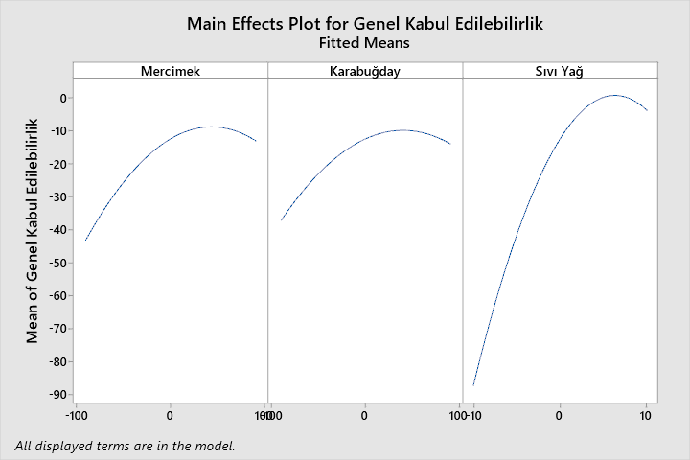
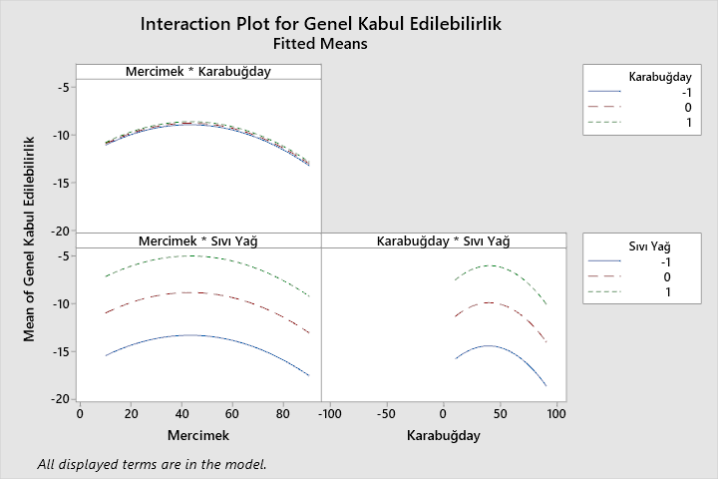
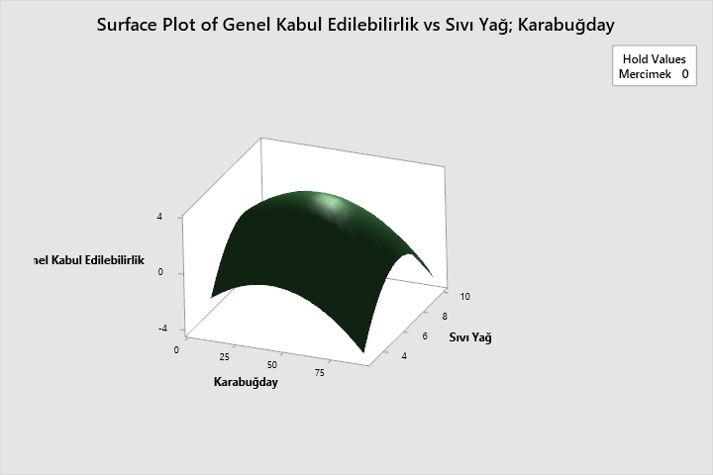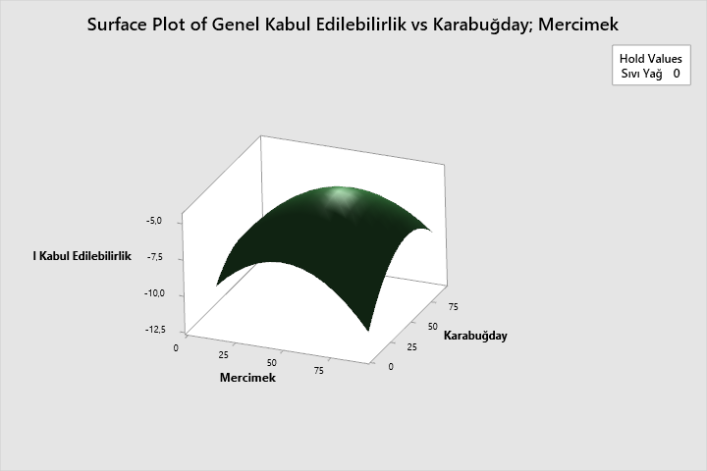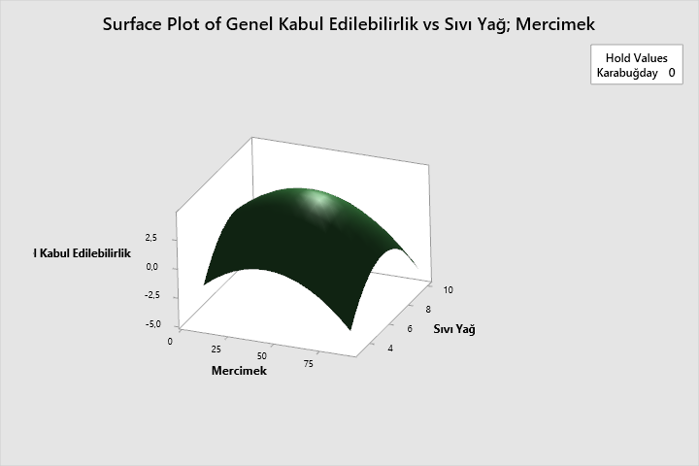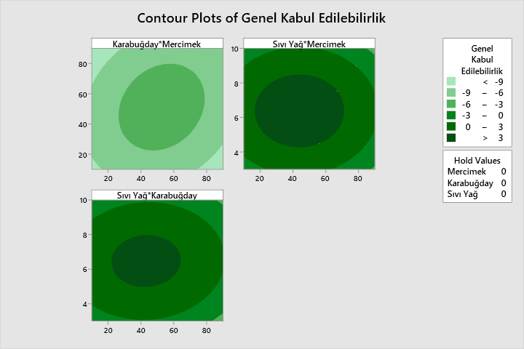
Interaction Plot of Swallowability
Fitted Means
Main Effects Plot of Swallowability
Fitted Means
Mean of Overall Acceptability

Mean of Overall Acceptability

Hold Values
Lentil 0 Buckwheat 0 Olive Oil 0
Overall
Acceptability
Contour Plot of Overall Acceptability
Surface Plot of Overall Acceptability & Olive Oil, Buckwheat

Hold Values
Buckwheat 0
Olive oil
Olive oil
Hold Values
Olive Oil 0
Hold Values
Lentil 0
Surface Plot of Overall Acceptability & Olive Oil, Lentil
Surface Plot of Overall Acceptability & Buckwheat, Lentil
Overall Acceptability
Lentil
Lentil
Overall Acceptability
Overall Acceptability
Olive oil
Olive oil

