Supplementary Data 1: Tables and Figures
Fate of Brain metastasis with Cerebrospinal fluid space invasion based on MRI findings: Clinical features and factors affecting progression to overt leptomeningeal metastasis
Yoontae Hong, M.D.,¹ Haechan Song, M.D.,¹ Ho-Shin Gwak, M.D., Ph.D.,^{2,3} Yun-Sik Dho, M.D., Ph.D.,² Sang Hoon Shin, M.D., Ph.D.,² Heon Yoo, M.D., Ph.D.,² Kyu Chang Wang, M.D., Ph.D.²
¹Department of Neurosurgery, Seoul National University College of Medicine, Seoul, Korea; ²Neuro-Oncology Clinic, National Cancer Center, ³Department of Cancer Biomedical Science, National Cancer Center Graduate School of Cancer Science and Policy, Goyang, Korea

Corresponding author:
Ho-Shin Gwak, M.D., Ph.D.
Department of Cancer Biomedical Science, National Cancer Center Graduate School of Cancer Science and Policy,
323 Ilsan-ro, Ilsandong-gu, Goyang-si, Gyeonggi-do, 10408, Republic of Korea
Tel: +82-31-920-1666 Fax: +82-31-920-2798
E-mail: nsghs@ncc.re.kr

Supplementary Table 1. Comparison of preoperative clinical and radiological characteristics of enrolled cohort with excluded patients.
Characteristics | No. of Patients (%) |  | p-value
Characteristics | Enrolled  (n = 297) | Excludedª  (n = 110) | p-value
Age  <65 years  ≥65 years | 214 (72.1)  83 (27.9) | 74 (67.3)  36 (32.7) | 0.41
Sex  Male  Female | 157 (52.9)  140 (47.1) | 51 (46.4)  59 (53.6) | 0.29
Primary cancer  NSCLC  SCLC  Breast  Other | 156 (52.5)  11 (3.7)  51 (17.2)  79 (26.6) | 60 (54.5)  4 (3.6)  26 (23.6)  20 (18.2) | 0.23
KPS score  <70  ≥70 | 27 (9.1)  270 (90.9) | 15 (13.6)  95 (86.3) | 0.25
Primary cancer controlled  Yes  No | 200 (67.3)  97 (32.7) | 78 (70.9)  32 (29.1) | 0.57
Extracranial metastasis  Yes  No | 95 (32.0)  202 (68.0) | 33 (30.0)  77 (70.0) | 0.79
RPA class  I  II  III | 102 (34.3)  168 (56.6)  27 (9.1) | 50 (45.5)  54 (49.1)  6 (5.5) | 0.09
Prior therapy for BM  None  Chemo alone  RT alone  Chemo + RT | 222 (74.7)  23 (7.7)  39 (13.1)  13 (4.4) | 70 (63.6)  14 (12.7)  16 (14.5)  10 (9.1) | 0.08
BM location  Supratentorial only  Infratentorial^{b} | 231 (77.8)  66 (22.2) | 81 (73.6)  29 (26.4) | 0.46
CSF proximity on MRI^{c}  Contact  Involved | 86 (29.0)  211 (71.0) | 35 (31.8)  75 (68.2) | 0.66
Dural attachment on MRI  No contact  Contact  Contact + Gd-E (+) | 105 (35.4)  48 (16.2)  144 (48.5) | 32 (29.1)  15 (13.6)  63 (57.3) | 0.29
ª Excluded patients were due to postoperative clinical follow-up duration under 6 months or without follow-up MRI, as explained in Methods section, ^{b} Infratentorial only or both supratentorial and infratentorial, ^{c} See the Methods section for definitions of CSF proximity.
Abbreviations: BM, brain metastasis; Chemo, chemotherapy; CSF, cerebrospinal fluid; Gd-E, gadolinium enhancement (of the attached dura); KPS, Karnofsky Performance Status; MRI, magnetic resonance imaging; NSCLC, non–small cell lung cancer; RPA, Recursive Partitioning Analysis; RT, radiation therapy; SCLC, small cell lung cancer.
Supplementary Table 2. Intraoperative characteristics according to leptomeningeal progression.
Characteristics | No. of Patients (%) |  |  | p-value
Characteristics | Total  (n = 297) | LM Progression (+)  (n = 91) | LM Progression (–) (n = 206)
Dural attachment during intraoperative visualizationª  Negative  Positive | 169 (66.3)  86 (33.7) | 54 (65.9)  28 (34.1) | 115 (66.5)  58 (33.5) | 0.99
Mode of resection  En bloc  Piecemeal | 115 (38.7)  182 (61.3) | 34 (37.4)  57 (62.6) | 81 (39.3)  125 (60.7) | 0.85
Ventricle opening  Yes  No | 27 (9.1)  270 (90.9) | 8 (8.8)  83 (91.2) | 19 (9.2)  187 (90.8) | 0.99
CUSA used  Yes  No | 138 (46.5)  159 (53.5) | 39 (42.9)  52 (57.1) | 99 (48.1)  107 (51.9) | 0.48
Intraoperative CSF cytology^{b}  Negative  Positive | 29 (85.3)  5 (14.7) | 11 (73.3)  4 (26.7) | 18 (94.7)  1 (5.3) | 0.15
ª The presence or absence of dural attachment was mentioned in the operative report in a total of 255 patients (LM progression (+) group, n = 82; LM progression (–) group, n = 173).
^{b} Intraoperative cytology was obtained in a total of 34 patients (LM progression (+) group, n = 15; LM progression (–) group, n = 19).
Abbreviations: CSF, cerebrospinal fluid; CUSA, cavitron ultrasonic surgical aspirator; LM, leptomeningeal metastasis.

Supplementary Table 3. Correlations between dural attachment on preoperative magnetic resonance imaging and dural attachment visualized during surgery.
Characteristics | No. of Patients (%) |  |  | p-value
Characteristics | Total  (n = 255ª) | Intraoperative dural attachment (–)  (n = 169) | Intraoperative dural attachment (+)  (n = 86)
Dural attachment on preoperative MRI  None  Contact  Contact + Gd-E (+) | 89 (34.9)  40 (15.7)  126 (49.4) | 79 (46.7)  28 (16.6)  62 (36.7) | 10 (11.6)  12 (14.0)  64 (74.4) | <0.01
ª The presence or absence of dural attachment was not mentioned in the operative report for 42 of the 297 study participants.
Abbreviations: Gd-E, gadolinium enhancement (of the attached dura); MRI, magnetic resonance imaging.

Supplementary Table 4. Postoperative characteristics according to leptomeningeal progression.
Characteristics | No. of Patients (%) |  |  | p-value
Characteristics | Total  (n = 297) | LM Progression (+) (n = 91) | LM Progression (–) (n = 206)
CSF cytology positive rateª  <50%  ≥50% | 87 (82.9)  18 (17.1) | 46 (74.2)  16 (25.8) | 41 (95.3)  2 (4.7) | <0.05
Adjuvant systemic chemotherapy  Yes  No | 189 (63.6)  108 (36.3) | 56 (61.5)  35 (38.5) | 133 (64.6)  73 (35.4) | 0.71
Intra-CSF chemotherapy  Yes  No | 7 (2.4)  290 (97.6) | 3 (3.3)  88 (96.7) | 4 (1.9)  202 (98.1) | 0.44
Adjuvant RT  None  Local only  WBRT (±local boost) | 86 (29.0)  94 (31.6)  117 (39.4) | 25 (27.5)  28 (30.8)  38 (41.8) | 61 (29.6)  66 (32.0)  79 (38.3) | 0.85
ª Postoperative cytology samples were obtained in a total of 105 patients (LM progression (+) group, n = 62; LM progression (–) group, n = 43).
Abbreviations: CSF, cerebrospinal fluid; LM, leptomeningeal metastasis; RT, radiotherapy; WBRT, whole brain radiotherapy.

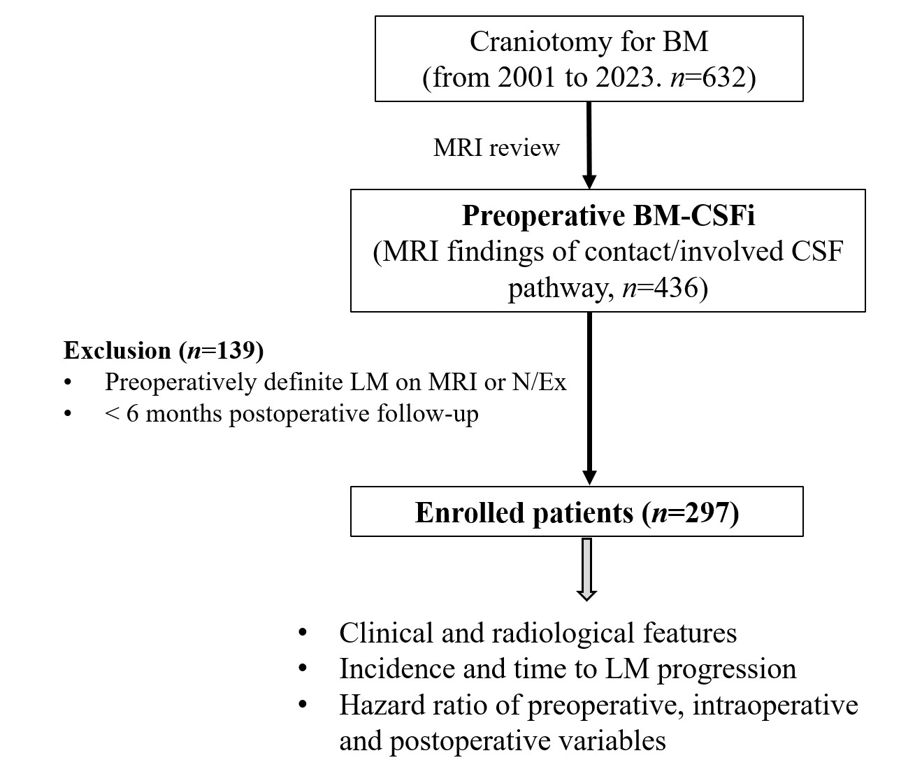
Supplementary Fig 1. Study flow diagram. Abbreviations: BM, brain metastasis; BM-CSFi, brain metastasis with CSF space invasion; CSF, cerebrospinal fluid; LM, leptomeningeal metastasis; MRI, magnetic resonance imaging; N/Ex, neurological examination.

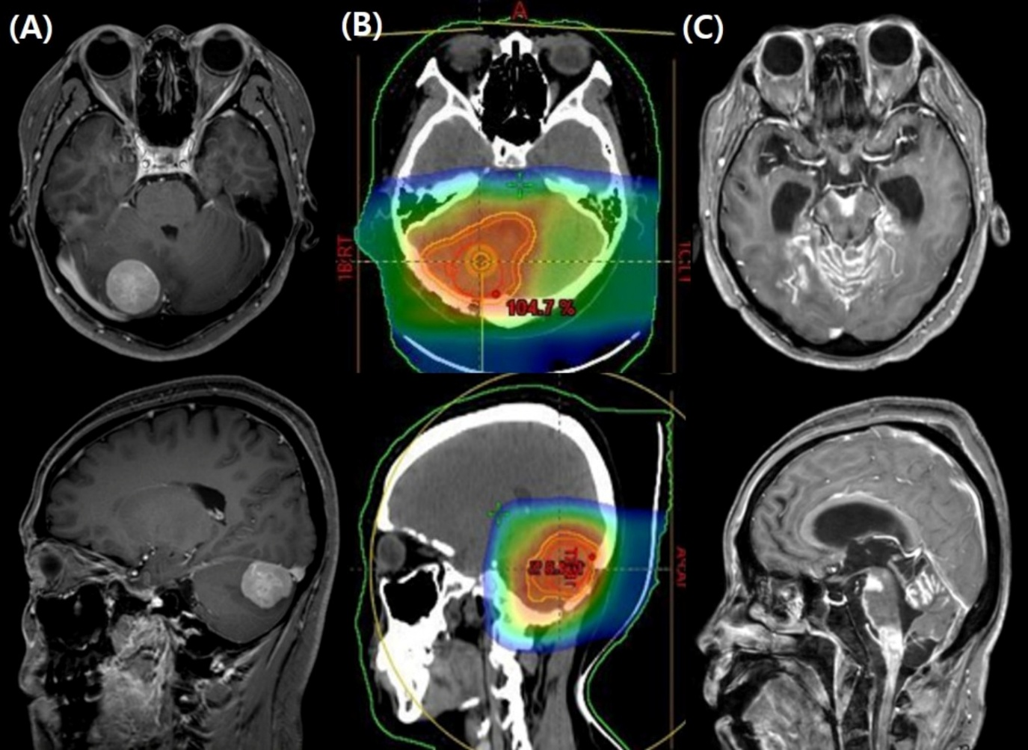
Supplementary Fig 2. Illustrative case of brain metastasis in a female patient with primary ovarian cancer that eventually progressed to leptomeningeal metastasis (LM). (A) Preoperative gadolinium-enhanced magnetic resonance imaging (MRI) revealed a solitary cerebellar metastasis attached to the tentorial dura. Operative findings confirmed the dural attachment, and intraoperative cerebrospinal fluid (CSF) cytology was positive for malignant cells. (B) Postoperatively, the patient received 15 cycles of adjuvant intrathecal methotrexate over 9 months, as serial CSF cytology results remained positive, although there were no MRI features or symptoms suggestive of LM. Proton beam therapy (4,500 cGy in 15 fractions) was administered to the posterior fossa for local recurrence control. (C) Definite LM was detected in the posterior fossa on MRI at 22 months postoperatively. The patient also developed methotrexate-induced necrotizing leukoencephalopathy.

