Supplementary Information

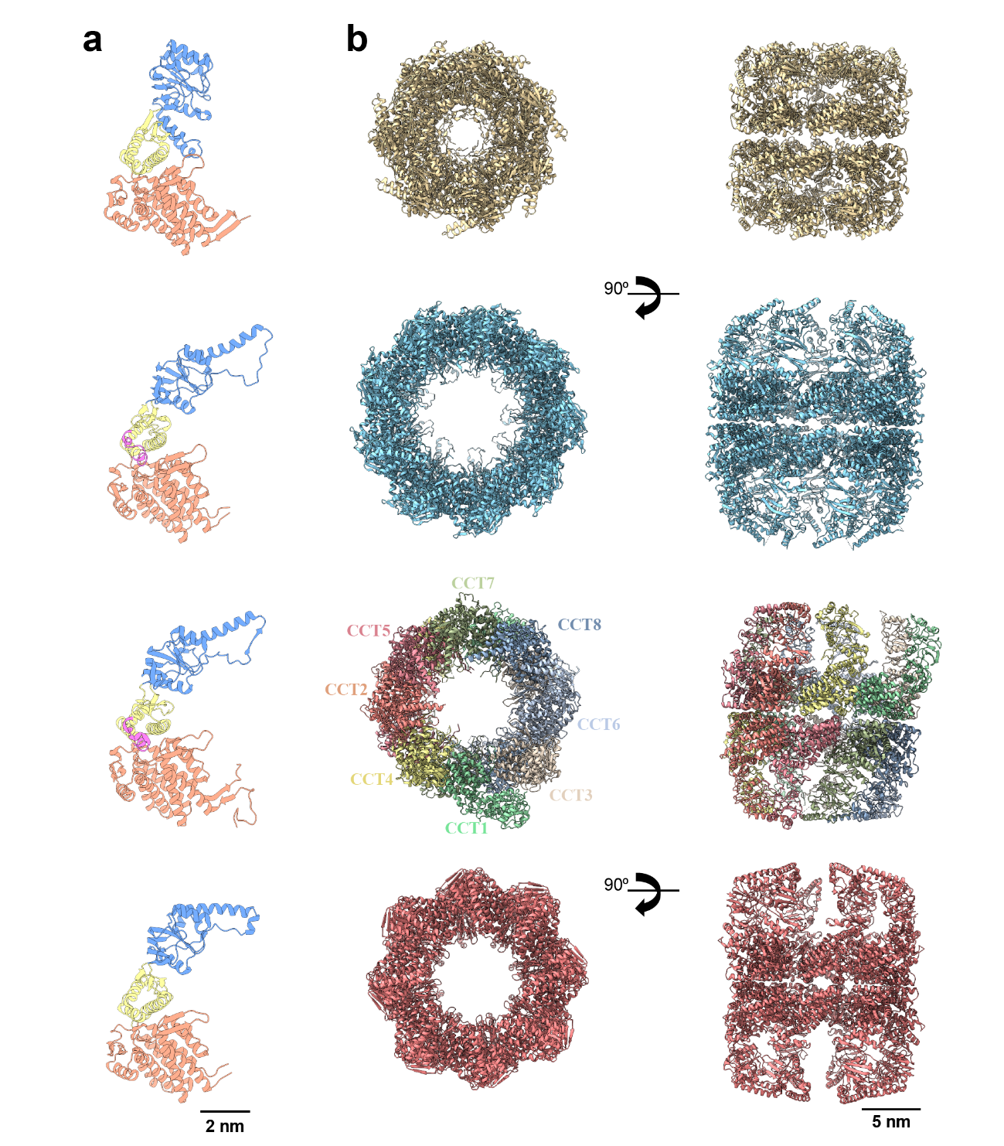

Supplementary Fig. 1.
a Atomic structure of the monomer of a group I chaperonin (Hydrogenobacter thermophilus, PDB: 8WUX), group II thermosome (Saccharolobus solfataricus, PDB:4XCD), group II CCT (Homo sapiens, PDB: 6QB8) and group III (Carboxydothermus hydrogenoformans, PDB: 5X9U) The color code indicates the classical three domains of a chaperonin monomer (orange, equatorial domain; yellow, Intermediate domain; blue, apical domain). The sequence colored in pink corresponds to the sensing loop. b Two orthogonal views (left, top view; right; side view) of (from top to bottom) group I GroEL, group. II thermosome from Saccharolobus solfataricus, group II human CCT and the group III chaperonin from Carboxydothermus hydrogenoformans.
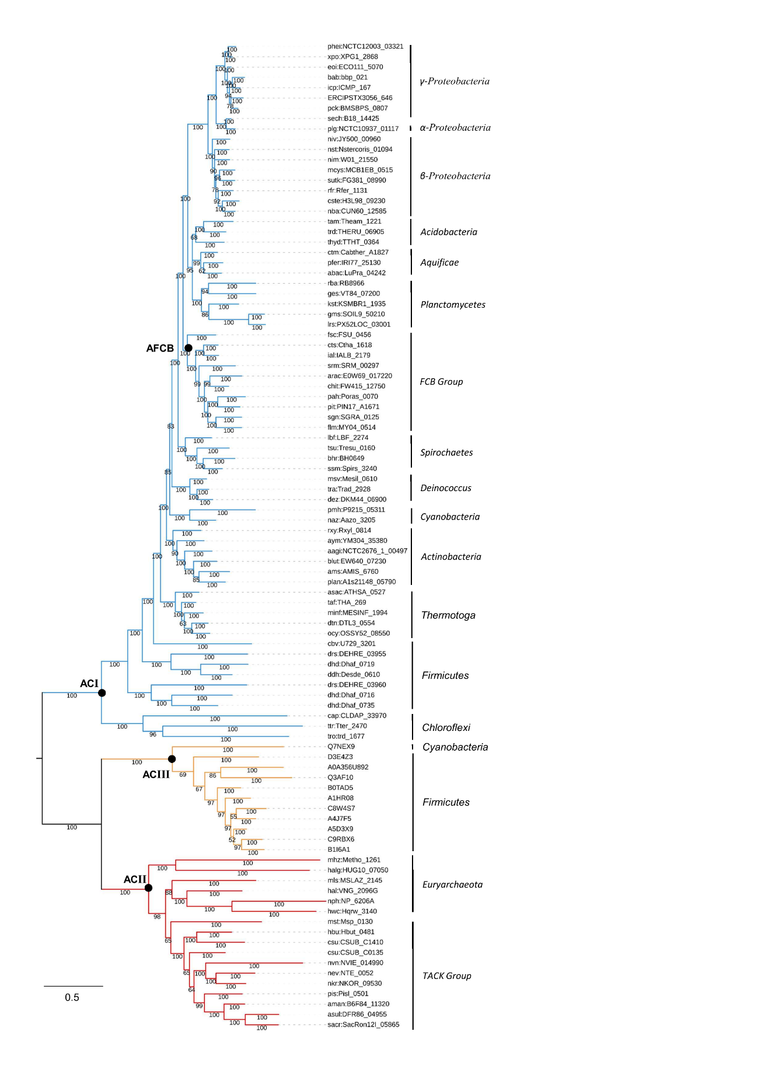

Supplementary Fig. 2. Phylogenetic reconstruction of prokaryotic chaperonins.
a Bayesian phylogeny of prokaryotic chaperonins from Group I (blue), Group II (red), and Group III (yellow), reconstructed with MrBayes 3.2.7²⁷. The tree was rooted between Group I and Group II, reflecting the widely accepted placement of LUCA between Bacteria and Archaea. Groups II and III cluster together as suggested previously^{14,15}. Four nodes were selected for protein resurrection (black circles), namely the Last Common Ancestors of Group I (ACI), Group II (ACII), Group III (ACII) and FCB Group (AFCB). Node labels represent posterior probabilities (%). Scale bar: substitutions per site.

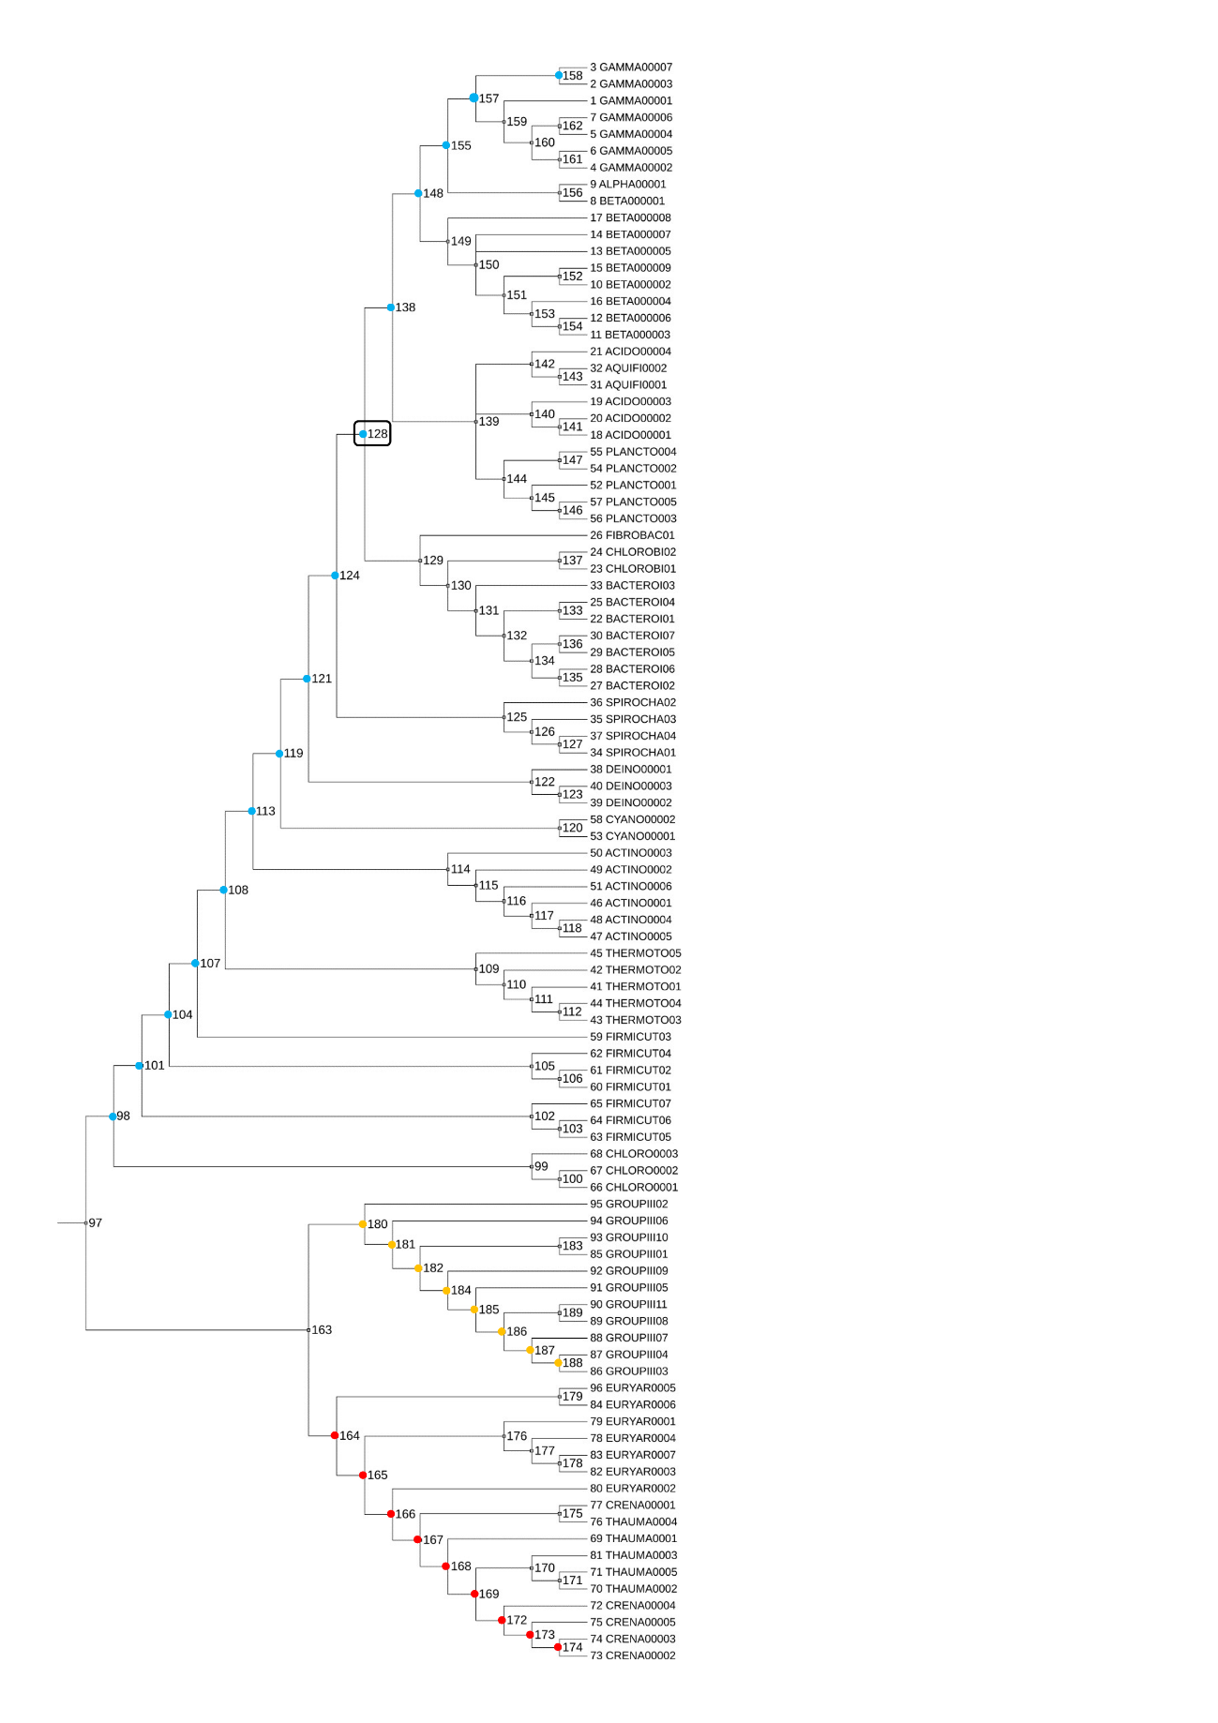

Supplementary Fig. 3. Cladogram with numbered ancestral nodes
Tree generated by PAML with ancestral nodes numbered (97-189). Colored nodes highlight those used for FoldX-based stability estimations. A black box highlights node 128.
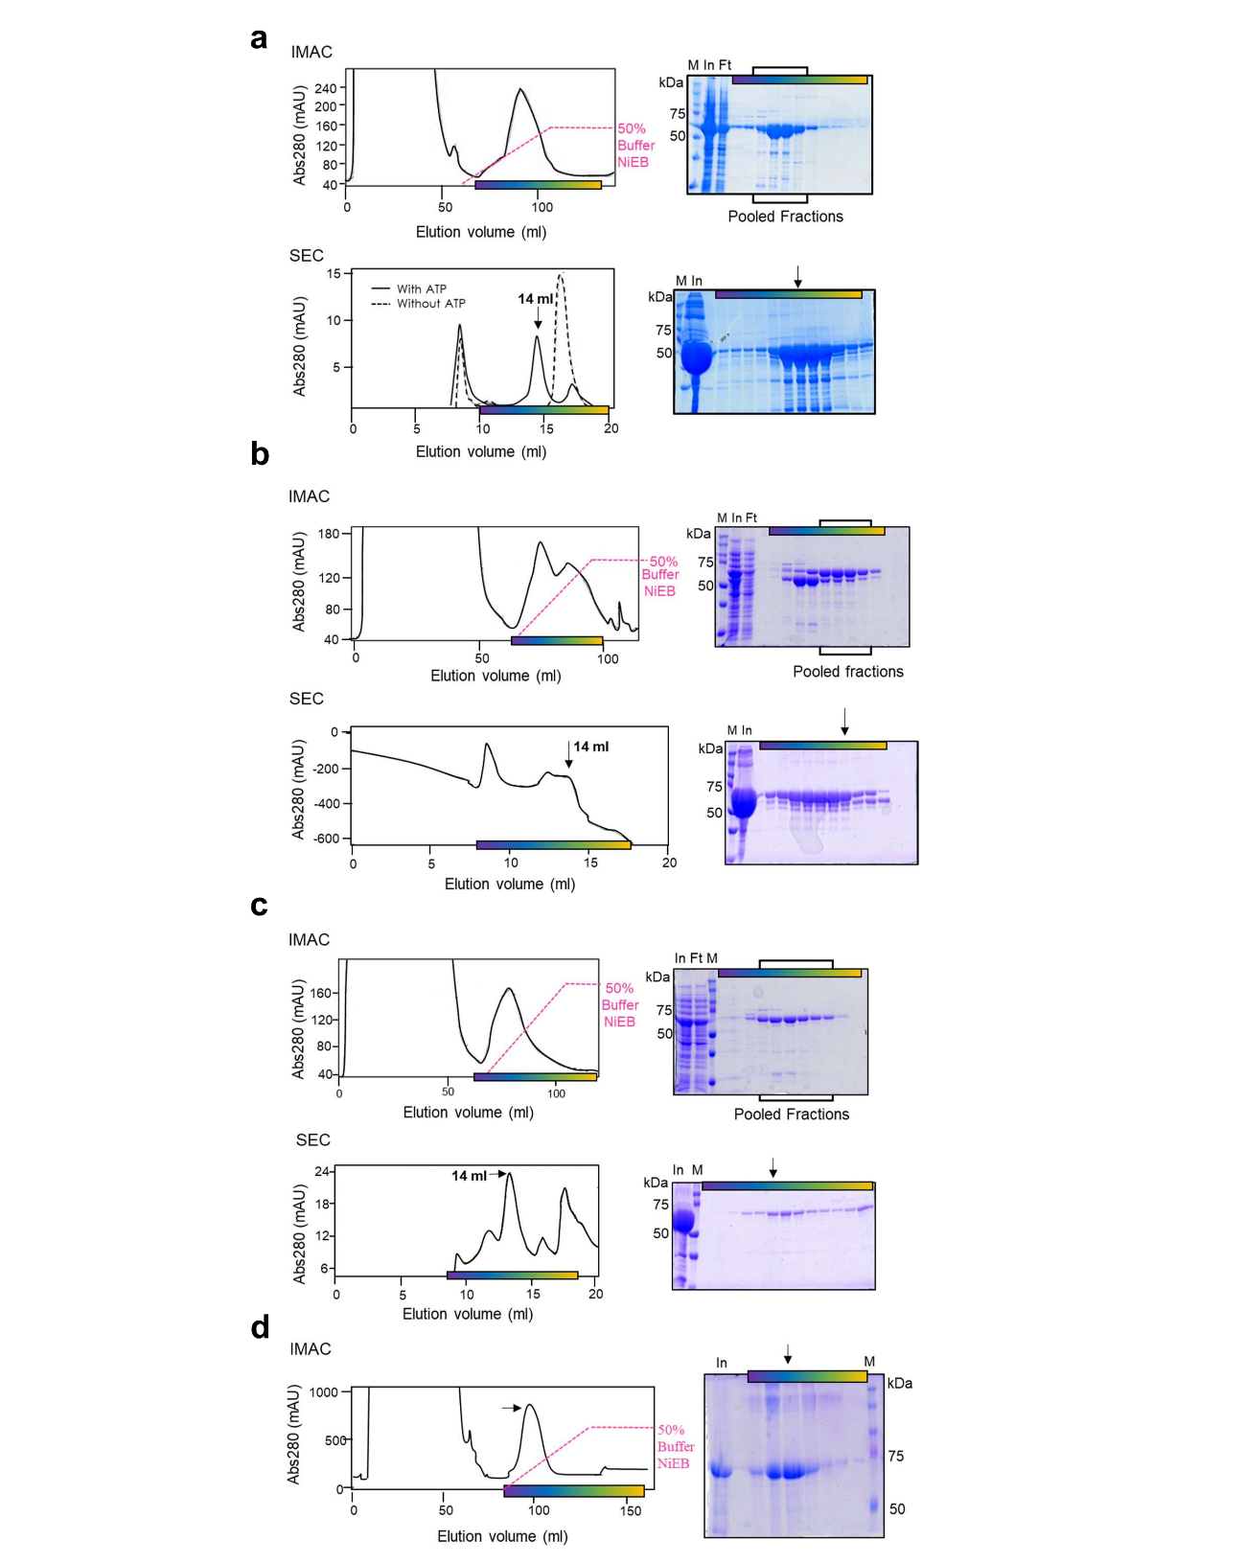

Supplementary Fig. 4. Purification and quality assessment of resurrected ancestral chaperonins
a-d Chromatography results and SDS-PAGE analysis are shown for the purification of four ancestral chaperonins ACI, ACII, ACIII, and AFCB, respectively. Proteins were purified from whole cell-lysate by immobilized metal affinity chromatography (IMAC) and size-exclusion chromatography (SEC), using Ni-NTA and Superose® 6 Increase 10/300 GL (GE Healthcare) columns, respectively. After analyzing the fractions, those with the best-assembled and higher amount of chaperonin were pooled, snap frozen in liquid nitrogen, and stored at -20°C. The purest SEC fraction was vitrified and used for 3D CryoEM reconstruction. M – molecular marker; In – input; Ft – flow through.

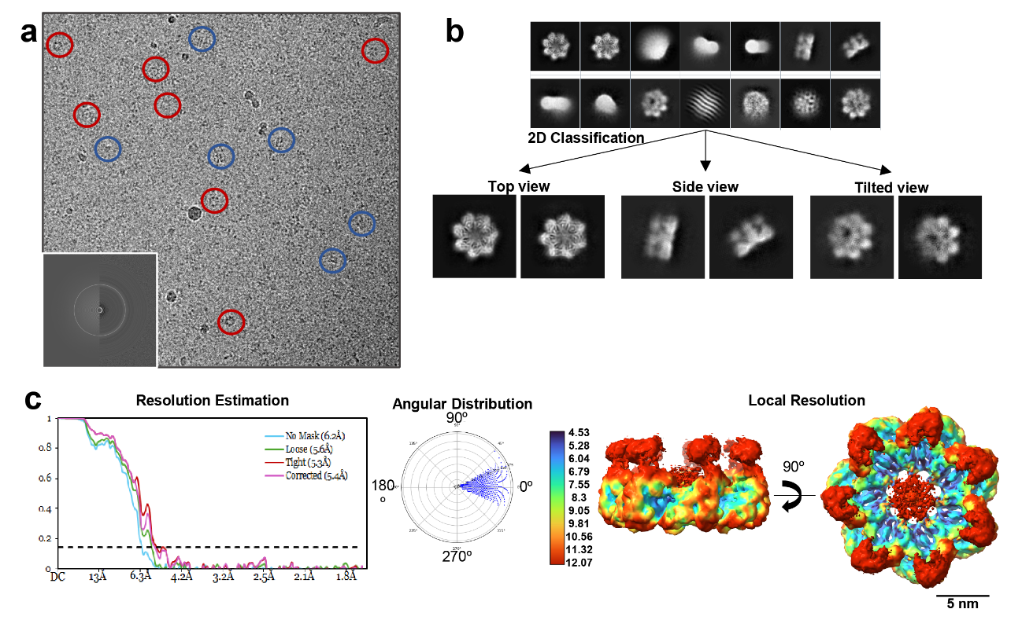

Supplementary Fig. 5 Cryo-EM data processing and workflow of ACI.
a Representative cryo-EM micrograph of ACI at ×120,000 magnification. Colored circles highlight different particle orientations: red circles indicate top views, blue circles indicate side views. The inset shows the CTF estimation of the micrograph. b 2D classification of cryo-EM particles, revealing different orientations of ACI. Representative top, side, and tilted views are shown. c Resolution estimation and angular distribution for ACI 3-D reconstruction. The left panel shows the gold standard Fourier shell correlation (FSC) curve, with the reported resolution indicated as 5.4 Å. The middle panel shows the angular distribution of particles used in the final reconstruction. The right panel displays a local resolution map generated using MonoRes in Xmipp, colored according to local resolution estimates, shown in two orthogonal views.

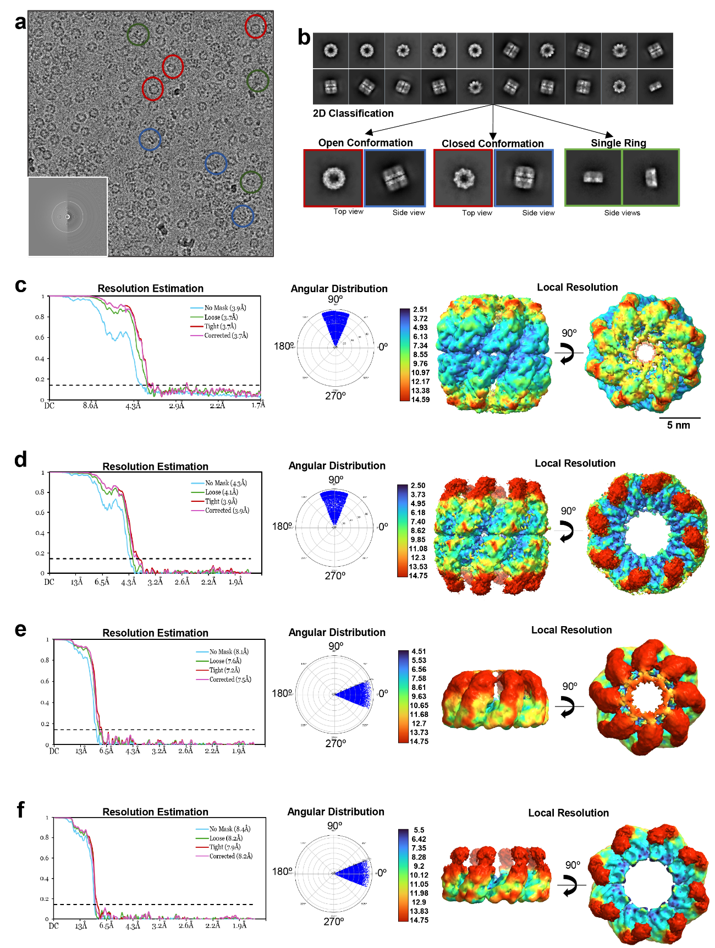

Supplementary Fig. 6. Cryo-EM data processing and workflow of ACII variants.
a Representative cryo-EM micrograph of ACII at ×120,000 magnification. Colored circles highlight different particle orientations: red circles indicate top views, blue circles indicate side views, and green circles indicate single-ring conformations. The inset shows the CTF estimation of the micrograph. b 2D classification of cryo-EM particles, revealing different conformations of ACII, including open and closed conformations, as well as single- and double-ring arrangements. Representative top and side views are shown for each conformation. c-f Resolution estimation and angular distribution for double-ring in closed (c) and open (d) conformation and single-ring in closed (e) and open (f) conformation. The left panel shows the gold standard Fourier shell correlation (FSC) curve, with the reported resolution indicated as 3.6 Å (c), 3.9 Å (d), 7.5 Å (e) and 8.2 Å (f). The middle panel shows the angular distribution of particles used in the final reconstruction. The right panel displays a local resolution map generated using MonoRes in Xmipp, colored according to local resolution estimates, shown in two orthogonal views.

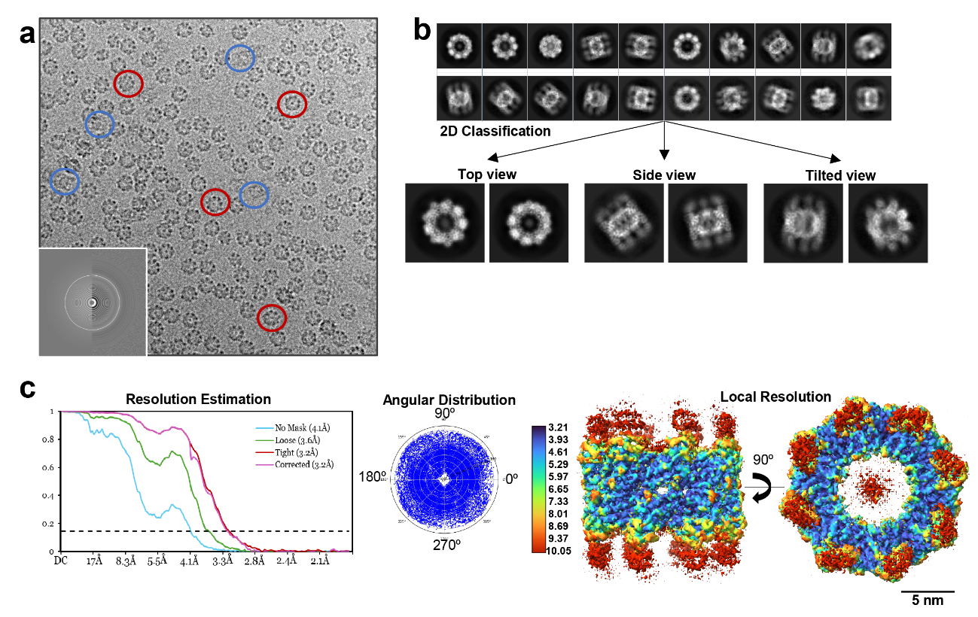

Supplementary Fig. 7: Cryo-EM data processing and structure validation of ACIII.
a Representative cryo-EM micrograph of ACIII at ×130,000 magnification. Colored circles highlight different particle orientations: red circles indicate top views, and blue circles indicate side views. The inset shows the CTF estimation of the micrograph. b 2D classification of cryo-EM particles, revealing different orientations of ACIII Representative top, side, and tilted views are shown. c Resolution estimation and angular distribution for ACIII 3-D reconstruction. The left panel shows the gold standard Fourier shell correlation (FSC) curve, with the reported resolution indicated as 3.2 Å. The middle panel shows the angular distribution of particles used in the final reconstruction. The right panel displays a local resolution map generated using MonoRes in Xmipp, colored according to local resolution estimates, shown in two orthogonal views.

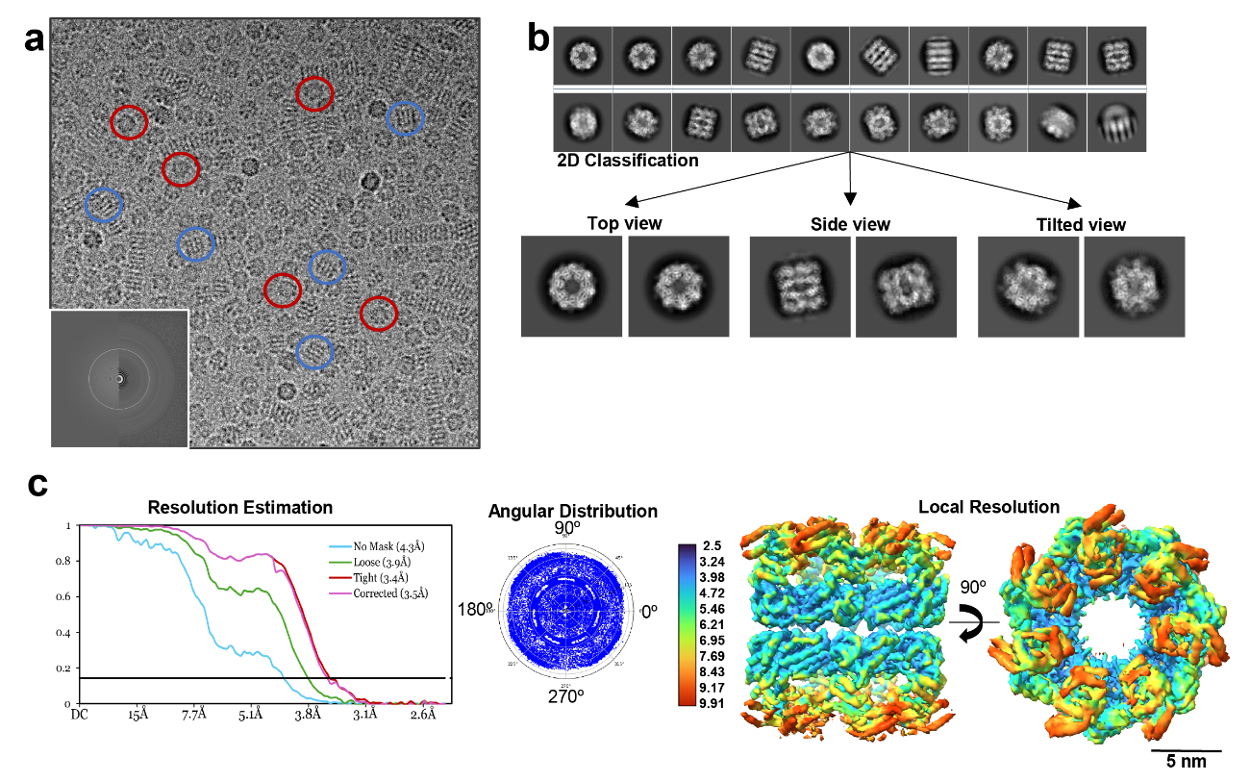

Supplementary Fig. 8: Cryo-EM data processing and structure validation of AFCB.
a Representative cryo-EM micrograph of AFCB at ×120,000 magnification. Colored circles highlight different particle orientations: red circles indicate top views, and blue circles indicate side views. The inset shows the CTF estimation of the micrograph. b 2D classification of cryo-EM particles, revealing different orientations of AFCB. Representative top, side, and tilted views are shown. c Resolution estimation and angular distribution for AFCB 3-D reconstruction. The left panel shows the gold standard Fourier shell correlation (FSC) curve, with the reported resolution indicated as 3.4 Å. The middle panel shows the angular distribution of particles used in the final reconstruction. The right panel displays a local resolution map generated using MonoRes in Xmipp, colored according to local resolution estimates, shown in two orthogonal views.

Supplementary Table I. Data acquisition for Resurrected Ancestral Chaperonins
 | ACI | AFCB | ACII | ACIII
Data collection & processing
Microscope |  | FEI TALOS Arctica |  | FEI Titan Krios
Voltage (KV) |  | 200 |  | 300
Camera | Falcon 4i | Falcon 3 | Falcon 4i | Gatan K3
Detector mode | Electron-counting
Total dose (e⁻/Å²) | 40 | 43 | 38 | 48
Frames | 1305 | 40 | 1035 | 40
Dose per frame (e⁻/Å²) | 0.038 | 1.075 | 0.029 | 1.2
Defocus range | -0.8 to -2.2 |  |  | -1 to -2.4
Pixel size (Å) | 0.85 |  |  | 0.92
Initial number of particles | 117,944 | 245,876 | 2,474,620 | 504,265
Final number of particles | 28,579 | 44,531 | 39,180 | 40,850
Map resolution (Å) | 5.38 | 3.45 | 3.68 | 3.21
FSC threshold | 0.143
Map resolution range (Å) | 4.5-12.1 | 2.5-9.9 | 2.5-9.9 | 3.25-10

Supplementary Table II. Posterior probabilities of key residues at the inter-ring interface across ancestral chaperonin nodes
 | Amino acid (probability)
Node* | R→R | D→E | A→S | E→V
98 | R (0.89) | D (0.95) | A (0.82) | E (0.48)
101 | R (0.89) | D (0.97) | A (0.72) | E (0.58)
104 | R (0.95) | D (0.97) | A (0.44) | E (0.69)
107 | R (0.96) | D (0.84) | S (0.59) | E (0.69)
108 | R (0.98) | D (0.75) | S (0.79) | V (1)
113 | R (0.99) | E (0.53) | S (0.96) | V (1)
119 | R (0.99) | E (0.69) | S (0.99) | V (1)
121 | R (1) | E (0.94) | S (1) | V (1)
124 | R (1) | E (0.97) | S (1) | V (1)
128 | R (1) | E (1) | S (1) | V (1)
138 | R (1) | E (1) | S (1) | V (1)
148 | R (1) | E (1) | S (1) | V (1)
155 | R (1) | E (1) | S (1) | V (1)
157 | R (1) | E (1) | S (1) | V (1)
*Node numbers according to Supplementary Fig. 3.

Supplementary Table III. Model refinement and statistics
MODEL | ACII Double-Ring in Closed Conformation |  | AFCB Double-Ring in Open Conformation |  | ACIII Double-Ring in Open Conformation
PDB accession ID | 9RWP |  | 9RWQ |  | 9RWR
Symmetry imposed | D8 |  | C1 |  | C1
Composition
Chains | 32 |  | 14 |  | 16
Atoms | 120944 (Hydrogens: 61056) |  | 112056 (Hydrogens: 57148) |  | 81968 (Hydrogens: 41472)
Residues | Protein: 7936  Nucleotide: 0 |  | Protein: 7308 Nucleotide: 0 |  | Protein: 5456 Nucleotide: 0
Ligands | MG: 16 ADP: 16 |  | 0 |  | 0
Bonds (RSMD)
Length (Å) | 0.006 |  | 0.006 |  | 0.006
Angles (º) | 1.239 |  | 1.338 |  | 1.309
MolProbity Score | 1.55 |  | 1.44 |  | 1.28
Clash score | 6.17 |  | 4.89 |  | 5.27
Ramachandran plot (%)
Outliers | 0.01 |  | 0 |  | 0
Allowed | 3.35 |  | 3.13 |  | 1.63
Favored | 96.63 |  | 96.87 |  | 98.37
Rotamer outliers (%) | 0 |  | 0.03 |  | 0.19
Cß outliers (%) | 0 |  | 0 |  | 0
Peptide plane (%)
Cis proline/general | 0.0/0.0 |  | 0.0/0.0 |  | 0.0/0.0
Twisted proline/general | 0.0/0.0 |  | 0.0/0.0 |  | 0.0/0.0
CaBLAM outliers (%) | 1.38 |  | 2.22 |  | 0.68
ADP (B-factors)
Iso/Aniso | 59888/0 |  | 54908/0 |  | 40496/0
min/max/mean
Protein | 67.22/188.38/118.24 |  | 43.35/191.62/106.43 |  | 39.35/156.94/84.48
Ligand | 59.79/88.54/79.53 |  | --- |  | ---
Occupancy
Mean | 1.0 |  | 1.0 |  | 1.0
Occ=1 (%) | 100 |  | 100 |  | 100
DATA
Box
Lengths (Å) | 165.62, 165.62, 179.99 |  | 162.19, 164.55, 164.55 |  | 172.23, 171.31, 116.05
Angles (Å) | 90.00, 90.00, 90.00 |  | 90.00, 90.00, 90.00 |  | 90.00, 90.00, 90.00
Supplied Resolution (Å) | 3.7 |  | 3.5 |  | 3.2
Resolution estimates (Å) | Masked | Unmasked | Masked | Unmasked | Masked | Unmasked
d FSC (half maps; 0.143) | 3.7 | 3.8 | 3.8 | 3.9 | 3.4 | 3.6
d 99 (full/half/half2) | 2.7/3.0/3.0 | 2.7/2.4/2.4 | 2.8/2.9/2.9 | 2.8/2.7/2.7 | 2.5/2.0/2.0 | 2.5/1.9/1.9
d model | 2.8 | 2.8 | 2.9 | 2.9 | 2.8 | 2.8
D FSC model (0/0.143/0.5) | 1.9/2.7/4.1 | 1.9/2.7/4.1 | 1.8/2.0/3.8 | 1.8/2.0/3.8 | 1.7/2.0/3.6 | 1.7/2.0/3.6
Map min/max/mean | -0.00/2.04/0.02 |  | -0.00/2.03/0.04 |  | -0.00/1.89/0.03
MODEL vs DATA
CC (mask) | 0.69 |  | 0.73 |  | 0.75
CC (box) | 0.65 |  | 0.72 |  | 0.72
CC (peaks) | 0.65 |  | 0.71 |  | 0.72
CC (volume) | 0.69 |  | 0.73 |  | 0.75
Mean CC for ligands | 0.78 |  | --- |  | ---

