Supplementary Materials for

Dissolved Bubble Microneedle Patches for Co-Delivery of Hydrophobic and Hydrophilic Drugs to Improve Acne Vulgaris Therapy

Authors:
Xiaopeng Zhang^{1,2,#}, Xiaotong Zhao^{1,2,#}, Yiting Li^{1,2,#}, Wanyue Zhang^{1,2}, Yuanyuan Chen³, Haidong Jia³, Zhibing Zhang⁵, Can Yang Zhang^{1,2,4,*}

*Corresponding authors:
Can Yang Zhang, E-mail: zhang.cy@sz.tsinghua.edu.cn
#These authors contributed equally to this work.
Affiliations:
¹Institute of Biopharmaceutical and Health Engineering, Shenzhen International Graduate School, Tsinghua University, Shenzhen 518055, China.
²Key Laboratory of Bioactive Proteins and Peptides Green Biomanufacturing of Guangdong Higher Education Institutes, Shenzhen International Graduate School, Tsinghua University, Shenzhen 518055, China.
³Shanghai Jahwa United Co., Ltd., Shanghai, 200082, China.
⁴Key Laboratory of Industrial Biocatalysis, Ministry of Education; Tsinghua University, Beijing 100084, China.
⁵School of Chemical Engineering, University of Birmingham, Birmingham B15 2TT, United Kingdom.

The Supplementary Materials include: Table S1 and Figs. S1 to S7

Table S1 HPLC Gradient elution program of drug DPG.
Time (min) | Methanol (%) | 0.06% Phosphoric Acid Aqueous Solution (%)
0 | 75 | 25
10 | 30 | 70
15 | 30 | 70
15.1 | 75 | 25
20 | 75 | 25

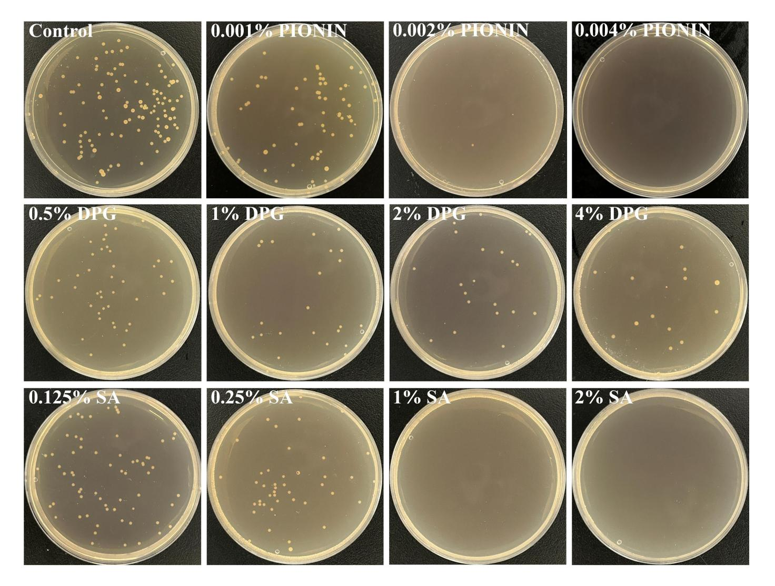
Fig. S1 Agar plate coating results of P. acnes after co-culture with different drug solution, n = 3.

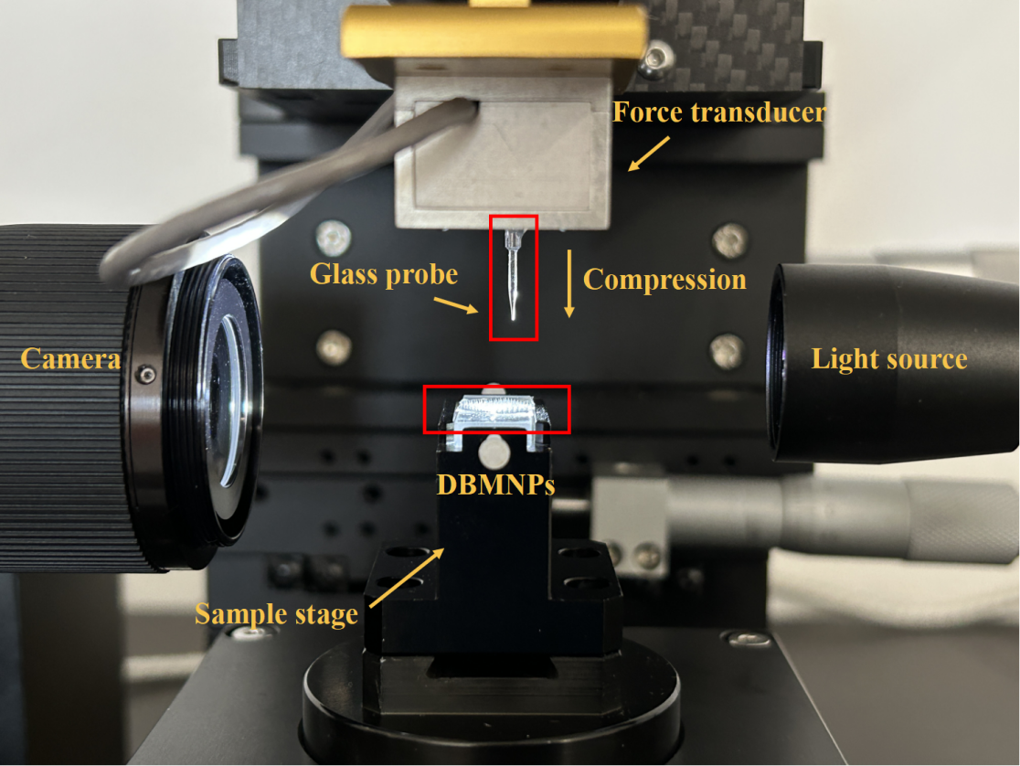
Fig. S2 Microparticle strength tester for measuring the mechanical properties of a single MN arranged on the DBMNPs.

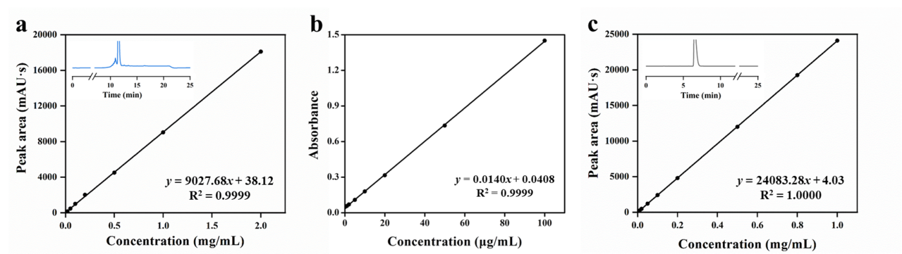
Fig. S3 Standard curve of (a) DPG, (b) PIONIN, and (c) SA. (Inset: liquid chromatogram of DPG and SA)

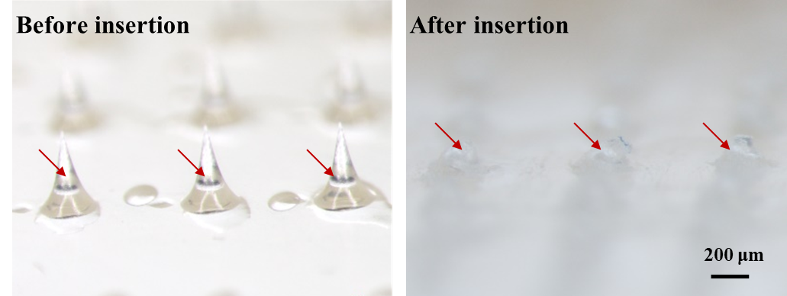
Fig. S4 Morphology of DBMNPs before and after insertion (5 min) into the mouse’s right ear.

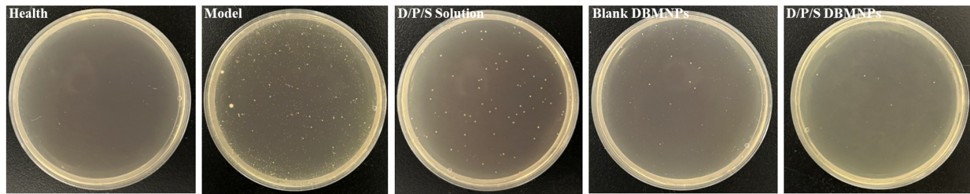
Fig. S5 Images of in vivo bacterial colonies spread on agar plate obtained from the right ear tissues of mice.

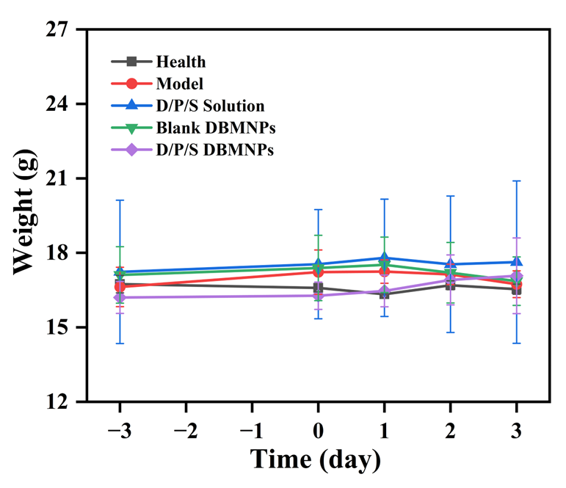
Fig. S6 Changes in body weight of mice during the therapy. n = 3 for each group. All calculated data are presented as mean ± standard deviation.

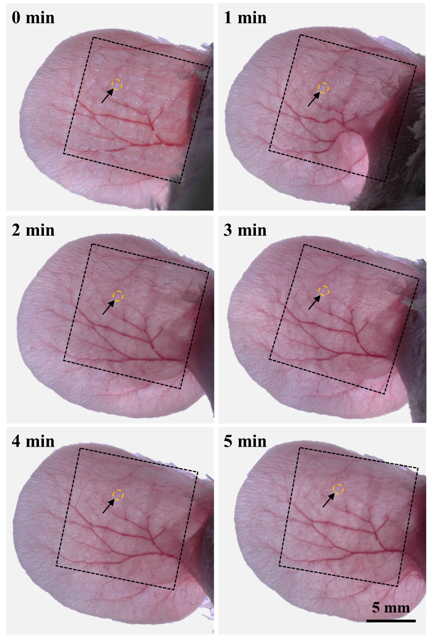
Fig. S7 Skin recovery at insertion sites (black dashed boxes) of mouse’s right ear after DBMNPs removal.

