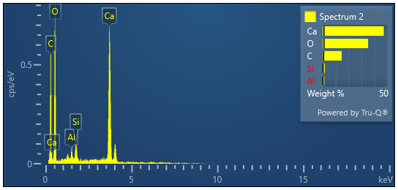
Fig. S1 Qualitative EDS spectrum of limestone powder and Biocement

Qualitative EDS spectrum of limestone powder
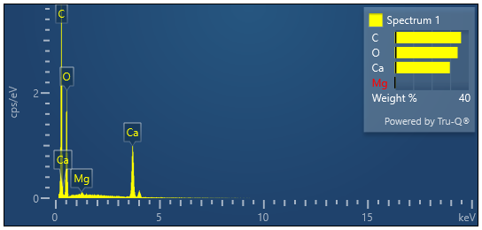
Qualitative EDS spectrum of biocement

