Fig S1. The genome assembly of D. fragrans.
a. Genome survey by Illumina reads; the blue dashed line indicates the A. thaliana genome survey with a heterozygosity rate of 0.5%. b. Hi-C heatmap. c. Telomere prediction results.

Fig S2. CEGMA evaluation of D. fragrans genome.

Fig S3. Functional annotation of the D. fragrans genome.
a. GO database annotation results. b. KOG database annotation results. c. KEGG database annotation results. d. Venn diagram of functional annotations.

Fig S4. Distribution of repetitive sequences on chromosomes.

Fig S5. Ks distribution of collinear gene pairs.

Fig S6. Expression responses of expanded and unique gene families to UV treatment.
a. Volcano plots showing expression differences of expanded and unique gene families under UV treatment. b. Proportion of UV-responsive genes in expanded and unique gene families.

Fig S7. Ks distribution of genes across different replication categories.
Fig S8. Genome-wide correlation between the number of genes with different duplication types and TE counts.

Fig S9. LTR classification and insertion time calculation.
a. Distribution of LTR and its subfamily content. b. Insertion time statistics for Gypsy subfamilies. c. Insertion time statistics for Copia subfamilies.

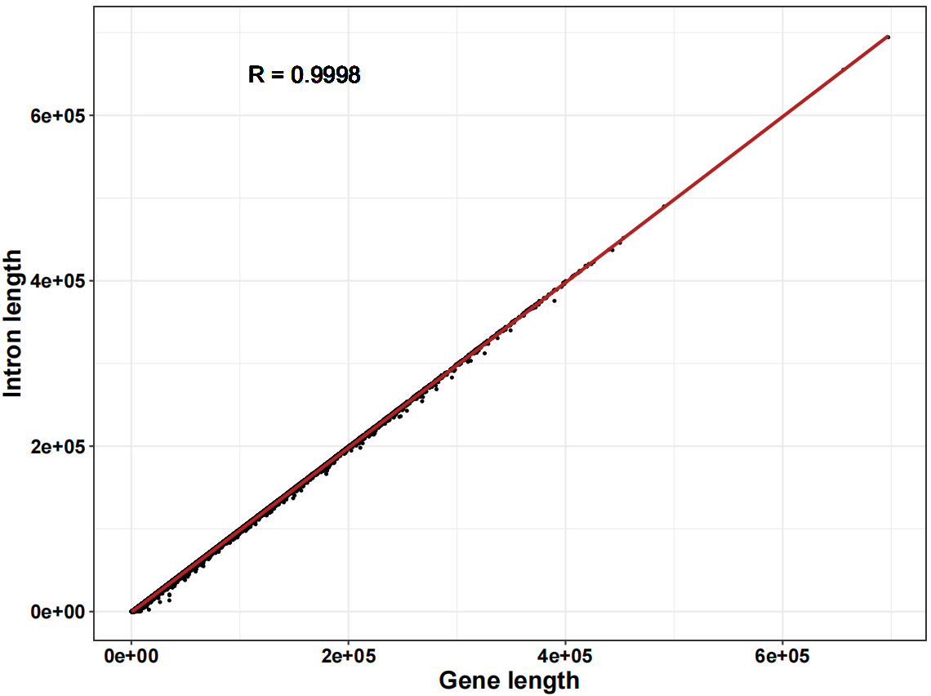
Fig S10. Correlation between gene length and intron lengths.

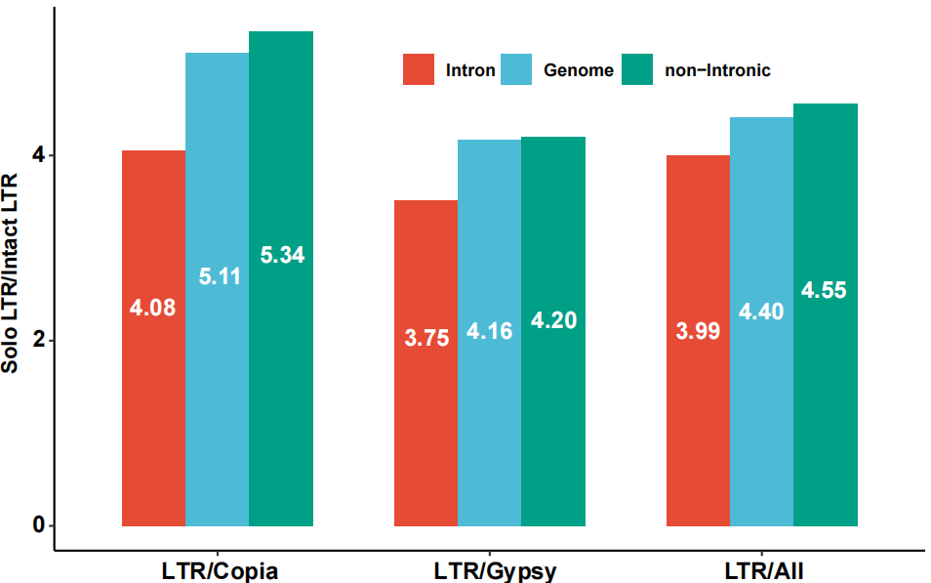
Fig S11. Ratio of Solo LTRs to Intact LTRs in different regions of the genome.

Fig S12. Schematic diagram of the four gene categories classified based on TE insertion proportion relative to intron length and intron length.

Fig S13. Statistics of intron number in genes.

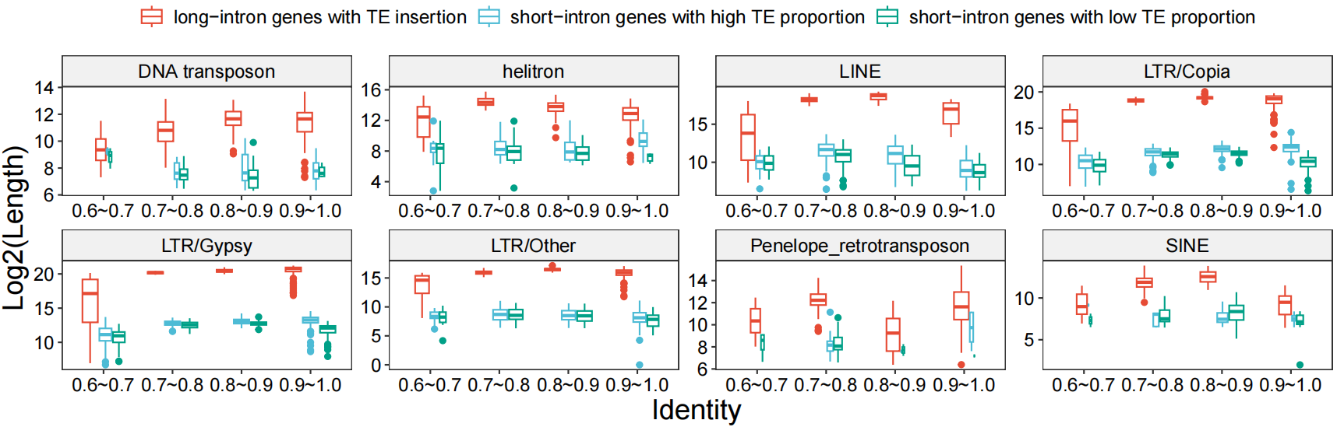
Fig S14. Statistical analysis of insertion lengths of different TEs across various identity ranges in diverse gene categories.

Fig S15. Influence of TE insertions on alternative splicing of genes.
a. Statistical analysis of the number of various AS events in TE-inserted and non-TE-inserted genes. b. Proportion of alternative splicing genes (ASGs) and non-alternative splicing genes (NASGs) across different gene categories. c. Statistics of the number of alternative splicing events across different gene categories.

