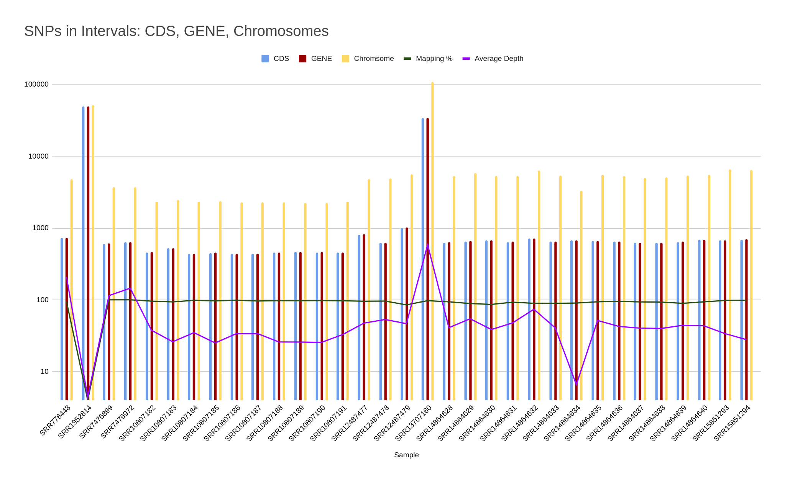

Supplementary Figure 1: The distribution of variants in the samples of L. Donovani across the coding sequecnes, gene intervals and chromosomal intervals has been represented in the graph.

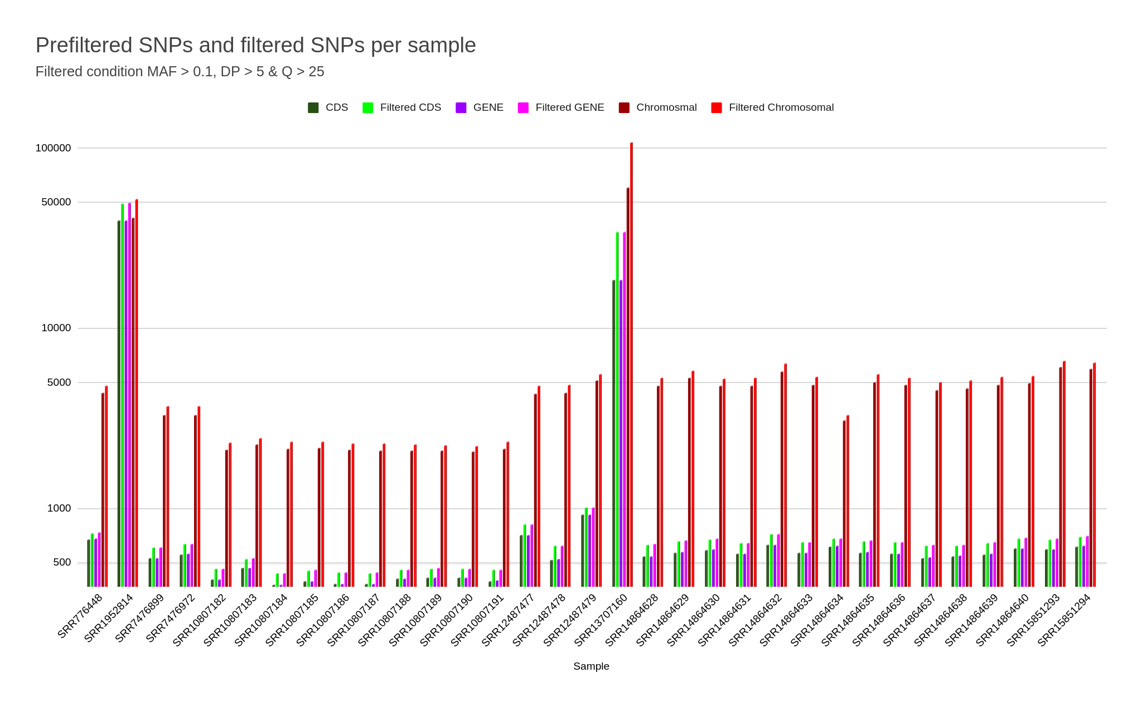
Supplementary Figure 2: After the application of hard GATK filters, the variants with high quality are retained for further analysis. The graph show the difference between the unfiltered and filtered variants of the samples.

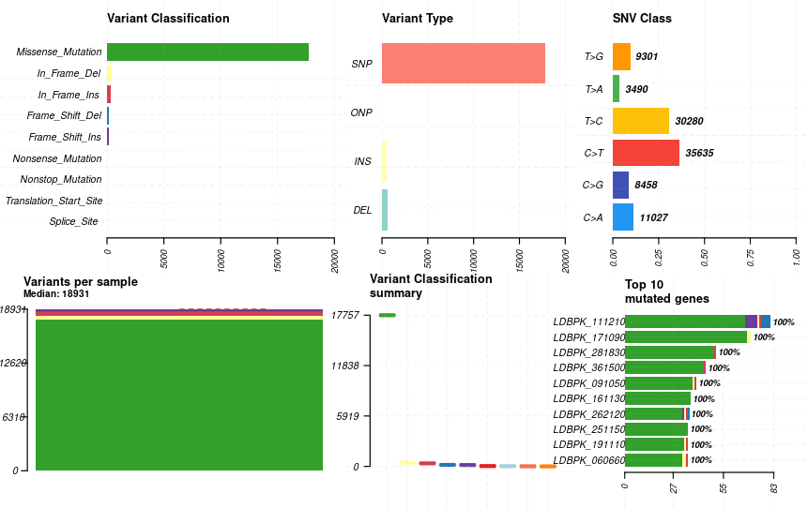
Supplementary Figure 3: The variant classification distribution, types of variant and top10 mutated genes in HPCL66.s

