Phosphate and iron stress control global surface ocean dissolved organic phosphorus concentrations

Zhou Liang^{1*}, Robert T. Letscher², and Angela N. Knapp¹

¹Department of Earth, Ocean and Atmospheric Science, Florida State University, Tallahassee, FL, 32306

²Earth Sciences & Ocean Process Analysis Laboratory, University of New Hampshire, Durham, NH, 03824

Supplementary information

Figure S1. Boxplots of mean DOP concentrations in the surface ocean (0 –50 m) in different ocean basins. Asterisks denote confidence levels when testing for unique mean concentrations between basins with ****: p<0.0001, ***: p<0.001, *: p<0.05, using Dunn test (pairwise Kruskal-Wallis test) with Bonferroni correction. Black dots above the Eastern North Pacific and Gulf of Mexico are outliers.

Figure S2. Annual mean geostrophic currents (0.25˚x 0.25˚, merged product) obtained from the Copernicus Marine Environmental Monitoring Service (www.marine.copernicus.eu). Three surface current convergence zones (SCZ) are identified in the North Pacific, South Pacific, and South Atlantic.

Figure S3. Predicted surface ocean DOP concentrations [µM] based on the linear relationship between DOP concentrations and P* (Figure 1; see main text).

Machine learning method

Two machine learning methods have been applied to map global surface DOP concentrations: support vector machine (SVM)¹ and boosted tree². For the SVM training model, data were standardized to their z scores and a Gaussian kernel was used. For the boosted tree training model, we built 30 decision trees and set the minimum leaf size to 8. Three predictors have been fed to train the model: climatological satellite derived iron stress $φ_{sat}$, climatological P*, and chlorophyll a concentration. The derived two machine learning models were used to predict the global DOP concentration distribution with 2˚x2˚ resolution.

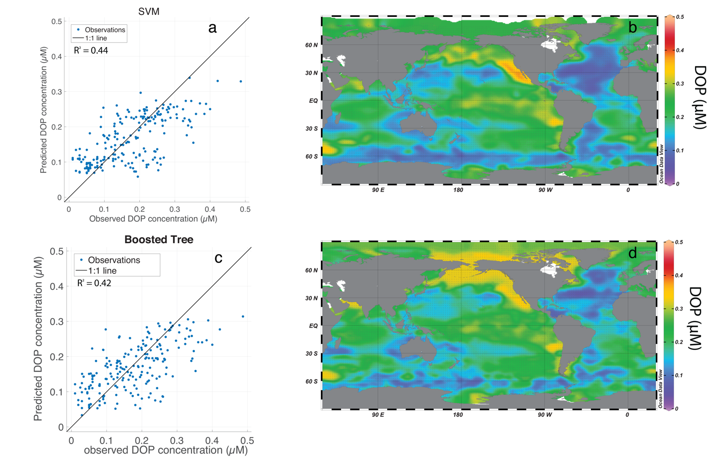
Figure S4. Predicted surface ocean DOP concentration distribution based on SVM and boosted tree approaches. (a) Predicted DOP concentration by the SVM method vs. observations, (b) global surface DOP concentration predicted by the SVM method, (c) predicted DOP concentration by the boosted tree method vs. observations, and (d) global surface DOP concentration predicted by the boosted tree method.

Reference

1. Vapnik, V. The Nature of Statistical Learning Theory. (Springer Science & Business Media, 2013).
2. Breiman, L. Random Forests. Mach. Learn. 45, 5–32 (2001).

