Supplementary materials

Genomic correlations for clinical outcomes in HER2-positive advanced gastric cancers treated using trastuzumab-based therapy

Sun Young Lee^{1,*}, Jaewon Hyung^{1,*}, Hyung-Don Kim¹, Hyungeun Lee¹, Meesun Moon¹, Young Soo Park², Min-Hee Ryu¹

¹ Department of Oncology, Asan Medical Center, University of Ulsan College of Medicine, Seoul, Republic of Korea
² Department of Pathology, Asan Medical Center, University of Ulsan College of Medicine, Seoul, Republic of Korea

* Equally contributed as co-first authors.

Corresponding author
Min-Hee Ryu, M.D., Ph.D.
Department of Oncology, Asan Medical Center, University of Ulsan College of Medicine, 88, Olympic-ro 43-gil, Songpa-gu, Seoul 05505, Republic of Korea
Tel.: +82-2-3010-5953
Email: miniryu@amc.seoul.kr
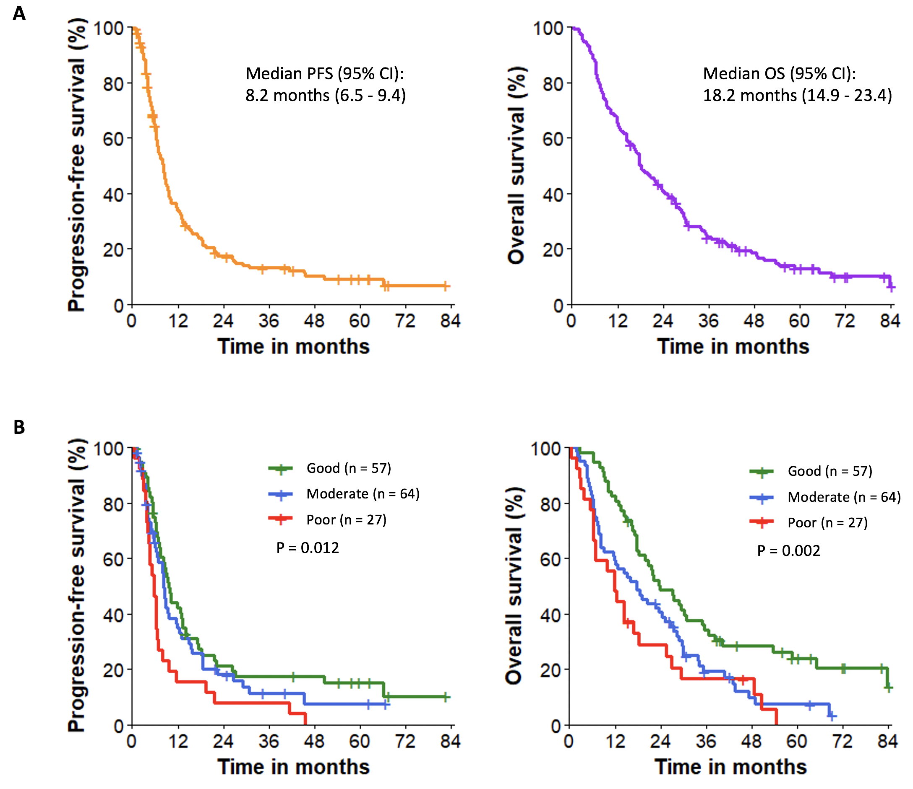

Supplementary fig. 1. Survival outcomes. (A) PFS and OS in the overall study population. (B) PFS and OS according to risk group.

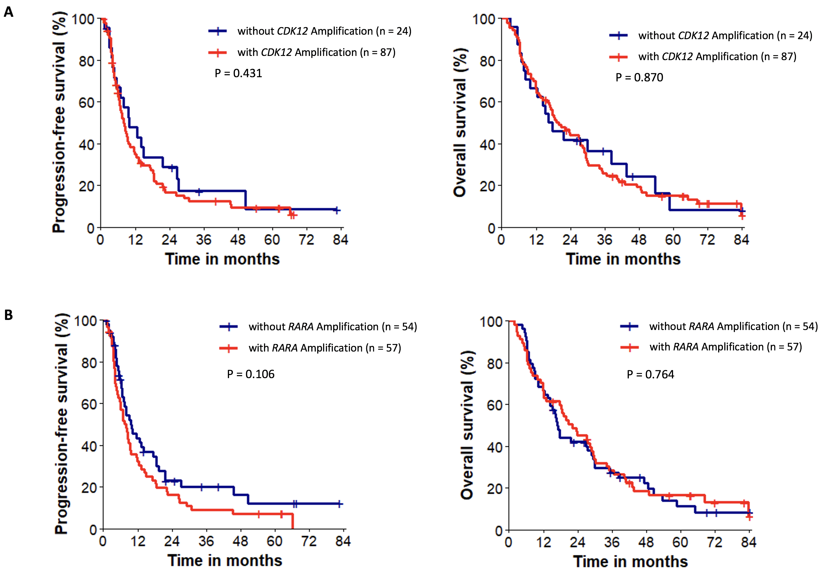

Supplementary fig. 2. Survival outcomes between 111 ERBB2-amplified patients with co-amplification versus without (A) CDK12 gene and (B) RARA gene.
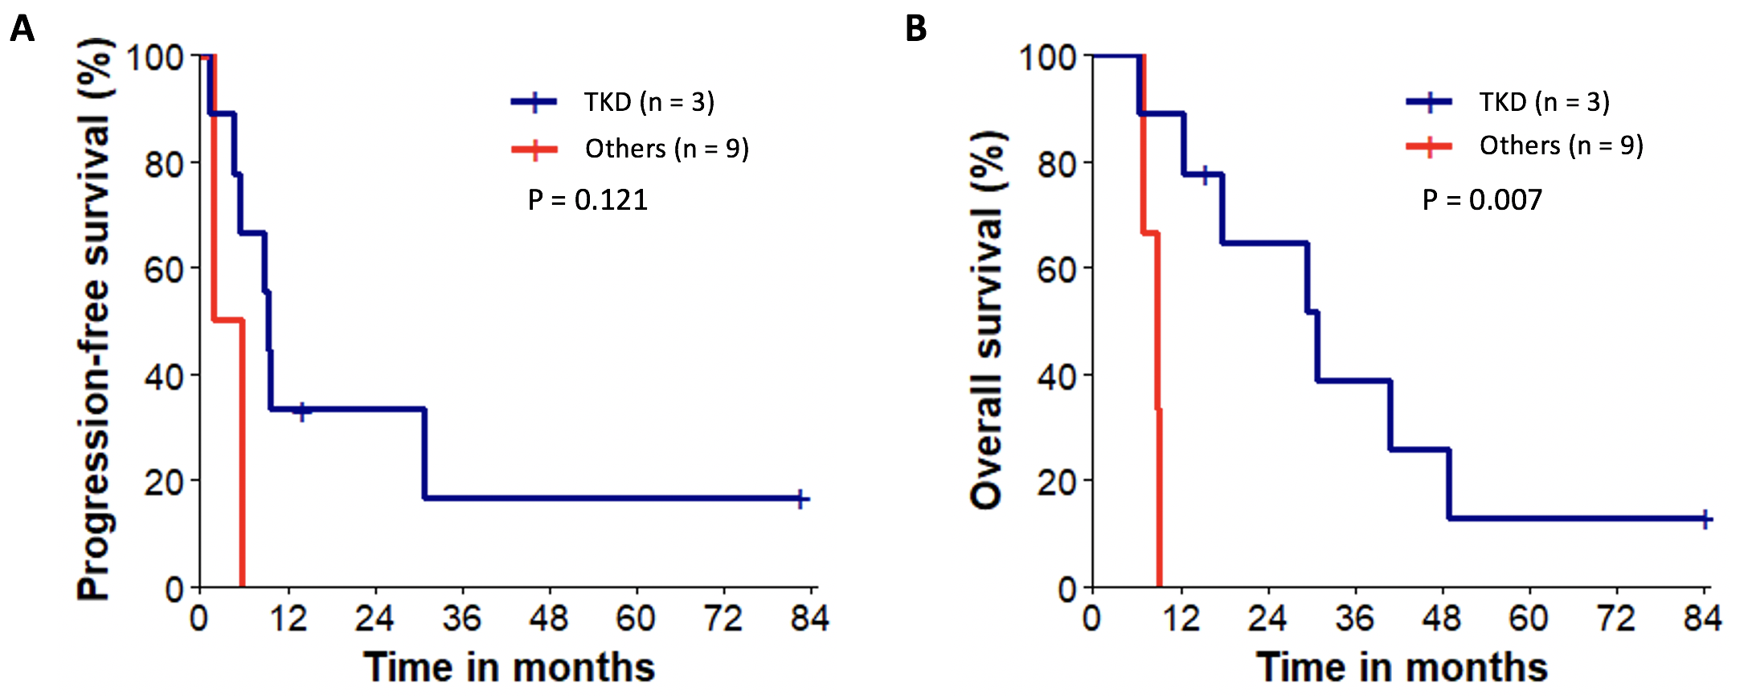

Supplementary fig. 3. Kaplan–Meier curves for survival based on ERBB2 tyrosine kinase domain mutations. (A) PFS and (B) OS. TKD, tyrosine kinase domain; others, other structural domains of the HER2 protein, including extracellular, transmembrane, juxtamembrane, and intracellular domains.

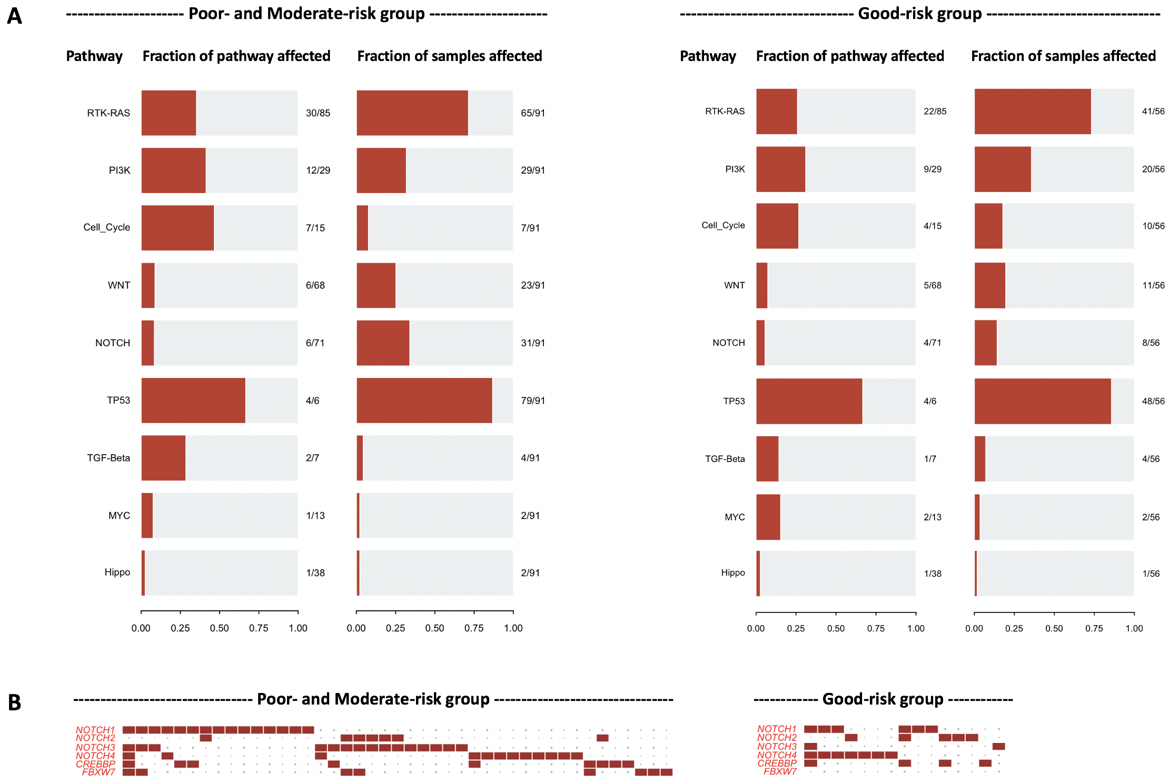

Supplementary fig. 4. Maftools analyses of genomic mutations in risk group. (A) Enrichment analysis of known oncogenic pathway among the risk group. (B) Alterations in NOTCH pathway. Only altered genes are presented, excluding non-altered genes in the pathway
Supplementary table 1. ERBB2 mutations detected by targeted cancer panel sequencing.

Patient with ERBB2 mutations | ERBB2 alteration  variant (VAF), amplification (CN) | ERBB2 domain | OncoKB annotation
1 | R157Q (0.03), amplification (5) | ECD | Unknown
2 | C227G (0.06), S656C (0.38), amplification (65) | ECD, TMD | Unknown, likely_GOF
3 | E265V (0.11), amplification (35) | ECD | Likely_GOF
4 | A270S (0.58), amplification (6) | ECD | Unknown
5 | D277Y (0.74), amplification (33) | ECD | GOF
6 | R678Q (0.12), amplification (6) | JMD | GOF
7 | V697L (0.27) | JMD | Inconclusive
8 | N708S (0.12), amplification (16) | JMD | Unknown
9 | D769H (0.92), amplification (38) | TKD | GOF
10 | V777L (0.35), amplification (6) | TKD | GOF
11 | L841V (0.92), amplification (37) | TKD | Likely_GOF
12 | S1050L (0.38), amplification (6) | ICD | Unknown
Abbreviations: VAF, variant allele frequency; CN, copy number; ECD, extracellular domain; TMD, transmembrane domain; JMD, juxtamembrane domain; TKD, tyrosine kinase domain; ICD, intracellular domain; GOF, gain of function.

