Supplementary Material

Skin-Conformal PMN-PT Ultrasonic Sensor for Cuffless Blood Pressure Sensing via Eutectic Solder Integration

Syed Turab Haider Zaidi^{1,3,†}, Dong Hun Kim^{2,†}, Muhammad Ali Shah^{1,4}, Young Jin Lee¹, Byung Chul Lee^{2,3,5, *}, and Shin Hur^{1,3,*}
¹Department of Nanomechatronics, Korea Institute of Machinery and Materials, Daejeon, 34103, South Korea
²Bionics Research Centers, Korea Institute of Science and Technology, 02792, Seoul, South Korea
³University of Science and Technology, 34113, Daejeon, Korea
⁴Dilli, 11311, Dongducheon, South Korea
⁵KHU-KIST Department of Converging Science and Technology, Kyung Hee University, 02447, Seoul, South Korea
† Contributed equally
*Correspondence: Shin Hur (shur@kimm.re.kr); Byung Chul Lee (bclee@kist.re.kr)

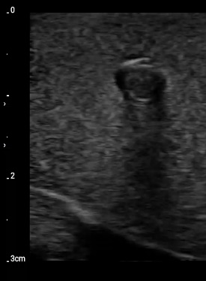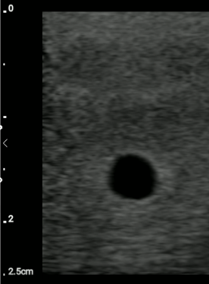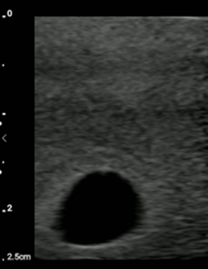
(a)
(b)
(c)
Fig. S1. Measurement of the phantom vessel diameter using the commercial L12-4V probe at (a) Location 1, (b) Location 2, and (c) Location 3

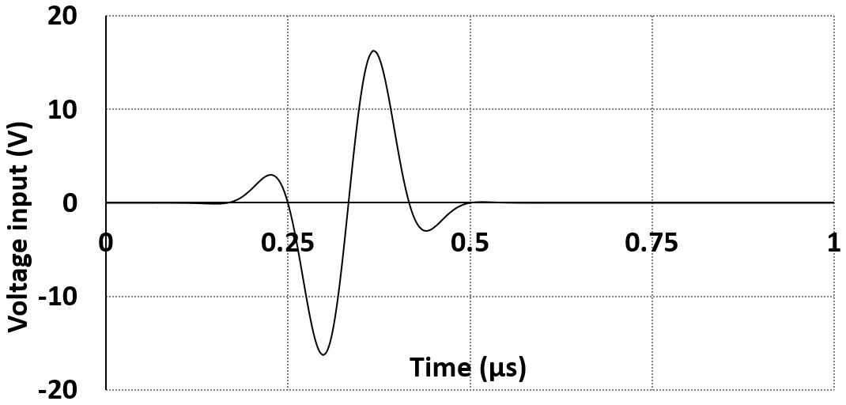
Fig. S2 Applied pulse echo input signal in COMSOL FEM model

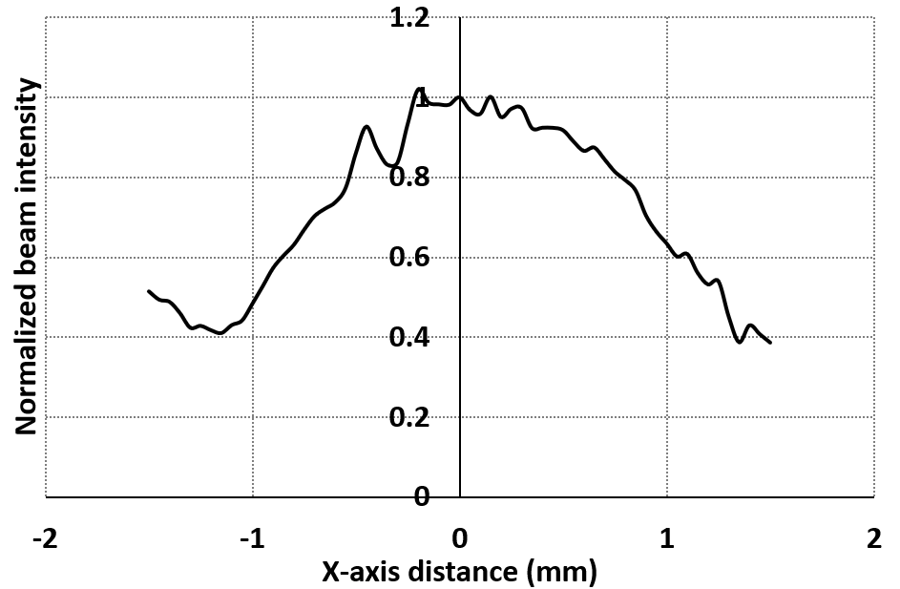
Fig. S3 Measurement of the UTA beam directivity measured by the hydrophone across the X axis at a depth of 15 mm.

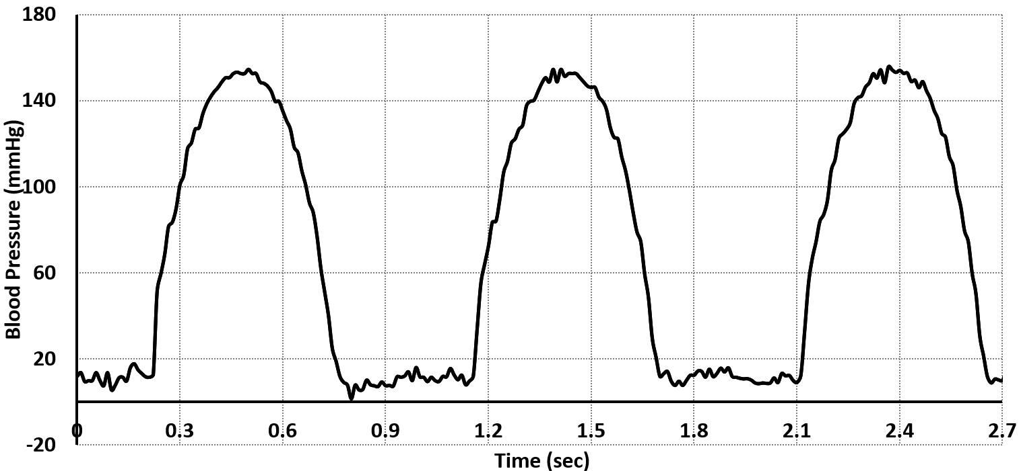
Fig. S4 Measurement of the pressure of the liquid flowing inside the phantom tube and achieved by the use of pressure sensor model 33A-005G-210

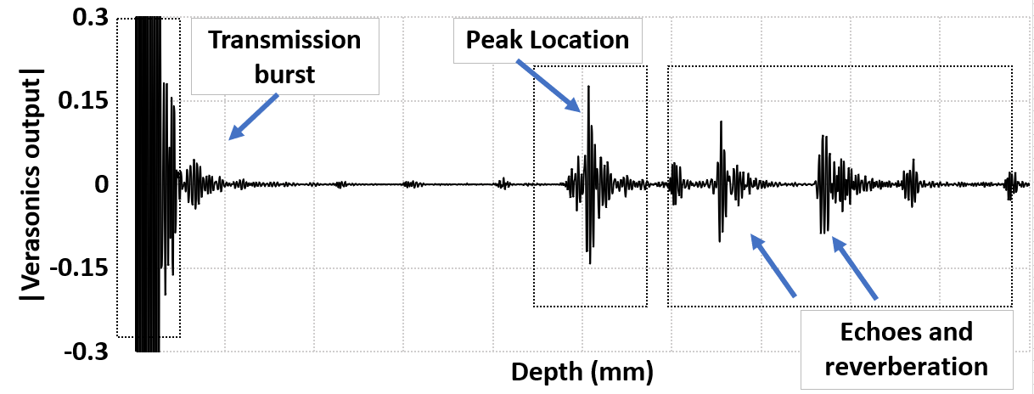
Fig. S5 Example of an RF-Output of the 1D array broken down in specific regions

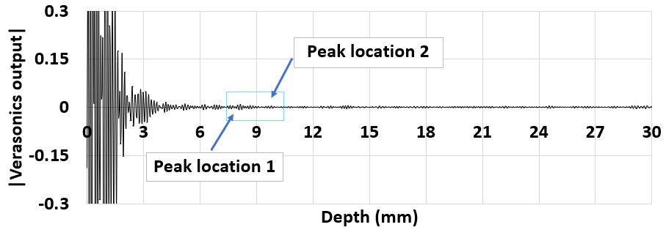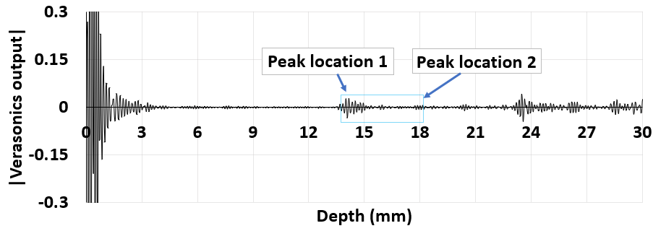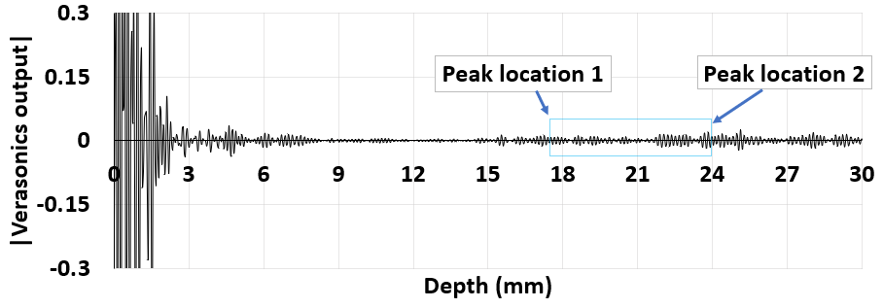
(a)
(b)
(c)
Fig. S6 RF-Outputs of different average measurement from the UTA for (a) – (c) Location 1 to Location 3
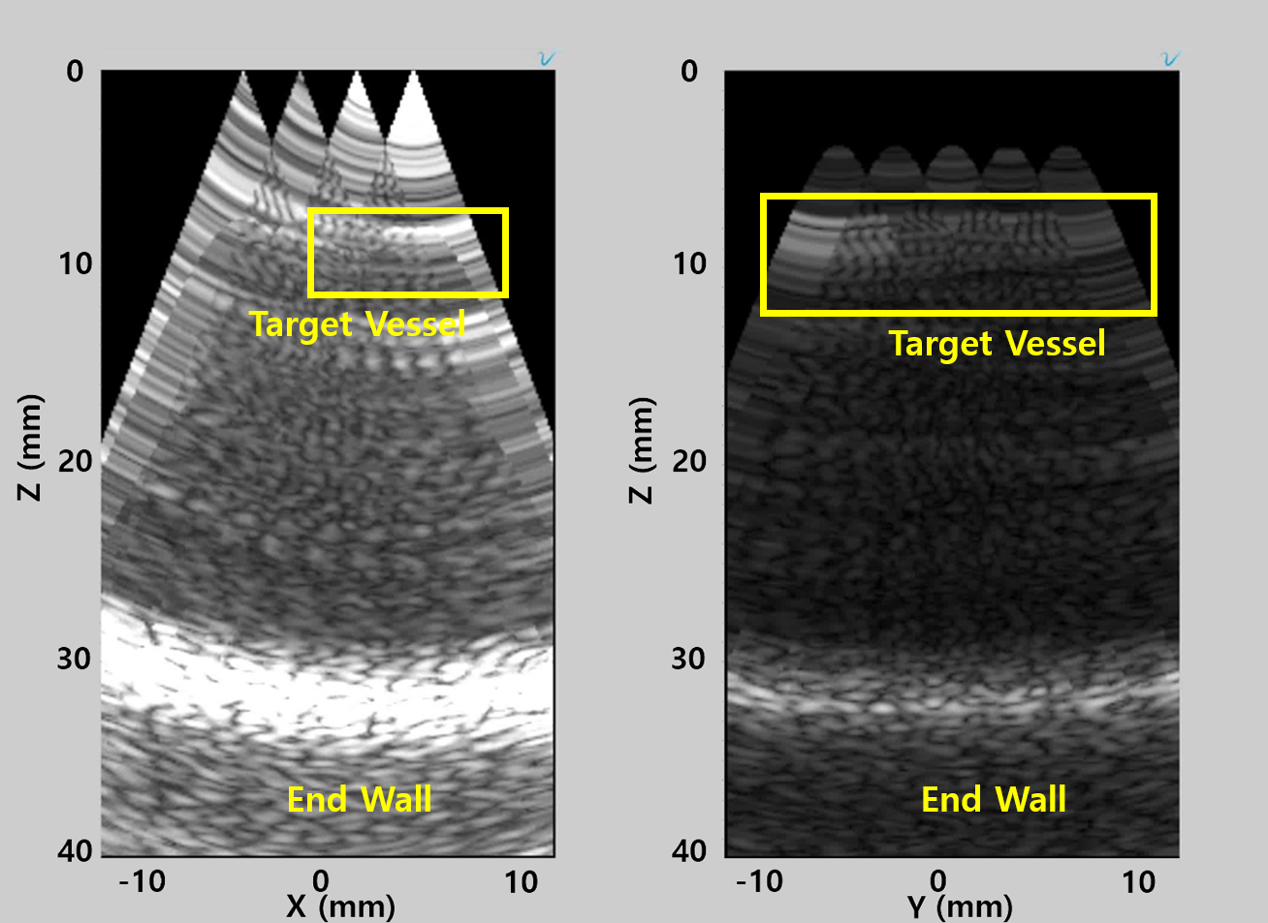
(b)
(a)
Fig. S7 B-Mode Imaging obtained from Verasonics with un focused 1D array of elements. (a) Cross section identification of Target Location # 1, (b) Longitudinal axis of Target Location # 1

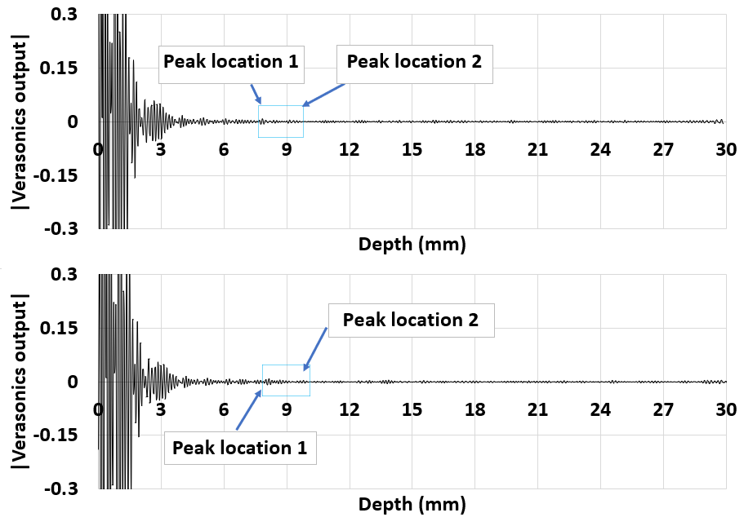
(a)
(b)
Fig. S8 RF-scan obtained from an individual transducer element acquired at different frames from a UTA element

