Supplementary Tables
Supplementary Table S1 Primers of gene expression for qRT-PCR analysis
Name | Primer sequence (5’-3’)
Actin-F： | CCGACCGTATGAGCAAGGAAA
Actin-R： | TTCCTGTGGACAATGGATGGA
WRKY40-F | AGAATCCTGAGATTAGTAAGGAGC
WRKY40-R | TGCCTTGATGTGTTCTTCCCTT
WRKY53-F | ACCGGCAACATCAGAATCCA
WRKY53-R | TGGGGACTTTGATTTCTCGCT
WRKY50-F | CCTTTGATGAGTGGTTCGAGG
WRKY50-R | CCCACTGTCATTGCCACCTT
CML46-F | AGCCATCGGTCTTTTGTCCA
CML46-R | GCTTGTCATCACCGTCTCCA
NCED3-F | CCCCAGCAGTCCCCAAAATA
NCED3-R | ACGTCCAAGGCTAAAGCAGC
PP2CA-F | GGTTAGAGCTCCGTCCGTTT
PP2CA-R | CCTCGCTCTGAATTGTTCGC
ABI1-F | TTCGACTTGGTCGCTGACAC
ABI1-R | CCGTCAACTCACCGATGGAA
ACO4-F | TTCTATGTGCGTCACCTCCC
ACO4-R | CCGTTTGCCCCATGAAAGAC
3MMP-F | GGCAATACCACGATGTGGAG
3MMP-R | GACTGAACTTGGAAGCTGGC
RBOHD-F | TTCAGGGCGCACTTCATCAT
RBOHD-R | CCGTGTCAAGGAAGCAAAGC
NAC029-F | CCCAACAAGACAACCCCACA
NAC029-R | ACATAGCCTCCTGTTTTGCCT
NAC72-F | TTTGCAGCATCTAGGGTCGG
NAC72-R | CCCGGAATTCACGTGGTACA
CHS-F | AAGGACACATACGTGAGGCG
CHS-R | CGGGGTGAGCAATCCAGAAT
DUR3-F | AAGATGGAAGCTGCGTGAGG
DUR3-R | ACCCCACGTATCGCTTTTCT
EP3-F | GTGTCTCAAGTGGCCAAACT
EP3-R | TCAGCAGAACCGGATCCAAA
GES -F | TTCCTGCAACTCTTGCTTGC
GES -R | ATAGCGAACCAACGAGGACA
SAG13-F | TCTTGGACGAAGTGAAGTCTCG
SAG13-R | ATCCGTTGACAGTGAATCCTCC
GSTU8-F | ATGAAGAAGCCGGTTCAATGC
GSTU8-R | CAAACTCATGGACTTGGCGG
HPT1-F | AGTCCGAGCAACAAGTCCTC
HPT1-R | CCATCTTGCAACGCCAAAGG
CLH1-F | CACTCCCCTTTTGGCTACGG
CLH1-R | GTTGCTGAGGGAAGTGCCAT
Supplementary Table S2 Transcriptome sequencing data profile
Sample | Total reads(b) | Total Clean Bases(Gb) | Clean Reads Q20(%) | Overall alignment rate
A3h_1 | 21706576 | 1.09 | 97.98 | 94.59%
A3h_2 | 21765983 | 1.09 | 98.22 | 95.37
A3h_3 | 21561216 | 1.08 | 97.62 | 94.04
A6h_1 | 21709367 | 1.09 | 97.97 | 94.66
A6h_2 | 21512031 | 1.08 | 97.58 | 93.17
A6h_3 | 21558432 | 1.08 | 97.72 | 93.96
control_1 | 21722858 | 1.09 | 98.04 | 94.92
control_2 | 21694998 | 1.08 | 97.97 | 94.78
control_3 | 21789683 | 1.09 | 98.14 | 95.4
D3h_1 | 21502055 | 1.08 | 97.62 | 93.88
D3h_2 | 21699979 | 1.08 | 98 | 94.79
D3h_3 | 21688245 | 1.08 | 98.06 | 94.86
D6h_1 | 21749540 | 1.09 | 98.18 | 94.9
D6h_2 | 21640690 | 1.08 | 98.12 | 94.44
D6h_3 | 21616042 | 1.08 | 97.94 | 94.44

Supplementary Table S3 Annotation of selected drought-response genes in ABA-dependent pathways
Gene ID | Preferred Name | annotation
Pt7g002450 | CHS | 12-oxophytodienoate reductase 2
Pt3g023680 | EP3 | Endochitinase EP3Belongs to the glycosyl hydrolase 19 family
Pt5g017520 | DUR3 | Metallo Urea-proton symporter DUR3
Pt9g007820 | GSTU8 | Glutathione S-transferase U8
PtUn036360 | HPT1 | Homogentisate phytyltransferase 1
Pt2g026200 | GES | (E,E)-geranyllinalool synthase0) biosynthesis
Pt8g010860 | SAG13 | Senescence-associated protein 13
Pt3g031700 | CLH1 | Chlorophyllase-1
Pt7g008470 | ABCG40 | ABC transporter G family member 40

Supplementary Table S4 Annotation of selected drought-response genes in ABA-independent pathways
Gene ID | Preferred Name |  | annotation
Pt1g023510 | WRKY50 | WRKY transcription factor 50
Pt6g003010 | CML46 | Calcium-binding protein CML46; Potential calcium sensor
Pt6g001850 | 3MMP | Metalloendoproteinase 3-MMP
PtUn009410 | RBOHD | Respiratory burst oxidase homolog protein D
Pt1g011900 | NAC072 | NAC domain-containing protein 72
Pt7g005910 | WRKY40 | WRKY transcription factor 40
Pt3g037470 | WRKY53 | Probable WRKY transcription factor 53
Pt2g015750 | ACO4 | 1-aminocyclopropane-1-carboxylate oxidase 4
Pt1g007890 | ABI1 | Protein phosphatase 2C 56
Pt4g000070 | NAC029 | NAC transcription factor 29

Supplementary Figures

Supplementary Figure S2. Expression trend clustering of genes under ABA treatment.
(A) Time series clustering analysis (Mfuzz) showing six clusters of gene expression patterns after 3 h and 6 h of dehydration treatment.
(B) Top 20 DEGs (according to the log2FC) in cluster 3 (genes induced at 3 h) and cluster 2 (genes induced at 6 h).
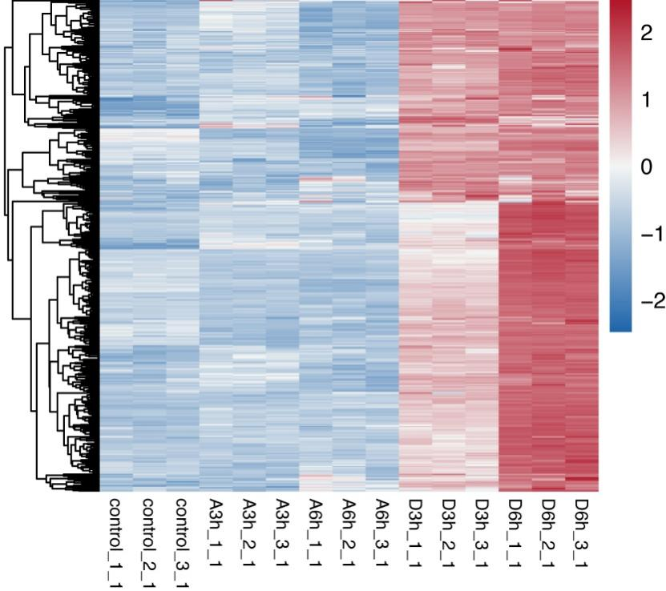
Supplementary Figure S3. Expression patterns of ABA-dependent drought-responsive genes.
Supplementary Figure S4. Expression patterns of ABA-independent drought-responsive genes.

