Supplemental files
Chemotherapy-free Survival in HR-positive HER2-negative Breast Cancer: CDK4/6 Inhibitor Combination Therapy vs. Endocrine Monotherapy
Supplemental Table 1: Status of First-Line Treatment and Reasons for Discontinuation
Supplemental Figure 1: Kaplan–Meier curves of chemotherapy-free survival 2 after the inverse probability of treatment weighting, Unadjusted analysis (a); after inverse probability of treatment weighting (b)
Supplemental Figure 2: Kaplan–Meier curves of time to treatment failure 1 after the inverse probability of treatment weighting, Unadjusted analysis (a); after inverse probability of treatment weighting (b)
Supplemental Figure 3: Kaplan–Meier curves of time to treatment failure 2 after the inverse probability of treatment weighting, Unadjusted analysis (a); after inverse probability of treatment weighting (b)
Supplemental Table 1: Reasons for Discontinuation of First-Line Treatment

 | Monotherapy  N = 318 | CDK4/6i  N = 125
Ongoing first-line treatment, n (%) | 18 (5.7) | 20 (16.0)
Reasons for Discontinuation, n (%) | 300 (94.3) | 105 (84.0)
Progressive disease | 244 (81.3) | 82 (78.1)
Adverse events | 14 (4.7) | 10 (9.5)
Patient’s wish | 9 (3.0) | 7 (6.6)
Physician’s decision (other reasons) | 29 (9.7) | 3 (2.9)
Unknown | 4 (1.3) | 3 (2.9)
CDK4/6i, cyclin-dependent kinase 4/6 inhibitor

Supplemental Figure 1: Kaplan–Meier curves of chemotherapy-free survival 2 after inverse probability of treatment weighting, Unadjusted analysis (a); after inverse probability of treatment weighting (b)
CFS, chemotherapy-free survival; CDK4/6i, cyclin-dependent kinase 4/6 inhibitor; HR, hazard ratio

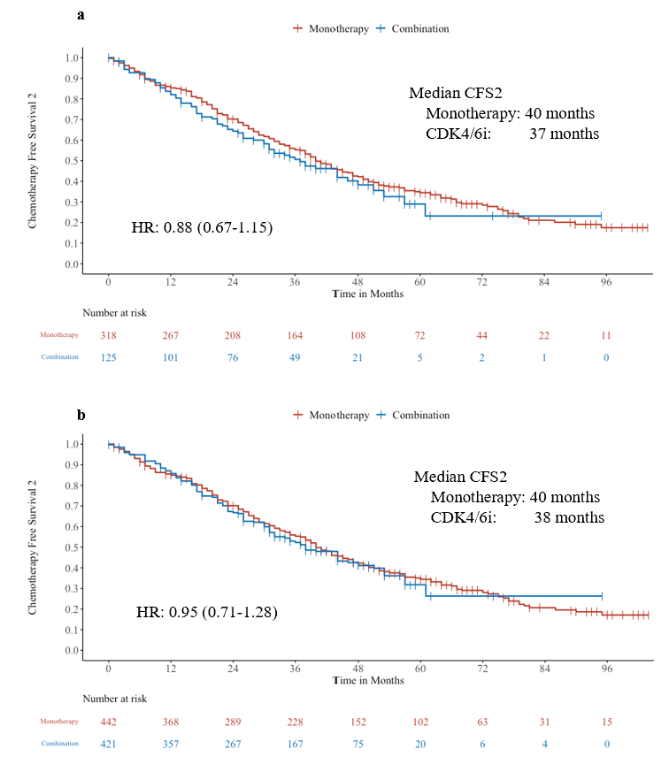

Supplemental Figure 2: Kaplan–Meier curves of time to treatment failure 1 after the inverse probability of treatment weighting, Unadjusted analysis (a); after inverse probability of treatment weighting (b)
TTF, time to treatment failure; CDK4/6i, cyclin-dependent kinase 4/6 inhibitor; HR, hazard ratio

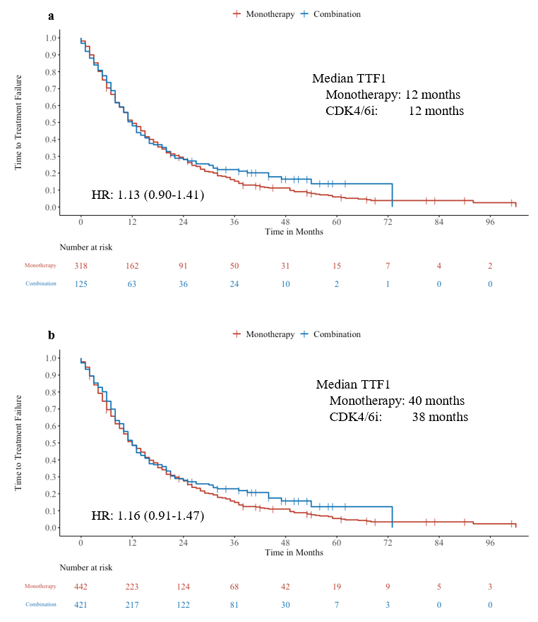

Supplemental Figure 3: Kaplan–Meier curves of time to treatment failure 2 after the inverse probability of treatment weighting, Unadjusted analysis (a); after inverse probability of treatment weighting (b)
TTF, time to treatment failure; CDK4/6i, cyclin-dependent kinase 4/6 inhibitor; HR, hazard ratio

