Part A. The Supplementary Information of the PHOENIX, BLOSSOM, CAMELLIA, SAILING and SHINY studies
Table S1 The health status classification and baseline visual acuity distribution
 | the PHOENIX study (n=81) |  |  | the BLOSSOM study (n=190) |  |  | the CAMELLIA study (n=190) |  |  | the SAILING study (n=248) |  |  | the SHINY study (n=177) *
No visual impairment | BCVA > 78 | / | / | 66≤BCVA≤100 | 48 | 25.3% | 66≤BCVA≤100 | 27 | 14.3% | BCVA > 75 | / | / | BCVA > 75 | / | /
Slight visual impairment | 68< BCVA≤ 78 | 9 | 11.11% | - | - | - | - | - | - | - | - | - | - | - | -
Mild visual impairment | 53< BCVA≤ 68 | 31 | 38.27% | 56≤BCVA≤65 | 70 | 36.6% | 56≤BCVA≤65 | 64 | 33.8% | 60< BCVA≤ 75 | 108 | 43.60% | 60< BCVA≤ 75 | 52 | 29.38%
Moderate visual impairment | 33< BCVA≤ 53 | 26 | 32.11% | 46≤BCVA≤55 | 41 | 21.5% | 46≤BCVA≤55 | 52 | 27.0% | 45< BCVA≤ 60 | 104 | 41.90% | 45< BCVA≤ 60 | 79 | 44.63%
Severe visual impairment | 18< BCVA≤ 33 | 14 | 17.28% | 36≤BCVA≤45 | 24 | 12.9% | 36≤BCVA≤45 | 27 | 14.3% | 30< BCVA≤ 45 | 29 | 11.70% | 30< BCVA≤ 45 | 36 | 20.34%
Blindness | BCVA ≤ 18 | 1 | 1.23% | BCVA≤35 | 7 | 3.7% | BCVA≤35 | 20 | 10.6% | BCVA ≤ 30 | 7 | 2.80% | BCVA ≤ 30 | 10 | 5.65%
The data in the table are the number and percentage of patients with corresponding baseline visual acuity.
* The number of participants in the SHINY study was 176 when designed, and 177 participants were actually enrolled.

The PHOENIX Study
Study Design
Study Type: Interventional (Clinical Trial)
Actual Enrollment: 125 participants
Allocation: Randomized
Intervention Model: Parallel Assignment
Masking: Quadruple - masking involving the participants, care providers, investigators, and outcomes assessors.
Primary Purpose: Treatment
Intervention: Recombinant Human VEGF Receptor-Fc Fusion Protein (Intravitreal injection of KH902 once per month)
Study Arms：
- Experimental Group
Treatment Regimen: Patients in the experimental group will first receive intravitreal injections of 0.5mg KH902 per eye once a month for three times in the study eye. At the end of month 3 (visit 5), they will get 2 sham injections monthly. After that, starting from month 5, they will receive intravitreal injections of KH902 once every three months until month 12 (specifically at month 5, month 8, and month 11).
Intervention: The intervention for this group is a biological agent, Recombinant Human VEGF Receptor - Fc Fusion Protein, in the form of intravitreal KH902 injections following the above - mentioned schedule.
- Sham Comparator Group
Treatment Regimen: Initially, patients in the sham comparator group will receive sham injections once a month for three times. Subsequently, they will receive intravitreal injections of 0.5mg KH902 per eye once a month for three times in the study eye. After three months of treatment, from month 8, they will receive intravitreal injections of KH902 once every three months until month 12 (at month 8 and month 11).
Intervention: The intervention for this group includes sham injections in the initial stage and then intravitreal injections of Recombinant Human VEGF Receptor - Fc Fusion Protein (KH902) following the specific schedule.

Eligibility Criteria
Ages Eligible for Study: 50 Years and older (Adult, Older Adult)
Sexes Eligible for Study: All
Accepts Healthy Volunteers: No
Criteria:
- Inclusion Criteria:
- The patient has signed the Informed Consent Form.
- The patient is at least 50 years old, regardless of gender.
- For the study eye, the total lesion size is no more than 30 mm².
- The BCVA score of the study eye ranges from 19 to 73 letters.
- The ocular media is clear, and the pupil can be dilated adequately to enable high - quality fundus photographic imaging.
- The BCVA score of the fellow eye is 19 letters or more.
- Exclusion Criteria:
- The patient currently has or has a history of non - exudative AMD diseases that can affect the inspection and measurement of the macula or central visual acuity.
- In the study eye, the subretinal hemorrhage area is 50% or more of the total lesion size.
- In the study eye, the scar or fibrosis area is 50% or more of the total lesion size; or there is central foveal scar, fibrosis, or atrophy of the macula.
- The study eye has a retinal pigment epithelial tear, retinal macular traction, macular epiretinal membrane, or has been diagnosed with polypoidal choroidal vasculopathy.
- The patient has received anti - VEGF drug treatment in the study eye within six months before screening, or anti - VEGF treatment in the fellow eye within three months before screening.
- The patient has had previous intraocular or periocular operations, except for eyelid operations that do not interfere with intravitreal injection in the study eye.
- The patient has had previous ophthalmologic operations in the study eye.
- There is currently active inflammation or infection in either eye.
- The patient has uncontrolled glaucoma (either previous or current) in either eye, or has had a previous glaucoma filtering operation in the study eye.
- The patient is currently taking systemic medications that may cause toxicity to the crystalline lens.
- The patient has a history of allergy or a current allergic response.
- The patient has had surgery within one month before enrollment.
- The patient has infectious diseases that require systemic treatment.
- The patient has systemic autoimmune diseases.
- The patient has any uncontrolled clinical disorders.
- Female patients of child - bearing potential have not used adequate contraception methods.
- The patient is pregnant or nursing.
- In the opinion of the investigators, the patient should be excluded.
The BLOSSOM Study
Study Design
Study Type: Interventional (Clinical Trial)
Actual Enrollment: 283 participants
Allocation: Randomized
Intervention Model: Parallel Assignment
Masking: Double - masked
Primary Purpose: Treatment
Official Title: Efficacy and Safety of Ranibizumab in Asian Patients with Branch Retinal Vein Occlusion: Results from the Randomized BLOSSOM Study
Intervention:
1.Ranibizumab 0.5 mg (Intravitreal injection of 0.5mg ranibizumab. The ranibizumab group received this treatment with a corresponding injection regimen).
2.Sham (Sham injection. The sham group received sham injections in the early stage, and some patients switched to receive ranibizumab treatment later).
Study Arms：
Experimental: Ranibizumab 0.5 mg：Patients will receive intravitreal injection of Ranibizumab 0.5mg/eye monthly for at least 3 times until stable maximal visual acuity (VA) is achieved. After that, an individualized VA stabilization criteria - driven pro re nata (PRN) regimen is followed.
Sham Comparator:Sham - injection：Patients will receive sham injection monthly up to month 5. From month 6, they could receive intravitreal injection of Ranibizumab 0.5mg/eye PRN. After that, they will receive intravitreal injection of Ranibizumab 0.5mg/eye once every three months, till month 12.
Intervention：
Experimental Group：Biological: Ranibizumab 0.5 mg (Intravitreal injection of Ranibizumab 0.5mg/eye with specific injection frequency according to the treatment plan)
Sham Comparator Group：Biological: Ranibizumab 0.5 mg (Intravitreal injection of Ranibizumab 0.5mg/eye with specific injection frequency after month 6 according to the treatment plan), Sham injection (Received in the early stage of the study)

Eligibility Criteria
Ages Eligible for Study: 18 Years and older
Sexes Eligible for Study: All
Accepts Healthy Volunteers: No
Criteria:
- Inclusion Criteria:
- Signed the Informed Consent Form.
- 18 years old or older.
- A study eye best - corrected VA (BCVA) score ≥19 and ≤73 Early Treatment Diabetic Retinopathy Study (ETDRS) letters at screening and baseline visits (approximate Snellen equivalent of 20/400 and 20/40) and at least 34 letters in the fellow eye. If both eyes were eligible, the eye with the worse VA at the screening visit was selected as the study eye, unless, on the basis of medical reasons, the investigator deemed the other eye more appropriate for treatment and study inclusion. Only the study eye was treated with ranibizumab or sham injections.
- Exclusion Criteria:
- Any ocular medical condition that may confound the interpretation of study results, compromise VA, affect ME, or require medical or surgical intervention in the study eye during the 12 - month study period.
- Any type of ocular or systemic disease or its treatment that may have biased the assessment of the clinical status of the patient to a significant degree or put the patient at special risk.
- Malignancy of any organ system within the 5 years before screening.
- Stroke or myocardial infarction <3 months before screening.
- Confirmed uncontrolled blood pressure defined as a systolic value of >160 mmHg or a diastolic value of >100 mmHg at the screening or baseline visit.
- Use of any systemic anti - VEGF agents within 6 months before the baseline visit, treatment with any antiangiogenic agents within 3 months before the baseline visit in either eye, panretinal photocoagulation within 3 months before the baseline or anticipated within the next 12 months after the baseline visit in the study eye.
- Focal/grid laser photocoagulation within 4 months before the baseline visit.
- Any intraocular procedure (including yttrium - aluminum - garnet capsulotomy) within 2 months before the baseline visit or anticipated within the next 12 months after the baseline visit.
- Use of systemic or topical corticosteroids administered for at least 30 days within 6 months before the screening visit.
- Use of intraocular/periocular corticosteroids (including sub - tenon and implants) within 3 months before screening visit.
- History of vitrectomy, optic neurotomy, sheathotomy, or filtration surgery.
- Use of other investigational drugs within 30 days or 5 half - lives of the baseline visit, whichever was longer.
- Current or planned use of systemic medications known to be toxic to the lens, retina, or optic nerve.
- Known hypersensitivity to ranibizumab or any component of the ranibizumab formulation, or fluorescein.
- Pregnant or nursing women and women not on reliable contraception.

The CAMELLIA Study
Study Design
Study Type: Interventional (Clinical Trial)
Actual Enrollment: 252 participants
Allocation: Randomized
Intervention Model: Parallel Assignment
Masking: Double
Primary Purpose: Treatment
Official Title:Ranibizumab 0.5 mg in Asian patients with visual impairment due to macular edema secondary to central retinal vein occlusion: results from the 12-month CAMELLIA study
Intervention:Patients with central retinal veinwere randomized 3:1 to receive ranibizumab pro re nata (PRN) or sham.The main intervention measure is to use ranibizumab 0.5 mg for treatment.
Study Arms:
- Ranibizumab-group patients received 3 initial consecutive monthly injections, followed by individualized stabilization criteria-driven PRN treatment.
- Sham-group patients received sham injections up to Month 2 and could receive ranibizumab PRN from Month 3 onwards.

The SAILING Study
Study Design
Study Type: Interventional (Clinical Trial)
Actual Enrollment: 248 participants
Allocation: Randomized
Intervention Model: Parallel Assignment
Masking: Quadruple (Participant, Care Provider, Investigator, Outcomes Assessor)
Primary Purpose: Treatment
Intervention:
- Drug: Conbercept (Intravitreal injection of 0.5 mg Conbercept in the first month, and then repeated as required.)
- Other: Sham injection (Sham intravitreal injection in the first month, and then repeated as required.)
- Procedure: Laser Treatment (Laser treatment in the first month, and then repeated as required.)
- Other: Sham Laser Treatment (Sham laser treatment in the first month, and then repeated as required.)
Study Arms:
- Experimental: Conbercept treatment group
Conduct the first Conbercept injection and sham laser treatment on day 0. Researchers will decide whether the subjects need to receive repeated treatment according to the monthly assessment results.
Interventions:
  - Drug: Conbercept
  - Other: Sham laser
- Positive Control Group: Laser treatment group
Conduct the first laser treatment and sham injection on day 0. Researchers will decide whether repeated laser treatment is needed according to the monthly results during the follow-up visit after 3 months.
Interventions:
  - Other: Sham injection
  - Procedure: Laser

Eligibility Criteria
Ages Eligible for Study: 18 years old and above (Adults, Older Adults)
Sexes Eligible for Study: All
Accepts Healthy Volunteers: No
Criteria:
- Inclusion Criteria:
- Patients sign the informed consent form and are willing and able to comply with all follow-up requirements.
- Age ≥ 18 years old, regardless of gender.
- Diagnosis of type 1 or type 2 diabetes mellitus.
- Serum glycated hemoglobin (HbA1c) ≤ 10%.
- The study eye must meet the following conditions.
- Visual impairment caused by diabetic macular edema (DME) involving the fovea centralis.
- The best corrected visual acuity (BCVA) score is ≥ 24 and ≤ 73 letters in the Early Treatment Diabetic Retinopathy Study (ETDRS) 4-meter/1-meter test (equivalent to Snellen visual acuity chart 20/40 to 20/320).
- Visual impairment caused by choroidal neovascularization (CNV) secondary to high myopia.
- The central retinal thickness (CRT) ≥ 300μm (measured by spectral domain optical coherence tomography (OCT), and the CRT measurement results must be confirmed by the central reading center).
- Opacities of the refractive media and miosis do not affect fundus examination.
- The BCVA of the non-study eye ≥ 24 letters (equivalent to Snellen visual acuity 20/320).
- Exclusion Criteria:
- Active infectious ocular inflammation in either eye.
- Proliferative diabetic retinopathy (PDR) in the study eye, except for inactive and regressed PDR.
- Any other ocular diseases in the study eye that may cause macular edema, excluding diabetic retinopathy.
- Iris neovascularization in the study eye.
- Uncontrolled glaucoma or a history of glaucoma surgery.
- Aphakia in the study eye.
- A history of vitrectomy in the study eye.
- A history of panretinal laser photocoagulation (PRP) in the study eye within 6 months before screening, or the possibility of needing panretinal photocoagulation of the study eye during the study.
- Hepatic or renal dysfunction.
- A history of allergic reactions to fluorescein, protein agents for diagnosis or treatment, or being allergic to more than 2 drug or non-drug factors, or having concurrent allergic diseases.
The SHINY Study
Study Design
Study Type: Interventional (Clinical Trial)
Actual Enrollment: 176 participants
Allocation: Randomized
Intervention Model: Parallel Assignment
Masking: Double (Participant, Investigator)
Primary Purpose: Treatment
Intervention:
- Drug:Conbercept, Fixed Dose Group (Intravitreal injection of 0.5 mg Conbercept per month, with fixed injection schedule)
- Drug: Conbercept, PRN (Pro Re Nata) Group (Intravitreal injection of 0.5 mg Conbercept
- Other: Sham Injection (Sham intravitreal injection per month, with fixed injection schedule)
Study Arms:
- Experimental: Conbercept Treatment Group
Subjects will receive Conbercept injections at a dose of 0.5 mg per eye. The injection will be administered once a month for the first 3 months. In the following 6 months, the investigators will decide whether repeated injections are needed based on the monthly assessment results.
InterventionsMeasures:
  - Drug: Conbercept, Fixed Dose Group
  - Drug: Conbercept, PRN Group
- Sham Injection Control Group: Sham
Subjects will receive sham injections monthly for 3 months and then receive a 0.5 mg per eye Conbercept injection at the 4th month. From the 5th month to the 9th month, the investigators will decide whether repeated injections are needed based on the monthly assessment results.
Interventions:
  - Drug: Conbercept, Fixed Dose Group
  - Drug: Conbercept, PRN Group
  - Other: Sham Injection

Eligibility Criteria
Ages Eligible for Study: 18 years old and above (Adults, Older Adults)
Sexes Eligible for Study: All genders are eligible
Accepts Healthy Volunteers: No
Criteria:
- Inclusion Criteria:
- Patients provide fully informed consent and are willing and able to comply with all study procedures.
- The study eye must meet the following criteria:
- Myopia with a degree of ≥ -6.00 diopters (D), and an axial length ≥ 26.5 mm.
- Diagnosis of active subfoveal, juxafoveal, or extrafoveal choroidalneovascularization (CNV) secondary to high myopia.
- Visual impairment caused by CNV secondary to high myopia.
- The best corrected visual acuity (BCVA) score in the Early Treatment Diabetic Retinopathy Study (ETDRS) is ≥ 24 and ≤ 73 letters (approximately equivalent to 20/40 to 20/320 on the Snellen visual acuity chart).
- The ocular media has sufficient quality to obtain fundus and optical coherence tomography (OCT) images.
- The BCVA score of the fellow eye is ≥ 19 ETDRS letters (approximately equivalent to 20/400 on the Snellen visual acuity chart)
- Exclusion Criteria:
- Current vitreous hemorrhage in either eye.
- The study eye has received intravitreal corticosteroid treatment within the last 3 months or periocular corticosteroid treatment within the last month.
- Active infectious ocular inflammation in either eye.
- Fibrosis or atrophy involving the center of foveal in the study eye.
- Any concurrent intraocular condition in the study eye that, in the opinion of investigator, could either require medical or surgical intervention during the study period to prevent or treat potential visual loss caused by that disease.
- The lesion size in the study eye is ≥ 30 square millimeters.
- Any ocular disease in the study eye that, in the opinion of the investigators, may interfere with the interpretation of the study results.
- Uncontrolled glaucoma in the study eye, or a cup-to-disc ratio > 0.8 in the study eye.
- Aphakia (excluding artificial lens) in the study eye.
- Severe amblyopia and amaurosis in the fellow eye.

Part B. Sensitivity Analysis
Supplemental Materials
Table of Contents | Page
Table S1. The prices of conbercept and ranibizumaband the daily wage. | 4
Table S2. The number of days lost from work. | 4
Table S3. The Two-way Sensitivity Analysis of Conbercept and Ranibizumab from the Perspective of the Whole Society in 2021. | 4
Table S4. The Two-way Sensitivity Analysis of Conbercept and Ranibizumab from the Perspective of the Whole Society in 2022. | 6
Table S5. The Two-way Sensitivity Analysis of Conbercept and Ranibizumab from the Perspective of the Whole Society in 2023. | 7
Table S6. The Two-way Sensitivity Analysis of Conbercept and Ranibizumab from the Perspective of the Whole Society in 2024. | 9
Figure S1. The Cost-Effectiveness Acceptability Curve of conbercept and ranibizumab in treatment of AMD from the Perspective of the Whole Society. | 11
Figure S2. The Cost-Effectiveness Acceptability Curve of conbercept and ranibizumab in treatment of BRVO from the Perspective of the Whole Society. | 12
Figure S3. The Cost-Effectiveness Acceptability Curve of conbercept and ranibizumab in treatment of CRVO from the Perspective of the Whole Society. | 13
Figure S4. The Cost-Effectiveness Acceptability Curve of conbercept and ranibizumab in treatment of DME from the Perspective of the Whole Society. | 14
Figure S5. The Cost-Effectiveness Acceptability Curve of conbercept and ranibizumab in treatment of PM from the Perspective of the Whole Society. | 15
Table S7.The Two-way Sensitivity Analysis of Conbercept and Ranibizumab from the Perspective of the Health Insurance Payer in 2021. | 16
Table S8.The Two-way Sensitivity Analysis of Conbercept and Ranibizumab from the Perspective of the Health Insurance Payer in 2022. | 17
Table S9. The Two-way Sensitivity Analysis of Conbercept and Ranibizumab from the Perspective of the Health Insurance Payer in 2023. | 19

Table S10. The Two-way Sensitivity Analysis of Conbercept and Ranibizumab from the Perspective of the Health Insurance Payer in 2024. | 21
Figure S6. The Cost-Effectiveness Acceptability Curve of conbercept and ranibizumab in treatment of AMD from the Perspective of the Health Insurance Payer. | 24
Figure S7. The Cost-Effectiveness Acceptability Curve of conbercept and ranibizumab in treatment of BRVO from the Perspective of the Health Insurance Payer. | 25
Figure S8. The Cost-Effectiveness Acceptability Curve of conbercept and ranibizumab in treatment of CRVO from the Perspective of the Health Insurance Payer. | 26
Figure S9. The Cost-Effectiveness Acceptability Curve of conbercept and ranibizumab in treatment of DME from the Perspective of the Health Insurance Payer. | 27
Figure S10. The Cost-Effectiveness Acceptability Curve of conbercept and ranibizumab in treatment of PM from the Perspective of the Health Insurance Payer. | 28
Table S11. The one-way sensitivity analysis with different numbers of conbercept injections from the Perspective of the Whole Society in 2021. | 29
Table S12. The one-way sensitivity analysis with different numbers of ranibizumabinjections from the Perspective of the Whole Society in 2021. | 31
Table S13. The one-way sensitivity analysis with different numbers of conbercept injections from the Perspective of the Whole Society in 2022. | 33
Table S14. The one-way sensitivity analysis with different numbers of ranibizumab injections from the Perspective of the Whole Society in 2022. | 35
Table S15. The one-way sensitivity analysis with different numbers of conbercept injections from the Perspective of the Whole Society in 2023. | 37
Table S16. The one-way sensitivity analysis with different numbers of ranibizumab injections from the Perspective of the Whole Society in 2023. | 39
Table S17. The one-way sensitivity analysis with different numbers of conbercept injections from the Perspective of the Whole Society in 2024. | 41
Table S18. The one-way sensitivity analysis with different numbers of ranibizumab injections from the Perspective of the Whole Society in 2024. | 43
Table S19. The one-way sensitivity analysis with different numbers of conbercept injections from the Perspective of the Health Insurance Payer in 2021. | 45
Table S20. The one-way sensitivity analysis with different numbers of ranibizumab injections from the Perspective of the Health Insurance Payer in 2021. | 47
Table S21. The one-way sensitivity analysis with different numbers of conbercept injections from the Perspective of the Health Insurance Payer in 2022. | 49
Table S22. The one-way sensitivity analysis with different numbers of ranibizumab injections from the Perspective of the Health Insurance Payer in 2022. | 51
Table S23. The one-way sensitivity analysis with different numbers of conbercept injections from the Perspective of the Health Insurance Payer in 2023. | 53
Table S24. The one-way sensitivity analysis with different numbers of ranibizumab injections from the Perspective of the Health Insurance Payer in 2023. | 55
Table S25. The one-way sensitivity analysis with different numbers of conbercept injections from the Perspective of the Health Insurance Payer in 2024. | 57
Table S26. The one-way sensitivity analysis with different numbers of ranibizumab injections from the Perspective of the Health Insurance Payer in 2024. | 59

Table S1. The prices of conbercept and ranibizumab and the daily wage.
 | conbercept | ranibizumab | Daily wage
2021（RMB） | 4160 | 3950 | 96.2
2022（RMB） | 3452.8 | 3950 | 101.05
2023（RMB） | 3452.8 | 3950 | 107.45
2024（RMB） | 3452.8 | 3673.5 | 113.19

Table S2. The number of days lost from work.
 | Days lost from work
Age-related macular degeneration | 98.14
Branch Retinal Vein Occlusion | 83.056
Central Retinal Vein Occlusion | 113.662
Diabetic macular edema | 108.96
Pathological myopia | 122.37

Table S3.The Two-way Sensitivity Analysis of Conbercept and Ranibizumab from the Perspective of the Whole Society in 2021.
 | Price | Strategy | Cost (RMB) | Incremental costs | Effectiveness (QALYs) | Incremental effectiveness | CER | ICER
Age-related macular degeneration | down 10% | conbercept | 202749.392 | - | 7.824 | - | 25913.777 | -
Age-related macular degeneration | down 10% | ranibizumab | 228136.002 | 25386.610 | 8.490 | 0.665 | 26871.143 | 38118.033
 | 0 | conbercept | 225277.102 | - | 7.824 | - | 28791.715 | -
 | 0 | ranibizumab | 253484.447 | 28207.346 | 8.490 | 0.665 | 29858.361 | 42404.890
 | up 10% | conbercept | 247804.812 | - | 7.824 | - | 31672.394 | -
 | up 10% | ranibizumab | 278832.892 | 31028.080 | 8.490 | 0.665 | 32842.508 | 46588.709
Branch Retinal Vein Occlusion | down 10% | conbercept | 145382.381 | - | 8.346 | - | 17419.408 | -
Branch Retinal Vein Occlusion | down 10% | ranibizumab | 261336.895 | 115954.514 | 8.297 | -0.049 | 31497.758 | -2366418.653
 | 0 | conbercept | 161535.979 | - | 8.346 | - | 19355.197 | -
 | 0 | ranibizumab | 290374.328 | 128838.350 | 8.297 | -0.049 | 34997.782 | -2632799.096
 | up 10% | conbercept | 177689.577 | - | 8.346 | - | 21290.388 | -
 | up 10% | ranibizumab | 319411.761 | 141722.184 | 8.297 | -0.049 | 38497.259 | -2892289.469
Central Retinal Vein Occlusion | down 10% | conbercept | 174852.645 | - | 8.156 | - | 21438.529 | -
Central Retinal Vein Occlusion | down 10% | ranibizumab | 267832.586 | 92979.941 | 8.135 | -0.021 | 32923.489 | -4427616.238
 | 0 | conbercept | 194280.717 | - | 8.156 | - | 23821.369 | -
 | 0 | ranibizumab | 297591.762 | 103311.045 | 8.135 | -0.021 | 36581.674 | -4982016.597
 | up 10% | conbercept | 213708.789 | - | 8.156 | - | 26202.647 | -
 | up 10% | ranibizumab | 327350.938 | 113642.149 | 8.135 | -0.021 | 40239.82 | -5411530.905
Diabetic macular edema | down 10% | conbercept | 286493.198 | - | 6.973 | - | 41084.540 | -
Diabetic macular edema | down 10% | ranibizumab | 266745.087 | -19748.111 | 6.758 | -0.215 | 39470.492 | 91778.336
 | 0 | conbercept | 318325.776 | - | 6.973 | - | 45649.489 | -
 | 0 | ranibizumab | 296383.430 | -21942.346 | 6.758 | -0.215 | 43856.103 | 101975.929
 | up 10% | conbercept | 350158.354 | - | 6.973 | - | 50214.438 | -
 | up 10% | ranibizumab | 326021.773 | -24136.581 | 6.758 | -0.215 | 48241.713 | 112173.521
Pathological myopia | down 10% | conbercept | 252750.189 | - | 7.528 | - | 33576.399 | -
Pathological myopia | down 10% | ranibizumab | 239932.551 | -12817.638 | 7.499 | -0.028 | 31994.505 | 450775.291
 | 0 | conbercept | 280833.543 | - | 7.528 | - | 37307.110 | -
 | 0 | ranibizumab | 266591.723 | -14241.820 | 7.499 | -0.028 | 35549.450 | 500861.434
 | up 10% | conbercept | 308916.897 | - | 7.528 | - | 41037.820 | -
 | up 10% | ranibizumab | 293250.895 | -15666.002 | 7.499 | -0.028 | 39104.395 | 550947.577

Table S4. The Two-way Sensitivity Analysis of Conbercept and Ranibizumab from the Perspective of the Whole Society in 2022.
 | Price | Strategy | Cost (RMB) | Incremental costs | Effectiveness (QALYs) | Incremental effectiveness | CER | ICER
Age-related macular degeneration | down 10% | conbercept | 258195.815 | - | 7.824 | - | 33000.488 | -
Age-related macular degeneration | down 10% | ranibizumab | 261766.628 | 3570.813 | 8.490 | 0.665 | 30832.347 | 5361.581
 | 0 | conbercept | 286884.239 | - | 7.824 | - | 36665.463 | -
 | 0 | ranibizumab | 290851.809 | 3967.570 | 8.490 | 0.665 | 34259.926 | 5964.559
 | up 10% | conbercept | 315572.663 | - | 7.824 | - | 40333.929 | -
 | up 10% | ranibizumab | 319936.990 | 4364.327 | 8.490 | 0.665 | 37683.98 | 6553.044
Branch Retinal Vein Occlusion | down 10% | conbercept | 237167.341 | - | 8.346 | - | 28416.887 | -
Branch Retinal Vein Occlusion | down 10% | ranibizumab | 258329.509 | 21162.168 | 8.297 | -0.049 | 31135.291 | -431880.98
 | 0 | conbercept | 263519.268 | - | 8.346 | - | 31574.807 | -
 | 0 | ranibizumab | 287032.788 | 23513.521 | 8.297 | -0.049 | 34595.038 | -480496.496
 | up 10% | conbercept | 289871.195 | - | 8.346 | - | 34731.751 | -
 | up 10% | ranibizumab | 315736.067 | 25864.872 | 8.297 | -0.049 | 38054.245 | -527854.531
Central Retinal Vein Occlusion | down 10% | conbercept | 230047.723 | - | 8.156 | - | 28205.949 | -
Central Retinal Vein Occlusion | down 10% | ranibizumab | 362504.442 | 132456.719 | 8.135 | -0.021 | 44561.087 | -6307462.81
 | 0 | conbercept | 255608.581 | - | 8.156 | - | 31340.971 | -
 | 0 | ranibizumab | 402782.713 | 147174.132 | 8.135 | -0.021 | 49512.344 | -7097246.654
 | up 10% | conbercept | 281169.439 | - | 8.156 | - | 34473.938 | -
 | up 10% | ranibizumab | 443060.984 | 161891.545 | 8.135 | -0.021 | 54463.551 | -7709121.19
Diabetic macular edema | down 10% | conbercept | 271807.115 | - | 6.973 | - | 38978.483 | -
Diabetic macular edema | down 10% | ranibizumab | 283629.053 | 11821.939 | 6.758 | -0.215 | 41968.827 | -54941.854
 | 0 | conbercept | 302007.905 | - | 6.973 | - | 43309.425 | -
 | 0 | ranibizumab | 315143.393 | 13135.487 | 6.758 | -0.215 | 46632.030 | -61046.505
 | up 10% | conbercept | 332208.696 | - | 6.973 | - | 47640.368 | -
 | up 10% | ranibizumab | 346657.732 | 14449.036 | 6.758 | -0.215 | 51295.233 | -67151.155
Pathological myopia | down 10% | conbercept | 250141.205 | - | 7.528 | - | 33229.810 | -
Pathological myopia | down 10% | ranibizumab | 266153.039 | 16011.834 | 7.499 | -0.028 | 35490.952 | -563109.933
 | 0 | conbercept | 277934.672 | - | 7.528 | - | 36922.011 | -
 | 0 | ranibizumab | 295725.599 | 17790.927 | 7.499 | -0.028 | 39434.392 | -625677.703
 | up 10% | conbercept | 305728.139 | - | 7.528 | - | 40614.212 | -
 | up 10% | ranibizumab | 325298.159 | 19570.020 | 7.499 | -0.028 | 43377.831 | -688245.473

Table S5. The Two-way Sensitivity Analysis of Conbercept and Ranibizumab from the Perspective of the Whole Society in 2023.
 | Price | Strategy | Cost (RMB) | Incremental costs | Effectiveness (QALYs) | Incremental effectiveness | CER | ICER
Age-related macular degeneration | down 10% | conbercept | 266040.590 | - | 7.824 | - | 34003.143 | -
Age-related macular degeneration | down 10% | ranibizumab | 263771.410 | -2269.180 | 8.490 | 0.665 | 31068.482 | -3407.177
 | 0 | conbercept | 295600.655 | - | 7.824 | - | 37779.472 | -
 | 0 | ranibizumab | 293079.345 | -2521.309 | 8.490 | 0.665 | 34522.311 | -3790.354
 | up 10% | conbercept | 325160.721 | - | 7.824 | - | 41559.397 | -
 | up 10% | ranibizumab | 322387.280 | -2773.441 | 8.490 | 0.665 | 37972.589 | -4164.326
Branch Retinal Vein Occlusion | down 10% | conbercept | 228294.902 | - | 8.346 | - | 27353.81 | -
Branch Retinal Vein Occlusion | down 10% | ranibizumab | 247780.234 | 19485.332 | 8.297 | -0.049 | 29863.834 | -397659.837
 | 0 | conbercept | 253661.002 | - | 8.346 | - | 30393.592 | -
 | 0 | ranibizumab | 275311.371 | 21650.369 | 8.297 | -0.049 | 33182.297 | -442423.176
 | up 10% | conbercept | 279027.102 | - | 8.346 | - | 33432.435 | -
 | up 10% | ranibizumab | 302842.508 | 23815.406 | 8.297 | -0.049 | 36500.242 | -486028.694
Central Retinal Vein Occlusion | down 10% | conbercept | 259437.466 | - | 8.156 | - | 31809.400 | -
Central Retinal Vein Occlusion | down 10% | ranibizumab | 304781.902 | 45344.436 | 8.135 | -0.021 | 37465.507 | -2159258.857
 | 0 | conbercept | 288263.851 | - | 8.156 | - | 35344.936 | -
 | 0 | ranibizumab | 338646.558 | 50382.707 | 8.135 | -0.021 | 41628.363 | -2429628.701
 | up 10% | conbercept | 317090.236 | - | 8.156 | - | 38878.155 | -
 | up 10% | ranibizumab | 372511.214 | 55420.978 | 8.135 | -0.021 | 45791.176 | -2639094.190
Diabetic macular edema | down 10% | conbercept | 271166.211 | - | 6.973 | - | 38886.574 | -
Diabetic macular edema | down 10% | ranibizumab | 284594.104 | 13427.893 | 6.758 | -0.215 | 42111.626 | -62405.446
 | 0 | conbercept | 301295.790 | - | 6.973 | - | 43207.305 | -
 | 0 | ranibizumab | 316215.671 | 14919.881 | 6.758 | -0.215 | 46790.696 | -69339.384
 | up 10% | conbercept | 331425.369 | - | 6.973 | - | 47528.035 | -
 | up 10% | ranibizumab | 347837.238 | 16411.870 | 6.758 | -0.215 | 51469.765 | -76273.323
Pathological myopia | down 10% | conbercept | 251683.913 | - | 7.528 | - | 33434.750 | -
Pathological myopia | down 10% | ranibizumab | 262193.222 | 10509.309 | 7.499 | -0.028 | 34962.919 | -369595.148
 | 0 | conbercept | 279648.792 | - | 7.528 | - | 37149.722 | -
 | 0 | ranibizumab | 291325.802 | 11677.010 | 7.499 | -0.028 | 38847.688 | -410661.276
 | up 10% | conbercept | 307613.672 | - | 7.528 | - | 40864.695 | -
 | up 10% | ranibizumab | 320458.383 | 12844.711 | 7.499 | -0.028 | 42732.457 | -451727.403

Table S6.The Two-way Sensitivity Analysis of Conbercept and Ranibizumab from the Perspective of the Whole Society in 2024.
 | Price | Strategy | Cost (RMB) | Incremental costs | Effectiveness (QALYs) | Incremental effectiveness | CER | ICER
Age-related macular degeneration | down 10% | conbercept | 224322.539 | - | 7.824 | - | 28671.081 | -
Age-related macular degeneration | down 10% | ranibizumab | 251404.609 | 27082.070 | 8.490 | 0.665 | 29611.850 | 40663.769
 | 0 | conbercept | 249247.265 | - | 7.824 | - | 31855.241 | -
 | 0 | ranibizumab | 279338.454 | 30091.189 | 8.490 | 0.665 | 32903.748 | 45236.924
 | up 10% | conbercept | 274171.992 | - | 7.824 | - | 35042.433 | -
 | up 10% | ranibizumab | 307272.299 | 33100.307 | 8.490 | 0.665 | 36192.261 | 49700.161
Branch Retinal Vein Occlusion | down 10% | conbercept | 233772.658 | - | 8.346 | - | 28010.144 | -
Branch Retinal Vein Occlusion | down 10% | ranibizumab | 224325.975 | -9446.683 | 8.297 | -0.049 | 27036.998 | 192789.449
 | 0 | conbercept | 259747.398 | - | 8.346 | - | 31122.862 | -
 | 0 | ranibizumab | 249251.083 | -10496.315 | 8.297 | -0.049 | 30041.344 | 214491.169
 | up 10% | conbercept | 285722.138 | - | 8.346 | - | 34234.620 | -
 | up 10% | ranibizumab | 274176.191 | -11545.947 | 8.297 | -0.049 | 33045.220 | 235631.571
Central Retinal Vein Occlusion | down 10% | conbercept | 287793.637 | - | 8.156 | - | 35286.125 | -
Central Retinal Vein Occlusion | down 10% | ranibizumab | 311074.804 | 23281.167 | 8.135 | -0.021 | 38239.066 | -1108627.000
 | 0 | conbercept | 319770.708 | - | 8.156 | - | 39208.091 | -
 | 0 | ranibizumab | 345638.671 | 25867.963 | 8.135 | -0.021 | 42487.873 | -1247442.826
 | up 10% | conbercept | 351747.779 | - | 8.156 | - | 43127.486 | -
 | up 10% | ranibizumab | 380202.538 | 28454.759 | 8.135 | -0.021 | 46736.637 | -1354988.524
Diabetic macular edema | down 10% | conbercept | 276488.936 | - | 6.973 | - | 39649.879 | -
Diabetic macular edema | down 10% | ranibizumab | 276611.102 | 122.166 | 6.758 | -0.215 | 40930.375 | -567.761
 | 0 | conbercept | 307209.929 | - | 6.973 | - | 44055.421 | -
 | 0 | ranibizumab | 307345.669 | 135.740 | 6.758 | -0.215 | 45478.194 | -630.846
 | up 10% | conbercept | 337930.922 | - | 6.973 | - | 48460.963 | -
 | up 10% | ranibizumab | 338080.236 | 149.314 | 6.758 | -0.215 | 50026.014 | -693.931
Pathological myopia | down 10% | conbercept | 252155.079 | - | 7.528 | - | 33497.342 | -
Pathological myopia | down 10% | ranibizumab | 267197.568 | 15042.489 | 7.499 | -0.028 | 35630.238 | -529019.661
 | 0 | conbercept | 280172.310 | - | 7.528 | - | 37219.269 | -
 | 0 | ranibizumab | 296886.187 | 16713.877 | 7.499 | -0.028 | 39589.154 | -587799.624
 | up 10% | conbercept | 308189.541 | - | 7.528 | - | 40941.195 | -
 | up 10% | ranibizumab | 326574.806 | 18385.265 | 7.499 | -0.028 | 43548.069 | -646579.586

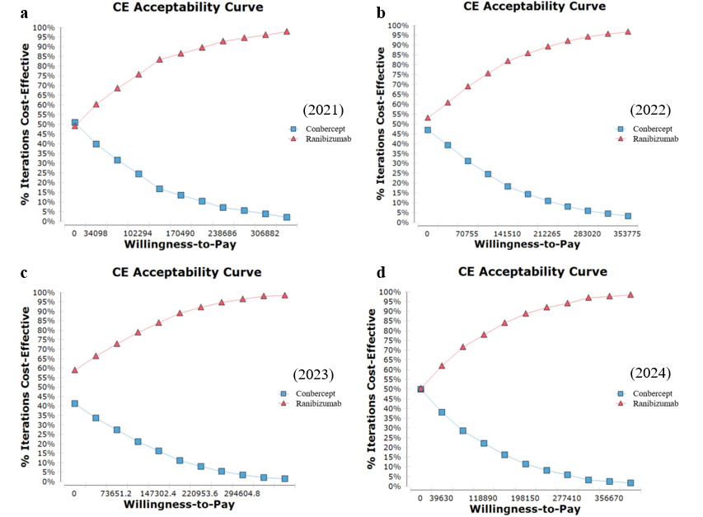
Figure S1. The Cost-Effectiveness Acceptability Curve of conbercept and ranibizumab in treatment of AMD from the Perspective of the Whole Society.
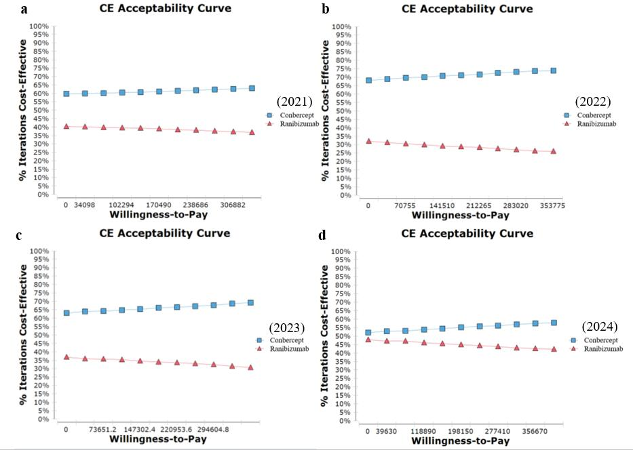

Figure S2. The Cost-Effectiveness Acceptability Curve of conbercept and ranibizumab in treatment of BRVO from the Perspective of the Whole Society.
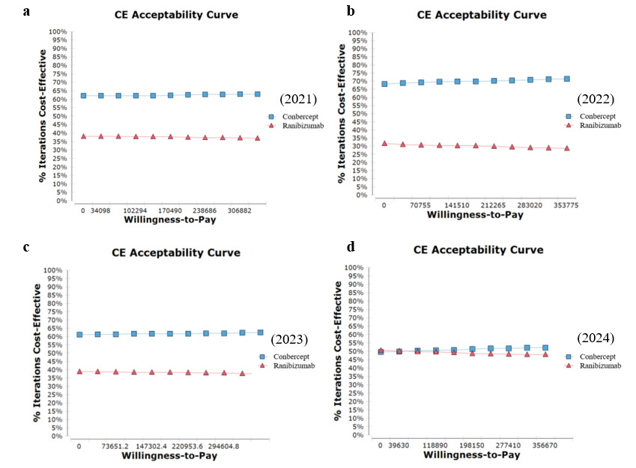

Figure S3. The Cost-Effectiveness Acceptability Curve of conbercept and ranibizumab in treatment of CRVO from the Perspective of the Whole Society.
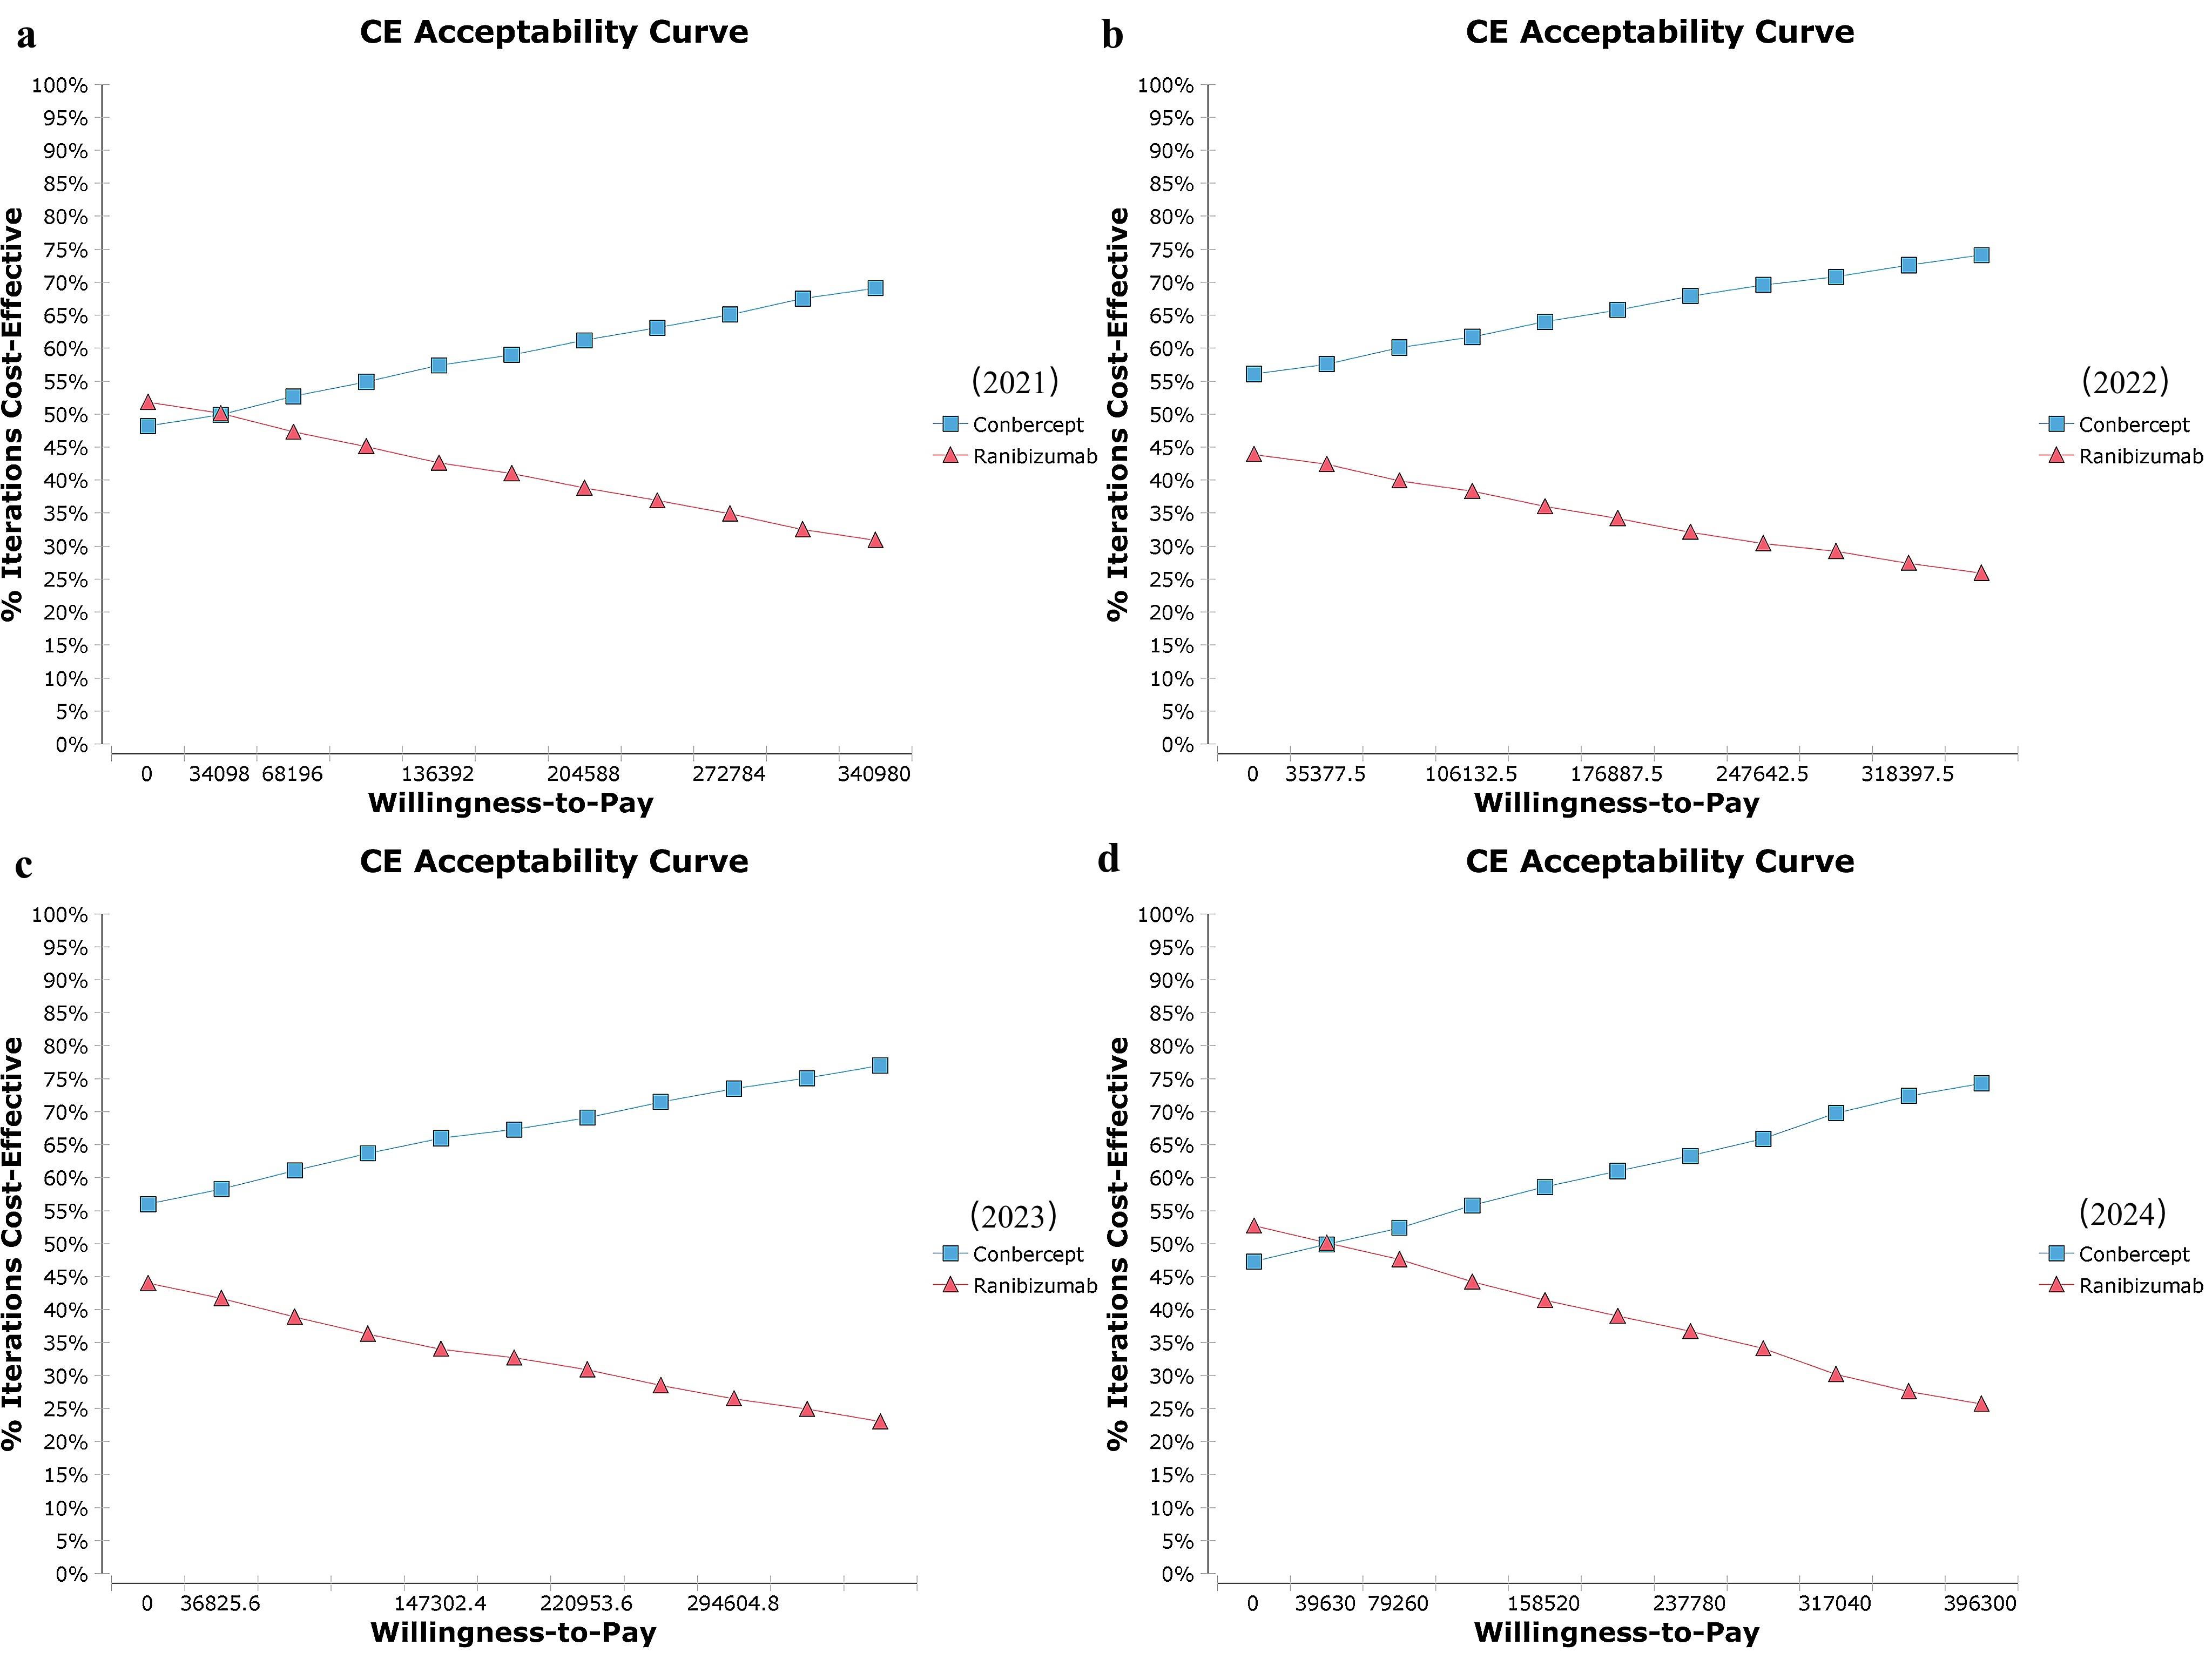
Figure S4. The Cost-Effectiveness Acceptability Curve of conbercept and ranibizumab in treatment of DME from the Perspective of the Whole Society.
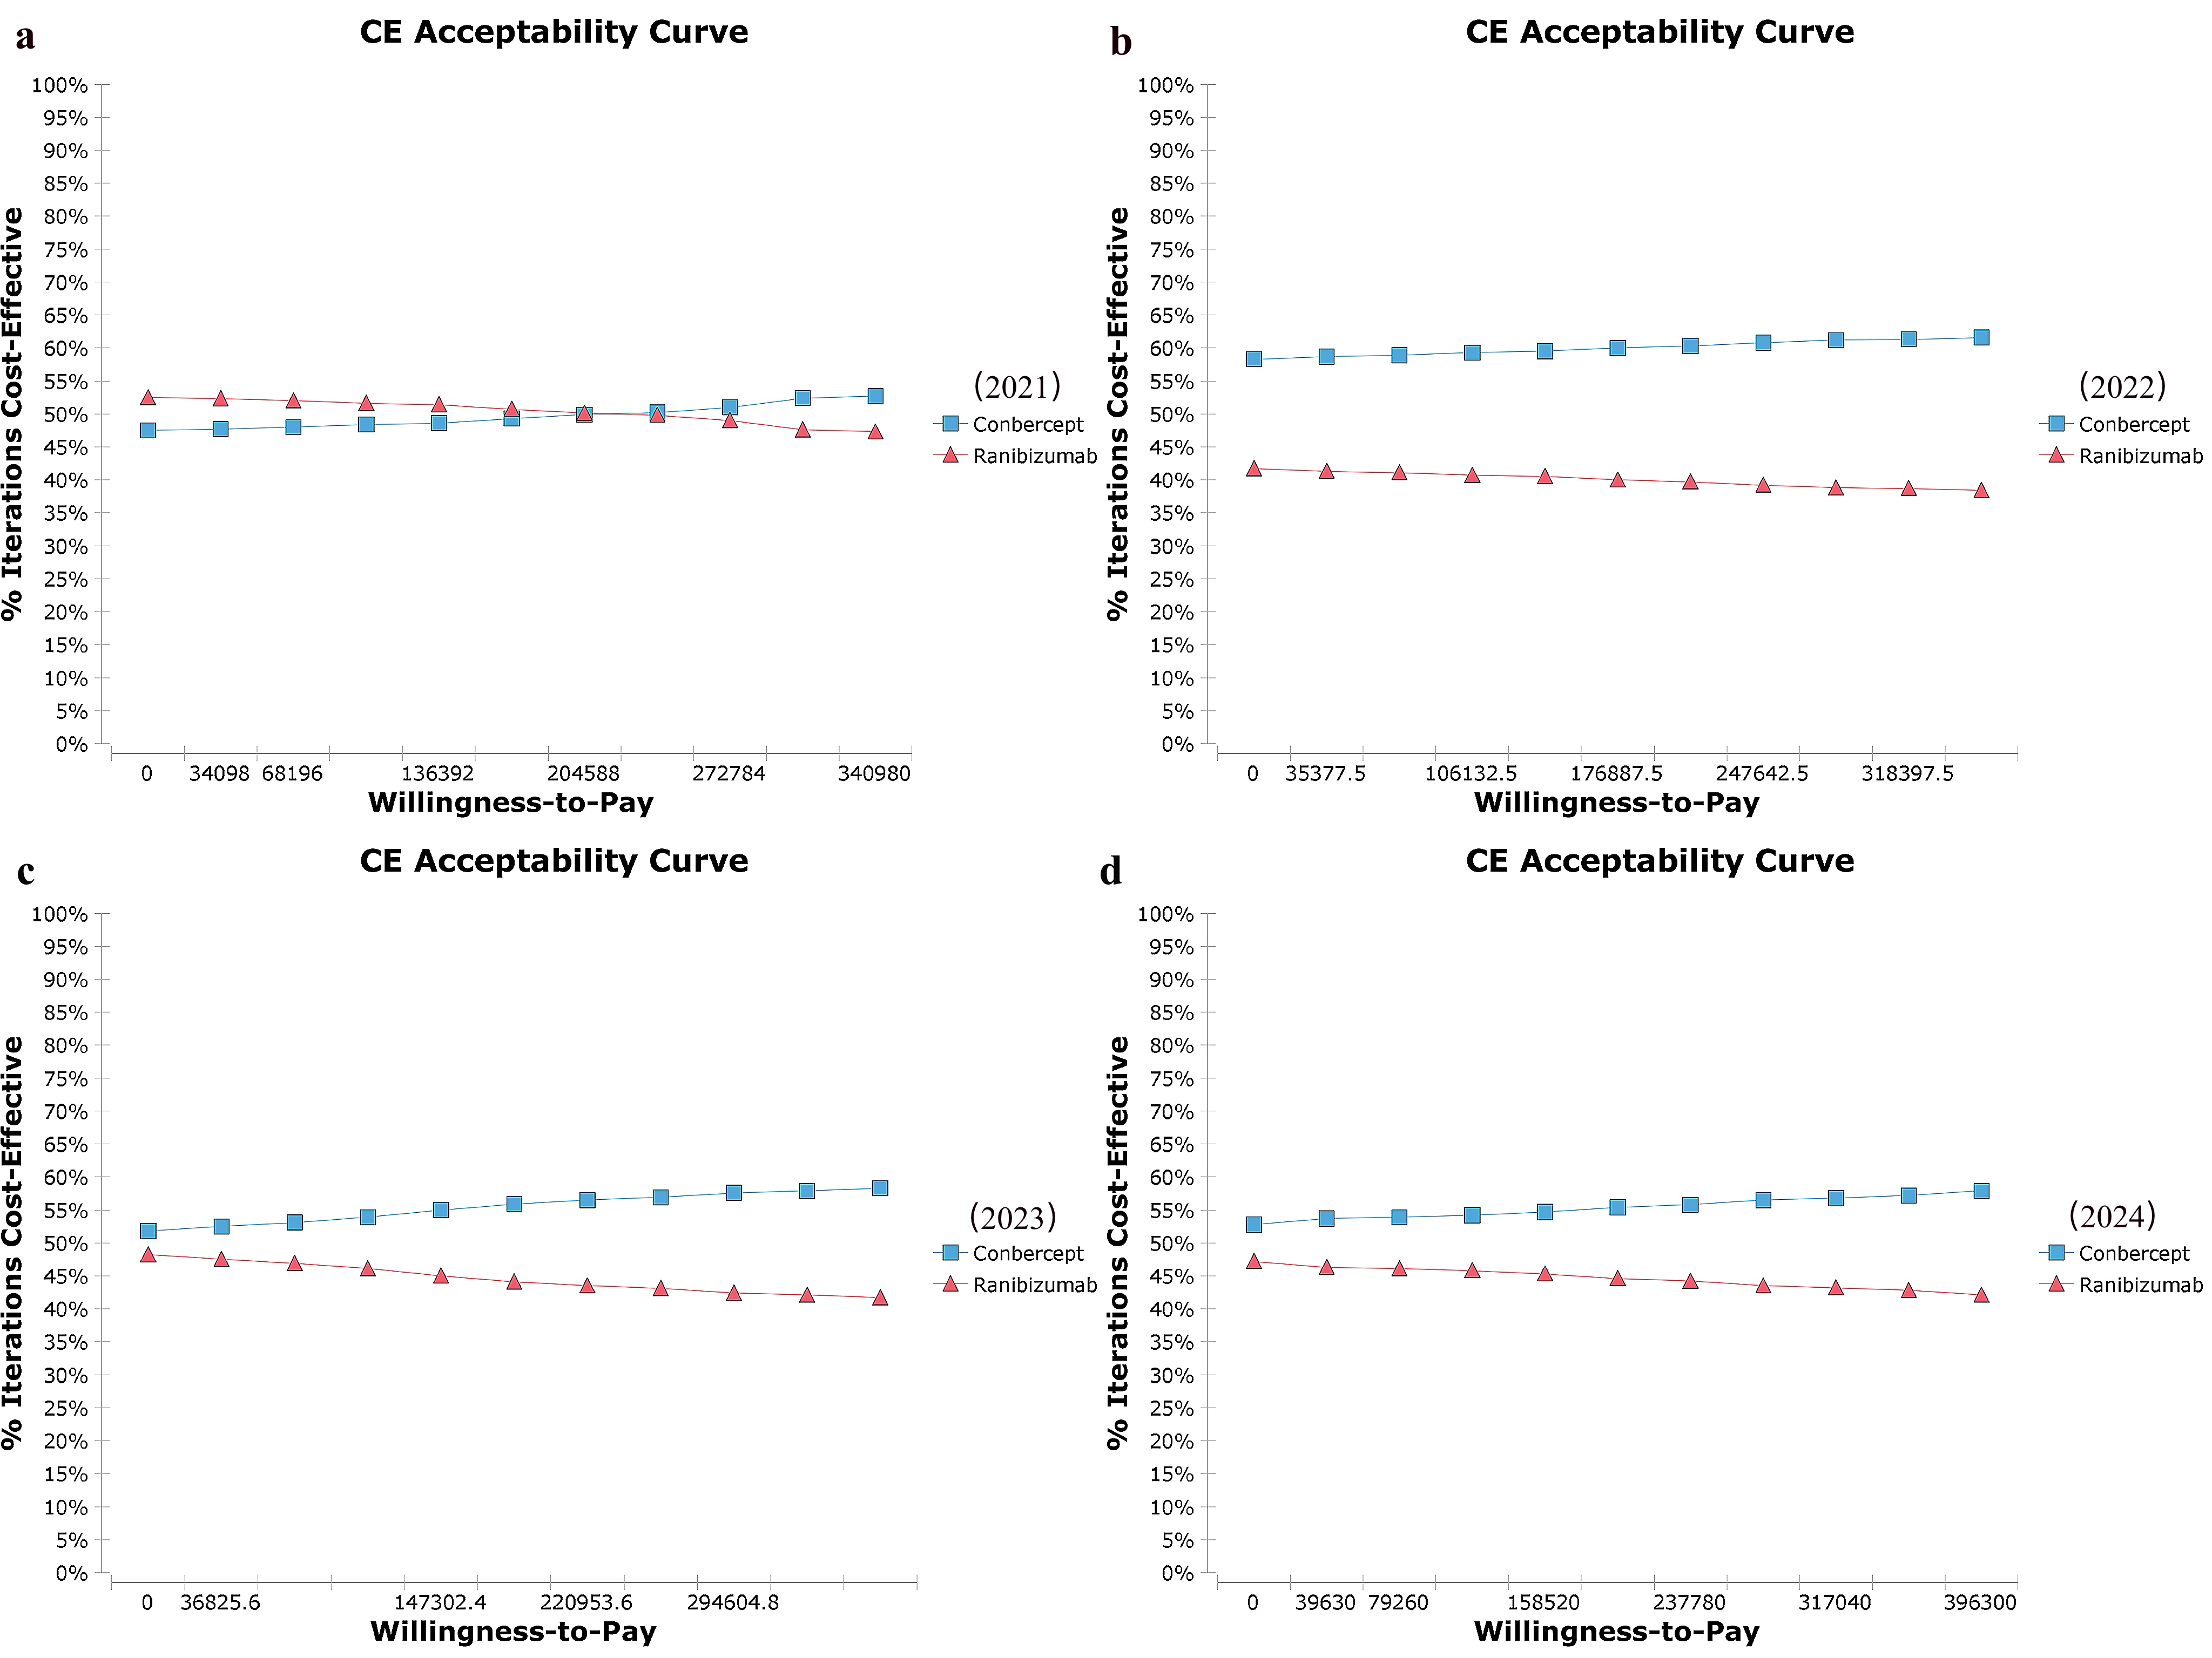
Figure S5. The Cost-Effectiveness Acceptability Curve of conbercept and ranibizumab in treatment of PM from the Perspective of the Whole Society
Table S7. The Two-way Sensitivity Analysis of Conbercept and Ranibizumab from the Perspective of the Health Insurance Payer in 2021.
 | Price | Strategy | Cost (RMB) | Incremental costs | Effectiveness (QALYs) | Incremental effectiveness | CER | ICER
Age-related macular degeneration | down 10% | conbercept | 111057.553 | - | 7.824 | - | 14194.473 | -
Age-related macular degeneration | down 10% | ranibizumab | 135061.134 | 24003.581 | 8.490 | 0.665 | 15908.261 | 36041.413
 | 0 | conbercept | 123397.281 | - | 7.824 | - | 15770.885 | -
 | 0 | ranibizumab | 150067.927 |  | 8.490 | 0.665 | 17676.755 | 40094.727
  26670.646
 | up 10% | conbercept | 135737.009 | - | 7.824 | - | 17348.800 | -
 | up 10% | ranibizumab | 165074.72 | 29337.711 | 8.490 | 0.665 | 19443.43 | 44050.617
Branch Retinal Vein Occlusion | down 10% | conbercept | 64538.735 |  | 8.346 |  | 7732.894
Branch Retinal Vein Occlusion | down 10% | ranibizumab | 179280.257 | 114741.522 | 8.297 | -0.049 | 21607.841 | -2341663.714
 | 0 | conbercept | 71709.705 | - | 8.346 | - | 8592.237 | -
 | 0 | ranibizumab | 199200.285 | 127490.581 | 8.297 | -0.049 | 24008.900 | -2605257.565
 | up 10% | conbercept | 78880.676 | - | 8.346 | - | 9451.315 | -
 | up 10% | ranibizumab | 219120.314 | 140239.638 | 8.297 | -0.049 | 26409.583 | -2862033.429
Central Retinal Vein Occlusion | down 10% | conbercept | 67671.671 | - | 8.156 | - | 8297.164 | -
Central Retinal Vein Occlusion | down 10% | ranibizumab | 159827.528 | 92155.857 | 8.135 | -0.021 | 19646.9 | -4388374.143
 | 0 | conbercept | 75190.746 | - | 8.156 | - | 9219.374 | -
 | 0 | ranibizumab | 177586.142 | 102395.396 | 8.135 | -0.021 | 21829.900 | -4937860.836
 | up 10% | conbercept | 82709.821 | - | 8.156 | - | 10140.979 | -
 | up 10% | ranibizumab | 195344.756 | 112634.935 | 8.135 | -0.021 | 24012.877 | -5363568.333
Diabetic macular edema | down 10% | conbercept | 177002.177 | - | 6.973 | - | 25382.987 | -
Diabetic macular edema | down 10% | ranibizumab | 161952.570 | -15049.607 | 6.758 | -0.215 | 23964.256 | 69942.278
 | 0 | conbercept | 196669.085 | - | 6.973 | - | 28203.318 | -
 | 0 | ranibizumab | 179947.300 | -16721.786 | 6.758 | -0.215 | 26626.952 | 77713.642
 | up 10% | conbercept | 216335.994 | - | 6.973 | - | 31023.650 | -
 | up 10% | ranibizumab | 197942.030 | -18393.964 | 6.758 | -0.215 | 29289.647 | 85485.007
Pathological myopia | down 10% | conbercept | 141254.955 | - | 7.528 | - | 18764.903 | -
Pathological myopia | down 10% | ranibizumab | 126473.751 | -14781.204 | 7.499 | -0.028 | 16865.011 | 519830.687
 | 0 | conbercept | 156949.953 | - | 7.528 | - | 20849.892 | -
 | 0 | ranibizumab | 140526.395 | -16423.558 | 7.499 | -0.028 | 18738.902 | 577589.580
 | up 10% | conbercept | 172644.945 | - | 7.528 | - | 22934.881 | -
 | up 10% | ranibizumab | 154579.029 | -18065.916 | 7.499 | -0.028 | 20612.791 | 635348.618

Table S8.TheTwo-way Sensitivity Analysis of Conbercept and Ranibizumab from the Perspective of the Health Insurance Payer in 2022.
 | Price | Strategy | Cost (RMB) | Incremental costs | Effectiveness (QALYs) | Incremental effectiveness | CER | ICER
Age-related macular degeneration | down 10% | conbercept | 159734.580 | - | 7.824 | - | 20415.974 | -
Age-related macular degeneration | down 10% | ranibizumab | 162563.243 | 2828.663 | 8.490 | 0.665 | 19147.614 | 4247.242
 | 0 | conbercept | 177482.867 | - | 7.824 | - | 22683.336 | -
 | 0 | ranibizumab | 180625.826 | 3142.960 | 8.490 | 0.665 | 21276.221 | 4724.899
 | up 10% | conbercept | 195231.154 | - | 7.824 | - | 24952.857 | -
 | up 10% | ranibizumab | 198688.409 | 3457.255 | 8.490 | 0.665 | 23402.639 | 5191.074
Branch Retinal Vein Occlusion | down 10% | conbercept | 135081.516 | - | 8.346 | - | 16185.18 | -
Branch Retinal Vein Occlusion | down 10% | ranibizumab | 171626.899 | 36545.383 | 8.297 | -0.049 | 20685.416 | -745824.143
 | 0 | conbercept | 150090.573 | - | 8.346 | - | 17983.812 | -
 | 0 | ranibizumab | 190696.554 | 40605.981 | 8.297 | -0.049 | 22983.975 | -829779.261
 | up 10% | conbercept | 165099.630 | - | 8.346 | - | 19781.887 | -
 | up 10% | ranibizumab | 209766.209 | 44666.579 | 8.297 | -0.049 | 25282.175 | -911562.837
Central Retinal Vein Occlusion | down 10% | conbercept | 84592.529 | - | 8.156 | - | 10371.816 | -
Central Retinal Vein Occlusion | down 10% | ranibizumab | 243172.948 | 158580.419 | 8.135 | -0.021 | 29892.188 | -7551448.524
 | 0 | conbercept | 93991.699 | - | 8.156 | - | 11524.617 | -
 | 0 | ranibizumab | 270192.165 | 176200.467 | 8.135 | -0.021 | 33213.559 | -8496997.088
 | up 10% | conbercept | 103390.869 | - | 8.156 | - | 12676.664 | -
 | up 10% | ranibizumab | 297211.382 | 193820.513 | 8.135 | -0.021 | 36534.896 | -9229548.238
Diabetic macular edema | down 10% | conbercept | 156595.658 | - | 6.973 | - | 22456.591 | -
Diabetic macular edema | down 10% | ranibizumab | 172768.208 | 16172.550 | 6.758 | -0.215 | 25564.655 | -75161.098
 | 0 | conbercept | 173995.175 | - | 6.973 | - | 24951.768 | -
 | 0 | ranibizumab | 191964.675 | 17969.500 | 6.758 | -0.215 | 28405.173 | -83512.331
 | up 10% | conbercept | 191394.693 | - | 6.973 | - | 27446.944 | -
 | up 10% | ranibizumab | 211161.143 | 19766.450 | 6.758 | -0.215 | 31245.690 | -91863.564
Pathological myopia | down 10% | conbercept | 137091.600 | - | 7.528 | - | 18211.825 | -
Pathological myopia | down 10% | ranibizumab | 146974.140 | 9882.540 | 7.499 | -0.028 | 19598.695 | -347552.713
 | 0 | conbercept | 152323.969 | - | 7.528 | - | 20235.357 | -
 | 0 | ranibizumab | 163304.587 | 10980.617 | 7.499 | -0.028 | 21776.326 | -386170.296
 | up 10% | conbercept | 167556.400 | - | 7.528 | - | 22258.897 | -
 | up 10% | ranibizumab | 179635.060 | 12078.660 | 7.499 | -0.028 | 23953.960 | -424786.650

Table S9.The Two-way Sensitivity Analysis of Conbercept and Ranibizumab from the Perspective of the Health Insurance Payer in 2023.
 | Price | Strategy | Cost (RMB) | Incremental costs | Effectiveness (QALYs) | Incremental effectiveness | CER | ICER
Age-related macular degeneration | down 10% | conbercept | 161568.409 | - | 7.824 | - | 20650.359 | -
Age-related macular degeneration | down 10% | ranibizumab | 155951.518 | -5616.891 | 8.490 | 0.665 | 18368.848 | -8433.770
 | 0 | conbercept | 179520.455 | - | 7.824 | - | 22943.751 | -
 | 0 | ranibizumab | 173279.464 | -6240.991 | 8.490 | 0.665 | 20410.881 | -9382.256
 | up 10% | conbercept | 197472.500 | - | 7.824 | - | 25239.328 | -
 | up 10% | ranibizumab | 190607.410 | -6865.090 | 8.490 | 0.665 | 22450.814 | -10307.943
Branch Retinal Vein Occlusion | down 10% | conbercept | 140229.438 | - | 8.346 | - | 16801.994 | -
Branch Retinal Vein Occlusion | down 10% | ranibizumab | 156547.395 | 16317.957 | 8.297 | -0.049 | 18867.952 | -333019.531
 | 0 | conbercept | 155810.487 | - | 8.346 | - | 18669.170 | -
 | 0 | ranibizumab | 173941.550 | 18131.063 | 8.297 | -0.049 | 20964.554 | -370506.503
 | up 10% | conbercept | 171391.536 | - | 8.346 | - | 20535.77 | -
 | up 10% | ranibizumab | 191335.705 | 19944.169 | 8.297 | -0.049 | 23060.83 | -407023.857
Central Retinal Vein Occlusion | down 10% | conbercept | 135843.081 | - | 8.156 | - | 16655.601 | -
Central Retinal Vein Occlusion | down 10% | ranibizumab | 182334.489 | 46491.408 | 8.135 | -0.021 | 22413.582 | -2213876.571
 | 0 | conbercept | 150936.757 | - | 8.156 | - | 18506.830 | -
 | 0 | ranibizumab | 202593.877 | 51657.120 | 8.135 | -0.021 | 24903.993 | -2491085.315
 | up 10% | conbercept | 166030.433 | - | 8.156 | - | 20356.846 | -
 | up 10% | ranibizumab | 222853.265 | 56822.832 | 8.135 | -0.021 | 27394.378 | -2705849.143
Diabetic macular edema | down 10% | conbercept | 154705.572 | - | 6.973 | - | 22185.543 | -
Diabetic macular edema | down 10% | ranibizumab | 167535.804 | 12830.232 | 6.758 | -0.215 | 24790.412 | -59627.846
 | 0 | conbercept | 171895.080 | - | 6.973 | - | 24650.604 | -
 | 0 | ranibizumab | 186150.893 | 14255.813 | 6.758 | -0.215 | 27544.902 | -66253.162
 | up 10% | conbercept | 189084.588 | - | 6.973 | - | 27115.664 | -
 | up 10% | ranibizumab | 204765.982 | 15681.395 | 6.758 | -0.215 | 30299.393 | -72878.478
Pathological myopia | down 10% | conbercept | 131056.290 | - | 7.528 | - | 17410.069 | -
Pathological myopia | down 10% | ranibizumab | 141016.320 | 9960.030 | 7.499 | -0.028 | 18804.232 | -350277.910
 | 0 | conbercept | 145618.124 | - | 7.528 | - | 19344.524 | -
 | 0 | ranibizumab | 156684.769 | 11066.645 | 7.499 | -0.028 | 20893.587 | -389195.748
 | up 10% | conbercept | 160179.910 | - | 7.528 | - | 21278.973 | -
 | up 10% | ranibizumab | 172353.170 | 12173.260 | 7.499 | -0.028 | 22982.936 | -428113.577

Table S10.The Two-way Sensitivity Analysis of Conbercept and Ranibizumab from the Perspective of the Health Insurance Payer in 2024.
 | Price | Strategy | Cost (RMB) | Incremental costs | Effectiveness (QALYs) | Incremental effectiveness | CER | ICER
Age-related macular degeneration | down 10% | conbercept | 108365.861 | - | 7.824 | - | 13850.442 | -
Age-related macular degeneration | down 10% | ranibizumab | 140650.478 | 32284.617 | 8.490 | 0.665 | 16566.605 | 48475.401
 | 0 | conbercept | 120406.512 | - | 7.824 | - | 15388.648 | -
 | 0 | ranibizumab | 156278.309 | 35871.797 | 8.490 | 0.665 | 18408.286 | 53927.073
 | up 10% | conbercept | 132447.163 | - | 7.824 | - | 16928.318 | -
 | up 10% | ranibizumab | 171906.140 | 39458.977 | 8.490 | 0.665 | 20248.073 | 59247.713
Branch Retinal Vein Occlusion | down 10% | conbercept | 142017.384 | - | 8.346 | - | 17016.221 | -
Branch Retinal Vein Occlusion | down 10% | ranibizumab | 129634.334 | -12383.05 | 8.297 | -0.049 | 15624.242 | 252715.306
 | 0 | conbercept | 157797.093 | - | 8.346 | - | 18907.205 | -
 | 0 | ranibizumab | 144038.149 | -13758.944 | 8.297 | -0.049 | 17360.404 | 281162.668
 | up 10% | conbercept | 173576.802 | - | 8.346 | - | 20797.604 | -
 | up 10% | ranibizumab | 158441.964 | -15134.838 | 8.297 | -0.049 | 19096.296 | 308874.245
Central Retinal Vein Occlusion | down 10% | conbercept | 161164.640 | - | 8.156 | - | 19760.255 | -
Central Retinal Vein Occlusion | down 10% | ranibizumab | 180841.867 | 19677.227 | 8.135 | -0.021 | 22230.100 | -937010.810
 | 0 | conbercept | 179071.822 | - | 8.156 | - | 21956.559 | -
 | 0 | ranibizumab | 200935.408 | 21863.586 | 8.135 | -0.021 | 24700.124 | -1054337.861
 | up 10% | conbercept | 196979.004 | - | 8.156 | - | 24151.423 | -
 | up 10% | ranibizumab | 221028.949 | 24049.945 | 8.135 | -0.021 | 27170.123 | -1145235.476
Diabetic macular edema | down 10% | conbercept | 156695.529 | - | 6.973 | - | 22470.913 | -
Diabetic macular edema | down 10% | ranibizumab | 154515.005 | -2180.524 | 6.758 | -0.215 | 22863.714 | 10133.875
 | 0 | conbercept | 174106.144 | - | 6.973 | - | 24967.681 | -
 | 0 | ranibizumab | 171683.339 | -2422.805 | 6.758 | -0.215 | 25404.126 | 11259.861
 | up 10% | conbercept | 191516.758 | - | 6.973 | - | 27464.449 | -
 | up 10% | ranibizumab | 188851.673 | -2665.085 | 6.758 | -0.215 | 27944.539 | 12385.848
Pathological myopia | down 10% | conbercept | 124587.540 | - | 7.528 | - | 16550.733 | -
Pathological myopia | down 10% | ranibizumab | 139251.600 | 14664.060 | 7.499 | -0.028 | 18568.910 | -515710.925
 | 0 | conbercept | 138430.550 | - | 7.528 | - | 18389.697 | -
 | 0 | ranibizumab | 154723.991 | 16293.440 | 7.499 | -0.028 | 20632.121 | -573013.557
 | up 10% | conbercept | 152273.660 | - | 7.528 | - | 20228.674 | -
 | up 10% | ranibizumab | 170196.400 | 17922.740 | 7.499 | -0.028 | 22695.335 | -630313.353

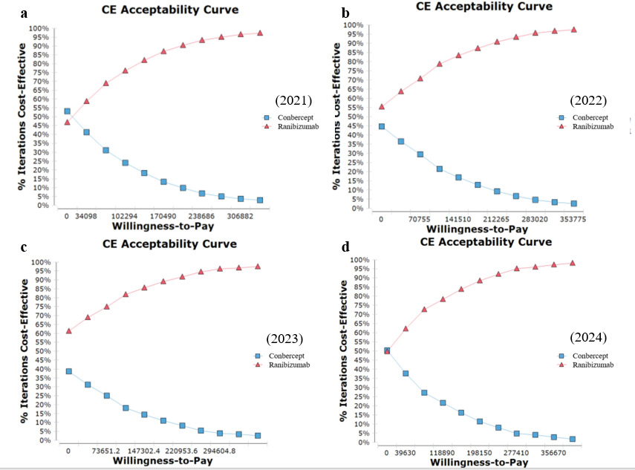

Figure S6. The Cost-Effectiveness Acceptability Curve of conbercept and ranibizumab in treatment of AMD from the Perspective of the Health Insurance Payer.
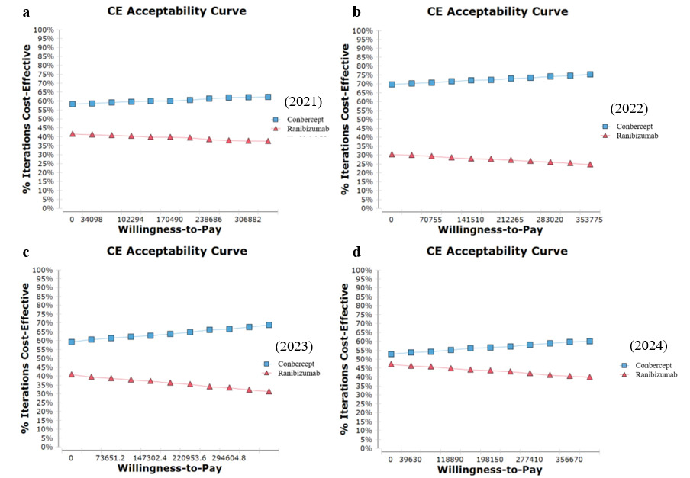

Figure S7. The Cost-Effectiveness Acceptability Curve of conbercept and ranibizumab in treatment of BRVO from the Perspective of the Health Insurance Payer.
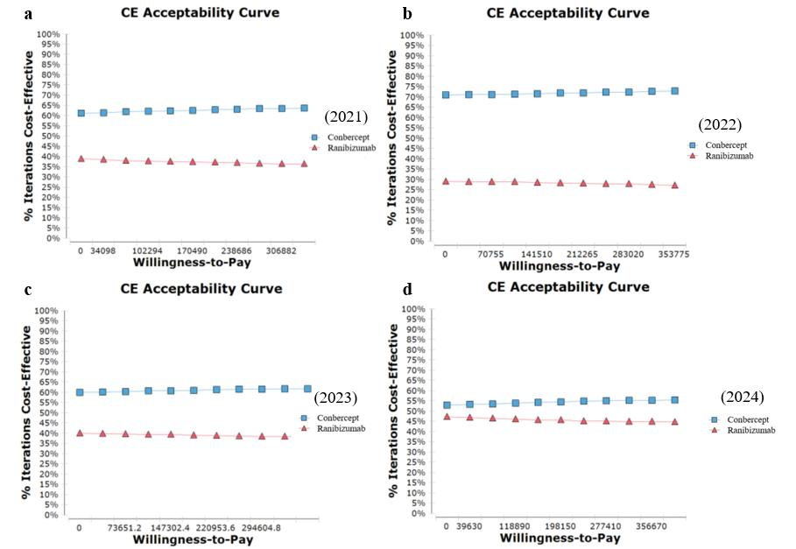

Figure S8. The Cost-Effectiveness Acceptability Curve of conbercept and ranibizumab in treatment of CRVO from the Perspective of the Health Insurance Payer.
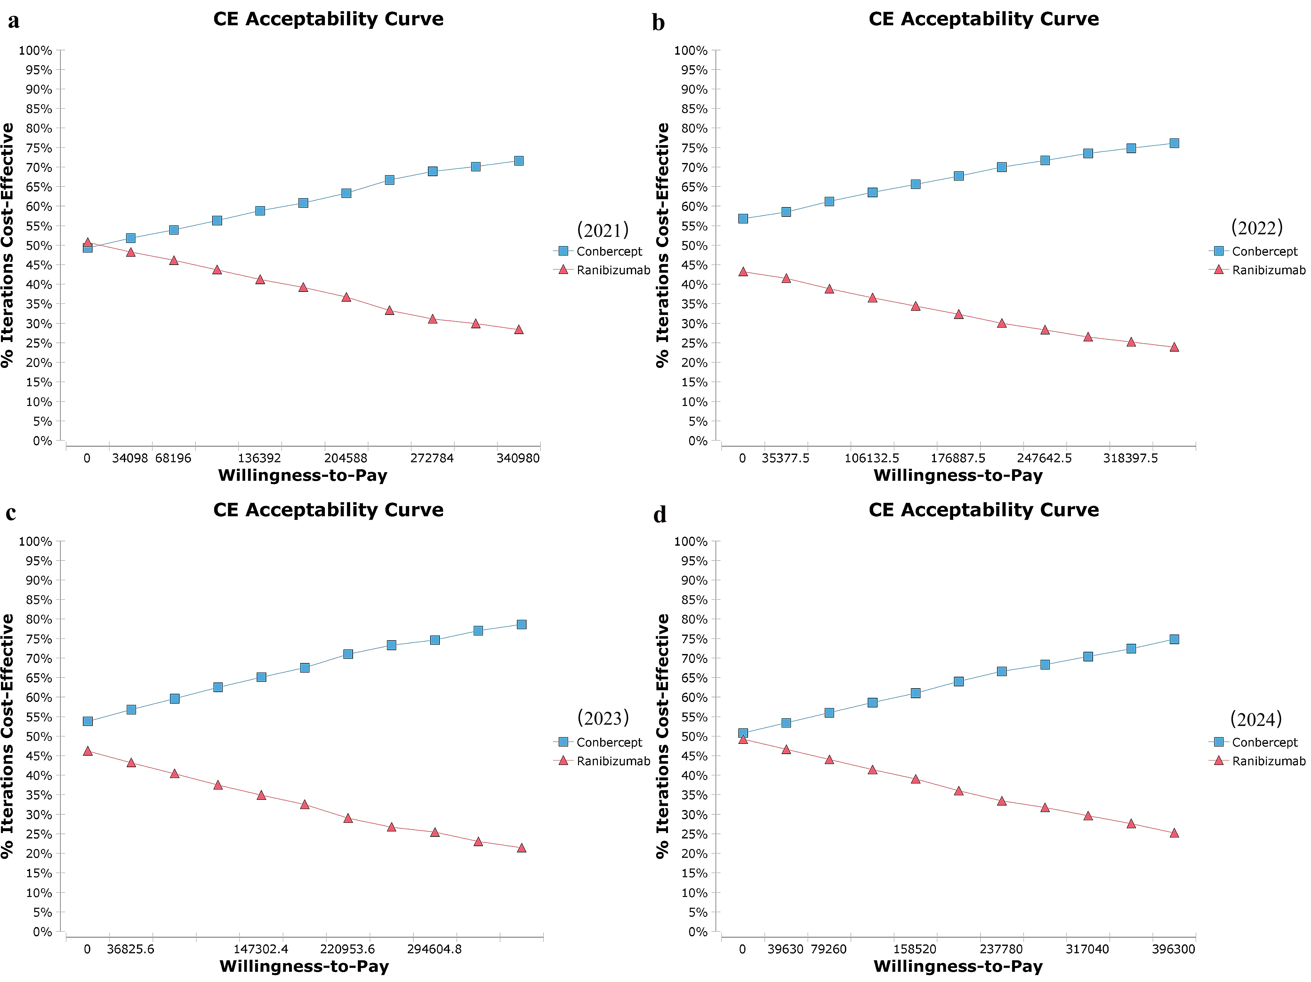
Figure S8. The Cost-Effectiveness Acceptability Curve of conbercept and ranibizumab in treatment of DME from the Perspective of the Health Insurance Payer.
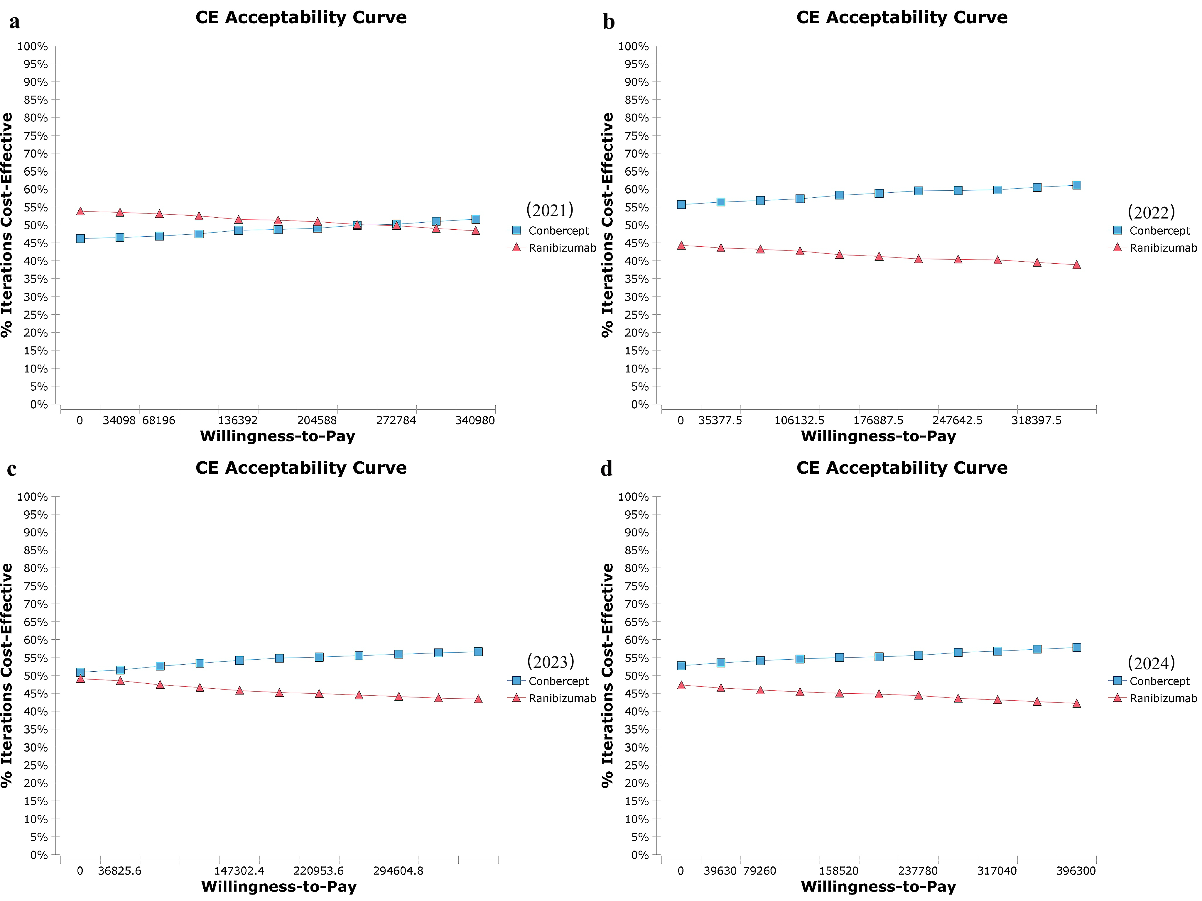
Figure S9. The Cost-Effectiveness Acceptability Curve of conbercept and ranibizumab in treatment of PM from the Perspective of the Health Insurance Payer.

Table S11. The one-way sensitivity analysis with different numbers of conbercept injections from the Perspective of the Whole Society in 2021.
 | Number of conbercept injections | Strategy | Cost (RMB) | Incremental costs | Effectiveness (QALYs) | Incremental effectiveness | CER | ICER
AMD | 1 | Conbercept | 187530.241 | - | 7.824 | - | 23967.448 | -
AMD | 1 | Ranibizumab | 253484.447 | 65954.206 | 8.490 | 0.665 | 29858.361 | 99150.799
AMD | 3 | Conbercept | 275313.638 | - | 7.824 | - | 35186.674 | -
AMD | 3 | Ranibizumab | 253484.447 | -21829.190 | 8.490 | 0.665 | 29858.361 | -32816.431
AMD | 5 | Conbercept | 363097.035 | - | 7.824 | - | 46405.899 | -
AMD | 5 | Ranibizumab | 253484.447 | -109612.587 | 8.490 | 0.665 | 29858.361 | -164783.662
AMD | 7 | Conbercept | 450880.432 | - | 7.824 | - | 57625.124 | -
AMD | 7 | Ranibizumab | 253484.447 | -197395.984 | 8.490 | 0.665 | 29858.361 | -296750.892
AMD | 9 | Conbercept | 538663.828 | - | 7.824 | - | 68844.350 | -
AMD | 9 | Ranibizumab | 253484.447 | -285179.381 | 8.490 | 0.665 | 29858.361 | -428718.122
BRVO | 1 | Conbercept | 161535.979 | - | 8.346 | - | 19355.197 | -
BRVO | 1 | Ranibizumab | 290374.328 | 128838.350 | 8.297 | -0.049 | 34997.782 | -2632799.096
BRVO | 2 | Conbercept | 206085.081 | - | 8.346 | - | 24693.058 | -
BRVO | 2 | Ranibizumab | 290374.328 | 84289.247 | 8.297 | -0.049 | 34997.782 | -1722442.541
BRVO | 3 | Conbercept | 250634.183 | - | 8.346 | - | 30030.919 | -
BRVO | 3 | Ranibizumab | 290374.328 | 39740.145 | 8.297 | -0.049 | 34997.782 | -812085.987
BRVO | 4 | Conbercept | 295183.285 | - | 8.346 | - | 35368.781 | -
BRVO | 4 | Ranibizumab | 290374.328 | -4808.957 | 8.297 | -0.049 | 34997.782 | 98270.568
BRVO | 5 | Conbercept | 339732.388 | - | 8.346 | - | 40706.642 | -
BRVO | 5 | Ranibizumab | 290374.328 | -49358.059 | 8.297 | -0.049 | 34997.782 | 1008627.123
CRVO | 1 | Conbercept | 194280.717 | - | 8.156 | - | 23821.369 | -
CRVO | 1 | Ranibizumab | 297591.762 | 103311.045 | 8.135 | -0.021 | 36581.674 | -4982016.597
CRVO | 2.25 | Conbercept | 249967.095 | - | 8.156 | - | 30649.251 | -
CRVO | 2.25 | Ranibizumab | 297591.762 | 47624.667 | 8.135 | -0.021 | 36581.674 | -2296626.494
CRVO | 3.5 | Conbercept | 305653.472 | - | 8.156 | - | 37477.133 | -
CRVO | 3.5 | Ranibizumab | 297591.762 | -8061.710 | 8.135 | -0.021 | 36581.674 | 388763.610
CRVO | 4.75 | Conbercept | 361339.850 | - | 8.156 | - | 44305.014 | -
CRVO | 4.75 | Ranibizumab | 297591.762 | -63748.088 | 8.135 | -0.021 | 36581.674 | 3074153.714
CRVO | 6 | Conbercept | 417026.228 | - | 8.135 | - | 51132.896 | -
CRVO | 6 | Ranibizumab | 297591.762 | -119434.466 | 8.156 | -0.021 | 36581.674 | 5759543.818
DME | 1 | Conbercept | 241348.872 | - | 6.973 | - | 34610.621 | -
DME | 1 | Ranibizumab | 296383.430 | 55034.558 | 6.758 | -0.215 | 43856.103 | -255770.287
DME | 3.75 | Conbercept | 362312.578 | - | 6.973 | - | 51957.413 | -
DME | 3.75 | Ranibizumab | 296383.430 | -65929.148 | 6.758 | -0.215 | 43856.103 | 306402.338
DME | 6.5 | Conbercept | 483276.284 | - | 6.973 | - | 69304.206 | -
DME | 6.5 | Ranibizumab | 296383.430 | -186892.854 | 6.758 | -0.215 | 43856.103 | 868574.962
DME | 9.25 | Conbercept | 604239.990 | - | 6.973 | - | 86650.999 | -
DME | 9.25 | Ranibizumab | 296383.430 | -307856.560 | 6.758 | -0.215 | 43856.103 | 1430747.587
DME | 12 | Conbercept | 725203.695 | - | 6.973 | - | 103997.792 | -
DME | 12 | Ranibizumab | 296383.430 | -428820.265 | 6.758 | -0.215 | 43856.103 | 1992920.212
PM | 1 | Conbercept | 220470.512 | - | 7.528 | - | 29288.231 | -
PM | 1 | Ranibizumab | 266591.723 | 46121.211 | 7.499 | -0.028 | 35549.450 | -1622007.284
PM | 3.25 | Conbercept | 320335.820 | - | 7.528 | - | 42554.758 | -
PM | 3.25 | Ranibizumab | 266591.723 | -53744.097 | 7.499 | -0.028 | 35549.450 | 1890091.697
PM | 5.5 | Conbercept | 420201.128 | - | 7.528 | - | 55821.286 | -
PM | 5.5 | Ranibizumab | 266591.723 | -153609.405 | 7.499 | -0.028 | 35549.450 | 5402190.678
PM | 7.75 | Conbercept | 520066.436 | - | 7.528 | - | 69087.814 | -
PM | 7.75 | Ranibizumab | 266591.723 | -253474.713 | 7.499 | -0.028 | 35549.450 | 8914289.659
PM | 10 | Conbercept | 619931.743 | - | 7.528 | - | 82354.341 | -
PM | 10 | Ranibizumab | 266591.723 | -353340.020 | 7.499 | -0.028 | 35549.450 | 12428421.394

Table S12. The one-way sensitivity analysis with different numbers of ranibizumab injections from the Perspective of the Whole Society in 2021.
 | Number of ranibizumab injections | Strategy | Cost (RMB) | Incremental costs | Effectiveness (QALYs) | Incremental effectiveness | CER | ICER
AMD | 1 | Conbercept | 225277.102 | - | 7.824 | - | 28791.715 | -
AMD | 1 | Ranibizumab | 197225.142 | -28051.959 | 8.490 | 0.665 | 23231.483 | -42171.293
AMD | 3 | Conbercept | 225277.102 | - | 7.824 | - | 28791.715 | -
AMD | 3 | Ranibizumab | 281825.601 | 56548.499 | 8.490 | 0.665 | 33196.714 | 85010.937
AMD | 5 | Conbercept | 225277.102 | - | 7.824 | - | 28791.715 | -
AMD | 5 | Ranibizumab | 366426.060 | 141148.958 | 8.490 | 0.665 | 43161.945 | 212193.168
AMD | 7 | Conbercept | 225277.102 | - | 7.824 | - | 28791.715 | -
AMD | 7 | Ranibizumab | 451026.518 | 225749.417 | 8.490 | 0.665 | 53127.176 | 339375.398
AMD | 9 | Conbercept | 225277.102 | - | 7.824 | - | 28791.715 | -
AMD | 9 | Ranibizumab | 535626.977 | 310349.875 | 8.490 | 0.665 | 63092.406 | 466557.629
BRVO | 1 | Conbercept | 161535.979 | - | 8.346 | - | 19355.197 | -
BRVO | 1 | Ranibizumab | 207042.877 | 45506.898 | 8.297 | -0.049 | 24954.139 | -929929.017
BRVO | 2.75 | Conbercept | 161535.979 | - | 8.346 | - | 19355.197 | -
BRVO | 2.75 | Ranibizumab | 281068.278 | 119532.299 | 8.297 | -0.049 | 33876.157 | -2442630.864
BRVO | 4.5 | Conbercept | 161535.979 | - | 8.346 | - | 19355.197 | -
BRVO | 4.5 | Ranibizumab | 355093.679 | 193557.701 | 8.297 | -0.049 | 42798.174 | -3955332.711
BRVO | 6.25 | Conbercept | 161535.979 | - | 8.346 | - | 19355.197 | -
BRVO | 6.25 | Ranibizumab | 429119.081 | 267583.102 | 8.297 | -0.049 | 51720.192 | -5468034.558
BRVO | 8 | Conbercept | 161535.979 | - | 8.346 | - | 19355.197 | -
BRVO | 8 | Ranibizumab | 503144.482 | 341608.503 | 8.297 | -0.049 | 60642.209 | -6980736.405
CRVO | 1 | Conbercept | 194280.717 | - | 8.156 | - | 23821.369 | -
CRVO | 1 | Ranibizumab | 225258.370 | 30977.653 | 8.135 | -0.021 | 27690.041 | -1493849.779
CRVO | 2.75 | Conbercept | 194280.717 | - | 8.156 | - | 23821.369 | -
CRVO | 2.75 | Ranibizumab | 299283.771 | 105003.054 | 8.135 | -0.021 | 36789.665 | -5063611.143
CRVO | 4.5 | Conbercept | 194280.717 | - | 8.156 | - | 23821.369 | -
CRVO | 4.5 | Ranibizumab | 373309.173 | 179028.456 | 8.135 | -0.021 | 45889.289 | -8633372.507
CRVO | 6.25 | Conbercept | 194280.717 | - | 8.156 | - | 23821.369 | -
CRVO | 6.25 | Ranibizumab | 447334.574 | 253053.857 | 8.135 | -0.021 | 54988.913 | -12203133.870
CRVO | 8 | Conbercept | 194280.717 | - | 8.156 | - | 23821.369 | -
CRVO | 8 | Ranibizumab | 521359.975 | 327079.258 | 8.135 | -0.021 | 64088.536 | -15772895.234
DME | 1 | Conbercept | 318325.776 | - | 6.973 | - | 45649.489 | -
DME | 1 | Ranibizumab | 219820.015 | -98505.761 | 6.758 | -0.215 | 32526.950 | 457800.477
DME | 3.75 | Conbercept | 318325.776 | - | 6.973 | - | 45649.489 | -
DME | 3.75 | Ranibizumab | 336145.646 | 17819.870 | 6.758 | -0.215 | 49739.751 | -82816.931
DME | 6.5 | Conbercept | 318325.776 | - | 6.973 | - | 45649.489 | -
DME | 6.5 | Ranibizumab | 452471.276 | 134145.500 | 6.758 | -0.215 | 66952.551 | -623434.339
DME | 9.25 | Conbercept | 318325.776 | - | 6.973 | - | 45649.489 | -
DME | 9.25 | Ranibizumab | 568796.907 | 250471.131 | 6.758 | -0.215 | 84165.351 | -1164051.747
DME | 12 | Conbercept | 318325.776 | - | 6.973 | - | 45649.489 | -
DME | 12 | Ranibizumab | 685122.537 | 366796.761 | 6.758 | -0.215 | 101378.152 | -1704669.155
PM | 1 | Conbercept | 280833.543 | - | 7.528 | - | 37307.110 | -
PM | 1 | Ranibizumab | 217100.455 | -63733.088 | 7.499 | -0.028 | 28949.893 | 2241388.119
PM | 2.25 | Conbercept | 280833.543 | - | 7.528 | - | 37307.110 | -
PM | 2.25 | Ranibizumab | 269975.741 | -10857.802 | 7.499 | -0.028 | 36000.702 | 381851.062
PM | 3.5 | Conbercept | 280833.543 | - | 7.528 | - | 37307.110 | -
PM | 3.5 | Ranibizumab | 322851.028 | 42017.485 | 7.499 | -0.028 | 43051.511 | -1477685.995
PM | 4.75 | Conbercept | 280833.543 | - | 7.528 | - | 37307.110 | -
PM | 4.75 | Ranibizumab | 375726.315 | 94892.772 | 7.499 | -0.028 | 50102.320 | -3337223.052
PM | 6 | Conbercept | 280833.543 | - | 7.528 | - | 37307.110 | -
PM | 6 | Ranibizumab | 428601.601 | 147768.058 | 7.499 | -0.028 | 57153.129 | -5196760.108

Table S13. The one-way sensitivity analysis with different numbers of conbercept injections from the Perspective of the Whole Society in 2022.
 | Number ofconbercept injections | Strategy | Cost (RMB) | Incremental costs | Effectiveness (QALYs) | Incremental effectiveness | CER | ICER
AMD | 1 | Conbercept | 206373.697 | - | 7.824 | - | 26375.751 | -
AMD | 1 | Ranibizumab | 290851.809 | 84478.113 | 8.490 | 0.665 | 34259.926 | 126998.305
AMD | 3 | Conbercept | 279233.916 | - | 7.824 | - | 35687.708 | -
AMD | 3 | Ranibizumab | 290851.809 | 11617.893 | 8.490 | 0.665 | 34259.926 | 17465.503
AMD | 5 | Conbercept | 352094.135 | - | 7.824 | - | 44999.665 | -
AMD | 5 | Ranibizumab | 290851.809 | -61242.326 | 8.490 | 0.665 | 34259.926 | -92067.298
AMD | 7 | Conbercept | 424954.355 | - | 7.824 | - | 54311.622 | -
AMD | 7 | Ranibizumab | 290851.809 | -134102.545 | 8.490 | 0.665 | 34259.926 | -201600.099
AMD | 9 | Conbercept | 497814.574 | - | 7.824 | - | 63623.579 | -
AMD | 9 | Ranibizumab | 290851.809 | -206962.765 | 8.490 | 0.665 | 34259.926 | -311132.900
BRVO | 1 | Conbercept | 201399.999 | - | 8.346 | - | 24131.693 | -
BRVO | 1 | Ranibizumab | 287032.788 | 85632.789 | 8.297 | -0.049 | 34595.038 | -1749897.676
BRVO | 2 | Conbercept | 238375.754 | - | 8.346 | - | 28562.118 | -
BRVO | 2 | Ranibizumab | 287032.788 | 48657.034 | 8.297 | -0.049 | 34595.038 | -994301.736
BRVO | 3 | Conbercept | 275351.509 | - | 8.346 | - | 32992.543 | -
BRVO | 3 | Ranibizumab | 287032.788 | 11681.279 | 8.297 | -0.049 | 34595.038 | -238705.795
BRVO | 4 | Conbercept | 312327.264 | - | 8.346 | - | 34595.038 | -
BRVO | 4 | Ranibizumab | 287032.788 | -25294.476 | 8.297 | -0.049 | 37422.968 | 516890.145
BRVO | 5 | Conbercept | 349303.019 | - | 8.346 | - | 34595.038 | -
BRVO | 5 | Ranibizumab | 287032.788 | -62270.231 | 8.297 | -0.049 | 41853.392 | 1272486.086
CRVO | 1 | Conbercept | 218632.826 | - | 8.156 | - | 26807.258 | -
CRVO | 1 | Ranibizumab | 402782.713 | 184149.887 | 8.135 | -0.021 | 49512.344 | -8880345.683
CRVO | 2.25 | Conbercept | 264852.520 | - | 8.156 | - | 32474.400 | -
CRVO | 2.25 | Ranibizumab | 402782.713 | 137930.194 | 8.135 | -0.021 | 49512.344 | -6651471.896
CRVO | 3.5 | Conbercept | 311072.213 | - | 8.156 | - | 38141.541 | -
CRVO | 3.5 | Ranibizumab | 402782.713 | 91710.500 | 8.135 | -0.021 | 49512.344 | -4422598.110
CRVO | 4.75 | Conbercept | 357291.907 | - | 8.156 | - | 43808.683 | -
CRVO | 4.75 | Ranibizumab | 402782.713 | 45490.807 | 8.135 | -0.021 | 49512.344 | -2193724.324
CRVO | 6 | Conbercept | 403511.600 | - | 8.135 | - | 49512.344 | -
CRVO | 6 | Ranibizumab | 402782.713 | -728.887 | 8.156 | -0.021 | 49475.825 | 35149.462
DME | 1 | Conbercept | 233005.809 | - | 6.973 | - | 33414.184 | -
DME | 1 | Ranibizumab | 315143.393 | 82137.584 | 6.758 | -0.215 | 46632.030 | -381730.213
DME | 3.75 | Conbercept | 333405.685 | - | 6.973 | - | 47812.022 | -
DME | 3.75 | Ranibizumab | 315143.393 | -18262.292 | 6.758 | -0.215 | 46632.030 | 84873.066
DME | 6.5 | Conbercept | 433805.560 | - | 6.973 | - | 62209.860 | -
DME | 6.5 | Ranibizumab | 315143.393 | -118662.168 | 6.758 | -0.215 | 46632.030 | 551476.344
DME | 9.25 | Conbercept | 534205.436 | - | 6.973 | - | 76607.698 | -
DME | 9.25 | Ranibizumab | 315143.393 | -219062.043 | 6.758 | -0.215 | 46632.030 | 1018079.623
DME | 12 | Conbercept | 634605.312 | - | 6.973 | - | 91005.537 | -
DME | 12 | Ranibizumab | 315143.393 | -319461.919 | 6.758 | -0.215 | 46632.030 | 1484682.901
PM | 1 | Conbercept | 222307.476 | - | 7.528 | - | 29532.261 | -
PM | 1 | Ranibizumab | 295725.599 | 73418.123 | 7.499 | -0.028 | 39434.392 | -2581994.882
PM | 3.25 | Conbercept | 305195.682 | - | 7.528 | - | 40543.479 | -
PM | 3.25 | Ranibizumab | 295725.599 | -9470.083 | 7.499 | -0.028 | 39434.392 | 333047.272
PM | 5.5 | Conbercept | 388083.887 | - | 7.528 | - | 51554.697 | -
PM | 5.5 | Ranibizumab | 295725.599 | -92358.288 | 7.499 | -0.028 | 39434.392 | 3248089.427
PM | 7.75 | Conbercept | 470972.093 | - | 7.528 | - | 62565.915 | -
PM | 7.75 | Ranibizumab | 295725.599 | -175246.494 | 7.499 | -0.028 | 39434.392 | 6163131.581
PM | 10 | Conbercept | 553860.298 | - | 7.528 | - | 73577.133 | -
PM | 10 | Ranibizumab | 295725.599 | -258134.699 | 7.499 | -0.028 | 39434.392 | 9078173.735

Table S14. The one-way sensitivity analysis with different numbers of ranibizumab injections from the Perspective of the Whole Society in 2022.
 | Number of ranibizumab injections | Strategy | Cost (RMB) | Incremental costs | Effectiveness (QALYs) | Incremental effectiveness | CER | ICER
AMD | 1 | Conbercept | 286884.239 | - | 7.824 | - | 36665.463 | -
AMD | 1 | Ranibizumab | 211327.378 | -75556.861 | 8.490 | 0.665 | 24892.609 | -113586.737
AMD | 3 | Conbercept | 286884.239 | - | 7.824 | - | 36665.463 | -
AMD | 3 | Ranibizumab | 295927.837 | 9043.598 | 8.490 | 0.665 | 34857.840 | 13595.493
AMD | 5 | Conbercept | 286884.239 | - | 7.824 | - | 36665.463 | -
AMD | 5 | Ranibizumab | 380528.296 | 93644.057 | 8.490 | 0.665 | 44823.071 | 140777.724
AMD | 7 | Conbercept | 286884.239 | - | 7.824 | - | 36665.463 | -
AMD | 7 | Ranibizumab | 465128.754 | 178244.515 | 8.490 | 0.665 | 54788.302 | 267959.954
AMD | 9 | Conbercept | 286884.239 | - | 7.824 | - | 36665.463 | -
AMD | 9 | Ranibizumab | 549729.213 | 262844.974 | 8.490 | 0.665 | 64753.533 | 395142.185
BRVO | 1 | Conbercept | 263519.268 | - | 8.346 | - | 24704.344 | -
BRVO | 1 | Ranibizumab | 204970.343 | -58548.924 | 8.297 | -0.049 | 31574.807 | 1196441.552
BRVO | 2.75 | Conbercept | 263519.268 | - | 8.346 | - | 31574.807 | -
BRVO | 2.75 | Ranibizumab | 278995.745 | 15476.477 | 8.297 | -0.049 | 33626.362 | -316260.296
BRVO | 4.5 | Conbercept | 263519.268 | - | 8.346 | - | 31574.807 | -
BRVO | 4.5 | Ranibizumab | 353021.146 | 89501.878 | 8.297 | -0.049 | 42548.379 | -1828962.143
BRVO | 6.25 | Conbercept | 263519.268 | - | 8.346 | - | 31574.807 | -
BRVO | 6.25 | Ranibizumab | 427046.547 | 163527.280 | 8.297 | -0.049 | 51470.397 | -3341663.990
BRVO | 8 | Conbercept | 263519.268 | - | 8.346 | - | 31574.807 | -
BRVO | 8 | Ranibizumab | 501071.948 | 237552.681 | 8.297 | -0.049 | 60392.414 | -4854365.837
CRVO | 1 | Conbercept | 255608.581 | - | 8.156 | - | 31340.971 | -
CRVO | 1 | Ranibizumab | 300839.161 | 45230.580 | 8.135 | -0.021 | 36980.862 | -2181175.290
CRVO | 2.75 | Conbercept | 255608.581 | - | 8.156 | - | 31340.971 | -
CRVO | 2.75 | Ranibizumab | 374864.562 | 119255.981 | 8.135 | -0.021 | 46080.486 | -5750936.654
CRVO | 4.5 | Conbercept | 255608.581 | - | 8.156 | - | 31340.971 | -
CRVO | 4.5 | Ranibizumab | 448889.963 | 193281.382 | 8.135 | -0.021 | 55180.110 | -9320698.017
CRVO | 6.25 | Conbercept | 255608.581 | - | 8.156 | - | 31340.971 | -
CRVO | 6.25 | Ranibizumab | 522915.365 | 267306.784 | 8.135 | -0.021 | 64279.734 | -12890459.381
CRVO | 8 | Conbercept | 255608.581 | - | 8.156 | - | 31340.971 | -
CRVO | 8 | Ranibizumab | 596940.766 | 341332.185 | 8.135 | -0.021 | 73379.357 | -16460220.745
DME | 1 | Conbercept | 302007.905 | - | 6.973 | - | 43309.425 | -
DME | 1 | Ranibizumab | 228427.923 | -73579.983 | 6.758 | -0.215 | 33800.670 | 341959.199
DME | 3.75 | Conbercept | 302007.905 | - | 6.973 | - | 43309.425 | -
DME | 3.75 | Ranibizumab | 344753.553 | 42745.648 | 6.758 | -0.215 | 51013.470 | -198658.209
DME | 6.5 | Conbercept | 302007.905 | - | 6.973 | - | 43309.425 | -
DME | 6.5 | Ranibizumab | 461079.184 | 159071.279 | 6.758 | -0.215 | 68226.270 | -739275.617
DME | 9.25 | Conbercept | 302007.905 | - | 6.973 | - | 43309.425 | -
DME | 9.25 | Ranibizumab | 577404.814 | 275396.909 | 6.758 | -0.215 | 85439.071 | -1279893.025
DME | 12 | Conbercept | 302007.905 | - | 6.973 | - | 43309.425 | -
DME | 12 | Ranibizumab | 693730.445 | 391722.540 | 6.758 | -0.215 | 102651.871 | -1820510.433
PM | 1 | Conbercept | 277934.672 | - | 7.528 | - | 36922.011 | -
PM | 1 | Ranibizumab | 231429.250 | -46505.422 | 7.499 | -0.028 | 30860.608 | 1635519.358
PM | 2.25 | Conbercept | 277934.672 | - | 7.528 | - | 36922.011 | -
PM | 2.25 | Ranibizumab | 284304.537 | 6369.865 | 7.499 | -0.028 | 37911.417 | -224017.699
PM | 3.5 | Conbercept | 277934.672 | - | 7.528 | - | 36922.011 | -
PM | 3.5 | Ranibizumab | 337179.824 | 59245.152 | 7.499 | -0.028 | 44962.226 | -2083554.755
PM | 4.75 | Conbercept | 277934.672 | - | 7.528 | - | 36922.011 | -
PM | 4.75 | Ranibizumab | 390055.110 | 112120.438 | 7.499 | -0.028 | 52013.035 | -3943091.812
PM | 6 | Conbercept | 277934.672 | - | 7.528 | - | 36922.011 | -
PM | 6 | Ranibizumab | 442930.397 | 164995.725 | 7.499 | -0.028 | 59063.844 | -5802628.869

Table S15. The one-way sensitivity analysis with different numbers of conbercept injections from the Perspective of the Whole Society in 2023.
 | Number of conbercept injections | Strategy | Cost (RMB) | Incremental costs | Effectiveness (QALYs) | Incremental effectiveness | CER | ICER
AMD | 1 | Conbercept | 216183.015 | - | 7.824 | - | 27629.438 | -
AMD | 1 | Ranibizumab | 293079.345 | 76896.330 | 8.490 | 0.665 | 34522.311 | 115600.399
AMD | 3 | Conbercept | 289043.235 | - | 7.824 | - | 36941.395 | -
AMD | 3 | Ranibizumab | 293079.345 | 4036.111 | 8.490 | 0.665 | 34522.311 | 6067.598
AMD | 5 | Conbercept | 361903.454 | - | 7.824 | - | 46253.352 | -
AMD | 5 | Ranibizumab | 293079.345 | -68824.109 | 8.490 | 0.665 | 34522.311 | -103465.204
AMD | 7 | Conbercept | 434763.674 | - | 7.824 | - | 55565.309 | -
AMD | 7 | Ranibizumab | 293079.345 | -141684.328 | 8.490 | 0.665 | 34522.311 | -212998.005
AMD | 9 | Conbercept | 507623.893 | - | 7.824 | - | 64877.266 | -
AMD | 9 | Ranibizumab | 293079.345 | -214544.548 | 8.490 | 0.665 | 34522.311 | -322530.806
BRVO | 1 | Conbercept | 191171.976 | - | 8.346 | - | 22906.174 | -
BRVO | 1 | Ranibizumab | 275311.371 | 84139.395 | 8.297 | -0.049 | 33182.297 | -1719380.316
BRVO | 2 | Conbercept | 228147.731 | - | 8.346 | - | 27336.599 | -
BRVO | 2 | Ranibizumab | 275311.371 | 47163.640 | 8.297 | -0.049 | 33182.297 | -963784.375
BRVO | 3 | Conbercept | 265123.486 | - | 8.346 | - | 31767.024 | -
BRVO | 3 | Ranibizumab | 275311.371 | 10187.885 | 8.297 | -0.049 | 33182.297 | -208188.435
BRVO | 4 | Conbercept | 302099.241 | - | 8.346 | - | 33182.297 | -
BRVO | 4 | Ranibizumab | 275311.371 | -26787.870 | 8.297 | -0.049 | 36197.449 | 547407.505
BRVO | 5 | Conbercept | 339074.996 | - | 8.346 | - | 33182.297 | -
BRVO | 5 | Ranibizumab | 275311.371 | -63763.625 | 8.297 | -0.049 | 40627.873 | 1303003.446
CRVO | 1 | Conbercept | 231690.946 | - | 8.156 | - | 28408.355 | -
CRVO | 1 | Ranibizumab | 338646.558 | 106955.612 | 8.135 | -0.021 | 41628.363 | -5157770.216
CRVO | 2.25 | Conbercept | 277910.640 | - | 8.156 | - | 34075.497 | -
CRVO | 2.25 | Ranibizumab | 338646.558 | 60735.918 | 8.135 | -0.021 | 41628.363 | -2928896.430
CRVO | 3.5 | Conbercept | 324130.333 | - | 8.156 | - | 39742.639 | -
CRVO | 3.5 | Ranibizumab | 338646.558 | 14516.224 | 8.135 | -0.021 | 41628.363 | -700022.643
CRVO | 4.75 | Conbercept | 370350.027 | - | 8.156 | - | 41628.363 | -
CRVO | 4.75 | Ranibizumab | 338646.558 | -31703.469 | 8.135 | -0.021 | 45409.780 | 1528851.143
CRVO | 6 | Conbercept | 416569.721 | - | 8.156 | - | 41628.363 | -
CRVO | 6 | Ranibizumab | 338646.558 | -77923.163 | 8.135 | -0.021 | 51076.922 | 3757724.929
DME | 1 | Conbercept | 228642.789 | - | 6.973 | - | 32788.505 | -
DME | 1 | Ranibizumab | 316215.671 | 87572.882 | 6.758 | -0.215 | 46790.696 | -406990.484
DME | 3.75 | Conbercept | 329042.665 | - | 6.973 | - | 47186.343 | -
DME | 3.75 | Ranibizumab | 316215.671 | -12826.993 | 6.758 | -0.215 | 46790.696 | 59612.794
DME | 6.5 | Conbercept | 429442.540 | - | 6.973 | - | 61584.182 | -
DME | 6.5 | Ranibizumab | 316215.671 | -113226.869 | 6.758 | -0.215 | 46790.696 | 526216.073
DME | 9.25 | Conbercept | 529842.416 | - | 6.973 | - | 75982.020 | -
DME | 9.25 | Ranibizumab | 316215.671 | -213626.745 | 6.758 | -0.215 | 46790.696 | 992819.351
DME | 12 | Conbercept | 630242.292 | - | 6.973 | - | 90379.858 | -
DME | 12 | Ranibizumab | 316215.671 | -314026.621 | 6.758 | -0.215 | 46790.696 | 1459422.630
PM | 1 | Conbercept | 228810.693 | - | 7.528 | - | 30396.175 | -
PM | 1 | Ranibizumab | 291325.802 | 62515.109 | 7.499 | -0.028 | 38847.688 | -2198553.797
PM | 3.25 | Conbercept | 311698.899 | - | 7.528 | - | 41407.393 | -
PM | 3.25 | Ranibizumab | 291325.802 | -20373.096 | 7.499 | -0.028 | 38847.688 | 716488.357
PM | 5.5 | Conbercept | 394587.104 | - | 7.528 | - | 52418.611 | -
PM | 5.5 | Ranibizumab | 291325.802 | -103261.302 | 7.499 | -0.028 | 38847.688 | 3631530.511
PM | 7.75 | Conbercept | 477475.309 | - | 7.528 | - | 63429.829 | -
PM | 7.75 | Ranibizumab | 291325.802 | -186149.507 | 7.499 | -0.028 | 38847.688 | 6546572.666
PM | 10 | Conbercept | 560363.515 | - | 7.528 | - | 74441.047 | -
PM | 10 | Ranibizumab | 291325.802 | -269037.712 | 7.499 | -0.028 | 38847.688 | 9461614.820

Table S16. The one-way sensitivity analysis with different numbers of ranibizumab injections from the Perspective of the Whole Society in 2023.
 | Number of ranibizumab injections | Strategy | Cost (RMB) | Incremental costs | Effectiveness (QALYs) | Incremental effectiveness | CER | ICER
AMD | 1 | Conbercept | 295600.655 | - | 7.824 | - | 37779.472 | -
AMD | 1 | Ranibizumab | 216938.933 | -78661.722 | 8.490 | 0.665 | 25553.603 | -118254.362
AMD | 3 | Conbercept | 295600.655 | - | 7.824 | - | 37779.472 | -
AMD | 3 | Ranibizumab | 301539.391 | 5938.737 | 8.490 | 0.665 | 35518.834 | 8927.869
AMD | 5 | Conbercept | 295600.655 | - | 7.824 | - | 37779.472 | -
AMD | 5 | Ranibizumab | 386139.850 | 90539.195 | 8.490 | 0.665 | 45484.065 | 136110.099
AMD | 7 | Conbercept | 295600.655 | - | 7.824 | - | 37779.472 | -
AMD | 7 | Ranibizumab | 470740.309 | 175139.654 | 8.490 | 0.665 | 55449.296 | 263292.330
AMD | 9 | Conbercept | 295600.655 | - | 7.824 | - | 37779.472 | -
AMD | 9 | Ranibizumab | 555340.767 | 259740.113 | 8.490 | 0.665 | 65414.527 | 390474.560
BRVO | 1 | Conbercept | 253661.002 | - | 8.346 | - | 24311.263 | -
BRVO | 1 | Ranibizumab | 201708.972 | -51952.030 | 8.297 | -0.049 | 30393.592 | 1061634.660
BRVO | 2.75 | Conbercept | 253661.002 | - | 8.346 | - | 30393.592 | -
BRVO | 2.75 | Ranibizumab | 275734.373 | 22073.371 | 8.297 | -0.049 | 33233.280 | -451067.187
BRVO | 4.5 | Conbercept | 253661.002 | - | 8.346 | - | 30393.592 | -
BRVO | 4.5 | Ranibizumab | 349759.774 | 96098.773 | 8.297 | -0.049 | 42155.298 | -1963769.034
BRVO | 6.25 | Conbercept | 253661.002 | - | 8.346 | - | 30393.592 | -
BRVO | 6.25 | Ranibizumab | 423785.176 | 170124.174 | 8.297 | -0.049 | 51077.315 | -3476470.881
BRVO | 8 | Conbercept | 253661.002 | - | 8.346 | - | 30393.592 | -
BRVO | 8 | Ranibizumab | 497810.577 | 244149.575 | 8.297 | -0.049 | 59999.333 | -4989172.728
CRVO | 1 | Conbercept | 288263.851 | - | 8.156 | - | 31176.795 | -
CRVO | 1 | Ranibizumab | 253623.097 | -106955.612 | 8.135 | -0.021 | 35344.936 | 1670497.208
CRVO | 2.75 | Conbercept | 288263.851 | - | 8.156 | - | 35344.936 | -
CRVO | 2.75 | Ranibizumab | 327648.498 | 60735.918 | 8.135 | -0.021 | 40276.419 | -1899264.156
CRVO | 4.5 | Conbercept | 288263.851 | - | 8.156 | - | 35344.936 | -
CRVO | 4.5 | Ranibizumab | 401673.900 | 14516.224 | 8.135 | -0.021 | 49376.042 | -5469025.520
CRVO | 6.25 | Conbercept | 288263.851 | - | 8.156 | - | 35344.936 | -
CRVO | 6.25 | Ranibizumab | 475699.301 | 31703.469 | 8.135 | -0.021 | 58475.666 | -9038786.884
CRVO | 8 | Conbercept | 288263.851 | - | 8.156 | - | 35344.936 | -
CRVO | 8 | Ranibizumab | 549724.702 | 77923.163 | 8.156 | 0.021 | 67575.290 | -12608548.248
DME | 1 | Conbercept | 301295.790 | - | 6.973 | - | 43207.305 | -
DME | 1 | Ranibizumab | 233307.222 | -67988.568 | 6.758 | -0.215 | 34522.664 | 315973.386
DME | 3.75 | Conbercept | 301295.790 | - | 6.973 | - | 43207.305 | -
DME | 3.75 | Ranibizumab | 349632.852 | 48337.063 | 6.758 | -0.215 | 51735.464 | -224644.022
DME | 6.5 | Conbercept | 301295.790 | - | 6.973 | - | 43207.305 | -
DME | 6.5 | Ranibizumab | 465958.483 | 164662.693 | 6.758 | -0.215 | 68948.264 | -765261.430
DME | 9.25 | Conbercept | 301295.790 | - | 6.973 | - | 43207.305 | -
DME | 9.25 | Ranibizumab | 582284.114 | 280988.324 | 6.758 | -0.215 | 86161.065 | -1305878.838
DME | 12 | Conbercept | 301295.790 | - | 6.973 | - | 43207.305 | -
DME | 12 | Ranibizumab | 698609.744 | 397313.954 | 6.758 | -0.215 | 103373.865 | -1846496.246
PM | 1 | Conbercept | 279648.792 | - | 7.528 | - | 37149.722 | -
PM | 1 | Ranibizumab | 233374.488 | -46274.304 | 7.499 | -0.028 | 31120.001 | 1627391.339
PM | 2.25 | Conbercept | 279648.792 | - | 7.528 | - | 37149.722 | -
PM | 2.25 | Ranibizumab | 286249.775 | 6600.982 | 7.499 | -0.028 | 38170.810 | -232145.718
PM | 3.5 | Conbercept | 279648.792 | - | 7.528 | - | 37149.722 | -
PM | 3.5 | Ranibizumab | 339125.062 | 59476.269 | 7.499 | -0.028 | 45221.619 | -2091682.775
PM | 4.75 | Conbercept | 279648.792 | - | 7.528 | - | 37149.722 | -
PM | 4.75 | Ranibizumab | 392000.348 | 112351.556 | 7.499 | -0.028 | 52272.428 | -3951219.832
PM | 6 | Conbercept | 279648.792 | - | 7.528 | - | 37149.722 | -
PM | 6 | Ranibizumab | 444875.635 | 165226.842 | 7.499 | -0.028 | 59323.238 | -5810756.889

Table S17. The one-way sensitivity analysis with different numbers of conbercept injections from the Perspective of the Whole Society in 2024.
 | Number of conbercept injections | Strategy | Cost (RMB) | Incremental costs | Effectiveness (QALYs) | Incremental effectiveness | CER | ICER
AMD | 1 | Conbercept | 204073.929 | - | 7.824 | - | 26081.827 | -
AMD | 1 | Ranibizumab | 279338.454 | 75264.525 | 8.490 | 0.665 | 32903.748 | 113147.261
AMD | 3 | Conbercept | 276934.149 | - | 7.824 | - | 35393.784 | -
AMD | 3 | Ranibizumab | 279338.454 | 2404.306 | 8.490 | 0.665 | 32903.748 | 3614.460
AMD | 5 | Conbercept | 349794.368 | - | 7.824 | - | 44705.741 | -
AMD | 5 | Ranibizumab | 279338.454 | -70455.914 | 8.490 | 0.665 | 32903.748 | -105918.341
AMD | 7 | Conbercept | 422654.587 | - | 7.824 | - | 54017.698 | -
AMD | 7 | Ranibizumab | 279338.454 | -143316.133 | 8.490 | 0.665 | 32903.748 | -215451.142
AMD | 9 | Conbercept | 495514.807 | - | 7.824 | - | 63329.655 | -
AMD | 9 | Ranibizumab | 279338.454 | -216176.352 | 8.490 | 0.665 | 32903.748 | -324983.944
BRVO | 1 | Conbercept | 198367.644 | - | 8.346 | - | 23768.357 | -
BRVO | 1 | Ranibizumab | 249251.083 | 50883.438 | 8.297 | -0.049 | 30041.344 | -1039798.092
BRVO | 2 | Conbercept | 235343.399 | - | 8.346 | - | 28198.782 | -
BRVO | 2 | Ranibizumab | 249251.083 | 13907.683 | 8.297 | -0.049 | 30041.344 | -284202.151
BRVO | 3 | Conbercept | 272319.154 | - | 8.346 | - | 30041.344 | -
BRVO | 3 | Ranibizumab | 249251.083 | -23068.072 | 8.297 | -0.049 | 32629.207 | 471393.789
BRVO | 4 | Conbercept | 309294.909 | - | 8.346 | - | 30041.344 | -
BRVO | 4 | Ranibizumab | 249251.083 | -60043.826 | 8.297 | -0.049 | 37059.632 | 1226989.729
BRVO | 5 | Conbercept | 346270.664 | - | 8.346 | - | 30041.344 | -
BRVO | 5 | Ranibizumab | 249251.083 | -97019.581 | 8.297 | -0.049 | 41490.056 | 1982585.670
CRVO | 1 | Conbercept | 246558.713 | - | 8.156 | - | 30231.338 | -
CRVO | 1 | Ranibizumab | 345638.671 | 99079.958 | 8.135 | -0.021 | 42487.873 | -4777978.903
CRVO | 2.25 | Conbercept | 292778.407 | - | 8.156 | - | 35898.480 | -
CRVO | 2.25 | Ranibizumab | 345638.671 | 52860.264 | 8.135 | -0.021 | 42487.873 | -2549105.117
CRVO | 3.5 | Conbercept | 338998.101 | - | 8.156 | - | 41565.622 | -
CRVO | 3.5 | Ranibizumab | 345638.671 | 6640.571 | 8.135 | -0.021 | 42487.873 | -320231.331
CRVO | 4.75 | Conbercept | 385217.794 | - | 8.156 | - | 42487.873 | -
CRVO | 4.75 | Ranibizumab | 345638.671 | -39579.123 | 8.135 | -0.021 | 47232.764 | 1908642.455
CRVO | 6 | Conbercept | 431437.488 | - | 8.156 | - | 42487.873 | -
CRVO | 6 | Ranibizumab | 345638.671 | -85798.816 | 8.135 | -0.021 | 52899.906 | 4137516.241
DME | 1 | Conbercept | 230906.023 | - | 6.973 | - | 33113.064 | -
DME | 1 | Ranibizumab | 307345.669 | 76439.646 | 6.758 | -0.215 | 45478.194 | -355249.338
DME | 3.75 | Conbercept | 331305.899 | - | 6.973 | - | 47510.903 | -
DME | 3.75 | Ranibizumab | 307345.669 | -23960.230 | 6.758 | -0.215 | 45478.194 | 111353.941
DME | 6.5 | Conbercept | 431705.775 | - | 6.973 | - | 61908.741 | -
DME | 6.5 | Ranibizumab | 307345.669 | -124360.106 | 6.758 | -0.215 | 45478.194 | 577957.219
DME | 9.25 | Conbercept | 532105.651 | - | 6.973 | - | 76306.579 | -
DME | 9.25 | Ranibizumab | 307345.669 | -224759.981 | 6.758 | -0.215 | 45478.194 | 1044560.498
DME | 12 | Conbercept | 632505.526 | - | 6.973 | - | 90704.417 | -
DME | 12 | Ranibizumab | 307345.669 | -325159.857 | 6.758 | -0.215 | 45478.194 | 1511163.776
PM | 1 | Conbercept | 232649.739 | - | 7.528 | - | 30906.170 | -
PM | 1 | Ranibizumab | 296886.187 | 64236.448 | 7.499 | -0.028 | 39589.154 | -2259090.459
PM | 3.25 | Conbercept | 315537.944 | - | 7.528 | - | 41917.388 | -
PM | 3.25 | Ranibizumab | 296886.187 | -18651.757 | 7.499 | -0.028 | 39589.154 | 655951.695
PM | 5.5 | Conbercept | 398426.150 | - | 7.528 | - | 52928.606 | -
PM | 5.5 | Ranibizumab | 296886.187 | -101539.963 | 7.499 | -0.028 | 39589.154 | 3570993.849
PM | 7.75 | Conbercept | 481314.355 | - | 7.528 | - | 63939.824 | -
PM | 7.75 | Ranibizumab | 296886.187 | -184428.168 | 7.499 | -0.028 | 39589.154 | 6486036.004
PM | 10 | Conbercept | 564202.560 | - | 7.528 | - | 74951.042 | -
PM | 10 | Ranibizumab | 296886.187 | -267316.373 | 7.499 | -0.028 | 39589.154 | 9401078.158

Table S18. The one-way sensitivity analysis with different numbers of ranibizumab injections from the Perspective of the Whole Society in 2024.
 | Number of ranibizumab injections | Strategy | Cost (RMB) | Incremental costs | Effectiveness (QALYs) | Incremental effectiveness | CER | ICER
AMD | 1 | Conbercept | 249247.265 | - | 7.824 | - | 31855.241 | -
AMD | 1 | Ranibizumab | 215215.537 | -34031.728 | 8.490 | 0.665 | 25350.602 | -51160.847
AMD | 3 | Conbercept | 249247.265 | - | 7.824 | - | 31855.241 | -
AMD | 3 | Ranibizumab | 293893.963 | 44646.698 | 8.490 | 0.665 | 34618.266 | 67118.627
AMD | 5 | Conbercept | 249247.265 | - | 7.824 | - | 31855.241 | -
AMD | 5 | Ranibizumab | 372572.390 | 123325.125 | 8.490 | 0.665 | 43885.931 | 185398.102
AMD | 7 | Conbercept | 249247.265 | - | 7.824 | - | 31855.241 | -
AMD | 7 | Ranibizumab | 451250.816 | 202003.551 | 8.490 | 0.665 | 53153.596 | 303677.576
AMD | 9 | Conbercept | 249247.265 | - | 7.824 | - | 31855.241 | -
AMD | 9 | Ranibizumab | 529929.243 | 280681.978 | 8.490 | 0.665 | 62421.261 | 421957.050
BRVO | 1 | Conbercept | 259747.398 | - | 8.346 | - | 24114.575 | -
BRVO | 1 | Ranibizumab | 200077.066 | -59670.331 | 8.297 | -0.049 | 31122.862 | 1219357.396
BRVO | 2.75 | Conbercept | 259747.398 | - | 8.346 | - | 31122.862 | -
BRVO | 2.75 | Ranibizumab | 268920.689 | 9173.292 | 8.297 | -0.049 | 32412.051 | -187455.322
BRVO | 4.5 | Conbercept | 259747.398 | - | 8.346 | - | 31122.862 | -
BRVO | 4.5 | Ranibizumab | 337764.313 | 78016.915 | 8.297 | -0.049 | 40709.527 | -1594268.039
BRVO | 6.25 | Conbercept | 259747.398 | - | 8.346 | - | 31122.862 | -
BRVO | 6.25 | Ranibizumab | 406607.936 | 146860.538 | 8.297 | -0.049 | 49007.004 | -3001080.757
BRVO | 8 | Conbercept | 259747.398 | - | 8.346 | - | 31122.862 | -
BRVO | 8 | Ranibizumab | 475451.559 | 215704.161 | 8.297 | -0.049 | 57304.480 | -4407893.475
CRVO | 1 | Conbercept | 319770.708 | - | 8.156 | - | 32381.051 | -
CRVO | 1 | Ranibizumab | 263419.716 | -56350.992 | 8.135 | -0.021 | 39208.091 | 2717440.124
CRVO | 2.75 | Conbercept | 319770.708 | - | 8.156 | - | 39208.091 | -
CRVO | 2.75 | Ranibizumab | 332263.339 | 12492.631 | 8.135 | -0.021 | 40843.701 | -602437.944
CRVO | 4.5 | Conbercept | 319770.708 | - | 8.156 | - | 39208.091 | -
CRVO | 4.5 | Ranibizumab | 401106.962 | 81336.254 | 8.135 | -0.021 | 49306.351 | -3922316.013
CRVO | 6.25 | Conbercept | 319770.708 | - | 8.156 | - | 39208.091 | -
CRVO | 6.25 | Ranibizumab | 469950.585 | 150179.877 | 8.135 | -0.021 | 57769.001 | -7242194.081
CRVO | 8 | Conbercept | 319770.708 | - | 8.156 | - | 39208.091 | -
CRVO | 8 | Ranibizumab | 538794.209 | 219023.500 | 8.135 | -0.021 | 66231.651 | -10562072.150
DME | 1 | Conbercept | 300596.784 | - | 6.973 | - | 43107.064 | -
DME | 1 | Ranibizumab | 225510.089 | -75086.695 | 6.758 | -0.215 | 33368.915 | 348961.570
DME | 3.75 | Conbercept | 300596.784 | - | 6.973 | - | 43107.064 | -
DME | 3.75 | Ranibizumab | 333692.925 | 33096.141 | 6.758 | -0.215 | 49376.820 | -153812.620
DME | 6.5 | Conbercept | 300596.784 | - | 6.973 | - | 43107.064 | -
DME | 6.5 | Ranibizumab | 441875.761 | 141278.978 | 6.758 | -0.215 | 65384.724 | -656586.809
DME | 9.25 | Conbercept | 300596.784 | - | 6.973 | - | 43107.064 | -
DME | 9.25 | Ranibizumab | 550058.598 | 249461.814 | 6.758 | -0.215 | 81392.628 | -1159360.999
DME | 12 | Conbercept | 300596.784 | - | 6.973 | - | 43107.064 | -
DME | 12 | Ranibizumab | 658241.434 | 357644.650 | 6.758 | -0.215 | 97400.532 | -1662135.188
PM | 1 | Conbercept | 280172.310 | - | 7.528 | - | 37219.269 | -
PM | 1 | Ranibizumab | 238270.759 | -41901.551 | 7.499 | -0.028 | 31772.909 | 1473608.776
PM | 2.25 | Conbercept | 280172.310 | - | 7.528 | - | 37219.269 | -
PM | 2.25 | Ranibizumab | 287444.776 | 7272.466 | 7.499 | -0.028 | 38330.161 | -255760.687
PM | 3.5 | Conbercept | 280172.310 | - | 7.528 | - | 37219.269 | -
PM | 3.5 | Ranibizumab | 336618.792 | 56446.482 | 7.499 | -0.028 | 44887.414 | -1985130.150
PM | 4.75 | Conbercept | 280172.310 | - | 7.528 | - | 37219.269 | -
PM | 4.75 | Ranibizumab | 385792.809 | 105620.499 | 7.499 | -0.028 | 51444.666 | -3714499.613
PM | 6 | Conbercept | 280172.310 | - | 7.528 | - | 37219.269 | -
PM | 6 | Ranibizumab | 434966.826 | 154794.516 | 7.499 | -0.028 | 58001.919 | -5443869.076

Table S19. The one-way sensitivity analysis with different numbers of conbercept injections from the Perspective of the Health Insurance Payer in 2021.
 | Number of conbercept injections | Strategy | Cost (RMB) | Incremental costs | Effectiveness (QALYs) | Incremental effectiveness | CER | ICER
AMD | 1 | Conbercept | 85650.420 | - | 7.824 | - | 10946.619 | -
AMD | 1 | Ranibizumab | 150067.927 | 64417.507 | 8.490 | 0.665 | 17676.755 | 96840.636
AMD | 3 | Conbercept | 173433.817 | - | 7.824 | - | 22165.844 | -
AMD | 3 | Ranibizumab | 150067.927 | -23365.890 | 8.490 | 0.665 | 17676.755 | -35126.595
AMD | 5 | Conbercept | 261217.214 | - | 7.824 | - | 33385.069 | -
AMD | 5 | Ranibizumab | 150067.927 | -111149.287 | 8.490 | 0.665 | 17676.755 | -167093.825
AMD | 7 | Conbercept | 349000.611 | - | 7.824 | - | 44604.294 | -
AMD | 7 | Ranibizumab | 150067.927 | -198932.684 | 8.490 | 0.665 | 17676.755 | -299061.055
AMD | 9 | Conbercept | 436784.007 | - | 7.824 | - | 55823.520 | -
AMD | 9 | Ranibizumab | 150067.927 | -286716.081 | 8.490 | 0.665 | 17676.755 | -431028.286
BRVO | 1 | Conbercept | 71709.705 | - | 8.346 | - | 8592.237 | -
BRVO | 1 | Ranibizumab | 199200.285 | 127490.581 | 8.297 | -0.049 | 24008.900 | -2605257.565
BRVO | 2 | Conbercept | 116258.807 | - | 8.346 | - | 13930.099 | -
BRVO | 2 | Ranibizumab | 199200.285 | 82941.478 | 8.297 | -0.049 | 24008.900 | -1694901.010
BRVO | 3 | Conbercept | 160807.909 | - | 8.346 | - | 19267.960 | -
BRVO | 3 | Ranibizumab | 199200.285 | 38392.376 | 8.297 | -0.049 | 24008.900 | -784544.455
BRVO | 4 | Conbercept | 205357.011 | - | 8.346 | - | 24605.821 | -
BRVO | 4 | Ranibizumab | 199200.285 | -6156.726 | 8.297 | -0.049 | 24008.900 | 125812.099
BRVO | 5 | Conbercept | 249906.114 | - | 8.346 | - | 29943.682 | -
BRVO | 5 | Ranibizumab | 199200.285 | -50705.828 | 8.297 | -0.049 | 24008.900 | 1036168.654
CRVO | 1 | Conbercept | 75190.746 | - | 8.156 | - | 9219.374 | -
CRVO | 1 | Ranibizumab | 177586.142 | 102395.396 | 8.135 | -0.021 | 21829.900 | -4937860.836
CRVO | 2.25 | Conbercept | 130877.124 | - | 8.156 | - | 16047.255 | -
CRVO | 2.25 | Ranibizumab | 177586.142 | 46709.019 | 8.135 | -0.021 | 21829.900 | -2252470.733
CRVO | 3.5 | Conbercept | 186563.502 | - | 8.156 | - | 22875.137 | -
CRVO | 3.5 | Ranibizumab | 177586.142 | -8977.359 | 8.135 | -0.021 | 21829.900 | 432919.371
CRVO | 4.75 | Conbercept | 242249.879 | - | 8.156 | - | 29703.019 | -
CRVO | 4.75 | Ranibizumab | 177586.142 | -64663.737 | 8.135 | -0.021 | 21829.900 | 3118309.475
CRVO | 6 | Conbercept | 297936.257 | - | 8.156 | - | 36530.901 | -
CRVO | 6 | Ranibizumab | 177586.142 | -120350.115 | 8.135 | -0.021 | 21829.900 | 5803699.579
DME | 1 | Conbercept | 119692.182 | - | 6.973 | - | 17164.450 | -
DME | 1 | Ranibizumab | 179947.300 | 60255.118 | 6.758 | -0.215 | 26626.952 | -280032.573
DME | 3.75 | Conbercept | 240655.888 | - | 6.973 | - | 34511.243 | -
DME | 3.75 | Ranibizumab | 179947.300 | -60708.588 | 6.758 | -0.215 | 26626.952 | 282140.051
DME | 6.5 | Conbercept | 361619.593 | - | 6.973 | - | 51858.036 | -
DME | 6.5 | Ranibizumab | 179947.300 | -181672.294 | 6.758 | -0.215 | 26626.952 | 844312.676
DME | 9.25 | Conbercept | 482583.299 | - | 6.973 | - | 69204.829 | -
DME | 9.25 | Ranibizumab | 179947.300 | -302635.999 | 6.758 | -0.215 | 26626.952 | 1406485.301
DME | 12 | Conbercept | 603547.005 | - | 6.973 | - | 86551.622 | -
DME | 12 | Ranibizumab | 179947.300 | -423599.705 | 6.758 | -0.215 | 26626.952 | 1968657.925
PM | 1 | Conbercept | 93031.384 | - | 7.528 | - | 12358.681 | -
PM | 1 | Ranibizumab | 138683.202 | 45651.818 | 7.499 | -0.028 | 18493.116 | -1605499.511
PM | 3.25 | Conbercept | 192896.692 | - | 7.528 | - | 25625.208 | -
PM | 3.25 | Ranibizumab | 138683.202 | -54213.490 | 7.499 | -0.028 | 18493.116 | 1906599.470
PM | 5.5 | Conbercept | 292761.999 | - | 7.528 | - | 38891.736 | -
PM | 5.5 | Ranibizumab | 138683.202 | -154078.798 | 7.499 | -0.028 | 18493.116 | 5418698.451
PM | 7.75 | Conbercept | 392627.307 | - | 7.528 | - | 52158.264 | -
PM | 7.75 | Ranibizumab | 138683.202 | -253944.105 | 7.499 | -0.028 | 18493.116 | 8930797.432
PM | 10 | Conbercept | 492492.615 | - | 7.528 | - | 65424.791 | -
PM | 10 | Ranibizumab | 138683.202 | -353809.413 | 7.499 | -0.028 | 18493.116 | 12444931.867

Table S20. The one-way sensitivity analysis with different numbers of ranibizumab injections from the Perspective of the Health Insurance Payer in 2021.
 | Number of ranibizumab injections | Strategy | Cost (RMB) | Incremental costs | Effectiveness (QALYs) | Incremental effectiveness | CER | ICER
AMD | 1 | Conbercept | 123397.281 | - | 7.824 | - | 15770.885 | -
AMD | 1 | Ranibizumab | 93808.622 | -29588.659 | 8.490 | 0.665 | 11049.876 | -44481.457
AMD | 3 | Conbercept | 123397.281 | - | 7.824 | - | 15770.885 | -
AMD | 3 | Ranibizumab | 178409.080 | 55011.800 | 8.490 | 0.665 | 21015.107 | 82700.774
AMD | 5 | Conbercept | 123397.281 | - | 7.824 | - | 15770.885 | -
AMD | 5 | Ranibizumab | 263009.539 | 139612.258 | 8.490 | 0.665 | 30980.338 | 209883.004
AMD | 7 | Conbercept | 123397.281 | - | 7.824 | - | 15770.885 | -
AMD | 7 | Ranibizumab | 347609.998 | 224212.717 | 8.490 | 0.665 | 40945.569 | 337065.235
AMD | 9 | Conbercept | 123397.281 | - | 7.824 | - | 15770.885 | -
AMD | 9 | Ranibizumab | 432210.456 | 308813.176 | 8.490 | 0.665 | 50910.800 | 464247.465
BRVO | 1 | Conbercept | 71709.705 | - | 8.346 | - | 8592.237 | -
BRVO | 1 | Ranibizumab | 115868.834 | 44159.129 | 8.297 | -0.049 | 13965.257 | -902387.485
BRVO | 2.75 | Conbercept | 71709.705 | - | 8.346 | - | 8592.237 | -
BRVO | 2.75 | Ranibizumab | 189894.235 | 118184.530 | 8.297 | -0.049 | 22887.275 | -2415089.332
BRVO | 4.5 | Conbercept | 71709.705 | - | 8.346 | - | 8592.237 | -
BRVO | 4.5 | Ranibizumab | 263919.636 | 192209.931 | 8.297 | -0.049 | 31809.292 | -3927791.180
BRVO | 6.25 | Conbercept | 71709.705 | - | 8.346 | - | 8592.237 | -
BRVO | 6.25 | Ranibizumab | 337945.037 | 266235.333 | 8.297 | -0.049 | 40731.310 | -5440493.027
BRVO | 8 | Conbercept | 71709.705 | - | 8.346 | - | 8592.237 | -
BRVO | 8 | Ranibizumab | 411970.439 | 340260.734 | 8.297 | -0.049 | 49653.327 | -6953194.874
CRVO | 1 | Conbercept | 75190.746 | - | 8.156 | - | 9219.374 | -
CRVO | 1 | Ranibizumab | 105252.750 | 30062.004 | 8.135 | -0.021 | 12938.267 | -1449694.018
CRVO | 2.75 | Conbercept | 75190.746 | - | 8.156 | - | 9219.374 | -
CRVO | 2.75 | Ranibizumab | 179278.151 | 104087.406 | 8.135 | -0.021 | 22037.891 | -5019455.382
CRVO | 4.5 | Conbercept | 75190.746 | - | 8.156 | - | 9219.374 | -
CRVO | 4.5 | Ranibizumab | 253303.553 | 178112.807 | 8.135 | -0.021 | 31137.515 | -8589216.746
CRVO | 6.25 | Conbercept | 75190.746 | - | 8.156 | - | 9219.374 | -
CRVO | 6.25 | Ranibizumab | 327328.954 | 252138.208 | 8.135 | -0.021 | 40237.139 | -12158978.109
CRVO | 8 | Conbercept | 75190.746 | - | 8.156 | - | 9219.374 | -
CRVO | 8 | Ranibizumab | 401354.355 | 326163.609 | 8.135 | -0.021 | 49336.762 | -15728739.473
DME | 1 | Conbercept | 196669.085 | - | 6.973 | - | 28203.318 | -
DME | 1 | Ranibizumab | 103383.885 | -93285.201 | 6.758 | -0.215 | 15297.799 | 433538.191
DME | 3.75 | Conbercept | 196669.085 | - | 6.973 | - | 28203.318 | -
DME | 3.75 | Ranibizumab | 219709.515 | 23040.430 | 6.758 | -0.215 | 32510.600 | -107079.217
DME | 6.5 | Conbercept | 196669.085 | - | 6.973 | - | 28203.318 | -
DME | 6.5 | Ranibizumab | 336035.146 | 139366.060 | 6.758 | -0.215 | 49723.400 | -647696.625
DME | 9.25 | Conbercept | 196669.085 | - | 6.973 | - | 28203.318 | -
DME | 9.25 | Ranibizumab | 452360.777 | 255691.691 | 6.758 | -0.215 | 66936.200 | -1188314.033
DME | 12 | Conbercept | 196669.085 | - | 6.973 | - | 28203.318 | -
DME | 12 | Ranibizumab | 568686.407 | 372017.322 | 6.758 | -0.215 | 84149.001 | -1728931.442
PM | 1 | Conbercept | 153394.414 | - | 7.528 | - | 20377.559 | -
PM | 1 | Ranibizumab | 89191.934 | -64202.481 | 7.499 | -0.028 | 11893.558 | 2257895.892
PM | 2.25 | Conbercept | 153394.414 | - | 7.528 | - | 20377.559 | -
PM | 2.25 | Ranibizumab | 142067.220 | -11327.194 | 7.499 | -0.028 | 18944.367 | 398358.835
PM | 3.5 | Conbercept | 153394.414 | - | 7.528 | - | 20377.559 | -
PM | 3.5 | Ranibizumab | 194942.507 | 41548.092 | 7.499 | -0.028 | 25995.177 | -1461178.222
PM | 4.75 | Conbercept | 153394.414 | - | 7.528 | - | 20377.559 | -
PM | 4.75 | Ranibizumab | 247817.793 | 94423.379 | 7.499 | -0.028 | 33045.986 | -3320715.279
PM | 6 | Conbercept | 153394.414 | - | 7.528 | - | 20377.559 | -
PM | 6 | Ranibizumab | 300693.080 | 147298.666 | 7.499 | -0.028 | 40096.795 | -5180252.336

Table S21. The one-way sensitivity analysis with different numbers of conbercept injections from the Perspective of the Health Insurance Payer in 2022.
 | Number of conbercept injections | Strategy | Cost (RMB) | Incremental costs | Effectiveness (QALYs) | Incremental effectiveness | CER | ICER
AMD | 1 | Conbercept | 96972.324 | - | 7.824 | - | 12393.623 | -
AMD | 1 | Ranibizumab | 180625.826 | 83653.502 | 8.490 | 0.665 | 21276.221 | 125758.644
AMD | 3 | Conbercept | 169832.544 | - | 7.824 | - | 21705.580 | -
AMD | 3 | Ranibizumab | 180625.826 | 10793.283 | 8.490 | 0.665 | 21276.221 | 16225.843
AMD | 5 | Conbercept | 242692.763 | - | 7.824 | - | 31017.537 | -
AMD | 5 | Ranibizumab | 180625.826 | -62066.937 | 8.490 | 0.665 | 21276.221 | -93306.958
AMD | 7 | Conbercept | 315552.983 | - | 7.824 | - | 40329.494 | -
AMD | 7 | Ranibizumab | 180625.826 | -134927.156 | 8.490 | 0.665 | 21276.221 | -202839.760
AMD | 9 | Conbercept | 388413.202 | - | 7.824 | - | 49641.451 | -
AMD | 9 | Ranibizumab | 180625.826 | -207787.376 | 8.490 | 0.665 | 21276.221 | -312372.561
BRVO | 1 | Conbercept | 87971.305 | - | 8.346 | - | 10540.698 | -
BRVO | 1 | Ranibizumab | 190696.554 | 102725.249 | 8.297 | -0.049 | 22983.975 | -2099180.441
BRVO | 2 | Conbercept | 124947.060 | - | 8.346 | - | 14971.123 | -
BRVO | 2 | Ranibizumab | 190696.554 | 65749.495 | 8.297 | -0.049 | 22983.975 | -1343584.501
BRVO | 3 | Conbercept | 161922.815 | - | 8.346 | - | 19401.547 | -
BRVO | 3 | Ranibizumab | 190696.554 | 28773.740 | 8.297 | -0.049 | 22983.975 | -587988.560
BRVO | 4 | Conbercept | 198898.570 | - | 8.346 | - | 22983.975 | -
BRVO | 4 | Ranibizumab | 190696.554 | -8202.015 | 8.297 | -0.049 | 23831.972 | 167607.380
BRVO | 5 | Conbercept | 235874.325 | - | 8.346 | - | 22983.975 | -
BRVO | 5 | Ranibizumab | 190696.554 | -45177.770 | 8.297 | -0.049 | 28262.397 | 923203.320
CRVO | 1 | Conbercept | 57015.944 | - | 8.156 | - | 6990.904 | -
CRVO | 1 | Ranibizumab | 270192.166 | 213176.222 | 8.135 | -0.021 | 33213.559 | -10280096.117
CRVO | 2.25 | Conbercept | 103235.637 | - | 8.156 | - | 12658.046 | -
CRVO | 2.25 | Ranibizumab | 270192.166 | 166956.528 | 8.135 | -0.021 | 33213.559 | -8051222.331
CRVO | 3.5 | Conbercept | 149455.331 | - | 8.156 | - | 18325.188 | -
CRVO | 3.5 | Ranibizumab | 270192.166 | 120736.835 | 8.135 | -0.021 | 33213.559 | -5822348.545
CRVO | 4.75 | Conbercept | 195675.024 | - | 8.156 | - | 23992.330 | -
CRVO | 4.75 | Ranibizumab | 270192.166 | 74517.141 | 8.135 | -0.021 | 33213.559 | -3593474.759
CRVO | 6 | Conbercept | 241894.718 | - | 8.156 | - | 29659.471 | -
CRVO | 6 | Ranibizumab | 270192.166 | 28297.447 | 8.135 | -0.021 | 33213.559 | -1364600.973
DME | 1 | Conbercept | 104993.079 | - | 6.973 | - | 15056.526 | -
DME | 1 | Ranibizumab | 191964.675 | 86971.597 | 6.758 | -0.215 | 28405.173 | -404196.039
DME | 3.75 | Conbercept | 205392.954 | - | 6.973 | - | 29454.364 | -
DME | 3.75 | Ranibizumab | 191964.675 | -13428.279 | 6.758 | -0.215 | 28405.173 | 62407.240
DME | 6.5 | Conbercept | 305792.830 | - | 6.973 | - | 43852.202 | -
DME | 6.5 | Ranibizumab | 191964.675 | -113828.155 | 6.758 | -0.215 | 28405.173 | 529010.518
DME | 9.25 | Conbercept | 406192.706 | - | 6.973 | - | 58250.041 | -
DME | 9.25 | Ranibizumab | 191964.675 | -214228.031 | 6.758 | -0.215 | 28405.173 | 995613.797
DME | 12 | Conbercept | 506592.582 | - | 6.973 | - | 72647.879 | -
DME | 12 | Ranibizumab | 191964.675 | -314627.907 | 6.758 | -0.215 | 28405.173 | 1462217.075
PM | 1 | Conbercept | 87311.396 | - | 7.528 | - | 11598.813 | -
PM | 1 | Ranibizumab | 159907.483 | 72596.088 | 7.499 | -0.028 | 21323.329 | -2553085.259
PM | 3.25 | Conbercept | 170199.601 | - | 7.528 | - | 22610.031 | -
PM | 3.25 | Ranibizumab | 159907.483 | -10292.118 | 7.499 | -0.028 | 21323.329 | 361956.895
PM | 5.5 | Conbercept | 253087.807 | - | 7.528 | - | 33621.249 | -
PM | 5.5 | Ranibizumab | 159907.483 | -93180.323 | 7.499 | -0.028 | 21323.329 | 3276999.050
PM | 7.75 | Conbercept | 335976.012 | - | 7.528 | - | 44632.467 | -
PM | 7.75 | Ranibizumab | 159907.483 | -176068.529 | 7.499 | -0.028 | 21323.329 | 6192041.204
PM | 10 | Conbercept | 418864.217 | - | 7.528 | - | 55643.685 | -
PM | 10 | Ranibizumab | 159907.483 | -258956.734 | 7.499 | -0.028 | 21323.329 | 9107083.358

Table S22. The one-way sensitivity analysis with different numbers of ranibizumab injections from the Perspective of the Health Insurance Payer in 2022.
 | Number of ranibizumab injections | Strategy | Cost (RMB) | Incremental costs | Effectiveness (QALYs) | Incremental effectiveness | CER | ICER
AMD | 1 | Conbercept | 177482.867 | - | 7.824 | - | 22683.336 | -
AMD | 1 | Ranibizumab | 101101.395 | -76381.472 | 8.490 | 0.665 | 11908.904 | -114826.398
AMD | 3 | Conbercept | 177482.867 | - | 7.824 | - | 22683.336 | -
AMD | 3 | Ranibizumab | 185701.854 | 8218.987 | 8.490 | 0.665 | 21874.135 | 12355.833
AMD | 5 | Conbercept | 177482.867 | - | 7.824 | - | 22683.336 | -
AMD | 5 | Ranibizumab | 270302.313 | 92819.446 | 8.490 | 0.665 | 31839.366 | 139538.063
AMD | 7 | Conbercept | 177482.867 | - | 7.824 | - | 22683.336 | -
AMD | 7 | Ranibizumab | 354902.771 | 177419.904 | 8.490 | 0.665 | 41804.597 | 266720.294
AMD | 9 | Conbercept | 177482.867 | - | 7.824 | - | 22683.336 | -
AMD | 9 | Ranibizumab | 439503.230 | 262020.363 | 8.490 | 0.665 | 51769.828 | 393902.524
BRVO | 1 | Conbercept | 150090.573 | - | 8.346 | - | 13093.282 | -
BRVO | 1 | Ranibizumab | 108634.110 | -41456.464 | 8.297 | -0.049 | 17983.812 | 847158.786
BRVO | 2.75 | Conbercept | 150090.573 | - | 8.346 | - | 17983.812 | -
BRVO | 2.75 | Ranibizumab | 182659.511 | 32568.938 | 8.297 | -0.049 | 22015.299 | -665543.061
BRVO | 4.5 | Conbercept | 150090.573 | - | 8.346 | - | 17983.812 | -
BRVO | 4.5 | Ranibizumab | 256684.912 | 106594.339 | 8.297 | -0.049 | 30937.317 | -2178244.908
BRVO | 6.25 | Conbercept | 150090.573 | - | 8.346 | - | 17983.812 | -
BRVO | 6.25 | Ranibizumab | 330710.313 | 180619.740 | 8.297 | -0.049 | 39859.334 | -3690946.755
BRVO | 8 | Conbercept | 150090.573 | - | 8.346 | - | 17983.812 | -
BRVO | 8 | Ranibizumab | 404735.715 | 254645.142 | 8.297 | -0.049 | 48781.352 | -5203648.602
CRVO | 1 | Conbercept | 93991.699 | - | 8.156 | - | 11524.617 | -
CRVO | 1 | Ranibizumab | 168248.613 | 74256.914 | 8.135 | -0.021 | 20682.077 | -3580925.724
CRVO | 2.75 | Conbercept | 93991.699 | - | 8.156 | - | 11524.617 | -
CRVO | 2.75 | Ranibizumab | 242274.014 | 148282.316 | 8.135 | -0.021 | 29781.701 | -7150687.088
CRVO | 4.5 | Conbercept | 93991.699 | - | 8.156 | - | 11524.617 | -
CRVO | 4.5 | Ranibizumab | 316299.415 | 222307.717 | 8.135 | -0.021 | 38881.325 | -10720448.452
CRVO | 6.25 | Conbercept | 93991.699 | - | 8.156 | - | 11524.617 | -
CRVO | 6.25 | Ranibizumab | 390324.817 | 296333.118 | 8.135 | -0.021 | 47980.949 | -14290209.816
CRVO | 8 | Conbercept | 93991.699 | - | 8.156 | - | 11524.617 | -
CRVO | 8 | Ranibizumab | 464350.218 | 370358.520 | 8.135 | -0.021 | 57080.572 | -17859971.180
DME | 1 | Conbercept | 173995.175 | - | 6.973 | - | 24951.768 | -
DME | 1 | Ranibizumab | 105249.205 | -68745.970 | 6.758 | -0.215 | 15573.812 | 319493.373
DME | 3.75 | Conbercept | 173995.175 | - | 6.973 | - | 24951.768 | -
DME | 3.75 | Ranibizumab | 221574.836 | 47579.661 | 6.758 | -0.215 | 32786.613 | -221124.035
DME | 6.5 | Conbercept | 173995.175 | - | 6.973 | - | 24951.768 | -
DME | 6.5 | Ranibizumab | 337900.466 | 163905.291 | 6.758 | -0.215 | 49999.413 | -761741.443
DME | 9.25 | Conbercept | 173995.175 | - | 6.973 | - | 24951.768 | -
DME | 9.25 | Ranibizumab | 454226.097 | 280230.922 | 6.758 | -0.215 | 67212.213 | -1302358.851
DME | 12 | Conbercept | 173995.175 | - | 6.973 | - | 24951.768 | -
DME | 12 | Ranibizumab | 570551.728 | 396556.552 | 6.758 | -0.215 | 84425.014 | -1842976.259
PM | 1 | Conbercept | 142938.592 | - | 7.528 | - | 18988.564 | -
PM | 1 | Ranibizumab | 95611.135 | -47327.457 | 7.499 | -0.028 | 12749.545 | 1664428.981
PM | 2.25 | Conbercept | 142938.592 | - | 7.528 | - | 18988.564 | -
PM | 2.25 | Ranibizumab | 148486.422 | 5547.830 | 7.499 | -0.028 | 19800.354 | -195108.076
PM | 3.5 | Conbercept | 142938.592 | - | 7.528 | - | 18988.564 | -
PM | 3.5 | Ranibizumab | 201361.708 | 58423.117 | 7.499 | -0.028 | 26851.164 | -2054645.132
PM | 4.75 | Conbercept | 142938.592 | - | 7.528 | - | 18988.564 | -
PM | 4.75 | Ranibizumab | 254236.995 | 111298.403 | 7.499 | -0.028 | 33901.973 | -3914182.189
PM | 6 | Conbercept | 142938.592 | - | 7.528 | - | 18988.564 | -
PM | 6 | Ranibizumab | 307112.281 | 164173.690 | 7.499 | -0.028 | 40952.782 | -5773719.246

Table S23. The one-way sensitivity analysis with different numbers of conbercept injections from the Perspective of the Health Insurance Payer in 2023.
 | Number of conbercept injections | Strategy | Cost (RMB) | Incremental costs | Effectiveness (QALYs) | Incremental effectiveness | CER | ICER
AMD | 1 | Conbercept | 100102.816 | - | 7.824 | - | 12793.718 | -
AMD | 1 | Ranibizumab | 156692.258 | 56589.442 | 8.490 | 0.665 | 18457.046 | 85072.487
AMD | 3 | Conbercept | 172963.035 | - | 7.824 | - | 22105.675 | -
AMD | 3 | Ranibizumab | 156692.258 | -16270.778 | 8.490 | 0.665 | 18457.046 | -24460.314
AMD | 5 | Conbercept | 245823.255 | - | 7.824 | - | 31417.632 | -
AMD | 5 | Ranibizumab | 156692.258 | -89130.997 | 8.490 | 0.665 | 18457.046 | -133993.116
AMD | 7 | Conbercept | 318683.474 | - | 7.824 | - | 40729.589 | -
AMD | 7 | Ranibizumab | 156692.258 | -161991.217 | 8.490 | 0.665 | 18457.046 | -243525.917
AMD | 9 | Conbercept | 391543.694 | - | 7.824 | - | 50041.546 | -
AMD | 9 | Ranibizumab | 156692.258 | -234851.436 | 8.490 | 0.665 | 18457.046 | -353058.718
BRVO | 1 | Conbercept | 93321.461 | - | 8.346 | - | 11181.752 | -
BRVO | 1 | Ranibizumab | 173941.550 | 80620.089 | 8.297 | -0.049 | 20964.554 | -1647463.642
BRVO | 2 | Conbercept | 130297.216 | - | 8.346 | - | 15612.177 | -
BRVO | 2 | Ranibizumab | 173941.550 | 43644.334 | 8.297 | -0.049 | 20964.554 | -891867.702
BRVO | 3 | Conbercept | 167272.971 | - | 8.346 | - | 20042.602 | -
BRVO | 3 | Ranibizumab | 173941.550 | 6668.579 | 8.297 | -0.049 | 20964.554 | -136271.761
BRVO | 4 | Conbercept | 204248.726 | - | 8.346 | - | 20964.554 | -
BRVO | 4 | Ranibizumab | 173941.550 | -30307.176 | 8.297 | -0.049 | 24473.027 | 619324.179
BRVO | 5 | Conbercept | 241224.481 | - | 8.346 | - | 20964.554 | -
BRVO | 5 | Ranibizumab | 173941.550 | -67282.931 | 8.297 | -0.049 | 28903.451 | 1374920.119
CRVO | 1 | Conbercept | 94363.852 | - | 8.156 | - | 11570.248 | -
CRVO | 1 | Ranibizumab | 202593.877 | 108230.025 | 8.135 | -0.021 | 24903.993 | -5219226.829
CRVO | 2.25 | Conbercept | 140583.546 | - | 8.156 | - | 17237.390 | -
CRVO | 2.25 | Ranibizumab | 202593.877 | 62010.331 | 8.135 | -0.021 | 24903.993 | -2990353.043
CRVO | 3.5 | Conbercept | 186803.239 | - | 8.156 | - | 22904.532 | -
CRVO | 3.5 | Ranibizumab | 202593.877 | 15790.637 | 8.135 | -0.021 | 24903.993 | -761479.257
CRVO | 4.75 | Conbercept | 233022.933 | - | 8.156 | - | 24903.993 | -
CRVO | 4.75 | Ranibizumab | 202593.877 | -30429.056 | 8.135 | -0.021 | 28571.674 | 1467394.529
CRVO | 6 | Conbercept | 279242.627 | - | 8.156 | - | 24903.993 | -
CRVO | 6 | Ranibizumab | 202593.877 | -76648.750 | 8.135 | -0.021 | 34238.816 | 3696268.315
DME | 1 | Conbercept | 99242.079 | - | 6.973 | - | 14231.804 | -
DME | 1 | Ranibizumab | 186150.893 | 86908.814 | 6.758 | -0.215 | 27544.902 | -403904.262
DME | 3.75 | Conbercept | 199641.955 | - | 6.973 | - | 28629.642 | -
DME | 3.75 | Ranibizumab | 186150.893 | -13491.061 | 6.758 | -0.215 | 27544.902 | 62699.017
DME | 6.5 | Conbercept | 300041.830 | - | 6.973 | - | 43027.481 | -
DME | 6.5 | Ranibizumab | 186150.893 | -113890.937 | 6.758 | -0.215 | 27544.902 | 529302.295
DME | 9.25 | Conbercept | 400441.706 | - | 6.973 | - | 57425.319 | -
DME | 9.25 | Ranibizumab | 186150.893 | -214290.813 | 6.758 | -0.215 | 27544.902 | 995905.574
DME | 12 | Conbercept | 500841.582 | - | 6.973 | - | 71823.157 | -
DME | 12 | Ranibizumab | 186150.893 | -314690.689 | 6.758 | -0.215 | 27544.902 | 1462508.852
PM | 1 | Conbercept | 86009.583 | - | 7.528 | - | 11425.875 | -
PM | 1 | Ranibizumab | 149152.393 | 63142.810 | 7.499 | -0.028 | 19889.160 | -2220628.996
PM | 2.5 | Conbercept | 168897.789 | - | 7.528 | - | 22437.093 | -
PM | 2.5 | Ranibizumab | 149152.393 | -19745.396 | 7.499 | -0.028 | 19889.160 | 694413.158
PM | 4 | Conbercept | 251785.994 | - | 7.528 | - | 33448.311 | -
PM | 4 | Ranibizumab | 149152.393 | -102633.601 | 7.499 | -0.028 | 19889.160 | 3609455.312
PM | 5.5 | Conbercept | 334674.199 | - | 7.528 | - | 44459.529 | -
PM | 5.5 | Ranibizumab | 149152.393 | -185521.806 | 7.499 | -0.028 | 19889.160 | 6524497.466
PM | 10 | Conbercept | 417562.405 | - | 7.528 | - | 55470.747 | -
PM | 10 | Ranibizumab | 149152.393 | -268410.012 | 7.499 | -0.028 | 19889.160 | 9439539.620

Table S24. The one-way sensitivity analysis with different numbers of ranibizumab injections from the Perspective of the Health Insurance Payer in 2023.
 | Number of ranibizumab injections | Strategy | Cost (RMB) | Incremental costs | Effectiveness (QALYs) | Incremental effectiveness | CER | ICER
AMD | 1 | Conbercept | 179520.455 | - | 7.824 | - | 22943.751 | -
AMD | 1 | Ranibizumab | 97139.052 | -82381.403 | 8.490 | 0.665 | 11442.173 | -123846.263
AMD | 3 | Conbercept | 179520.455 | - | 7.824 | - | 22943.751 | -
AMD | 3 | Ranibizumab | 181739.510 | 2219.055 | 8.490 | 0.665 | 21407.404 | 3335.968
AMD | 5 | Conbercept | 179520.455 | - | 7.824 | - | 22943.751 | -
AMD | 5 | Ranibizumab | 266339.969 | 86819.514 | 8.490 | 0.665 | 31372.635 | 130518.198
AMD | 7 | Conbercept | 179520.455 | - | 7.824 | - | 22943.751 | -
AMD | 7 | Ranibizumab | 350940.428 | 171419.972 | 8.490 | 0.665 | 41337.866 | 257700.429
AMD | 9 | Conbercept | 179520.455 | - | 7.824 | - | 22943.751 | -
AMD | 9 | Ranibizumab | 435540.886 | 256020.431 | 8.490 | 0.665 | 51303.097 | 384882.659
BRVO | 1 | Conbercept | 155810.487 | - | 8.346 | - | 12093.520 | -
BRVO | 1 | Ranibizumab | 100339.151 | -55471.336 | 8.297 | -0.049 | 18669.170 | 1133551.334
BRVO | 2.75 | Conbercept | 155810.487 | - | 8.346 | - | 18669.170 | -
BRVO | 2.75 | Ranibizumab | 174364.552 | 18554.065 | 8.297 | -0.049 | 21015.537 | -379150.513
BRVO | 4.5 | Conbercept | 155810.487 | - | 8.346 | - | 18669.170 | -
BRVO | 4.5 | Ranibizumab | 248389.954 | 92579.467 | 8.297 | -0.049 | 29937.555 | -1891852.360
BRVO | 6.25 | Conbercept | 155810.487 | - | 8.346 | - | 18669.170 | -
BRVO | 6.25 | Ranibizumab | 322415.355 | 166604.868 | 8.297 | -0.049 | 38859.572 | -3404554.208
BRVO | 8 | Conbercept | 155810.487 | - | 8.346 | - | 18669.170 | -
BRVO | 8 | Ranibizumab | 396440.756 | 240630.269 | 8.297 | -0.049 | 47781.590 | -4917256.055
CRVO | 1 | Conbercept | 150936.757 | - | 8.156 | - | 14452.425 | -
CRVO | 1 | Ranibizumab | 117570.416 | -33366.341 | 8.135 | -0.021 | 18506.830 | 1609040.595
CRVO | 2.75 | Conbercept | 150936.757 | - | 8.156 | - | 18506.830 | -
CRVO | 2.75 | Ranibizumab | 191595.817 | 40659.060 | 8.135 | -0.021 | 23552.049 | -1960720.769
CRVO | 4.5 | Conbercept | 150936.757 | - | 8.156 | - | 18506.830 | -
CRVO | 4.5 | Ranibizumab | 265621.219 | 114684.461 | 8.135 | -0.021 | 32651.672 | -5530482.133
CRVO | 6.25 | Conbercept | 150936.757 | - | 8.156 | - | 18506.830 | -
CRVO | 6.25 | Ranibizumab | 339646.620 | 188709.863 | 8.135 | -0.021 | 41751.296 | -9100243.497
CRVO | 8 | Conbercept | 150936.757 | - | 8.156 | - | 18506.830 | -
CRVO | 8 | Ranibizumab | 413672.021 | 262735.264 | 8.156 | 0.021 | 50850.920 | -12670004.861
DME | 1 | Conbercept | 171895.080 | - | 6.973 | - | 24650.604 | -
DME | 1 | Ranibizumab | 103242.444 | -68652.636 | 6.758 | -0.215 | 15276.870 | 319059.609
DME | 3.75 | Conbercept | 171895.080 | - | 6.973 | - | 24650.604 | -
DME | 3.75 | Ranibizumab | 219568.074 | 47672.995 | 6.758 | -0.215 | 32489.671 | -221557.799
DME | 6.5 | Conbercept | 171895.080 | - | 6.973 | - | 24650.604 | -
DME | 6.5 | Ranibizumab | 335893.705 | 163998.625 | 6.758 | -0.215 | 49702.471 | -762175.207
DME | 9.25 | Conbercept | 171895.080 | - | 6.973 | - | 24650.604 | -
DME | 9.25 | Ranibizumab | 452219.335 | 280324.256 | 6.758 | -0.215 | 66915.271 | -1302792.616
DME | 12 | Conbercept | 171895.080 | - | 6.973 | - | 24650.604 | -
DME | 12 | Ranibizumab | 568544.966 | 396649.886 | 6.758 | -0.215 | 84128.071 | -1843410.024
PM | 1 | Conbercept | 136847.683 | - | 7.528 | - | 18179.422 | -
PM | 1 | Ranibizumab | 91201.079 | -45646.604 | 7.499 | -0.028 | 12161.474 | 1605316.139
PM | 2.25 | Conbercept | 136847.683 | - | 7.528 | - | 18179.422 | -
PM | 2.25 | Ranibizumab | 144076.366 | 7228.683 | 7.499 | -0.028 | 19212.283 | -254220.918
PM | 3.5 | Conbercept | 136847.683 | - | 7.528 | - | 18179.422 | -
PM | 3.5 | Ranibizumab | 196951.652 | 60103.970 | 7.499 | -0.028 | 26263.092 | -2113757.975
PM | 4.75 | Conbercept | 136847.683 | - | 7.528 | - | 18179.422 | -
PM | 4.75 | Ranibizumab | 249826.939 | 112979.256 | 7.499 | -0.028 | 33313.901 | -3973295.032
PM | 6 | Conbercept | 136847.683 | - | 7.528 | - | 18179.422 | -
PM | 6 | Ranibizumab | 302702.225 | 165854.543 | 7.499 | -0.028 | 40364.710 | -5832832.088

Table S25. The one-way sensitivity analysis with different numbers of conbercept injections from the Perspective of the Health Insurance Payer in 2024.
 | Number of conbercept injections | Strategy | Cost (RMB) | Incremental costs | Effectiveness (QALYs) | Incremental effectiveness | CER | ICER
AMD | 1 | Conbercept | 75233.176 | - | 7.824 | - | 9615.235 | -
AMD | 1 | Ranibizumab | 156278.309 | 81045.133 | 8.490 | 0.665 | 18408.286 | 121837.410
AMD | 3 | Conbercept | 148093.395 | - | 7.824 | - | 18927.192 | -
AMD | 3 | Ranibizumab | 156278.309 | 8184.913 | 8.490 | 0.665 | 18408.286 | 12304.609
AMD | 5 | Conbercept | 220953.615 | - | 7.824 | - | 28239.149 | -
AMD | 5 | Ranibizumab | 156278.309 | -64675.306 | 8.490 | 0.665 | 18408.286 | -97228.192
AMD | 7 | Conbercept | 293813.834 | - | 7.824 | - | 37551.106 | -
AMD | 7 | Ranibizumab | 156278.309 | -137535.525 | 8.490 | 0.665 | 18408.286 | -206760.994
AMD | 9 | Conbercept | 366674.054 | - | 7.824 | - | 46863.063 | -
AMD | 9 | Ranibizumab | 156278.309 | -210395.745 | 8.490 | 0.665 | 18408.286 | -316293.795
BRVO | 1 | Conbercept | 96417.340 | - | 8.346 | - | 11552.699 | -
BRVO | 1 | Ranibizumab | 144038.149 | 47620.810 | 8.297 | -0.049 | 17360.404 | -973126.593
BRVO | 2 | Conbercept | 133393.094 | - | 8.346 | - | 15983.124 | -
BRVO | 2 | Ranibizumab | 144038.149 | 10645.055 | 8.297 | -0.049 | 17360.404 | -217530.652
BRVO | 3 | Conbercept | 170368.849 | - | 8.346 | - | 17360.404 | -
BRVO | 3 | Ranibizumab | 144038.149 | -26330.700 | 8.297 | -0.049 | 20413.549 | 538065.288
BRVO | 4 | Conbercept | 207344.604 | - | 8.346 | - | 17360.404 | -
BRVO | 4 | Ranibizumab | 144038.149 | -63306.455 | 8.297 | -0.049 | 24843.974 | 1293661.228
BRVO | 5 | Conbercept | 244320.359 | - | 8.346 | - | 17360.404 | -
BRVO | 5 | Ranibizumab | 144038.149 | -100282.210 | 8.297 | -0.049 | 29274.399 | 2049257.169
CRVO | 1 | Conbercept | 105859.828 | - | 8.156 | - | 12979.806 | -
CRVO | 1 | Ranibizumab | 200935.408 | 95075.580 | 8.135 | -0.021 | 24700.124 | -4584873.938
CRVO | 2.25 | Conbercept | 152079.521 | - | 8.156 | - | 18646.948 | -
CRVO | 2.25 | Ranibizumab | 200935.408 | 48855.887 | 8.135 | -0.021 | 24700.124 | -2356000.152
CRVO | 3.5 | Conbercept | 198299.215 | - | 8.156 | - | 24314.090 | -
CRVO | 3.5 | Ranibizumab | 200935.408 | 2636.193 | 8.135 | -0.021 | 24700.124 | -127126.366
CRVO | 4.75 | Conbercept | 244518.908 | - | 8.156 | - | 24700.124 | -
CRVO | 4.75 | Ranibizumab | 200935.408 | -43583.501 | 8.135 | -0.021 | 29981.232 | 2101747.420
CRVO | 6 | Conbercept | 290738.602 | - | 8.156 | - | 24700.124 | -
CRVO | 6 | Ranibizumab | 200935.408 | -89803.194 | 8.135 | -0.021 | 35648.373 | 4330621.206
DME | 1 | Conbercept | 97802.238 | - | 6.973 | - | 14025.324 | -
DME | 1 | Ranibizumab | 171683.339 | 73881.101 | 6.758 | -0.215 | 25404.126 | -343358.630
DME | 3.75 | Conbercept | 198202.114 | - | 6.973 | - | 28423.162 | -
DME | 3.75 | Ranibizumab | 171683.339 | -26518.775 | 6.758 | -0.215 | 25404.126 | 123244.648
DME | 6.5 | Conbercept | 298601.990 | - | 6.973 | - | 42821.000 | -
DME | 6.5 | Ranibizumab | 171683.339 | -126918.651 | 6.758 | -0.215 | 25404.126 | 589847.927
DME | 9.25 | Conbercept | 399001.866 | - | 6.973 | - | 57218.839 | -
DME | 9.25 | Ranibizumab | 171683.339 | -227318.527 | 6.758 | -0.215 | 25404.126 | 1056451.205
DME | 12 | Conbercept | 499401.741 | - | 6.973 | - | 71616.677 | -
DME | 12 | Ranibizumab | 171683.339 | -327718.402 | 6.758 | -0.215 | 25404.126 | 1523054.484
PM | 1 | Conbercept | 83155.755 | - | 7.528 | - | 11046.760 | -
PM | 1 | Ranibizumab | 147207.716 | 64051.961 | 7.499 | -0.028 | 19629.842 | -2252602.360
PM | 2.5 | Conbercept | 166043.960 | - | 7.528 | - | 22057.978 | -
PM | 2.5 | Ranibizumab | 147207.716 | -18836.244 | 7.499 | -0.028 | 19629.842 | 662439.794
PM | 4 | Conbercept | 248932.166 | - | 7.528 | - | 33069.196 | -
PM | 4 | Ranibizumab | 147207.716 | -101724.450 | 7.499 | -0.028 | 19629.842 | 3577481.948
PM | 5.5 | Conbercept | 331820.371 | - | 7.528 | - | 44080.414 | -
PM | 5.5 | Ranibizumab | 147207.716 | -184612.655 | 7.499 | -0.028 | 19629.842 | 6492524.102
PM | 10 | Conbercept | 414708.576 | - | 7.528 | - | 55091.632 | -
PM | 10 | Ranibizumab | 147207.716 | -267500.860 | 7.499 | -0.028 | 19629.842 | 9407566.257

Table S26. The one-way sensitivity analysis with different numbers of ranibizumab injections from the Perspective of the Health Insurance Payer in 2024.
 | Number of ranibizumab injections | Strategy | Cost (RMB) | Incremental costs | Effectiveness (QALYs) | Incremental effectiveness | CER | ICER
AMD | 1 | Conbercept | 120406.512 | - | 7.824 | - | 15388.648 | -
AMD | 1 | Ranibizumab | 92155.391 | -28251.121 | 8.490 | 0.665 | 10855.139 | -42470.698
AMD | 3 | Conbercept | 120406.512 | - | 7.824 | - | 15388.648 | -
AMD | 3 | Ranibizumab | 170833.818 | 50427.306 | 8.490 | 0.665 | 20122.804 | 75808.776
AMD | 5 | Conbercept | 120406.512 | - | 7.824 | - | 15388.648 | -
AMD | 5 | Ranibizumab | 249512.244 | 129105.732 | 8.490 | 0.665 | 29390.469 | 194088.250
AMD | 7 | Conbercept | 120406.512 | - | 7.824 | - | 15388.648 | -
AMD | 7 | Ranibizumab | 328190.671 | 207784.159 | 8.490 | 0.665 | 38658.134 | 312367.725
AMD | 9 | Conbercept | 120406.512 | - | 7.824 | - | 15388.648 | -
AMD | 9 | Ranibizumab | 406869.097 | 286462.585 | 8.490 | 0.665 | 47925.798 | 430647.199
BRVO | 1 | Conbercept | 157797.093 | - | 8.346 | - | 11433.635 | -
BRVO | 1 | Ranibizumab | 94864.132 | -62932.960 | 8.297 | -0.049 | 18907.205 | 1286028.895
BRVO | 2.75 | Conbercept | 157797.093 | - | 8.346 | - | 18907.205 | -
BRVO | 2.75 | Ranibizumab | 163707.756 | 5910.663 | 8.297 | -0.049 | 19731.112 | -120783.823
BRVO | 4.5 | Conbercept | 157797.093 | - | 8.346 | - | 18907.205 | -
BRVO | 4.5 | Ranibizumab | 232551.379 | 74754.286 | 8.297 | -0.049 | 28028.588 | -1527596.540
BRVO | 6.25 | Conbercept | 157797.093 | - | 8.346 | - | 18907.205 | -
BRVO | 6.25 | Ranibizumab | 301395.002 | 143597.909 | 8.297 | -0.049 | 36326.064 | -2934409.258
BRVO | 8 | Conbercept | 157797.093 | - | 8.346 | - | 18907.205 | -
BRVO | 8 | Ranibizumab | 370238.625 | 212441.533 | 8.297 | -0.049 | 44623.540 | -4341221.976
CRVO | 1 | Conbercept | 179071.822 | - | 8.156 | - | 14593.302 | -
CRVO | 1 | Ranibizumab | 118716.452 | -60355.370 | 8.135 | -0.021 | 21956.559 | 2910545.089
CRVO | 2.75 | Conbercept | 179071.822 | - | 8.156 | - | 21956.559 | -
CRVO | 2.75 | Ranibizumab | 187560.075 | 8488.253 | 8.135 | -0.021 | 23055.952 | -409332.979
CRVO | 4.5 | Conbercept | 179071.822 | - | 8.156 | - | 21956.559 | -
CRVO | 4.5 | Ranibizumab | 256403.699 | 77331.876 | 8.135 | -0.021 | 31518.602 | -3729211.047
CRVO | 6.25 | Conbercept | 179071.822 | - | 8.156 | - | 21956.559 | -
CRVO | 6.25 | Ranibizumab | 325247.322 | 146175.500 | 8.135 | -0.021 | 39981.252 | -7049089.116
CRVO | 8 | Conbercept | 179071.822 | - | 8.156 | - | 21956.559 | -
CRVO | 8 | Ranibizumab | 394090.945 | 215019.123 | 8.135 | -0.021 | 48443.903 | -10368967.184
DME | 1 | Conbercept | 174106.144 | - | 6.973 | - | 24967.681 | -
DME | 1 | Ranibizumab | 96545.442 | -77560.702 | 6.758 | -0.215 | 14285.909 | 360459.389
DME | 3.75 | Conbercept | 174106.144 | - | 6.973 | - | 24967.681 | -
DME | 3.75 | Ranibizumab | 204728.278 | 30622.134 | 6.758 | -0.215 | 30293.814 | -142314.800
DME | 6.5 | Conbercept | 174106.144 | - | 6.973 | - | 24967.681 | -
DME | 6.5 | Ranibizumab | 312911.115 | 138804.971 | 6.758 | -0.215 | 46301.718 | -645088.990
DME | 9.25 | Conbercept | 174106.144 | - | 6.973 | - | 24967.681 | -
DME | 9.25 | Ranibizumab | 421093.951 | 246987.807 | 6.758 | -0.215 | 62309.622 | -1147863.179
DME | 12 | Conbercept | 174106.144 | - | 6.973 | - | 24967.681 | -
DME | 12 | Ranibizumab | 529276.788 | 355170.644 | 6.758 | -0.215 | 78317.526 | -1650637.369
PM | 1 | Conbercept | 130678.326 | - | 7.528 | - | 17359.859 | -
PM | 1 | Ranibizumab | 88592.288 | -42086.038 | 7.499 | -0.028 | 11813.597 | 1480096.875
PM | 2.25 | Conbercept | 130678.326 | - | 7.528 | - | 17359.859 | -
PM | 2.25 | Ranibizumab | 137766.305 | 7087.979 | 7.499 | -0.028 | 18370.849 | -249272.588
PM | 3.5 | Conbercept | 130678.326 | - | 7.528 | - | 17359.859 | -
PM | 3.5 | Ranibizumab | 186940.321 | 56261.996 | 7.499 | -0.028 | 24928.102 | -1978642.051
PM | 4.75 | Conbercept | 130678.326 | - | 7.528 | - | 17359.859 | -
PM | 4.75 | Ranibizumab | 236114.338 | 105436.012 | 7.499 | -0.028 | 31485.354 | -3708011.514
PM | 6 | Conbercept | 130678.326 | - | 7.528 | - | 17359.859 | -
PM | 6 | Ranibizumab | 285288.355 | 154610.029 | 7.499 | -0.028 | 38042.607 | -5437380.977

