Hydrogel-based delivery of antimiR-195 in a porcine model of myocardial infarction
Aina Cervera-Barea^{1,2,3,4}, Maaike J.G. Schotman^{5,7}, Evelien Roos^{1,2,3}, Marlijn S. Jansen^{1,2,3}, Joyce M.J. Visser^{1,2,3}, Eva van Rooij^{3,6}, Gerard J.J. Boink^{4,8,9}, Klaus Neef^{1,2,3,4,9}, Patricia Y.W. Dankers^{5,7}, Joost P.G. Sluijter^{1,2,3}*, Steven A.J. Chamuleau⁸*
¹ Experimental Cardiology Laboratory, Department of Cardiology, University Medical Center Utrecht, Heidelberglaan 100, 3584 CX Utrecht, The Netherlands
² Regenerative Medicine Center Utrecht, Circulatory Health Research Center, University Medical Center Utrecht, Uppsalalaan 8, 3584 CT Utrecht, The Netherlands
³ Department of Cardiology, Division of Heart and Lungs, University Medical Center Utrecht, Heidelberglaan 100, 3584 CX Utrecht, The Netherlands
⁴ Department of Medical Biology, Amsterdam Cardiovascular Sciences, Amsterdam UMC, Meibergdreef 9, 1105 AZ Amsterdam, The Netherlands
⁵ Laboratory of Chemical Biology, Department of Biomedical Engineering, Eindhoven University of Technology, Den Dolech 2, 5612AZ Eindhoven, The Netherlands
⁶ Hubrecht Institute, Royal Dutch Academy of Sciences (KNAW), Uppsalalaan 8, 3584 CT Utrecht, The Netherlands
⁷ Institute for Complex Molecular Systems, Eindhoven University of Technology, Groene Loper 7, 5612AZ Eindhoven, The Netherlands
⁸ Amsterdam UMC Heart Center, Department of Cardiology, Amsterdam Cardiovascular Sciences, Amsterdam UMC, Meibergdreef 9, 1105 AZ Amsterdam, The Netherlands
⁹ PacingCure B.V., Roetersstraat 35, 1018 WB Amsterdam, The Netherlands

*Authors equally contributed to the manuscript
- Supplementary methods
  - UPy-PEG-RCPhC1 hydrogel
    - Rheological measurements of the hydrogel
To assess rheological properties, hydrogel disks were made in cylindrical Teflon molds (8 mm ø, 2 mm height) by pipetting 100 µL of precursor gels and 10 µL of acidic PBS (13 mM HCl), resulting in a final weight percentage of 10 wt/vol %. The hydrogel was left to equilibrate for approximately 90 min before measuring and a plate-plate geometry was used (8 mm ø), using a gap distance of 1 mm. The storage and loss moduli were recorded as a function of angular frequency (0.1 – 100 rad/s), of which 0.1 – 10 rad/s was plotted in a graph at 1% strain, as a function of strain (1-1 000%) at 1 rad/s, and recovery at 1% strain, and 1 rad/s. The hydrogelator was stored at 7°C, but the viscosity was determined at room temperature (RT) using the cone plate geometry (25 mm, 1°), and measured at different strain points, with an increasing logarithmic strain slope of 0.1 to 100 s-1 from one up to eight days after preparation. All measurements were performed in duplicate. The rheological measurements were performed using an Anton Paar Physica MCR501 rheometer (Anton Paar, Graz, Austria), equipped with a P-PTD 200 evaporation blocker to prevent sample drying. The gelation and viscosity properties of the gel state were measured before and after sterilization.
    - Sterilization of the hydrogel
Prior the sub-epicardial injections, the polymers used to produce the hydrogel were sterilized and examined. Sterilization was performed using ethylene oxide (STERIS), a low-temperature vacuum-based sterilization solution for healthcare products.
    - Intactness of the hydrogel upon sterilization
Reverse-phase high-performance liquid chromatography-mass spectrometry (RP-HPLC-MS) was performed on a Thermo Scientific LCQ fleet spectrometer (Thermo Fisher Scientific, Waltham, MA, USA). ¹H-NMR spectra were recorded on a Varian Mercury Vx 400 MHz or Varian 400MR 400 MHz spectrometers (Agilent Technologies, Santa Clara, CA, USA). Gel permeation chromatography was performed on a Shimadzu Prominence-I GPC system (Shimadzu Corporation, Kyoto, Japan), equipped with a differential refractive index detector, equipped with a PL gel 5 µm mixed D column (Polymer Laboratories) and THF as an eluent at a flow rate of 1 mL/min to examine the purity of the BF UPy-PEG moiety before and after sterilization. Waters Xevo G2 Quadrupole Time of Flight (QToF) Liquid Chromatography – Mass Spectrometry (Waters Corporation, Milford, MA, USA) equipped with an Agilent Polaris C18A reverse phase column was used to examine the purity of the UPy-PEG-RCPhC1 derivative before and after sterilization.
  - AntimiR-195 release testing
AntimiR-195 was dissolved in the 10% viscous liquid precursor solution of UPy-PEG-RCPhC1 (pH ~8.7), stirred for 15 min., and 100 µL gels were prepared in 8 µm pore size Millicell® plate inserts (Merck, Darmstadt, Germany) placed in 24-well plates containing PBS. The PBS supernatant was analyzed starting on day 0 and every other day until day 14 to monitor antimiR-195 release using a molecular beacon with the following structure: 56-FAM/CAT GCA GCA GCA CAG AAA TAT GCA TG/3IABkFQ (IDT). The antimiR-195 concentrations were measured in triplicate using a Spark M10 multimode plate reader (Tecan Group Ltd., Männedorf, Switzerland).
  - Procurement and sterilization of implantable loop recorders (ILRs)
Cardiac ILRs (Reveal LINQ®, Medtronic) were procured upon removal surgery in human patients and solely reused in animal subjects. Upon recovery, ILRs were cleaned, disinfected with 70% EtOH and stored in sealable pouches for further sterilization with hydrogen peroxide gas plasma.
  - Recovery of the heart and extracardiac tissues
At the end of the study, all the animals were treated with 5 000 IU of heparin followed by exsanguination. Upon recovery, the hearts were cleaned, adherences were removed and thus, weighed. Subsequently, we sectioned them into five horizontal planes (~1.5-cm thickness), discarding the top slice containing the atria. Each slice was divided into 2-11 segments (~1.5 cm width) and subsequently divided into three pieces: one for molecular analyses and two for histology, respectively. For all quantifications, we only considered slices 2, 3 and apex, which included two remote areas and three infarct/ border zones (I/BZ) in total; the apex was always considered I/BZ. Segments F and G were mainly near the posterior wall and were considered remote regions due to the absence of a visible fibrotic lesion and being on the opposite side of the antero-septal segments where the scar was found. As for segments I, J and K, they contained the infarct scar. To achieve reproducible results, we aimed to process the same segments in all the animals.
In addition to the recovered hearts, three pieces were collected from the liver, lungs, spleen and both kidneys. Two of these tissue pieces from each organ were snap-frozen, whereas the third was fixed in 4% PFA, all of them for further downstream analyses.
  - Tissue homogenization, RNA isolation and two-step SYBR-Green RT-qPCR
    - Tissue homogenization and RNA isolation
Prior sample processing, the surfaces in contact with the tissue were first disinfected with 70% EtOH and decontaminated with an RNAse decontaminator (Thermo Fisher Scientific), followed by a rapid mincing with a sterile blade. The minced tissue was introduced in a 2 mL tube containing 6-8 zirconium beads (1.5 mm ø) and 1 mL of an RNA isolation solution (Roche, Basel, Switzerland) for RNA Extraction, followed by homogenization at 4ºC using a tube shaker.

    - cDNA synthesis and RT-qPCR
Reverse transcription was achieved using a microRNA assay TaqMan (Applied Biosystems, Waltham, MA, USA) and a cDNA synthesis kit (QuantaBio, Beverly, MA, USA) for miRs and direct gene transcripts, respectively. Expression of miR expression was measured using a TaqMan® Fast Advanced Master Mix (Applied Biosystems), cDNA template and miR-specific probes (Applied Biosystems). Expression of direct gene targets was determined using PerfeCTa SYBR® Green SuperMix (QuantaBio), cDNA template and gene-specific primers (Integrated DNA Technologies, Leuven, Belgium). Each sample was run in duplicate, and the mean value was used to calculate the miR, gene target and housekeeping gene (U6 for miRs and Gapdh for direct targets). Messenger RNA levels were quantified to that of remote regions using the 2^{-∆∆CT} quantification method.
Table S1. Nucleotide sequence primers for qPCR
Target and sequence | Identifier | Source
Arl2  (fw) 5'-CTACTGGGACATGGGGCTTC-3'  (rv) 5'-ATTGTCCAGGCCGAGCATTA-3' | N/A | This study
Bcl2  (fw) 5’-GATAACGGAGGCTGGGATGC-3’  (rv) 5’-TTATGGCCCAGATAGGCACC-3’ | N/A | This study
Gapdh  (fw) 5'-TCGGAGTGAACGGATTTGGC-3'  (rv) 5'-TGACAAGCTTCCCGTTCTCC-3' | N/A | This study
Myh7  (fw) 5'-ACCTGTCCAAGTTCCGCAAG-3'  (rv) 5-CTCGTTCAAGCCCTTGGTGC-3' | N/A | This study
Nppa  (fw) 5'-AAGGAGAGGGAAGAGGAGCAA-3'  (rv) 5'-CAAGTGGTCCAGCAAATTCTTGAAA-3' | N/A | This study
Nppb  (fw) 5’-CAAGTCCTCCGGGGAATACG-3’  (rv) 5’-ACCTCCTGAGCACATTGCAG-3’ | N/A | This study
Vgef  (fw) 5’-GCGAGGCAAGAAAATCCCTGT-3’  (rv) 5’-GCGAGTCTGTGTTTTTGCAGG-3’ | N/A | This study
Sirt1  (fw) 5’-GAGAAGGAAACAATGGGCCG-3’  (rv) 5’-ACCAAACAGAAGGTTATCTCGGT-3’ | N/A | This study
U6  GTGCTCGCTTCGGCAGCACATATACTAAAATT  GGAACGATACAGAGAAGATTAGCATGGCCCC  TGCGCAAGGATGACACGCAAATTCGTGAAGC  GTTCCATATTTT | #4427975  ID 001973 | Applied Biosystems
miR-15a-5p  UAGCAGCACAUAAUGGUUUGUG | #4427975  ID 000389 | Applied Biosystems
miR-15b-5p  UAGCAGCACAUCAUGGUUUACA | #4427975  ID 000390 | Applied Biosystems
miR-16  UAGCAGCACGUAAAUAUUGGCG | #4427975  ID 000391 | Applied Biosystems
miR-195  UAGCAGCACAGAAAUAUUGGC | #4427975  ID 000494 | Applied Biosystems
FW, forward primer; RV, reverse primer.
  - Histological analyses
Two heart pieces were stored for histology, one piece immediately embedded for cryotomy (Sakura Finetek, Torrance, CA, USA) and the other was fixed in 4% PFA for 48 hours, processed, and embedded in paraffin. For the WGA staining, the paraffin-embedded pieces were sectioned into 4-µm thickness slices, de-paraffinized and heat-induced antigen retrieval by boiling the tissue in sodium citrate (pH = 6) for 20 min. The slices were then incubated in the dark for 30 min at RT with WGA-FITC conjugated antibody (1:40) in PBS, continued by nuclear staining with Hoechst (1:10000; Life Technologies) in PBS for five min at RT, and finally mounted (Fluoromount-G™, Invitrogen, Waltham, MA, USA). Imaging was performed using a confocal microscope (Leica SP8 X, Leica Microsystems, Wetzlar, Germany) and analysis with ImageJ.
- Supplementary figures
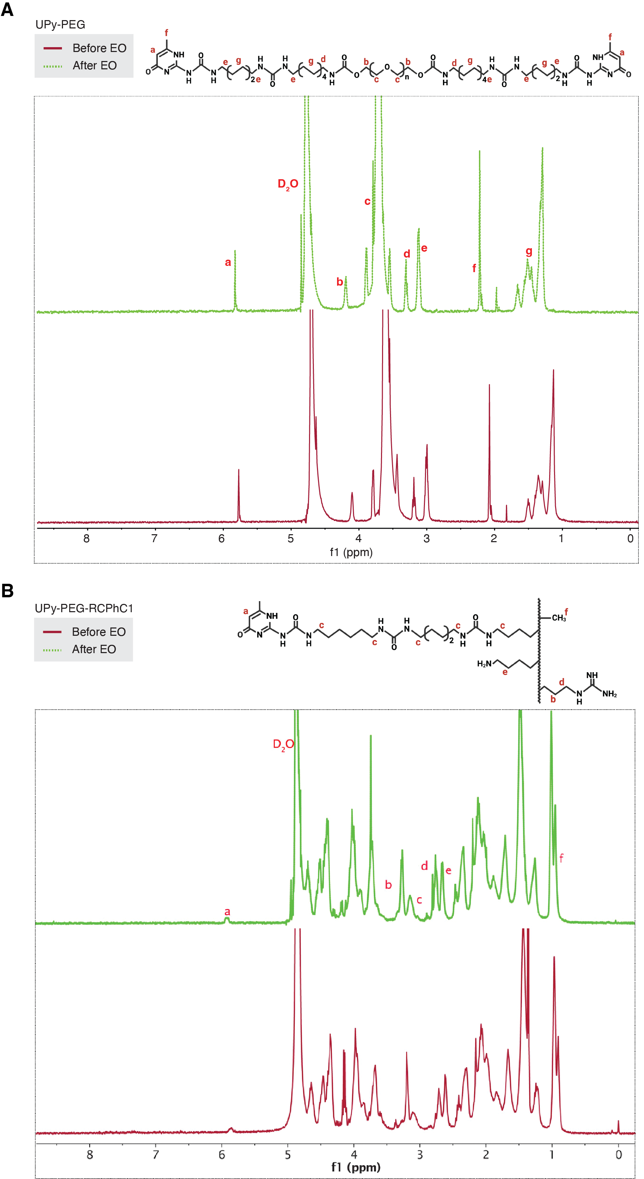
Fig. S1. Characterization of hydrogel precursors’ intactness prior (red) and after (green) sterilization with EO. (A) Overlay of chromatograms to assess possible degradation and (B) overlay of their viscosities at pH ~ 8.7 before (red) and after (green) EO sterilization to assess intactness of UPy-PEG-RCPhC1. Data are represented as ± SD (n = 2). EO, ethylene oxide.
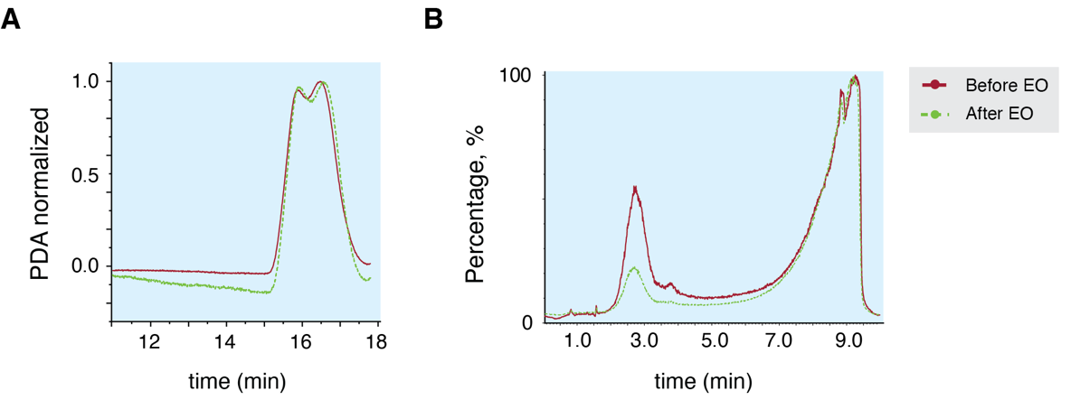
Fig. S2. Characterization of possible degradation upon sterilization with EO. ¹H-NMR spectroscopy profiles of (A) UPy-PEG and (B) UPy-PEG-RCPhC1 hydrogels before (red) and after (green) sterilization. Plots show representative ¹H-NMR spectra pre- and post-sterilization (n = 1). EO, ethylene oxide; ¹H-NMR, proton nuclear magnetic resonance.
Table S2. Blood chemistry parameters prior MI, during (occlusion), five minutes (reperfusion), seven days and 28 days post-MI
 | UPy-PEG-RCPhC1  (n = 3) | antimiR-195  (n = 3) | UPy-PEG-RCPhC1 + antimiR-195  (n = 3)
cTnI, ng/L
Baseline | 52.667 ± 33.471 | 52.333 ± 32.47 | 46.333 ± 37.072
Occlusion | 317.667 ± 163.36 | 424.667 ± 248.148 | 400.333 ± 207.597
Reperfusion | 1541 ± 986.236 | 1756 ± 1561.143 | 1 758.333 ± 1 287.531
Day 7 | 1524 ± 1438.808 | 504.333 ± 193.252 | 671 ± 823.062
Day 28 | 39 ± 3.606 | 73.333 ± 28.676 | 60 ± 9.644
AST, U/L
Baseline | 44.667 ± 10.599 | 47 ± 13.077 | 45 ± 11.358
Occlusion | 61.667 ± 9.866 | 58.333 ± 13.577* | 65.333 ± 15.177
Reperfusion | 68.333 ± 17.616 | 65 ± 22.539 | 74 ± 10.583*
Day 7 | 60 ± 17.776 | 54.333 ± 11.676 | 75 ± 20.809
Day 28 | 54 ± 23.643 | 58 ± 9 | 53.667 ± 11.719‡‡
Creatinine, µmol/L
Baseline | 119.667 ± 4.726 | 115.667 ± 19.502 | 122.667 ± 9.866
Occlusion | 119.333 ± 4.509 | 113.667 ± 16.01 | 122 ± 12.288
Reperfusion | 120.333 ± 4.933 | 116.667 ± 20.404 | 122 ± 16.462
Day 7 | 107.667 ± 7.572 | 104.667 ± 2.887 | 107 ± 14
Day 28 | 140.333 ± 13.317 | 134.333 ± 15.567*,# | 145.667 ± 13.317*,##,‡
*P < 0.05 versus baseline from group; #P < 0.05 versus occlusion from group; ##P < 0.01 versus occlusion from group; ‡P < 0.05 versus reperfusion from group; ‡‡P < 0.01 versus reperfusion from group
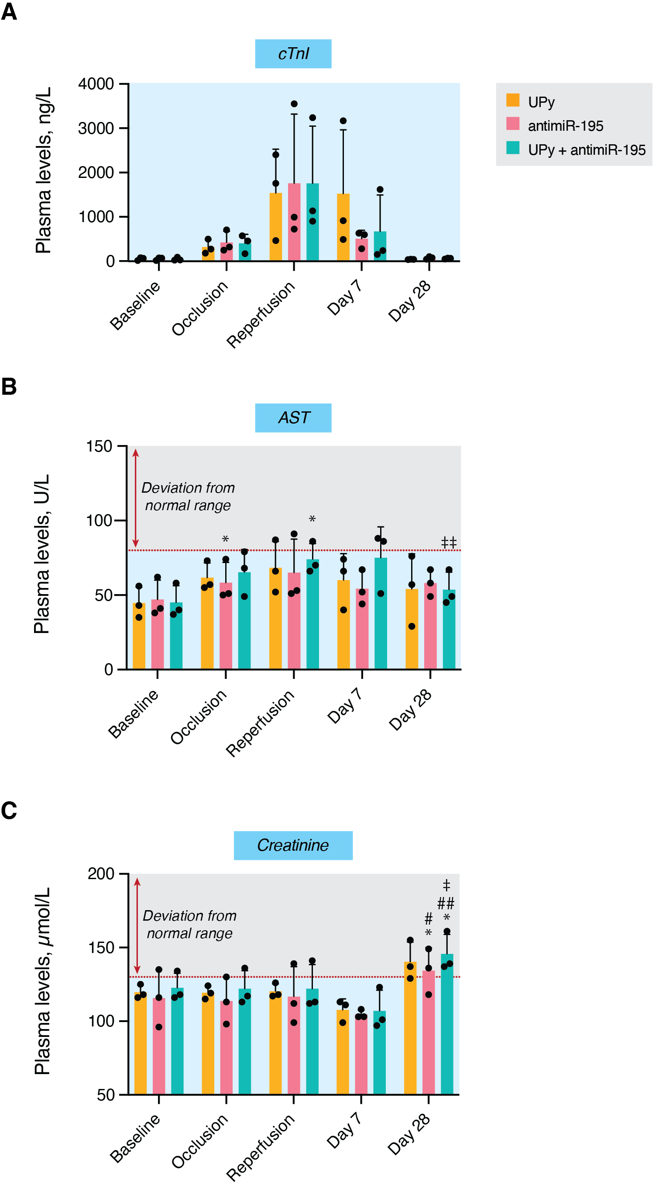
Fig. S3. Blood chemistry parameters prior, during (occlusion), five minutes (reperfusion), seven days and 28 days post-MI. (A) Myocardial, (B) liver and (C) renal biomarkers were used to monitor the health status of post-MI pigs after hydrogel and/or antimiR-195 treatment. Data are mean and individual values ± SD (n = 3 animals per group); *P < 0.05 versus baseline from group; #P < 0.05 versus occlusion from group; ##P < 0.01 versus occlusion from group; ‡P < 0.05 versus reperfusion from group; ‡‡P < 0.01 versus reperfusion from group; two-way ANOVA with Tukey’s post hoc test. AST, aspartate aminotransferase; cTnI, cardiac troponin I.
Table S3. CMR-based analysis of cardiac volumes and heart function 28 days post-MI
 | EDV  (mL) | ESV  (mL) | EF  (%) | SV  (mL) | CO  (L/min)
UPy-PEG-RCPhC1  Day 28 (n = 3) | 142.173 ± 13.547 | 72.977 ±  2.534 | 48.463 ± 3.323 | 69.193 ± 11.421 | 4.780 ±  1.081
antimiR-195  Day 28 (n = 3) | 136.807 ± 17.426 | 70.407 ± 13.327 | 48.560 ± 7.157 | 66.400 ± 13.369 | 4.707 ±  0.422
UPy-PEG-RCPhC1 + antimiR-195  Day 28 (n = 3) | 129.857 ± 5.645 | 66.017 ± 11.401 | 49.340 ± 6.644 | 63.843 ± 6.318 | 4.563 ±  0.271
CO, cardiac output; EDV, end-diastolic volume; EF, ejection fraction; ESV, end-systolic volume; SV, stroke volume. Data are mean values ± SD.
Table S4. CMR-based linear internal measurements of the heart 28 days post-MI
 | Diastole |  |  | Systole |  |  | FS  (%)
 | LVIDd  (mm) | ASd  (mm) | PWd  (mm) | LVIDs  (mm) | ASs  (mm) | PWs  (mm) | FS  (%)
UPy-PEG-RCPhC1  Day 28 (n = 3) | 59.590 ±  1300 | 13.200 ±  1.784 | 18.470 ±  4.695 | 37.217 ±  5.829 | 20.957 ±  5.556 | 22.603 ±  7.644 | 37.617 ±  8.876
antimiR-195  Day 28 (n = 3) | 57.543 ±  5.231 | 17.297 ±  2.987 | 17.483 ±  0.581 | 34.630 ±  4.573 | 23.783 ±  0.918 | 23.890 ±  1.319 | 39.963 ±  3.092
UPy-PEG-RCPhC1 + antimiR-195  Day 28 (n = 3) | 57.810 ±  3.002 | 17.830 ±  2.576 | 17.187 ± 1.494 | 33.013 ±  1.927 | 25.987 ±  0.297 | 26.547 ±  3.458 | 42.907 ±  0.626
ASd, anterior septum thickness in diastole; ASs, anterior septum thickness in systole; FS, fractional shortening; LVIDd, left ventricular internal dimensions in diastole; LVIDs, left ventricular internal dimensions in systole; PWd, posterior wall thickness in diastole; PWs, posterior wall thickness in systole. Data are mean values ± SD.
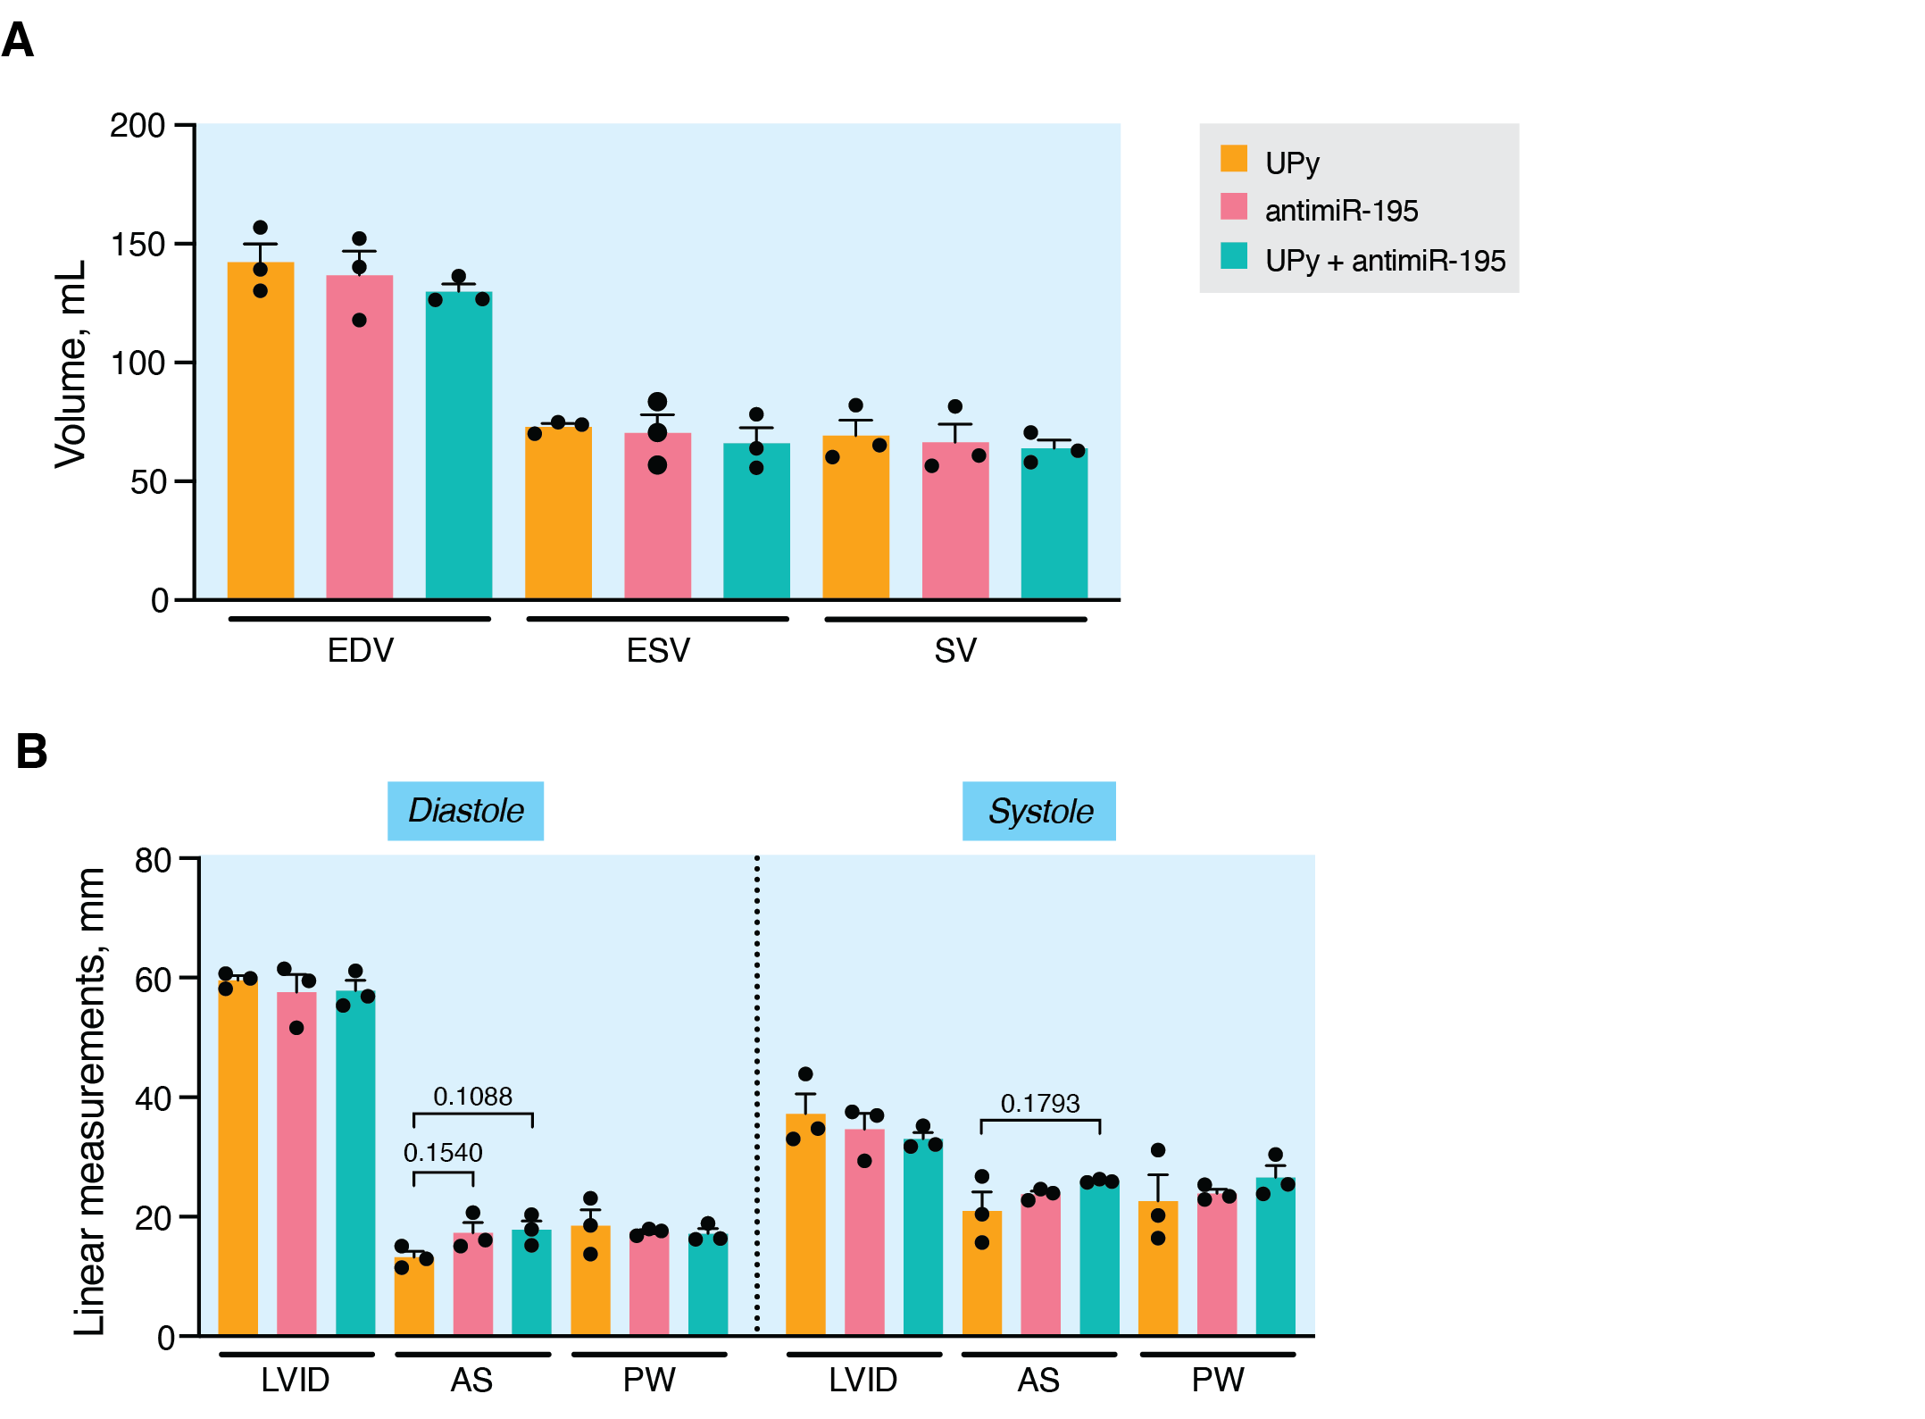
Fig. S4. CMR-based cardiac volumes and geometry evaluation 28 days post-MI. Assessment of (A) LV volumes and (B) ventricular dimensions from infarcted pigs 28 days post-MI obtained from multi-slice short axis cine images acquired using cardiac magnetic resonance imaging (cMRI). Data are mean and individual values ± SD (n = 3 animals per group); one-way ANOVA with Dunnett’s post hoc test. AS, anterior septum; EDV, end-diastolic volume; ESV, end-systolic volume; LVID, left ventricular internal dimensions; PW, posterior wall; SV, stroke volume.
Table S5. CMR-based scar mass and size analyses 28 days post-MI
 | Infarct mass, g |  |  |  | Infarct size, %
 | Myocardium (LV) | Infarct | Hyper-enhancement | Hypo-enhancement | Infarct | Hyper-enhancement | Hypo-enhancement
UPy-PEG-RCPhC1  Day 28  ( n= 3) | 111.480 ±  16.816 | 22.517 ±  6.401 | 10.967 ±  1.881 | 11.547 ±  6016 | 19.967 ±  2.83 | 9.967 ±  2.289 | 10 ±  3.599
antimiR-195  Day 28  (n = 3) | 117.693 ±  15.746 | 17.090 ±  5.429 | 9.350 ±  3.815 | 7.740 ±  2.282 | 15.060 ±  6.122 | 8.250 ±  3.901 | 6.810 ±  2.740
UPy-PEG-RCPhC1 + antimiR-195  Day 28  (n = 3) | 120.607 ±  26.998 | 19.113 ±  3.944 | 10.483 ±  1.908 | 8.630 ±  3.272 | 16.380 ±  4.792 | 9.167 ±  3.226 | 7.213 ±  2.785
LV, left ventricle. Data are average mean values ± SD.
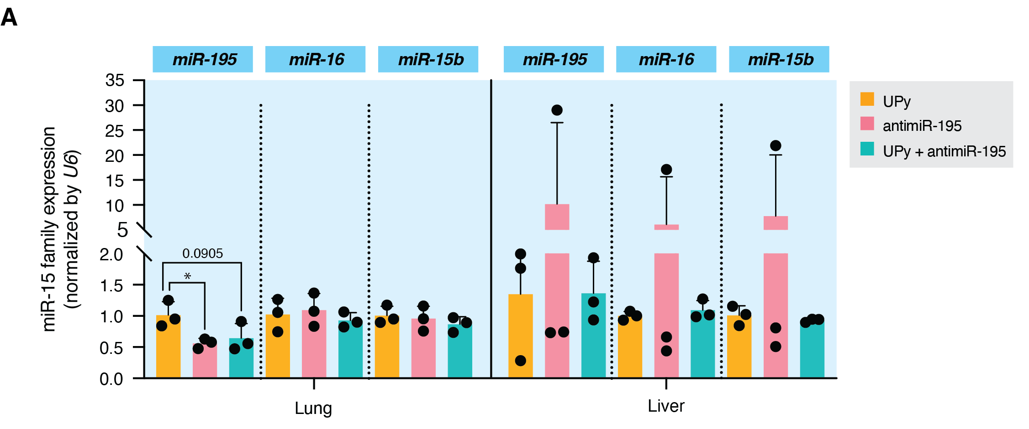Fig. S5. Expression profile of miR-15 family in lung and liver. (A) Expression levels of miR-15 family in lungs and liver to assess off-target repression 28 days post-MI. Data are mean and individual values ± SD (n = 3 biological samples); *P < 0.05 versus UPy group; one-way ANOVA with Dunnett’s post hoc test.
Table S6. Arrhythmia burden quantification over the course of 28 days post-MI
 | UPy-PEG-RCPhC1  (n = 3) | antimiR-195  (n = 3) | UPy-PEG-RCPhC1 + antimiR-195  (n = 3)
Week 1, min | 51.206 ± 29.147 | 235.394 ± 397.695 | 47.806 ± 51.442
Week 2, min | 23.561 ± 6.908 | 12.783 ± 11.834 | 5.461 ± 5.909
Week 3, min | 10.917 ± 8.444 | 12.244 ± 14.458 | 5.467 ± 6.198
Week 3, min | 20.878 ± 18.557 | 7.089 ± 0.828 | 6.394 ± 5.053
Data are mean values ± SD.
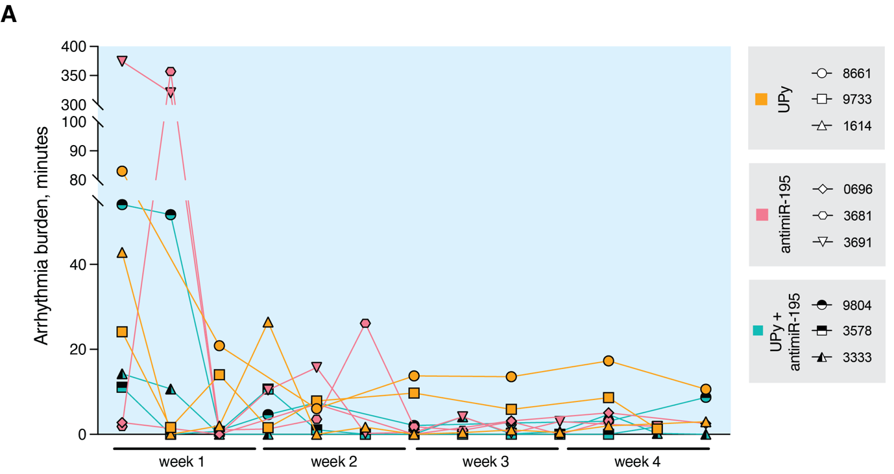
Figure S6. Electrical outcomes 28 days post-MI in pigs. (A) Individual traces on arrhythmia burden throughout the monitoring period of four weeks. Data are individual values (n = 3 animals per group).
Table S7. Intravascular interrogation of LAD at baseline and 28 days post-MI
 | UPy-PEG-RCPhC1  (n = 2) | antimiR-195  (n = 2) | UPy-PEG-RCPhC1 + antimiR-195  (n = 3)
Coronary Flow Reserve
Day 0 | 3.496 ± 0.933 | 1.539 ± 1.191 | 2.26 ± 0.349
Day 28 | 1.862 ± 0.787 | 1.724 ± 0.355 | 1.656 ± 1.043
Fractional Flow Reserve
Day 0 | 0.969 ± 0.061 | 0.903 ± 0.066 | 0.941 ± 0.033
Day 28 | 0.834 ± 0.008 | 0.879 ± 0.005 | 0.949 ± 0.094
Index of Microvascular Resistance, U
Day 0 | 10.03 ± 3.021 | 18.814 ± 0.558 | 16.898 ± 6.231
Day 28 | 26.338 ± 0.476 | 19.295 ± 14.655 | 34.957 ± 11.956
Data are mean values ± SD.
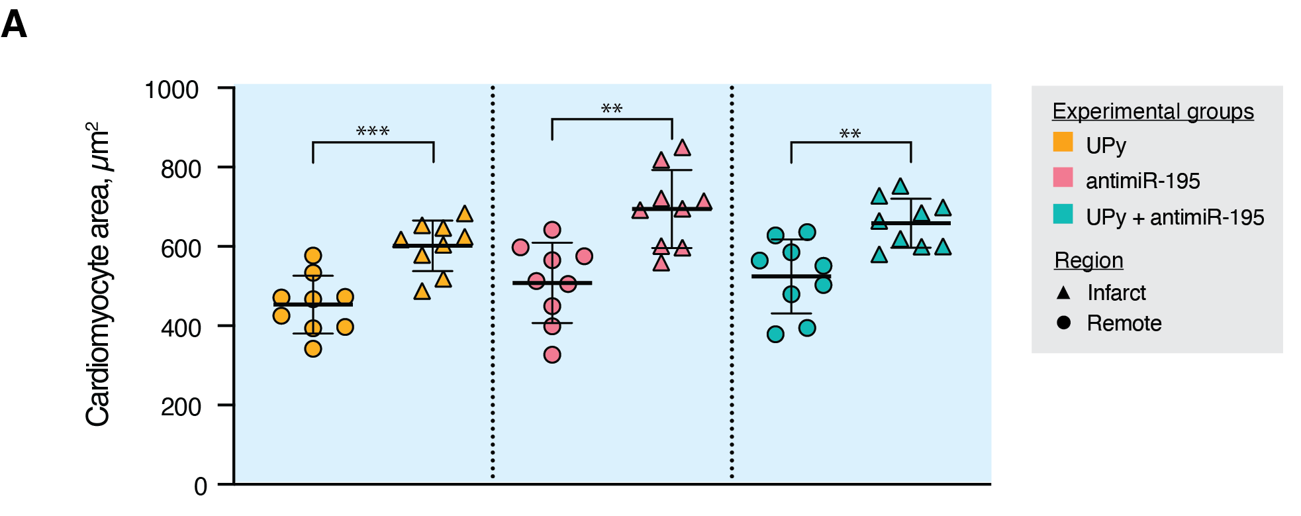
Fig. S7. Differential cross-sectional area from I/BZ and remote cardiomyocytes. (A) Quantification and comparison of cardiomyocyte size between infarcted and remote regions from a WGA staining. I/BZ, infarct/ border zone. Data are mean and individual values ± SD (n = 3 technical replicates per biological sample; 3 biological samples per region); **P < 0.01 versus remote; ***P < 0.001 versus remote; unpaired t-test.

