Scheme 1. Synthesis of functionalized N-phenyl pyrazoles 3a-f

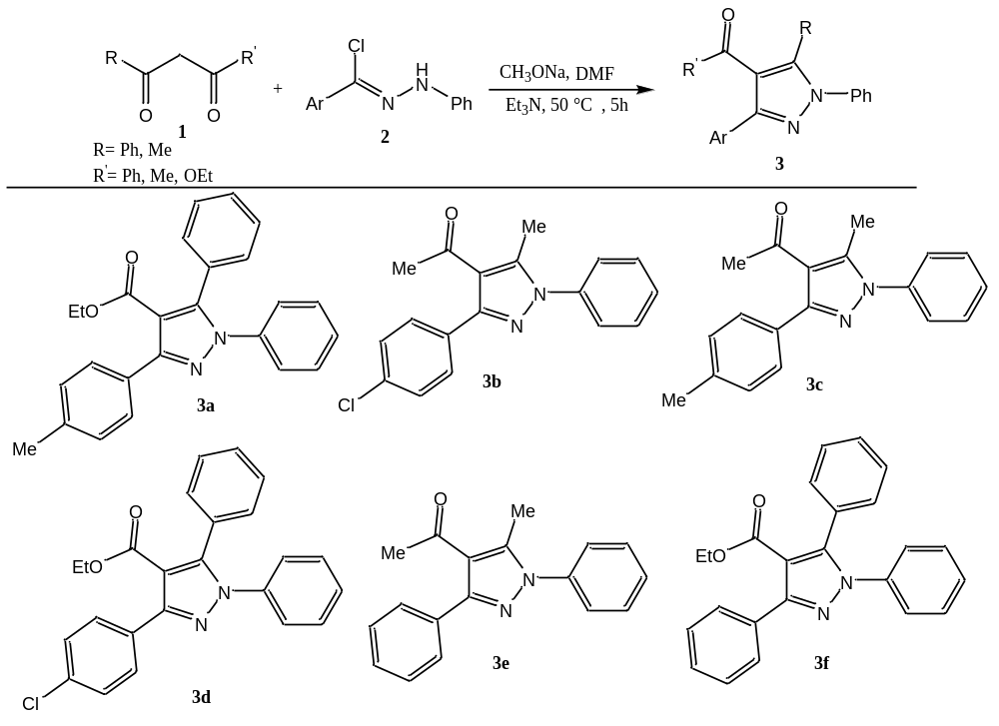

Scheme 2. Synthesis of functionalized amino pyrazoles 5

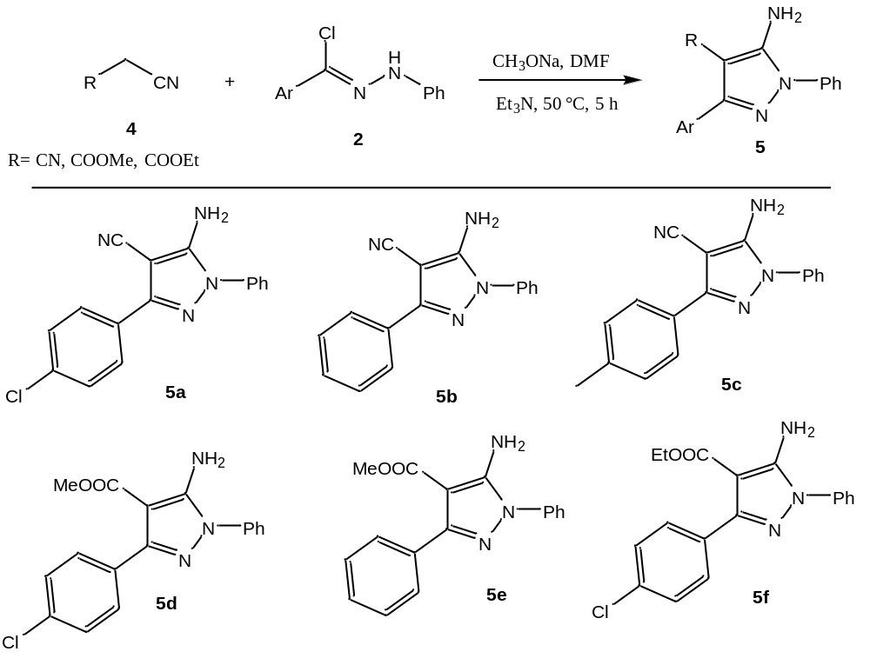

Scheme 3. Synthesis of 1-((4-chlorophenyl)(tosyl)methylene)-2-phenylhydrazine 7
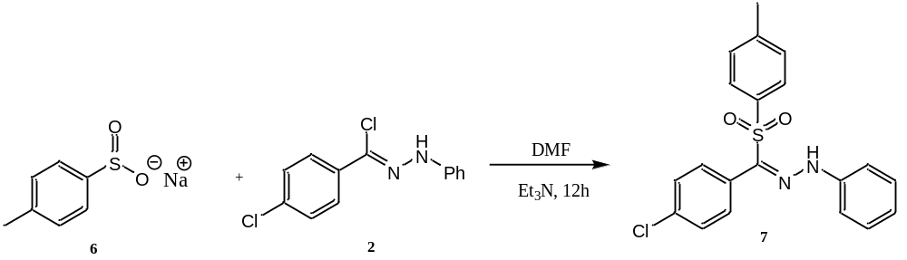
Scheme 4. Synthesis of functionalized amino pyrazoles 9
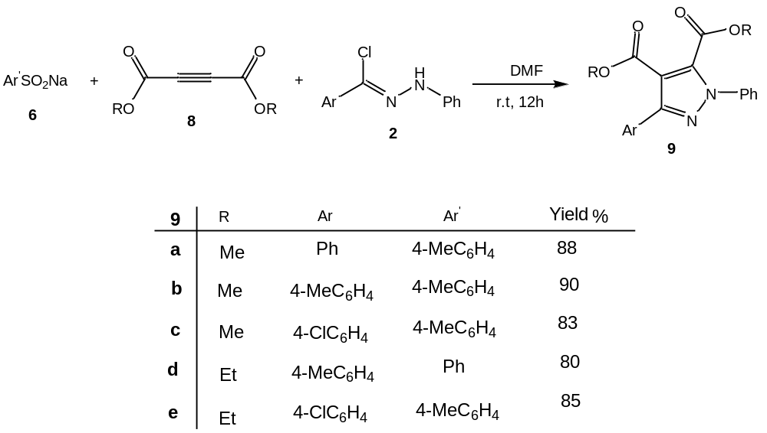
Scheme 5. Proposed Mechanism Pathway of 3
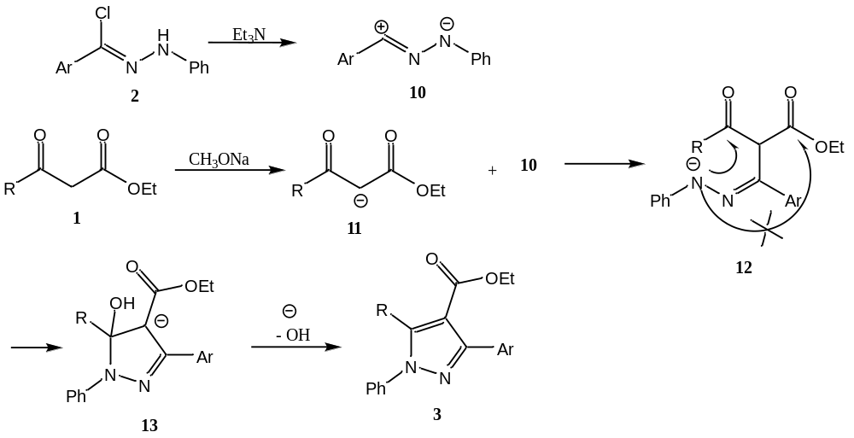

Scheme 6. Proposed Mechanism Pathway of 9
