Direct Dual-Functionalisation of Amine-Oligonucleotides for Conjugation Purposes
Jan H. Meffert ¹, Mónica Lopes ^{2,3}, Enrico Cadoni¹, Martin Bollmark ³, Ulf Tedebark ⁴, Annemieke Madder ^{1,*}

¹Organic and Biomimetic Chemistry Research Group, Department of Organic and Macromolecular Chemistry, Ghent University, Krijgslaan 281, 9000 Ghent, Belgium.
²School of Chemistry & Chemical Engineering and Institute for Life Sciences, University of Southampton, Highfield, Southampton SO17 1BJ, United Kingdom.
³RISE, Department Chemical Process and Pharmaceutical Development, Forskargatan 18, SE-15136 Södertälje, Sweden.
⁴SynMer AB, S17568 Järfälla, Sweden.
Supporting Information

1.0 General Information 4
1.1 Instrumentation 4
1.2 PNA Model Constructs 5
1.3 DNA Model Constructs 6
2.0 Mechanistic Background 8
3.0 Direct functionalisation of AONs via activated 2-methylfuran 10
3.1 Initial Condition Screening 10
3.2 Stability of keto-enal stock solution 13
3.3 Side Product Elucidation 14
3.4 Kinetic Measurements 16
3.5 NHS-mediated 5HP2O/Maleimide Functionalisation 18
4.0 Direct functionalisation of AON via activated 2-methylfuran 20
4.1 D1-ON 20
4.2 D2-ON 22
4.3 D3-ON 24
4.4 D4-ON 26
4.5 Int1-ON 28
4.6 Int2-ON 30
5.0 Direct functionalisation of amine-PNA via activated 2-methylfuran 32
5.1 Characterisation of amine-PNA 32
5.2 Functionalisation of amine-PNA using activated 2-methylfuran 36
6.0 Negative Control 38
6.1 NC1-ON 38
6.2 Melting Curves 40
7.0 Synthesis of small molecule building blocks 41
7.1 Synthesis of 2-(3-Azidopropyl)furan (MF4) 41
7.2 Synthesis of N-2-Propyn-1-yl-2-furanpropanamide (MF2) 42
7.3 Synthesis of N-Propyl-2-furanpropanamide (MF3) 42
7.4 Synthesis of 4-(2-Furyl)-2-butanone (MF5) 43
7.5 Synthesis of 2-(2-(furan-2-yl)ethyl)-2-methyl-1,3-dioxolane (MF6) 43
7.6 Synthesis of N-[2-(2-{2-(2-Azidoethoxy)ethoxy}ethoxy)ethyl]-7-nitro-2,1,3-benzoxadiazol-4-amine (NBD-Azide) 44
7.7 Synthesis of N-(6-Maleimidocaproyloxy)succinimide (Mal-C5-NHS) 44
7.8 Synthesis of 2,5-dioxopyrrolidin-1-yl 6-(2-hydroxy-2-methyl-5-oxo-2,5-dihydro-1Hpyrrol-1-yl)hexanoate (5HP2O-C5-NHS) 45
8.0 Direct Dual Functionalisation of AON 46
8.1 5HP2O(Azide)-D1-ON 46
8.2 5HP2O(Acetal)-D1-ON 48
8.3 5HP2O(COOH)-D1-ON 49
8.4 5HP2O(Alkane)-D1-ON 50
8.5 5HP2O(Alkyne)-D1-ON 51
9.0 Conjugation of 5HP2O-functionalised oligonucleotides 52
9.1 Glutathione and Alphabody Conjugation to 5HP2O(Me)-ON 52
9.2 Glutathione and CUAAC labelling of 5HP2O(Alkyne)-ON 54
10.0 NMR Spectra 56
10.1 SI1 56
10.2 SI2 56
10.3 MF4 57
10.4 MF2 57
10.5 MF3 58
10.6 MF5 59
10.7 MF6 60
10.8 NBD-azide 61
10.9 Mal-C5-NHS 62
10.10 5HP2O-C5-NHS 62
11.0 HRMS / LCMS Data 63
11.1 MF2 63
11.2 MF3 63
11.3 SI2 64
11.4 MF4 64
11.5 MF5 65
11.6 NBD-azide 65
11.7 Mal-C5-NHS 66
12.0 References 66

General Information
All the reagents and solvents (HPLC grade) were used as received from chemical vendors without any further purification. Commercial chemicals were ordered from BLD-Pharma, Merck, TCI Europe, ABCR while the solvents were ordered from Chemlab. Synthesized products were stored under argon atmosphere at −20 ◦C. All reactions involving buffered aqueous solutions are using Carmody buffers of a specific pH, which was prepared according to the literature¹.

Instrumentation
HPLC-MS of small molecules was performed on an Agilent 1100 series HPLC, equipped with quaternary pump and DAD detector, coupled to an Agilent G1946C single quadrupole MS, equipped with an ESI-ionisation source. A Phenomenex Kinetex C18 column (150 x 4.6 mm, 5 μm at 35 °C) was used with the following solvent system (A) 5 mM NH₄OAc in H₂O and (B) MeCN and the following gradient (flow rate of 1.5 mL/min): 0.5 min 100%A, then a linear gradient from 100% A to 100% B in 6 min, then flushing with 100%B for 2 min.
HPLC-MS of PNA oligomers was performed on an Agilent 1100 series HPLC, equipped with quaternary pump and DAD detector, coupled to an Agilent G1956B single quadrupole MS, equipped with an ESI-ionisation source. A Phenomenex Kinetex C18 column (150 x 4.6 mm, 5 μm at 35 °C) was used with the following solvent system (A) 0.1% HCOOH in H₂O and (B) MeCN and the following gradient (flow rate of 1.5 mL/min): 0.5 min 100%A, then a linear gradient from 100% A to 100% B in 6 min, then flushing with 100%B for 2 min.
HPLC-MS of DNA oligonucleotides (DNA Functionalisation) was performed using a Waters (Manchester, UK) Acquity TQD mass tandem quadrupole mass spectrometer. Samples were introduced to the mass spectrometer via an Acquity H-Class quaternary solvent manager (with UV detector at 260 nm, sample and column manager). Ultrahigh performance liquid chromatography was performed using Acquity UPLC BEH C18 column (50 mm x 2.1 mm 1.7 μm). Gradient elution from 5% acetonitrile in 20 mM Triethylammonium acetate (TEAA) to 100% acetonitrile was performed over fourteen minutes at a flow rate of 0.250 mL/min.
HPLC-UV (PNA) was performed on an Agilent 1100 or 1200 series instrument connected to a DAD using the following solvent system: (A): 0.1% TFA in H2O and (B) 0.1% TFA in MeCN. PNA was purified using a Phenomenex Luna C18(2) (5 μm, 100 Å, 250x4.6 mm) column. Gradient: 100% A for 5 min, then a gradient from 0 to 30% B over 18 min at a flow rate of 4.0 ml/min (HPLC 2). PNA direct functionalisation was analysed on a Waters XTERRA RP18 5μm column (250 x 2.1 mm at 40°C) connected to a DAD using a flow rate of 0.35 ml/min with the following solvent systems: (A): H2O and (B MeCN. Gradient: 100% A for 4 min, then a gradient from 0 to 75% B in 27 min, and then to 100% B in 1 min, followed by 3.5 min of flushing with 100% B.

HPLC-UV (DNA Functionalisation) analyses and purifications were performed on either an Agilent 1100 or 1200 series instrument, connected to a DAD on a Waters X-Bridge BEH C18 XP Column (130 Å, 2.5 μm, 4.6 mm X 50 mm) with a flow rate of 0.8 mL/min from 100 % A and 0 % B to 70 % A and 30 % B over 13 min respectively to 70% B over 13 min. Solvent A: 5 % acetonitrile, 95% Triethylammonium acetate buffer 0.1M. Solvent B: Acetonitrile.

NMR spectra were recorded with a resolution of 300 or 400 MHz. The 300 MHz measurements were performed on a 300 MHz Avance I (Bruker) with a 5 mm dual channel probe head, ¹H and Broadband (BBO-type), equiped with an ultrashield type magnet. Measurements with 400 MHz resolution was carried out on a 400 MHz Avance II (Bruker) with a 5 mm dual channel probe head, 1H and Broadband (BBO-type), and an ultrashield type magnet. The chemical shifts are expressed in ppm and the residual solvent peak was used as internal reference. Scalar couplings (J) are reported in Hertz (Hz). The multiplicity of the signals were indicated by the following abbreviations: s, singlet; d, doublet; t, triplet; q, quadruplet; p, quintuplet; sx, sextet; sept, septuplet; m, multiplet; br, broadened; band, several overlapping signals).
HRMS were recorded on an Agilent Accurate Mass Quadrupole Time-of-Flight mass spectrometer (small molecules) or an Orbitrap mass spectrometer (DNA oligomers).
Light Irradiation for 2-substituted furan activation was performed using Euromex Illuminator EK-1 Lamps, equipped with a 100 W halogen lamp LE.5210 and connected to a Euromex LE.5214 dual arm light conductor. Lamp was used at maximum brightness.
Freeze-drying of DNA samples was achieved via a Heto Drywinner freeze dryer in combination with a Thermoelectron corporation Savat SPD111V Speedvac concentrator. PNA\Peptide samples were freeze-dried in a RVC 2-18 Cdplus (Christ) in combination with an Alpha 2-4 Ldplus (Christ).
MALDI-TOF mass spectrometry data of PNA were collected on a Sciex/Applied Biosystems 4800plus MALDI-TOF/TOF analyser equipped with a Nd-YAG solid-state laser (355 nm) and a pulse frequency of 200 Hz using 2,5-Dihydroxybenzoic acid matrix (10 g/L in ACN : 0.1 % TFA in mQ, 1:2 v/v). Samples were analysed in positive mode linear and spotted by allowing 0.7 µL matrix to dry and subsequent addition of 0.7 µL of PNA sample on the dried matrix spot.
UV-vis measurements for oligomer quantification was performed on a Thermo Scientific Nanodrop instrument measuring the absorption at 260nm

PNA Model Constructs
Table S 1: PNA constructs employed in this work. Lowercase letters indicate PNA monomers whereas capital letters indicate L-amino acids. O: 2-(2-aminoethoxy)ethoxyacetyl (AEEA spacer).
PNA | Sequence (N to C term.) | MW _{calc.} / Da | M_{obs.} / Da
P1 | H-EE-aaacccagcagacaatgt-G-NH2 | 5197.04 | 5195.30
P2 | H-OEE- aaacccagcagacaatgt-G-NH2 | 5342.20 | 5340.38
P3 | H-RR- aaacccagcagacaatgt-G-NH2 | 5251.20 | 5248.97
P4 | H-ORR- aaacccagcagacaatgt-G-NH2 | 5396.36 | 5395

The synthesis of the soluble PNA constructs was performed under standard automated Fmoc-based solid-phase synthesis conditions on an Intavis automatic peptide synthesizer. HBTU\DIPEA was used as coupling mixture with commercially available Fmoc-PNA-OH monomers (PolyOrg Inc., Massachusets, USA) as well as standard Fmoc-protected amino acids. Rinkamide tentagel resin was first loaded with Fmoc-Gly-OH (0.23 mmol/g). Final Fmoc deprotection was performed prior to probe cleavage from the solid support using a TFA/m-cresol (9:1 v/v) cleavage cocktail. After RP-HPLC purification (HPLC 2), the purity and identity of PNA-peptides were evaluated by HPLC-MS (HPLC 1).

DNA Model Constructs
Table S 2: DNA constructs employed in this work. * = Phosphorothioate, ^{m}C = methylCytosine, LNA, PAMBA = para-aminomethylbenzoic acid, intNH2-C6H12 = commercial iUniAmM IDT Amino Modifier, NH2-C6H12 = commercial 5AmMC6 IDT Amino Modifier
DNA | Source | Type of AON | Sequence (5’ to 3’) | MW_{calc} / Da | M_{obs.}/ Da
D1 | IDT | PO | NH₂-C₆H₁₂-(CGA)₇ | 6638.41 | 6638.19
D2 | RISE | PS, LNA | PAMBA-Ribose- G*^{m}C*A*T*T*C*T*A*A*T*A*G*C*A*G*^{m}CTCATCAG*C*G*T*A*G*A*C | 10180.87 | 10080.60
D3 | RISE | PS, LNA | PAMPA-Ribose-A*C*G* T*T*G*G*G*T*C*T*A*C*G*C | 5251.25 | 5250.43
D4 | RISE | PS, LNA | NH₂-Ribose-G*^{m}C*A*T*T*C*T*A*A*T*A*G*C*A*G*^{m}CTCATCAG*C*G*T*A*G*A*C | 10047.72 | 10048.25
Int1 | IDT | PO | CGACGACGAC/intNH₂-C₆H₁₂/ACGACGACGA | 6339.23 | 6338.79
Int2 | IDT | PO | CGACGAC/intNH₂-C₆H₁₂/ACGAC / intNH₂-C₆H₁₂/ACGACGA | 6219.20 | 6219.16
NC1 | IDT | PO | (GCT)₇ | 6396.15 | 6395.67

IDT Oligonucleotides were ordered and used as received.
RISE Oligonucleotides were synthesized on ÄKTA oligopilot 10 DNA/RNA synthesizer, through standard solid-phase phosphoramidite chemistry. All syntheses were carried out at 50 μmol scale. NittoPhase®HL UnyLinkerTM 400 were purchase from Kinovate Life Sciences, Inc.; T, Ac-protected dC, iBu protected dG and Bz-protected dA DMTr 5ʹ hydroxyl protected phosphoramidites were purchased from Thermo Fisher Scientific Inc. and LNA T, LNA Bz-protected me-C, LNA Bz-protected A and LNA dmf-protected G DMTr 5ʹ hydroxyl protected phosphoramidites were purchased from Hongene Biotech Corporation. All solvents and reagents were used without further purification. Anhydrous acetonitrile (< 10ppm H₂O), Deblocking (3% DCA in toluene) reagent, Capping A and B and Oxidizer Reagent were obtained from emp BIOTECH GmbH, BTT Activator and 20% DEA in ACN were obtained from Sigma-Aldrich, sulfurisation solution was prepared in house (0.2 M Xanthane Hydride in Pyridine). Stepwise coupling efficiencies were determined by the automated trityl cation UV monitoring of the DNA/RNA synthesizer. All phosphoramidite monomers were dissolved in anhydrous acetonitrile to a concentration of 0.1 M, with exception of LNA Bz-protected me-C phosphoramidite which was dissolved in 3:1 solution of anhydrous acetonitrile and anhydrous THF, to a concentration of 0.1 M; for all phosphoramidite solutions, the head space was purged and left under nitrogen atmosphere with 3Å molecular sieves for 30 minutes to 18h prior to use. Deprotection and cleavage from the solid support was achieved through suspension of the resin in 8 mL of concentrated aqueous ammonia solution, over 30 minutes at room temperature with shaking, followed by overnight heating at 55 °C. The resin was then filtered through ISOLUTE® Single fritted reservoir (AG), 25 mL 10 μm PE with a nitrogen flow, and washed with water, to a known volume. The purity of oligonucleotides (crude and isolated product) were confirmed by Reverse-Phase Liquid Chromatography-Mass Spectrometry (RP-LC-MS) using electrospray ionization (ESI) in negative ion mode, carried out on a RP-LC-MS system equipped with UV detection at 254 nm using an ACQUITYTM PREMIER oligonucleotide BEH C18, 130 Å (1.7 μm, 2.1 × 50 mm) column with 0.2 mL flow rate and a linear gradient from 0-95% of buffer B in buffer A over 15 min at 40 °C. Buffers for RP-HPLC were as follows: (A) 8.6 mM TEA, 100 mM HFIP in H₂O, (B) 8.6 mM TEA, 100 mM HFIP in MeOH.
Purification: Oligonucleotides were purified through reverse phase chromatography, carried out on Biotage Selekt using Biotage Sfär C18 D - duo 100 Å 30 μm or Biotage Sfär C18 D - duo 300 Å 20 μm prepacked columns (acquired from Biotage), with 25 mL/min and 40 mL/min flow rates, respectively, and a linear gradient from 0-30% MeCN (with 1-5% of TEEA) in 0.1 mM of TEEA (both were degassed prior to purifications).

Mechanistic Background
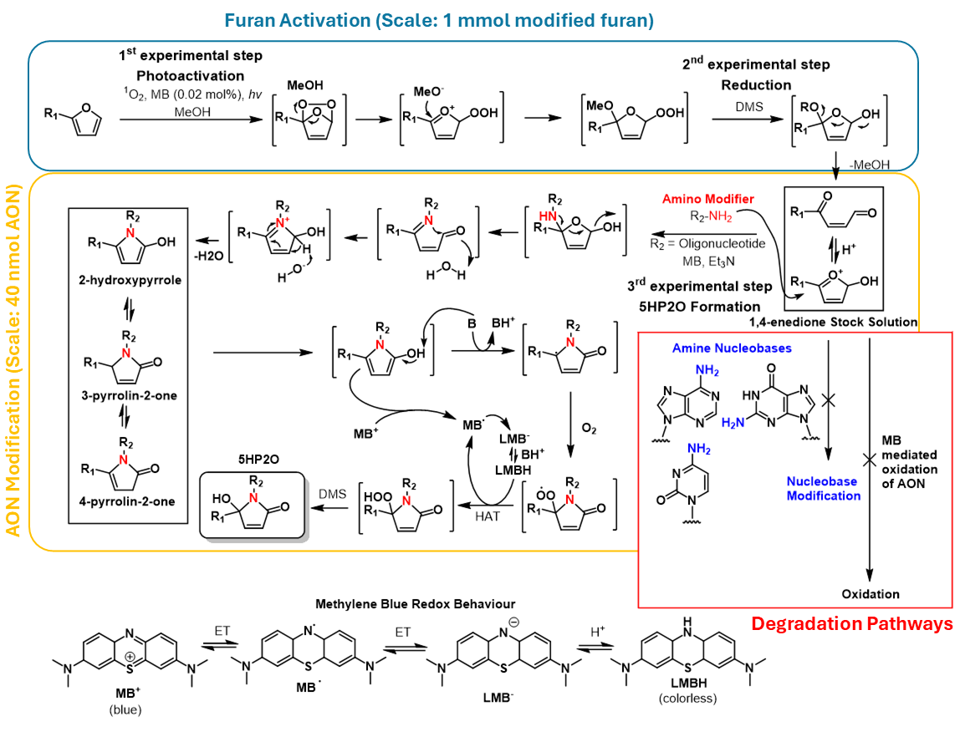
Scheme 1: Proposed mechanism of 5HP2O formation on Oligonucleotides (adapted from Vassilikogianakis and coworkers²). Furan activation (top, blue) is performed on 1 mmol scale as previously described. AON Functionalisation (yellow, middle) is performed in diluted conditions. Possible degrading pathways are highlighted in red and in Scheme 2. Observed side products were analysed in Supporting Figure 6. Possible methylene blue redox and charge states are listed below.
Scheme 2: Proposed side product formations of methyl-keto-enal on nucleobases according to the groups previous research³.

Direct functionalisation of AONs via activated 2-methylfuran

Initial Condition Screening
The general procedure as described in section 2.4 was adapted to the different conditions. Methanol was not evaporated but the crude reaction was directly analysed by injection in HPLC and analysed with a gradient to 30% MeCN.

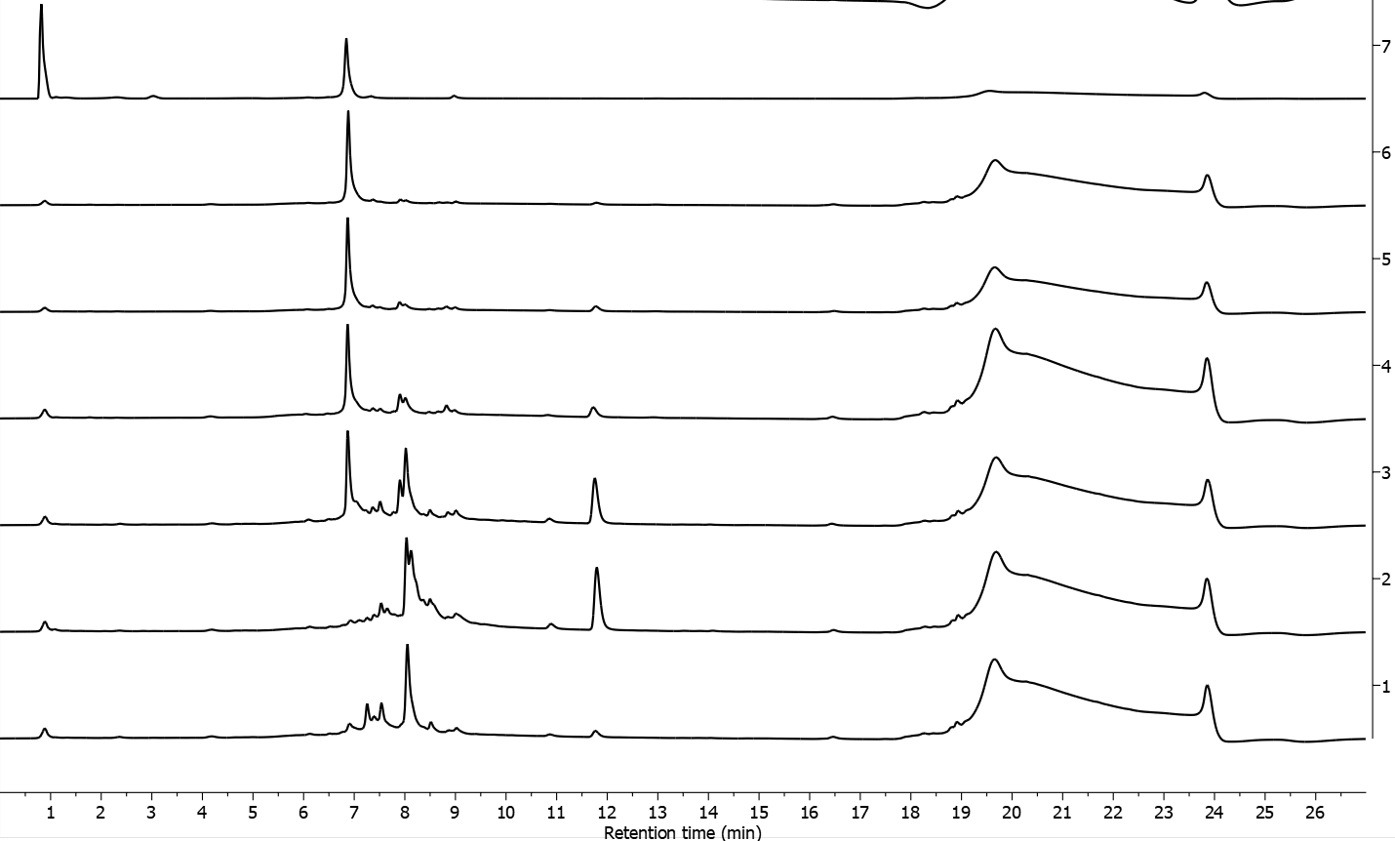
Supplementary Figure 1: Full HPLC chromatograms (260 nm) of condition screening as shown zoomed in in Figure 2B. Additional signal at 12 min (not discussed in main manuscript) is Methylene Blue.

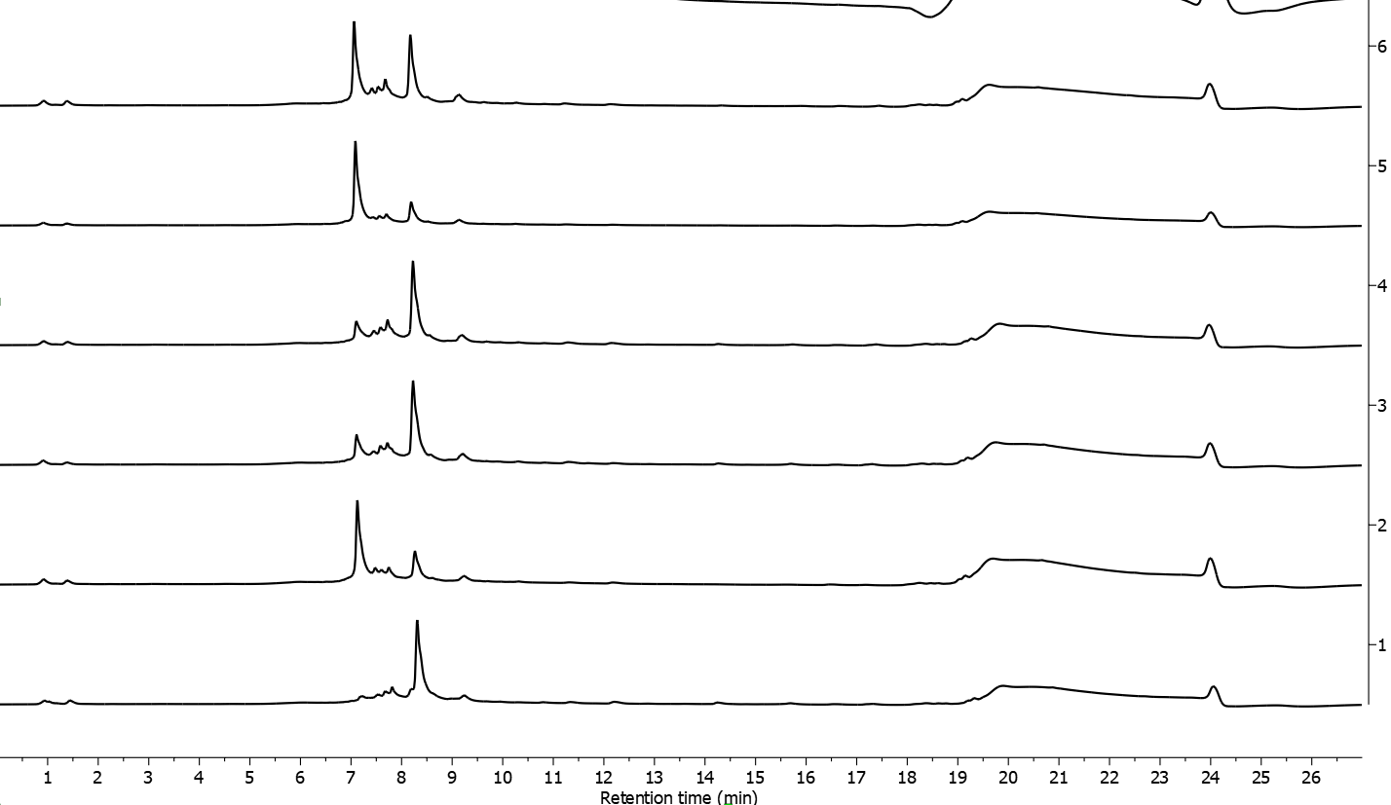
Supplementary Figure 2: Full HPLC chromatograms (260 nm) of condition screening as shown zoomed in in Figure 2C.

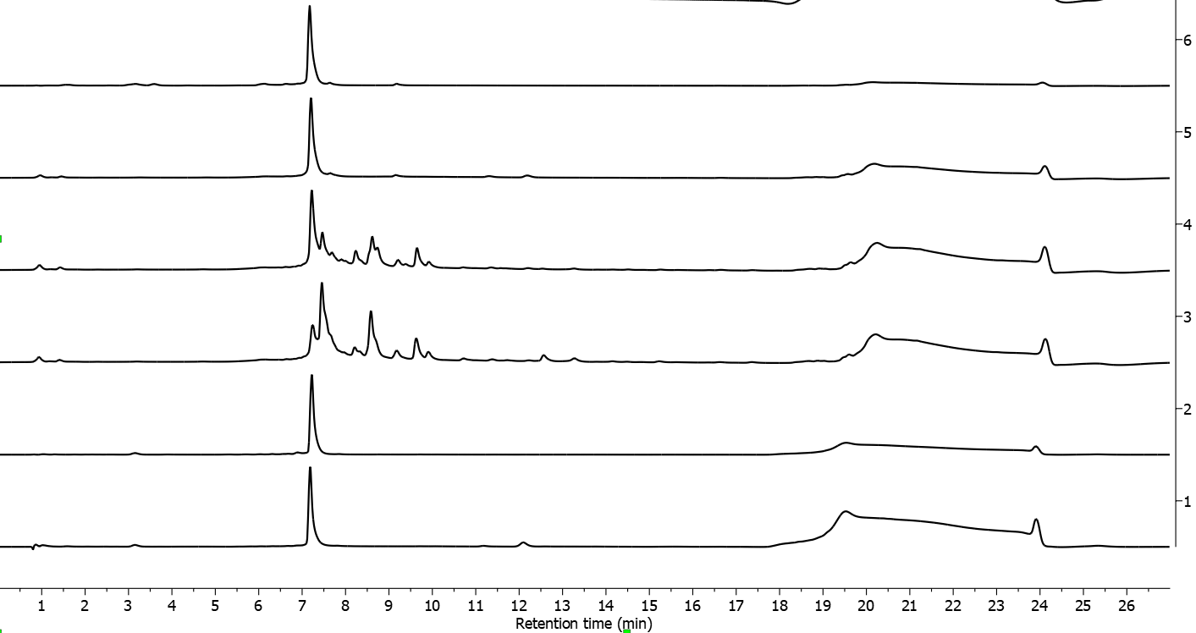
Supplementary Figure 3: Full HPLC chromatograms (260 nm) of condition screening as shown zoomed in in Figure 2D.
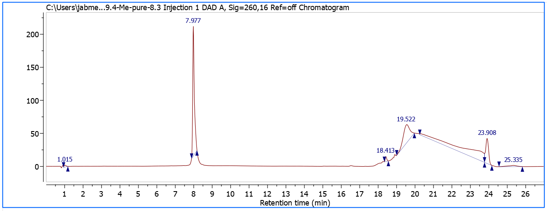
Supplementary Figure 4: Full HPLC chromatogram (260 nm) of purified product as analysed by Orbitrap HRMS shown in Figure 2E+F. 32% isolated yield on 40 nmol reaction scale following the procedure as described in methods section.

Stability of keto-enal stock solution
Supplementary Figure 5: HPLC evaluation of stock solution stability. Methyl-keto-enal was measured directly after furan activation (trace 1 and 3, 210 nm and 254 nm) and a frozen sample (-20 °C) after 2 months (trace 2 and 4, 210 nm and 254 nm). The stock solution was used continuously for two years without any decrease in product formation (data not shown). Analysis was performed on a Phenomenex Kinetex C18 column (150 x 4.6 mm, 5 μm at 35 °C) with the following solvent system (A) 0.1% TFA in H2O and (B) MeCN and the following gradient (flow rate of 1.5 mL/min): 0.5 min 100% A, then a linear gradient from 100% A to 100% B in 6 min, then flushing with 100%B for 2 min.

Side Product Elucidation

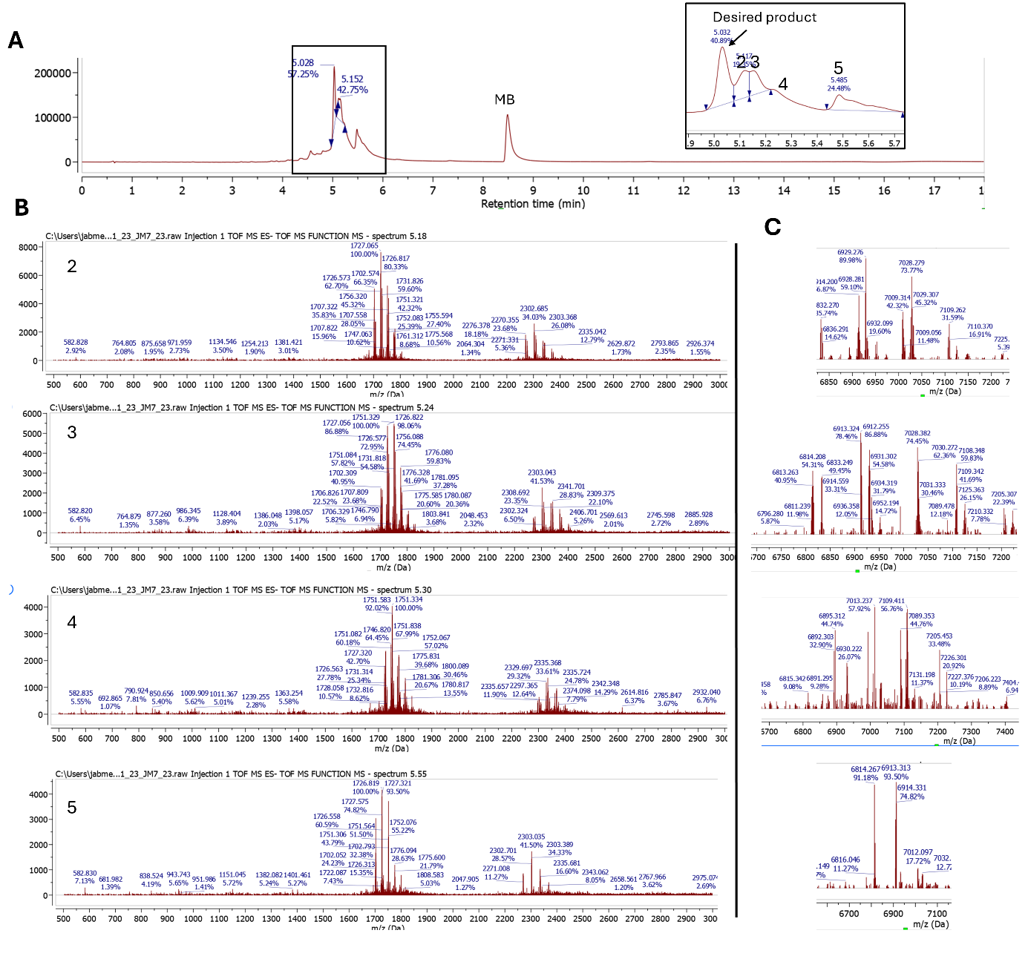

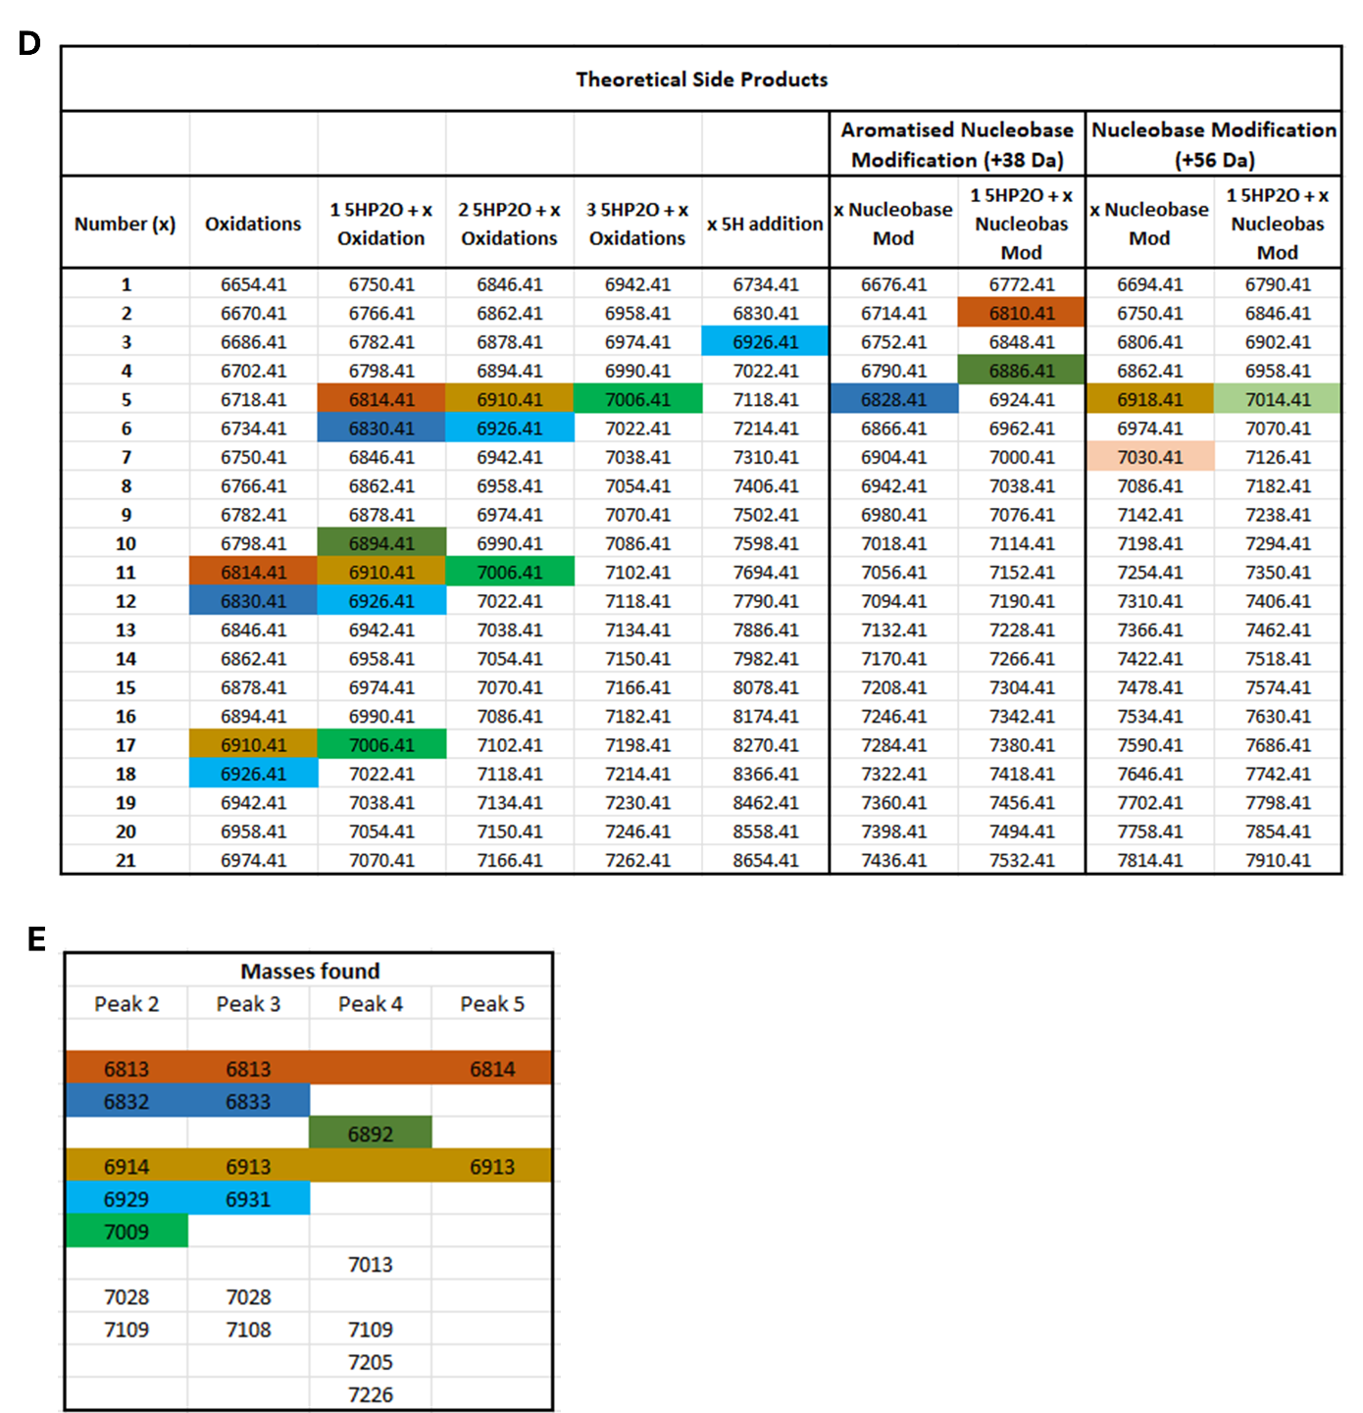
Supplementary Figure 6: Side-Product Elucidation (A) Crude LCMS of AON direct functionalisation with 800 equiv. of photoactivated Methylfuran. (B) ESI Mass Spectra at different timepoints (C) Deconvolution of mass spectra. (D) Theoretical side product masses. (E) Observed masses according to C.
Several masses heavier than the starting oligomer can be observed in the mass deconvolution of side product peaks (see C). A plethora of undesired modifications can theoretically occur (see Scheme 2). Multiples of 16 Da (oxidation), 38 Da (Aromatised nucleobase modification), 54 Da (Nucleobase Modification), 96 Da (5HP2O Formation), and combinations of product formation (1*5HP2O) and the aforementioned mass additions were calculated (see D). The observed masses were compared to the calculated ones and hits (delta smaller 5 Da) were highlighted (see E). Due to the complex mechanistic pathways involved with additional reagents (DMS, MeOH, Et3N, MB) which are not present to that extent in previous mechanistic considerations of our group, we are at this stage not ready to make final mechanistic conclusions on the degradation pathways.

Kinetic Measurements

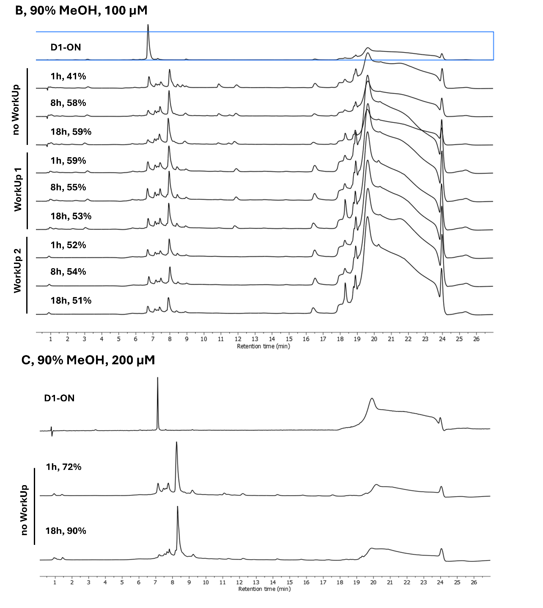
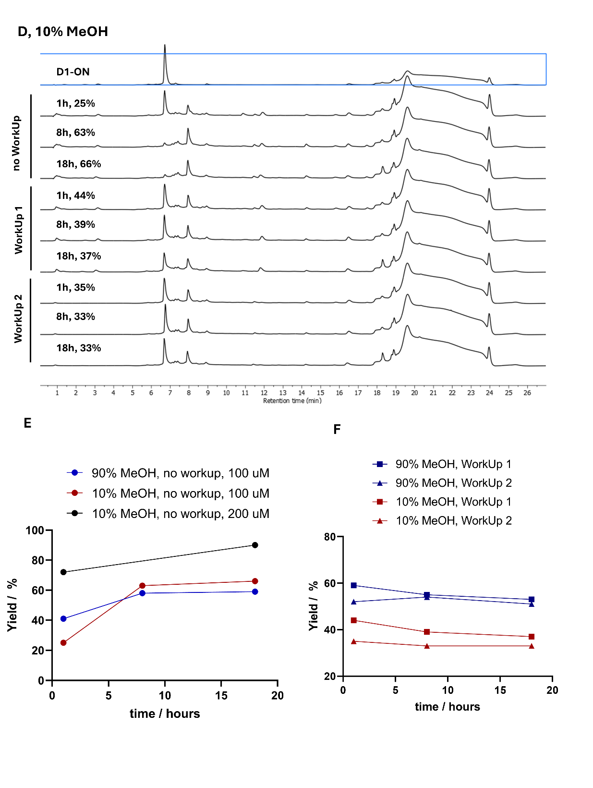
Supplementary Figure 7: Kinetic Measurements (A) Scheme of experimental procedure to determine kinetics of direct functionalisation and a suitable work-up procedure. Reaction was either continuously monitored or worked up after an approximate 1-hour reaction time by concentration under reduced pressure followed by dissolving the residue in water (WorkUp1) or by following WorkUp1 and subsequently performing an additional size-exclusion spin column (Micro BioSpin 6 kDa cutoff, WorkUp2). Lower yields compared to initial experiments as discussed in Figure 2 might arise through the use of an old batch of keto-enal stock solution. (B) Crude HPLC Chromatograms (260 nm) of direct functionalisation of D1 AON with activated 2-methylfuran at 100 µM and in 9:1 (v/v) MeOH:H₂O. Samples without workup show continuous reaction up until 60% yield after 18h (overnight). In contrast, when performing WorkUp procedure 1 or 2 after one hour initial reaction time, the reaction does not continue and stalls at 38% respectively 33%. (C) Crude HPLC Chromatograms (260 nm) of direct functionalisation of D1 AON with activated 2-methylfuran at 200 µM and in 90% MeOH. (D) Crude HPLC chromatograms (260 nm) of direct functionalisation of D1 AON with activated 2-methylfuran at 100 µM in 1:9 (v/v) MeOH:H₂O. Samples without workup show continuous reaction up until 66% yield after 18h. In contrast, when performing WorkUp procedure 1 or 2 after one hour initial reaction time, the reaction does not continue and stalls around ca. 40% respectively 33% (E) Extracted reaction yields (as seen in chromatograms of panel B-D) of different conditions plotted against time. (F) Work up by concentration under reduced pressure alone or in combination with additional spin-column quenches the reaction.

NHS-mediated 5HP2O/Maleimide Functionalisation as Comparison
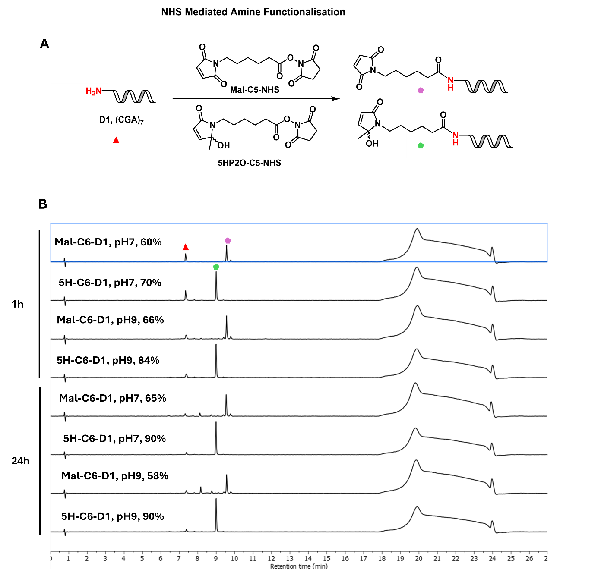

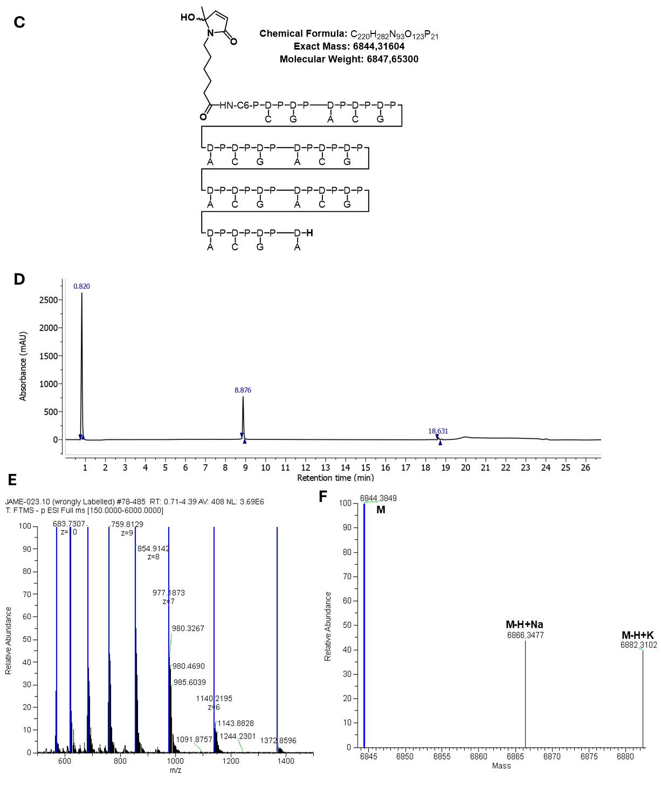
Supplementary Figure 8: NHS-mediated 5HP2O respectively maleimide functionalisation. (A) Scheme of NHS mediated 5HP2O and Maleimide functionalisation of D1 AON (B) Crude HPLC chromatograms (260nm, to 30% ACN) of NHS-mediated amide coupling at two timepoints (1h and 24h) and at two pH (7 and 9) with 40 equiv. of NHS building block. Reactions were performed at 50 µM AON concentration. Maleimide functionalisation leads do lower yields due to continuous maleimide hydrolysis. (C) Structure and mass of 5HP2O(Me)-C6-D1 (D) HPLC Chromatogram (260 nm, to 30% ACN) of purified compound (E) Orbitrap ESI- Mass spectrum of purified compound (F) Deconvoluted mass is in accordance with calculated exact mass.
5HP2O(Methyl)-C6-D1: t_{r}: 8.88 min (to 30% ACN); 90% yield, 34% isolated yield; ε = 212400 M⁻¹cm⁻¹; ESI-MS m/z deconv. 6844.38.27 [M]: 569.61 [M-12H]¹²⁻, 621.48 [M-11H]¹¹⁻, 683.73 [M-10H]¹⁰⁻, 759.81 [M-9H]⁹⁻, 854.91 [M-8H]⁸⁻, 977.19 [M-7H]⁷⁻, 1140.22 [M-6H]⁶⁻, 1368.46 [M-5H]⁵⁻.

Direct functionalisation of AON via activated 2-methylfuran

D1-ON
Supplementary Figure 9: Structure and LCMS of NH2-D1-ON. Total absorbance chromatogram (top), total ion chromatogram (middle) and ESI- spectrum (bottom). Molecular Weight: 6638.41 Da, Observed Mass: 6638.19 Da.
NH₂-D1-ON: t_{r}: 4.5 min; ε = 212400 M⁻¹cm⁻¹; ESI-MS m/z deconv. 6638.19 [M]: 1326.44 [M-5H]⁵⁻, 1658.55 [M-4H]⁴⁻, 2211.690 [M-3H]³⁻.

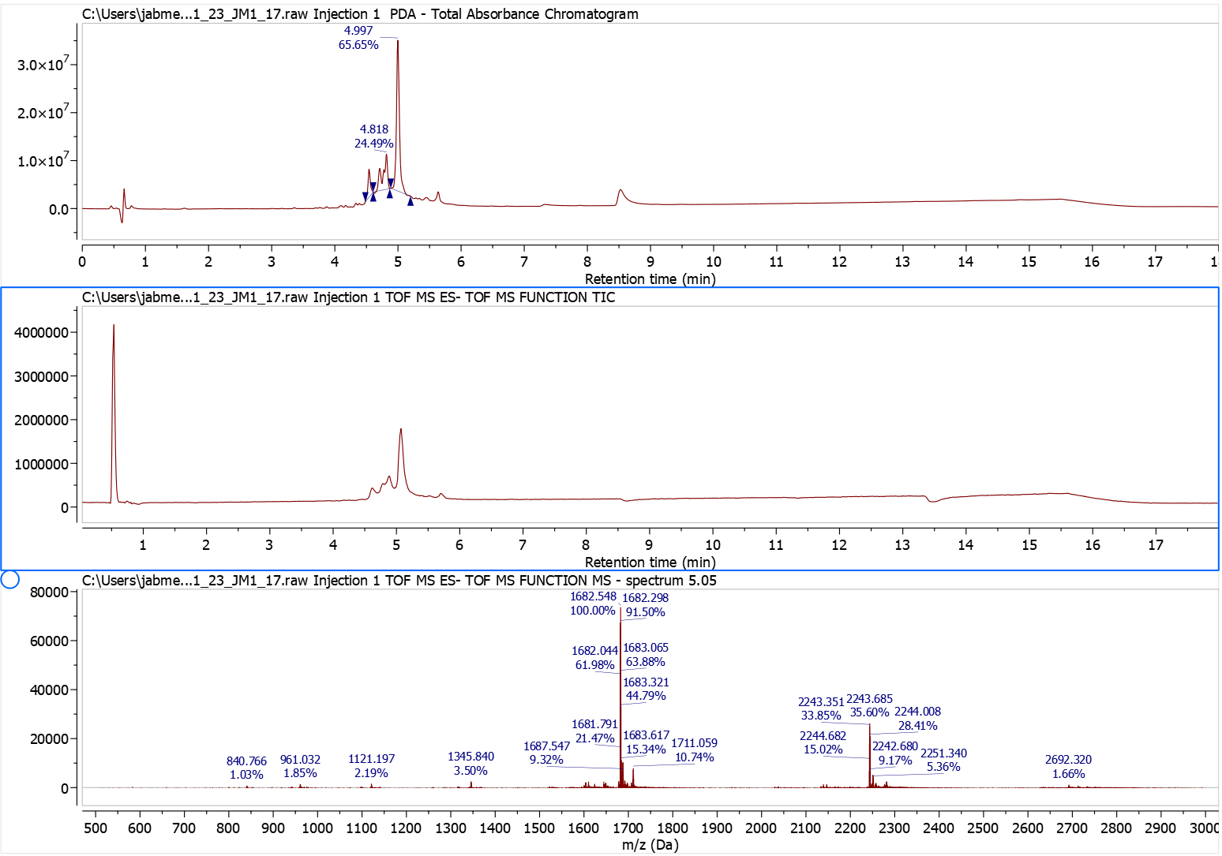
Supplementary Figure 10: Structure of desired product of direct functionalisation of NH2-D1-ON with activated 2-methylfuran. Crude LCMS of the reaction. Total absorbance chromatogram (top), total ion chromatogram (middle) and ESI- spectrum (bottom). Molecular Weight: 6734.49 Da. Observed Mass: 6734.15 Da.
5HP2O(Me)-D1-ON: t_{r}: 5.0 min; 66% yield; ε = 212400 M⁻¹cm⁻¹; ESI-MS m/z deconv. 6734.15 [M]: 1345.84 [M-5H]⁵⁻, 1682.55 [M-4H]⁴⁻, 2243.68 [M-3H]³⁻.

D2-ON
Supplementary Figure 11: Structure and LCMS of NH₂-D2-ON. Total absorbance chromatogram (top), total ion chromatogram (middle) and ESI- spectrum (bottom). Molecular Weight: 10180.87 Da, Observed Mass 10080.60 Da.
NH₂-D2-ON: t_{r}: 5.54 min; ε = 287500 M⁻¹cm⁻¹; ESI-MS m/z deconv. 10080.60 [M]: 1696.02 [M-6H]⁶⁻, 2035.01 [M-5H]⁵⁻, 2543.91 [M-4H]⁴⁻.

Supplementary Figure 12: Structure of desired product of direct functionalisation of NH₂-D2-ON with activated 2-methylfuran. Crude LCMS of the reaction. Total absorbance chromatogram (top), total ion chromatogram (middle) and ESI- spectrum (bottom). Molecular Weight: 10276.96 Da. Observed Mass: 10275.94 Da.
5HP2O(Me)-D2-ON: t_{r}: 6.0 min; 63% yield; ε = 287500 M⁻¹cm⁻¹; ESI-MS m/z deconv. 10275.94 [M]: 1711.69 [M-6H]⁶⁻, 2054.21 [M-5H]⁵⁻, 2567.91 [M-4H]⁴⁻.

D3-ON
Supplementary Figure 13: Structure and LCMS of NH₂-D3-ON. Total absorbance chromatogram (top), total ion chromatogram (middle) and ESI- spectrum (bottom). Molecular Weight: 5251.25 Da, Observed Mass: 5250.43 Da.
NH₂-D3-ON: t_{r}: 4.84 min; ε = 139900 M⁻¹cm⁻¹; ESI-MS m/z deconv. 5250.43 [M]: 1311.63 [M-4H]⁴⁻, 1749.18 [M-3H]³⁻, 2624.12 [M-2H]²⁻.

Supplementary Figure 14: Structure of desired product of direct functionalisation of NH₂-D3-ON with activated 2-methylfuran. Crude LCMS of the reaction. Total absorbance chromatogram (top), total ion chromatogram (middle) and ESI- spectrum (bottom). Molecular Weight: 5347.33 Da. Observed Mass: 5346.75 Da.
5HP2O(Me)-D3-ON: t_{r}: 5.46 min; 100% yield; ε = 139900 M⁻¹cm⁻¹; ESI-MS m/z deconv. 5346.75 [M]: 1335.88 [M-4H]⁴⁻, 1781.18 [M-3H]³⁻, 2672.10 [M-2H]²⁻.

D4-ON
Supplementary Figure 15: Structure and LCMS of NH2-D4-ON. Total absorbance chromatogram (top), total ion chromatogram (middle) and ESI- spectrum (bottom). Molecular Weight: 10047.72 Da, Observed Mass: 10048.25 Da.
NH₂-D4-ON: t_{r}: 5.49 min; ε = 287500 M⁻¹cm⁻¹; ESI-MS m/z deconv. 10048.25 [M]: 1673.85 [M-6H]⁶⁻, 2008.60 [M-5H]⁵⁻, 2510.91 [M-4H]⁴⁻.

Supplementary Figure 16: Structure of desired product of direct functionalisation of NH2-D4-ON with activated 2-methylfuran. Crude LCMS of the reaction. Total absorbance chromatogram (top), total ion chromatogram (middle) and ESI- spectrum (bottom). Molecular Weight: 10143.81 Da. Observed Mass: 10143.57 Da.
5HP2O(Me)-D4-ON: t_{r}: 5.0 min; 100% yield; ε = 287500 M⁻¹cm⁻¹; ESI-MS m/z deconv. 10143.57 [M]: 1689.36 [M-6H]⁶⁻, 2028.00 [M-5H]⁵⁻, 2534.89 [M-4H]⁴⁻.

Int1-ON
Supplementary Figure 17: Structure and LCMS of NH₂-Int1-ON. Total absorbance chromatogram (top), total ion chromatogram (middle) and ESI- spectrum (bottom). Molecular Weight: 6339.22 Da, Observed Mass: 6338.79 Da.
NH₂-Int1-ON: t_{r}: 4.42 min; ε = 201800 M⁻¹cm⁻¹; ESI-MS m/z deconv. 6338.79 [M]: 1266.63 [M-5H]⁵⁻, 1583.79 [M-4H]⁴⁻, 2112.02 [M-3H]³⁻.

Supplementary Figure 18: Structure of desired product of direct functionalisation of NH₂-Int1-ON with activated 2-methylfuran. Crude LCMS of the reaction. Total absorbance chromatogram (top), total ion chromatogram (middle) and ESI- spectrum (bottom). Molecular Weight: 6435.31 Da. Observed Mass: 6434.83 Da.
5HP2O(Me)-Int1-ON: t_{r}: 4.63 min; 100% yield; ε = 201800 M⁻¹cm⁻¹; ESI-MS m/z deconv. 6434.83 [M]: 1285.84 [M-5H]⁵⁻, 1607.80 [M-4H]⁴⁻, 2144.03 [M-3H]³⁻.

Int2-ON
Supplementary Figure 19: Structure and LCMS of NH₂-Int2-ON. Total absorbance chromatogram (top), total ion chromatogram (middle) and ESI- spectrum (bottom). Molecular Weight: 6219.20 Da, Observed Mass: 6219.16 Da.
NH₂-Int2-ON: t_{r}: 4.10 min; ε = 191300 M⁻¹cm⁻¹; ESI-MS m/z deconv. 6219.16 [M]: 1242.84 [M-5H]⁵⁻, 1553.80 [M-4H]⁴⁻, 2072.03 [M-3H]³⁻.

Supplementary Figure 20: Structure of desired product of direct functionalisation of NH₂-Int2-ON with activated 2-methylfuran. Crude LCMS of the reaction. Total absorbance chromatogram (top), total ion chromatogram (middle) and ESI- spectrum (bottom). Molecular Weight: 6411.37 Da. Observed Mass: 6411.20 Da. 88% Double Functionalisation (4.77 min), 12% Mono Functionalisation (4.77 min)
5HP2O(Me)-Int2-ON: t_{r}: 4.84 min; 88% yield; ε = 191300 M⁻¹cm⁻¹; ESI-MS m/z deconv. 6411.20 [M]: 1281.25 [M-5H]⁵⁻, 1601.81 [M-4H]⁴⁻, 2136.04 [M-3H]³⁻.

Direct functionalisation of amine-PNA via activated 2-methylfuran

Characterisation of amine-PNA
Supplementary Figure 21: LCMS of purified P1. Total Absorbance Chromatogram (top) and ESI+ spectrum (bottom). Molecular Weight: 5197.04 Da, Observed Mass: 5195.32 Da.
P1: t_{r}: 3.05 min; ε = 194900 M⁻¹cm⁻¹; ESI-MS m/z deconv. 5195.30 [M]: 578.3 [M+9H]⁹⁺, 650.4 [M+8H]⁸⁺, 743.2 [M+7H]⁷⁺, 866.9 [M+6H]⁶⁺, 1040.0 [M+5H]⁵⁺, 1299.8 [M+4H]⁴⁺.

Supplementary Figure 22: LCMS of purified P2. Total Absorbance Chromatogram (top) and ESI+ spectrum (bottom). Molecular Weight: 5342.20 Da, Observed Mass: 5340.38 Da.
P2: t_{r}: 3.07 min; ε = 194900 M⁻¹cm⁻¹; ESI-MS m/z deconv. 5340.38 [M]: 535.1 [M+10H]¹⁰⁺, 594.3 [M+9H]⁹⁺, 668.6 [M+8H]⁸⁺, 763.9 [M+7H]⁷⁺, 891.0 [M+6H]⁶⁺, 1069.1 [M+5H]⁵⁺.

Supplementary Figure 23: LCMS of purified P3. Total Absorbance Chromatogram (top) and ESI+ spectrum (bottom). Molecular Weight: 5251.20 Da, Observed Mass: 5248.97 Da.
P3: t_{r}: 3.00 min; ε = 194900 M⁻¹cm⁻¹; ESI-MS m/z deconv. 5248.97 [M]: 584.3 [M+9H]⁹⁺, 657.1 [M+8H]⁸⁺, 750.8 [M+7H]⁷⁺, 875.9 [M+6H]⁶⁺, 1050.7 [M+5H]⁵⁺, 1313.2 [M+4H]⁴⁺.

Supplementary Figure 24: LCMS of purified P4. Total Absorbance Chromatogram (top) and ESI+ spectrum (bottom). Molecular Weight: 5396.36 Da, Observed Mass: 5394.18 Da.
P4 t_{r}: 3.0 min; ε = 194900 M⁻¹cm⁻¹; ESI-MS m/z deconv. 5394.18 [M]: 540.4 [M+10H]¹⁰⁺, 600.3 [M+9H]⁹⁺, 675.3 [M+8H]⁸⁺, 771.6 [M+7H]⁷⁺, 900.1 [M+6H]⁶⁺.

Functionalisation of amine-PNA using activated 2-methylfuran

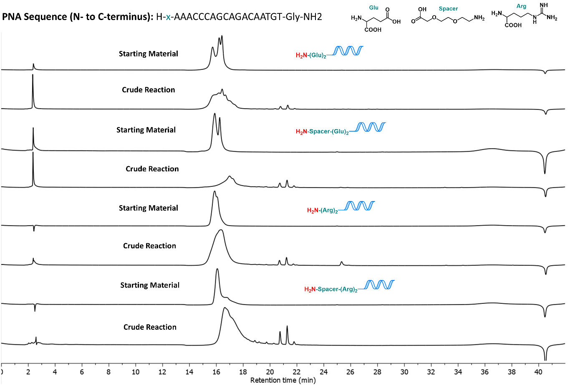

Supplementary Figure 25: HPLC chromatograms (260 nm, to 75% ACN) of starting material P1 to P4 and the corresponding crude functionalisation reaction with activated methylfuran. Peak shift of PNA oligomers and product formation is only seen in case of PNAs containing the terminal amino-spacer. Direct 5HP2O functionalisation on the terminal amine of amino acids (Glu and Arg) in contrast seems to be hampered sterically or electronically. The full signal was collected and analysed via MALDI-TOF (see Supplementary Figure 26). Reactions were performed as described in general procedure I at a reaction volume of 10 µL and a reaction concentration of 100 µM. Broad signals might arise through the absence of pH control (Gradient without TFA) in a long gradient.

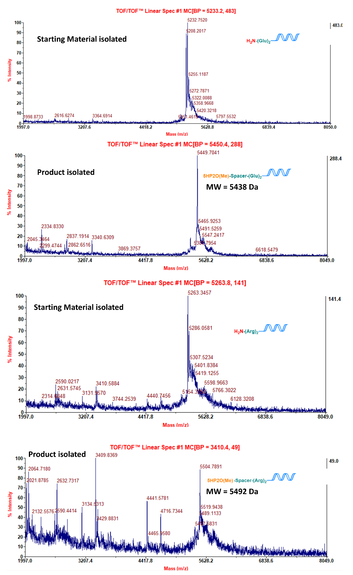
Supplementary Figure 26: MALDI-TOF of full isolated peak (vide supra) of direct functionalisation of PNA oligomers (P1 to P4).

Negative Control

NC1-ON
Supplementary Figure 27: Structure and LCMS of NC1-ON (no primary amine). Total absorbance chromatogram (top), total ion chromatogram (middle) and ESI- spectrum (bottom). Molecular Weight: 6396.15 Da, Observed Mass: 6395.67 Da.
NH₂-NC1-ON: t_{r}: 4.56 min; ε = 170600 M⁻¹cm⁻¹; ESI-MS m/z deconv. 6395.67 [M]: 1278.01 [M-5H]⁵⁻, 1598.00 [M-4H]⁴⁻, 2130.99 [M-3H]³⁻.

Supplementary Figure 28: Crude LCMS of direct functionalisation of NC1-ON (no primary amine). Total absorbance chromatogram (top), total ion chromatogram (middle) and ESI- spectrum (bottom). No functionalisation or degradation observed.

Melting Curves

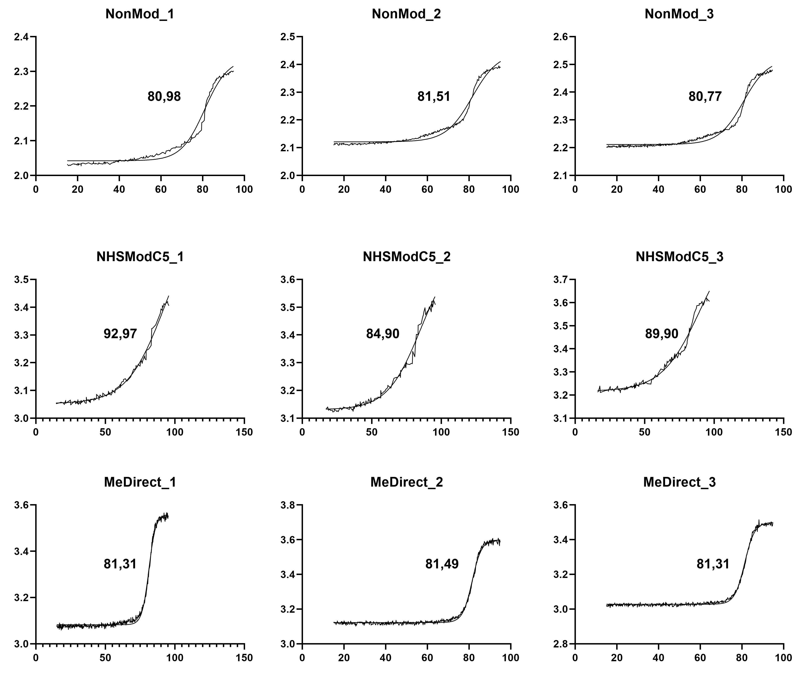
Supplementary Figure 29: Thermal denaturation experiments were performed using a Varian Cary 300 Bio spectrophotometer equipped with a six-cell thermostatted cell holder. To ensure the formation of the most stable secondary structure, samples were pre-annealed at 95 °C for 5 minutes and then cooled to 15 °C at a rate of 1 °C/min. Denaturation profiles were recorded by heating the samples from 15 °C to 95 °C and subsequently cooling from 95 °C to 15 °C, both at a rate of 1 °C/min, with data acquisition every 0.1 °C. Absorbance was monitored at 260 nm. The results were fitted to a Boltzmann distribution. Melting temperatures (Tₘ) were determined using a two-state transition model with the fitting function available in GraphPad Prism (version 10.0). Melting temperatures are indicated in the graph.

Synthesis of small molecule building blocks

Synthesis of 2-(3-Azidopropyl)furan (MF4)
2-(3-Azidopropyl)furan was synthesized adapting the reported procedure starting from 3-(furan-2-yl)propanoic acid⁴.
SI1: To a solution of 3-(furan-2-yl)propanoic acid (2.00 g, 14.27 mmol) in dry THF (20 mL) under argon atmosphere was slowly added DMS-borane (1.5 equiv., 1.63 g, 2.03 mL) under ice bath cooling. The solution was allowed to come to room temperature and stirred overnight. Quenching was performed by addition of Methanol, before concentration under reduced pressure. 3-(furan-2-yl)propan-1-ol was purified as colorless oil (qt.) by silica flash chromatography (0 to 100% EtOAc).
¹H NMR (300 MHz, CDCl3) δ 7.36 – 7.27 (m, 1H), 6.28 (dd, J = 3.2, 1.9 Hz, 1H), 6.01 (dd, J = 2.6, 1.5 Hz, 1H), 3.68 (t, J = 6.3 Hz, 2H), 2.73 (t, J = 7.4 Hz, 2H), 1.98 – 1.83 (m, 2H), 1.59 (s, 1H), 1.25 (tt, J = 7.2, 0.6 Hz, 2H). In accordance with literature.

SI2: To a solution of 3-(furan-2-yl)propan-1-ol (750 mg, 5.95 mmol) in DCM (10 mL) was added pTsCl (1.5 equiv., 8.93 mmol, 1.70 g) and Et₃N (2.0 equiv., 11.9 mmol, 1.65 mL). The solution was stirred for 4 hours at room temperature. Diluted HCl (3M, 5 mL) was added and the solution was extracted twice with DCM. The organic layer was dried over Na₂SO4 and concentrated under reduced pressure. 3-(furan-2-yl)propyl 4-methylbenzenesulfonate was obtained as white solid (913 mg, 55%) upon silica flash chromatography using pentane:diethylether (0 to 100% diethylether).
¹H NMR (300 MHz, CDCl3) δ 7.84 – 7.73 (m, 1H), 7.34 (d, J = 7.8 Hz, 1H), 7.25 (dd, J = 1.9, 0.8 Hz, 1H), 6.23 (dd, J = 3.2, 1.9 Hz, 1H), 5.91 (dd, J = 3.2, 0.9 Hz, 1H), 4.05 (t, J = 6.2 Hz, 2H), 2.67 (td, J = 7.3, 0.8 Hz, 2H), 2.45 (s, 3H), 1.98 (tt, J = 7.3, 6.2 Hz, 2H). LCMS t_{ret}=6.58 min, ESI-MS+ m/z calculated for C₁₄H₁₆O₄S 280.08 [M], 281.07 [M+H]⁺. In accordance with literature.
MF4: To a solution of 3-(furan-2-yl)propyl 4-methylbenzenesulfonate (913 mg, 3.26 mmol) in DMF:water (75:25 v/v, 10 mL) was added NaN3 (2.5 equiv, 8.15 mmol, 529 mg). The solution was stirred overnight at 60 °C before addition of water and extraction with diethylether. The organic layer was washed twice with brine, prior to drying over Na₂SO4 and concentration under reduced pressure. The product (334 mg, 68%) was obtained as colorless oil and further used without purification.
¹H NMR (300 MHz, CDCl3) δ 7.40 – 7.24 (m, 1H), 6.29 (dd, J = 3.2, 1.9 Hz, 1H), 6.02 (dd, J = 3.1, 0.8 Hz, 1H), 3.31 (t, J = 6.8 Hz, 2H), 2.73 (t, J = 7.3 Hz, 3H), 1.93 (p, J = 7.0 Hz, 3H). LCMS t_{ret}=6.28 min, ESI-MS+ m/z calculated for C₇H₉N₃O 151.07 [M], found 228.10 [M+2K-H]⁺. In accordance with literature.

Synthesis of N-2-Propyn-1-yl-2-furanpropanamide (MF2)

To a solution of 3-(furan-2-yl)propanoic acid (560 mg, 4.00 mmol) in dry DMF (15 mL) was added HBTU (1.1 equiv., 1.67 g) and DIPEA (3.0 equiv, 2.04 mL). The mixture was stirred for 20 min at room temperature. Propargylamine (1.2 equiv., 0.30 mL) was added dropwise over 10 min. The solution was stirred overnight before concentration under reduced pressure. N-2-Propyn-1-yl-2-furanpropanamide (83%, 0.59 g) was obtained as white solid upon silica flash chromatography (0 to 100% EtOAc:Cyclohexane).
¹H NMR (300 MHz, CDCl₃) δ 7.31 – 7.25 (m, 1H, H2/5), 6.28 – 6.24 (dd, J = 3.2, 1.8 Hz, 1H, H1), 6.06 – 5.98 (m, 1H, H2/5), 4.03 (dd, J = 5.0, 2.6 Hz, 2H, H11), 2.98 (dd, J = 8.6, 6.7 Hz, 2H, H6/7), 2.53 (dd, J = 8.3, 6.9 Hz, 2H, H6/7) 2.24 – 2.18 (m, 1H, H13).¹³C NMR (101 MHz, CDCl₃) δ 171.67 (C4/8), 154.20 (C4/8), 141.34 (C2/5), 110.37 (C1), 105.66 (C2/5), 79.49 (C12), 71.73 (C13), 34.71 (C6/7), 29.34 (C11), 23.95 (C6/7). HRMS (ESI+): calculated for C₁₀H₁₁NO₂: 177.0790 [M]; found 178.0870 [M+H]⁺.

Synthesis of N-Propyl-2-furanpropanamide (MF3)

To a solution of 3-(furan-2-yl)propanoic acid (560 mg, 4.00 mmol) in dry DMF (15 mL) was added HBTU (1.1 equiv., 1.67 g) and DIPEA (3.0 equiv, 2.04 mL). The mixture was stirred for 20 min at room temperature. Propylamine (1.2 equiv., 0.32 mL) was added dropwise over 10 min. The solution was stirred overnight before concentration under reduced pressure. N-Propyl-2-furanpropanamide (72%, 0.51 g) was obtained as white solid upon silica flash chromatography (0 to 100% EtOAc:Cyclohexane).

¹H NMR (400 MHz, CDCl₃) δ 7.28 (dd, J = 1.9, 0.8 Hz, 1H), 6.26 (dd, J = 3.2, 1.9 Hz, 1H), 6.02 (dd, J = 3.2, 1.0 Hz, 1H), 3.18 (td, J = 7.3, 5.7 Hz, 2H), 2.97 (t, J = 7.5 Hz, 2H), 2.52 (t, J = 7.5 Hz, 2H), 1.48 (h, J = 7.4 Hz, 2H), 0.88 (t, J = 7.4 Hz, 3H). ¹³C NMR (101 MHz, CDCl₃) δ 172.09, 154.41, 141.18, 110.31, 105.53, 41.38, 34.97, 24.24, 22.58, 11.37. HRMS (ESI+): calculated for C₁₀H₁₅NO₂: 181.1103 [M]; found 182.1177 [M+H]⁺.

Synthesis of 4-(2-Furyl)-2-butanone (MF5)

4-(2-Furyl)-2-butanone was synthesized according to the reported procedure⁵.
¹H NMR (300 MHz, CDCl₃) δ 7.33 – 7.25 (m, 1H), 6.27 (dd, J = 3.1, 2.0 Hz, 1H), 6.04 – 5.96 (m, 1H), 2.98 – 2.86 (m, 2H), 2.79 (ddd, J = 8.2, 6.9, 1.6 Hz, 2H), 2.17 (d, J = 0.6 Hz, 3H). In accordance with literature. ). LCMS t_{ret}=5.12 min, ESI-MS+ m/z calculated for C₈H₁₀O₂ 138.06 [M], found 379.29 [2M+ACN+Na]⁺. In accordance with literature.

Synthesis of 2-(2-(furan-2-yl)ethyl)-2-methyl-1,3-dioxolane (MF6)

To a solution of 4-(2-Furyl)-2-butanone (250 mg, 1.81 mmol) in dry DCM (10 mL) was added triethylorthoformate (3.0 equiv., 0.94 mL), ethylene glycol (1.1 equiv., 123 mg) and p-toluenesulfonic acid (0.1 equiv., 34 mg). The reaction mixture was stirred overnight at room temperature before the solution was concentrated under reduced pressure. 2-(2-(furan-2-yl)ethyl)-2-methyl-1,3-dioxolane (38%, 74 mg) was obtained upon silica flash chromatography (0:100 to 100:0 Ether:Pentane).

¹H NMR (300 MHz, CDCl₃) δ 7.33 – 7.26 (m, 1H, H2/5), 6.31 – 6.23 (m, 1H, H1), 5.98 (m, 1H, H2/5), 4.05 – 3.88 (m, 4H, H11+12), 2.83 – 2.66 (m, 2H, H6/7), 2.07 – 1.95 (m, 2H, H6/7), 1.35 (s, 3H, H10). ¹³C NMR (101 MHz, CDCl₃) δ 140.91 (C2/5), 110.28 (C1), 104.47 (C2/5), 64.81 (2C, C11+12), 37.40 (C6/7), 24.04 (C10), 22.87 (C6/7). LCMS t_{ret}=5.80 min; ESI-MS+ m/z calculated for C₁₀H₁₄O₃: 182.0943 [M]; found 183.087 [M+H]⁺.

Synthesis of N-[2-(2-{2-(2-Azidoethoxy)ethoxy}ethoxy)ethyl]-7-nitro-2,1,3-benzoxadiazol-4-amine (NBD-Azide)

NBD-Cl (0.5 mmol, 99.8 mg) was dissolved in DMF (5 mL) in a round bottomed flask. DIPEA (1.4 equiv., 0.5 mmol, 85 µL) and NH₂-(CH₂CH₂O)₃-CH₂CH₂-N₃ (amine-TEG-azide, 1.4 equiv., 0.5 mmol, 109 mg) was added and the solution was stirred overnight before concentration in vacuo yielding a brown oil (qt., containing ca. 37% free amine-TEG-azide as determined by NMR). The crude was used without further purification.
¹H NMR (400 MHz, CDCl₃): δ = 8.47 (d, J = 8.7 Hz, 1H), 7.68 (br s, 1H), 6.20 (d, J = 8.7 Hz, 1H), 3.86 (dd, J = 5.5, 4.5 Hz, 3H), 3.73–3.67 (m, 12 H), 3.37 (t, J = 5.0 Hz, 3H). ¹³C NMR (101 MHz, CDCl₃) δ 144.44, 144.13, 142.09, 140.25, 136.65, 135.06, 70.84, 70.81, 70.74, 70.65, 70.11, 68.33, 50.80, 42.15). LCMS t_{ret}=5.60 min; ESI-MS+ m/z calculated for C₁₄H₁₉ N₇O₆: 381.14 [M]; found 382.12 [M+H]⁺. In accordance with the literature⁶.

Synthesis of N-(6-Maleimidocaproyloxy)succinimide (Mal-C5-NHS)
6-Maleimidehexanoic acid (1 mmol, 211 mg) was dissolved in DMF (20 mL) in a round bottomed flask and cooled by an ice bath. N-Hydroxysuccinimide (3.0 equiv., 3.0 mmol, 345 mg) and Dicyclohexylcarbodiimid (3.0 equiv., 3.0 mmol, 619 mg) were added in one portion. The solution was stirred overnight and was allowed to come to room temperature. Upon concentration under high vacuum, the dicyclohexylurea was precipitated in MeCN (5 mL). The filtrate was again concentrated and DCU got precipitated a second time. The product was obtained as pale yellow oil (291 mg, 94%) upon silica flash chromatography (0 to 100% EtOAc in 20 minutes).
¹H NMR (300 MHz, CDCl₃) δ 6.68 (s, 2H), 3.53 (t, J = 7.1 Hz, 2H), 2.82 (s, 4H), 2.60 (t, J = 7.4 Hz, 2H), 1.77 (p, J = 7.4 Hz, 2H), 1.70 – 1.55 (m, 2H), 1.48 – 1.35 (m, 2H). LCMS t_{ret}=5.02 min; ESI-MS+ m/z calculated for C₁₄H₁₆N₂O₆: 308.10 [M]; found 309.11 [M+H]⁺. In accordance with the literature⁷.

Synthesis of 2,5-dioxopyrrolidin-1-yl 6-(2-hydroxy-2-methyl-5-oxo-2,5-dihydro-1Hpyrrol-1-yl)hexanoate (5HP2O-C5-NHS)

2,5-dioxopyrrolidin-1-yl-6-(2-hydroxy-2-methyl-5-oxo-2,5-dihydro-1Hpyrrol-1-yl)hexanoate was synthesised according to the reported procedure.⁸
¹H NMR (300 MHz, CD₃CN) δ 6.93 (d, J = 5.9 Hz, 1H), 5.94 (d, J = 5.9 Hz, 1H), 3.43 – 3.30 (m, 1H), 3.24 – 3.11 (m, 1H), 2.76 (s, 4H), 2.62 (t, J = 7.4 Hz, 2H), 1.81 – 1.56 (m, 4H), 1.45 (s, 3H), 1.44 – 1.37 (m, 2H). LCMS t_{ret}=4.26 min; ESI-MS+ m/z calculated for C₁₅H₂₀N₂O₆: 324.14 [M]; found 325.15 [M+H]⁺. In accordance with the literature⁸.

Direct Dual Functionalisation of AON

5HP2O(Azide)-D1-ON
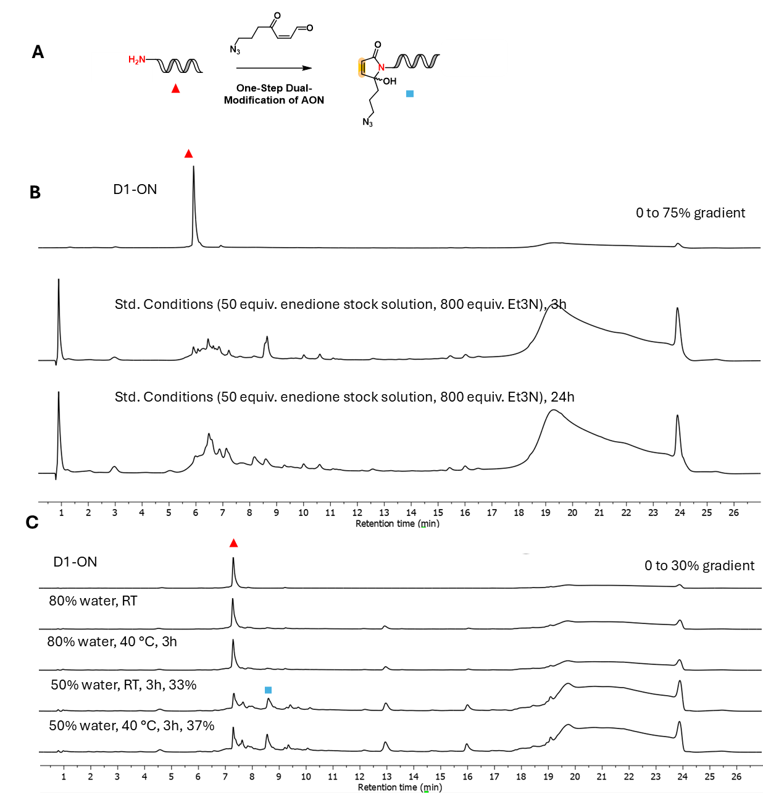
Supplementary Figure 30: Condition Screening for direct dual functionalisation (A) Reaction scheme (B) Crude HPLC chromatograms (260nm, to 75% ACN) of AON direct functionalisation with photoactivated MF4 (azide-bearing keto-enal) using the previously determined conditions (50 equiv. keto-enal stock solution, 800 equiv. Et3N, 90% MeOH) which mostly leads to degradation. (C) Crude HPLC chromatograms (260 nm, to 30% ACN) of condition screening for the direct dual modification of D1 AON with azide-bearing keto enal at different solvent conditions and reaction times. Controllable Reaction is only seen by lowering the amount of water to 50%. At 80% water no consumption of AON is seen.

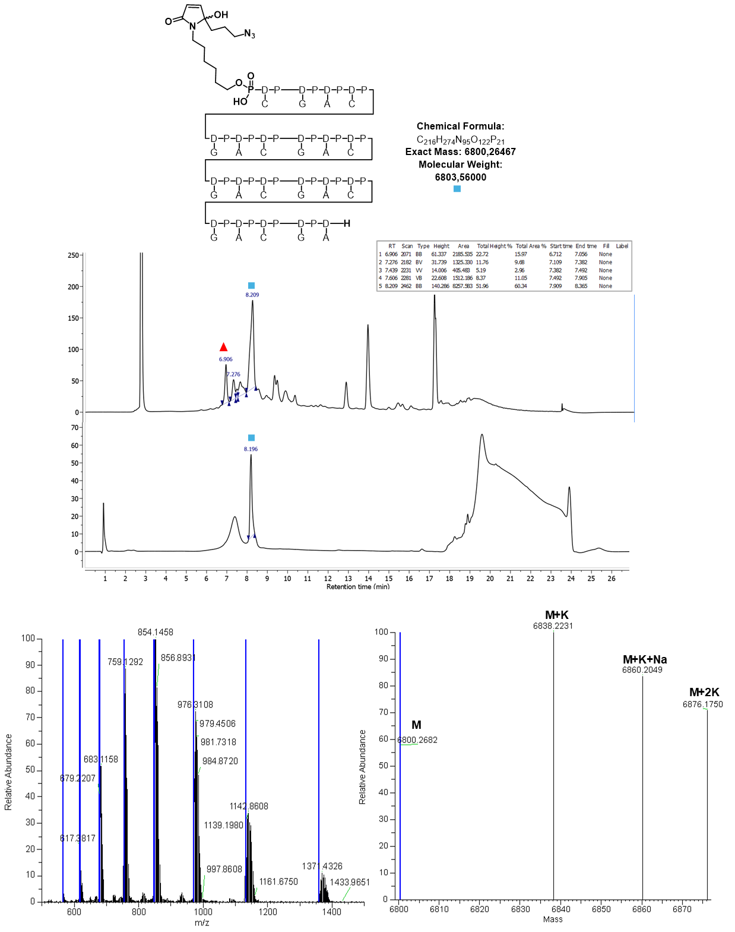
Supplementary Figure 31: Structure of 5HP2O(Azide)-D1-ON (top), HPLC chromatogram (to 30% ACN) of crude reaction (50% MeOH, 50 equiv. keto-enal, 800 equiv. Et₃N, overnight, 40 °C) and isolated fraction (middle), which was analysed on Orbitrap HRMS (bottom). Exact Mass: 6800.26 Da, Observed Mass: 6800.27 Da
5HP2O(Azide)-D1-ON: t_{r}: 8.2 min (to 30% ACN); 60% theoretical yield, 11% isolated yield; ε = 212400 M⁻¹cm⁻¹; ESI-MS m/z deconv. 6800.27 [M]: 565.93 [M-12H]¹²⁻, 617.47 [M-11H]¹¹⁻, 679.32 [M-10H]¹⁰⁻, 754.91 [M-9H]⁹⁻, 849.20 [M-8H]⁸⁻, 970.89 [M-7H]⁷⁻, 1132.87 [M-6H]⁶⁻, 1132.87 [M-5H]⁵⁻.

5HP2O(Acetal)-D1-ON
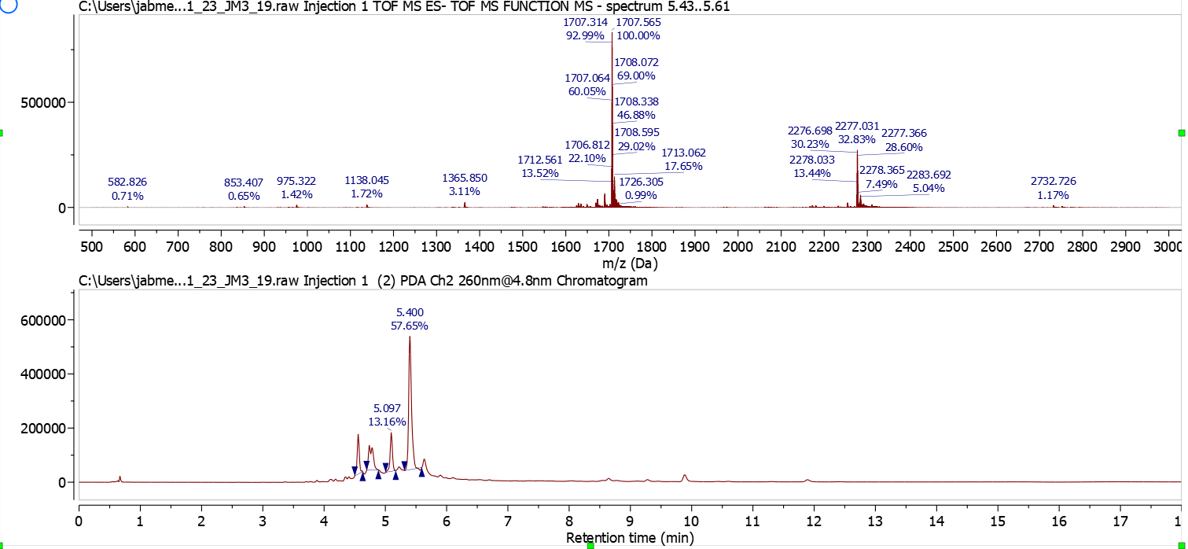
Supplementary Figure 32: Crude LCMS of AON direct functionalisation with photoactivated MF6. 13% unprotected ketone product (5HP2O(Ketone)-D1-ON) observed at 5.1 min. Molecular Weight: 6834.61 Da. Observed Mass: 6834.25 Da
5HP2O(Acetal)-D1-ON: t_{r}: 5.4 min; 58% yield; ε = 212400 M⁻¹cm⁻¹; ESI-MS m/z deconv. 6834.25 [M]: 1365.85 [M-5H]⁵⁻, 1707.57 [M-4H]⁴⁻, 2277.03 [M-3H]³⁻.
5HP2O(Ketone)-D1-ON: t_{r}: 5.1 min; 13% yield; ε = 212400 M⁻¹cm⁻¹; 6787.25 Da calculated mass; ESI-MS m/z deconv. 6790.27 [M]: 1357.25 [M-5H]⁵⁻, 1696.31 [M-4H]⁴⁻, 2262.36 [M-3H]³⁻.

5HP2O(COOH)-D1-ON
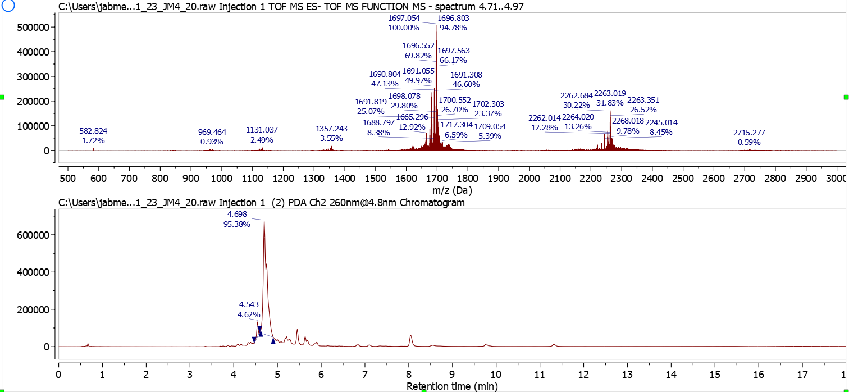
Supplementary Figure 33: Crude LCMS of AON direct functionalisation with photoactivated MF1. Molecular Weight: 6792.53 Da. Observed Mass: 6791.24 Da
5HP2O(Alkane)-D1-ON: t_{r}: 4.7 min; 95% yield; ε = 212400 M⁻¹cm⁻¹; ESI-MS m/z deconv. 6791.24 [M]: 1357.24 [M-5H]⁵⁻, 1697.05 [M-4H]⁴⁻, 2263.02 [M-3H]³⁻.

5HP2O(Alkane)-D1-ON
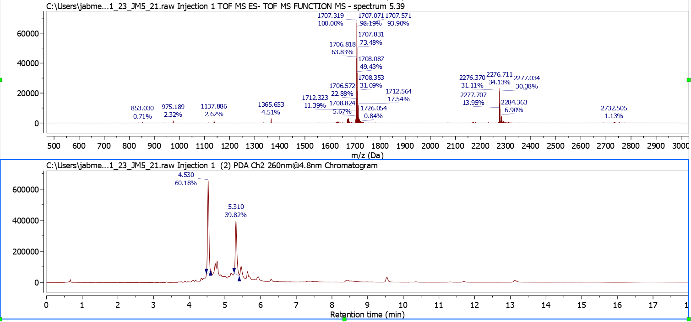Supplementary Figure 34: Crude LCMS of AON direct functionalisation with photoactivated MF3. Calculated Mass: 6833.63 Da. Observed Mass: 6833.28 Da
5HP2O(Alkane)-D1-ON: t_{r}: 5.3 min; 40% yield; ε = 212400 M⁻¹cm⁻¹; ESI-MS m/z deconv. 6833.28 [M]: 1365.65 [M-5H]⁵⁻, 1707.32 [M-4H]⁴⁻, 2276.71 [M-3H]³⁻.

5HP2O(Alkyne)-D1-ON
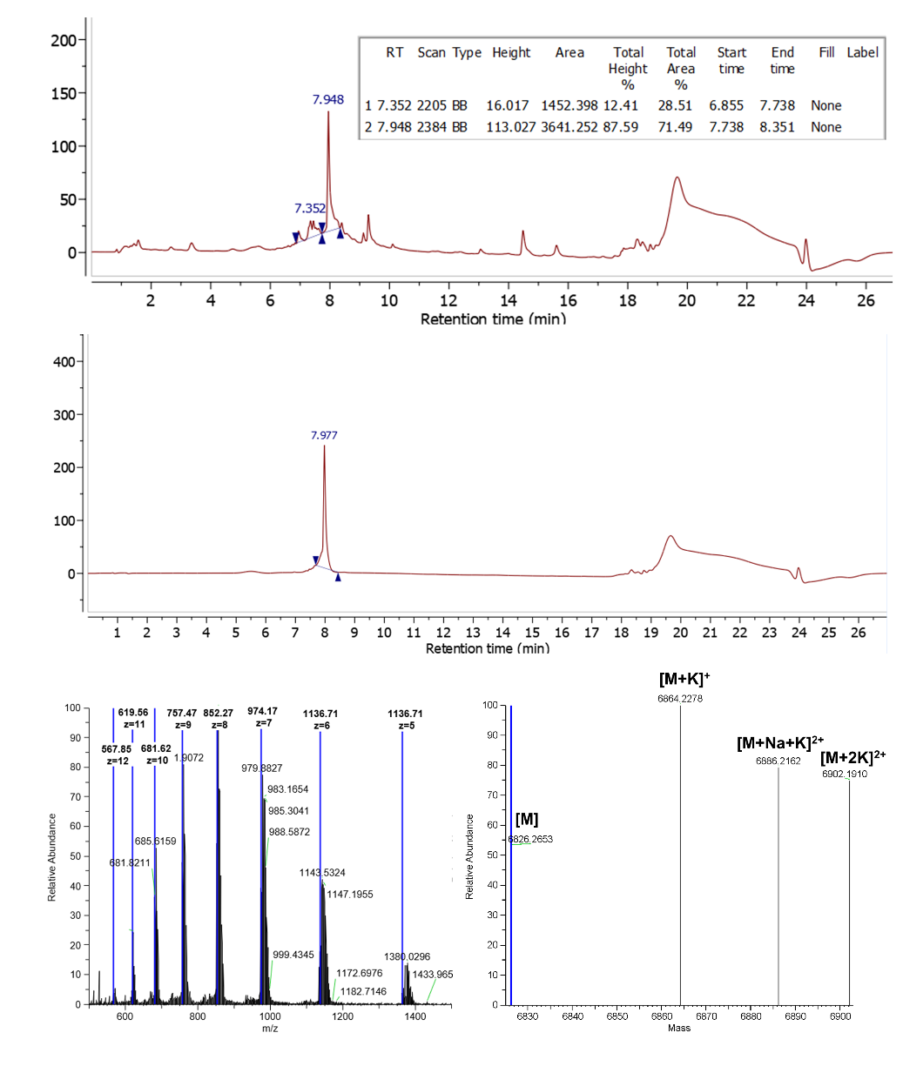
Supplementary Figure 35: Crude HPLC of AON direct functionalisation with photoactivated MF2 (top) and purified product (middle). Mass characterization via Orbitrap HRMS of purified product (bottom). Exact Mass: 6826.27 Da, Observed Mass: 6826.27 Da
5HP2O(Alkyne)-D1-ON: t_{r}: 7.98 min (to 30% ACN); 71% yield; ε = 212400 M⁻¹cm⁻¹; ESI-MS m/z deconv. 6826.27 [M]: 567.85 [M-12H]¹²⁻, 619.56 [M-11H]¹¹⁻, 681.62 [M-10H]¹⁰⁻, 757.47 [M-9H]⁹⁻, 852.27 [M-8H]⁸⁻, 974.17 [M-7H]⁷⁻, 1136.71 [M-6H]⁶⁻, 1136.71 [M-5H]⁵⁻.

Conjugation of 5HP2O-functionalised oligonucleotides

Glutathione and Alphabody Conjugation to 5HP2O(Me)-ON
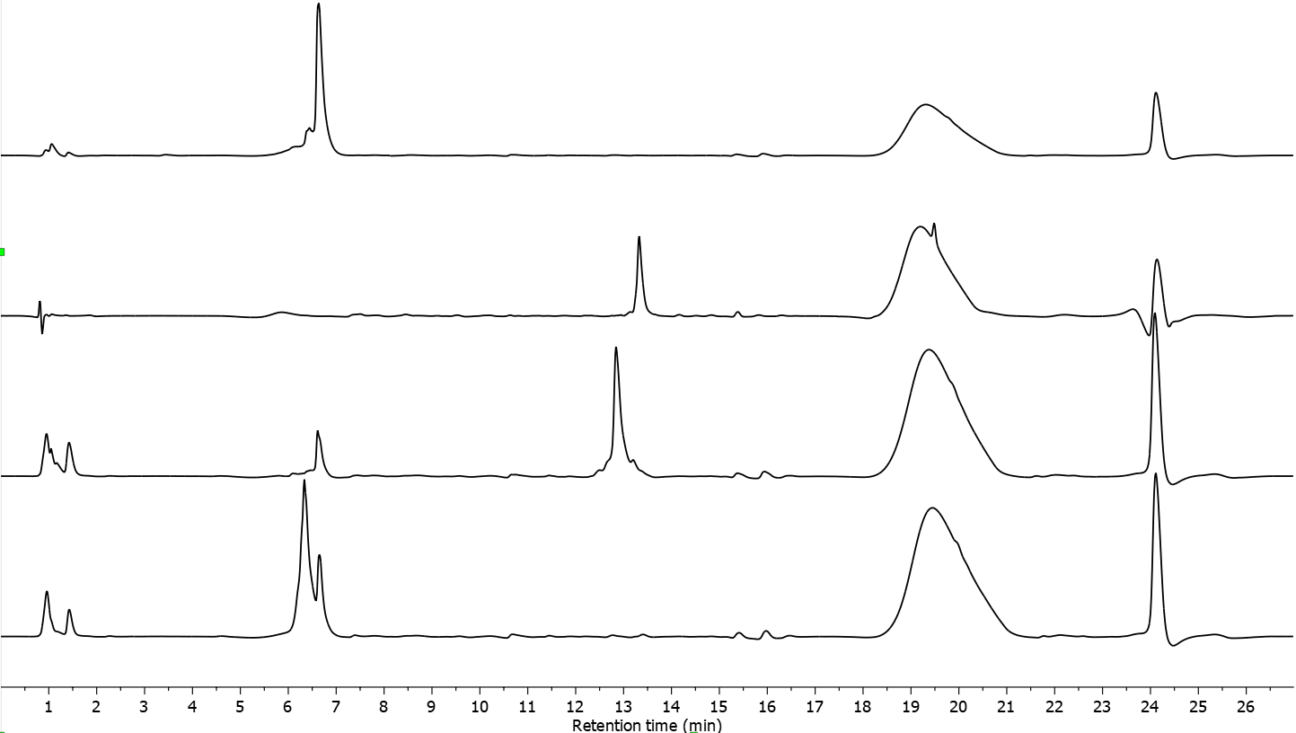
Supplementary Figure 36: Full HPLC traces (260 nm) as shown in figure 5B. Baseline correction was applied. From top to bottom: purified 5HP2O(Me)-ON, Alphabody, crude bioconjugation with alphabody, crude bioconjugation with glutathione. Gradient to 75% ACN. Alphabody characterisation and pre-reduction has been performed as previously described⁸. Employed Alphabody MB23 Mass: 11468.65 Da

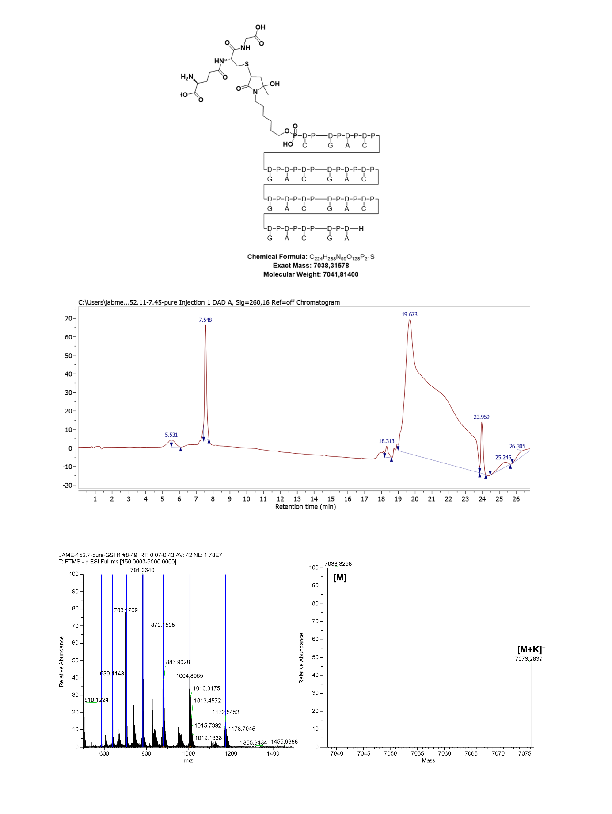
Supplementary Figure 37: Analysis of glutathione product (GSH-5HP2O(Methyl)-D1-ON). Structure (top), purified product fraction (middle, 260 nm, to 30% MeCN), Orbitrap HRMS and deconvoluted spectrum (bottom). Exact Mass: 7038.32 Da, Observed mass: 7038.33 Da.

Glutathione and CUAAC labelling of 5HP2O(Alkyne)-ON

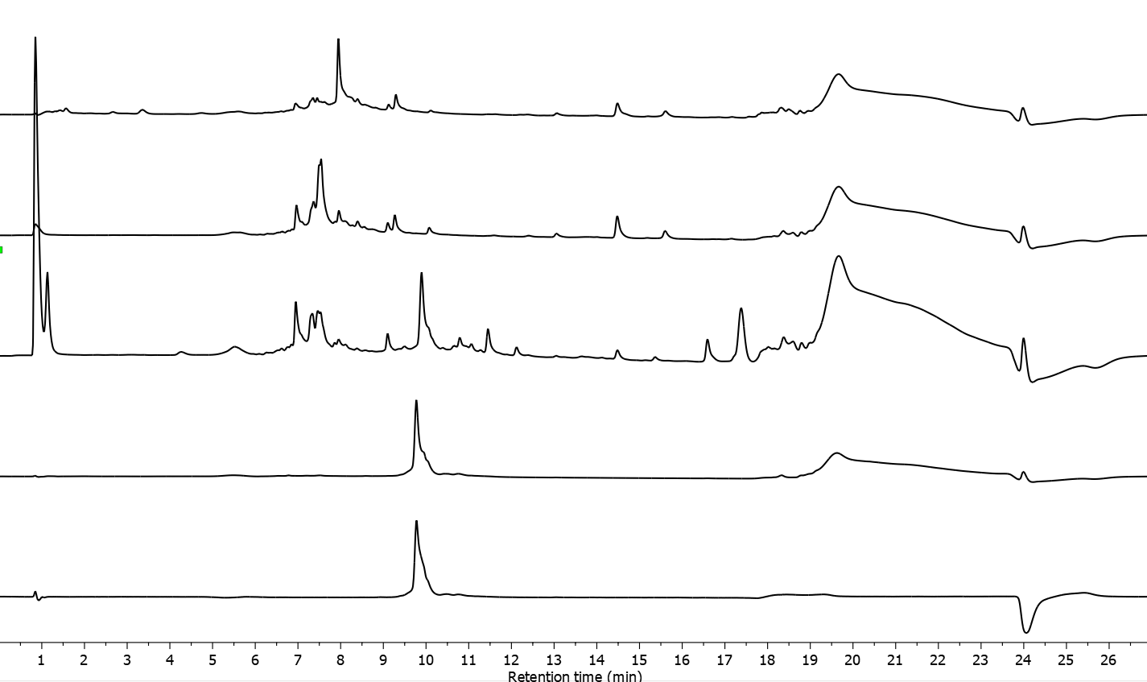
Supplementary Figure 38: Full HPLC traces (260 nm, to 30% ACN) as shown in figure 5F. From top to bottom: 5HP2O(Alkyne)-ON crude, Glutathione bioconjugation crude, CUAAC labelling crude, purified product 260 nm, purified product 475 nm. Gradient to 30% ACN. Uncomplete CUAAC towards NBD-labelled product can be explained by the small amount of free amine-TEG-azide in the reaction mixture yielding the (see 7.6).
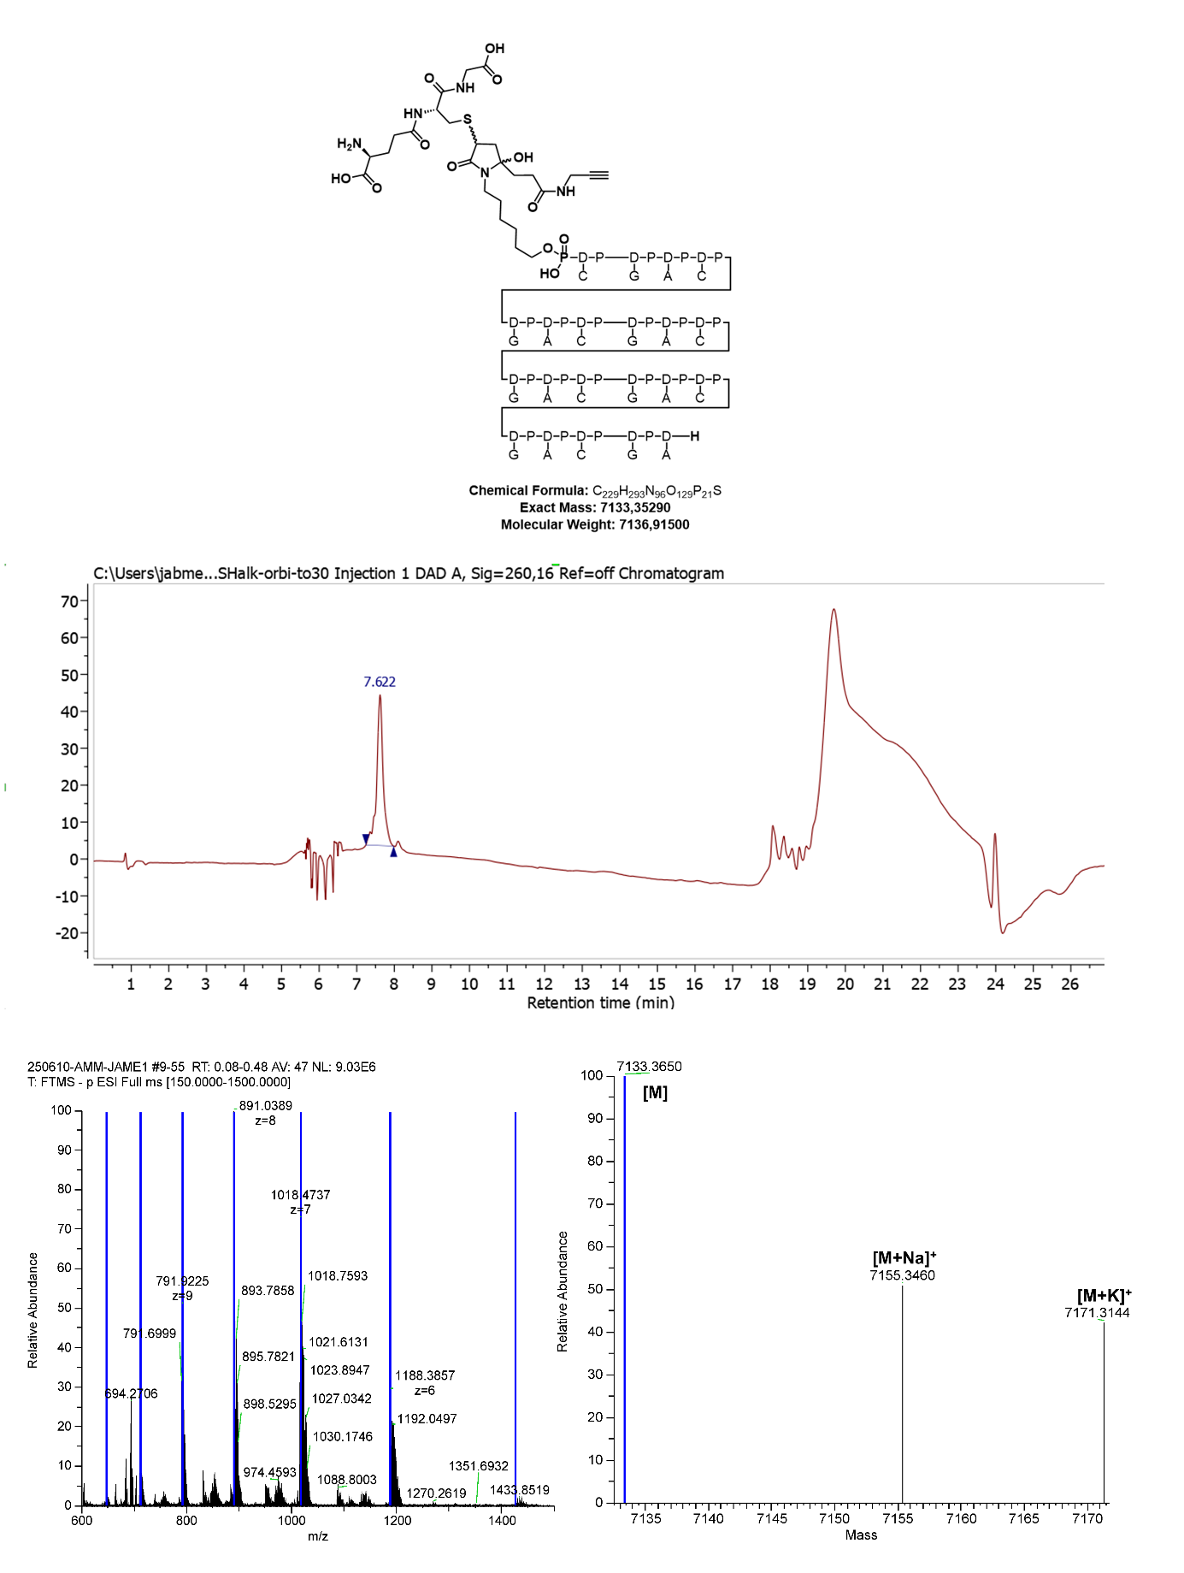
Supplementary Figure 39: Analysis of Intermediate (GSH-5HP2O(Alkyne)-D1-ON). Structure (top), purified product fraction (middle, 260 nm), Orbitrap HRMS and deconvoluted spectrum (bottom). Exact Mass: 7133.35 Da, Observed mass: 7133.37 Da.

NMR Spectra

SI1
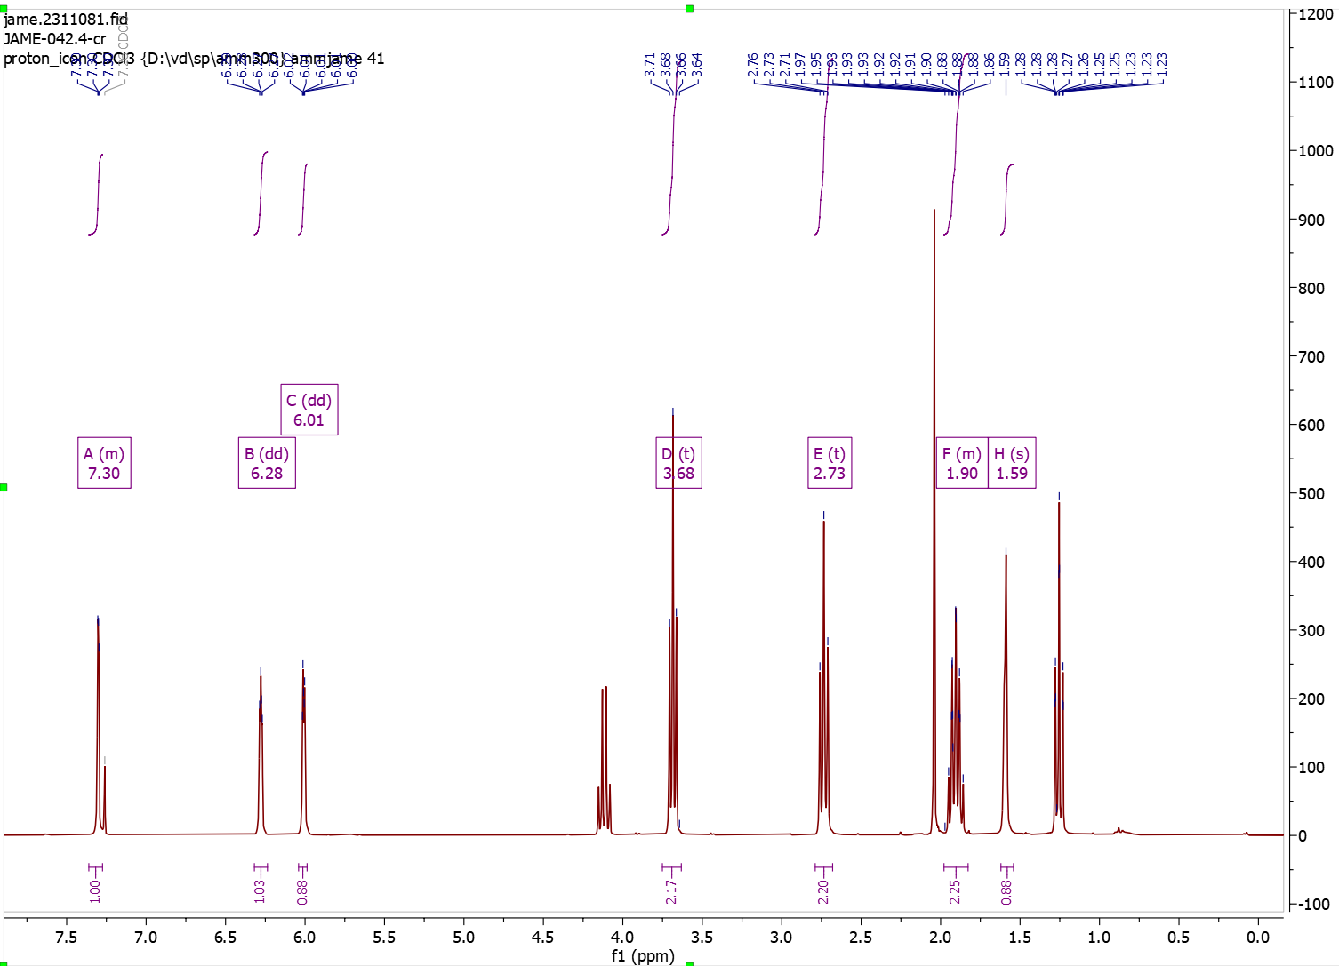

SI2
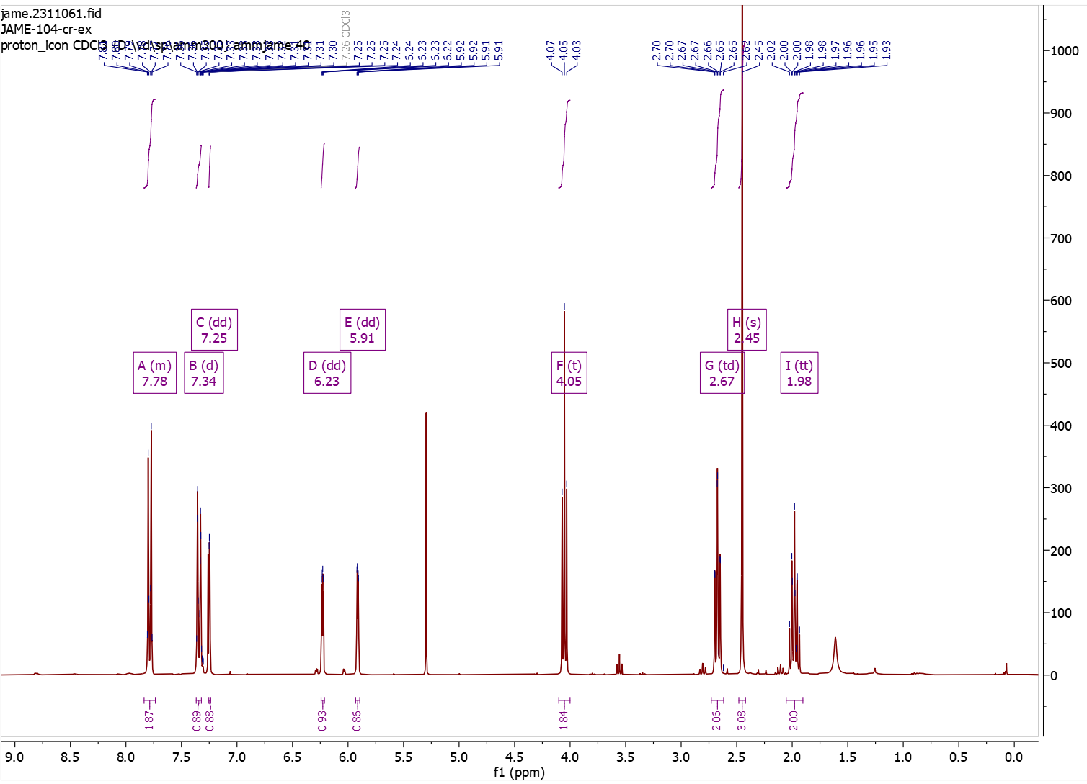

MF4
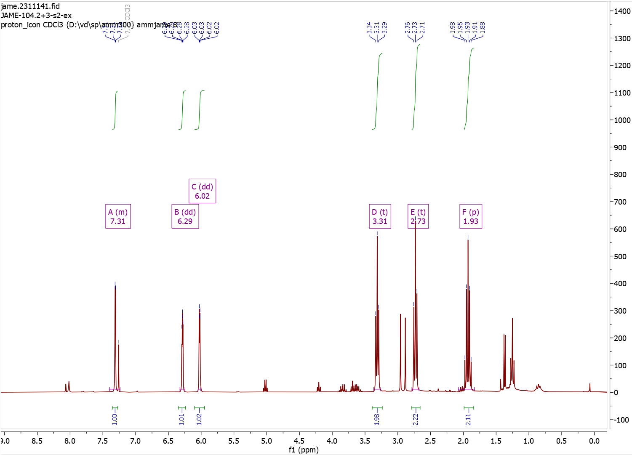

MF2
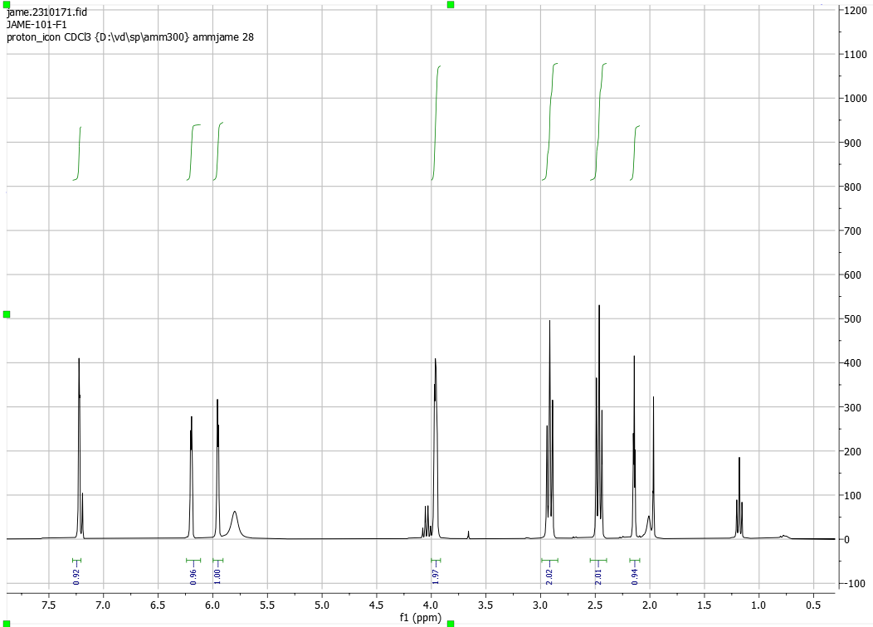
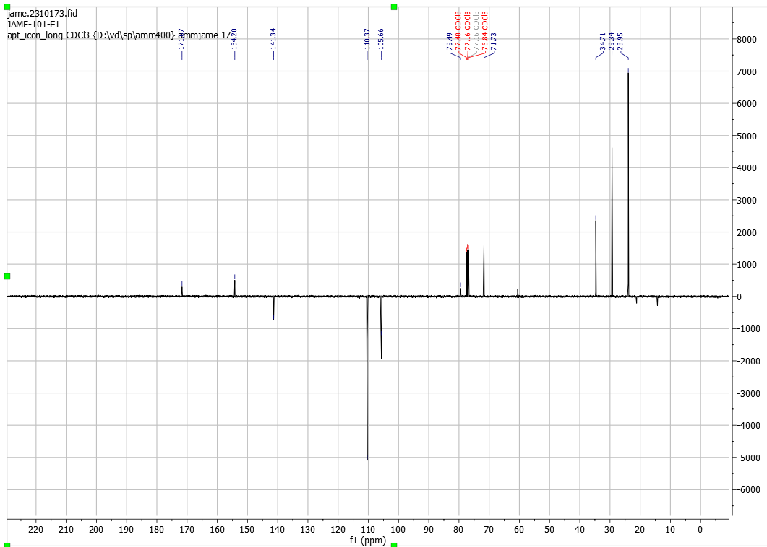

MF3
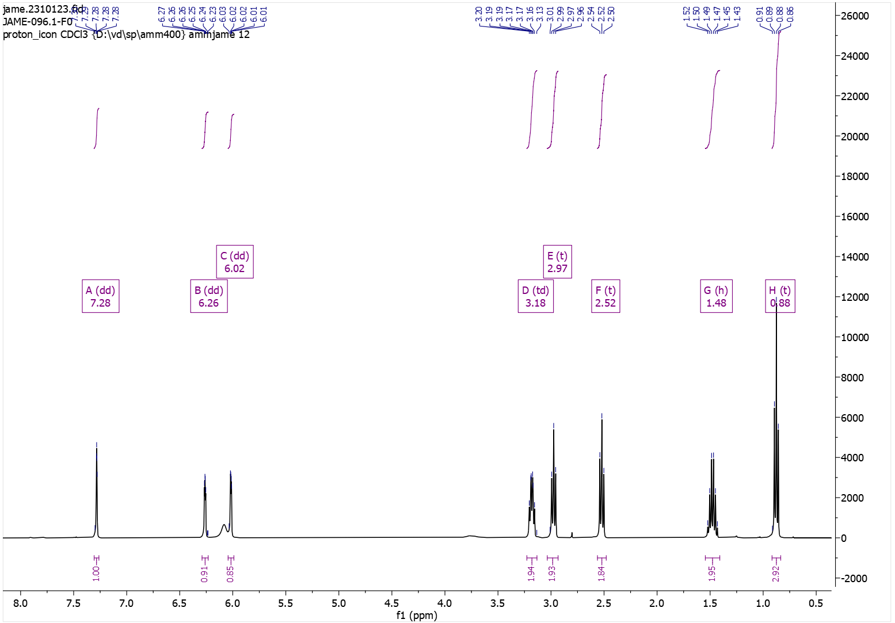
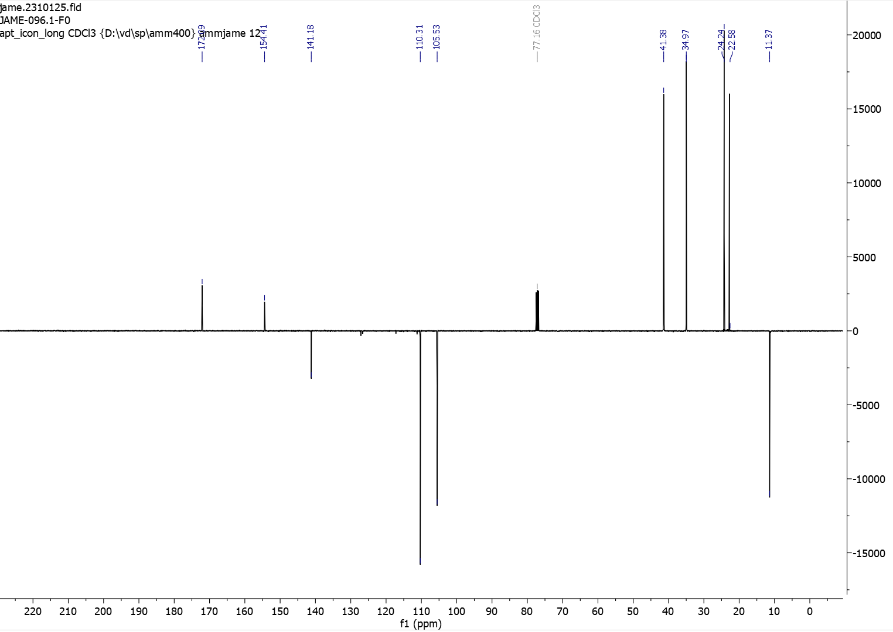

MF5
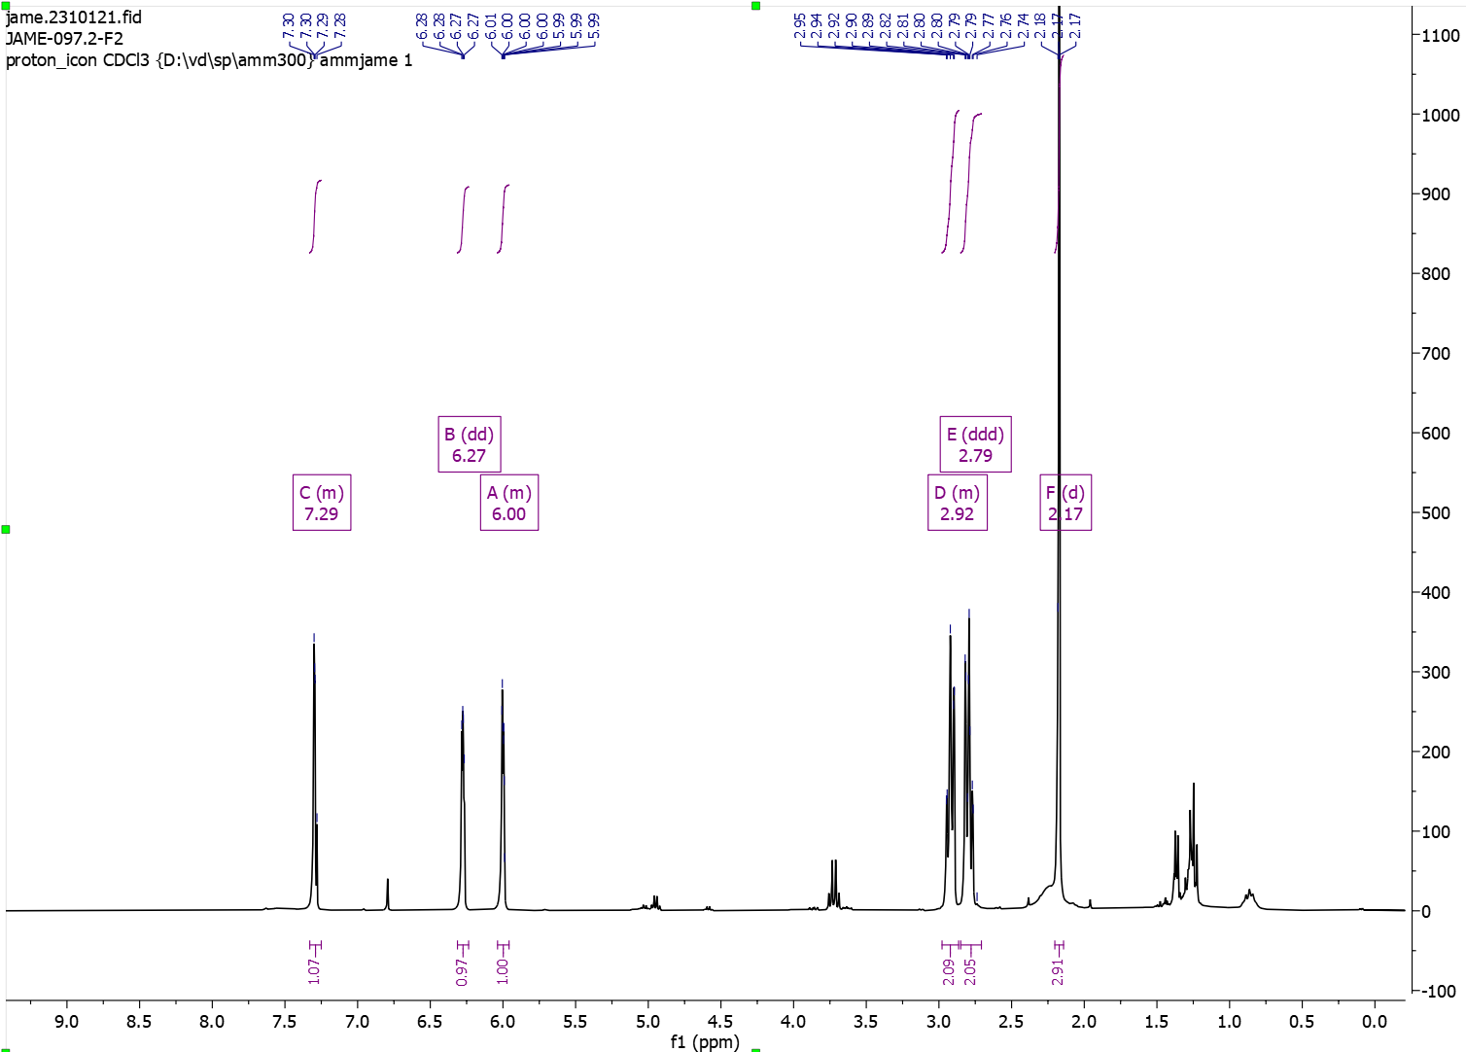

MF6
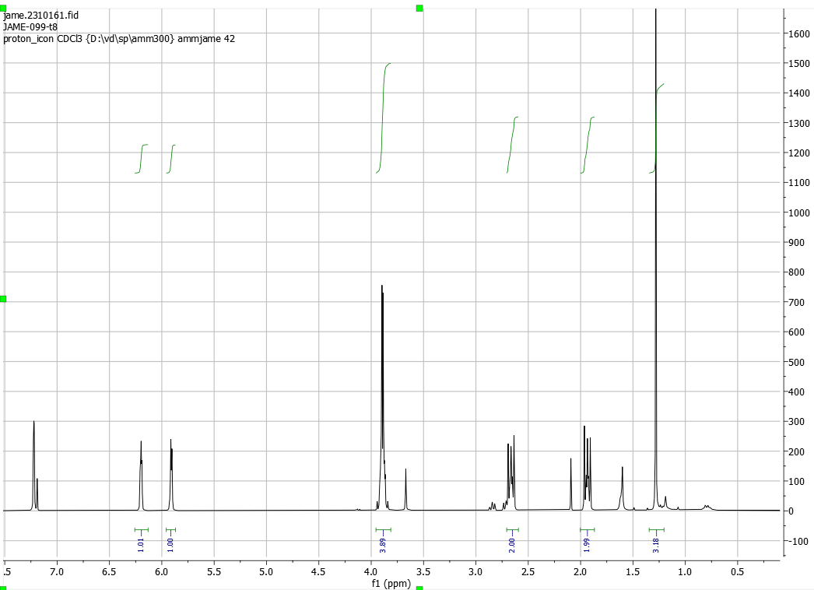\
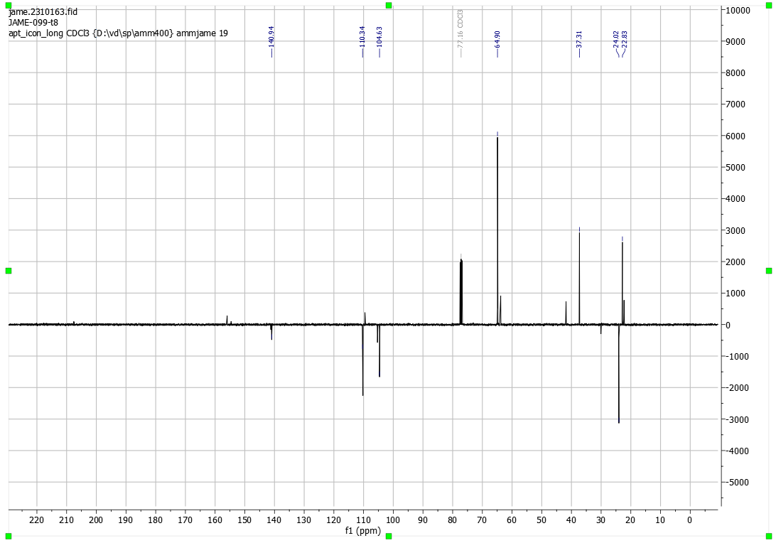

NBD-azide
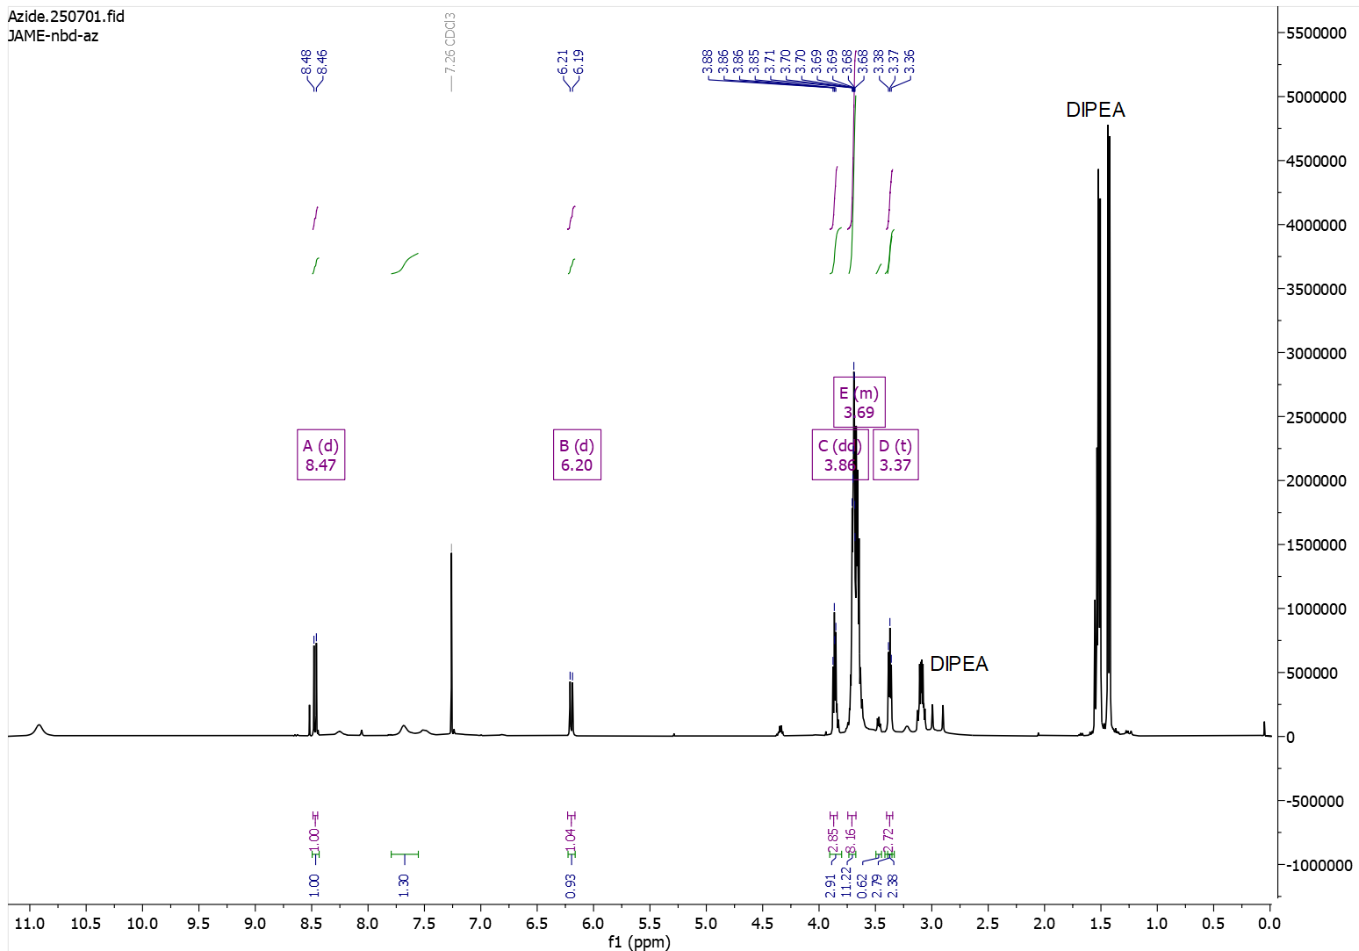
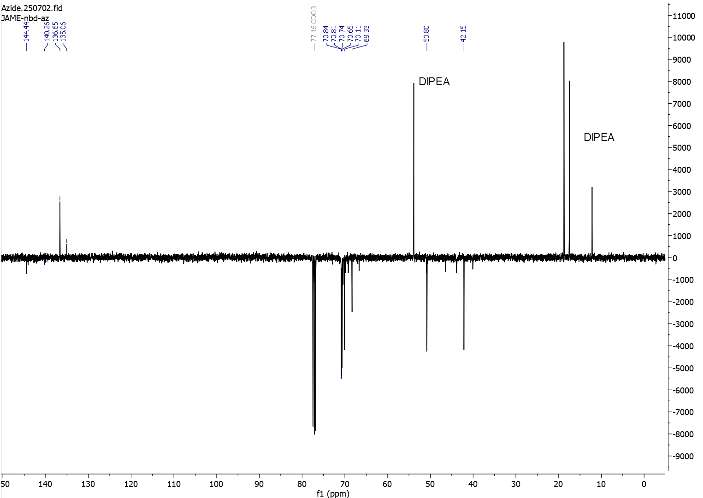

Mal-C5-NHS

5HP2O-C5-NHS

HRMS / LCMS Data

MF2
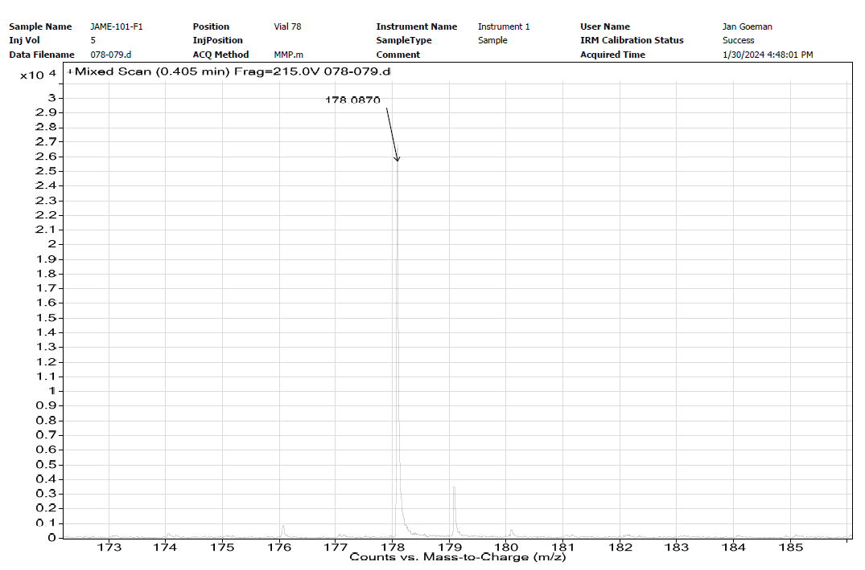

MF3
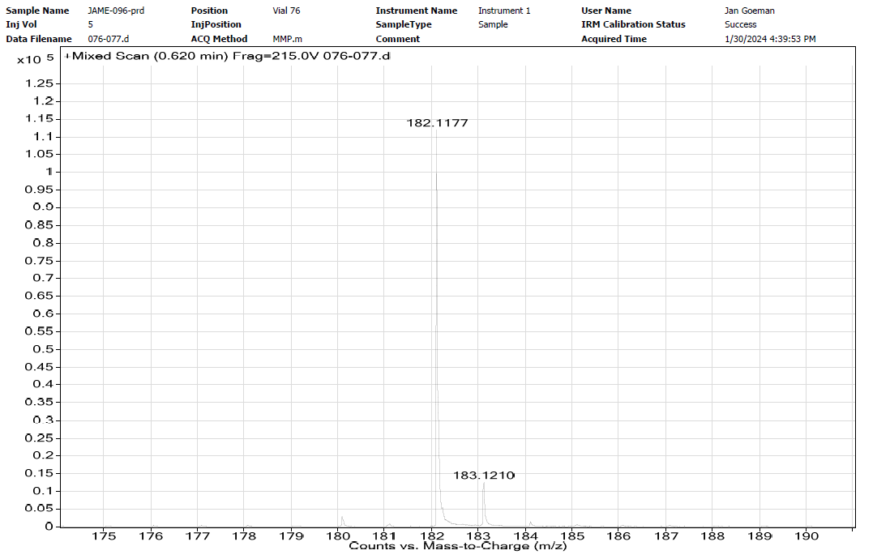

SI2

MF4
(low to no ionisation of product in positive mode ESI).

MF5

NBD-azide
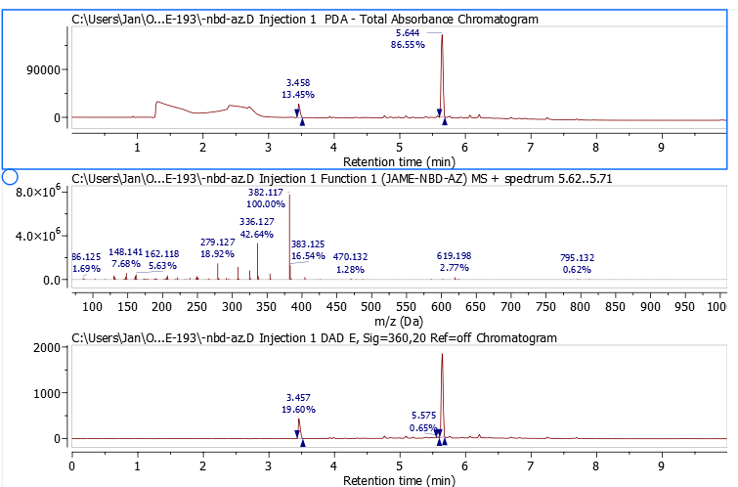

Mal-C5-NHS

References
1. Carmody, W. R. Easily prepared wide range buffer series. J. Chem. Educ. 38, 559 (1961).
2. Kalaitzakis, D., Kouridaki, A., Noutsias, D., Montagnon, T. & Vassilikogiannakis, G. Methylene Blue as a Photosensitizer and Redox Agent: Synthesis of 5-Hydroxy-1H-pyrrol-2(5H)-ones from Furans. Angew Chem Int Ed Engl 54, 6283–6287 (2015).
3. Beeck, M. op de & Madder, A. Sequence specific DNA cross-linking triggered by visible light. J Am Chem Soc 134, 10737–10740 (2012).
4. Mancuso, L. et al. Preparation of thermocleavable conjugates based on ansamitocin and superparamagnetic nanostructured particles by a chemobiosynthetic approach. Chemistry 20, 17541–17551 (2014).
5. Law, J. A., Callen, D. P., Paola, E. L., Gomes, G. & Frederich, J. H. A Stereoselective Photoinduced Cycloisomerization Inspired by Ophiobolin A. Org. Lett. 24, 6499–6504 (2022).
6. Berchel, M. et al. Modular Construction of Fluorescent Lipophosphoramidates by Click Chemistry. European J Organic Chem 2011, 6294–6303 (2011).
7. Surnar, B. et al. Orally Administrable Therapeutic Synthetic Nanoparticle for Zika Virus. ACS Nano 13, 11034–11048 (2019).
8. Geyter, E. de et al. 5-Hydroxy-pyrrolone based building blocks as maleimide alternatives for protein bioconjugation and single-site multi-functionalization. Chem Sci 12, 5246–5252 (2021).

