S1: Description of the data collection platform using the TIDieR¹ checklist

Item 1: Brief name
Electronic Patient Generated Health Data (ePGHD) – data collection platform

Item 2: Rationale, theory or goal of the elements essential to the intervention
Self-care for people with musculoskeletal conditions often includes taking pain-relieving medication at times of need and organising help with daily activities (social care). Information on this self-care is not systematically documented by healthcare providers but could be generated by patients themselves by completing a web-based questionnaire.
Item 3: Physical or informational materials used in the intervention, including those provided to participants or used in intervention delivery or in training of intervention providers

- PGHD instructions: PDF instructions emailed to consented participants during onboarding process. Instructions outlined how to open the personalised weblinks sent to each participant. Instructions included; trouble-shooting information, how to answer the different types of questions (slider questions and main question block) including examples, and how to reach out for further support.

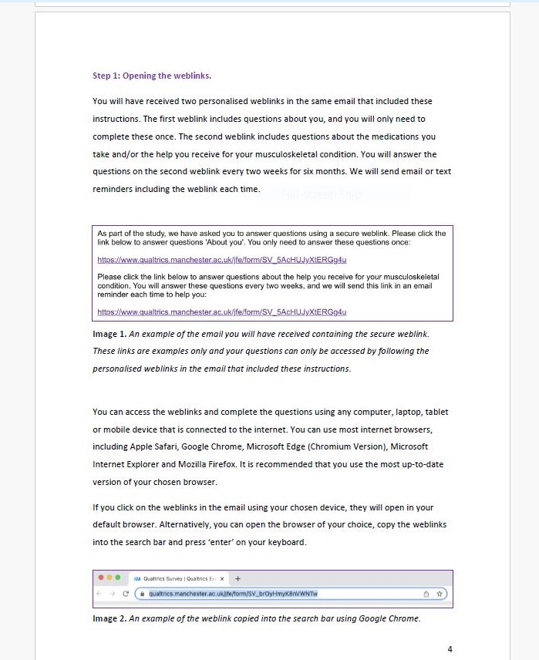

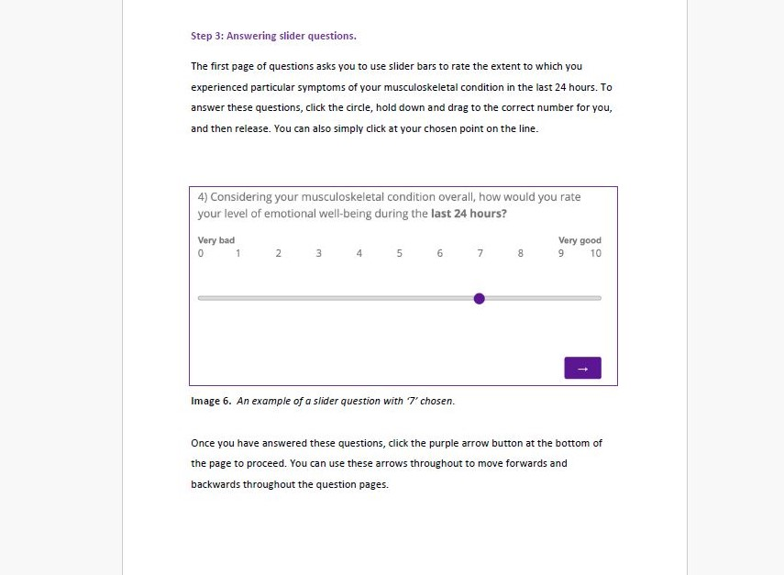

Screenshots of extracts from .PDF instructions sent to participants.

Item 4: Procedures, activities, and/or processes used in the intervention, including any enabling or support activities
Once consented, participants were asked to complete two questionnaires developed in Qualitrics. Along with PDF instructions, participants were emailed two personalised web-links. The first web-link took participants to a questionnaire to obtain demographic information – including date of birth, gender and ethnicity. Participants were only asked to complete this questionnaire once.
Participants were then asked to complete their first self-care questionnaire. Depending on whether they had an opioid prescription and/or used social care (see eligibility criteria for study), we asked them to submit ePGHD on ‘medication use’ and/or ‘Help received’, respectively. These are the questions that they were to be asked to complete every 2 weeks for 6 months. There were three item sets; i)‘About you’ (4 questions: pain, emotional well-being, ability to complete physical tasks, fatigue); ii) ‘Medication use’ (questions on opioid/over-the-counter drugs used, frequency and dose, any medication side effects, and use of additional supplements), and iii) ‘Help received’ (5 questions about the level and purpose of formal/informal social care needed). See Supplementary File S2 for the full questionnaire.
Participants were informed that they could complete these questionnaires more frequently, should they wish, at any time in-between their 13 scheduled dates. All participants were informed in their initial email of their questionnaire schedule (dates their questionnaires were to be completed) and the date their study period would end (6 months from the completion of the first survey).
Participants were sent reminder emails every two weeks for the study period (6 months). Participants could choose whether to also receive reminders via text message.
To thank participants for their time in the study, participants received a £20 voucher at the end of the study period. They also had the opportunity to be entered into a prize draw for another £20 voucher. Participants who completed >4 question sets received two newsletters at months 2 and 4 about the study and interviews with patient partners and researchers.
Item 5: Description of the expertise, background and specific training given to intervention providers
Research team had internal training on the use and design of Qualitrics.
Item 6: Modes of delivery (such as face to face or by some other mechanism, such as internet or telephone) of the intervention and whether it was provided individually or in a group
Data on self-care was collected form patients electronically using a web-based platform. Questionnaires were developed in Qualitrics, and personalised weblinks emailed to participants. Additional support (if necessary) was provided over the telephone.
Item 7: Type(s) of location(s) where the intervention occurred, including any necessary infrastructure or relevant features
Participants completed the questionnaire online, wherever they were based. Necessary technical equipment such as computer or smartphone was required and an internet connection.
Item 8: Number of times the intervention was delivered and over what period of time including the number of sessions, their schedule, and their duration, intensity, or dose
Participants were asked to complete the questionnaire at 13 time points (due dates) over six months. The collection period began when a participant had been on-boarded (i.e. completed the demographic survey at baseline and their first questionnaire).
Item 9: What, why, when, and how the intervention was planned to be personalised, titrated or adapted

Participants could choose whether to complete the questionnaire at each time point. They were also able to complete additional questionnaires as they wished.

Item 10: What, why, when, and how the intervention was modified during the course of the study
The questionnaire was co-designed with input from health professionals, researchers, and a patient and public involvement group of people living with a musculoskeletal condition. The research team developed an initial list of ePGHD items and obtained feedback from the group during an initial virtual workshop, with a focus on prioritising important and removing unnecessary items. The group also determined the frequency of data collection and acceptable average questionnaire completion time. During a second virtual workshop, the group commented on a prototype version of the questionnaire, co-produced participant instructions, and proposed engagement and participant support activities (i.e. prize draw, £20 acknowledgment and newsletters).

Item 11: How and by whom intervention adherence or fidelity was assessed, and any strategies that were used to maintain or improve adherence or fidelity
ePGHD completion was monitored throughout the study by the research team. If participants did not submit information for 3 consecutive time points (i.e. six weeks), a member of the research team contacted them via email or telephone call to offer support.

Item 12: The extent to which the intervention was delivered as planned in terms of adherence and fidelity
This is reported in the paper “Feasibility, acceptability, and added value of electronic patient-generated data on self-care use for people with musculoskeletal conditions: a mixed method study”

References
¹Hoffmann TC, Glasziou PP, Boutron I, Milne R, Perera R, Moher D, et al. Better reporting of interventions: template for intervention description and replicatin (TIDie) checklist and guide. BMJ. 2014;348:g1687. doi: 10.1136/bmj

Supplementary File S2: Full questionnaire set

Assembling the data jigsaw: Improving MSK research using patient-generated health data (PGHD)

PGHD Questions

Email address:___________________________________________________

Thank you for taking part in our study about medication use and help received by people with musculoskeletal conditions, led by researchers at The University of Manchester in partnership with the rheumatology team at Salford Royal.
Please use this weblink and answer the questions every two weeks. We will send an email to remind you each time. If you’d like to, you can complete the questions more frequently than this, such as every week, or when you feel your condition has been particularly good or challenging. We would still like you to still respond at the two-weekly intervals if possible, even if you respond extra times in between these intervals.
The questions will take around 10 minutes to complete (or 15 minutes if you answer question sets on both medication use and help received). You may find that it takes a little longer during your first few entries, but that you get quicker over time when you become familiar with the questions (and some questions e.g. ‘About you’ section will only be asked once). At the end of the questionnaire, you will be asked if you would like to spend an additional few minutes to complete some optional questions to inform our research. Your responses will be seen by the research team only, and will not be shared with your clinical team (doctors and specialist nurses). If you are concerned your disease is flaring, please contact the clinical team via the nurse helpline.
To ensure that we can match your answers with future entries, please answer the series of memorable questions below to generate your unique participant ID:
First letter of your mum’s first name | Day of your birthday (e.g. 02 for 2nd day of the month) |  | Last two letters of the town in which you were born |  | Last letter of your last name
The ID should consist of: letter-number-number-letter-letter-letter (e.g. N23ONE).
We will ask you these questions each time to help you remember and enter your unique participant ID before you begin the study questions. If you prefer, you can make a note of your unique participant ID instead. Your ID is also included in your study email with the instructions.
Your symptoms
This section asks questions about the symptoms of your musculoskeletal condition in the last 24 hours.

- Select the number that best describes the pain you felt due to your musculoskeletal condition during the last 24 hours.

- 1 2 3 4 5 6 7 8 9 10
None Extreme pain

- Considering your musculoskeletal condition overall, how would you rate your level of emotional well-being during the last 24 hours?

- 1 2 3 4 5 6 7 8 9 10
Very bad Very good

- Select the number that best describes the difficulty you had in doing daily physical activities due to your musculoskeletal condition during the last 24 hours

- 1 2 3 4 5 6 7 8 9 10
No difficulty Extreme difficulty

- Select the number that best describes how much fatigue have impacted your ability to function during the last 24 hours.

- 1 2 3 4 5 6 7 8 9 10
Not impacted at all Extreme impact

Help received
This section asks questions about if you have received help in the last two weeks with any of the following tasks, even if you don’t usually need help:
- Having a bath or shower/ washing your face and hands/ dressing or undressing/ using the toilet/
- Getting in and out of bed/ eating, including cutting up food/ taking the right amount of medicine at the right times/ getting around indoors/ getting up and down stairs/
- Getting out of the house/ shopping for food / doing routine housework or laundry/ doing paperwork or paying bills

- Have you received help from anyone with the tasks listed above in the last two weeks? Include help even if it was for a short time or provided anyone including professional social care staff, family members or friends and neighbours.
- Yes
- No

If no:
Skip to medication questions.

- Who helped with these tasks in the last two weeks? Please choose all that apply.
- Informal care (e.g., partner, family member, friend or neighbour)
- Funded homecare (e.g., homecare worker, home help, personal assistant)
- Reablement teams and/or intermediate care staff team
- Occupational therapist and/or physiotherapist
- Sheltered accommodation (e.g., housing manager, warden)
- Other (please specify)
- Prefer not to say

- Which activities did you need help with in the last two weeks? Please choose all that apply.
Having a bath or shower | Getting around indoors
Getting in and out of bed | Getting up and down stairs
Washing your face and hands | Getting out of the house
Dressing or undressing | Shopping for food
Using the toilet | Doing routine housework or laundry
Eating, including cutting up food | Doing paperwork or paying bills
Taking the right amount of medicine at the right times | Prefer not to say

- Did you receive help with any leisure activities, such as hobbies, socialising or meeting up with friends in the last two weeks?
- Yes
- No
- Prefer not to say

- Did you pay for the help you receive in the last two weeks? If you pay family/friends/neighbours to help you, please choose yes.
- Yes
- No
- Prefer not to say

If no/prefer not to say:
Thank you for your answers. You have now completed this question set. Would you like to spend another two minutes answering two additional questions to inform our research?
- Yes
- No

If Yes, skip to Optional questions. If No, skip to medication questions.

- Who paid for the help you received in the last two weeks?
- I pay for it myself (through own resources)
- I pay for it myself (through personal budget)
- The council/local authority/social services
- Continuing Health Care funding
- A family member (with their own money)
- Other (please specify)
- Prefer not to say

Thank you for your answers. You have now completed this question set. Would you like to spend another two minutes answering two additional questions to inform our research?
- Yes
- No

If Yes, skip to Optional questions. If No, skip to medication questions.

Optional questions (Help received)

- Thinking about the activities you get help with, how often did you receive help with them in the last two weeks?
- More than once a day
- Once a day
- Two to six times a week
- Once a week
- Once every two weeks
- Prefer not to say

- Thinking about the person/people who helped you with your activities, how many hours in total have they helped you in the last two weeks? Do not include time they were around the house or there to help you if you needed it.
- Less than one hour
- 1-4 hours
- 5-9 hours
- 10-19 hours
- 20-34 hours
- 35-49 hours
- 50 hours or more
- Prefer not to say

Skip to medication questions.

Opioid and over-the-counter medications
This section asks questions about if you have taken opioids and over-the-counter medications in the last two weeks.
Please note the information collected below will be used by researchers to improve future care and will not be used to inform your current or future prescriptions.

- Are you prescribed opioid tablets/preparations (e.g. codeine, tramadol, morphine) to manage your musculoskeletal condition?
- Yes
- No

If no:
Proceed to Q9

- For which condition(s) have you taken your opioid tablet/preparation for in the last two weeks? Please choose all that apply.
- Joint conditions:  - Osteoarthritis  - Rheumatoid arthritis  - Psoriatic arthritis  - Ankylosing spondylitis  - Gout  - Other joint condition (please specify)  - Muscle conditions:  - Sarcopenia  - Other muscle condition (please specify)  - Other (please specify) | - Bone conditions:  - Osteoporosis  - Osteopenia  - Fragility or traumatic fractures  - Other bone condition (please specify)  - Spine conditions:  - Back pain  - Neck pain  - Other spine condition (please specify)  - Prefer not to say

- Which opioid tablet(s)/preparation(s) have you taken in the last two weeks? Please choose all that apply.
- Codeine  - Dihydrocodeine  - Cocodamol  - Codydramol  - Tramadol  - Morphine  - Oromorph  - Oxycodone | - Patches:  - Buprenorphine  - Fentanyl  - Other (please specify)  - Prefer not to say
For each opioid you have chosen, we will now ask you about the dose, frequency and length of time you have been taking it.
For every opioid chosen in question 3, participant will be asked i), ii), and iii) with relevant information inserted (as X).
If prefer not to say:
Proceed to Q4.

- You said you take X. We are interested in the total dose of X that you take per day on an average day.

What strength of X did you take each day (e.g. 30mg) in the last two weeks?

________ | - Milligrams (mg)  - Micrograms (mcg)  - Millilitres (mls)  - Not sure or prefer not to say

- In the last two weeks, how many doses of X did you take per day? If you do not take X every day, please choose per week.
________ | - Per day  - Per week

- How long have you been taking X for? Please answer for the current episode (e.g. since you most recently began taking X regularly), rather than when you first ever took X.
- Less than 1 month
- 1-3 months
- 4-12 months
- More than 12 months
- Prefer not to say

- How have you felt about your opioid tablet/preparation prescription in the last two weeks (e.g. you are happy with your prescription because it meets your needs, or you are not happy with your prescription because you experience unpleasant symptoms whilst taking it)?

If you are unsure, please write 'don't know' in the box. If you prefer not to say, please leave blank.

- Many people find that after being on opioids for some time they become less effective even though their pain/condition has not changed (e.g. you need to take a higher dose to feel the same effect on your pain). Is this something you have experienced in the last two weeks?
- Yes
- No
- Prefer not to say

- Have you ever missed doctors’ appointments, family/friend activities or other commitments because of the effects from opioids?
  - Yes
  - No
  - Prefer not to say

- Have you taken your opioid medication even when not in pain, just in case in the last two weeks?
- Yes
- No
- Prefer not to say

- Have you had to borrow an opioid medication from a family member or friend to help with the pain in the last two weeks?
- Yes
- No
- Prefer not to say

- Have you needed to get your opioid prescription refilled early (e.g., before you are due a new prescription) in the last two weeks?
- Yes
- No
- Prefer not to say

- Have you taken any additional over-the-counter pain relievers in the last two weeks? Please choose all that apply.
- Simple pain relievers:  - Paracetamol (with or without caffeine)  - Anti-inflammatories:  - Ibuprofen (e.g., Nurofen)  - Aspirin | - Weak opioids:  - Codeine containing preparations (e.g., Panadol Ultra, Nurofen plus, Solpadeine, codeine cough syrup)  - Dihydrocodeine containing preparations (e.g., Paramol)  - Other (please specify)  - Prefer not to say
If one or more chosen, participants will be asked i). If none chosen, skip to Q10.

- Is there anything you want to share about your experience of purchasing additional over-the-counter pain relievers? E.g., if you were questioned by the pharmacist, financial implications, etc.

If you are unsure, please write 'don't know' in the box. If you prefer not to say, please leave blank.



- Whilst taking your opioid tablet/preparation or additional over-the-counter pain relievers for your musculoskeletal condition, have you experienced any of the following symptoms in the last two weeks? Please choose all that apply.
Effect on stomach/bowel: Effect on breathing/sleep/heart:
Drowsiness
Poor sleep
Palpitations (feeling of heart racing)
Fast pulse rate
Slow pulse rate
Slowed breathing
Constipation
Feeling sick
Vomiting
Indigestion
Dry mouth
Stomach cramps
Low appetite
Difficulty swallowing



Others:

Excessive sweating | Tremor
Difficulty passing urine | Watering eyes
Sexual dysfunction | Dry eyes
Fatigue | Loss of smell
New rash | Unsteady on feet
Increased infections | Other (please specify)
Weight gain | Prefer not to say
Effect on mood/brain:

Brain fog | Hallucinations
Poor concentration | Nightmares
Feeling low | Restlessness
Feeling euphoric | Dizziness
Confusion | Headaches

- Have you taken any of the following over-the-counter supplements, including vitamins and minerals, herbal or nutritional supplements in the last two weeks? Please choose all that apply. Do not include supplements you take on prescription.

Vitamins and minerals: Speciality supplements:
Vitamin D
Calcium
Vitamin C
Indigestion
Zinc
Vitamin B/B complex
Multivitamin
Magnesium

CBD oil
Omega-3
Omega-6
Probiotics
Glucosamine
Chrondroitin
Coenzyme-Q10

Echinacea
Tumeric
St John’s wort
Valerian
Ginseng
Ginkgo biloba
Cranberry

Herbal supplements: Sports nutrition & weight management:
Protein supplement
Green tea extract
Fat binder tablets
Keto supplements
Creatine

- Have you tried any additional non-drug related treatments to help with your pain in the last two weeks?
- Exercises
- Devices (please specify)
- Others (please specify)
- I have not tried any non-drug related treatments.
- Prefer not to say

Thank you for your answers. You have now completed this question set. Would you like to spend another few minutes answering four additional questions to inform our research?
- Yes
- No

If Yes, skip to Optional questions. If No:
Thank you for your answers. You have now completed this question set.
End of questions
Optional questions
Opioid and over-the-counter medications

- Could you describe how your pain has affected you in the last two weeks?

If you are unsure, please write 'don't know' in the box. If you prefer not to say, please leave blank.

- Are there any other effects of your opioid you would like to tell us about (e.g., withdrawal effects)?

If you are unsure, please write 'don't know' in the box. If you prefer not to say, please leave blank.

- Are there any other effects of your over-the-counter pain relievers you would like to tell us about (e.g., withdrawal effects)?

If you are unsure, please write 'don't know' in the box. If you prefer not to say, please leave blank.

- How much did you spend per month on over-the-counter pain relievers or supplements in the last two weeks? Please do not include prescription costs.

If you are unsure, please write 'don't know' in the box. If you prefer not to say, please leave blank.

£________

Thank you for your answers. You have now completed this question set.
End of questions.

To be completed once on a separate link (at baseline entry).

About you
This section asks questions about you.

- To which gender identity do you most identify?

  - Female
- Male
- Transgender female
- Transgender male
- Gender variant/non-conforming
- Not listed (free text option)
- Prefer not to say

- Please tell us your date of birth

- Prefer not to say

- Please tell us your ethnicity

White:

English, Welsh, Scottish, Northern Irish or British

Irish

Gypsy or Irish Traveller

Any other White background

Mixed or Multiple ethnic groups:

White and Black Caribbean

White and Black African

White and Asian

Any other Mixed or Multiple ethnic background

Asian or Asian British:

Indian

Pakistani

Bangladeshi

Chinese

Any other Asian background

Black, African, Caribbean or Black British:

African

Caribbean

Any other Black, African or Caribbean background

Other ethnic group:

Arab

Any other ethnic group

Prefer not to say

- Please tell us your employment status:
- Paid work full-time (at least 32 hours per week)
- Paid work part-time
- Full-time student
- Part-time student
- Homemaker or carer for member of your household (e.g., children or elderly)
- Volunteering (unpaid)
- Retired
- Unemployed
- Other (please specify)
- Prefer not to say
5) Please tell us your highest level of educational attainment:

- Some high school
- Finished high school/college
- Trade/technical/vocational training
- Bachelor’s degree
- Postgraduate degree (e.g. Masters or Doctorate)
- Other (please specify)
- Prefer not to say

Thank you for your answers. You have now completed this question set.
End of questions.

Supplementary File S3: Structured template for comparison of records

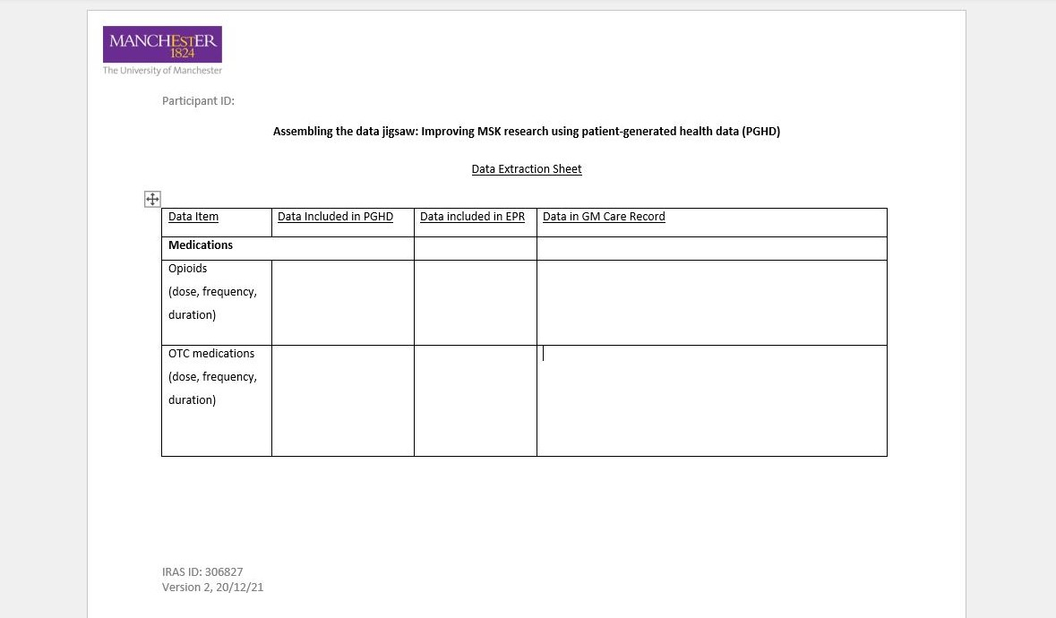
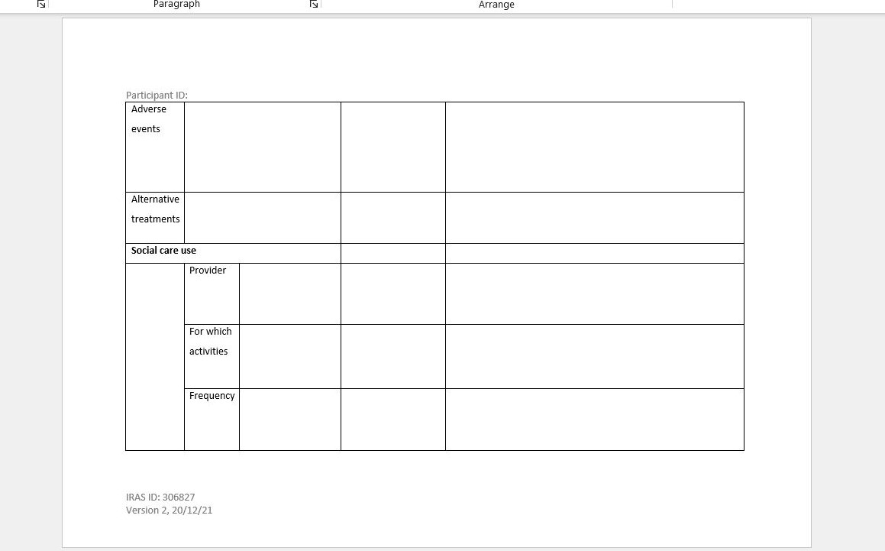
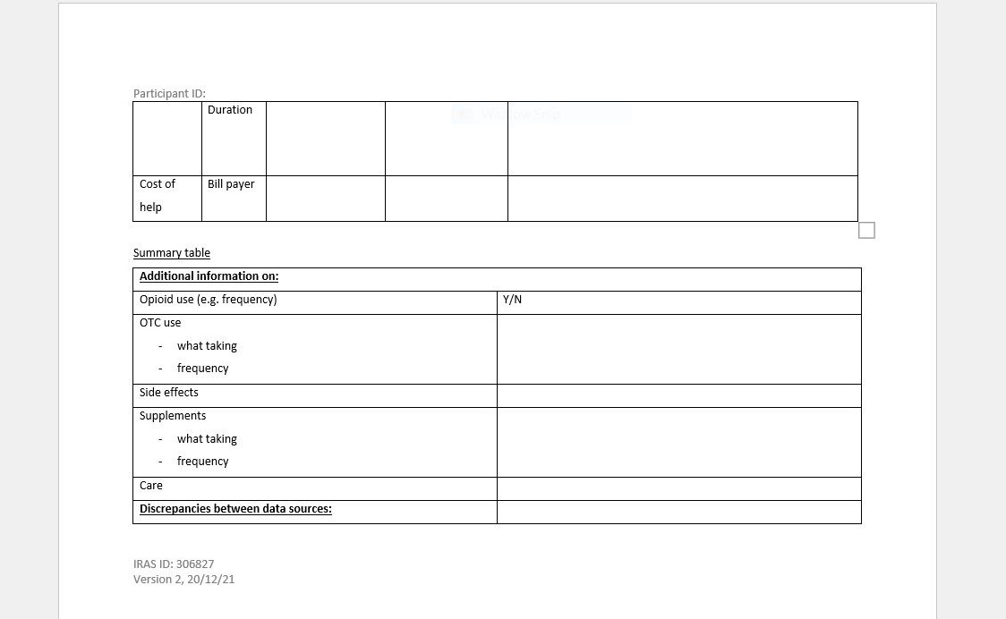

Supplementary File S4: Semi-structured interview schedule

Assembling the data jigsaw: Improving MSK research using patient-generated health data (PGHD)

Interview topic guide

Project title: Assembling the data jigsaw; Assessing the feasibility, acceptability and added value of collecting novel patient-generated health data (PGHD) on social care and over-the-counter (OTC) medication use in patients with musculoskeletal conditions: a mixed methods study.

Prior to commencement, check if the participant is happy to proceed and that it is still a good time for them to take part in the interview. Ask for permission to remind the participant about some important details:
  - the interview will be audio recorded and transcribed;
  - names/identifying information will be removed during transcription;
  - a unique participant ID will be used to link interview data to PGHD, hospital and GP EHR data;
  - the interview will last around 45 minutes, and they can refuse to answer any questions or stop the interview at any time.

The purpose of this interview is to understand the participant’s experience of taking part in PGHD collection. Explain there will be three sections to the interview:
- understanding perceptions and attitudes towards collecting PGHD for healthcare;
- exploring the experience of collecting PGHD in the study;
- opportunity for the participant to ask questions and add anything else.

Ask the participant if they have any questions at this point. Once these have been answered, explain to the participant that you will now start the recording device. Check that the recording device is working and turned on before beginning the interview questions.

Section 1 – Understanding perceptions and attitudes towards collecting PGHD for healthcare (10 mins)
- What had you heard about collecting PGHD for healthcare before participating in this study?
  - Have you collected PGHD for healthcare/another study before?

- How do you think collecting PGHD could impact care for your MSK condition?
  - Benefits (e.g. insight into condition, accurate information)?
  - Drawbacks (e.g. burden of completion, perception of unused information)?
  - Expectations (e.g. discuss at some/every appointment, contacted in-between)?
  - Collecting OTC medication use data, in particular?
  - Collecting social care use data, in particular?

Section 2 – Exploring the experience of collecting PGHD in this study (30 mins)
- How did you feel about collecting PGHD in this study?
  - What did you like/not like about it?
  - How interested/motivated were you to collect PGHD for this study? Why?
  - How did collecting PGHD fit with your daily life?
  - How open were you to collect PGHD? Why?
  - How does collecting PGHD fit with your perception of optimum healthcare?

- How was it to use the web-based platform to collect PGHD?
  - What did you like/not like about it?
  - Was it easy/complex to use?
  - What was the impact of the guidance and materials?
  - How confident, if at all, were you that you had the necessary IT knowledge to take part in the study?
  - How far, if at all, did using the web-based platform to collect PGHD fit with daily life?

- How far, if at all, did the data items capture your experience of your OTC medication use?
  - Items you would add? Why?
  - Items you would remove? Why?
- Did you know (easily) which medications you take?/how much?
- How did you feel about providing info on your OTC medication use? Probe: any hesitations providing info on this? How did you feel about the answers to your opioid questions? Probe: any surprises? E.g. Had you previously thought about how long you had been on opioids?/about side effects from opioids?
- How far, if at all, did the data items capture your experience of your social care use?
  - Items you would add? Why? Do you feel the questions captured everything that is important to you?
  - Were there any items you would remove? Why?
  - Had you previously thought about how much help you received informally? Was it a surprise to you? Has this changed anything for you?

  - If you had completed this survey a year ago, would your answers have looked fairly similar? Would the data items have captured everything then?

  - Do you think that this information will already be in your EHR? Do you think that this information adds anything of value to your EHR? What will this impact, and it what way?
    - Do you think the degree of support you receive is captured in your EHR?
    - Medication – do you think there will be discrepencies between what you have contributed and what is in your EHR?
    - Are you aware of any errors in medication in your EHR?
  - How do you feel about your doctor having the information that you have provided? Probe: confident/happy with the accuracy of the data?

- How did you feel about the length of time required to collect the PGHD (e.g. 15 mins)?
  - How did you feel about the frequency (e.g. weekly)?
  - How did you feel about the duration of the study (e.g. six months)?
  - Which parts, if any, of collecting PGHD felt effortful? Why?
  - Do you feel that it is your responsibility to contribute this information? (Probe: Is it shifting responsibility from your doctor to ask these questions?)

- How far, if at all, did collecting PGHD impact your daily life?
  - How far, if at all, did you change your schedule/activities? Why?
  - How far, if at all, did it change your mood/symptom experience? Why?

Section 3 – Participant questions and any other thoughts (5 mins)
- Do you have any questions for me?
- Is there anything else you would like to add?

At the end of the interview, thank the participant for taking part and turn the recorder off. Remind the participant again that:
- the interview has been audio recorded and will be transcribed;
- identifying information (such as names, places mentioned) will be removed upon transcription;

END OF INTERVIEW

