Table S1. Covariates used to model jungle cat (Felis chaus) distribution in the ensemble framework (MaxEnt and Random Forest), including data sources, spatial resolution, temporal coverage, and a priori expectations of their relationship with jungle cat occurrence.

S. No. | Covariate | Time Period | Resolution | Source | Reference | A Priori Hypothesis (with Justification)
1 | Bioclimatic Variables | 1970–2000 | 1 km | WorldClim v2 | Fick & Hijmans, 2017 | Jungle cats are expected to occur predominantly in arid to semi-arid and dry tropical regions, favoring areas with higher temperatures and lower rainfall. This preference is linked to their physiological tolerance to heat, their avoidance of dense wet forests, and their known occurrence in dry deciduous forests, scrublands, and grasslands where prey like rodents and birds are abundant (Mukherjee et al., 2004; Sunquist & Sunquist, 2002).
2 | Human Modification Index | 2019 | 1 km | SEDAC | Kennedy et al., 2019 | Jungle cats are likely to avoid highly modified landscapes but may persist in areas with low to moderate human-induced disturbance. This is due to their ecological plasticity and tolerance of fragmented landscapes, especially in agricultural mosaics with cover and prey availability, although they still require some refuge from intensive urbanization or infrastructure (Mukherjee et al., 2010; Bandyopadhyay et al., 2024).
3 | Livestock Density | 2010 | 10 km² | Gridded Livestock of the World v3 | Gilbert et al., 2018 | Jungle cats are expected to occur in areas with low to moderate livestock densities. These densities may create favorable edge habitats and increase prey like rodents, but very high densities may lead to overgrazing, habitat degradation, competition with domestic dogs, and increased human-wildlife conflict (Gray et al., 2016).

Table S2. Home-range sizes of Jungle cats estimated by radio-telemetry.
ID | Sex | 95%KDE (sq. km) | Reference
Uttan | M | 3.59 | This study
Jio | M | 7.89 | This study
Leo | M | 9.17 | This study
Yellow | M | 5.29 | This study
Jungle cat 04 | F | 3.08 | Katna et al.2022
Jungle cat 05 | M | 6.74 | Katna et al.2022
Jungle cat 06 | F | 2.46 | Katna et al.2022
Jungle cat 07 | M | 2.87 | Katna et al.2022
Jungle cat 08 | M | 4.03 | Katna et al.2022
Jungle cat 09 | M | 5.98 | Katna et al.2022
Jungle cat 11 | M | 20.68 | Katna et al.2022
Jungle cat 12 | F | 3.72 | Katna et al.2022
Jungle cat 13 | F | 1.77 | Katna et al.2022
Jungle cat 15 | M | 5.69 | Katna et al.2022
Jungle cat 16 | M | 1.85 | Katna et al.2022
Jungle cat 17 | F | 1.01 | Katna et al.2022

Figure S1. Map of jungle cat (Felis chaus) presence locations across India, overlaid on land use–land cover patterns. Presence locations are marked in light yellow
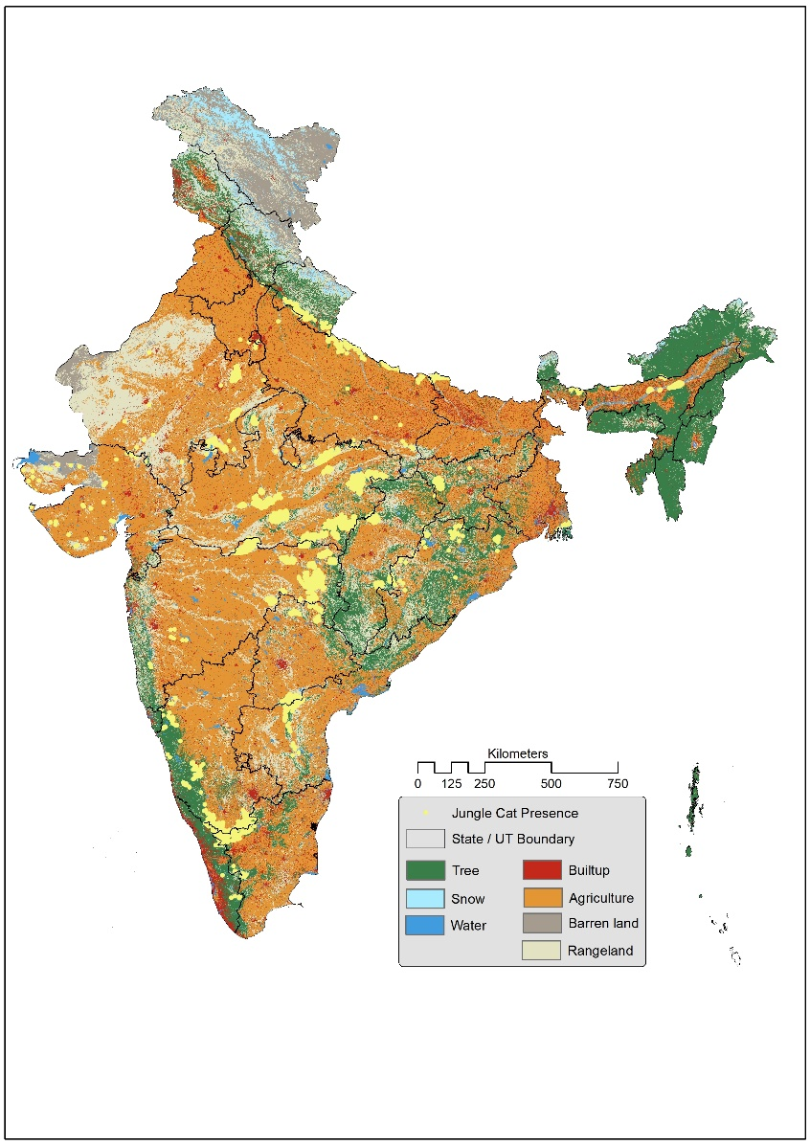

References:
- Bandyopadhyay, K., Banerjee, K., Vittoria Mazzamuto, M., Koley, S., Koprowski, J. L., Qureshi, Q., & Jhala, Y. (2024). Review of small cat ecology and status within India. Mammal Review, 54(4), 341-356. https://doi.org/10.1111/mam.12348
- Buchhorn M, Lesiv M, Tsendbazar N-E, Herold M, Bertels L, Smets B. (2020). Copernicus Global Land Cover Layers—Collection 2. Remote Sensing 12(6):1044. https://doi.org/10.3390/rs12061044
- Didan, K. (2015). MOD13C2 MODIS/Terra Vegetation Indices Monthly L3 Global 0.05Deg CMG V006 [Data set]. NASA EOSDIS Land Processes DAAC. Accessed 2021-10-31 from https://doi.org/10.5067/MODIS/MOD13C2.006
- Elvidge, C.D., Baugh, K., Zhizhin, M., Hsu, F.C. and Ghosh, T. 2017. VIIRS night-time lights. International Journal of Remote Sensing, 38 (21), 5860-5879.
- Gilbert, M., Nicolas, G., Cinardi, G. et al.(2018) Global distribution data for cattle, buffaloes, horses, sheep, goats, pigs, chickens and ducks in 2010. Sci Data 5, 180227. https://doi.org/10.1038/sdata.2018.227
- Gray, T. N. E., Timmins, R. J., Jathana, D., Duckworth, J. W., Baral, H., & Mukherjee, S. (2016). Felis chaus. The IUCN Red List of Threatened Species 2016: e. T8540A50651463.
- Katna, A., Kulkarni, A., Thaker, M., & Vanak, A. T. (2022). Habitat specificity drives differences in space‐use patterns of multiple mesocarnivores in an agroecosystem. Journal of Zoology, 316(2), 92-103. https://doi.org/10.1111/jzo.12933
- Kennedy, C.M., J.R. Oakleaf, D.M. Theobald, S. Baurch-Murdo, and J. Kiesecker. 2019. Managing the middle: A shift in conservation priorities based on the global human modification gradient. Global Change Biology 25(3):811-826. https://doi.org/10.1111/gcb.14549.
- Mukherjee, S., Goyal, S. P., Johnsingh, A. J. T., & Pitman, M. L. (2004). The importance of rodents in the diet of jungle cat (Felis chaus), caracal (Caracal caracal) and golden jackal (Canis aureus) in Sariska Tiger Reserve, Rajasthan, India. Journal of Zoology, 262(4), 405-411. https://doi:10.1017/S0952836903004783
- OpenStreetMap contributors (2015). Retrieved from https://planet.openstreetmap.org
- Sunquist, M. & Sunquist, F. Wild Cats of the World. (University of Chicago Press, 2002).

