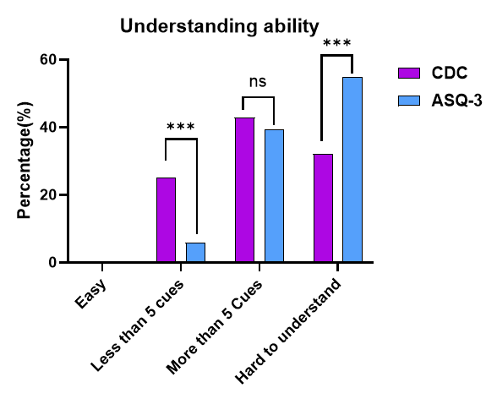
Bar Graph 1: Understanding Ability

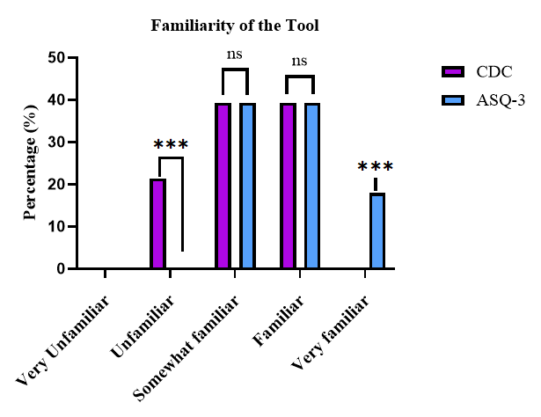
Bar Graph 2: Familiarity of Screening Tool Questions

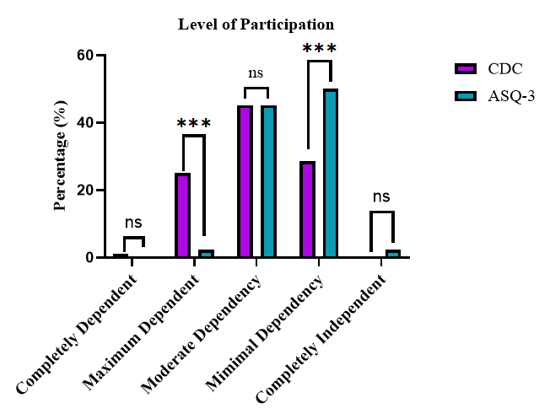
Bar Graph 3: Comparison of parental level of Participation

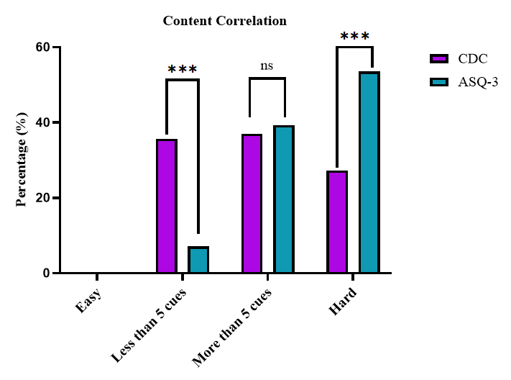
Bar Graph 4: Comparison of Content Correlation

Bar Graph 5: Comparison of Curiosity of Participation
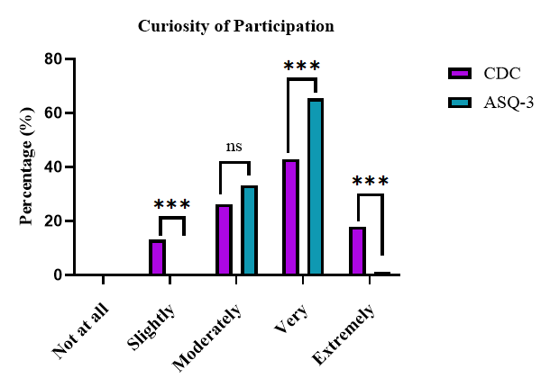

Bar Graph 6: Comparison of Duration of Participation
