Supplementary Material
Table 6: Initial quantitative (Two-independent groups)- Mann-Whitney U test results
Sub Categories | Reading skill | Understanding Ability | Content Correlation | Level of Participation | Curiosity of Participation | Familiarity with questions | Duration of Participation
Z-value | -0.105 | -1.325 | -1.872 | -0.978 | -0.742 | -1.115 | -0.921
p-value | 0.916 | 0.185 | 0.061 | 0.328 | 0.458 | 0.265 | 0.327
p<0.005**,p<0.05*
Bar Graph 7: Level of participation of Preterm and full-term parents
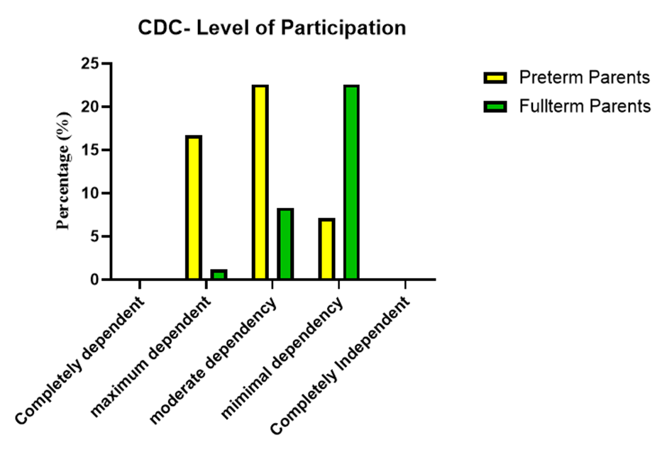
Bar graph 8: Curiosity of Participation by Preterm and Full-term parents
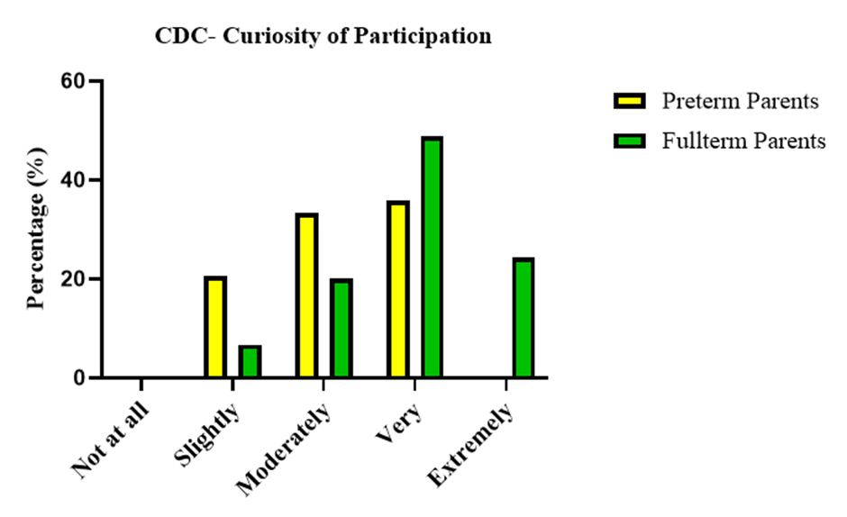
Bar graph 9: ASQ-3 Understanding Ability of Preterm and Full-term Parents
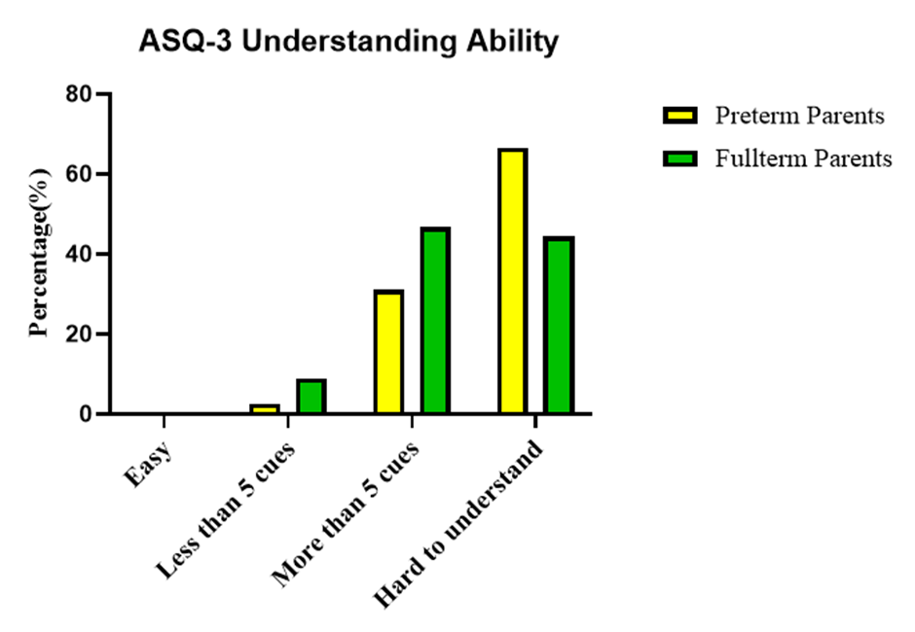

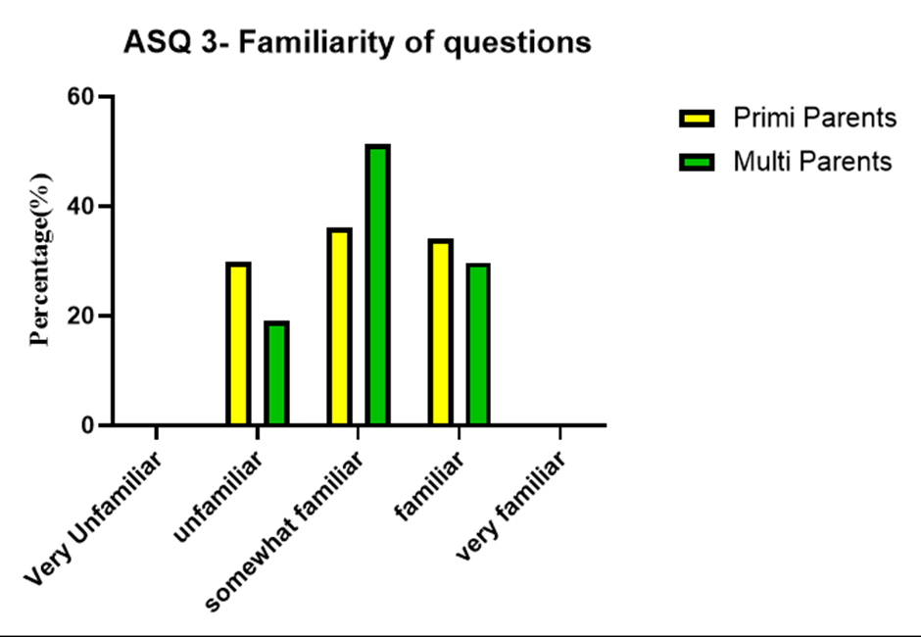
Bar Graph 10: ASQ-3 Familiarity of questions by Primi and Multi Gravida parents

