Supplementary Information.
Wavelength-Dependent Feedback Behavior in Light-Gated Polymersome Nanoreactors
Uthaya Lathan^{1ǂ}, Beyzanur Kaya^{1ǂ}, Farzina Matubbar¹, Mohamed Chami², Jonathan Yeow³,
Omar Rifaie-Graham¹*
¹Department of Chemistry, School of Physical and Chemical Sciences, Queen Mary University of London, London, E1 4NS United Kingdom
²BioEM Lab, Biozentrum, University of Basel, Basel, 4058 Switzerland
³Graduate School of Biomedical Engineering, University of New South Wales, Sydney, NSW, 2052 Australia
^{ǂ}Authors contributed equally
Correspondence: o.rifaiegraham@qmul.ac.uk
Supplementary Section 1. Structural analysis of the PYRA polymer. GPC analysis indicated that the polymer exhibited a dispersity (Đ) of 1.23 and an apparent number-average molecular weight (M_{n}) of 18 800 g·mol⁻¹, based on poly(methyl methacrylate) calibration standards (see Supplementary Fig. 1). Further characterisation using ¹H NMR spectroscopy (Supplementary Fig. 3) enabled the calculation of the M_{n} of the poly(ethylene glycol) segment using the following equation:
$$PEG M_{n}\left(g∙{mol}^{-1}\right)=\frac{3e}{4f}∙44.05+M$$
Where, M represents the molar mass of the methoxy end group on the PEG chain, which is 31.03 g·mol⁻¹. Based on NMR analysis, the average number of ethylene glycol units per polymer chain was estimated to be 45.6, resulting in a calculated M_{n} for the PEG segment of 2 040 g·mol⁻¹.
The extent of functionalization of the hydrophobic block was determined using the integrals from the ¹H NMR spectrum, calculated according to the equation provided (see Supplementary Fig. 4 for peak assignments and integral values):
$$anisole content (mol\%)=\frac{e+f}{e+f+2a}∙100$$
Approximately 9.2 mol% of the hydrophobic residues were functionalized with the pyrazolone-based DASA, while the remaining 90.8 mol% were attributed to poly(hexyl methacrylate) segments. Using the M_{n}​ of the PEG block, estimated from the ¹H NMR data (Supplementary Fig. 4A), as 2 040 g·mol⁻¹, the M_{n}​ of the hydrophobic block was derived based on the ratio of repeating units within that segment:
$$\frac{hydrophobic block repeating units}{hydrophylic block repeating units}=\frac{2a+e+d}{c}$$
The hydrophobic block was estimated to contain 45.54 repeat units per chain. Based on the molar ratio and the molecular weight of each repeating unit, the number-average molar mass (M_{n}​) of the hydrophobic block was calculated to be approximately 7 320 g·mol⁻¹. Consequently, the M_{n}​ of the full diblock copolymer incorporating the aromatic amine DASA precursor was determined to be around 18 060 g·mol⁻¹.
Supplementary Section 2. Determination of esterase encapsulation in PYRA-esterase nanoreactors. A 200 μL aliquot of trypsinized PYRA–esterase nanoreactors was treated with 40 μL of an aqueous solution containing the trypsin inhibitor aprotinin (30.7 nmol) and incubated overnight at room temperature. The nanoreactors were subsequently lysed by dilution in Triton X-100 (20 mmol∙mL⁻¹) to a final volume of 1 mL, following a previously reported protocol.¹ Enzymatic activity was assessed by transferring 2 μL of the treated solution into a 96-well microplate containing 300 μL of BP (3.7∙10⁻¹ μmol∙mL⁻¹) and saturated ethyl acetate at pH 7.4. Absorbance at 405 nm was monitored over time. As a control, a fresh aliquot of non-encapsulated esterase (at equivalent concentration) was subjected to solvent exchange under the same conditions used for preparing DASA–esterase nanoreactors, but in the absence of DASA polymer and trypsin. This control sample was spiked with aprotinin and Triton X-100 as described above but was not incubated at room temperature to preserve enzymatic activity. Instead, it was immediately tested for ethyl acetate hydrolysis under the same BP assay conditions used for the PYRA–esterase nanoreactors. Retention of enzymatic activity was calculated using the following formula:
$$Encapsulation Efficiency=\frac{m_{PE}}{m_{FE}}$$
Where, m_{PE} is the slope of the reaction catalysed by the enzyme liberated from the PYRA-esterase nanoreactors, and m_{FE} is the slope catalysed by the treated free esterase. No blank reaction was observed. It was calculated that an equivalent of 6.78% of the enzyme activity was retained, which corresponds to the encapsulation efficiency (assuming no loss of enzyme activity for the loading and trypsinisation process for PYRA-esterase). This data also confirms successful protection of esterase from proteases when encapsulated within PYRA polymersomes.
Supplementary Section 3. Dissecting photoinduced negative feedback mechanisms via external esterase addition. To investigate whether the cessation of catalytic activity was driven by light-dependent feedback mechanisms, free esterase was added to PYRA-esterase dispersions previously exposed to yellow or blue light. In the presence of bromocresol purple and ethyl acetate, catalytic activity was monitored by absorbance, as detailed in the Methods section. Samples were irradiated with yellow light (λ = 590 nm) at 1.76 mW·cm⁻² for 160 minutes (Fig. 2F), or blue light (λ = 405 nm) at 1.54 mW·cm⁻² for 240 minutes (Fig. 3F). Following the formation of a steady-state absorbance plateau, 5 μL of an aqueous solution containing 90 pmol of free esterase was introduced. No subsequent change in absorbance was observed in yellow-light-irradiated samples, indicating enzyme deactivation due to local acidification. In contrast, samples previously exposed to blue light showed a renewed increase in absorbance, suggesting that the reaction plateau was caused by a light-induced photomask effect rather than substrate depletion. These observations confirm two distinct feedback mechanisms: a pH-mediated inhibition in the yellow-light condition, and a photomask-based optical inhibition in the blue-light case. pH values were estimated by extrapolating absorbance readings onto the calibration curve shown in Supplementary Fig. 13.
Supplementary Section 4. Assessment of nanoreactor stability under light irradiation. To assess the structural stability of the PYRA–esterase nanoreactors upon light activation, dispersions were irradiated with either blue light (405 nm, 1.10 mW·cm⁻²) or yellow light (590 nm, 1.06 mW·cm⁻²) for 30 minutes. The samples were subsequently analyzed by DLS (Supplementary Fig. 5) and cryogenic transmission electron microscopy (cryo-TEM) (Supplementary Figs. 8 and 10). Both techniques revealed no detectable changes in particle size or morphology, confirming that the nanoreactors retained their structural integrity under both irradiation conditions.
Supplementary Section 5. Nanoreactor stability to variations of pH. To determine whether the PYRA–esterase nanoreactors maintain their structural integrity during pH fluctuations, dispersions initially adjusted to pH 8 were acidified to pH 6 by the addition of acetic acid. Both the neutral and acidified samples were incubated at room temperature for 24 hours. Structural analysis by cryo-TEM at both pH conditions (Supplementary Fig. 9) revealed no observable morphological changes, indicating that the nanoreactors remained intact and functionally stable during pH cycling.
Supplementary Section 6. Absorbance–pH Relationship in Bromocresol Purple Solutions. To explore the relationship between absorbance and pH in BP-containing solutions, 300 μL aliquots of an aqueous solution of the dye (3.7∙10⁻¹ mmol·mL⁻¹) and saturated ethyl acetate (pH 7.6) were dispensed into the wells of a 96-well Corning microplate made of non-binding polystyrene. Small volumes (less than 1 μL) of either acetic acid or sodium hydroxide were added to adjust the pH across a range. The pH of each sample was measured using a pH electrode, and absorbance spectra were acquired using a Spectramax M5 UV-Vis plate reader (Molecular Devices) (Supplementary Fig. 13). The resulting data were modelled using an exponential decay function, yielding a strong fit with an r² value of 0.99 and producing the following correlation equation (Supplementary Fig. 13):
$$pH=7.24349+{1.01835}^{\frac{-(x-0.83726)}{0.04639}}+{0.98563}^{\frac{-(x-0.83726)}{0.20131}}+{1.1027}^{\frac{-(x-0.83726)}{0.20128}}$$

Supplementary Figures
Supplementary Scheme 1. Synthesis of PYRA polymer. A. RAFT polymerization of PEG-based macroCTA with PFPMA and HMA to form an activated ester diblock copolymer. B. Subsequent removal of the RAFT end group. C. Formation of the aromatic amine DASA precursor polymer via amidation of the activated esters with MPDP. D. Final conjugation with a pyrazolone-derived furan adduct to yield the DASA-functionalized diblock copolymer.
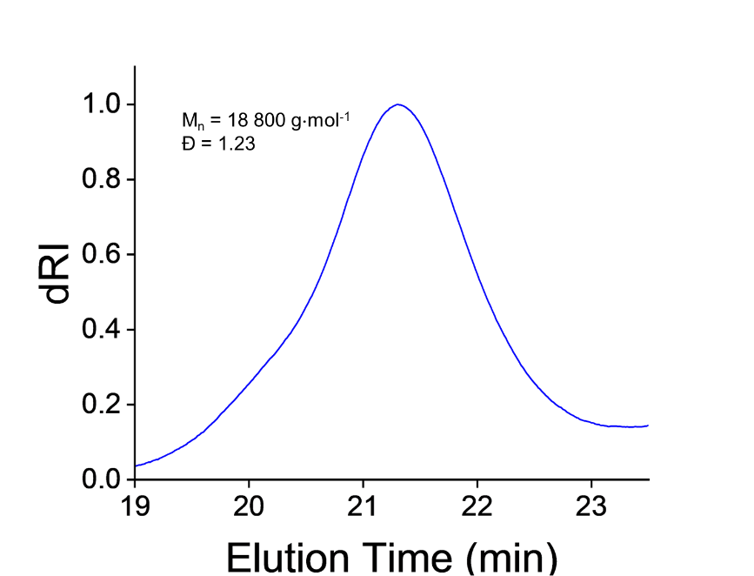
Supplementary Figure 1. GPC traces of the PYRA polymer in DMF containing 0.075% w/w LiBr.
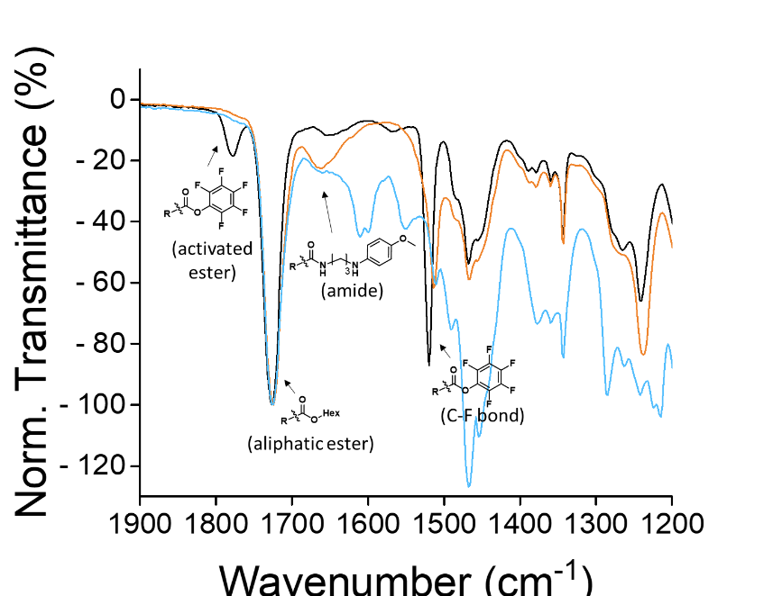
Supplementary Figure 2. ATR FT-IR spectra illustrating the sequential synthesis of DASA-functionalized polymers. The initial activated ester diblock copolymer, PEG-b-(PHMA-co-PPFPA) (black), was first reacted with the aromatic amine precursor MPDP (orange), resulting in the loss of the ester signal and the appearance of an amide-associated peak. Subsequent reaction with the pyrazolone-derived furan adduct led to formation of the DASA-containing polymer (blue).
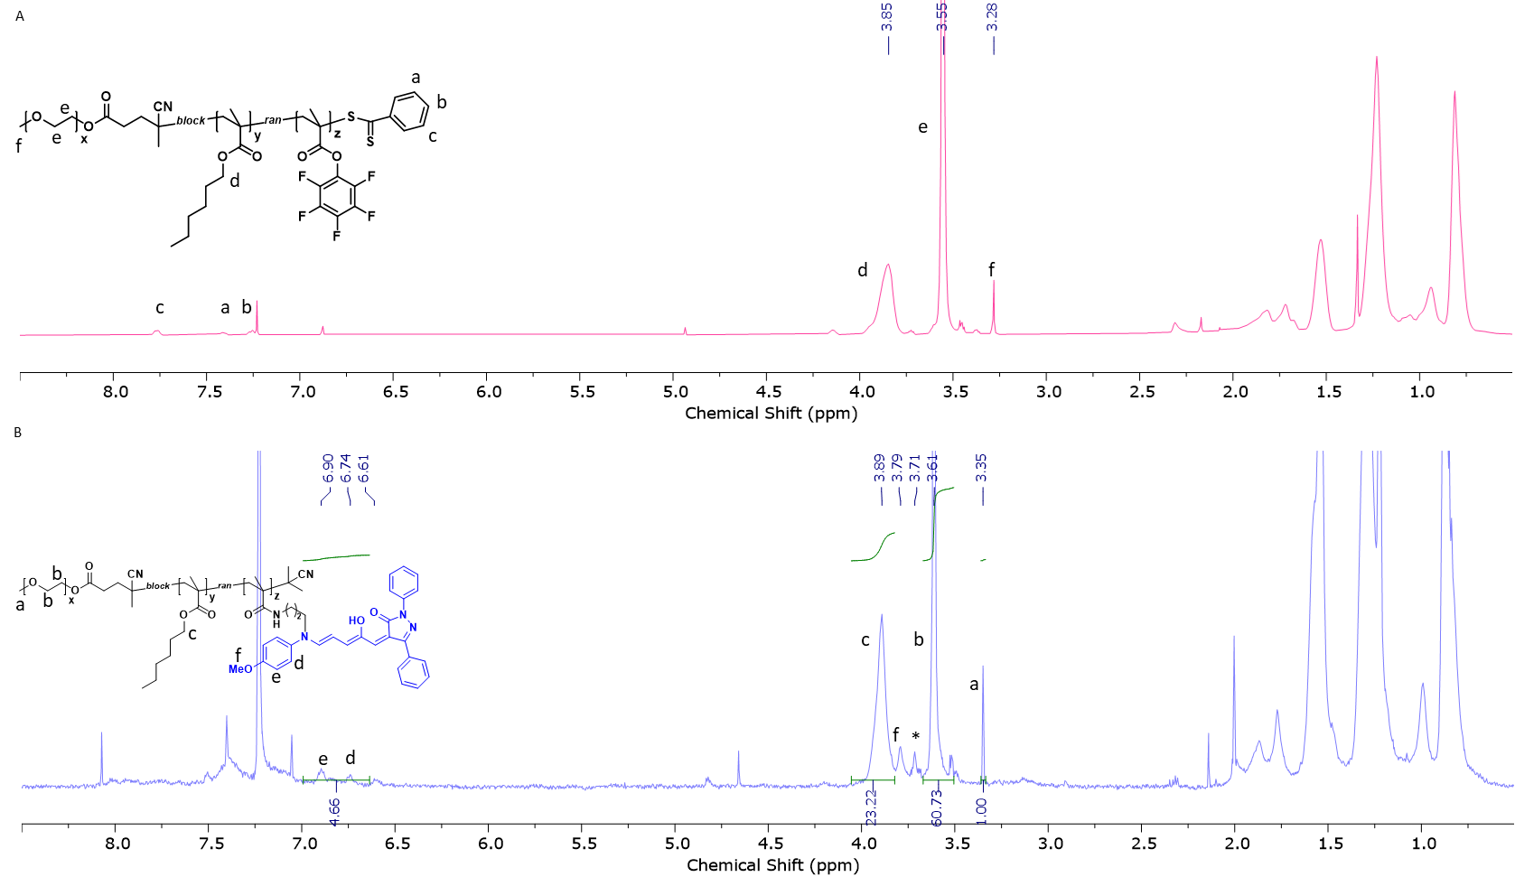
Supplementary Figure 3. ¹H NMR analysis of the stepwise synthesis leading to DASA-functionalized block copolymers. A. Spectrum of the unmodified PEG-b-(PHMA-co-PPFPA) diblock copolymer (400 MHz). B. Diffusion-edited ¹H NMR spectrum of the DASA-modified block copolymer (600 MHz). Peaks corresponding to the open isomers are indicated by letters, while those of the closed form are denoted with an asterisk.
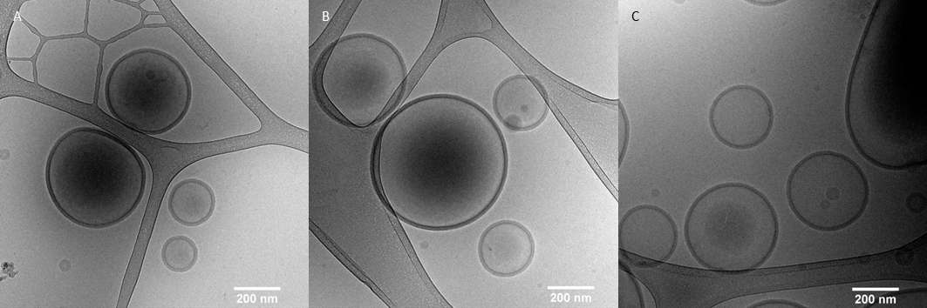
Supplementary Figure 4. Cryo-TEM images of PYRA-esterase nanoreactors. Vesicular morphology is clearly observed, indicating successful self-assembly in the absence of light-induced structural changes. Scale bar: 200 nm.

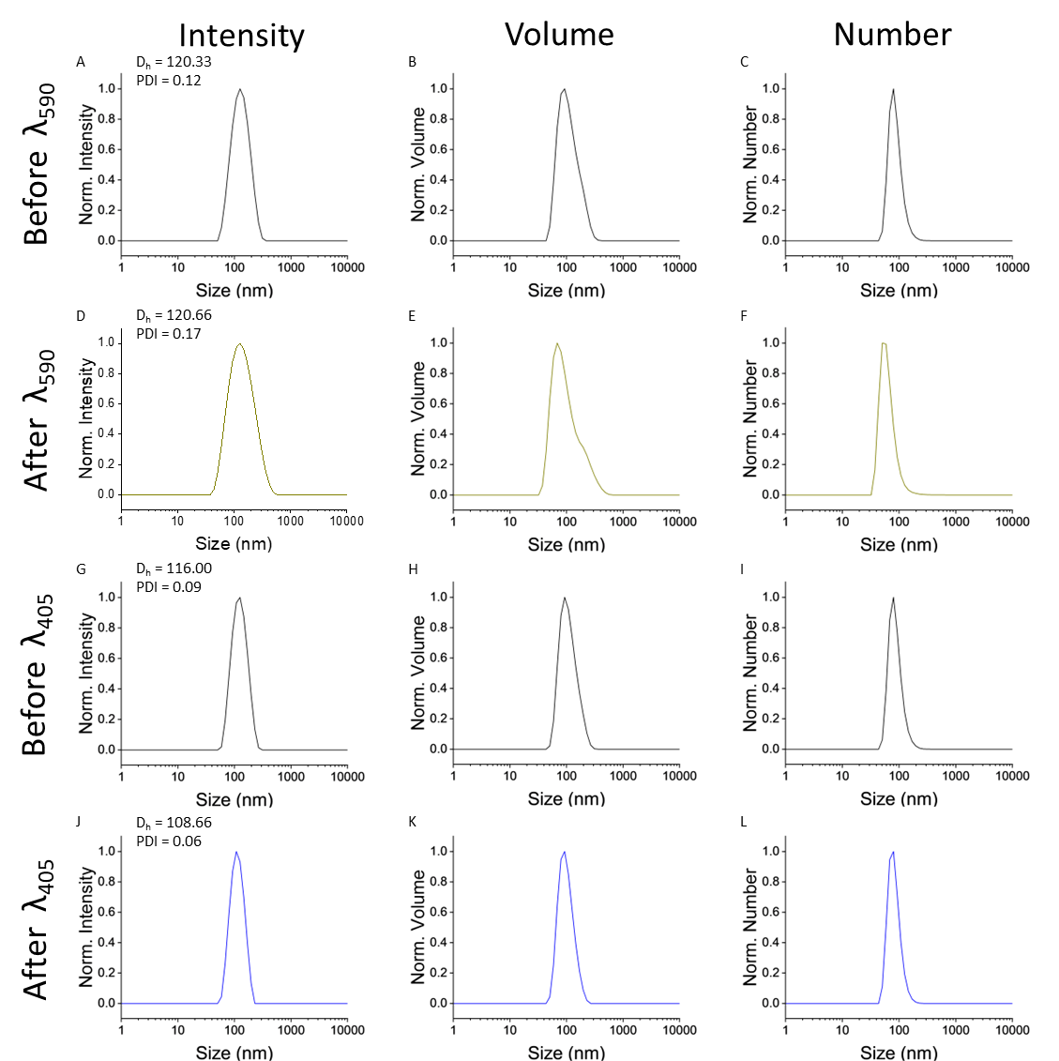
Supplementary Figure 5. Dynamic light scattering (DLS) analysis of DASA-containing polymersomes under different light conditions. A–C. Prior to yellow light irradiation. D–F. After yellow light exposure. G–I. Before blue light irradiation. J–L. Following blue light exposure. For each condition, the hydrodynamic diameter (D_{h}) and polydispersity index (PDI) are reported, reflecting changes in vesicle size and distribution in response to light stimuli.
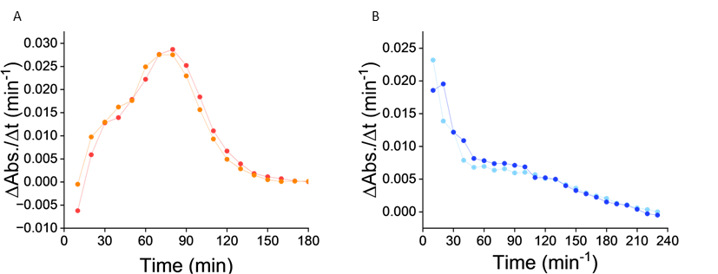
Supplementary Figure 6. Evolution of rate of change in absorbance over time in presence of orthogonal wavelength. A. The values are calculated from the data in Figure 2D with samples being irradiated with yellow light at 1.76 mW·cm⁻² (red) and 1.57 mW·cm⁻² (orange). B. The values are calculated from the data in Figure 2D with samples being irradiated with yellow light at 1.88 mW·cm⁻² (dark blue) and 1.54 mW·cm⁻² (light blue).
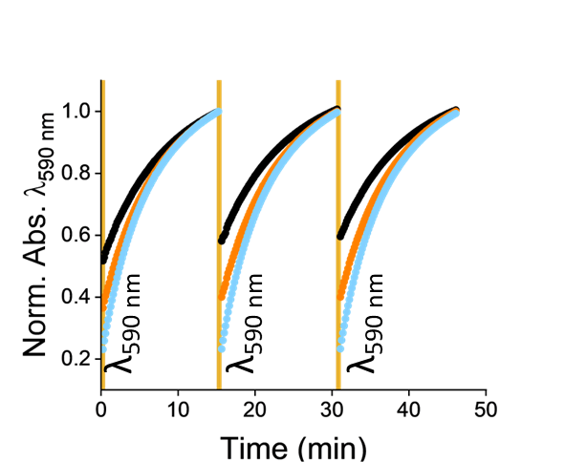
Supplementary Figure 7. Photoisomerization of the PYRA polymer in THF upon blue light irradiation. The samples were irradiated at intensities of 2.23 mW·cm⁻² (blue), 1.56 mW·cm⁻² (orange), and 1.1 mW·cm⁻² (black). Samples were irradiated for 15 seconds across three consecutive cycles.

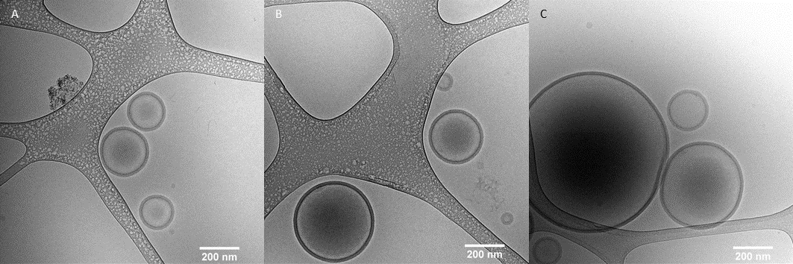
Supplementary Figure 8. Cryo-TEM images of PYRA-esterase nanoreactors after yellow light irradiation. Vesicular structures are still observed, indicating that self-assembly is retained after light exposure. Scale bar: 200 nm.
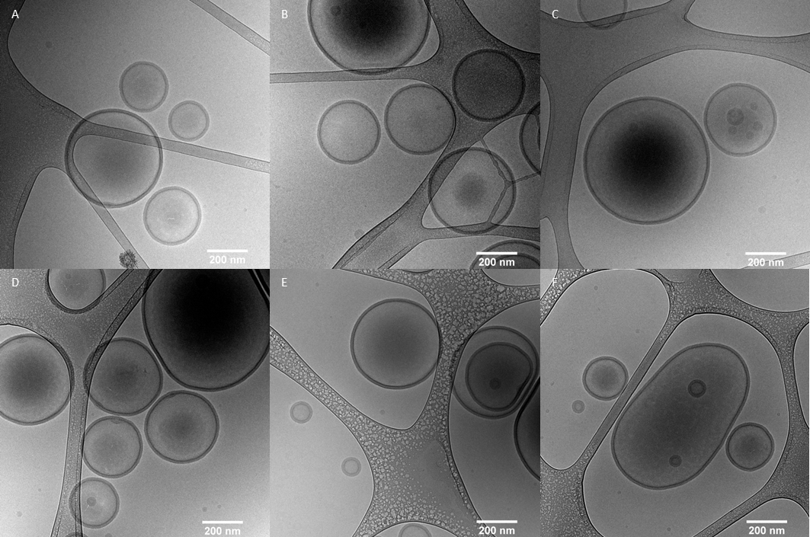
Supplementary Figure 9. Cryo-TEM analysis of DASA-containing polymersomes under alkaline and acidic conditions. Cryo-TEM images of DASA-containing polymersomes before (A–C) and after (D–F) transitioning from alkaline (pH = 8) to acidic pH (pH = 6). Vesicular morphology is maintained in all cases, indicating structural stability of the self-assembled assemblies across pH conditions. Scale bar: 200 nm.
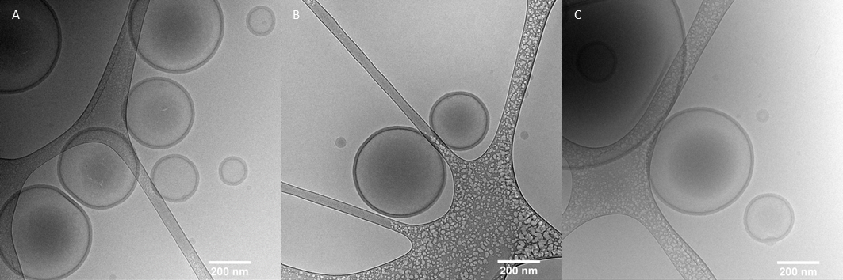
Supplementary Figure 10. Cryo-TEM images of PYRA-esterase nanoreactors after blue light irradiation. Vesicular structures are still observed, indicating that self-assembly is retained after light exposure. Scale bar: 200 nm.
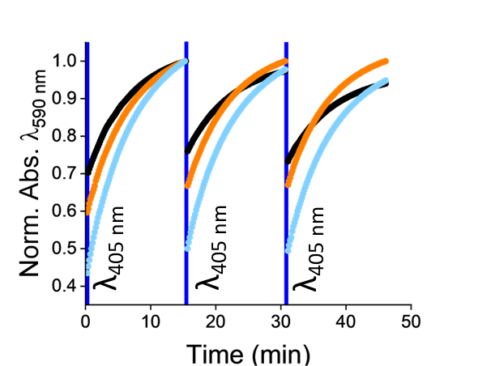
Supplementary Figure 11. Photoisomerization of the PYRA polymer in THF upon blue light irradiation. The samples were irradiated at intensities of 3.5·10⁻³ mW·cm⁻² (blue), 1.6·10⁻³ mW·cm⁻² (orange), and 1.1·10⁻³ mW·cm⁻² (black). Samples were irradiated for 15 seconds across three consecutive cycles.
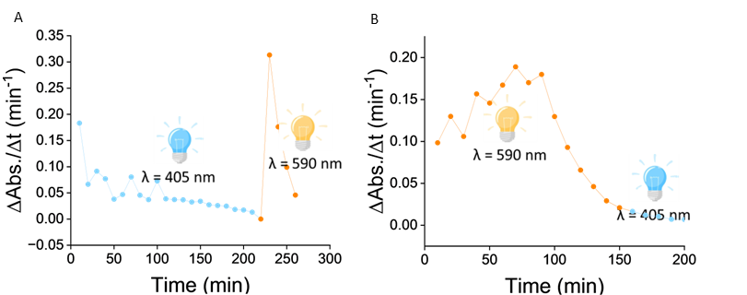
Supplementary Figure 12. Evolution of rate of change in absorbance over time in presence of orthogonal wavelength. A. Samples were first exposed to blue light (405 nm, 1.54 mW·cm⁻²) (blue dots) and then irradiated with yellow light (590 nm, 1.86 mW·cm⁻²) (yellow dots). B. Complementary experiment in which samples were initially irradiated with yellow light (590 nm, 1.86 mW·cm⁻²) (yellow dots), followed by blue light (405 nm, 1.54 mW·cm⁻²) exposure (blue dots).

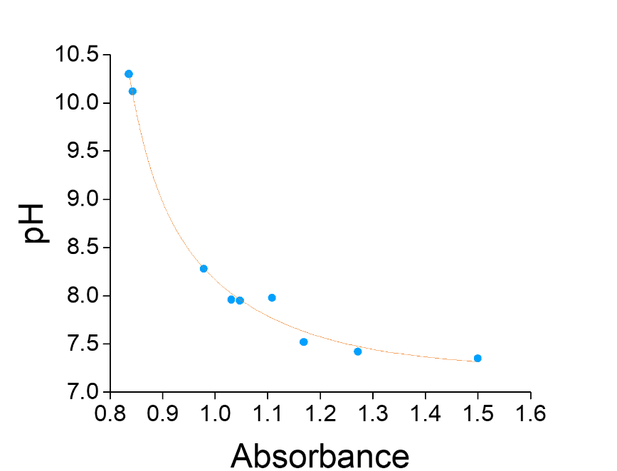
Supplementary Figure 13. Dose–response curve showing the relationship between absorbance and pH. pH and absorbance values were quantified simultaneously, enabling quantitative estimation of pH changes based on optical measurements. This calibration curve was used to interpret pH variations in light-triggered experiments.
Supplementary References
1 Cheng, Z. & Tsourkas, A. Paramagnetic porous polymersomes. Langmuir 24, 8169-8173 (2008).

