Supporting Information

Engineered APP C-terminus Alters APP Expression Dynamics in Differentiated SH-SY5Y-Derived Neurons

D. Chanuka M. Kulatunga¹, Umanthi Ranaraja¹, Eun Young Kim², Kukbin Ji¹, Ho Yong Choi¹, JaeHyeok Yoon¹, Kangsun Park², Min Kyu Kim* ^{1,2}

¹ Department of Animal Science and Biotechnology, Chungnam National University,
Yuseong-gu, Daejeon, Republic of Korea.
² Stem cell Research Team, MK Biotech Inc., Yuseong-gu, Daejeon, Republic of Korea.
* Corresponding author, Email: kminkyu@cnu.ac.kr

ORCID of the authors,
D. Chanuka M. Kulatunga : 0000-0002-2998-9217
Umanthi Ranaraja : 0000-0002-8794-1908
Eun Young Kim : 0009-0002-4819-0934
Kukbin Ji : 0000-0002-3144-9746
Ho Yong Choi : 0000-0001-9527-7544
JaeHyeok Yoon : 0009-0008-2789-7088
Kangsun Park : 0000-0002-9395-2881
Min Kyu Kim : 0000-0001-7099-9735

Supplementary Tables

Table S1: Neuron markers and corresponding primers used in RTQPCR.

Gene Target  [NCBI RefSeq ID] | bp | Name | Sequence (5'→3') | Size (Nt) | Tm°C  Primer blast
ASCL1 [NM_004316.4] | 165 | qASCL1(MASH1)-F | GAGGGCTCTTACGACCCGCTCAG | 23 | 66.5
ASCL1 [NM_004316.4] | 165 | qASCL1(MASH1)-R | CTCCCAACGCCACTGACAAGAAAGC | 25 | 66.3
MAPT [NM_016835.5] | 196 | qMAPT(Tau)-F | CAAGGACAGAGTCCAGTCGAAGATTGG | 27 | 64.9
MAPT [NM_016835.5] | 196 | qMAPT(Tau)-R | GACATTGCTGAGATGCCGTGGAGAC | 25 | 65.8
ACHE [NM_000665.5] | 188 | qChol.ACHE-F | CTCAGCAGTACGTTAGTCTGGACCTG | 26 | 64.4
ACHE [NM_000665.5] | 188 | qChol.ACHE-R | GTTCTTCCAGTGCACCATGTAGGAGC | 26 | 65.6

Table S2: APP total, endogenous, and transcript-group specific primers used in RTQPCR
APP Targets  [NCBI RefSeq ID] | bp | Name | Sequence (5'→3') | Size (Nt) | Tm°C  Primer blast
APP-ED  [Any splice variant] | 147 | qAPP-ED-F | CTGACCACTCGACCAGGTTCTGGG | 24 | 66
APP-ED  [Any splice variant] | 147 | qAPP-ED-R | GTTTGAACCCACATCTTCTGCAAAGAACACC | 31 | 66
APP-AICD  [Any splice variant] | 143 | qAPP-AICD-F | TGCTGAAGAAGAAACAGTACACATCCATTCATC | 33 | 65
APP-AICD  [Any splice variant] | 143 | qAPP-AICD-R | CTGCATCTGCTCAAAGAACTTGTAGGTTGG | 30 | 66
APP-3’UTR  [Any splice variant] | 154 | qAPP-3UTR2-F | CCTGATTATTTATCACATAGCCCCTTAGCCAG | 32 | 65
APP-3’UTR  [Any splice variant] | 154 | qAPP-3UTR2-R | GGAATACTTAGGCAAGAGAAGCAGCTGAAC | 30 | 66
APPv1  [NM_000484.4] | 190 | qAPP-770v1-F | CGAGCAATGATCTCCCGCTGGTAC | 24 | 65
APPv1  [NM_000484.4] | 190 | qAPP-770v1-R | GTTTAACAGGATCTCGGGCAAGAGGTTC | 28 | 65
APPv2  [NM_201413.3] | 145 | qAPPv2.4.9-F(Ex7-9) | GTGTGGCAGCGCCATTCCTACAAC | 24 | 66
APPv2  [NM_201413.3] | 145 | qAPPvAll-R(Ex9) | GGACATTCTCTCTCGGTGCTTGGC | 24 | 65
APPv3.5.7.10  [NM_201414.3] | 152 | qAPPv3.5.7.10-F(Ex6-9) | CTGTGGAAGAGGTGGTTCGAGTTCCTAC | 28 | 66
APPv3.5.7.10  [NM_201414.3] | 152 | qAPPvAll-R(Ex9) | GGACATTCTCTCTCGGTGCTTGGC | 24 | 65
APPv11  [NM_001385253.1] | 204 | qAPPv11-F(Ex6-8) | GAAGAGGTGGTTCGAGTGTCCCAAAG | 26 | 65
APPv11  [NM_001385253.1] | 204 | qAPPvAll-R(Ex9) | GGACATTCTCTCTCGGTGCTTGGC | 24 | 65

Table S3: Housekeeping genes and corresponding primers used in RTQPCR

Gene Target  [NCBI RefSeq ID] | bp | Name | Sequence (5'→3') | Size (Nt) | Primer-blast  Tm°C
SNRPD3  [NM_004175.5] | 192 | SNRPD3-F | GAGATGGCCGAGTGGCACAGC | 21 | 66
SNRPD3  [NM_004175.5] | 192 | SNRPD3-R | CACGTCCTCTTCCTCTTGCGGC | 22 | 66
ACTB|  [NM_001101.5] | 209 | qACTB-F | GAGCACAGAGCCTCGCCTTTGC | 22 | 66
ACTB|  [NM_001101.5] | 209 | qACTB-R | CTTCTGACCCATGCCCACCATCAC | 24 | 65

Table S4: APP exons 6 and 9 targeted primers used in Fragment analysis

Gene Target  [NCBI RefSeq ID] | bp | Name | Sequence (5'→3') | Size (Nt) | Primer-blast  Tm°C
APPv1  [NM_000484.4]  APPv2  [NM_201413.3]  APPv3  [NM_201414.3]  APPv11  [NM_001385253.1] | 579 (v1)  522 (v2)  354 (v3)  411 (v11) | APPEx6-F | ACAGACTATGCAGATGGGAGTGAAGAC | 21 | 66
 | 579 (v1)  522 (v2)  354 (v3)  411 (v11) | qAPPvAll-R(Ex9) | GGACATTCTCTCTCGGTGCTTGGC | 22 | 66
6FAM-tagged Forward primer for fragment analysis |  | 6FAM·APPEx6-F | 6FAM-ACAGACTATGCAGATGGGAGTGAAGAC | 21 | 66

Supplementary Figures
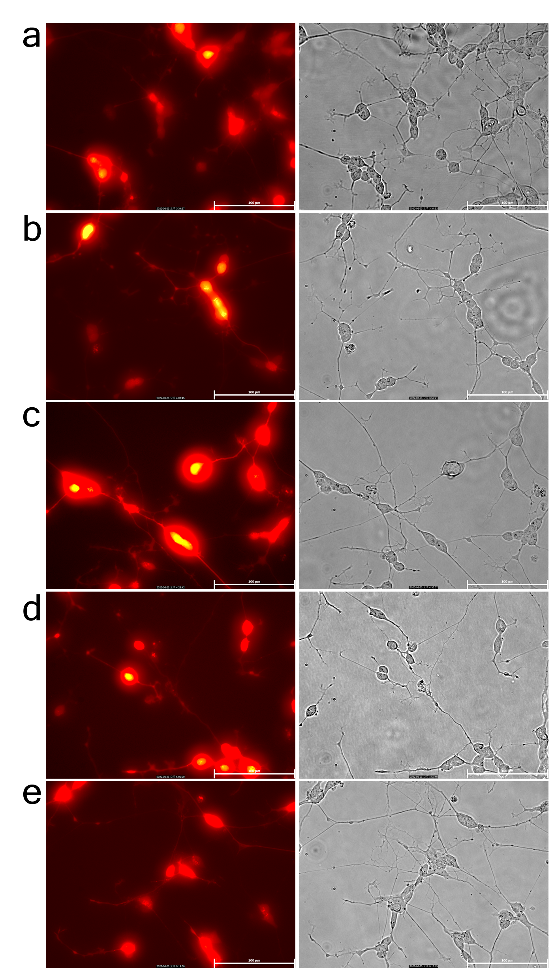
Figure S1:

Figure S1: Differentiation of SH-SY5Y-derived transgenic neuronal cell lines expressing various APP constructs.
Representative fluorescence (left panels) and corresponding bright-field (right panels) images of differentiated SH-SY5Y cells stably transfected with (a) Mock control (SH-SY5Y-Mock), (b) AICD50 fragment (SH-SY5Y-AICD50), (c) CTF75 fragment (SH-SY5Y-CTF75), (d) wild-type full-length APP (SH-SY5Y-NaAPP), and (e) Swedish mutant APP (SH-SY5Y-SwAPP). Cells were differentiated and imaged at 20× magnification. Red fluorescence indicates neuronal morphology and differentiation status, with clear neurite extensions and soma localization visible in transfected lines. Bright-field images further confirm the morphological features of neuronal differentiation including cell body clustering and extended neuritic processes. Scale bar: 100 μm.

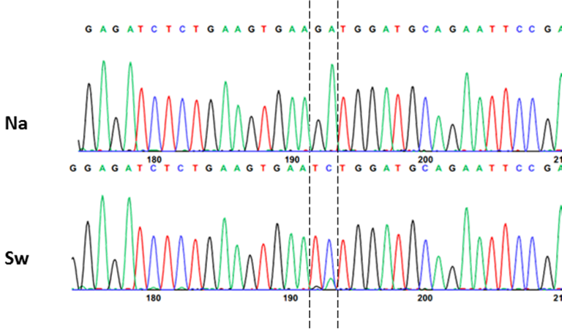
Figure S2: Sequencing chromatograms obtained from the cDNA of wild-type and transgenic (Tg) SH-SY5Y cells confirming the overexpression of APP with the Swedish mutation in Tg SH-SY5Y cells.
The top chromatogram (Na) represents the wild-type (Native) cDNA sequence, showing consistent GA peaks at the relevant position, while the lower chromatogram (Sw) corresponds to the Tg sequence, demonstrating the overlapping signals of mutant TC expression and native GA expression. Tg cells overexpress APP carrying the Swedish mutation (KM670/671NL). The Swedish mutation results in a GA to TC nucleotide substitution, identified as a distinct peak in the sequencing chromatogram. In the chromatogram for the Tg sequence, the GA to TC mutation introduces noticeable changes in peak patterns. These alterations are superimposed on the smaller, native GA expression signals, which are still detectable in the Tg sequence as minor peaks, reflecting the presence of endogenous APP expression. The chromatogram highlights these differences in nucleotide sequences, allowing differentiation between native APP expression and overexpressed Swedish-mutant APP in Tg cells.

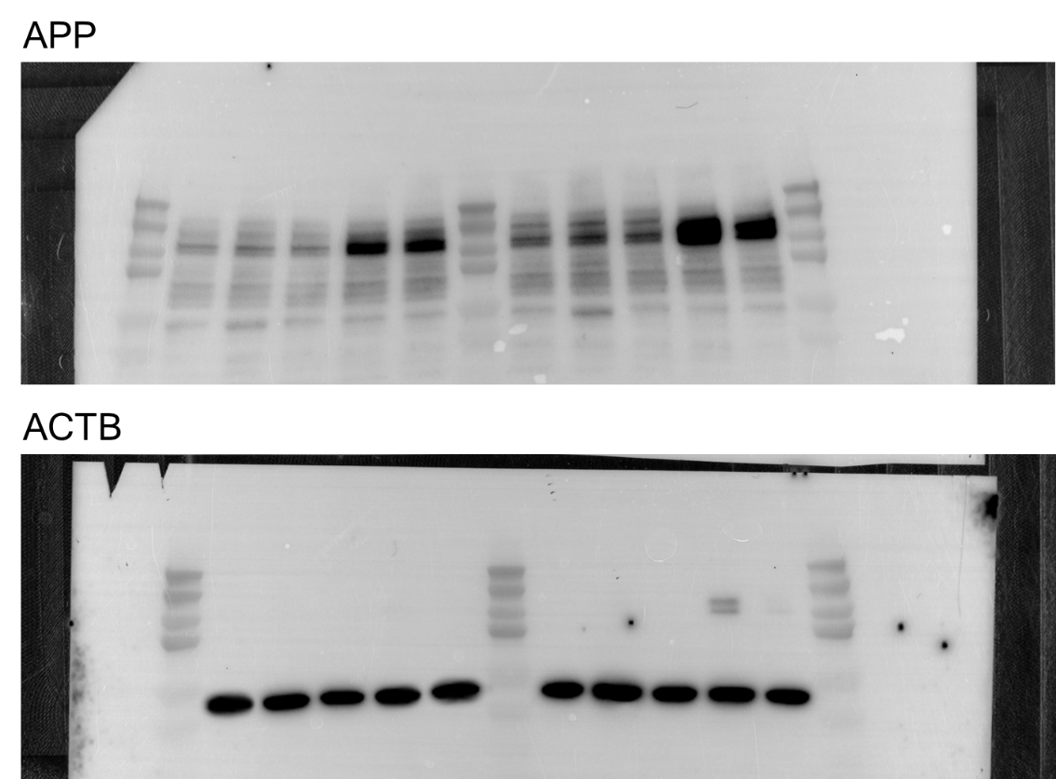

Figure S3: Full-length Western blot images of APP expression in transgenic SH-SY5Y cell lines.
Western blot analysis of APP fragment expression in undifferentiated (left blot) and differentiated (right blot) SH-SY5Y cell lines stably overexpressing Mock (wild-type control), AICD50, CTF75, NaAPP, and SwAPP constructs. The blots were probed with antibodies specific to APP fragments to confirm transgene expression. ACTB (β-actin) was used as a loading control for normalization. Enhanced expression of the respective APP fragment is observed in each corresponding transgenic line, both before and after neuronal differentiation. These full blot images correspond to the cropped data presented in Figure 2B of the main manuscript and provide validation of the specificity and size of the detected bands.

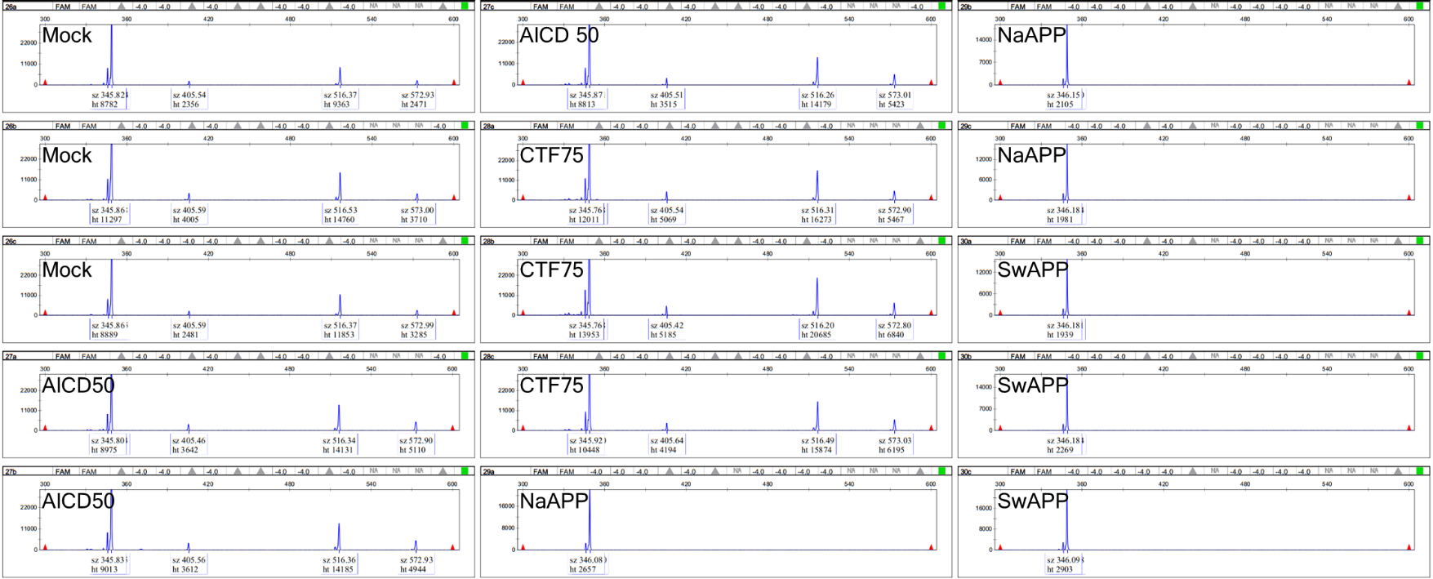
Figure S4:

Figure S4: Full electropherogram profiles of APP transcript fragments spanning exons 6 to 9 in differentiated SH-SY5Y transgenic cell lines.
Capillary electrophoresis analysis showing three biological replicates for each differentiated SH-SY5Y-derived transgenic cell line: Mock (wild-type control), AICD50, CTF75, NaAPP, and SwAPP. The electropherograms represent the relative abundance and size distribution of APP-amplified cDNA fragments spanning exons 6-9, detected using FAM-labeled primers. Distinct transcript-fragment profiles are observed among the APP-expressing cell lines, reflecting the differential expression and processing of APP variants. The Mock cell line shows a baseline fragment pattern, while AICD50, CTF75, NaAPP, and SwAPP lines exhibit additional or altered peaks consistent with overexpression of their respective APP constructs. These replicate data support the summary presented in Figure 7 and confirm reproducibility of APP fragment amplification.

