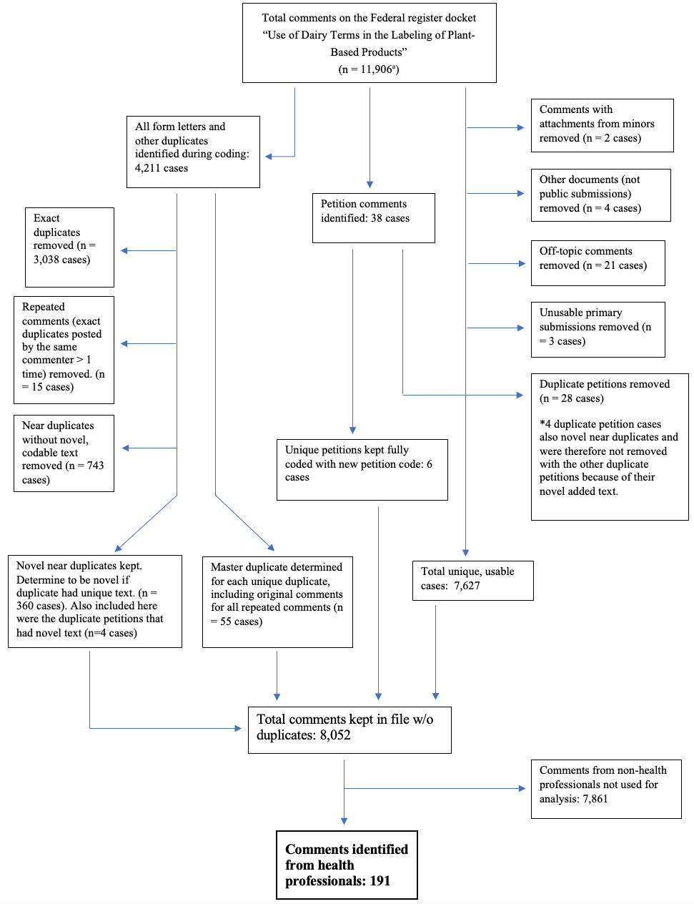
Additional File 1: Removal process for comment submissions not included in analysis.

ª Originally 11,907; comment 11899 withdrawn by FR (late comment)

