Amirhossein Sadr:
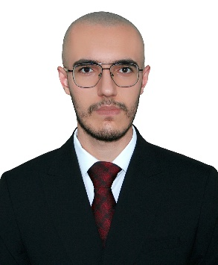
Amirhossein Sadr (Student Member, IEEE) is currently an undergraduate student in Computer Engineering at Shahid Beheshti University, Tehran, Iran. He is a graduate of the National Organization for Development of Exceptional Talents. He is also a Research Assistant at the High Performance Computing Center of the Institute for Research in Fundamental Sciences (IPM). His academic interests include unconventional computing, computer architecture, and hardware accelerators.

Shayan Haghighat:
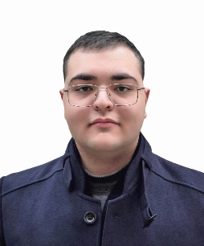
Shayan Haghighat is an undergraduate student in Computer Engineering at Shahid Beheshti University, Tehran, Iran. He is currently a Research Assistant at the High Performance Computing Center of the Institute for Research in Fundamental Sciences (IPM). His academic interests include unconventional computing, and hardware accelerators.

Aida Pakniyat:
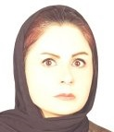
Aida pakniyat earned her Bachelor's degree in Computer Engineering from Azad University of Qazvin in 2008. She later completed her Master's in Artificial Intelligence at Kharazmi University in 2016. Most recently, she graduated with a Ph.D. in Computer Science from Shahid Beheshti University in 2023. Currently, she is a researcher at the Institute for Research in Fundamental Sciences (IPM), where focus on Artificial Intelligence, Machine Learning, and broader Computer Science topics. Her work at IPM is supervised by Dr. Rahmati.

Dara Rahmati:
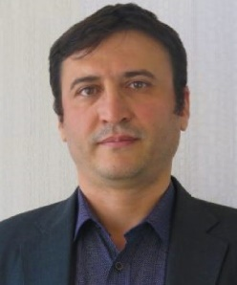
Dara Rahmati received the B.Sc. and M.Sc. degrees in Computer Engineering from the University of Tehran, Iran, in 1998 and 2001, respectively, and the Ph.D. degree in Computer Engineering from Sharif University of Technology, Tehran, Iran. He is currently an Assistant Professor in the Department of Computer Science and Engineering at Shahid Beheshti University, Tehran, Iran. His research interests include the design of optimized networks-on-chip architectures, computing architectures, and DNN hardware accelerators.

Saeid Gorgin:
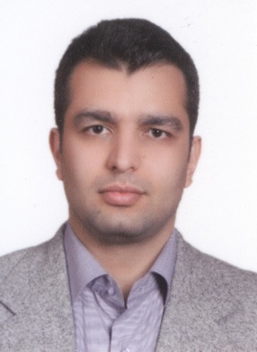
Saeid Gorgin received the B.S. degree in Computer Engineering from Azad University, South Tehran Branch, Tehran, Iran, in 2001, the M.S. degree in Computer Engineering from the Azad University, Science and Research Branch, Tehran, in 2004, and the Ph.D. degree in Computer System Architecture from Shahid Beheshti University, Tehran, in 2010. He previously served as an Associate Professor of Computer Engineering in the Department of Electrical Engineering and Information Technology at the Iranian Research Organization for Science and Technology (IROST), Tehran. He is currently a Research Professor at Sungkyunkwan University, South Korea. His research interests include applied machine learning, embedded AI, hardware accelerators, computer arithmetic, and VLSI design.

