Supplementary materials A
Location description and camera configuration and settings of each of the locations used in this study with a plot of the location.
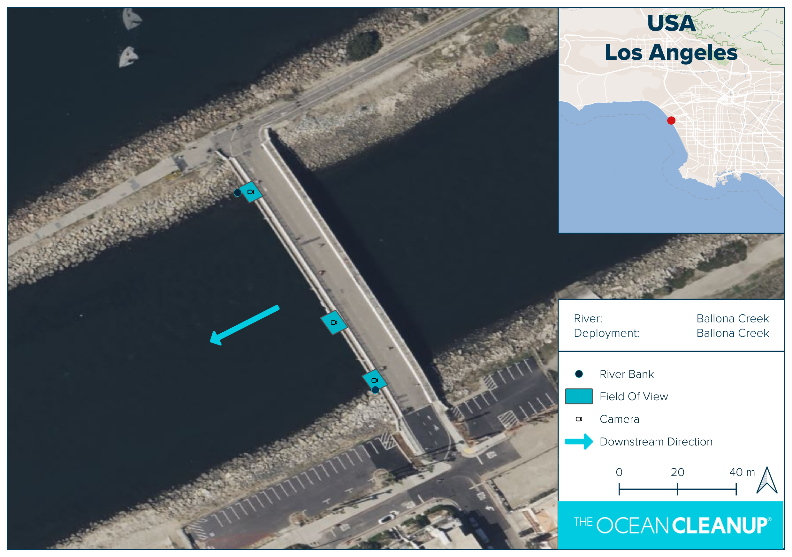
Name | BC IC007
Sampling interval | 15 minutes
Focal length | 6mm
Deployment height | 5m

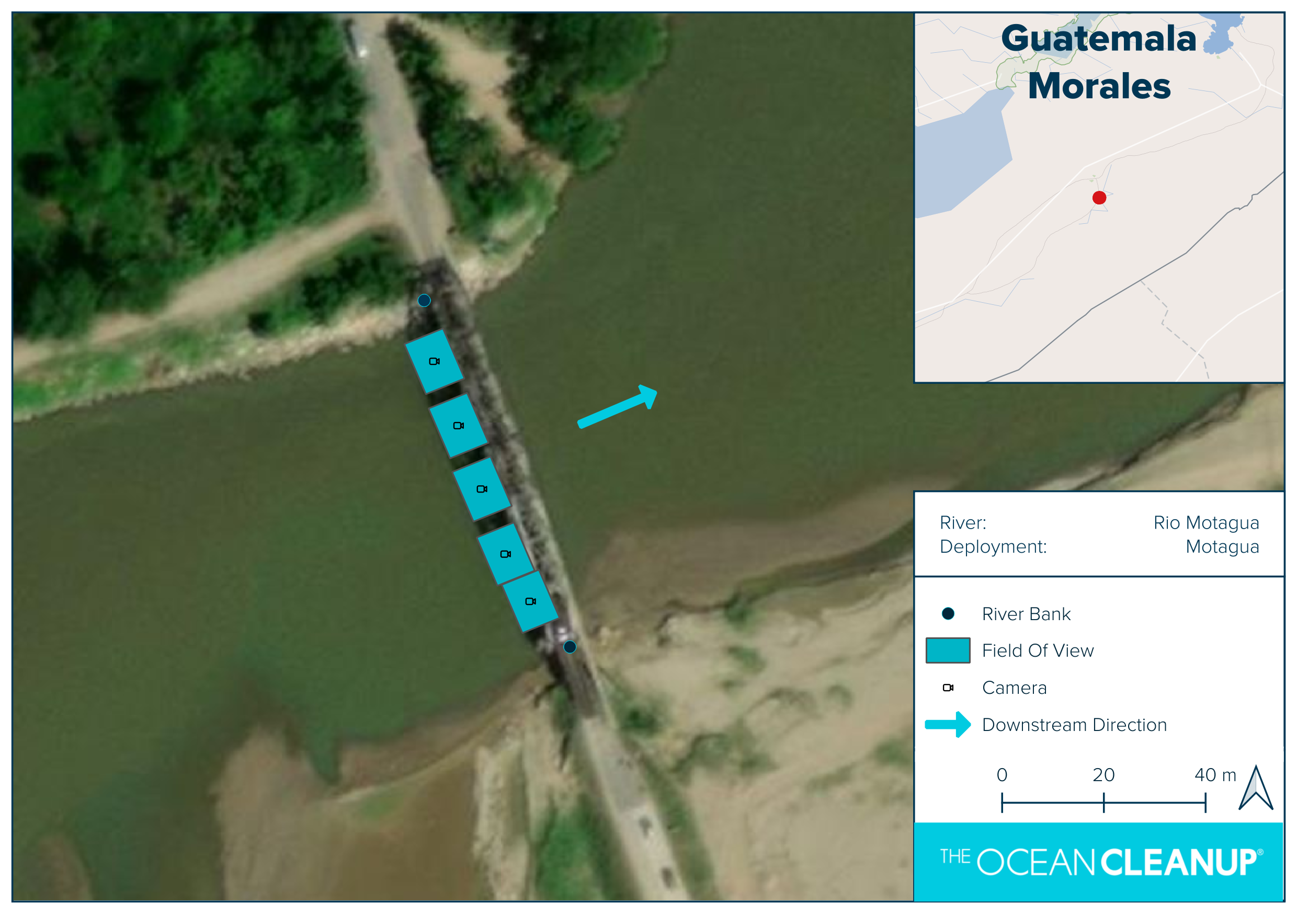
Name | RM Morales
Sampling interval | 10 minutes
Focal length | 4mm
Deployment height | 6.5m
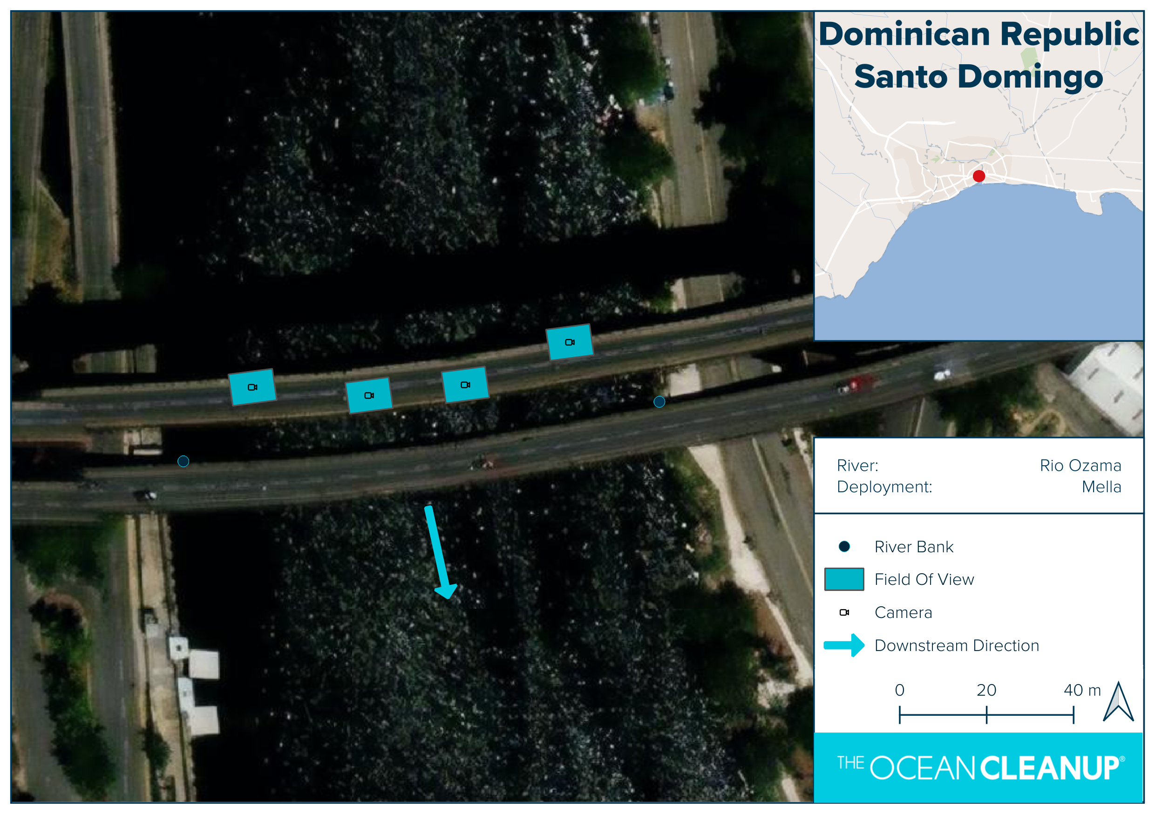
Name | RO Mella
Sampling interval | 10 minutes
Focal length | 25mm
Deployment height | 38m
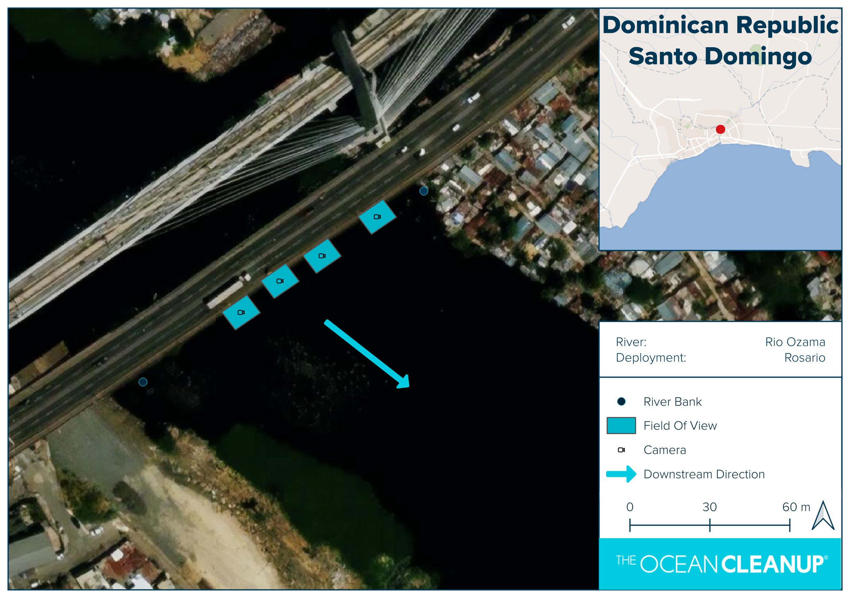
Name | RO Rosario
Sampling interval | 15 minutes
Focal length | 25mm
Deployment height | 43m
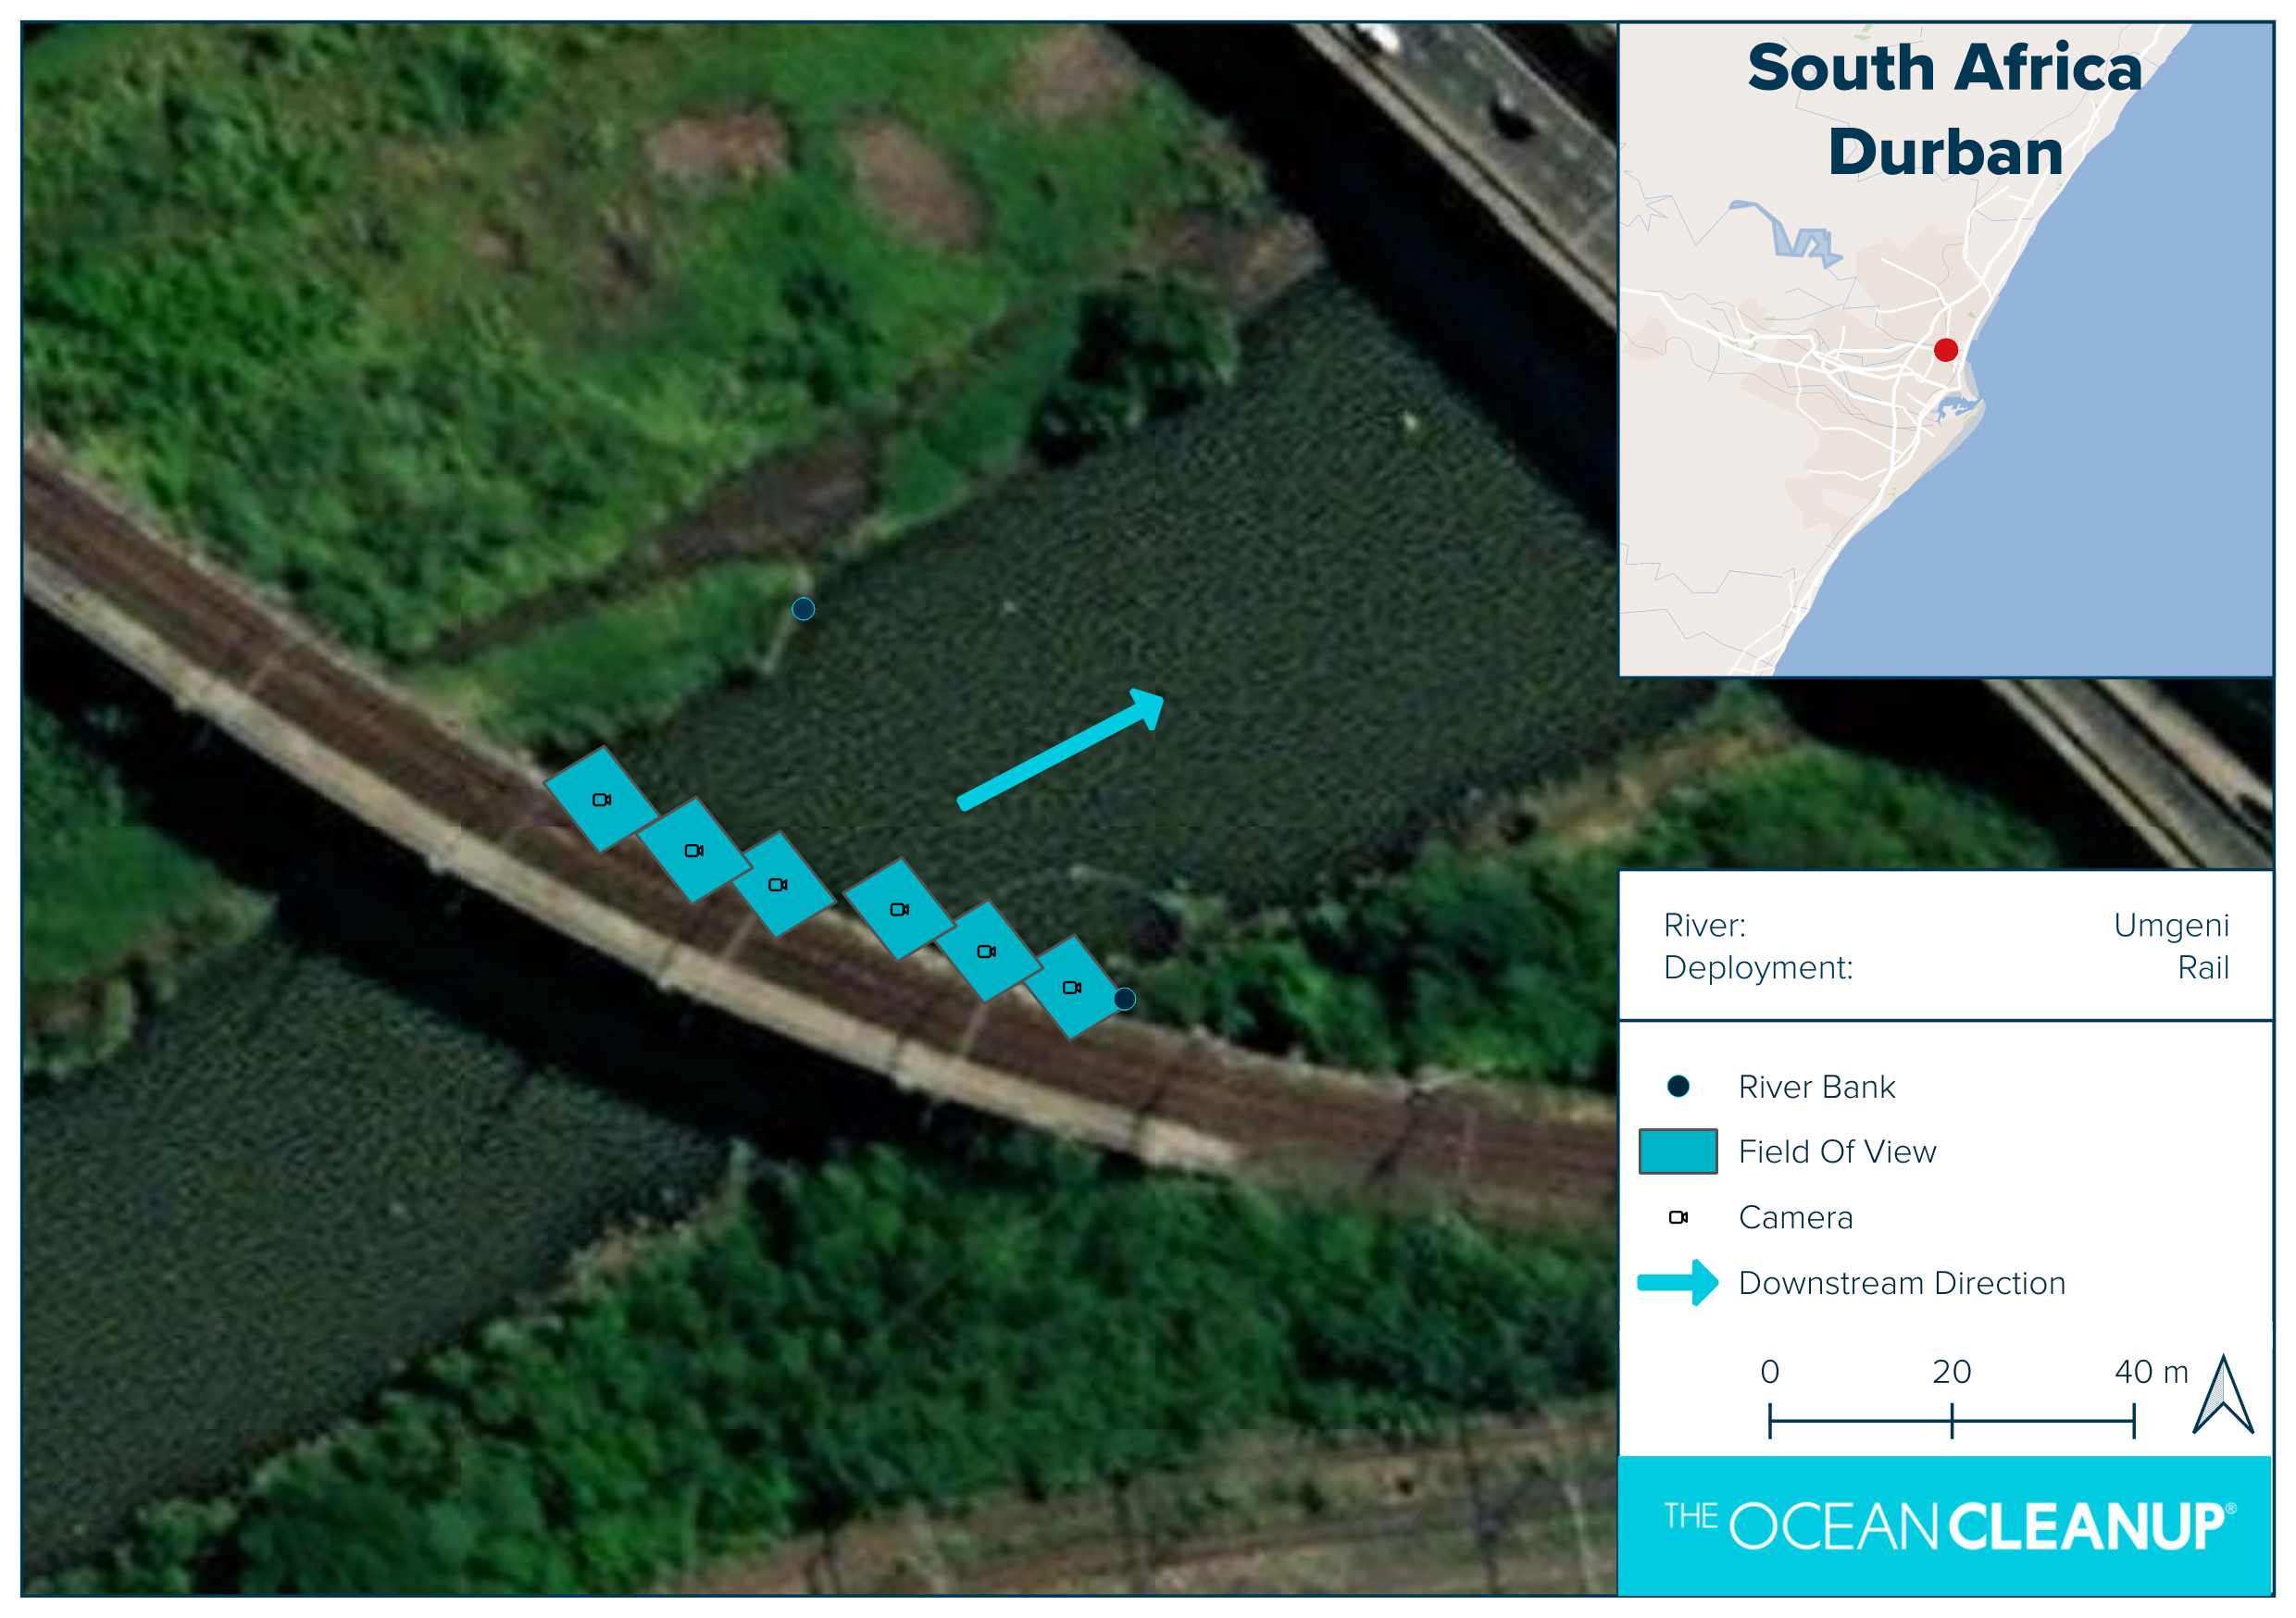
Name | UM Rail
Sampling interval | 15 minutes
Focal length | 8mm
Deployment height | 12m
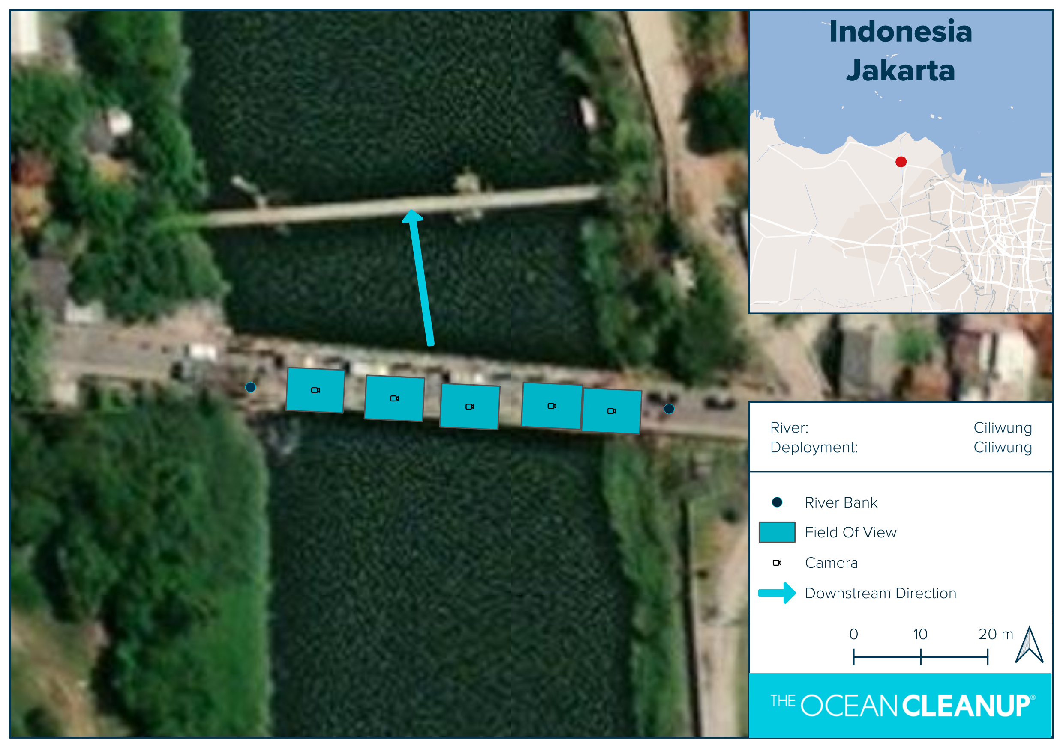
Name | CW Mandara
Sampling interval | 15 minutes
Focal length | 4mm
Deployment height | 2.5m
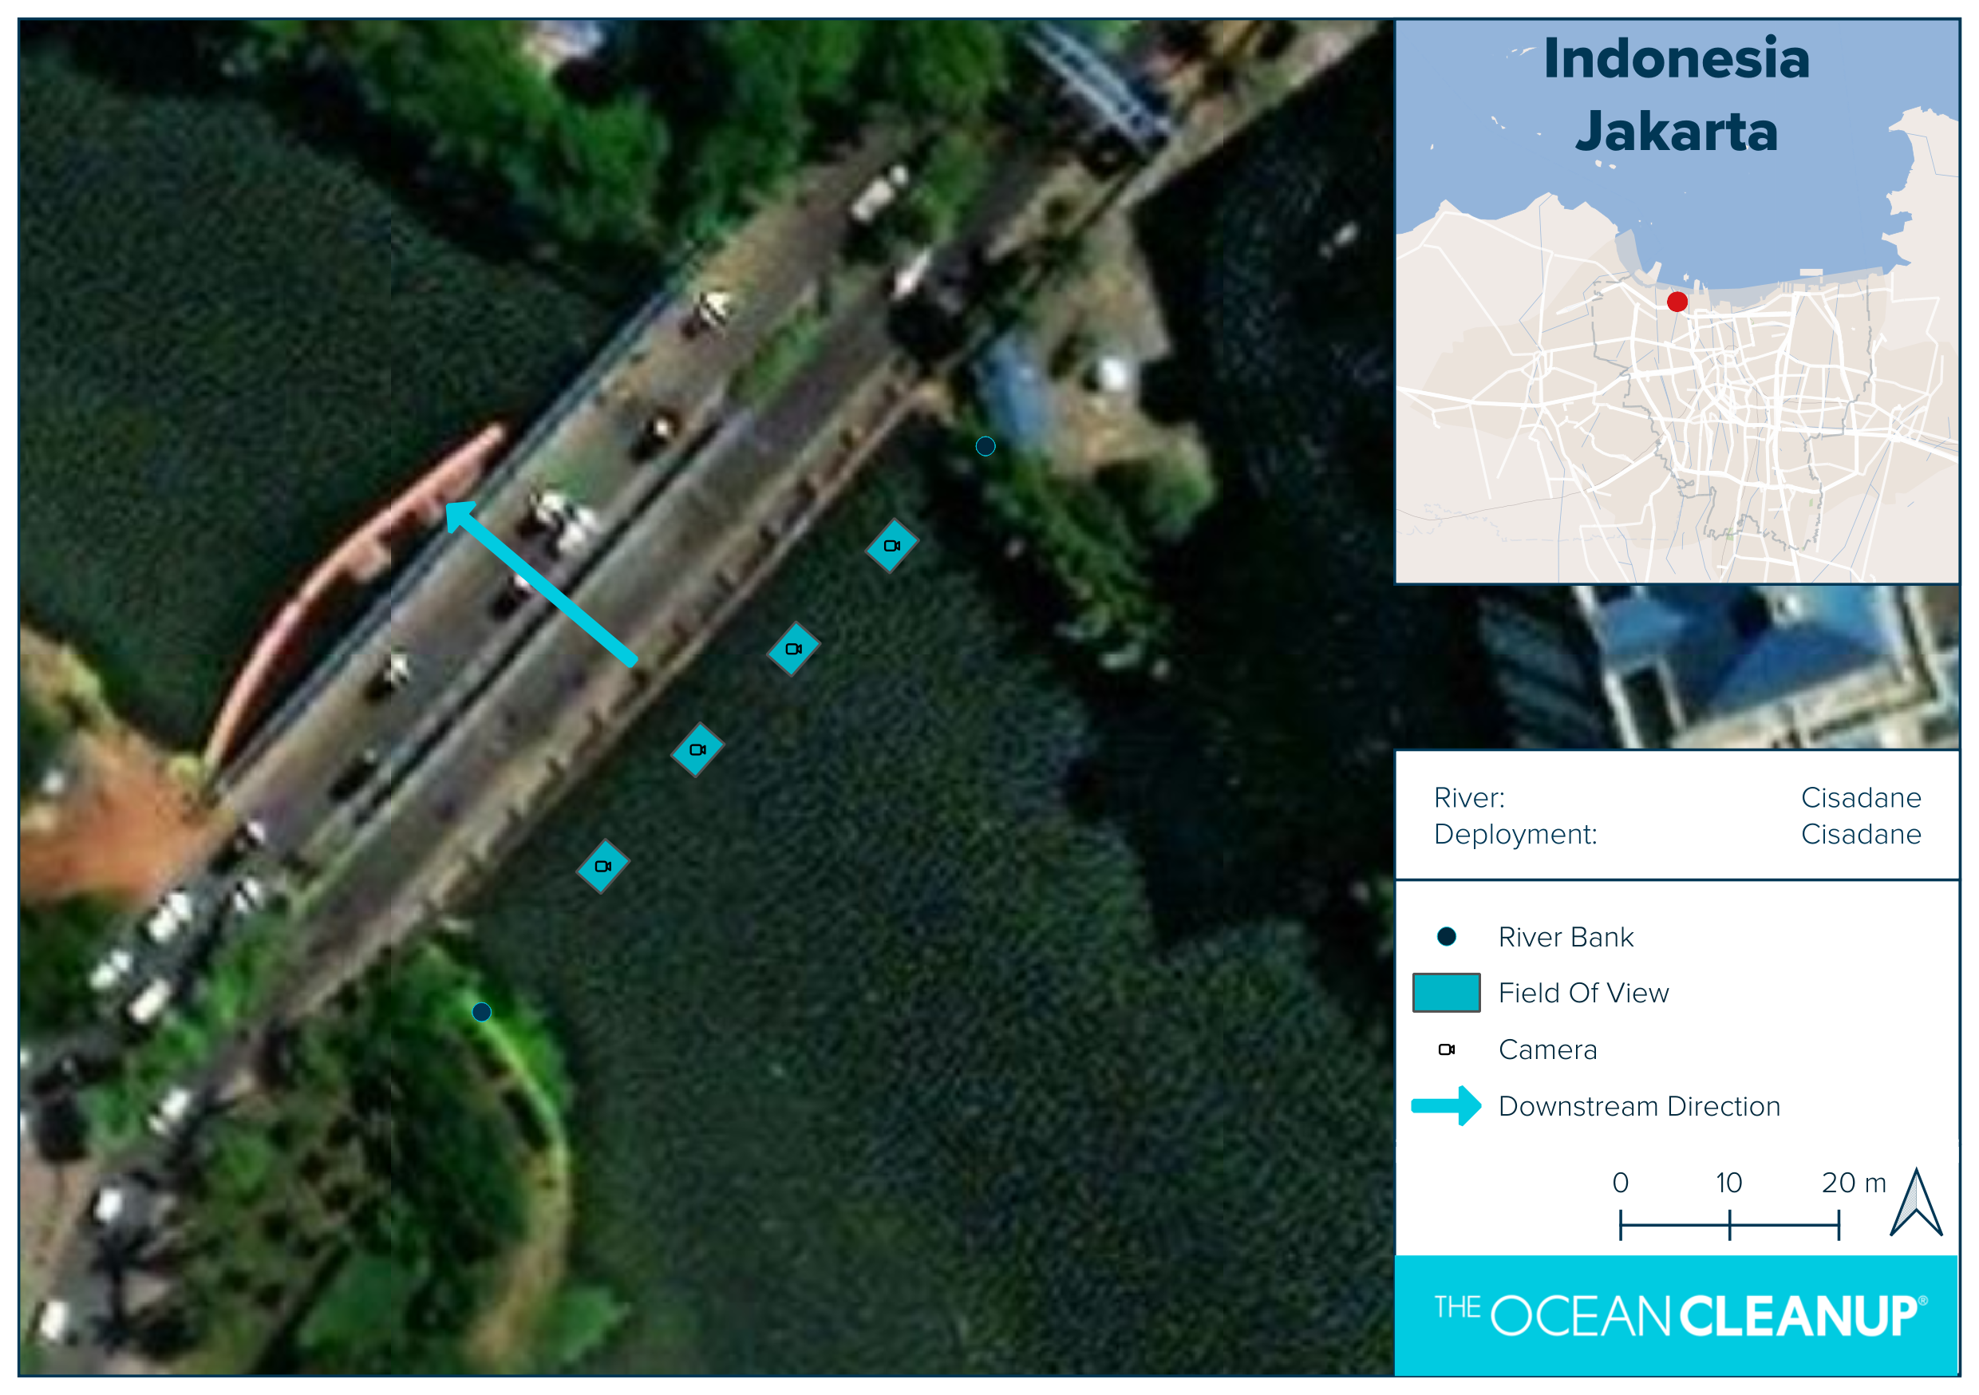
Name | CD Baru
Sampling interval | 15 minutes
Focal length | 4mm
Deployment height | 5.5m
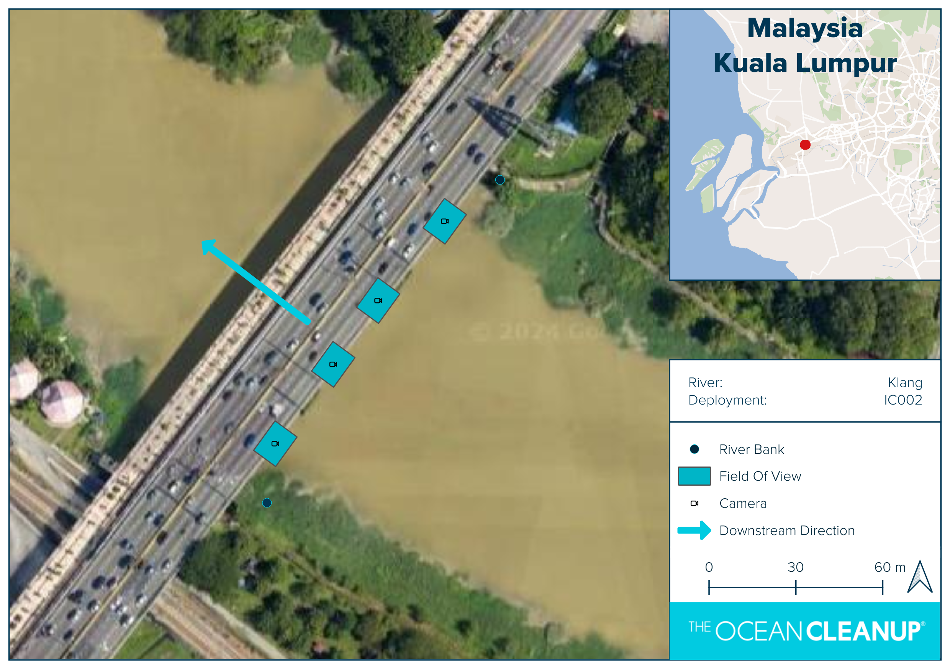
Name | KL IC002
Sampling interval | 15 minutes
Focal length | 6mm
Deployment height | 12m
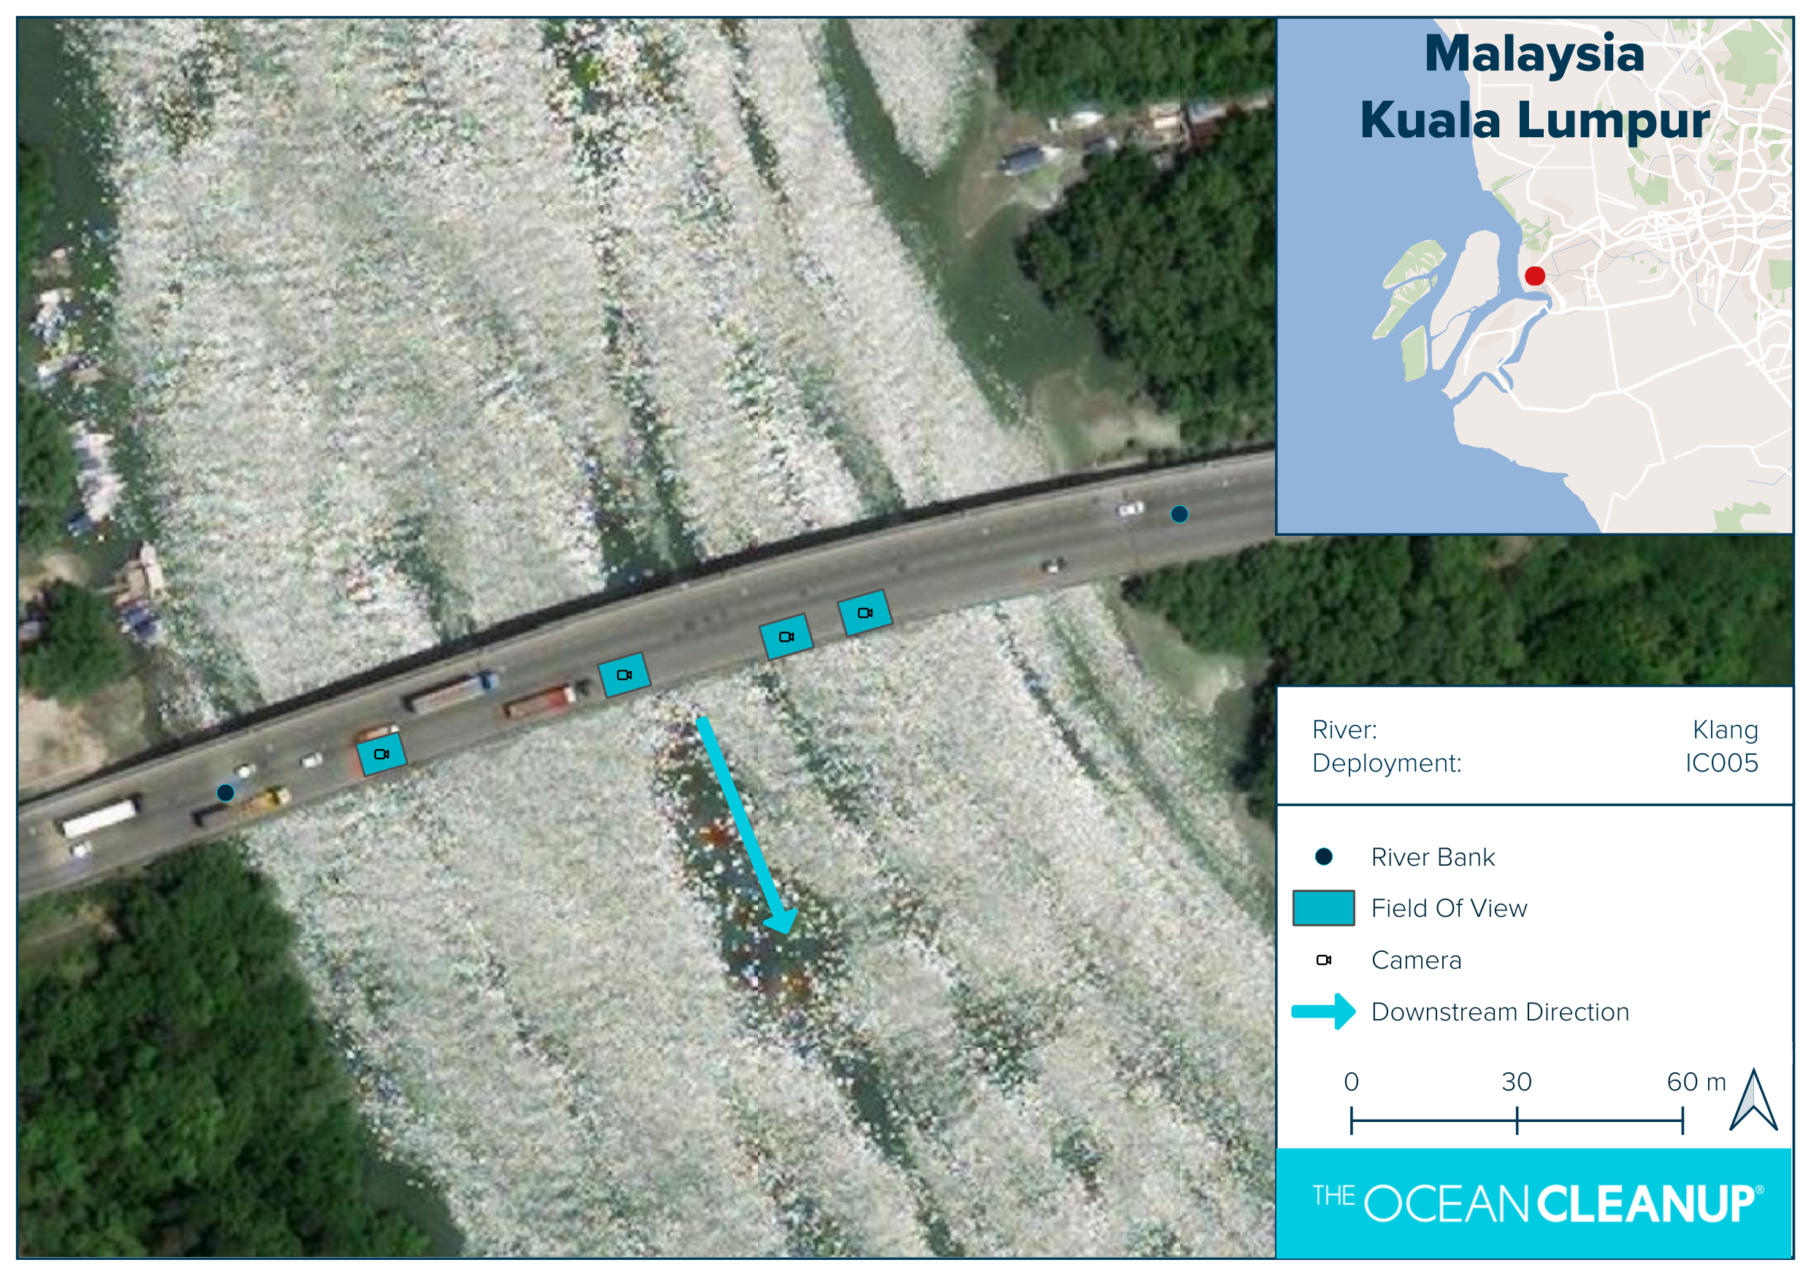
Name | KL IC005
Sampling interval | 15 minutes
Focal length | 6mm
Deployment height | 8m
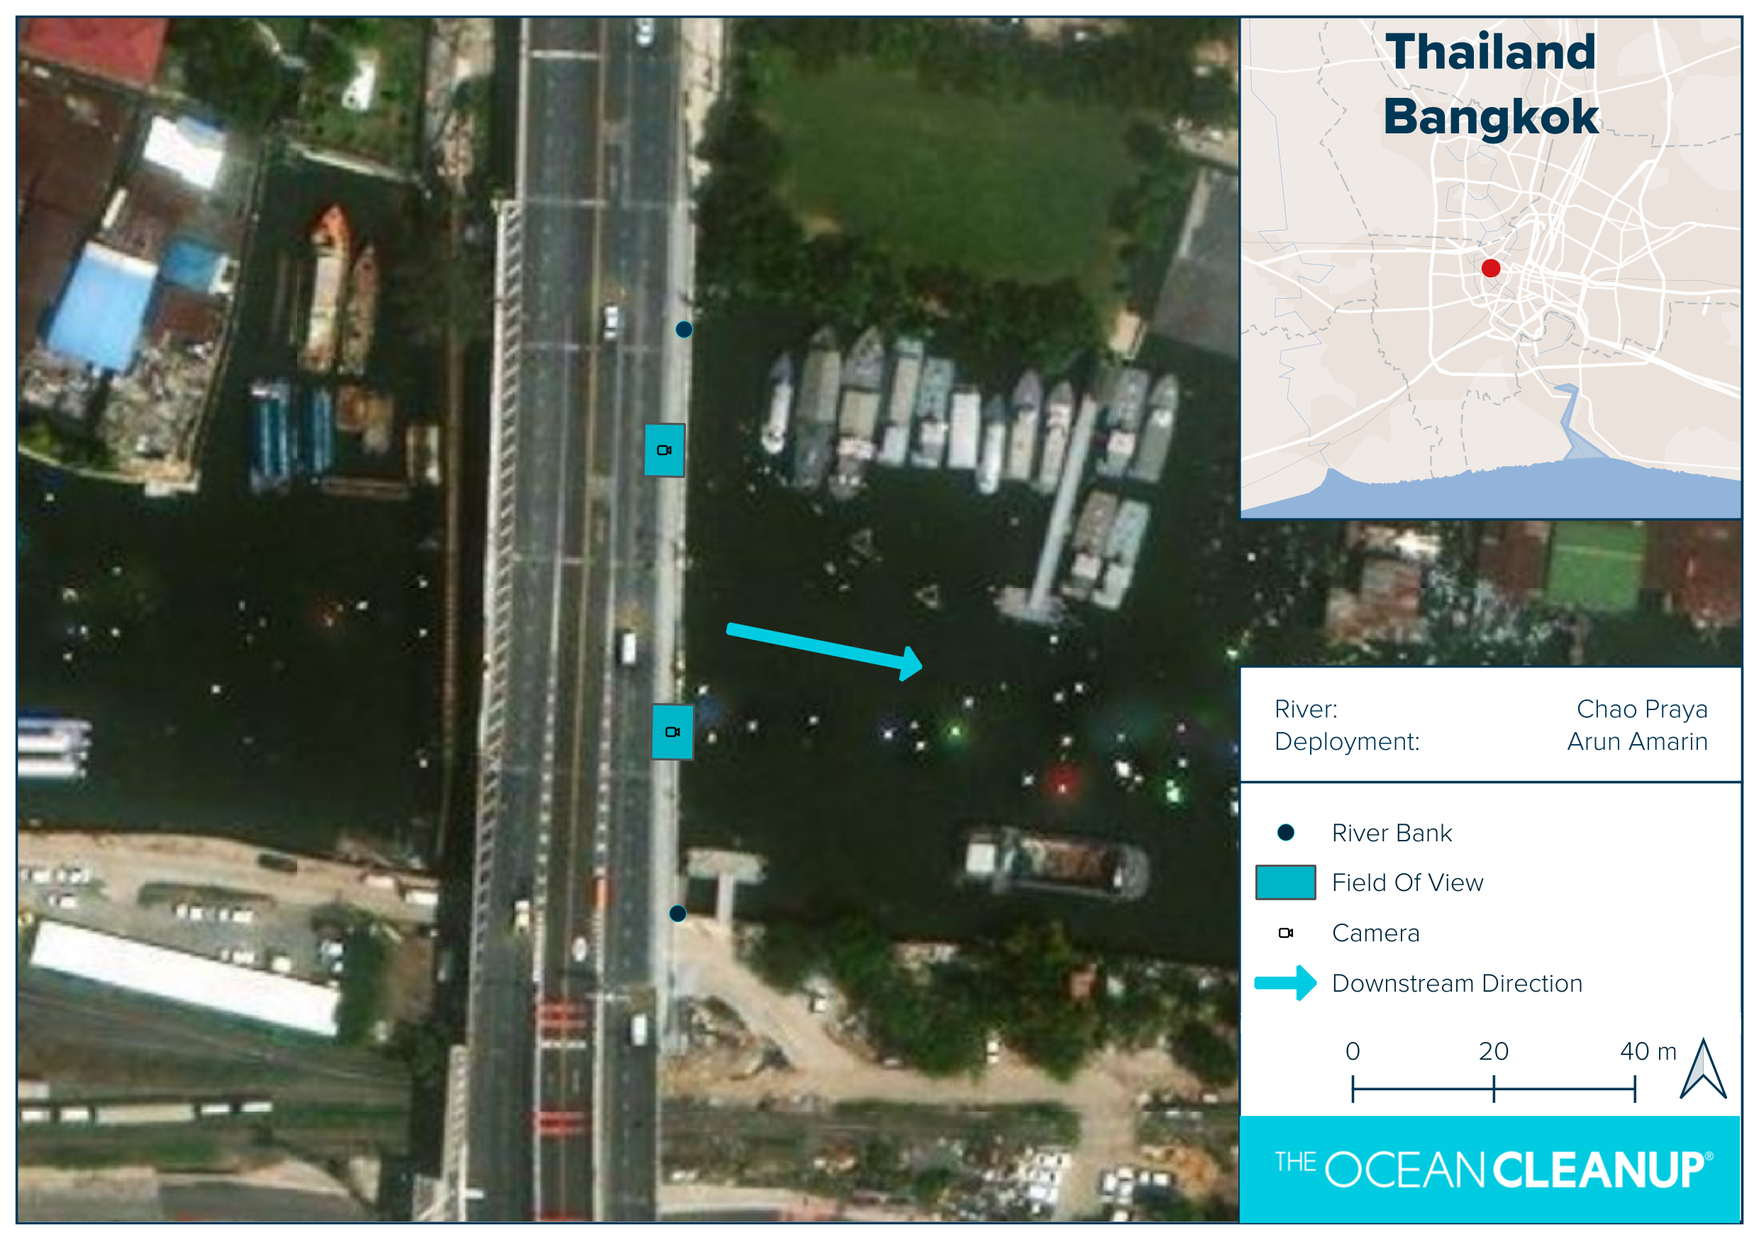
Name | CP Arun
Sampling interval | 15 minutes
Focal length | 6mm
Deployment height | 7m
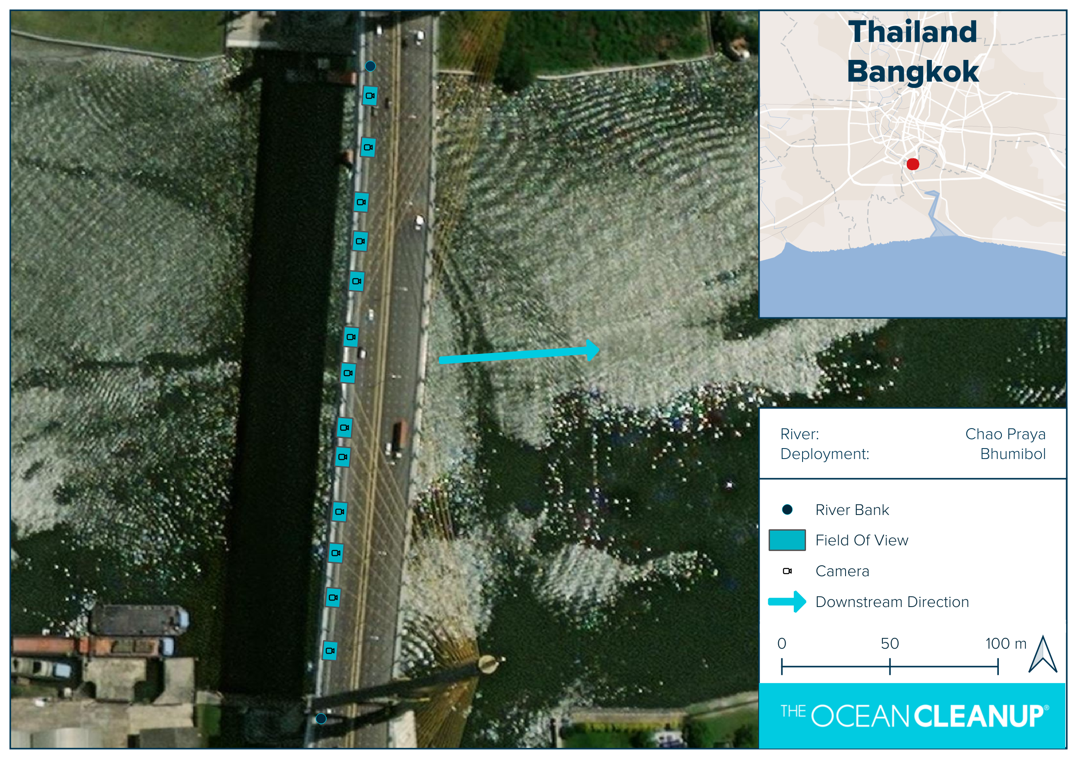
Name | CP Bhumibol
Sampling interval | 15 minutes
Focal length | 35mm
Deployment height | 50m

Supplementary materials B

Object detection
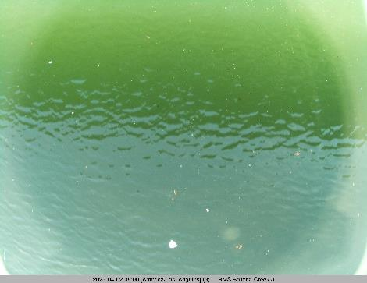
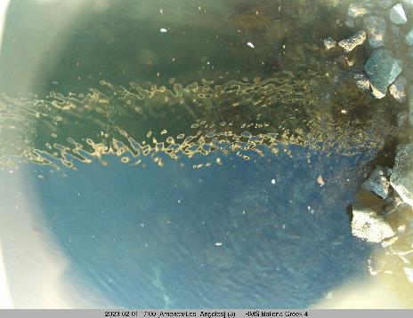
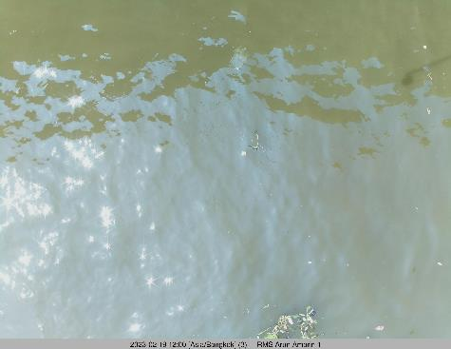
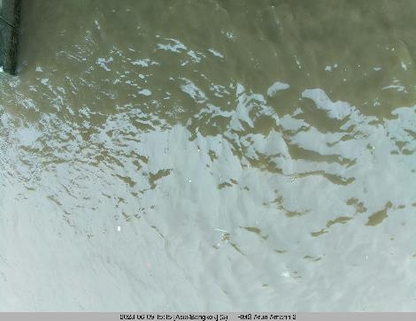
Figure B 1 shows a sample of the images from different locations and cameras. The dataset was split such that there roughly is an equal amount of empty images and distribution of bounding boxes per location between the training, validation and testing dataset splits as shown in Figure B 2. For each location, an equal distribution of the images from different cameras and equal split over different seasons was used such that the dataset is representative for a range of different conditions and seasons, as shown in the sample.
Figure B 1. Sample of images from the dataset. Upper row shows two images from BC IC007 from different cameras in the deployment and different times. Bottom row shows two images from CP Arun from two different cameras and different times.
Every image is only used once and only occurs either in the training or validation split. All images are the same area and aspect ratio. The images and the split were selected such that in both the training and validation split the range of annotations per image is from 0 to roughly 300 with a roughly equal distribution in the training and validation dataset, as shown in Figure B 3, Figure B 4 and Figure B 5. The training dataset has 9% empty images, while the validation dataset has 11% empty images.
Location | Validation image count | Validation Relative Percentage (%) | Training Relative Percentage (%) | Training image count
CP Arun | 44 | 7.2 | 8.0 | 131
BC IC007 | 77 | 12.7 | 14.2 | 233
CP Bhumibol | 36 | 5.7 | 6.4 | 106
CW Amarin | 21 | 4.3 | 2.7 | 44
CD Baru | 76 | 13.3 | 12.9 | 212
KL IC002 | 53 | 8.6 | 9.3 | 153
KLC IC005 | 35 | 5.7 | 6.4 | 106
MO Morales | 34 | 6.3 | 4.8 | 79
RO Rosario | 96 | 16.6 | 16.8 | 276
UM Rail | 97 | 19.4 | 18.5 | 305
Figure B 2. Details on data per location between training and validation datasets. Validation image count is the # of images in the validation dataset. Validation relative percentage is the percentage of data of that location compared to the total validation dataset. Training relative percentage the percentage of data of that location in the total training dataset. Training image count the # of images used for available for training.
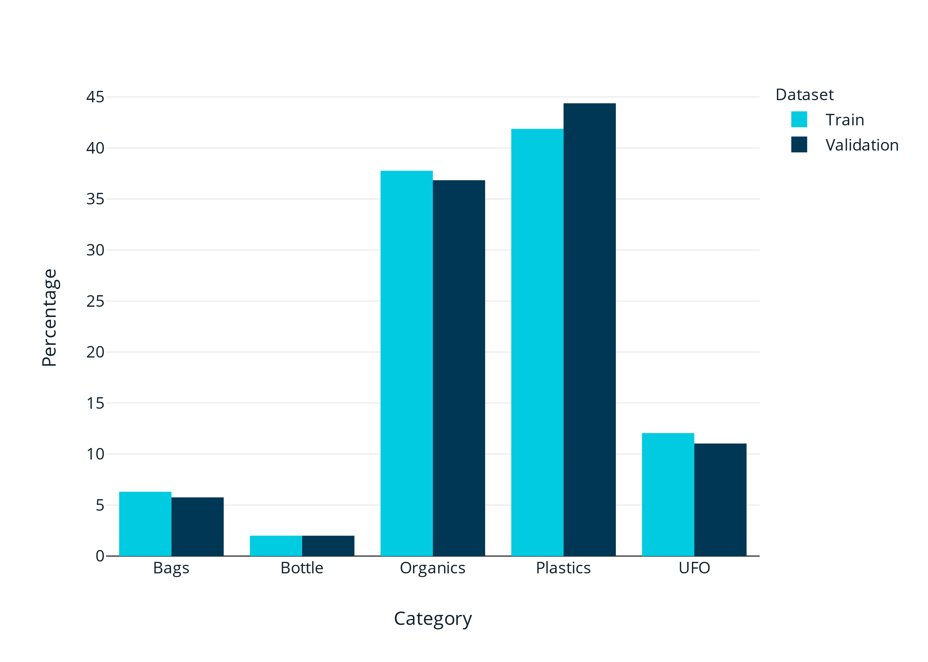
Figure B 3. Annotations per category. a. Training dataset. b. Validation dataset.

Figure B 4. Distribution of annotations per annotation category for training and validation datasets.
Category | Train (%) | Validation (%) | Train Count | Validation Count
Bag | 6.3 | 5.5 | 1778 | 482
Bottle | 2.0 | 2.0 | 564 | 172
Plastics | 41.9 | 42.9 | 11803 | 3753
UFO | 12.1 | 10.6 | 3398 | 924
Organic | 37.8 | 39.1 | 10647 | 3422

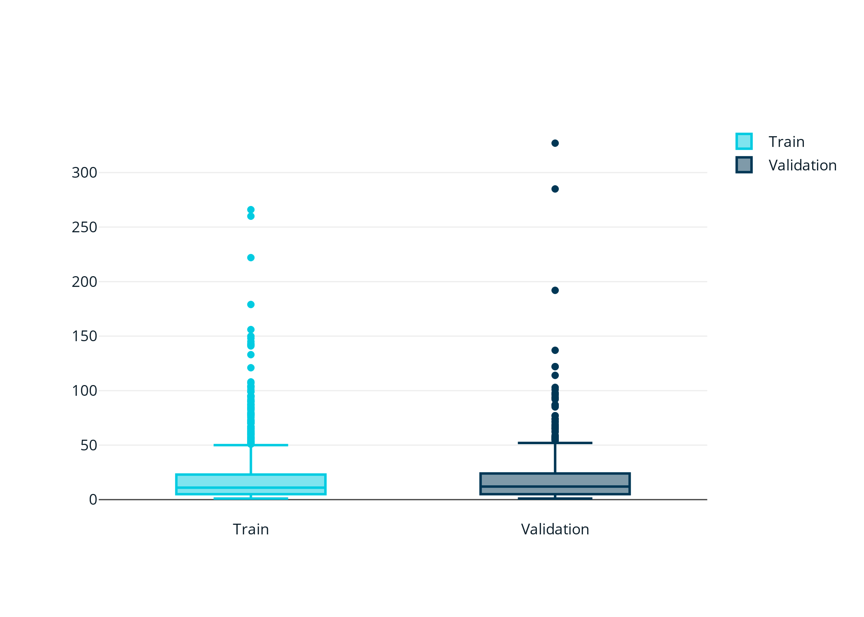
Figure B 5. Distribution of annotations per image in training dataset and validation dataset.

Object tracking
Figure B 6 and Figure B 7 show the distribution of the datasets used for the validation of the tracking. In the tracking dataset track ground truths were labelled for 6 locations, all of the data used for validation.

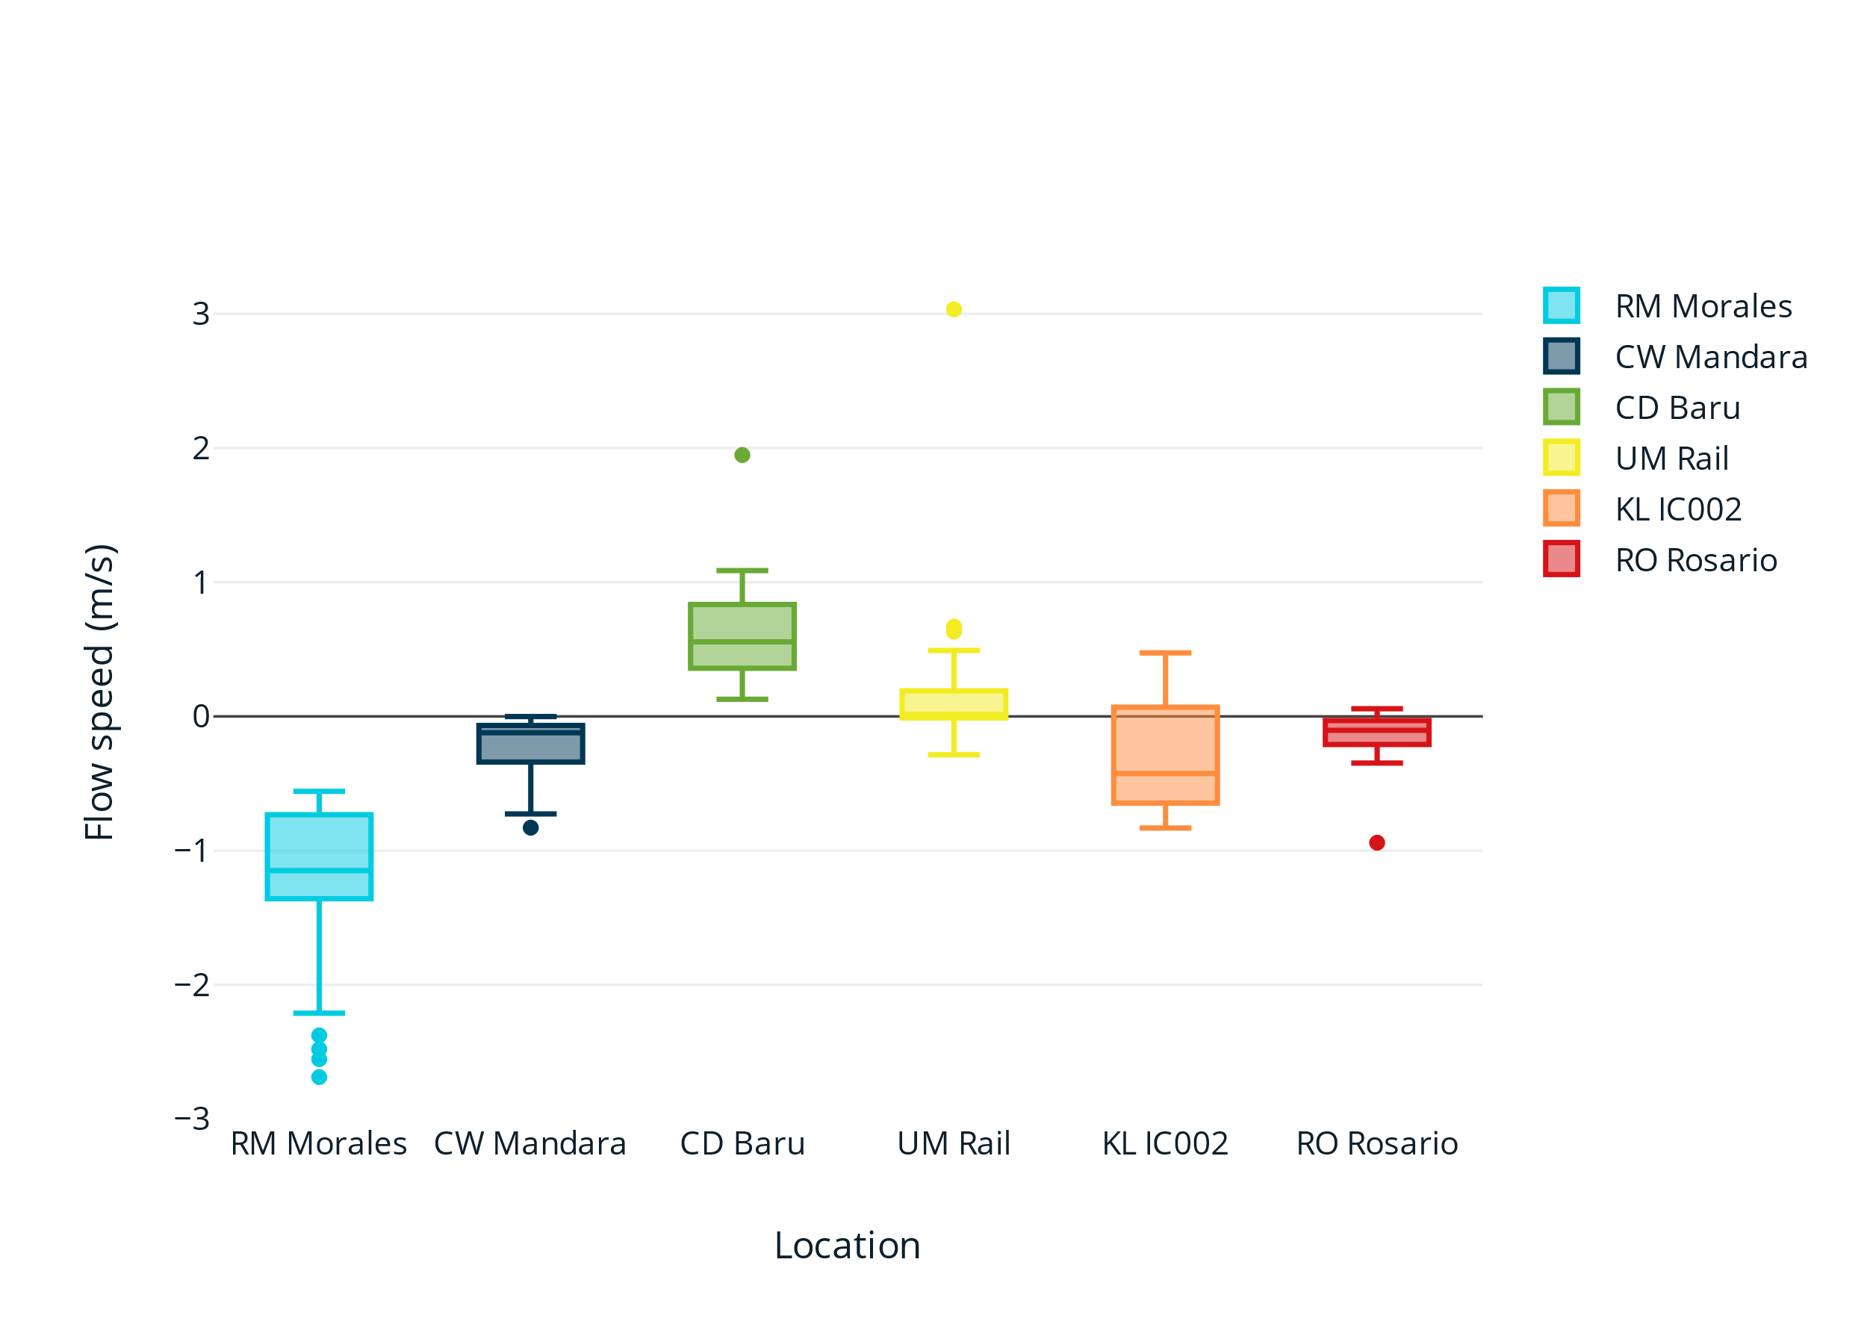
Figure B 6. Distribution of flow speeds per location for the tracking ground truth dataset. The sign of the flow speed depends on the definition for that specific location.

Location | Number of Tracked Objects | Number of Image Bursts | Percentage of Total Dataset
RM Morales | 352 | 40 | 24.4%
CW Mandara | 4326 | 38 | 23.2%
CD Baru | 681 | 27 | 16.5%
UM Rail | 794 | 19 | 11.6%
KL IC002  RO Rosario | 262  153 | 16  24 | 9.8%  14.5%
Figure B 7. Distribution of objects and images per location in the tracking ground truth dataset.

Supplementary Results S

Object detection

Validation Location/Experiments (AP%) | EC | E2A | E2B | E3A | E3B | E4F | E5F | E6 | Yolovl11
RO Rosario | 75 | 79 | 78 | 77 | 77 | 78 | 77 | 77 | 77
UM Rail | 64 | 67 | 66 | 69 | 65 | 68 | 67 | 66 | 66
CD Baru | 76 | 79 | 81 | 80 | 83 | 82 | 81 | 81 | 79
CP Arun | 61 | 65 | 68 | 68 | 69 | 70 | 65 | 70 | 67
BC IC007 | 40 | 37 | 45 | 50 | 46 | 43 | 74 | 75 | 72
CP Bhumibol | 57 | 63 | 72 | 71 | 70 | 70 | 64 | 69 | 70
CW Mandara | 63 | 65 | 66 | 63 | 62 | 77 | 72 | 74 | 75
KL IC002 | 59 | 64 | 69 | 77 | 77 | 77 | 76 | 78 | 77
KL IC005 | 73 | 73 | 74 | 75 | 77 | 77 | 76 | 77 | 78
RM Morales | 60 | 51 | 55 | 49 | 58 | 54 | 65 | 50 | 67
Table S 1. AP₅₀ results from generalization experiments per location and per experiment for the plastic category.
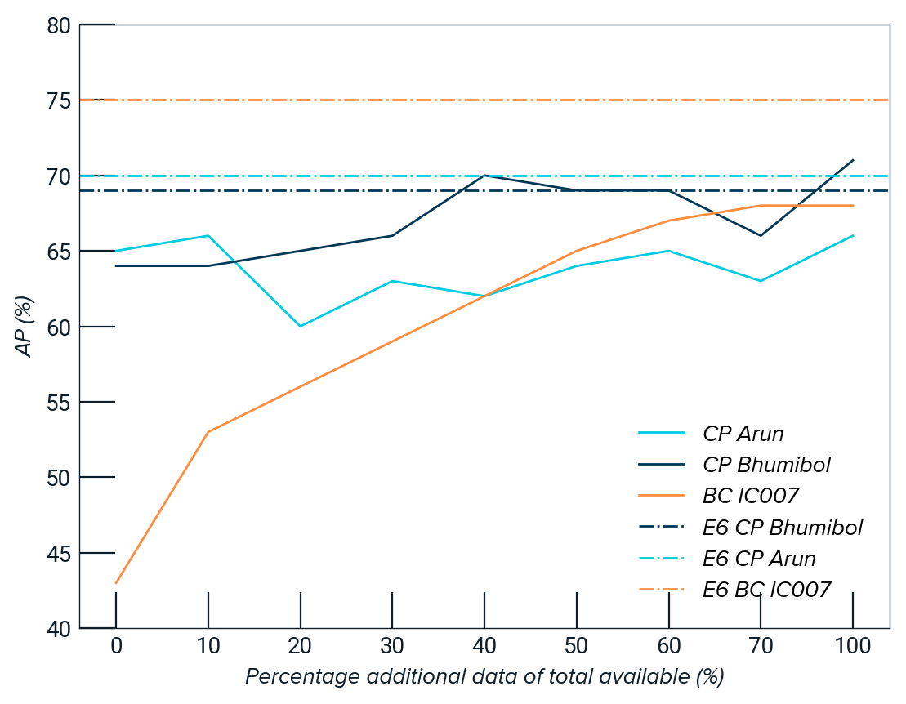
Figure S 1. AP for finetune experiments E3 and E4, with on the x-axis the % of training data of total available training data and y-axis the AP (%) for finetuning with that % of additional training data. The solid lines are the evaluations of the finetuning experiment, the dashed lines the results from experiment E6 with training on all the data.

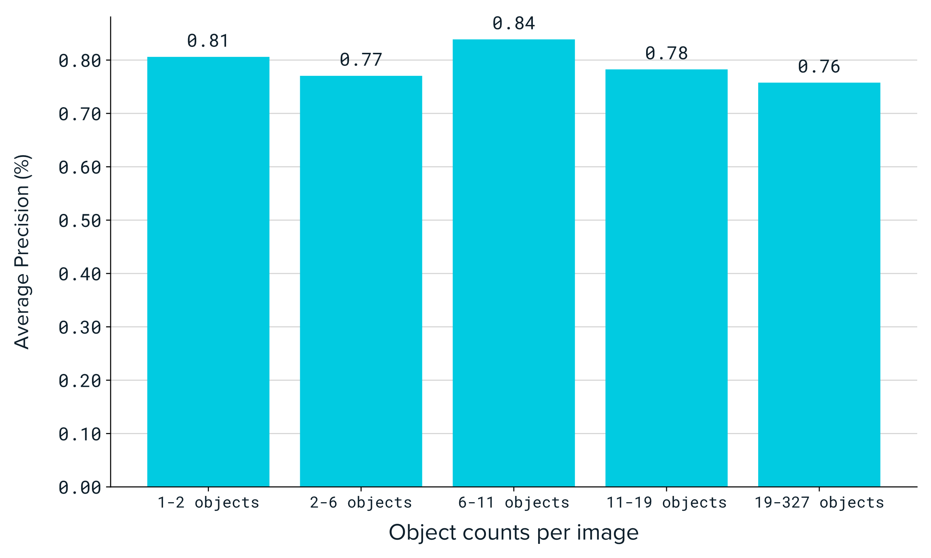
Figure S 2. AP₅₀ per number of plastics in the image. Each block of objects has the same number of images. So there are as many with 1-2 objects as there are with 2-6 objects and 19-327 objects.

Location | Optimal confidence threshold | Plastic detection error MAE (items)
CP Arun | 0.25 | 3.1
BC IC007 | 0.19 | 1.5
CP Bhumibol | 0.24 | 2.6
CW Mandara | 0.24 | 2.5
CD Baru | 0.33 | 2.9
KL IC002 | 0.26 | 2.5
KL IC005 | 0.24 | 4
RM Morales | 0.36 | 0.3
RO Rosario | 0.25 | 1.7
Table S 2. Optimal plastic detection error and associated optimal confidence threshold per location. The plastic detection error is the mean absolute error between the plastic counts in the detection and plastic counts in the annotations per image. The plastic detection error presented here is the minimized error from changing the confidence threshold filtering of detections. The associated optimal confidence threshold is the threshold at which the error is minimized. For example, an error of 3.1 items corresponds with an average difference of 3.1 items between the detections and annotations at the optimal confidence threshold of 0.25.

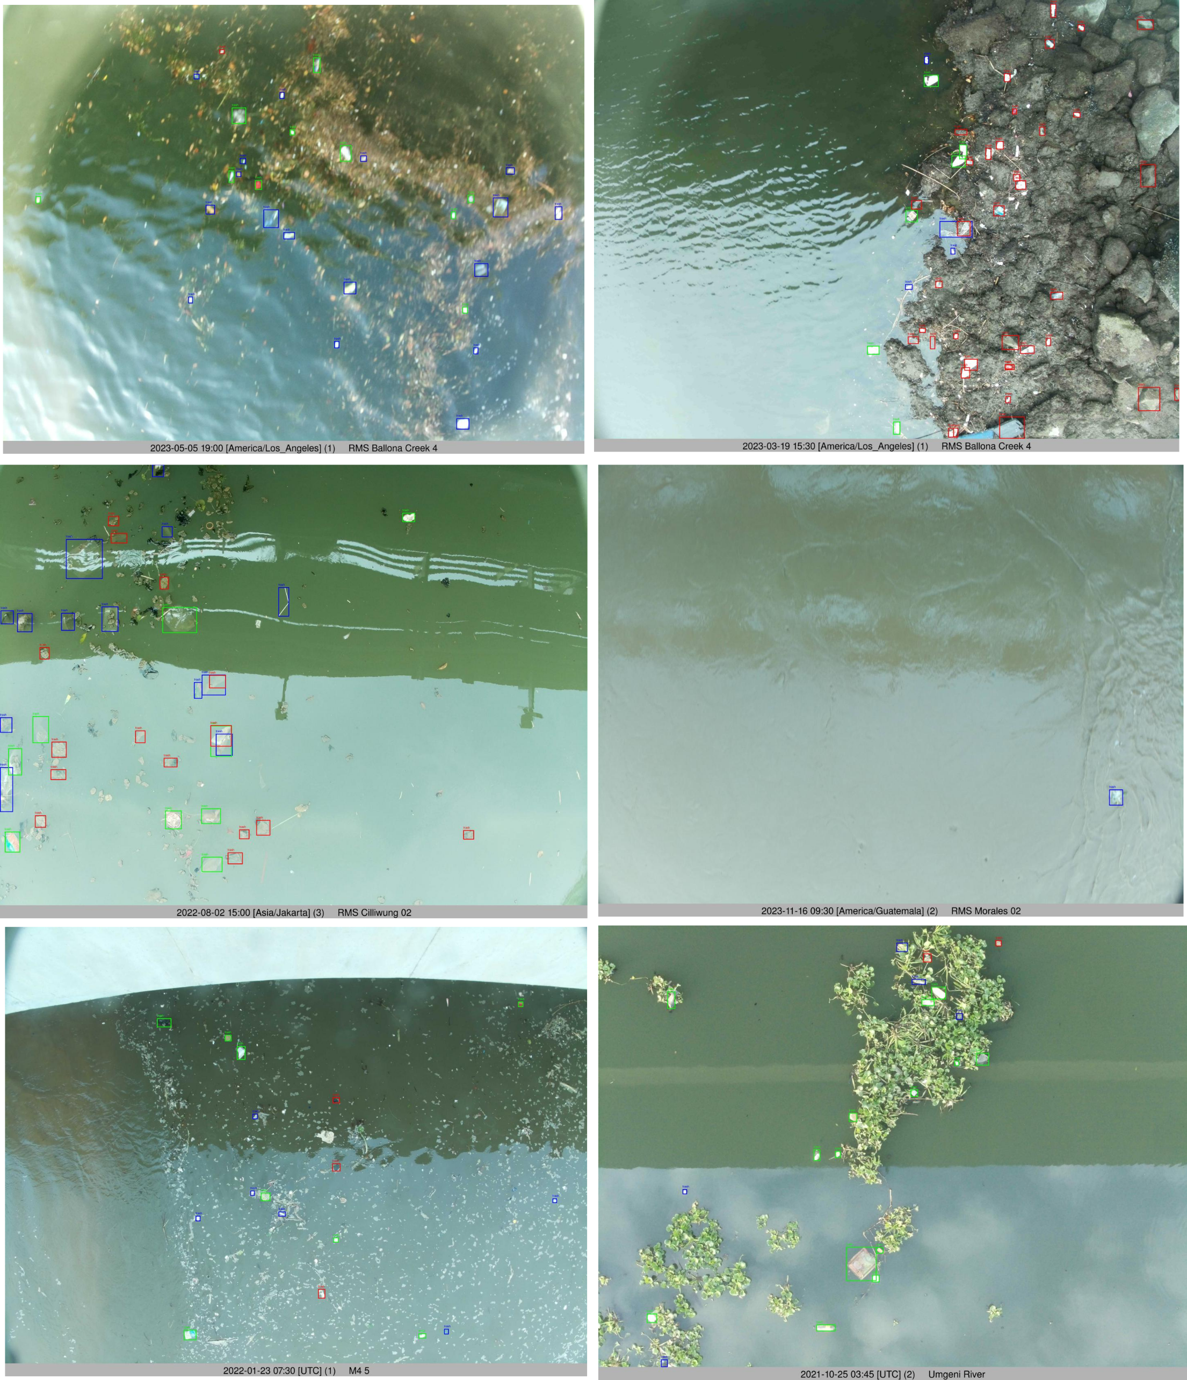
Figure S 3. Detection examples of plastic on images with high relative amounts of false positives or false negatives. Selected because they have a large contribution to the reduction of the average precision. Detection boxes in green are correct detections, detections in red are false positives (no ground truth annotations) and in blue false negatives (ground truth annotation but no prediction by the detection model). Note the high variety in organics or changing background for these images.

Tracking
In these graphs, the following metrics are used:
Coverage: the percentage of image bursts with results compared to the total image bursts with detections, MAPE: Mean Absolute Percentage Error, MdAPE: Median Absolute Percentage Error, MSE: Mean Squared Error, and MAE: Mean Absolute Error.
 | MdAPE (%) | MSE (items) | MAE (items)
Inference | 12% | 38.88 | 2.44
Tracking | 42% | 93.48 | 5.22
Filtering | 50% | 223.74 | 6.72
Table S 3. Performance metrics for the number of objects per image burst after Inference, Tracking, and Filtering.
 | Coverage (%) | MAPE (%) | MdAPE (%) | MSE (pixels) | MAE (pixels)
Tracking | 82.72% | 37% | 6% | 6519.90 | 23.93
Filtering | 75.31% | 9% | 4% | 487.00 | 6.04
Table S 4. Performance metrics for the displacement (pixels) per image burst after Tracking and Filtering
 | Coverage (%) | MAPE (%) | MdAPE (%) | MSE (m/s) | MAE (m/s)
Tracking | 82.72% | 60% | 7% | 1.05 | 0.30
Filtering | 75.31% | 15% | 4% | 0.05 | 0.06
Table S 5. Performance metrics for the flow speed (m/s) per image burst after Tracking and Filtering.
 | Coverage (%) | MAPE (%) | MdAPE (%) | MSE (items/burst) | MAE  (items/burst)
Inference (f) | 75.31% | 27% | 16% | 8.60 | 1.45
Tracking (t) | 82.72% | 84% | 39% | 116.98 | 4.98
Filtering (f) | 75.31% | 49% | 43% | 64.77 | 4.37
Table S 6. Performance metrics for the flux per image burst after Inference, Tracking, and Filtering. (f) means that the filtered flow speed was used and (t) the tracked flow speed.

SUPPLEMENTARY MATERIALS C
See https://doi.org/10.4121/fad0aa03-37b4-4a3c-8263-8ed60a03b393.v1.

SUPPLEMENTARY MATERIALS D
See https://doi.org/10.4121/fad0aa03-37b4-4a3c-8263-8ed60a03b393.v1.

Supplementary Materials E
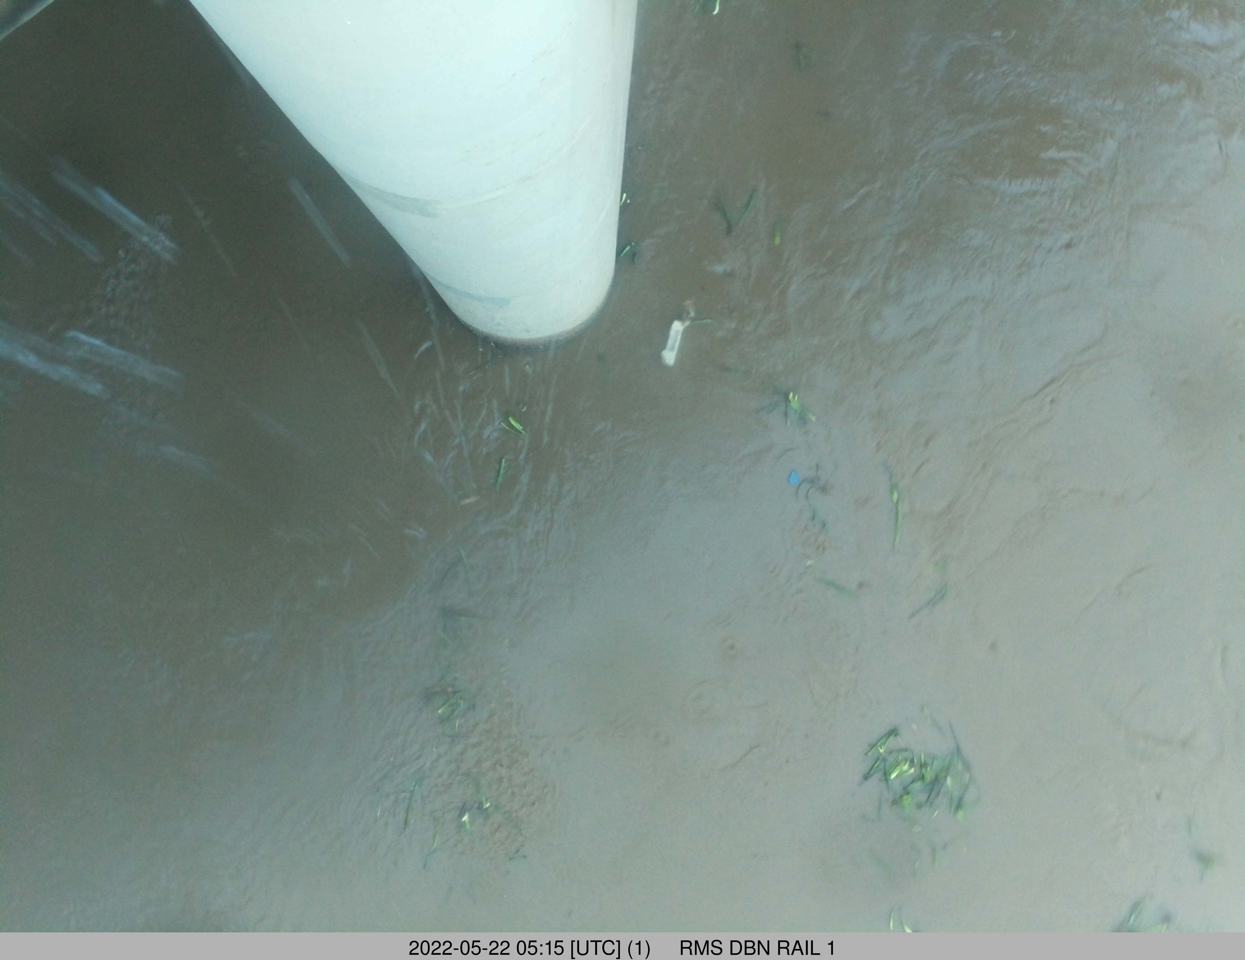
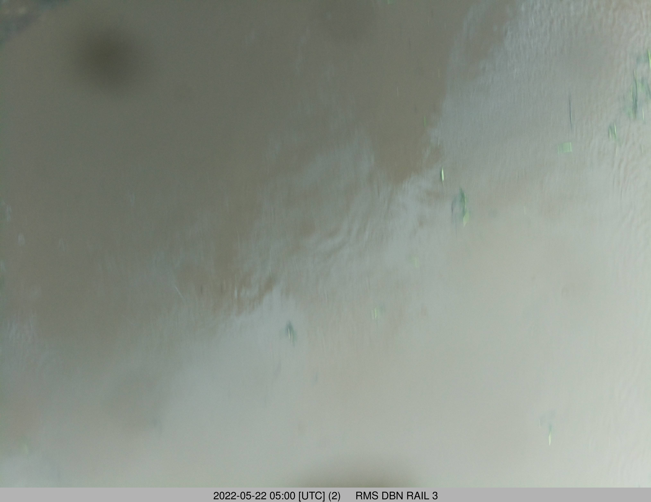
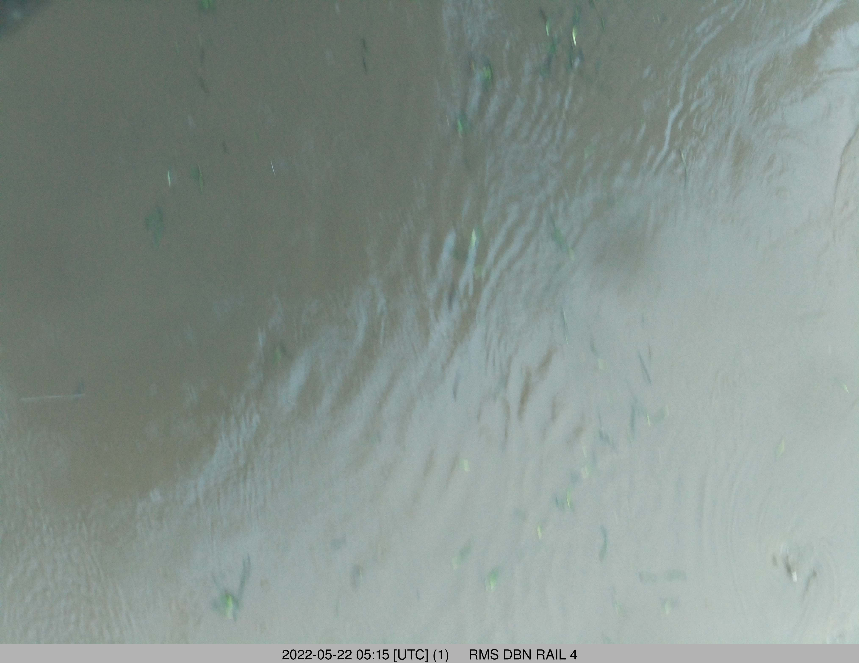
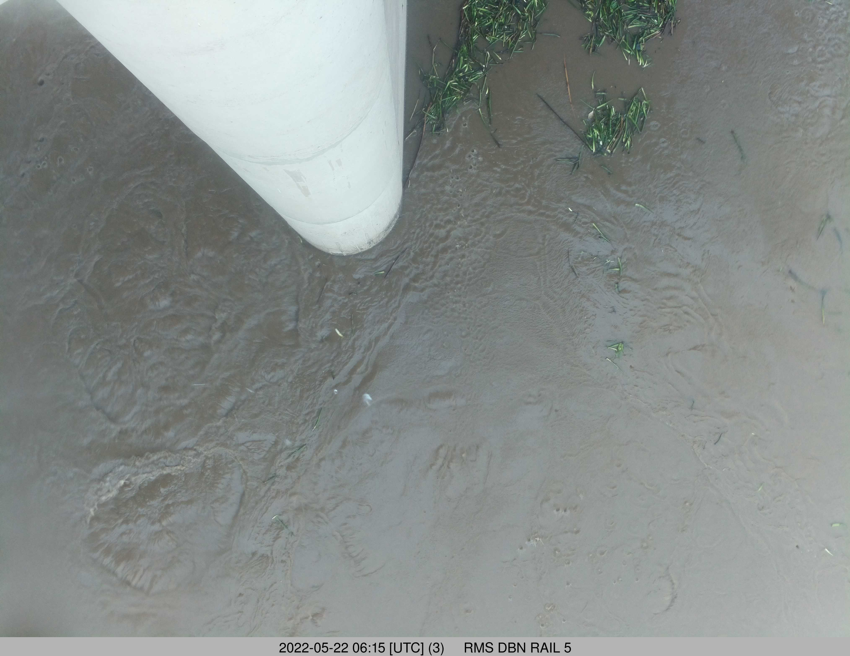
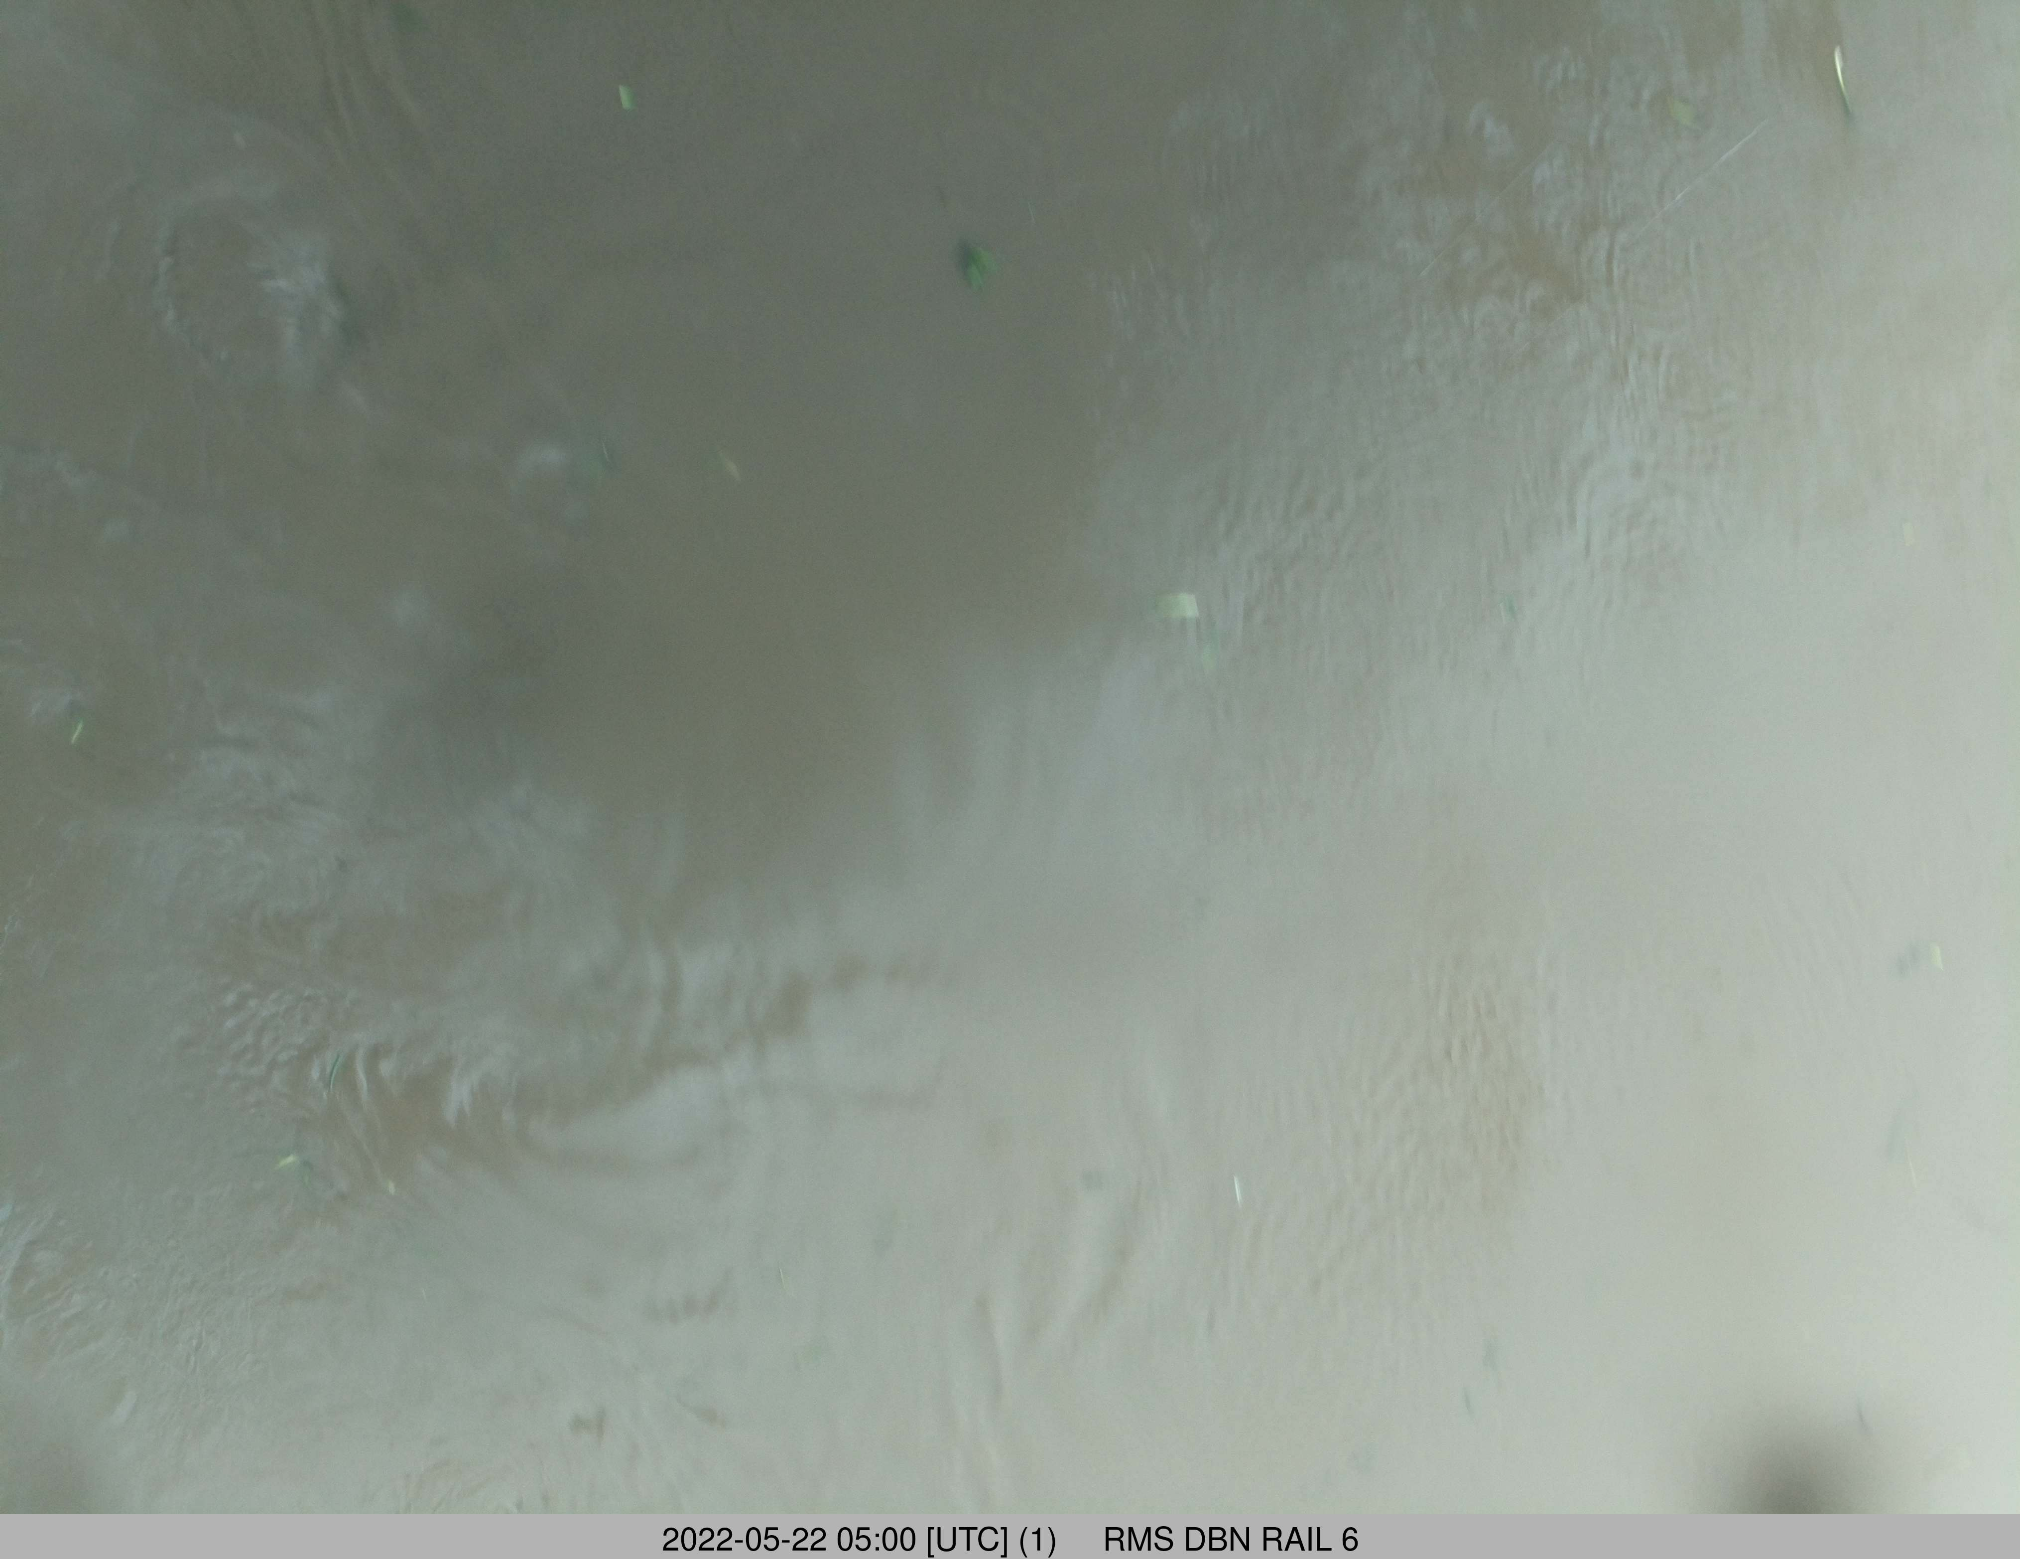
Example images taken during the SA Umgeni flood event. These are the earliest images taken for each of the cameras, except for Rail 2 due to unavailability, in the morning of May 22 2022.

The image below is an example of when the water is turbulent. It was taken during another flooding event in the Umgeni River.
