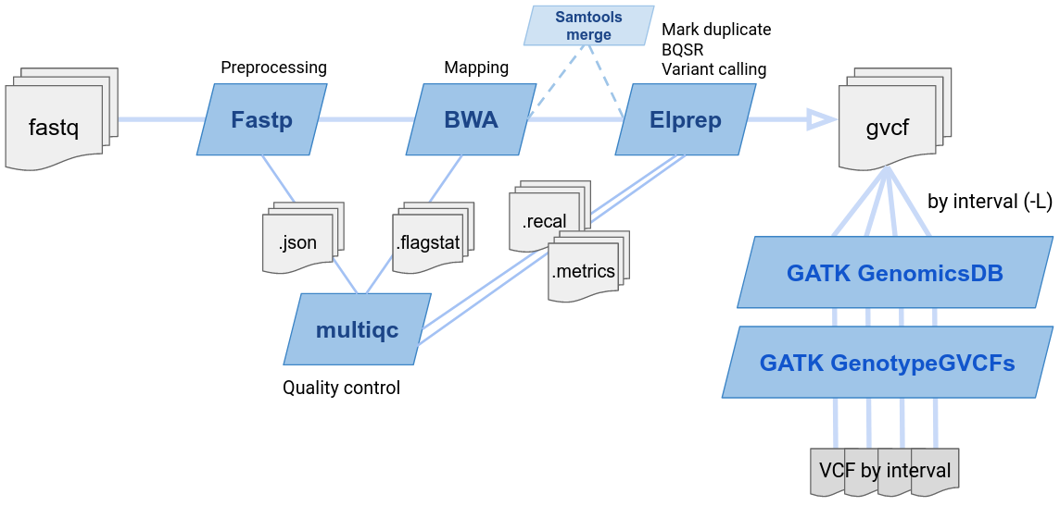

Supplementary information, Fig. S1. Processing Pipeline: To maintain consistency across samples, all datasets were re-processed starting from the raw fastq reads. The workflow included pre-processing and quality control of the reads, followed by alignment to the chicken genome assembly GRCg7b, variant calling, and the generation of a VCF file.

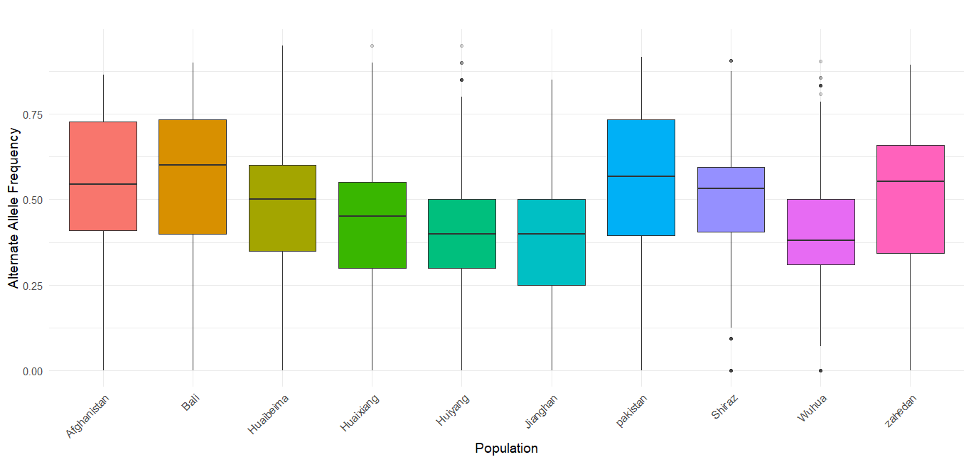
Supplementary information, Fig. S2. Distribution of Alternate Allele Frequency per Population.

