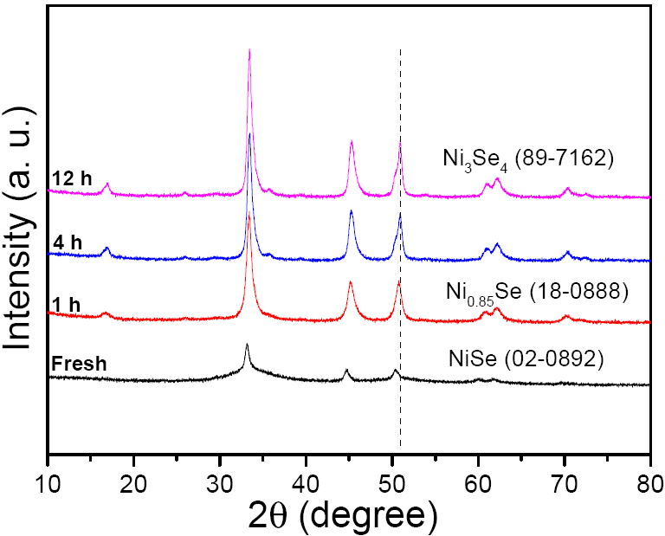
Fig. S1 XRD patterns of nickel selenides at different reaction times from NiCl₂·6H₂O

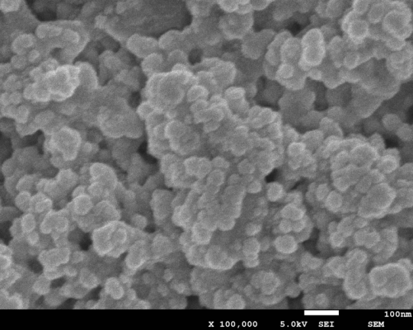
Fig. S2 SEM images and size distribution of Ni₃Se₄ nanoparticles from NiCl₂·6H₂O

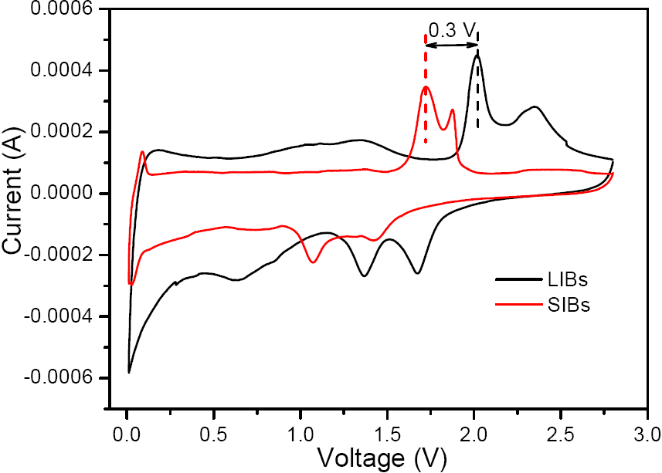
Fig. S3 the 2nd cycle CV curve of Ni₃Se₄/C electrode as both LIBs and SIBs anodes

