Supplementary Material

Copper effects on net N₂O production and associated gene expression by the deep-sea isolate Shewanella loihica PV-4

Archives of Microbiology

Laurine Mathé^{1,2}, Leonor Pizarro^{1,3}, C. Marisa R. Almeida^{1,4}, Catarina Magalhães^{1,5}, Miguel Semedo¹*

¹ CIIMAR/CIIMAR LA, Interdisciplinary Centre of Marine and Environmental Research (CIIMAR), University of Porto, Matosinhos 4450-208, Portugal

²Faculty of Science and Engineering, University Pierre et Marie Curie, Sorbonne University, Paris 75005, France.

³Institute of Biomedical Sciences Abel Salazar, University of Porto, Porto 4050-313, Portugal

⁴Department of Chemistry and Biochemistry, Faculty of Sciences (FCUP), University of Porto, Porto 4169-007, Portugal

⁵Department of Biology, Faculty of Sciences (FCUP), University of Porto, Porto 4169-007, Portugal

*Corresponding author (msemedo@ciimar.up.pt)

Supplementary Tables (one per page)

Table S1. Media used to activate and grow S. loihica PV-4 (Luria Bertani) and media used for the exposure experiments (Marine Basal Media).
Luria Bertani agar media (solid) |  |  | Marine Basal Media (liquid)
NaCl | 10 g/L |  | Sea salt | 20 g/L
Tryptone | 10 g/L |  | Basal media | 250 ml/L
Yeast extract  Agar | 6 g/L  15 g/L |  | - 1M Tris-HCL pH 7,5  - K₂HPO₄.3H₂O  - NH4Cl | 285 ml/L  0.165 g/L  2.85 g/L
Deionized water | 1L |  | Deionized water | QSP 1L

Table S2 – qPCR conditions used to quantify the gene expression of nirK, nosZ, rpoB, and recA.
Reagent | Volume (concentration)
PowerUp SYBR Green Master 2X | 10µL
forward/reverse primer – recA, rpoB, nosZ, nirK (Table S3) | 1µL (0,5µM)
cDNA template | 1µL (50ng/µL and 114ng/µL)
Nuclease free water | 7µL
BSA – nosZ only | 1 µL (10mg/ml)

Phases | Temperature (°C) | Time (seconds)
Pre-incubation | 50 | 120
Pre-incubation | 95 | 120
Amplification (recording the results) | 95 | 15
Amplification (recording the results) | 60 _{(recA, nirK, nosZ)} / 58 _{(rpoB)} | 60
Melting curves stage | 95 | 15
Melting curves stage | 60 | 60
Melting curves stage | 95 | 15

Table S3 – Primers used to amplify recA, rpoB, nirK and nosZ gene in PV-4 during qPCR and PCR.
Gene | Reference | Product length (bp) | primer | Primer length (bp) | Sequence 5’-3’ | Tm (°C) | % GC
nosZ | (Yoon, Sanford, Löffler 2015) | 160 | SlonosZ599f | 20 | ATGGTAAGGAGACGCTGGAA | 58.4 | 50.0
nosZ | (Yoon, Sanford, Löffler 2015) | 160 | SlonosZ758f | 21 | TTGTAGCAGGTAGAGGCGAAG | 59.5 | 52.4
nirK | (Yoon, Sanford, Löffler 2015) | 188 | SlonirK853f | 20 | AAGGTGGGTGAGTCTGTGCT | 61.1 | 55.0
nirK | (Yoon, Sanford, Löffler 2015) | 188 | SlonirK1040f | 18 | GGCTGGCGGAAGGTGTAT | 59.4 | 51.1
rpoB | (Pizarro et al. 2023) | 123 | SlrpoB253f | 20 | GGGTAGCGAAGAGATCACCG | 60.0 | 60.0
rpoB | (Pizarro et al. 2023) | 123 | SlrpoB2660r | 20 | TTACCAACCAGGATGTCGCC | 60.0 | 55.0
recA | (Pizarro et al. 2023) | 117 | SlrecA725f | 20 | AGACTCGCGTTAAGGTGGTG | 60.0 | 55.0
recA | (Pizarro et al. 2023) | 117 | SlrecA841r | 20 | TCACGCCAAGGTCTACCAAC | 60.0 | 55.0

Table S4 – S. loihica growth rate for each bioreactor of the three exposure experiments. The growth rate is calculated from the slope of the linear regression with Castilleja method (Castilleja et al. 2017).

Treatments | Experiments | Bioreactors | Growth rate (OD.h⁻¹) | R²
Control | A | R2 | 0.0187 | 0.90
Control | B | R4 | 0.0169 | 0.77
Control | C | R2 | 0.0229 | 0.76
Control | C | R3 | 0.0223 | 0.78
Copper | A | R1 | 0.0126 | 0.83
Copper | A | R3 | 0.0122 | 0.74
Copper | B | R1 | 0.0165 | 0.88
Copper | C | R1 | 0.0251 | 0.78
Copper | C | R4 | 0.0245 | 0.77

Table S5 – nirK and nosZ relative expression over time, mean from 4 replicates for control and 5 replicates for Cu treatment, and standard deviation. As well as their calculated nirK/nosZ ratios for Cu and control treatments.
Treatment | Time | nirK |  | nosZ |  | nirK/nosZ ratio
Treatment | Time | Relative expression | SEM | Relative expression | SEM | nirK/nosZ ratio
Copper | -45 | 3,11 | 2,63 | 2,44 | 1,40 | 0,57
Copper | 10 | 16,87 | 5,55 | 17,30 | 5,13 | 1,02
Copper | 60 | 3,52 | 1,69 | 10,21 | 2,77 | 0,38
Copper | 120 | 3,94 | 2,19 | 7,84 | 4,31 | 0,57
Control | -45 | 0,34 | 0,20 | 1,67 | 1,08 | 0,14
Control | 10 | 5,67 | 3,07 | 7,21 | 0,74 | 0,92
Control | 60 | 7,05 | 3,98 | 10,43 | 2,32 | 0,76
Control | 120 | 9,08 | 6,43 | 11,11 | 2,63 | 0,69

Table S6 – NO₂⁻ and NO₃⁻ concentrations as well as their calculated NO₂⁻:NO₃⁻ ratios during anoxia in both control and copper-treated reactors. Ti corresponds to the sample taken before the induction of anoxia and Tf corresponds to the sample taken after the end of the anoxia, once the growth reaches the stationary phase.

Time (min) | treatment | NO₂⁻ (mM) | NO₃⁻ (mM) | NO₂⁻ : NO₃⁻ ratio
Ti | control | 0 | 0,248 | 0,00
0 | control | 0,451 | 0,217 | 2,08
30 | control | 0,737 | 0,175 | 4,21
60 | control | 0,613 | 0,159 | 3,86
90 | control | 0,479 | 0,141 | 3,40
120 | control | 0,283 | 0,061 | 4,64
Tf | control | 0 | 0,031 | 0,00
Ti | copper | 0 | 0,211 | 0,00
0 | copper | 0,589 | 0,192 | 3,07
30 | copper | 0,565 | 0,212 | 2,67
60 | copper | 0,561 | 0,153 | 3,67
90 | copper | 0,355 | 0,11 | 3,23
120 | copper | 0,317 | 0,062 | 5,11
Tf | copper | 0 | 0,037 | 0,00

Supplementary Figures (one per page)

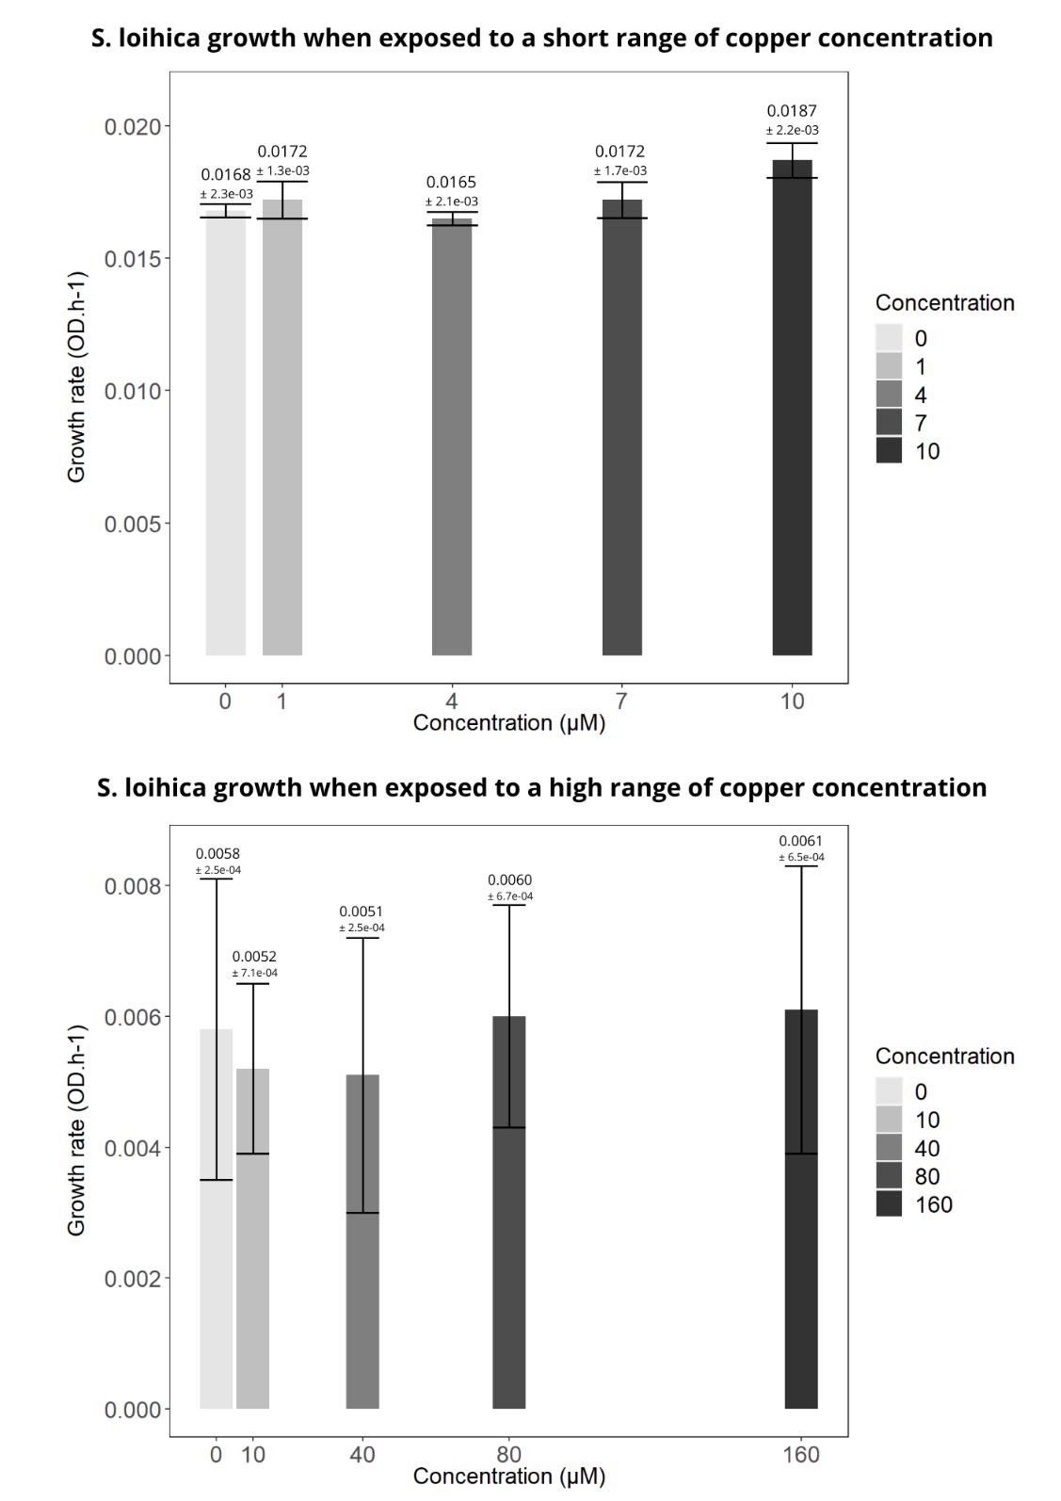

Figure S1 – S. loihica growth rate when exposed to Cu in aerobic conditions. Method from Castilleja and co-authors (Castilleja et al. 2017). Low range experiment corresponding to Cu concentration from 0 to 10 µM. High range experiment corresponding to Cu concentration from 0 to 160 µM. Bars represent mean ± SD from triplicate culture flasks.

Figure S2 - Nitrous oxide amount during anoxia in control (blue) and Cu-treated (orange) reactors from experiments A, B, and C. Each point represents the N₂O measurement from a single reactor at a given time point during the anoxic period. The slope represents the linear N₂O flux over time. For linear regression with R² < 0.80 the flux was considered null.

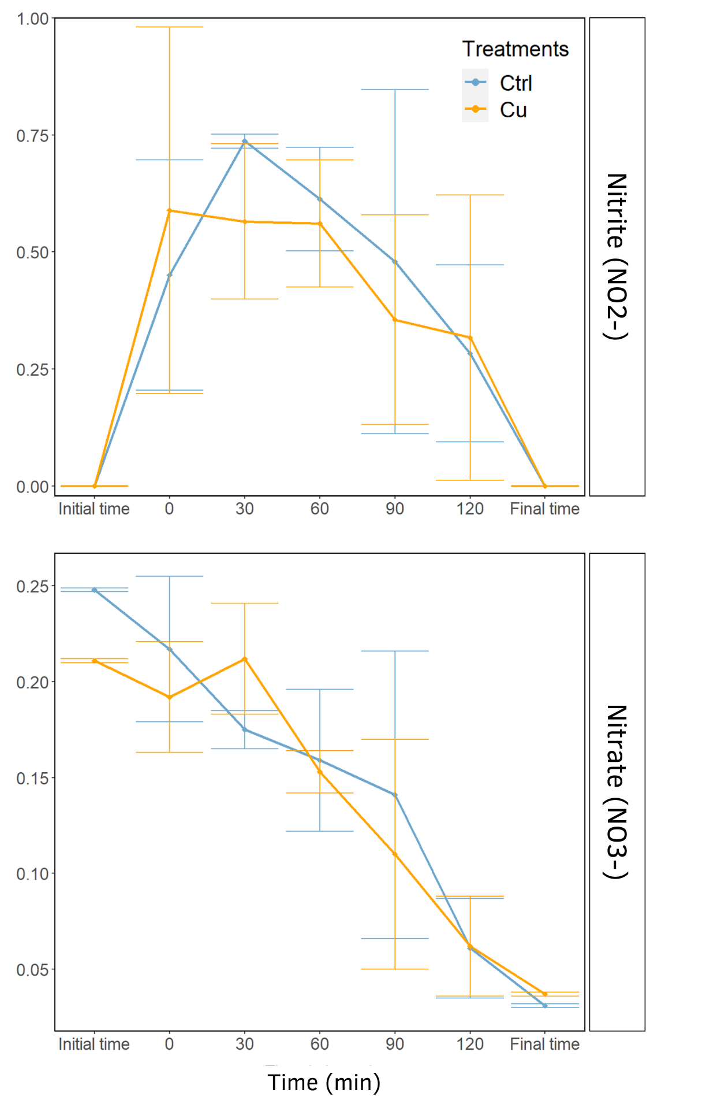
Concentration (mM)
Figure S3 – Nitrogen intermediates concentration (NO₂⁻ and NO₃⁻) during anoxia. Control treatment shown in blue and Cu treatment shown in orange. Standard deviation indicated by the vertical error bars.

