Figure 1F
E-cadherin
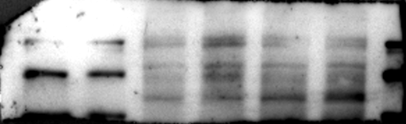 135 kDa
Snail
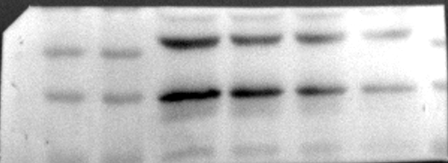 29 kDa
GAPDH
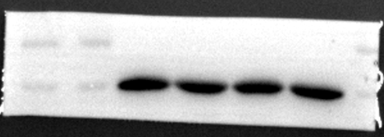 37 kDa

E-cadherin
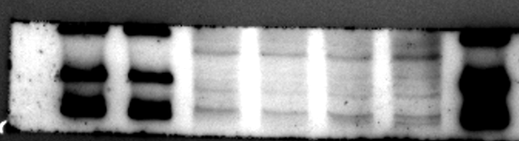 135 kDa
Snail
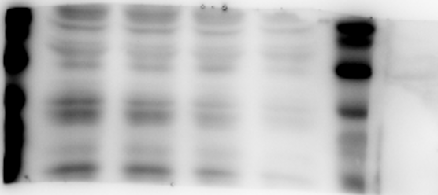29 kDa
GAPDH
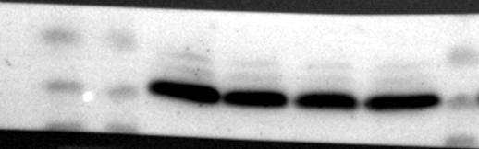 37 kDa

Figure 3E and 3F
BAX
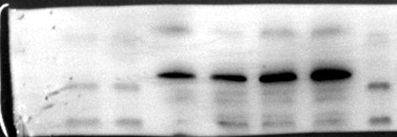 21 kDa
Bcl2
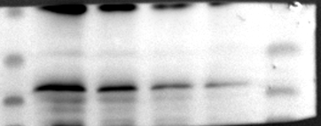 27 kDa
Cleaved-caspase 3
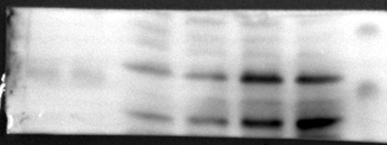 17 kDa
GAPDH
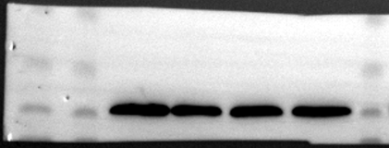 37 kDa
BAX
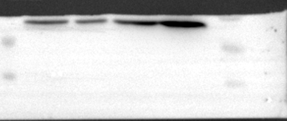 21 kDa
BCl2
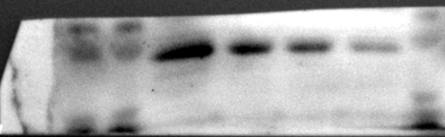 27 kDa
Cleaved caspase 3
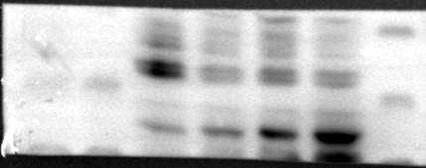 17 kDa
GAPDH
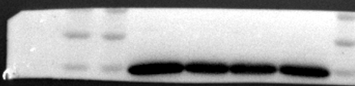 37 kDa

Figure 4E
FAK
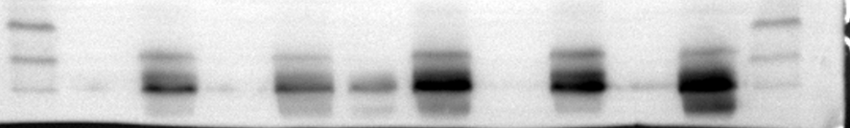 125 kDa
GAPDH
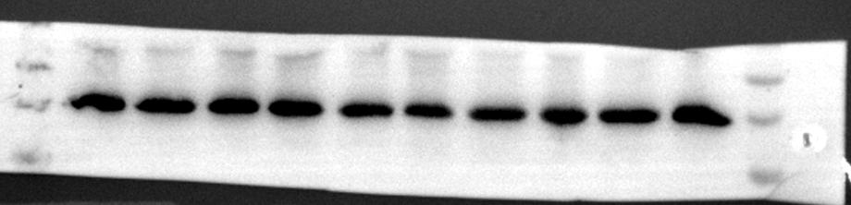 37 kDa

Figure 5B
p-FAK
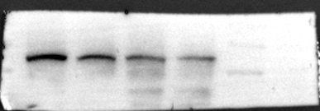 125 kDa

FAK
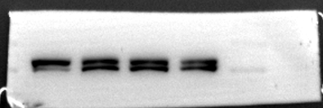 125 kDa
GAPDH
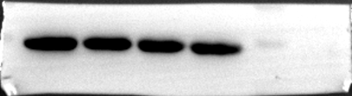 37 kDa

p-FAK
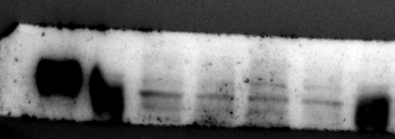 125 kDa
FAK
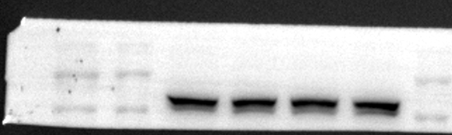 125 kDa

GAPDH
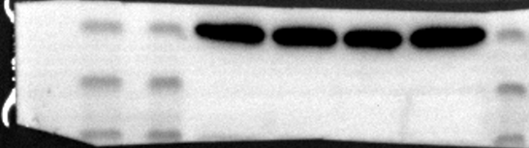 37 kDa
Figure 5D
MCF7
LRG1
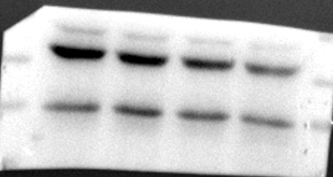 45 kDa
GAPDH
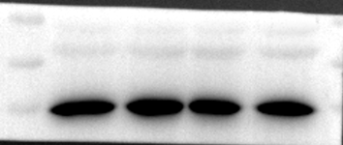 37 kDa

MDA-MB-231
LRG1
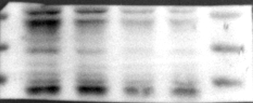 45 kDa
GAPDH
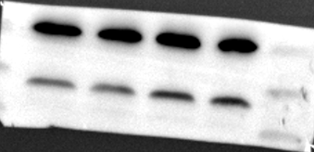 37 kDa

Figure 5E
MCF7
p-PI3K
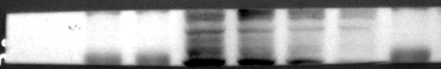 85 kDa
PI3K
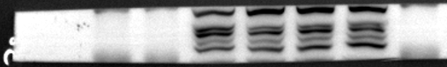 85 kDa
p-AKT
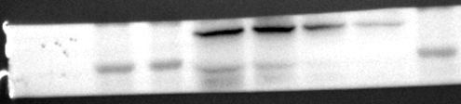 60 kDa
AKT
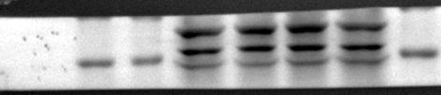 60 kDa
p-mTOR
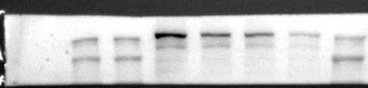 289 kDa
mTOR
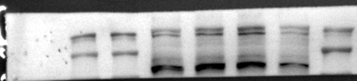 289 kDa
GAPDH
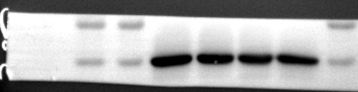 37 kDa
MDA-MB-231
p-PI3K
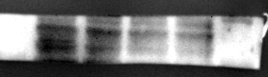 85 kDa
PI3K
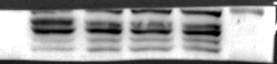 85 kDa
p-AKT
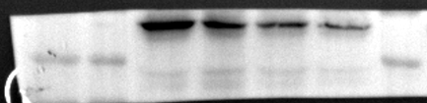 60 kDa
AKT
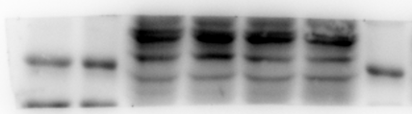 60 kDa
p-mTOR
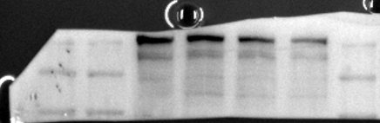 289 kDa
mTOR
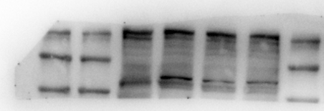 289 kDa
GAPDH
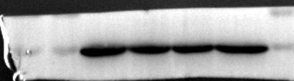 37 kDa

Figure 6
FAK
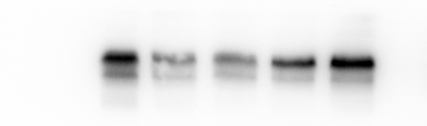 125 kDa
GAPDH
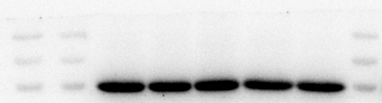 37 kDa
FAK
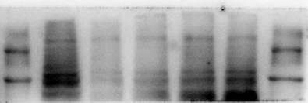 125 kDa
GAPDH
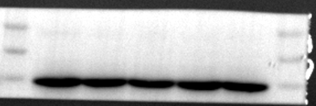 37 kDa

Figure 6C
BD-FAK
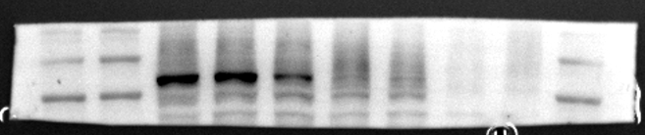 125 kDa
BD-DMSO
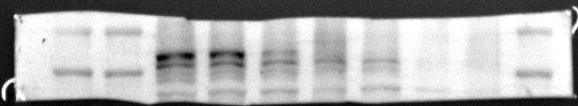 125 kDa
BD-FAK
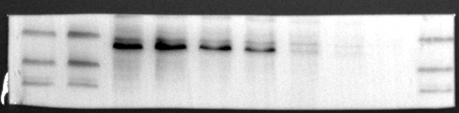 125 kDa
BD-DMSO
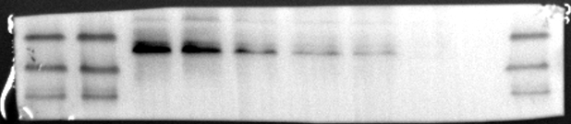 125 kDa

Figure 6F and 6G
MCF-7
p-FAK
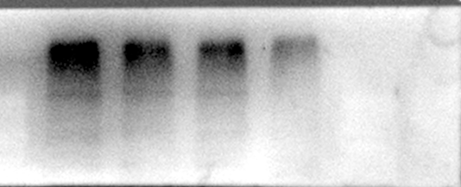 125 kDa
FAK
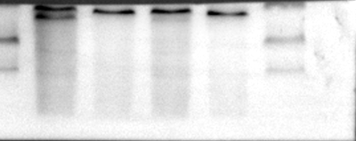 125 kDa
LRG1
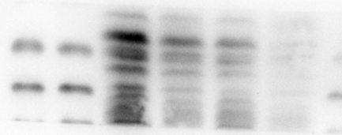 45 kDa
p-PI3K
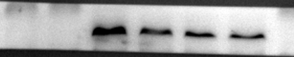 85 kDa
PI3K

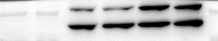 85 kDa
p-AKT
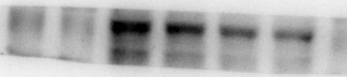 60 kDa
AKT
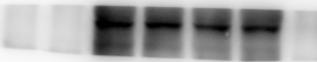 60 kDa
p-mTOR
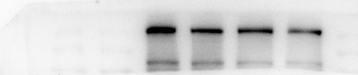 289 kDa
mTOR
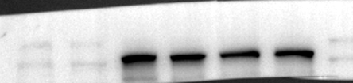 289 kDa
GAPDH
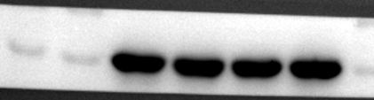 37 kDa
MDA-MB-231
p-FAK
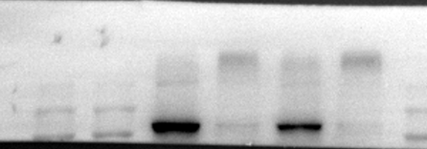 125 kDa
FAK
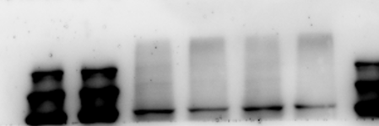 125 kDa
LRG1
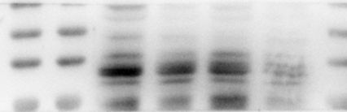 45 kDa
p-PI3K
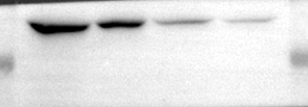 85 kDa
PI3K
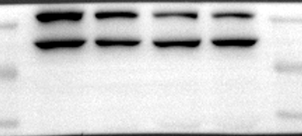 85 kDa
p-AKT
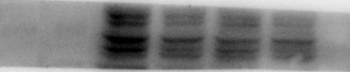 60 kDa
AKT
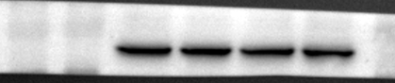 60 kDa
p-mTOR
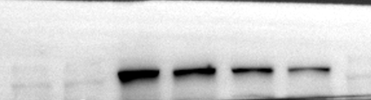 289 kDa
mTOR
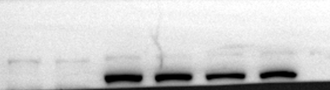 289 kDa
GAPDH
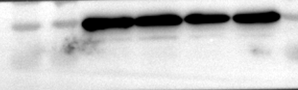 37 kDa

