Supporting informantion

Facile synthesis of La_{0.5}Sr_{0.5}Co_{0.53}Mn_{0.47}O₃/g-C₃N₄ hybrid materials and study on bifunctional ORR and OER performance
Rui Yanª, Kai Wang^{a*},Lei Zouª, Hewei Xuª, Tao Zhangª,
ªDepartment of Materials Engineering, Taiyuan Institute of Technology, Taiyuan 030008, China

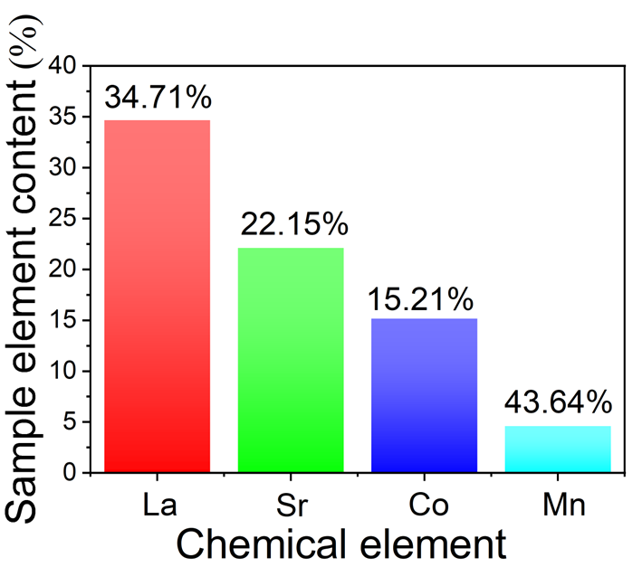

Fig. S1. Content of different elements in LCO-70% samples
Fig. S1 shows the contents of different elements of La_{x}Sr_{1-x}Co_{y}Mn_{1-y}O₃. According to the Fig. S1, the mass fraction of La is 34.71%, Sr is 22.15%, Co is 15.21%, and Mn is 43.64%, n(La):n(Sr):n(Co):n(Mn):n(O)= 0.5:0.5:0.53:0.47:3. So this perovskite precursor of structural formula for La_{0.5}Sr_{0.5}Co_{0.53}Mn_{0.47}O₃.

Fig. S2. Potentiostatic polarization curve of LCO-70% (a) Polarization curve without adding alcohol; (b) Polarization curve of methanol added in 1500s.

Fig. S2 show the polarization curve of LCO-70% at a constant potential of -0.26 V. It can be seen from figure S3a that the current density of the sample basically does not change after 3000s, indicating that LCO-70% has good stability. Fig.S2b shows that 1ml of anhydrous methanol is added at 1500 s. It can be found from the figure that the current density does not change after methanol is added. Therefore, it can be concluded that LCO-70% has excellent anti-methanol toxicity performance.

Fig. S3. EIS curve of different samples: (a) LCO-0%; (b) LCO-70%; (c)g-C₃N₄
Electrochemical impedance spectroscopy (EIS) analysis of the Nyquist plots (Fig. S3) reveals distinct interfacial charge transfer characteristics among the materials. The equivalent series resistance (ESR) follows the order: LCO-70% (68 Ω) > g-C₃N₄ (61 Ω) > LCO (50 Ω), suggesting increased bulk resistivity in the hybrid system. Contrastingly, the charge transfer resistance (R_{ct}) demonstrates an optimized value of 44 Ω for LCO-70%, representing a 2.2% reduction compared to pristine LCO (45 Ω) despite its higher ESR. This apparent contradiction resolves through the conductive bridging effect of g-C₃N₄, where its π-conjugated network facilitates interfacial electron tunneling between perovskite nanoparticles, thereby accelerating charge transfer kinetics while slightly compromising bulk conductivity.

