Synergistic antimicrobial effect of combined sterilization strategies against Listeria monocytogenes: Mechanistic insights and practical validation in prepared salad

Jinyuan Wei^{1,2,§}, Mohamedelfatieh Ismael^{1,§}, Mingxin Huang¹, Tian Han¹, Qingping Zhong^{1,}*

¹Guangdong Provincial Key Laboratory of Food Quality and Safety, College of Food Science, South China Agricultural University, Guangzhou 510642, China
²Guangdong Province Key Laboratory of Microbial Signals and Disease Control, College of Plant Protection, South China Agricultural University, Guangzhou 510642, China

*Corresponding author: Qingping Zhong
Mailing address: College of Food Science, South China Agricultural University, 510642, Guangzhou, China
Tel: +86-13535121218, +86-20-85288292
E-mail: zhongqp@scau.edu.cn
§These authors have contributed equally to this work.

Contents

Figure S1-S3, Table S1 and S2:
Interpretation of PMA-qPCR method development

Figure S4-5:
Supplementary data related to electronic nose experiments

Supplementary Figure 1. Specificity of the hlyA - based qPCR assay.
(a) Amplification curves showing positive detection in Listeria monocytogenes reference strains and no amplification in 11 non-target strains (negative control) (Supplementary Table 2). (b) Characteristic melting peak of L. monocytogenes at Tm ≈80°C. Results confirm high specificity of the assay and reliability of primer design.

Supplementary Figure 2. Listeria monocytogenes qPCR standard curve. Bacterial concentrations by plate counting exhibit a strong linear relationship with Ct values. Curve equation: y = -3.314x + 48.21 (R² = 0.992). Effective range: 1.2×10³–1.2×10⁹ CFU/mL. Enables detection of VBNC-state bacteria when combined with plate counting.
Supplementary Figure 3. Effects of PMA treatment conditions on detection of viable Listeria monocytogenes. (a) PMA concentration (μM), (b) dark incubation time (min), (c) light exposure time (min)
Live Ratio |  | PMA-qPCR | qPCR | Theoretical Live Count | Detected Live Count
 |  | log(CFU/mL) | log(CFU/mL) | log(CFU/mL) | log(CFU/mL)
1 | - | 8.33±0.10 | 8.47 | 8.47 | 8.33
- | 1 | 3.28±0.09 | 7.02 | - | 3.28
100 | 1 | 8.23±0.08 | 8.34 | 8.33 | 8.23
10 | 1 | 8.30±0.09 | 8.28 | 8.24 | 8.30
1 | 1 | 8.23±0.12 | 8.37 | 8.07 | 8.23
1 | 10 | 7.27±0.10 | 8.14 | 7.10 | 7.27

Supplementary Table 1. Detection results of qPCR and PMA-qPCR for mixed suspensions of viable and dead bacteria. Quantitative detection of Listeria monocytogenes in mixed viable/dead bacterial suspensions. PMA-qPCR data represent viable counts (CFU/mL), while qPCR data indicate total bacterial loads (CFU/mL). Theoretical viable counts were calculated from total counts based on mixing ratios; detected viable counts are PMA-qPCR means. No significant difference between theoretical and detected values (p > 0.05, t-test) confirms PMA-qPCR's validity for viable-cell quantification.

Scientific Name (Latin) | Number
Listeria monocytogenes | ATCC-19115
Listeria seeligeri | ATCC-35967
Listeriaivanovii | ATCC-19119
Listeria innocua | ATCC-33090
Enterococcus faecium | ATCC-29212
Staphylococcus epidermidis | CGMCC-26069
Staphylococcus aureus | ATCC-25923
Salmonella typhimurium | ATCC-14028
Escherichia coli | ATCC-25922
Shigella flexneri | ATCC-12022
Vibrio parahaemolyticus | ATCC-17802
Enterobacter aerogenes | ATCC-13048
Pseudomonas aeruginosa | ATCC-9027
Supplementary Table 2. 11 non-target strains. ATCC: American type culture collection, CGMCC: China General Microbiological Culture Collection Center.

Supplementary Figure 5. PCA of electronic nose analysis.
a-day 0, b-stored at 4 ℃, c-stored at 10 ℃. 1-3 represented 3rd, 6th and 9th days of storage period. Green was the control group, red was 4 MIC SAEW, and blue was the combined sterilization method US+1 MIC SAEW+1 MIC SAEW

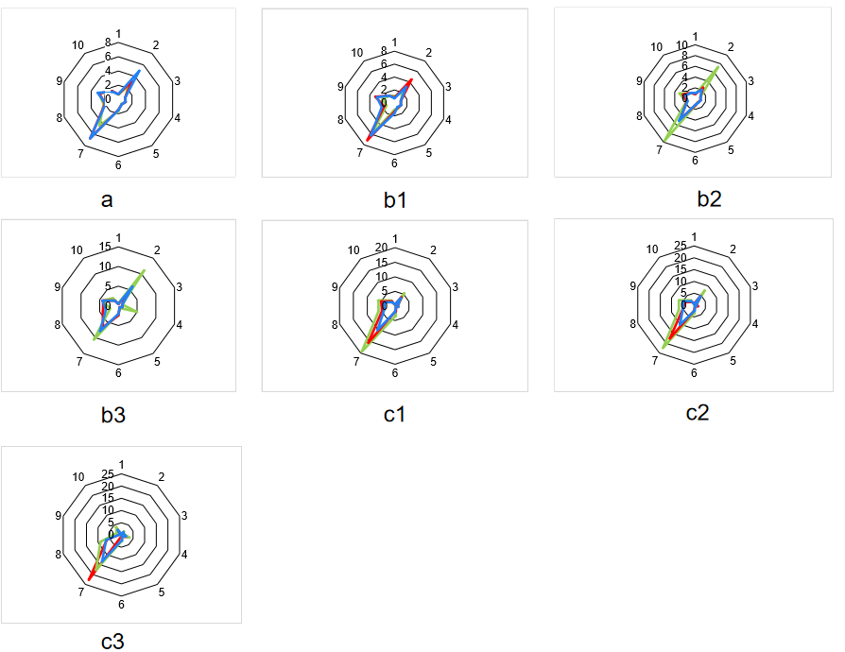
Supplementary Figure 6. Radar chart of electronic nose analysis of premade salad after treatment with different sterilization methods.
a-day 0, b-stored at 4 ℃, c-stored at 10 ℃. 1-3 represented 3rd, 6th and 9th days of storage period. Green was the control group, red was 4 MIC SAEW, and blue was the combined sterilization method US+1 MIC SAEW+1 MIC SAEW.

