Supplementary Material for “E-Cigarette Use, Cigarette Use, and Sex Modify the Nasal Microbiome and Nasal Host-Microbiota Interactions”

Elise Hickman^{1,2}*, Andrew Hinton^{3,4,}*, Bryan Zorn⁵, Meghan E. Rebuli^{1,2}, Carole Robinette¹, Matthew Wolfgang^{5, 6}, Peter J. Mucha^{3,7}, Ilona Jaspers^{1,2#}

*These authors contributed equally to the published work.
# Corresponding author

¹ Center for Environmental Medicine, Asthma, and Lung Biology
² Curriculum in Toxicology & Environmental Medicine
³ Curriculum in Bioinformatics and Computational Biology
⁴ UNC Food Allergy Initiative, School of Medicine
⁵ Marsico Lung Institute
⁶ Department of Microbiology and Immunology
⁷ Department of Mathematics and Department of Applied Physical Sciences
University of North Carolina, Chapel Hill, NC, United States

Supplementary Table 1. Commercially available ELISA kits used to measure mediators of host-microbiota interaction.
Mediator | Limit of Detection | Company | Company Location
Neutrophil Elastase | 0.8 ng/mL | Thermo Fisher Scientific (Invitrogen) | Waltham, MA
Total IgA | 1.6 ng/mL | Thermo Fisher Scientific (Invitrogen) | Waltham, MA
Lactoferrin | 156.3 pg/mL | Abcam | Cambridge, UK
Lysozyme | 31.25 pg/mL | Abcam | Cambridge, UK
IL-8 | 3.1 pg/mL | BD Biosciences | San Diego, CA
Beta-Defensin 1 | 7.8125 pg/mL | LifeSpan Biosciences | Seattle, WA
Beta-Defensin 2 | 7.8125 pg/mL | LifeSpan Biosciences | Seattle, WA

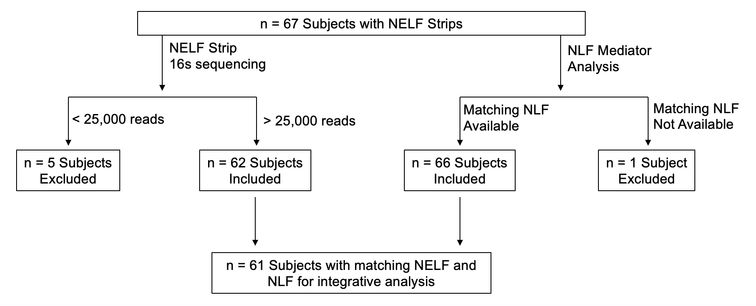
Figure S1. Flow chart showing inclusion and exclusion criteria for NELF microbiome component, NLF component, and integrative analysis.

Figure S2 | SelEnergyPerm taxa subset selection and significance results. (A) Left - Selection of number of taxa (t = 10) by normalized energy maximization to test in the final by Sex microbial log ratio signature. Right – SelEnergyPerm by Sex microbial signature significance via permutation testing. (B) Left - Selection of number of taxa (t = 20) by normalized energy maximization to test in the final by Subject microbial log ratio signature. Right – SelEnergyPerm by Exposure group microbial signature significance results via permutation testing.

Figure S3 | NLF Mediator Analysis (A) Histogram of total NLF mediator concentrations by sample. (B) DCV scoring of NLF mediator log ratios. Grey: DCV < 0; Blue: DCV > 0 (C) Graph representation of DCV derived key NLF mediators. (D) Log ratio values of key NLF mediator log ratios by exposure group with subsequent Wilcoxon Rank-Sum test pairwise comparison displayed. (E) NLF mediator exposure group discrimination via ROC curve displaying the multi-class AUC results of 50 repeats of 10-fold cross-validation using a 2-component PLS-DA model.

Figure S4 | By Exposure group Nasal Microbial Signature Latent Space Analysis (A) 2-Component PLS-DA Biplot (B) Violin plot with means showing the distribution of first PLS-DA component scores by exposure group (C) PLS-DA loadings on the first component.

