Table 2 The structure and binding pockets of SARS-CoV2 main protease along with its native ligand (PDB ID:7BQY)
S.No. | PDB ID |  | Macromolecule | Native Ligand | Active site
1. |  | 7BQY | 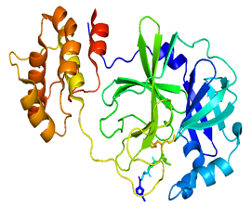 | 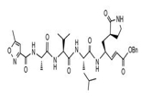 | PHE140,LEU141,ASN142,GLY143,SER14,CYS145,HIS163,HIS164,MET165,GLU166,LEU167,PRO168
Table 3 Molecular docking of FDA approved drugs with their respective binding energies in (Kcal/mol) and docking poses intereacting with the amino acids of active groove of target SAR-CoV-2 M^{pro} (PDB ID 7BQY)
S. No. | Compound | Interaction | Binding affinity (kcal/mol) | Residue Interacting with Compounds
1. | Lopinavir* | 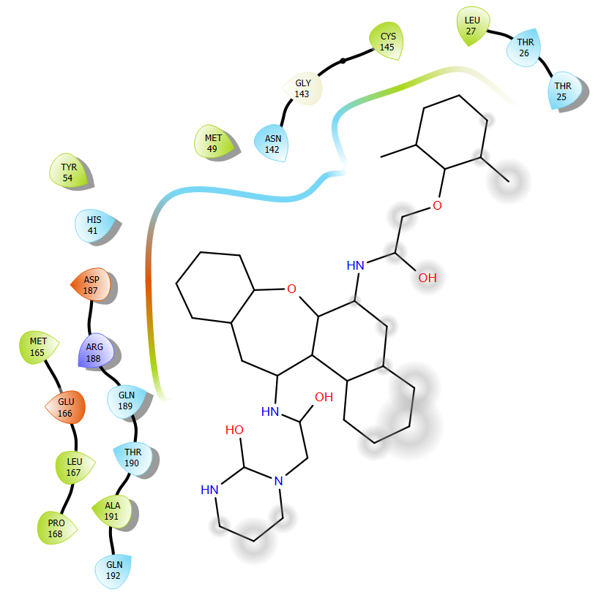 | -8.71 | GLU166, GLN192
2. | Ritonavir* | 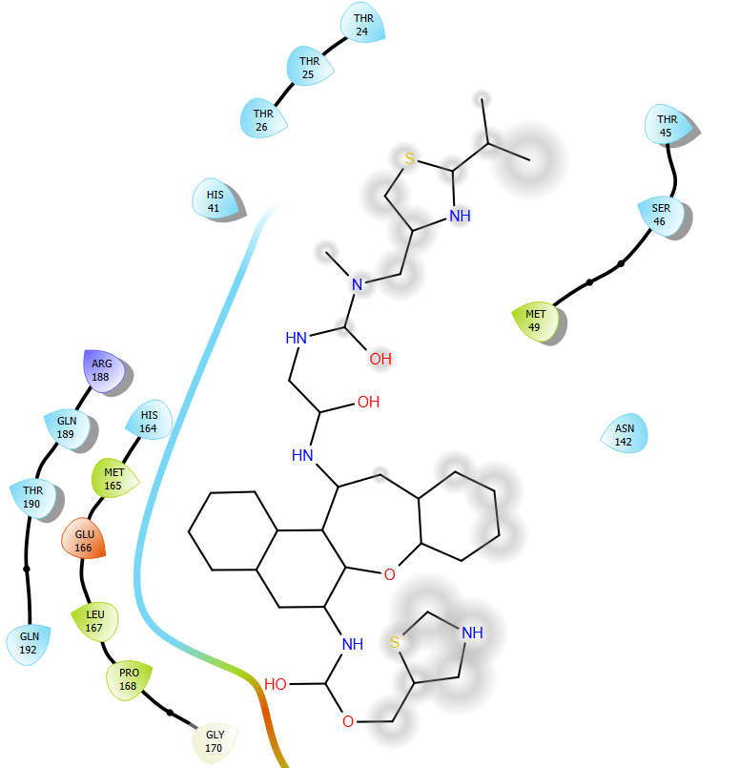 | -8.08 | GLU166
3. | Atazanavir | 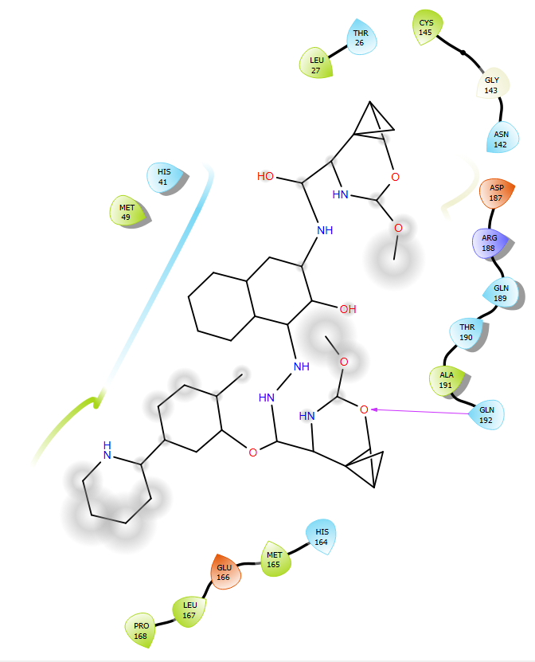 | -10.36 | HIS41, GLY143, GLN192
4. | Nelfinavir | 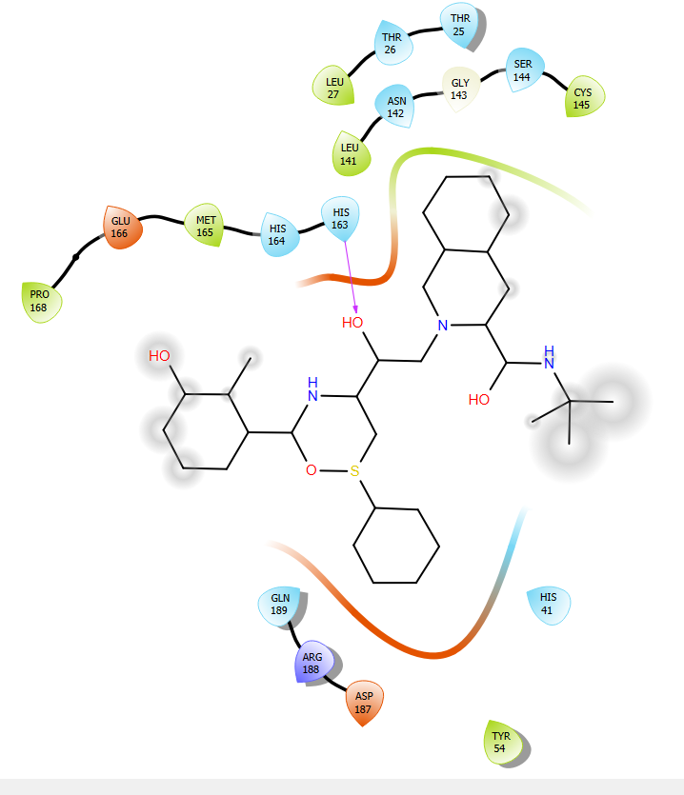 | -9.47 | ASN142, HIS163, GLU166
5. | Letermovir | 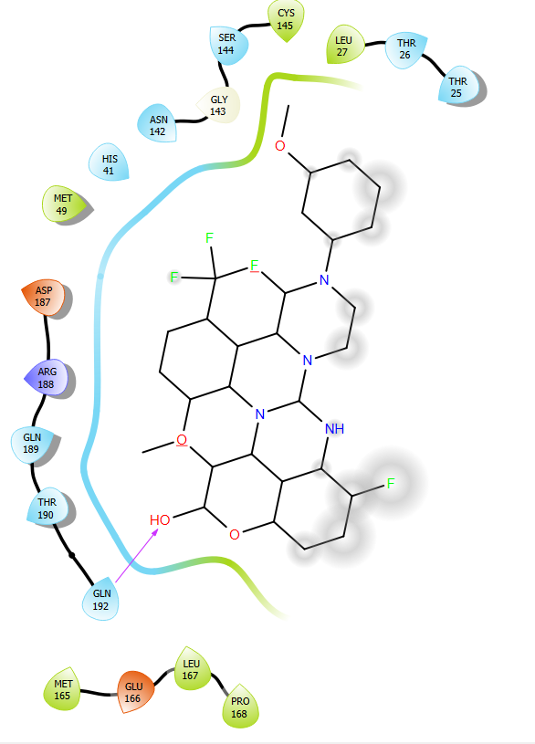 | -9.43 | HIS41, GLN192
6. | Indinavir | 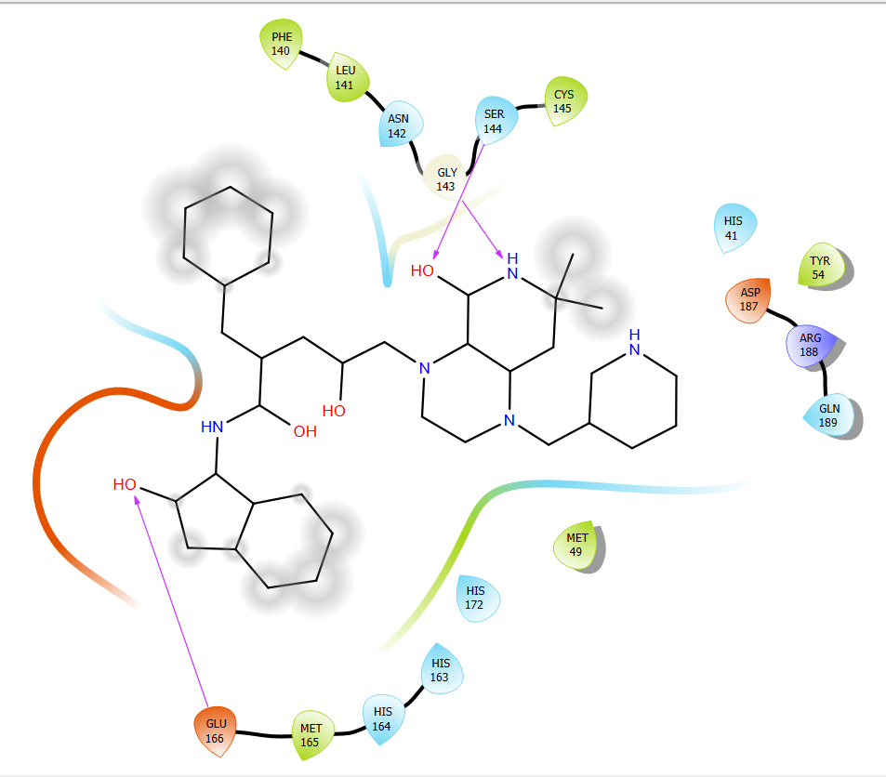 | -8.65 | GLY143 , SER144, CYS145, HIS163, GLU166, GLU166, HIS172
7. | Irinotecan | 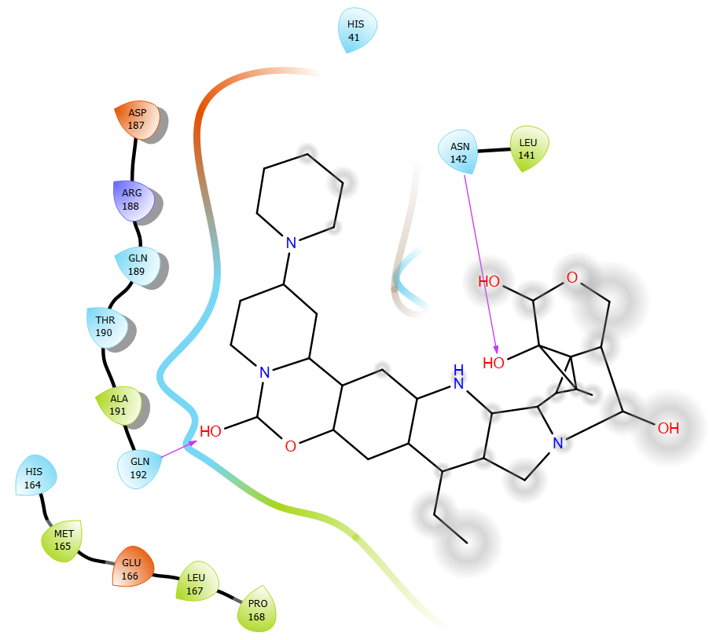 | -8.61 | ASN142, GLN192
8. | Amprenavir | 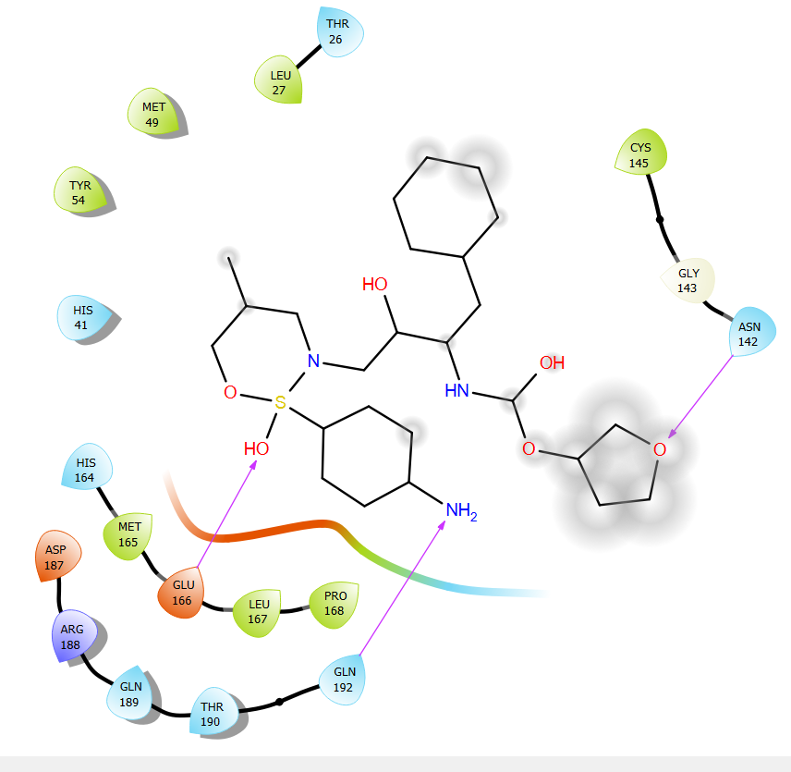 | -8.38 | ASN142, GLU166, GLN192
9. | Raltegravir | 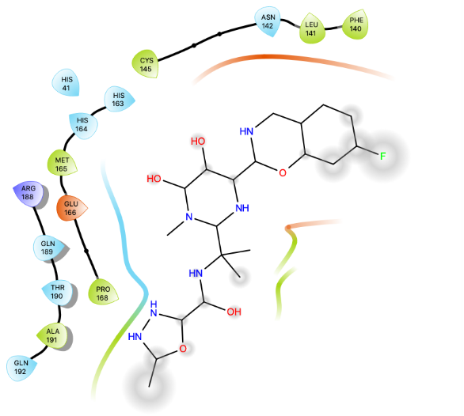 | -7.97 | GLU166, THR190, GLN192
10. | Saquinavir | 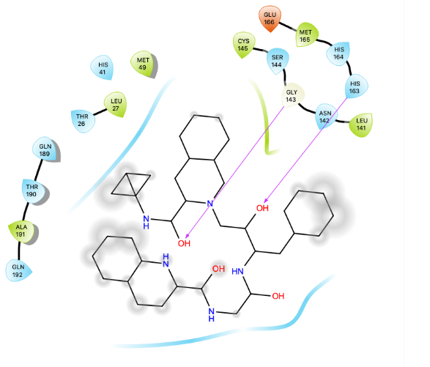 | -7.89 | HIS41
11. | Darunavir | 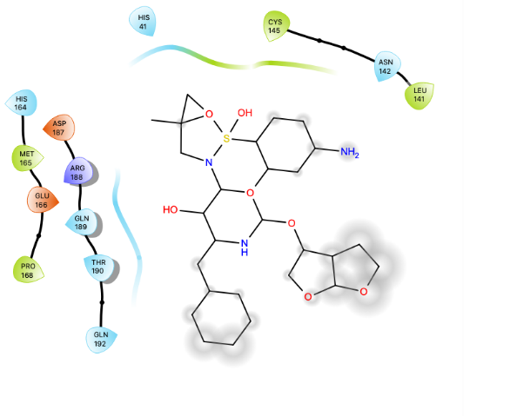 | -7.44 | PHE140, GLU166
12. | Elbasvir | 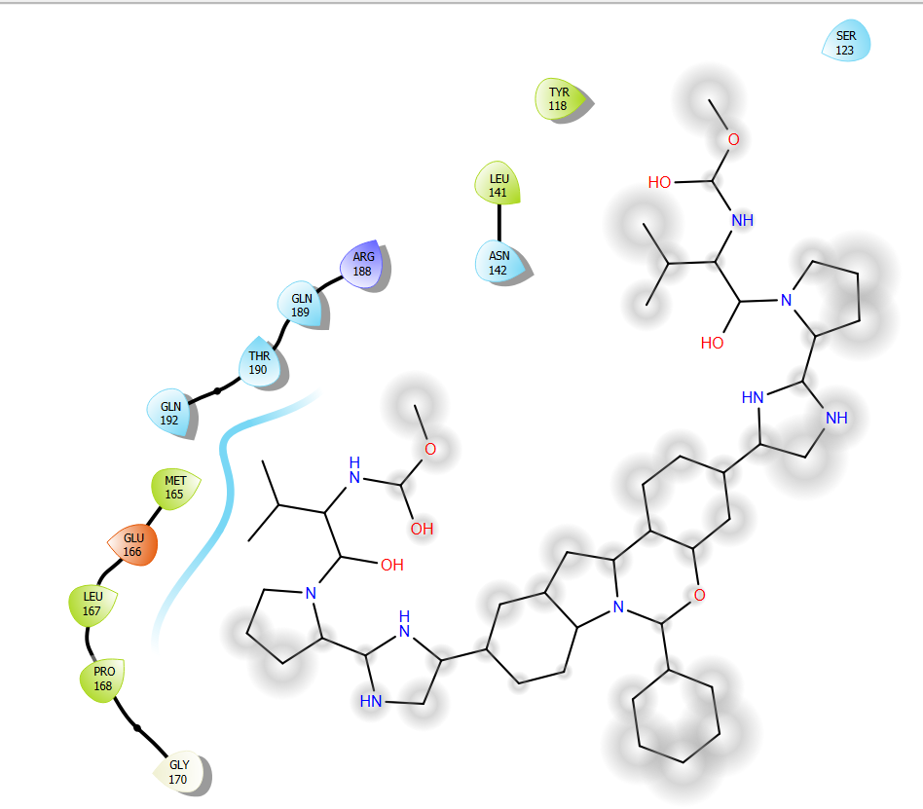 | -5.81 | No hydrogen bond

