This file contains numbers of protocol and procedure, follow the page
Protocols and Procedures
1. RNA extraction and DNase I treatment methodology
Based on the literatures, the maximum expression of BBD129 gene has been reported in the cauda regions of buffalo so the cattle caudal tissues were selected for the total RNA isolation. RNA isolation was done by manually by using TRIzol (Qiazol, USA) as follows:
- Tissue was taken from LN2 and removed outer surface layer with the help of sterile scalpel and crushed with LN2 in DEPC-treated sterile pistol-mortar and processed for TRIzol treatment for 5 minutes by vortexing followed by centrifugation at 5000xg.
- The supernatant was transferred into DEPC-treated 1.5 ml centrifuge tube containing 200 µl chloroform (Sigma, USA) and mixed the tissue lysate by turning up-down for 2 minutes (pink syrup color will appear) and kept on ice for 10 minutes.
- Centrifugation was performed at 12000xg for 15 minutes at 4 °C and approximately 200 µl of supernatant was transferred to fresh DEPC-treated 1.5 ml centrifuge tube.
- An equal volume of 2-isopropanol (Sigma, USA) was added and placed at -20°C for 45 minutes followed by centrifugation at 12000xg at 4°C for 20 minutes.
- Pellet was washed with DEPC-treated 70% ethanol and pellet was air dried for 5-10 minutes and pellet was dissolved in 30µl DEPC-treated nuclease free water.
- The quality and quantity was isolated of RNA was measured by NanoDropND-1000 UV Vis spectrophotometer (NanoDrop technologies Inc., Wilmington, DE, USA).
- The A_{260/280} and A_{260/230} ratio was very close to 2.0. The quality of extracted RNA was assessed by running 200-300ng of RNA (heat at 70ºC for 1 minute) in non-denaturing TAE buffered 1% agarose (Lonza, USA).
B) DNase I treatment and DNase inactivation
The steps followed were as described below:
- A10x DNase I buffer (1/10th volume of RNA eluted) was added along with 1 µl of DNase I to the RNA containing tube.
- The mixture was incubated at 37ºC for 30 minutes. During the incubation DNase inactivation regent was taken out form -20ºC and allowed to thaw at room temperature (RT) and vortex vigorously.
- After 30 minutes, 1/10th volume (i.e. if the RNA volume is 50 µl and 1 µl DNase I and 5 µl DNase buffer was used in the step 1 add 5.8 µl of DNase Inactivation reagent) of DNase inactivation reagent was added to the reaction mixture.
- The reaction mixture was stored at room temperature for 2 minutes and in between the incubation period once the mild vortexing was done to disperse the DNase inactivation reagent.
- The RNA (present in supernatant) was then transferred to a new RNase free tube and processed for RLM-RACE amplification.

2. The protocol was followed according to RLM-RACE kit (Ambion cat# 1700). The overview of 5’RLM-RACE and 3’ RLM-RACE procedure has been depicted in figure 3.1.4.1 and 3.1.4.2 respectively.
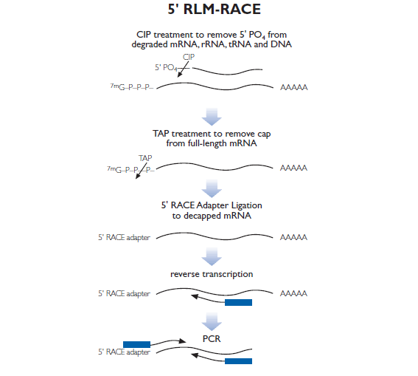

Figure 3.1.4.1: 5’ RLM-RACE procedure used for amplification of 5’end of Buffalo BBD129 gene
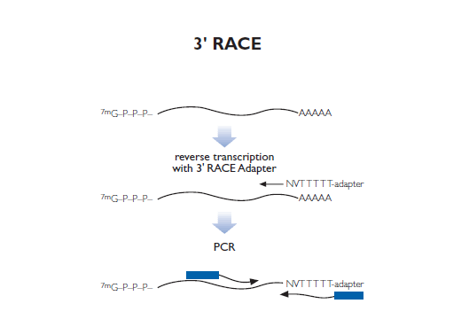
Figure 3.1.4.2: 3’ RACE procedure used for amplification of 3’end of Buffalo BBD129 gene

RNA processing for 5’ RLM-RACE
A) Calf Intestine Alkaline Phosphate (CIP) treatment: Dephosphorylation of incomplete and non-mRNAs
A mixture of 10µg of total RNA was taken and heat up at 55°C for 5 minutes and added 10X CIP buffer (5µl), Calf Intestine Alkaline Phosphate (CIP) enzyme (2µl), RNase inhibitor (1µl) and DEPC-nuclease free water (20 µl) was taken into DEPC-treated 200µl PCR tube followed by gentle mixing by pipetting and incubated at 37°C for one hour.
B) Termination of CIP
To terminate CIP action, CIP treated solution was washed in DEPC-nuclease free water (250µl), 10M ammonium acetate (75µl), and acidic Phenol: Chloroform, 1:1 (375µl) followed by thoroughly vortexes and centrifuged at 12000xg for 5 minutes at room temperature. Aqueous layer was transferred into a separate DEPC-treated tube and 150µl chloroform was added followed by thoroughly vortex and centrifuged at 12000xg for 5 minutes at room temperature. Precipitation was done by addition of150 µl isopropanol, vortexes thoroughly and chilled at -20°C for 10 minutes. Subsequently, centrifuged at 12000xg for 20 minutes at 4°C was done. Pellet was washed in70% DEPC-treated Ethanol. The pellet was dried in air and dissolved in 20 µl of DEPC-treated nuclease free water for further use.
C) Tobacco Acid Pyrophosphatase (TAP) associated enzymatic decapping of mRNA molecules:
After termination of CIP, the following regents were added to the sterile RNase free microcentrifuge: 10 X TAP buffers (5µl), TAP (2µl), RNase Inhibitor (1µl), and DEPC-water (20µl) to 18µl of CIP treated RNA was processed for the TAP (Tobacco Acid Pyrophosphatase) treatment and 2 µl of CIP RNA was kept for –TAP control reaction. Gently pipette mixing was done and incubates at 37°C for 1 hour, followed by solution with DEPC-nuclease free water (250µl), 10M ammonium acetate (75µl), and acidic Phenol: Chloroform, (in 1:1 ratio) (375µl) followed by thoroughly vortex and centrifuged at 12000xg for 5 minutes at room temperature. Recovered aqueous layer in separate DEPC-treated tube and added 150µl chloroform, vortex thoroughly, centrifuged at 12000xg for 5 minutes at room temperature. Precipitation was done by adding 150 µl isopropanol, vortex thoroughly and chilled at -20°C for 10 minutes followed by centrifugation at 12000xg for 20 minutes at 4°C. Pellet washed with 70% DEPC-treated Ethanol. Allowed the pellet to air dry and dissolved in 20 µl of DEPC-treated nuclease free water.
D) 5’ RLM-RACE Adapter ligation
The following components were added to sterile RNase free microcentrifuge tube: TAP treated RNA (10 µl), 5’ RACE Adapter (2 µl, 5'-GCUGAUGGCGAUGAAUGAACACUGCGU-UUGCUGGCUUUGAUGAAA-3'), 10X RNA ligase buffer (5µl), T4 RNA ligase (2 µl), RNase inhibitor (1 µl) and 40% polyethylene glycol (10 µl) was added into a DEPC-treated 200µl PCR tube and gently pipette mixing was done followed by incubation at 17°C for 1 hour and at 37°C for next one hour. A 10µl of ligated products was used for the reverse transcription reaction and remaining ligated product was kept in -80°C for future use. Similarly, TAP control reaction was prepared.

3. Plasmid isolation and PCR protocol
Plasmid isolation was performed manually by alkaline lysis method. 2 ml of overnight grown broth culture was centrifuged at 8000xg at room temperature for 10 minutes. Supernatant was decanted, alkaline lysis solution 1 (50mM glucose, 25mM Tris-HCl, 10mM EDTA) was added, vortexes the sample. Addition of alkaline lysis solution 2 (0.2N NaOH, 1% SDS) followed by addition of alkaline solution 3 (5M potassium acetate, glacial acetic acid), mixed the contents by inverting the tube and stored at room temperature for 10 minutes followed by centrifugation at 12000xg for 10 minutes at 4°C. A 200 µl of supernatant was collected in fresh sterile 1.5 ml centrifuge tube and the nucleic acid was precipitated by adding equal volume of 2-isoprpanol (sigma company), incubated at -20°C for 10 minutes followed by centrifugation at 12000 rpm for 20 minutes at 4°C. The supernatant was decanted, washed the pellet with 70% ethanol, centrifuged at 12000xg for 5 minutes at 4°C and pellet was dissolved in 20 µl nuclease free water after briefly dried in air. Quality of isolated plasmid was evaluated by measuring 280/260 nm and 260/230 nm ratio using NanoDrop ND1000 spectrophotometer and agarose gel electrophoresis.
PCR was done for the confirmation of BBD129in the plasmid in a 25µl PCR reaction mixture consisting of 0.5 µl of each pJET1.2 forward and pJET1.2 reverse primers (10mM/ml), 0.5 µl mix dNTPs (Fermentas, USA), 2.5 µl Taq buffer 10X, 0.25 µl of dream Taq polymerase (Fermentas, USA), single colony as DNA template and remaining nuclease free water. PCR reaction profile was used 95°C for 5 minutes (initial denaturation), 94°C for 30 seconds (denaturation), 60°C for annealing of primers, 72°C for 40 seconds (extension), 35 cycles were run followed by final extension at 72°C for 10 minutes) and positive plasmids were processed for sequencing (Agri-Genomic, India).
4. Copy number variation analysis:
A) Primer designing, optimization of primer annealing temperature
The primers were designed against coding region of exon 2 (coding for mature protein) of BBD129 gene to amplify a stretch of less than 150 bp. The corresponding predicted mRNA sequences of bovine, owine, caprine, and porcine DEFB129 gene from NCBI database (https://www.ncbi.nlm.nih.gov/). Multiple sequence alignment was done using Clustal W (https://www.genome.jp/tools-bin/clustalw) and primers were picked up from the regions of mRNA sequences of which are conserved across the mammalian species. Primers parameters (i.e. hairpin loop formation, self-complementary, GC%, nucleotides repetition, primer dimmers) were confirmed by using Oligocalculator tool (http://biotools.nubic.northwestern.edu/Oligo-Calc.html).To optimize primers annealing temperature, PCR reaction of 25µl volume was set-up with following components: 0.5 µl of each primer (Forward primer = 5’TGTCATGATGCAG-ACCGAAC3’, Reverse primer = 5’TGGTGGCATTTGGGATGAT-GA3’), 0.5 µl mix dNTPs (Fermentas USA), 2.5 µlTaq buffer 10X, 0.25 µl of dream Taq polymerase (Fermentas), and 1 µl of gDNA (20 ng/µl) as template. PCR thermal profile was used: initial denaturation (95°C for 3 minutes), denaturation (95°C for 15 seconds), annealing (45°C to 55°C temperature), extension or polymerization (72°C for 15 seconds), and 35 cycles were run. Non-template reaction was included as negative control to check nucleic acid contaminations to other PCR components. Amplified products were analyzed on 2 % agarose gel (Lonza Company) with 100bp DNA ladder (thermo) (BioMetra T-Professional Basic Gradient PCR Machine, Germany).

B) Optimization of primer concentration and gDNA template
After standardization of primers annealing temperature, the selection of concentration of forward and reverse primer was done by q-PCR assay with the following reaction components: SYBR (5 µl), forward primer (0.25µl/0.5µl/1µl/1.5µl), reverse primer (0.25µl/0.5µl/1µl/1.5µl), nuclease free water, and gDNA template (2µl of 40ng/µl). The following qPCR thermal profile was used: initial denaturation (95°C for 3 min), denaturation (95°C for 10 second), annealing (49°C for 15seconds), extension (72°C for 15 min) and 35 cycles were run on Bio-Rad CFX96 Maestro qPCR machine by using SYBR Green Master Mix (Bio-Rad, USA).
The gDNA concentration was standardized with qPCR selecting best concentration which can differentiate amplification between two samples. The concentration of gDNA was fixed (40 ng/µl, 20 ng/µl, 15 ng/µl, 10 ng/µl, 5 ng/µl, 2.5 ng/µl, 1.25 ng/µl) with the help of NanoDrop spectrophotometer. qPCR reaction was consisted of following components: SYBR (5 µl), forward primer (1.5µl), reverse primer (1.5 µl), nuclease free water, and gDNA template (40 ng/µl, 20 ng/µl, 15 ng/µl, 10 ng/µl, 5 ng/µl, 2.5 ng/µl, 1.25 ng/µl) with same thermal profile as mentioned above.
C) Construction of double-stranded plasmid standard curve
The concentration of recombinant plasmid containing insert of exon 2 of BBD129 gene was adjusted to 1.25 ng/µl with the help of NanoDrop spectrophotometer. The concentration of copy number of the r-plasmid was converted to corresponding copy concentration using the following equation (Ayanmukharjee et al., 2013).

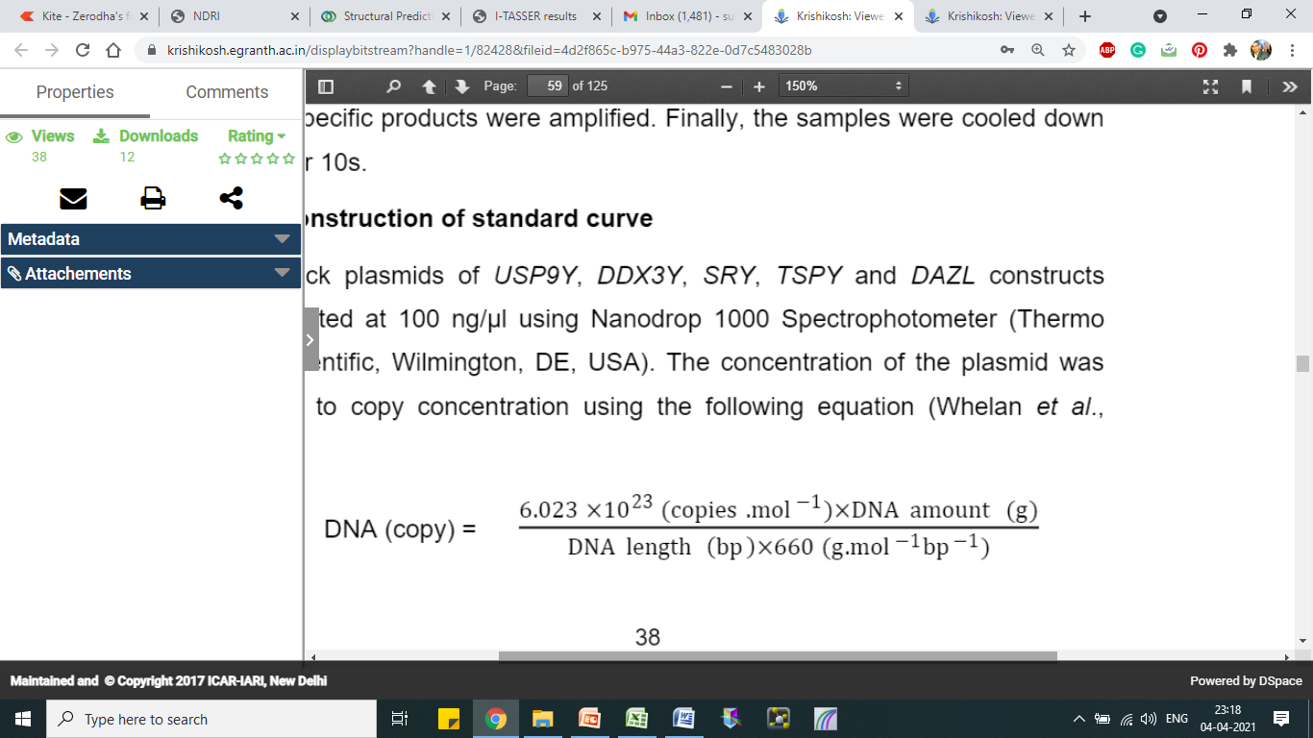
A dilution series of plasmid construct was used to construct the corresponding standard curve of BBD129 gene. Standard dilution was assayed in duplicate; qPCR was performed using 2 µl templates. The Cq values was plotted against the logarithm of the initial template copies. Standard curve was generated by liner regression of the plotted points. From the slope of curve, PCR amplification efficiency (E) was calculated according to the following equation:
E = 10^{-1/slope-1}

